Name: Mohsin Ali
Roll Number: 25P-0545
NU ID: p250545@pwr.nu.edu.pk

QUESTION#1
Create a basic Scratch application that prompts the user to input their First Name and Last Name. Once entered, the app should display the message “Hello Mr. First Name Last Name”.

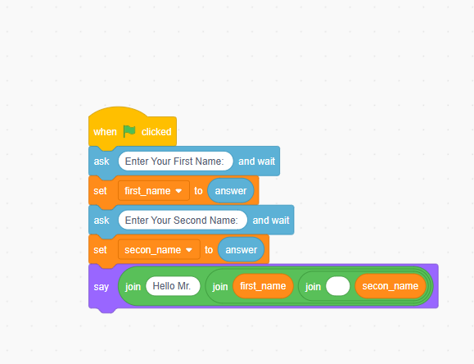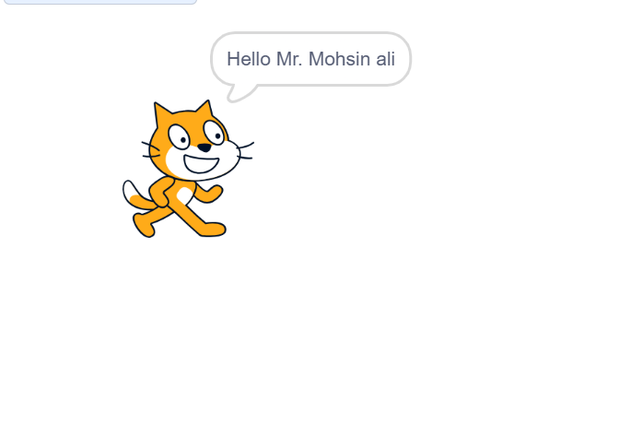

QUESTION#2
Create a Scratch program that takes two numbers from the user. Display the square of the first number and the cube of the second number.

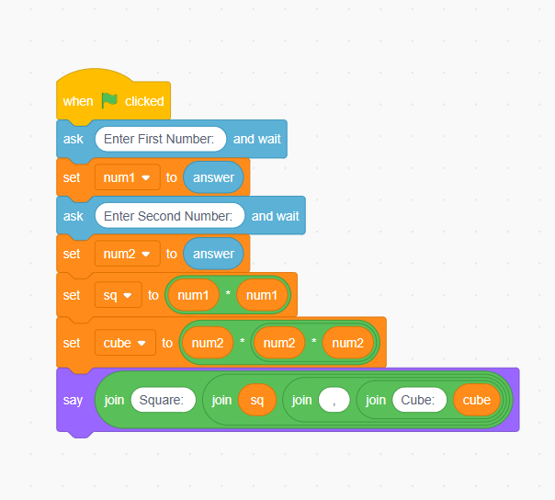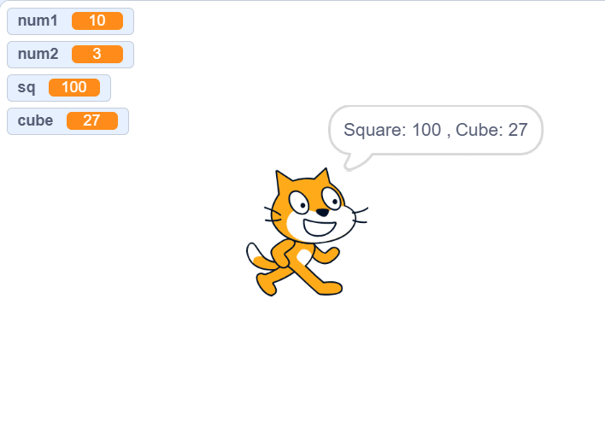

QUESTION#3 Sara has a cylindrical water tank with a radius of 5 meters and a height of 8 meters. Calculate and output the volume of the water tank using Scratch. (Hint V = π * r^2 * h).
[ Using Given Values]

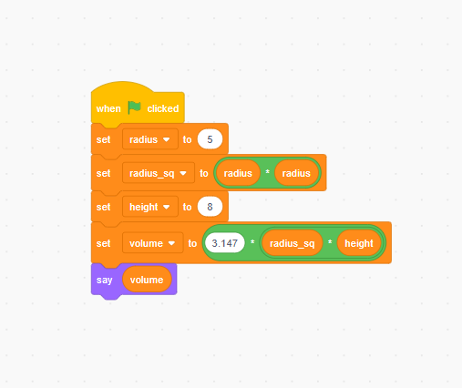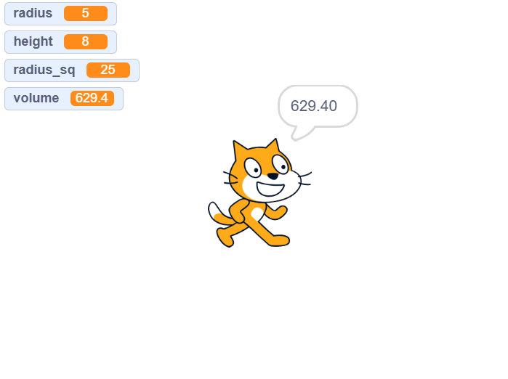

[ Using User Given Values]

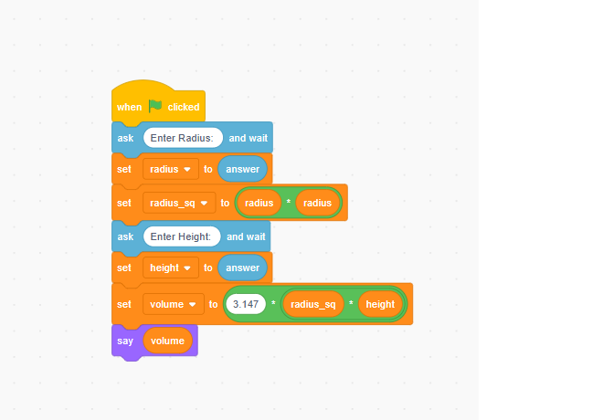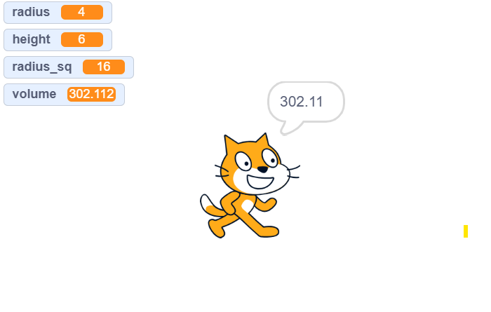

QUESTION#4
A high-tech gadget is originally priced at 2000 Rs. Due to stock storage concerns, its price has increased by 20%.
Create a Scratch program to calculate and display the new price of the gadget after the increase.
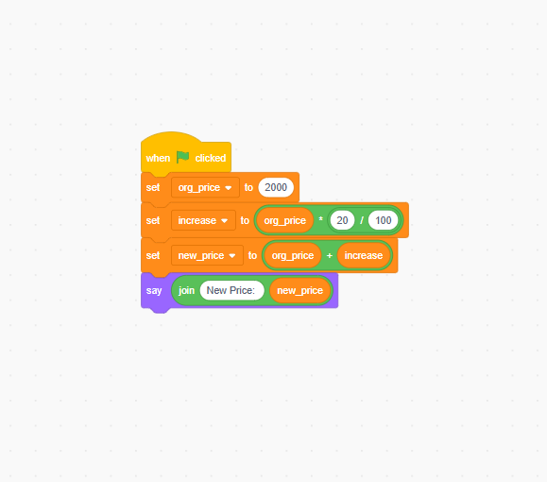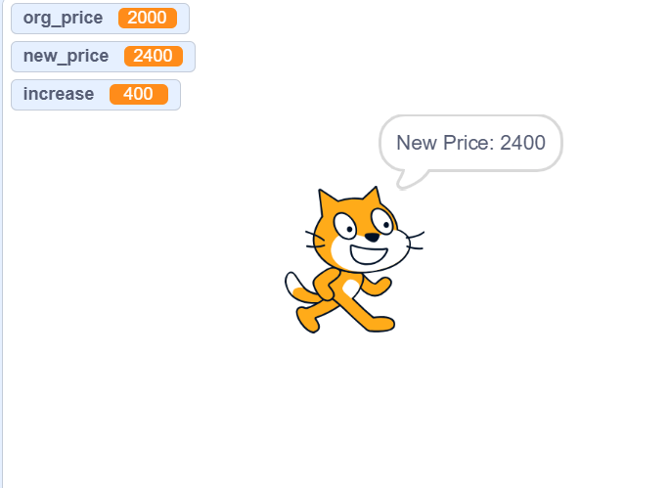

QUESTION#5
An ice cream seller sets up shop in four different areas of Karachi: Clifton Corner, Saddar Square, Gulshan Glades,
and Korangi Crossing. The price of each ice cream is 150 Rs. In Clifton Corner, 35 ice creams are sold, in Saddar.
Square, 50 are sold; in Gulshan Glades, 20 are sold; and in Korangi Crossing, 45 are sold. To calculate the total
sales, the seller adds up the ice creams sold in each area and computes the total money earned.
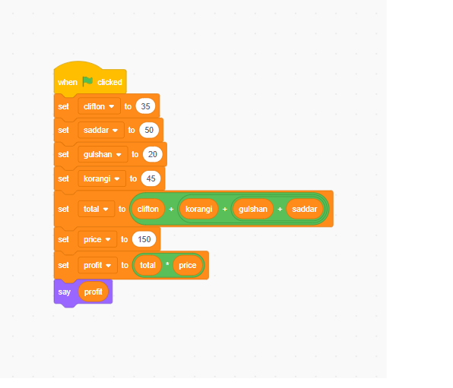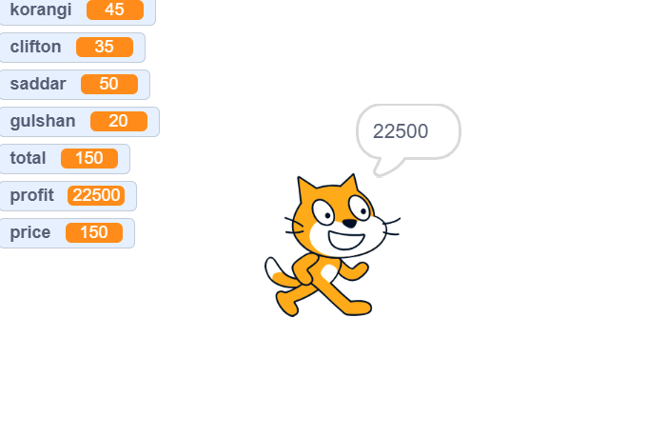

QUESTION#6
Imagine you’re developing a drone for navigating around obstacles. Create a Scratch program that takes the drone position (x1, y1) and the obstacles position (x2, y2) as input. Then, use the 2-dimensional distance formula, D = √((x2 - x1)^2 + (y2 - y1)^2), to calculate and display the distance between the drone and the obstacle. This will help the drone decide whether it can safely fly over the obstacle and avoid collisions
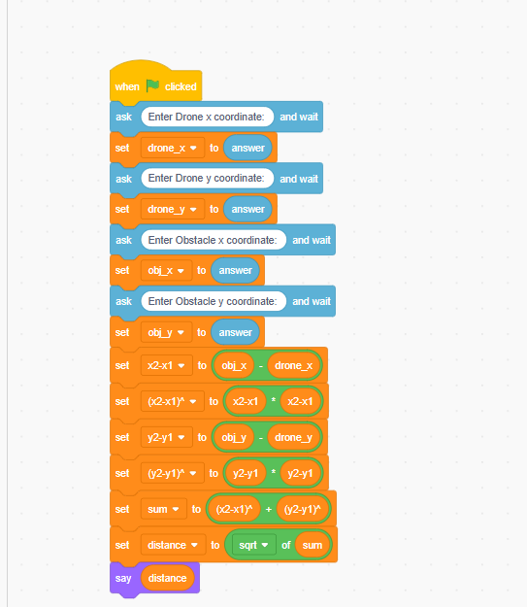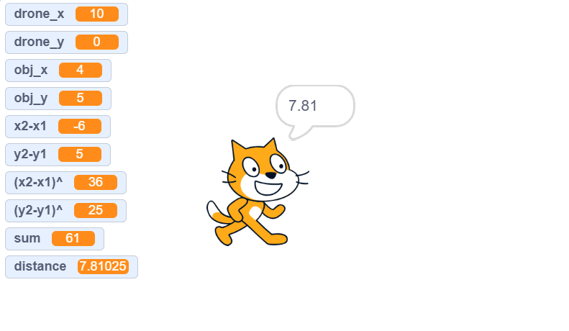

Thank You:)

