Lab task 2
Name: Mohsin Ali
Roll Number: 25P-0545
Section: BSC-1C
  - Programming Fundamentals Lab.

TASK # 1: Write a program that takes a user input and, if the input is divisible by 3, outputs ‘Fizz’. If the input is divisible by 5, it outputs ‘Buzz’. If the input is divisible by both 3 and 5, it outputs ‘FizzBuzz’.

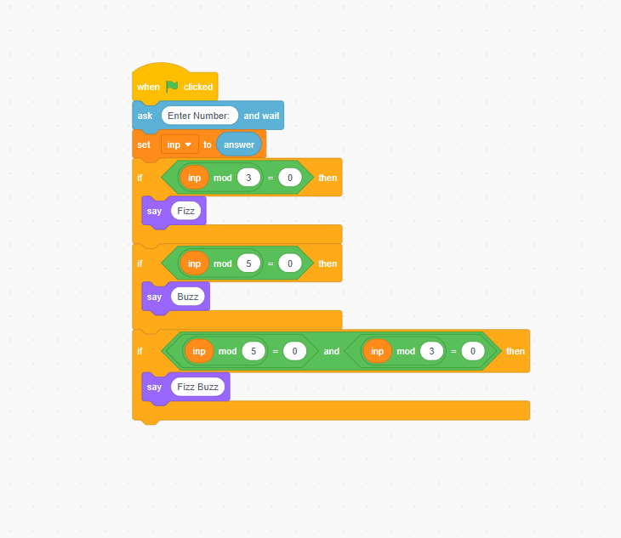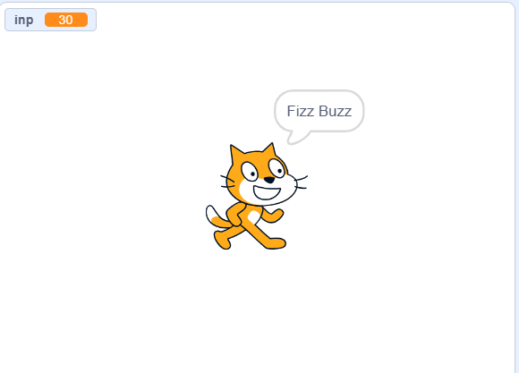

TASK # 2: Complete the number sequence for 20 terms total: 1, 4, 9, 16….

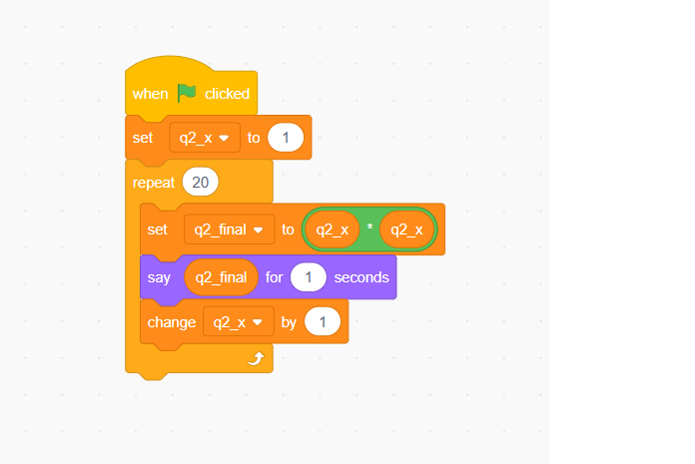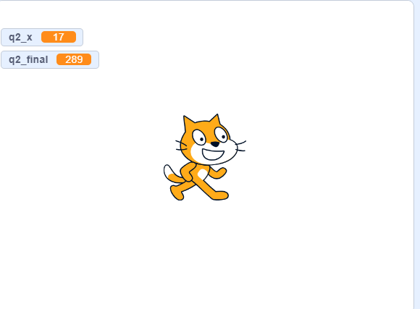

TASK # 3: Build a program for computing the adjusted electricity bill for K Electric’s customers. Prompt the user to input the number of units consumed. With a unit price of 8 Rs, apply the following guidelines: no extra charge for units under 300, add 5% for units between 300 and 400, raise by 10% for units between 400 and 500, and augment by 50% for units exceeding 500. The program will end and display ‘Invalid input’ when a negative unit value is entered. Output the adjusted bill amount for valid inputs.
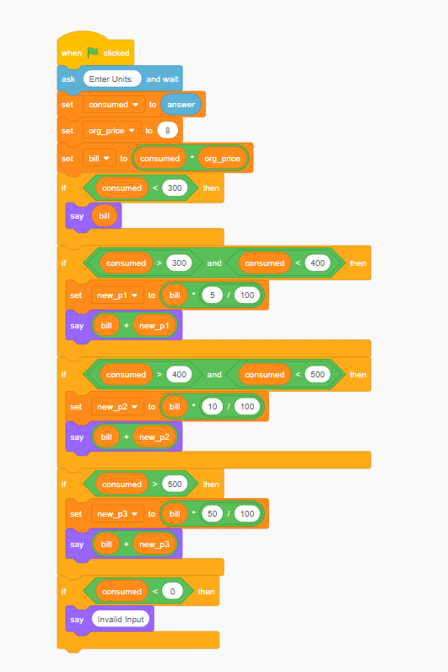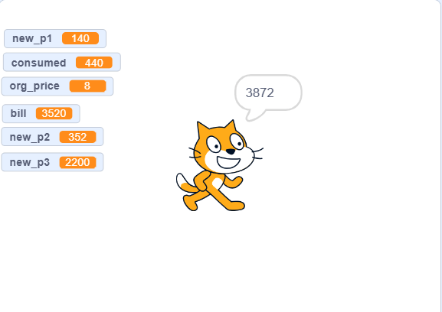

TASK # 4: You are supposed to create a mark sheet. There are total 4 subjects. Each subject has maximum marks 100, therefore total maximum marks are 400. Take marks of 4 subjects as an input from the user. Calculate the average percentage and output the final overall letter grade using table below. Note: There should only be ONE grade in output (if marks are 87 then only A should be output, not A, B, C, D, and F).
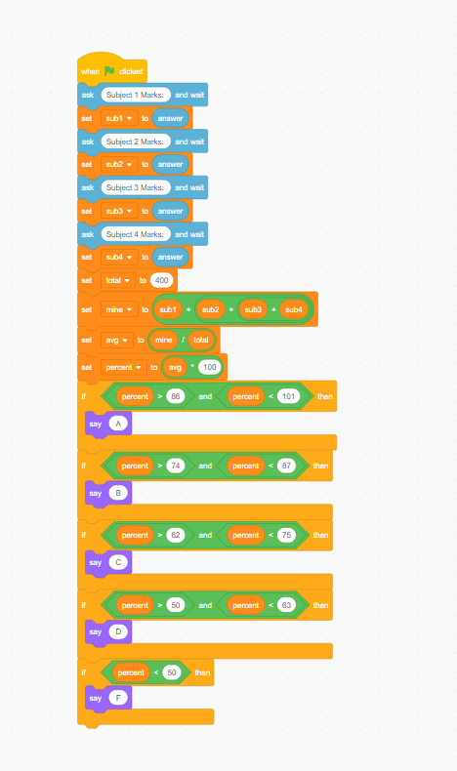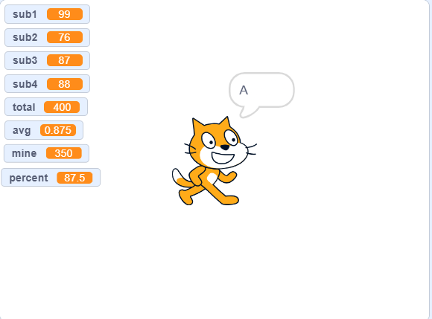
Table:
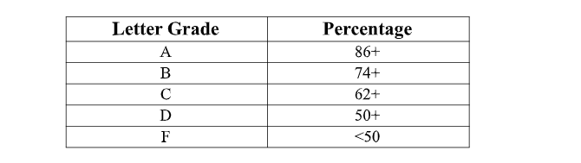

TASK # 5: Given below is a flow chart. Identify the decision and iterative structures in it. Convert the flow chart in to scratch diagram.

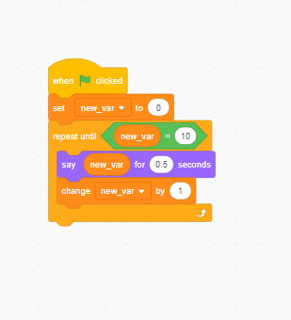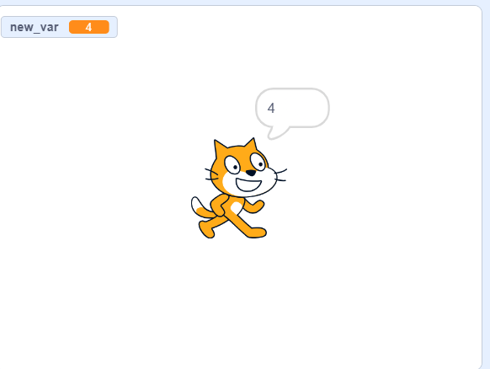
Flowchart:
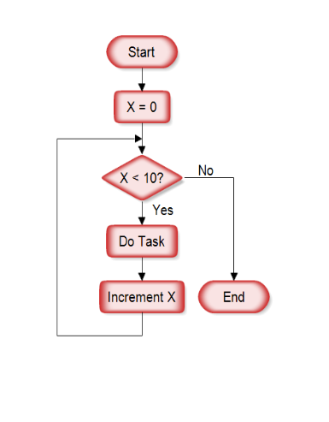

TASK # 6: Design a Scratch program for a step counting tracker. Continuously input the number of steps taken and categorize the activity levels as follows: if steps are above 10,000, label it as HIGH activity, below 5,000 as LOW activity, and in between as MEDIUM activity. If a negative step count is entered, display an ERROR message for 5 seconds and stop the system. Develop the program to prompt for step counts and show the corresponding activity levels using suitable visual elements and sprites.

