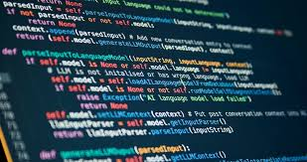  Programming Fundamentals  LAB TASK | Name: Mohsin Ali  Roll Number: 25P-0545  Section: BCS-1C

QUESTION# 01

//Mohsin Ali
//25P-0545
#include <stdio.h>
int main(){
printf("NAME: Mohsin Ali\nRoll Number: 25P-0545\n");
int r1,r2,fz=0,bz=0,fbz=0;
printf("Enter Starting Number: ");
scanf("%d",&r1);
printf("Enter Ending Number: ");
scanf("%d",&r2);

for(int i=r1;i<=r2;i++){
if(i%3==0){
fz++;
}
if(i%5==0){
bz++;
}
if(i%3==0 && i%5==0){
fbz++;
}
}

printf("FIZZ = %d\nBUZZ = %d\nFIZZ-BUZZ = %d",fz,bz,fbz);

}
Write a program to take range from user
starting number and ending number), count
the number fizz, Buzz and Fizz-Buzz,
in the given range
Fizz In Multiple of 3
Buzz is Multiple of 5
Fizz-Buzz is Multiple of 3 and 5

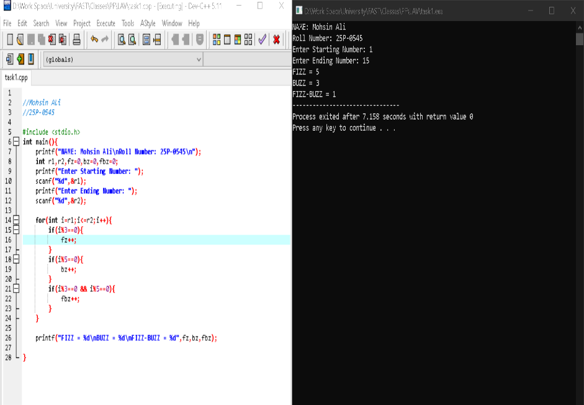

QUESTION# 02
//Mohsin Ali
//25P-0545

#include <stdio.h>
int main(){
printf("NAME: Mohsin Ali\nRoll Number: 25P-0545\n");
int a=0,b=1,fab=1,sum=0;

for(int i=1;i<=10;i++){ /* after many turns it will exceed int range and then it will print garbage values */
fab=a+b;
printf("%d ",b);
if(b%3==0 || b%5==0 || b%7==0){
sum+=b;
}
a=b;
b=fab;

}
printf("\nSum = %d",sum);

}
Write a program that will generate the
Fibonacci series up to 10000.
Also find the sum of
the generated Fibonacci numbers
divisible by 3, 5 or 7 only.
An example of the Fibonacci series is:
1 1 2 3 5 8 13 21..........
Note: Do this task by using a for
loop DO NOT use arrays for this.
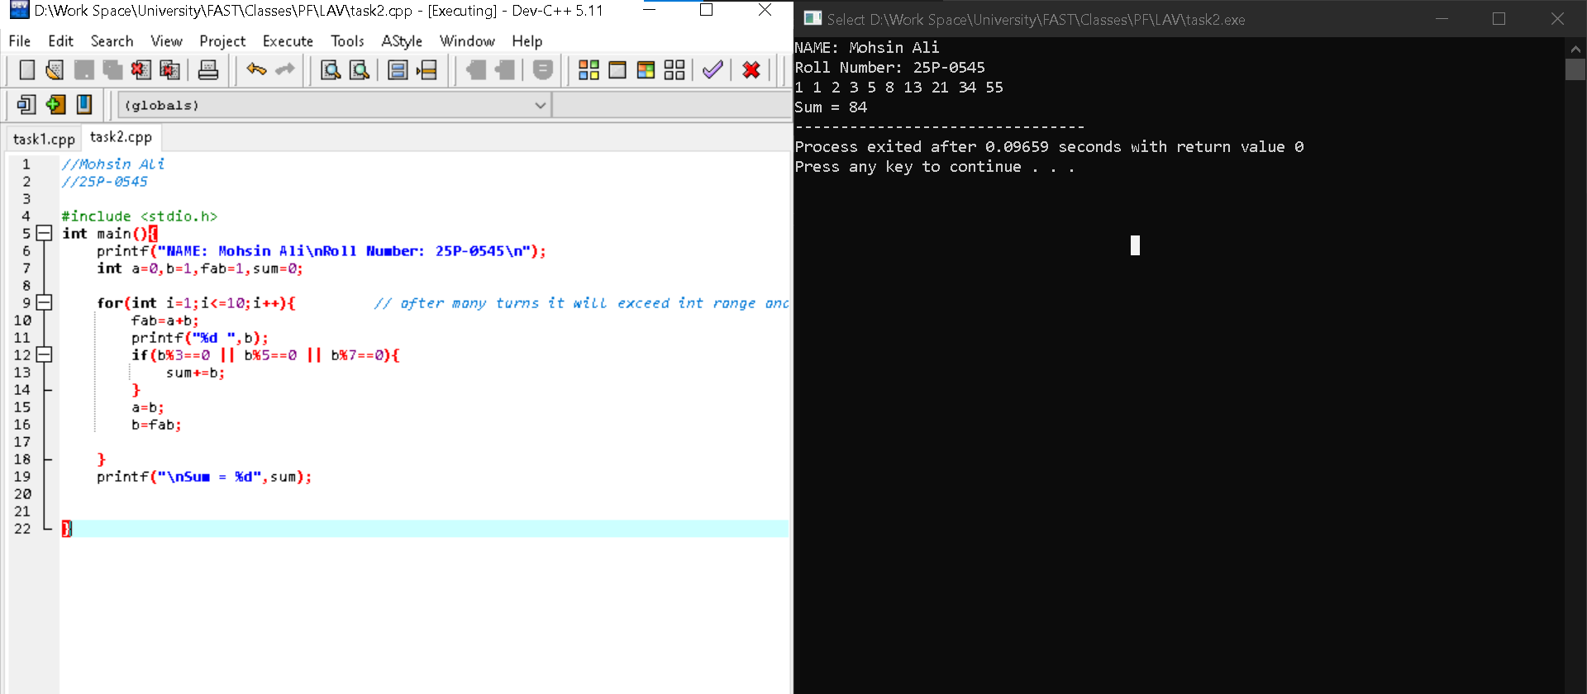

QUESTION# 03
//Mohsin Ali
//25P-0545

#include <stdio.h>
int main(){
printf("NAME: Mohsin Ali\nRoll Number: 25P-0545\n");
int n1,n2,temp,gcd,lcm;
int x,y;
printf("Enter Num1: ");
scanf("%d",&n1);
printf("Enter Num2: ");
scanf("%d",&n2);

x=n1,y=n2;
while(n2!=0){
temp=n2;
n2=n1%n2;
n1=temp;
}
gcd=n1;
lcm=(x*y)/gcd;

printf("LCM = %d\nGCD = %d",lcm,gcd);

}
Write a C Program to compute the
LCM and GCD of two numbers.

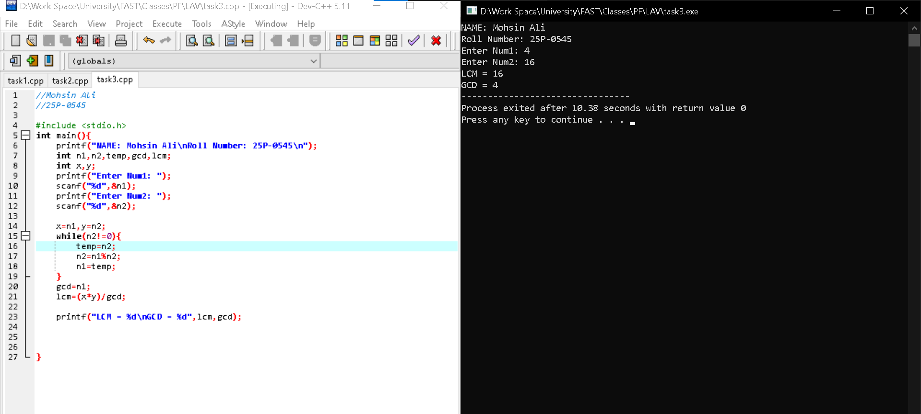

QUESTION# 04
Consider Two integers a and b taken as i
nput from the user.
Using Loops iterate the value of
a till the value of b.
If the value of a&lt;=9
the output should correspond
to the English representation of the
numbers i.e., 8=Eight, 9=Nine etc.
If the iteration exceeds 9 then the
programs should print if the exceeded
number is even or
odd.

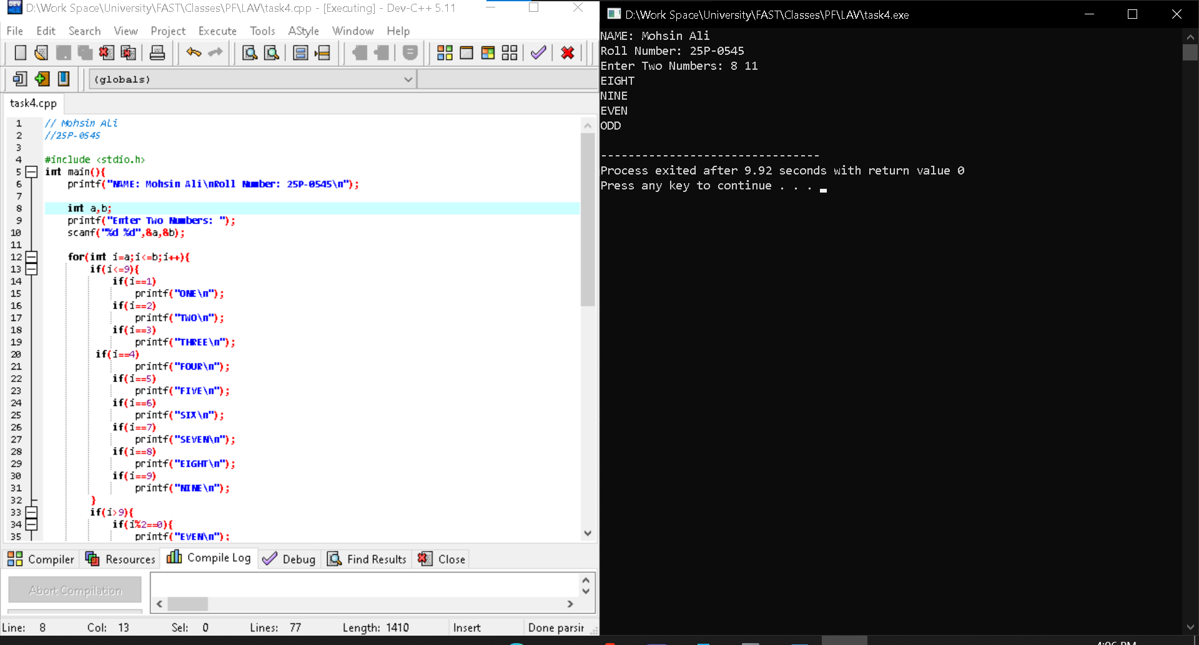

Source Code:

// Mohsin Ali
//25P-0545
#include <stdio.h>
int main(){
printf("NAME: Mohsin Ali\nRoll Number: 25P-0545\n");
int a,b;
printf("Enter Two Numbers: ");
scanf("%d %d",&a,&b);
for(int i=a;i<=b;i++){
if(i<=9){
if(i==1)
printf("ONE\n");
if(i==2)
printf("TWO\n");
if(i==3)
printf("THREE\n");
if(i==4)
printf("FOUR\n");
if(i==5)
printf("FIVE\n");
if(i==6)
printf("SIX\n");
if(i==7)
printf("SEVEN\n");
if(i==8)
printf("EIGHT\n");
if(i==9)
printf("NINE\n");
}
if(i>9){
if(i%2==0){
printf("EVEN\n");
}else{
printf("ODD\n");
}
}
}return 0;}

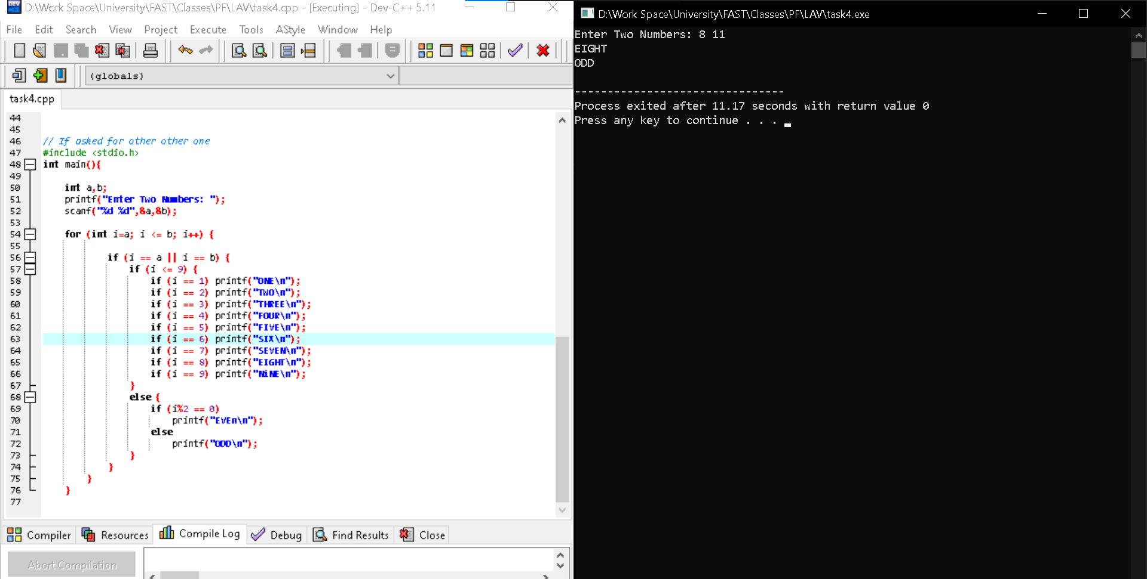
Another Method to solve this Task
//Mohsin Ali
//25P-0545

#include <stdio.h>
int main(){

int a,b;
printf("Enter Two Numbers: ");
scanf("%d %d",&a,&b);

for (int i=a; i <= b; i++) {

if (i == a || i == b) {
if (i <= 9) {
if (i == 1) printf("ONE\n");
if (i == 2) printf("TWO\n");
if (i == 3) printf("THREE\n");
if (i == 4) printf("FOUR\n");
if (i == 5) printf("FIVE\n");
if (i == 6) printf("SIX\n");
if (i == 7) printf("SEVEN\n");
if (i == 8) printf("EIGHT\n");
if (i == 9) printf("NiNE\n");
}
else {
if (i%2 == 0)
printf("EVEn\n");
else
printf("ODD\n");
}
}
}
}
QUESTION#05
//Mohsin Ali
//25P-0545

#include <stdio.h>
int main(){

int size=7;
int temp[size]={15,25,30,33,11,23,43};
int cold=0,mild=0,hot=0;

for(int i=0;i<size;i++){
if(temp[i]<=20)
cold++;
if(temp[i]>20 && temp[i]<35)
mild++;
if(temp[i]>=35)
hot++;
}

printf("Total Cold Day (<=20) = %d\nTotal Mild Day (20 - 35) = %d\nTotal Hot Day (>35) = %d",cold,mild,hot);

}
Write a C program that uses
one-dimensional array name
daily_temp to store one-
week temperature reading.
Declare array with size of 7
e.g., {15,28,35,30,12,25,40}
Classify temperature using these
parameters
Cold day &gt;&gt;&gt; temp&lt;=20
Mild day &gt;&gt;&gt; temp&gt;20
and temp &lt;35
Hot day &gt;&gt;&gt; temp&gt;=35
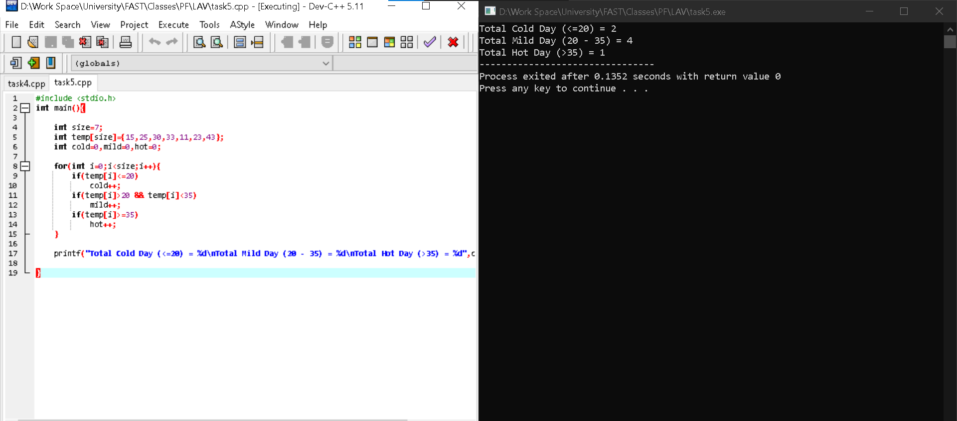
Count number of Cold, mild and hot day

QUESTION# 06
// Mohsin Ali
//25P-0545

#include <stdio.h>
int main(){
printf("NAME: Mohsin Ali\nRoll Number: 25P-0545\n");

int i=0;

while(i<=6){

printf(" %d\t %d\t %d\t %d\t \n\n",i,i,i,i);
if(i+1<=6){
printf(" %d\t %d\t \n\n",i+1,i+1);

}
i+=2;
}

}
Write a C program that produces
the following output:
0 0 0 0
1 1
2 2 2 2
3 3
4 4 4 4
5 5
6 6 6 6

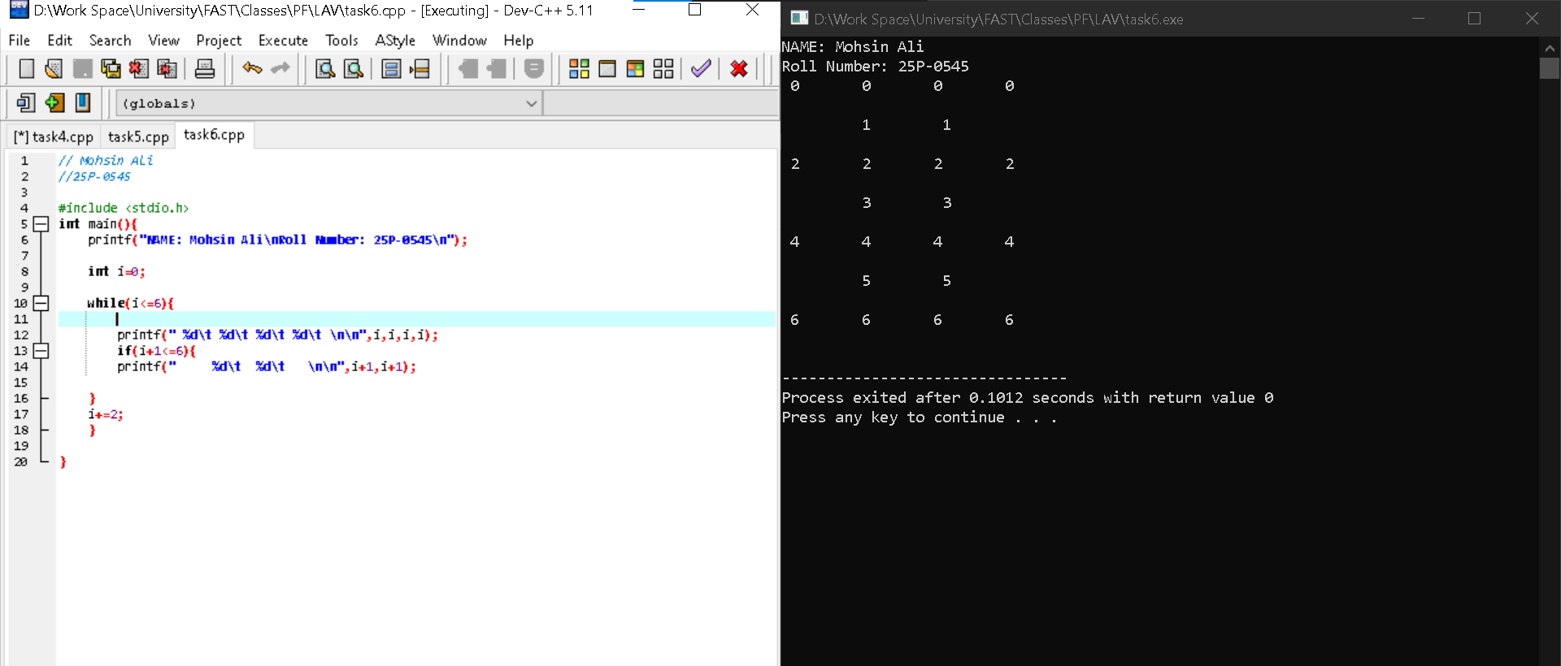

QUESTION# 07
// Mohsin Ali
//25P-0545

#include <stdio.h>
int main(){

int size,sum=0;
printf("Enter Array Size: ");
scanf("%d",&size);
int arr[size];

for(int i=0;i<size;i++){
printf("Enter Value: ");
scanf("%d",&arr[i]);
sum+=arr[i];
}
printf("SUM: %d",sum);

}
Write a C Program that takes a user
input array and prints the sum of its elements.

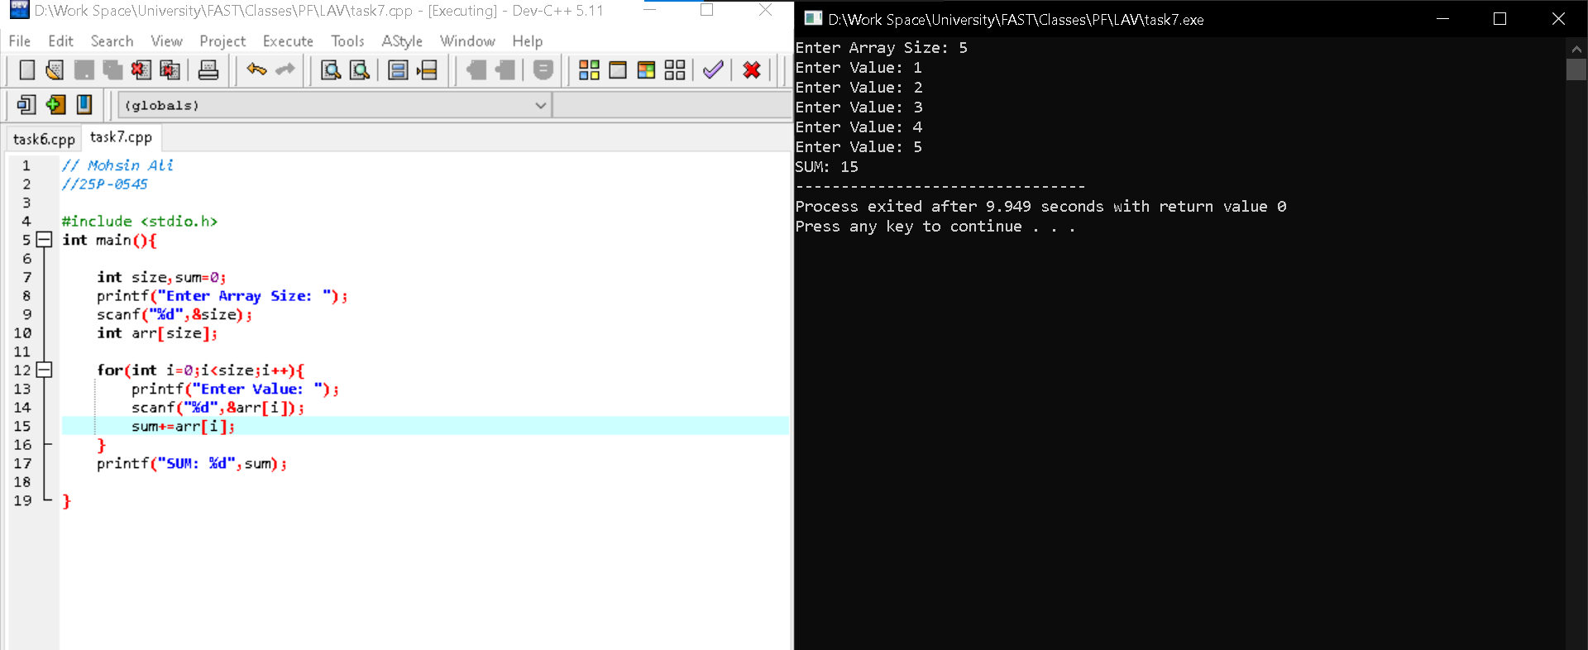

QUESTION# 08
#include <stdio.h>
int main(){

int size;
printf("Enter Array Size: ");
scanf("%d",&size);
int arr[size];

for(int i=0;i<size;i++){
printf("Enter Value: ");
scanf("%d",&arr[i]);
}

printf("\nARRAY IN REVERSE ORDER:\n");

for(int j=size-1;j>=0;j--){

printf("%d ",arr[j]);
}

}
Write a program in C to read n number of
values in an array and display it in reverse
order.

