Programming Fundamentals Lab: Task 5

Mohsin Ali
25P-0545

Task-1
Create a calculator asking for operator (+ or – or * or /) and 2 operands and
perform calculation according to the user input using switch statement.
Code:
#include <stdio.h>
int main(){
printf("NAME: Mohsin Ali \nRoll Number: 25P-0545");
printf("________________________________________________\n");
float num1,num2;
char ch;
printf("Enter Operation to be perfomered (+ - * /): ");
scanf(" %c",&ch);
switch(ch){
case '+':
printf("Enter Number 1: ");
scanf("%f",&num1);
printf("Enter Number 2: ");
scanf("%f",&num2);
printf("%f + %f = %.3f",num1,num2,num1+num2);
break;
case '-':
printf("Enter Number 1: ");
scanf("%f",&num1);
printf("Enter Number 2: ");
scanf("%f",&num2);
printf("%f - %f = %.3f",num1,num2,num1-num2);
break;
case '*':
printf("Enter Number 1: ");
scanf("%f",&num1);
printf("Enter Number 2: ");
scanf("%f",&num2);
printf("%f * %f = %.3f",num1,num2,num1*num2);
break;
case '/':
printf("Enter Number 1: ");
scanf("%f",&num1);
printf("Enter Number 2: ");
scanf("%f",&num2);
printf("%f / %f = %.3f",num1,num2,num1/num2);
break;
default:
printf("Invalid Operation: ");
}}

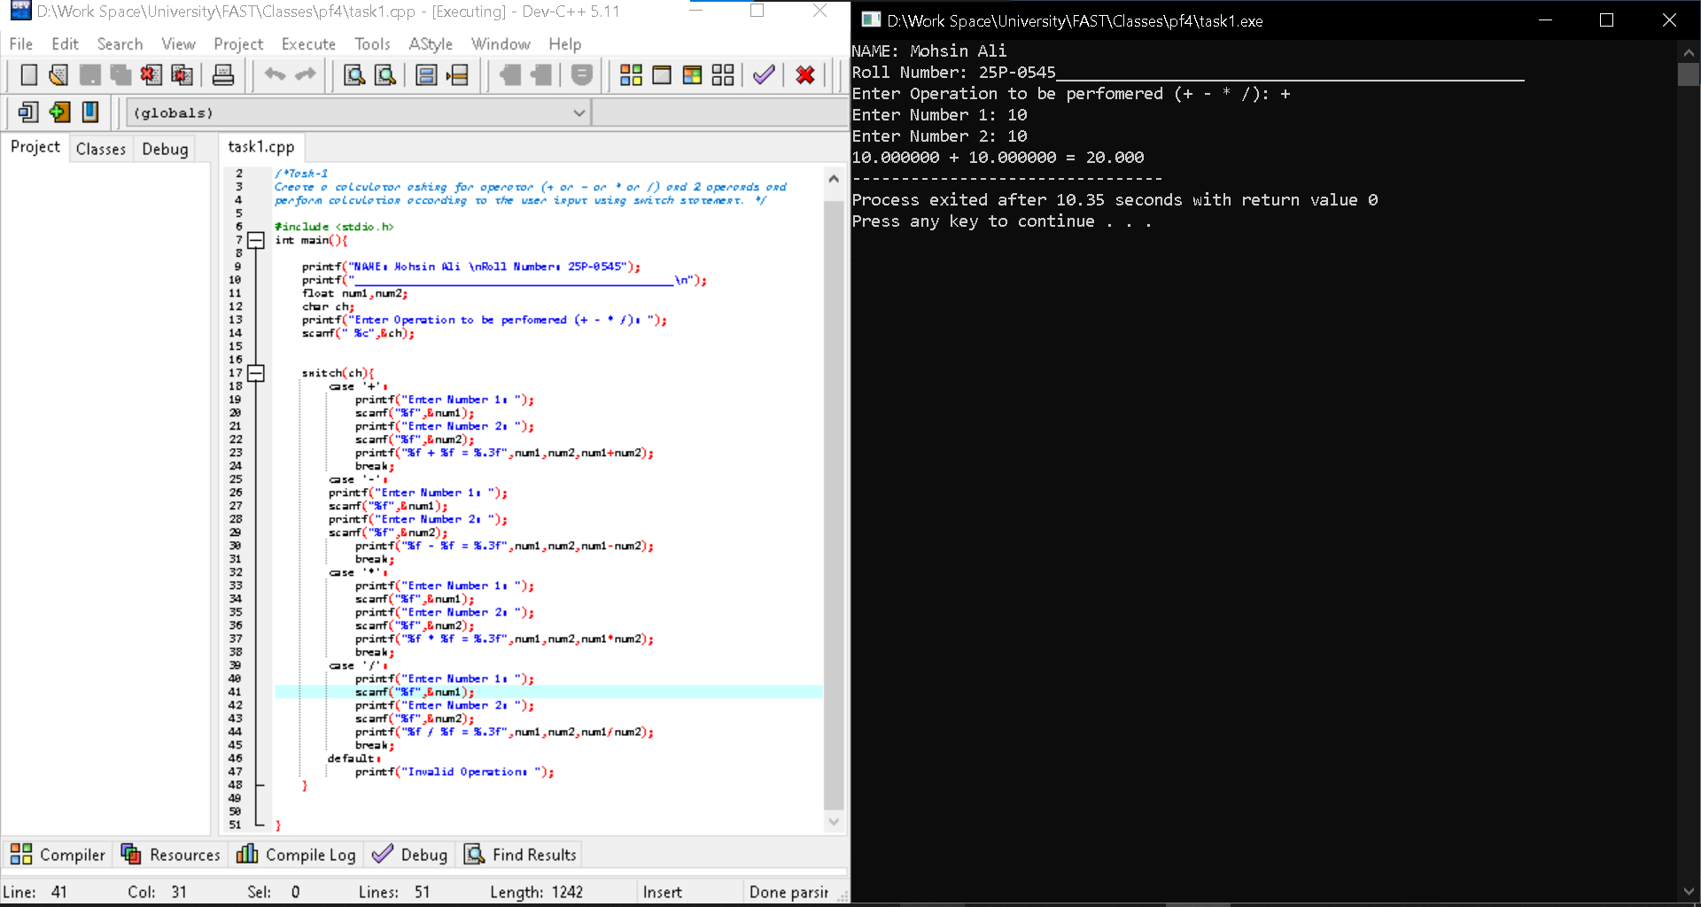

Task-2
There are 2 wolves and 1 sheep in a line. Both wolves will attempt to eat the
sheep. You are supposed to find out which wolf will reach the sheep and eat it,
assuming both wolves move at the same speed and the sheep does not move.
Take as input the positions of wolf A, wolf B and the sheep on the line (x-
coordinate) and find out which wolf will reach the sheep first and eat it.
If Wolf A reaches the sheep first, print “Wolf A”
If Wolf B reaches the sheep first, print “Wolf B”
If both wolves reach the sheep at the same time, the wolves will get distracted
and fail to eat the sheep, so print “Wolves distracted, Sheep escaped”

Code:
#include <stdio.h>
int main(){
printf("NAME: Mohsin Ali \nRoll Number: 25P-0545\n");
printf("_________________________________________\n");
int wolf_a,wolf_b,sheep,distA,distB;
printf("Enter Sheep's Distance: ");
scanf(" %d",&sheep);
printf("Enter Wolf A's Distance: ");
scanf(" %d",&wolf_a);
printf("Enter Wolf B's Distance: ");
scanf(" %d",&wolf_b);

if(sheep>=wolf_a){
distA=sheep-wolf_a;
}else{
distA=wolf_a-sheep;
}
if(sheep>=wolf_b){
distB=sheep-wolf_b;
}else{
distB=wolf_b-sheep;
}
if(distA<distB){
printf("Wolf A is Closer to Sheep. ");
}else if(distA>distB){
printf("Wolf B is Closer to Sheep. ");
}else if (distA==distB){
printf("Both are at the same distance. ");
}else{
printf("Wolf Distracted: Sheep Escaped. ");
}
}

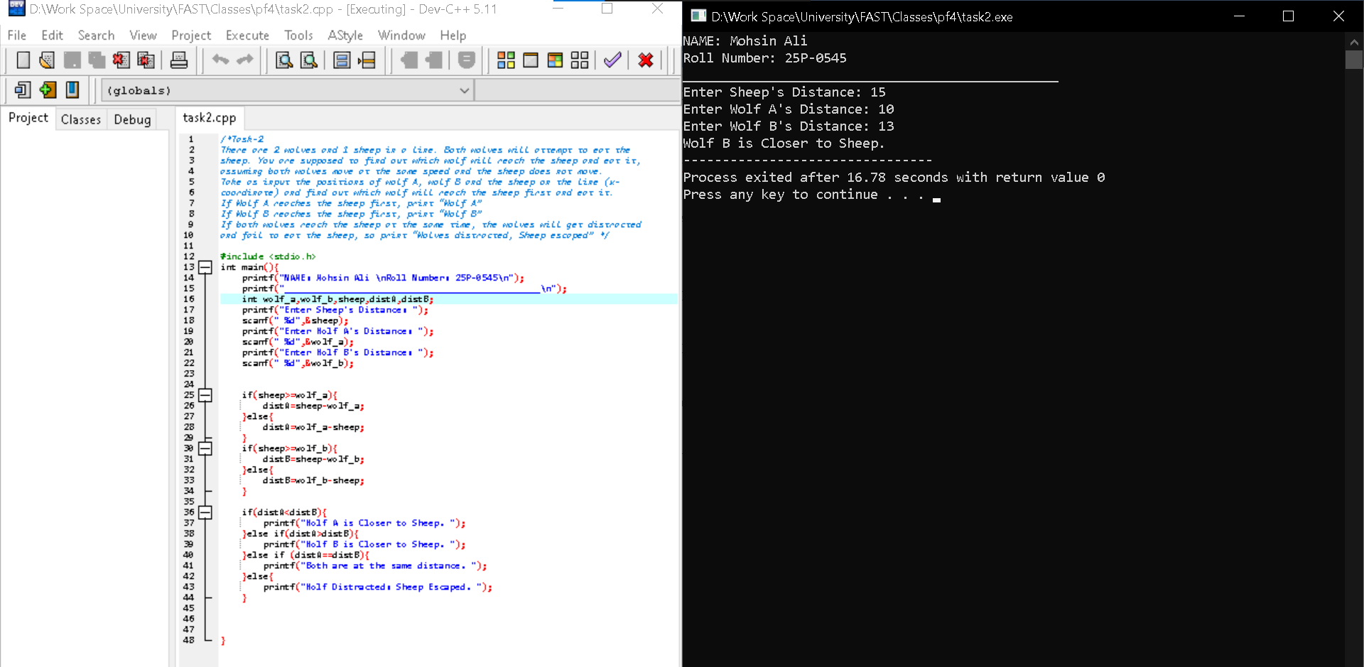

Task-3
An online shopping store is providing discounts on the items due to the Eid. If the
cost of items is more than 1999 it will give a discount upto 50%. If the cost of
shopping is 2000 to 4000, a 20% discount will be applied. If the cost of shopping is 4001 to 6000, a 30% discount will be applied. If it&#39;s more than 6000 then 50% discount will be applied to the cost of shopping. Print the actual amount, saved amount and the amount after discount.

Code:

#include <stdio.h>
int main(){
printf("NAME: Mohsin Ali \nRoll Number: 25P-0545\n");
printf("________________________________________________\n");
float cost,saved_am,final_p;
int disc;
printf("Enter Amount Spent: ");
scanf(" %f",&cost);
if(cost>1999 && cost<=4000){
disc=20;
}else if(cost>4000 && cost<=6000){
disc=30;
}else if(cost>6000){
disc=50;
}else{
disc=0;
}
saved_am=cost*(disc/100.0);
final_p=cost-saved_am;
printf("Actual Amount (Before Discount): %f",cost);
printf("\nFinal Amount (After Discount): %f",final_p);
printf("\nTotal Discount: %d",disc);
printf("\nSaved Amount: %f",saved_am);
}
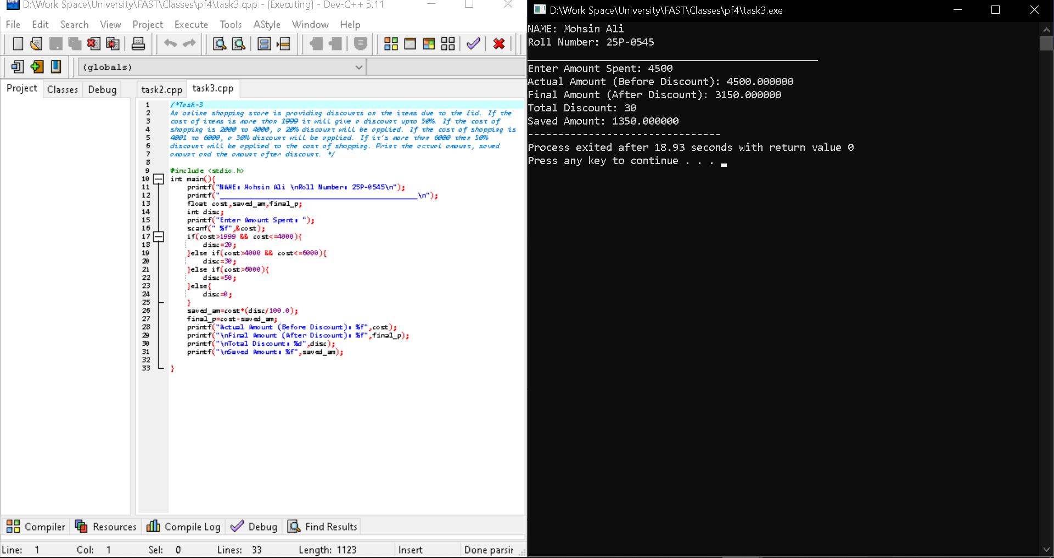

Task-4
Write a program in which user enters his NTS and F.Sc marks and your program
will help student in selection of university. Based on these marks Student will be
allocated a seat at different department of different university.
• Oxford University
IT: Above 70% in Fsc. and 70 % in NTS
Electronics: Above 70% in Fsc. and 60 % in NTS
Telecommunication Above 70% in Fsc. and 50 % in NTS
• MIT
IT: 70% - 60 % in Fsc. and 50 % in NTS
Chemical: 59% – 50 % in Fsc. and 50 % in NTS
Computer: Above 40% and below 50 % in Fsc. and 50 % in NTS

Code:
#include <stdio.h>
int main(){
printf("Name: Mohsin Ali \n Roll Number: 25P-0545\n");
printf("______________________________________________\n");
int fsc,nts;
float fsc_p;
printf("Enter FSC Obtained Marks out of 1100: ");
scanf("%d",&fsc);
fsc_p=(fsc/1100.0)*100;
printf("Enter NTS Obtained Marks out of 100: ");
scanf("%d",&nts);
if(fsc_p>=70){
printf("OXFORD UNIVERSITY: ");
if(fsc_p>70&&nts>70){
printf("\nIT");
}else if(fsc_p>70&&nts>60){
printf("\nElectronics: ");
}
else if(fsc_p>70&&nts>50){
printf("\nTeleCommunication");
}
}else if(nts>=50&&fsc_p<70){
if((fsc_p>=60 && fsc_p<70)&&nts>=50){
printf("MIT\n");
printf("IT");
}else if((fsc_p>=50 && fsc_p<60)&&nts>=50){
printf("MIT\n");
printf("Chemical");
}else if((fsc_p>=40 && fsc_p<50)&&nts>=50){
printf("MIT\n");
printf("Computer Science");
}
}else{
printf("Invalid Input");
}
}

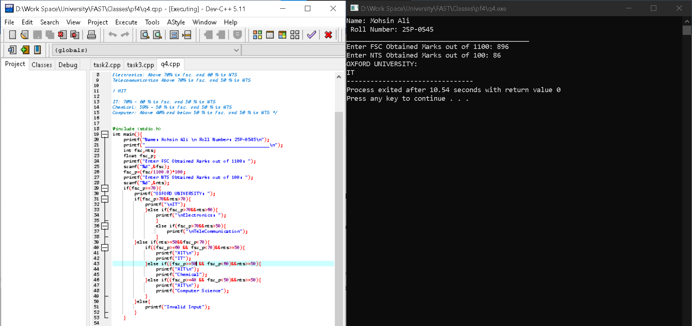

Task-5:
Write a program to control a coffee machine. Allow the user to input the type of coffee as B for Black
and W for White. Ask the user if the cup size is double and if the coffee is manual. The following table
details the time chart for the machine for each coffee type. Display a statement for each step. If the
coffee size is double, increase the baking time by 50 percent

Code:
#include <stdio.h>
int main(){
printf("Name: Mohsin Ali\nRoll Number: 25P-0545\n");
printf("__________________________________________\n");
char type,size;
float timeW,timeB,timeW_f1,timeW_f2;
printf("Enter Coffee Type:(b for black : w for white): ");
scanf("%c",&type);
printf("Enter Cup Size: (d for double : m for manual): ");
scanf(" %c",&size);

switch(type){
case 'w':
timeW=15+15+20+2+4+20;
switch(size){
case 'd':
printf("Step 1: Put Water (15mins)\n");
printf("Step 2: Add Sugar (15mins)\n");
printf("Step 3: Mix Well (20mins)\n");
printf("Step 4: Add Coffee (2mins)\n");
printf("Step 5: Add Milk (4mins)\n");
printf("Step 6: Mix Well (20mins)\n");
timeW_f1=timeW*(50.0/100.0);
timeW_f2=timeW+timeW_f1;
printf("Total Time Taken for White Coffee with Cup Size Double: %.1f mins\n", timeW_f2);
break;
case 'm':
printf("Step 1: Put Water (15 mins)\n");
printf("Step 2: Add Sugar (15 mins)\n");
printf("Step 3: Mix Well (20 mins)\n");
printf("Step 4: Add Coffee (2 mins)\n");
printf("Step 5: Add Milk (4 mins)\n");
printf("Step 6: Mix Well (20 mins)\n");

printf("Total Time Taken for White Coffee with Cup Size Manual: %f",timeW);
break;
default:
printf("Invalid Input");
break;
}
break;
case 'b':
timeB=20+20+25+15+25;
switch(size){
case 'd':
printf("Step 1: Put Water (20mins)\n");
printf("Step 2: Add Sugar (20mins)\n");
printf("Step 3: Mix Well (25mins)\n");
printf("Step 4: Add Coffee (15 mins)\n");
printf("Step 5: Mix Well (25mins)\n");
timeW_f1=timeB*(50.0/100.0);
timeW_f2=timeB+timeW_f1;
printf("Total Time Taken for Black Coffee with Cup Size Double: %f",timeW_f2);
break;
case 'm':
printf("Step 1: Put Water (20 mins)\n");
printf("Step 2: Add Sugar (20 mins)\n");
printf("Step 3: Mix Well (25 mins)\n");
printf("Step 4: Add Coffee (15 mins)\n");
printf("Step 5: Mix Well (25 mins)\n");
printf("Total Time Taken for Black Coffee with Cup Size Manual: %f",timeB);
break;
default:
printf("Invalid Input");
}
}
}
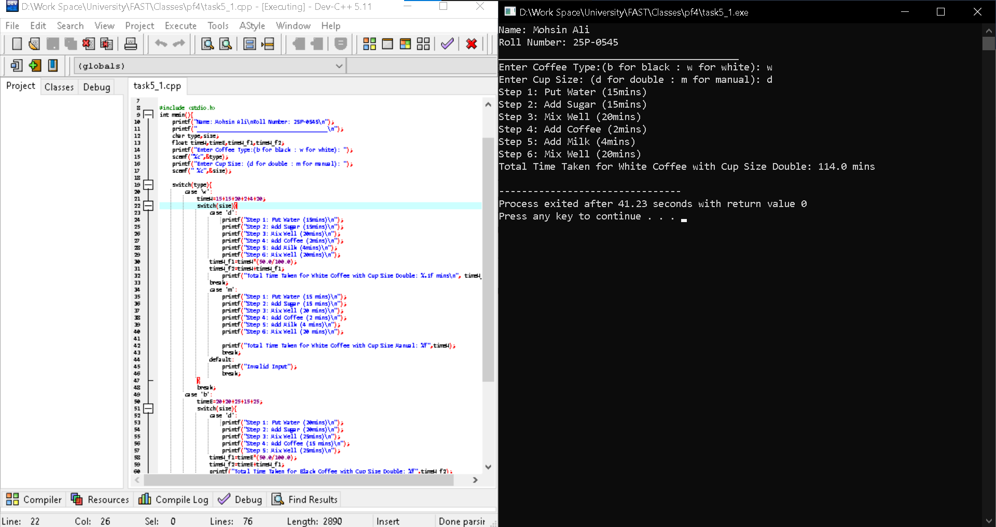

Task-6
Using IF and Switch statement, write a program that displays the following menu for the food items available to take order from the customer:
· B= Burger (Rs. 200)
· F= French Fries (Rs. 50)
· P= Pizza (Rs. 500)
· S= Sandwiches (Rs. 150)
The costumer can order any combination of available food. The program first ask to enter the no of types of snacks i.e. 2, 3 or 4 then it ask to enter the choice i.e. B for Burger and then for quantity. The program should finally display the total charges for the order.

Code:

#include <stdio.h>
int main(){
printf("Name: Mohsin Ali\nRoll Number: 25P-0545\n");
char ch,ch2,ch3,ch4;
int q,buy,buy2,buy3,buy4,total=0;
printf("\t\t\t\t\tABC RESTAURENT\t\t\t\t\t\n");
printf("\t\t\t\t\t WELCOME!!\n");
printf(" MENU:: \n\n");
printf(". B= Burgers (RS: 200)\n. F= French Fries (RS: 50)\n. P= Pizza (RS:500)\n. S= Sandwiches (RS:150)\n");
printf("Enter Number of Snacks You Want to you: ");
scanf("%d",&q);

switch(q){
case 1:
printf("Enter First Snack to order: ");
scanf(" %c",&ch);
printf("Enter Quantity: \n");
scanf("%d",&buy);
printf("\nYou Have Ordered: \n");
if(ch=='B'){
total+=buy*200;
printf("%d Burgers value %d\n",buy,buy*50);
}else if(ch=='F'){
total+=buy*50;
printf("%d Fries value %d\n",buy,buy*50);
}else if(ch=='P'){
total+=buy*500;
printf("%d Pizza value %d\n",buy,buy*500);
}else if(ch=='S'){
total+=buy*150;
printf("%d Sandwiches value %d\n",buy,buy*150);
}else{

printf("Invalid Choice: ");
}
break;
case 2:
printf("Enter First Snack to order: ");
scanf(" %c",&ch);
printf("Enter Quantity: \n");
scanf(" %d",&buy);
printf("Enter Second Snack to order: ");
scanf(" %c",&ch2);
printf("Enter Quantity: \n");
scanf(" %d",&buy2);
printf("\nYou Have Ordered: \n");
if(ch=='B'){
total+=buy*200;
printf("%d Burgers value %d\n",buy,buy*200);
}else if(ch=='F'){
total+=buy*50;
printf("%d Fries value %d\n",buy,buy*50);
}else if(ch=='P'){
total+=buy*500;
printf("%d Pizza value %d\n",buy,buy*500);
}else if(ch=='S'){
total+=buy*150;
printf("%d Sandwiches value %d\n",buy,buy*150);
}
if(ch2=='B'){
total+=buy2*200;
printf("%d Burgers value %d\n",buy2,buy2*200);
}else if(ch2=='F'){
total+=buy2*50;
printf("%d Fries value %d\n",buy2,buy2*50);
}else if(ch2=='P'){
total+=buy2*500;
printf("%d Pizza value %d\n",buy2,buy2*500);
}else if(ch2=='S'){
total+=buy2*150;
printf("%d Sandwiches value %d\n",buy2,buy2*150);
}else{
printf("Invalid CHOICE: ");
}
break;

case 3:
printf("Enter First Snack to order: ");
scanf(" %c",&ch);
printf("Enter Quantity: \n");
scanf(" %d",&buy);
printf("Enter Second Snack to order: ");
scanf(" %c",&ch2);
printf("Enter Quantity: \n");
scanf(" %d",&buy2);
printf("Enter Third Snack to Order: ");
scanf(" %c",&ch3);
printf("Enter Quantity: \n");
scanf(" %d",&buy3);
printf("\nYou Have Ordered: \n");
if(ch=='B'){
total+=buy*200;
printf("%d Burgers value %d\n",buy,buy*200);
}else if(ch=='F'){
total+=buy*50;
printf("%d Fries value %d\n",buy,buy*50);
}else if(ch=='P'){
total+=buy*500;
printf("%d Pizza value %d\n",buy,buy*500);
}else if(ch=='S'){
total+=buy*150;
printf("%d Sandwiches value %d\n",buy,buy*150);
}
if(ch2=='B'){
total+=buy2*200;
printf("%d Burgers value %d\n",buy2,buy2*200);
}else if(ch2=='F'){
total+=buy2*50;
printf("%d Fries value %d\n",buy2,buy2*50);
}else if(ch2=='P'){
total+=buy2*500;
printf("%d Pizza value %d\n",buy2,buy2*500);
}else if(ch2=='S'){
total+=buy2*150;
printf("%d Sandwiches value %d\n",buy2,buy2*150);
}
if(ch3=='B'){
total+=buy3*200;
printf("%d Burgers value %d\n",buy3,buy3*200);
}else if(ch3=='F'){
total+=buy3*50;
printf("%d Fries value %d\n",buy3,buy3*50);
}else if(ch3=='P'){
total+=buy3*500;
printf("%d Pizza value %d\n",buy3,buy3*500);
}else if(ch3=='S'){
total+=buy3*150;
printf("%d Sandwiches value %d\n",buy3,buy3*150);
}else{
printf("INVALID CHOICE: ");
}
case 4:
printf("Enter First Snack to order: ");
scanf(" %c",&ch);
printf("Enter Quantity: \n");
scanf(" %d",&buy);
printf("Enter Second Snack to order: ");
scanf(" %c",&ch2);
printf("Enter Quantity: \n");
scanf(" %d",&buy2);
printf("Enter Third Snack to Order: ");
scanf(" %c",&ch3);
printf("Enter Quantity: \n");
scanf(" %d",&buy3);
printf("Enter Fourth Snack to Order: ");
scanf(" %c",&ch4);
printf("Enter Quantity: ");
scanf(" %d",&buy4);
printf("\nYou Have Ordered: \n");
if(ch=='B'){
total+=buy*200;
printf("%d Burgers value %d\n",buy,buy*200);
}else if(ch=='F'){
total+=buy*50;
printf("%d Fries value %d\n",buy,buy*50);
}else if(ch=='P'){
total+=buy*500;
printf("%d Pizza value %d\n",buy,buy*500);
}else if(ch=='S'){
total+=buy*150;
printf("%d Sandwiches value %d\n",buy,buy*150);
}
if(ch2=='B'){
total+=buy2*200;
printf("%d Burgers value %d\n",buy2,buy2*200);
}else if(ch2=='F'){
total+=buy2*50;
printf("%d Fries value %d\n",buy2,buy2*50);
}else if(ch2=='P'){
total+=buy2*500;
printf("%d Pizza value %d\n",buy2,buy2*500);
}else if(ch2=='S'){
total+=buy2*150;
printf("%d Sandwiches value %d\n",buy2,buy2*150);
}
if(ch3=='B'){
total+=buy3*200;
printf("%d Burgers value %d\n",buy3,buy3*200);
}else if(ch3=='F'){
total+=buy3*50;
printf("\n%d Fries value %d\n",buy3,buy3*50);
}else if(ch3=='P'){
total+=buy3*500;
printf("\n%d Pizza value %d\n",buy3,buy3*500);
}else if(ch3=='S'){
total+=buy3*150;
printf("\n%d Sandwiches value %d\n",buy3,buy3*150);
}
if(ch4=='B'){
total+=buy4*200;
printf("\n%d Burgers value %d\n",buy4,buy4*200);
}else if(ch4=='F'){
total+=buy4*50;
printf("\n%d Fries value %d\n",buy4,buy4*50);
}else if(ch4=='P'){
total+=buy4*500;
printf("\n%d Pizza value %d\n",buy4,buy4*500);
}else if(ch4=='S'){
total+=buy4*150;
printf("\n%d Sandwiches value %d\n",buy4,buy4*150);
}else{
printf("\nInvalid Input");
}
}
printf("\nTotal Price: %d",total);
}
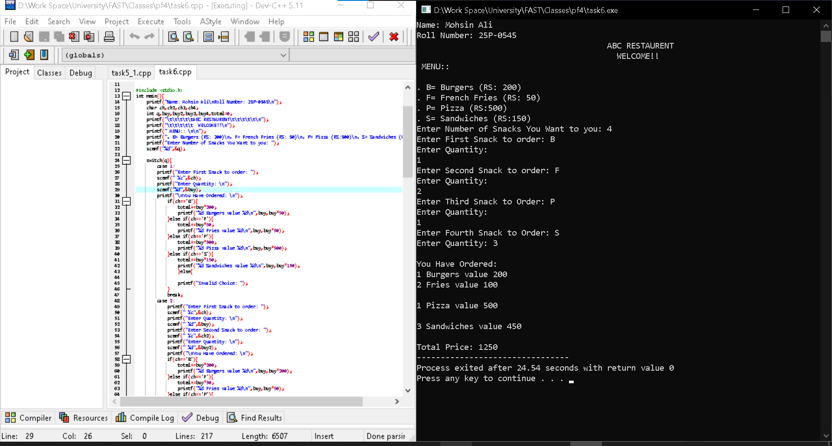

Task-7:
Mortgage Calculator) Develop a C program to calculate the interest accrued on a bank customer&#39;s
mortgage. For each customer, the following facts are available:
a) the account number
b) the mortgage amount
c) the mortgage term
d) the interest rate
The program should input each fact, calculate the
total interest payable (= mortgage amount × interest rate × mortgage term), and add it to thmortgage amount to get the total amount payable. It should calculate the required monthly payment by dividing the total amount payable by the number of months in the mortgage term. The program should display the required monthly payment rounded off to the nearest dollar. The program should process each customer&#39;s account at a time

Code:
#include <stdio.h>
#include <math.h>
int main(){
printf("Name: Mohsin Ali \nRoll Number: 25P-0545\n");
printf("______________________________________________\n");

float total_in,rate;
int mort_am,mort_term,acc,total_pm,mort_term_m;
printf("Enter Account Number: (-1 to end): ");
scanf("%d",&acc);
switch(acc){
case -1:
printf("Good Bye: ");
break;
default:
printf("Mortgage Amount:(in dollars): ");
scanf("%d",&mort_am);
printf("Mortgage Term: (in years): ");
scanf("%d",&mort_term);
printf("Enter Interest Rate: (in decimal): ");
scanf("%f",&rate);
total_in=mort_am*rate*mort_term;
mort_am+=total_in;

mort_term_m=mort_term*12;

total_pm=round((float)mort_am/mort_term_m);

printf("The monthly Payable Interest $: %d",total_pm);

return 0;
}
}
