INTERVIEW

FUNCTIONAL REQUIREMENTS

Q1. Describe the different types of accounts

A1. They are individual and company accounts

Q2. Should the system generate any reports

* It shouldn’t generate any reports

Q3. Daily transactions limits for deposit or withdrawals

-yes, limit can be dictated

Q4. Are they age restrictions for customers opening an account

-No although children below 16 register through guardians

Q5. Failed Transactions should log out the customer

-Show alert message and show transaction history

NON- FUNCTIONAL REQUIREMENTS

Q1 Is the bank system user friendly

-it is easy to navigate requiring minimum training

Q2.how easy is it to update the system

-the design makes it easier to maintain , update and debug without affecting the system

Q3.how does the system perform

-it will perform at a quick pace avoiding delays

Q4. Is the customers data going to be secured

-before storing data they will be passwords which will protect all the customers data

Q5. Can customers access their accounts anytime

-the banking system will be operational at all times allowing customers to have access to their accounts.

STRUCTURAL UML MODELLING

USE CASE DIAGRAM

# 

CLASS DIAGRAM

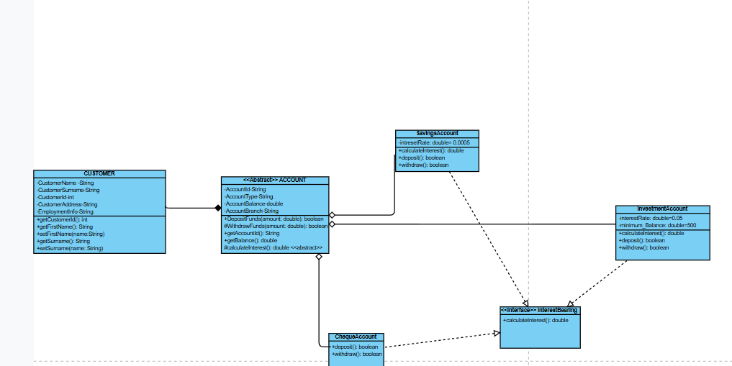

SEQUENCE DIAGRAMS

DEPOSIT

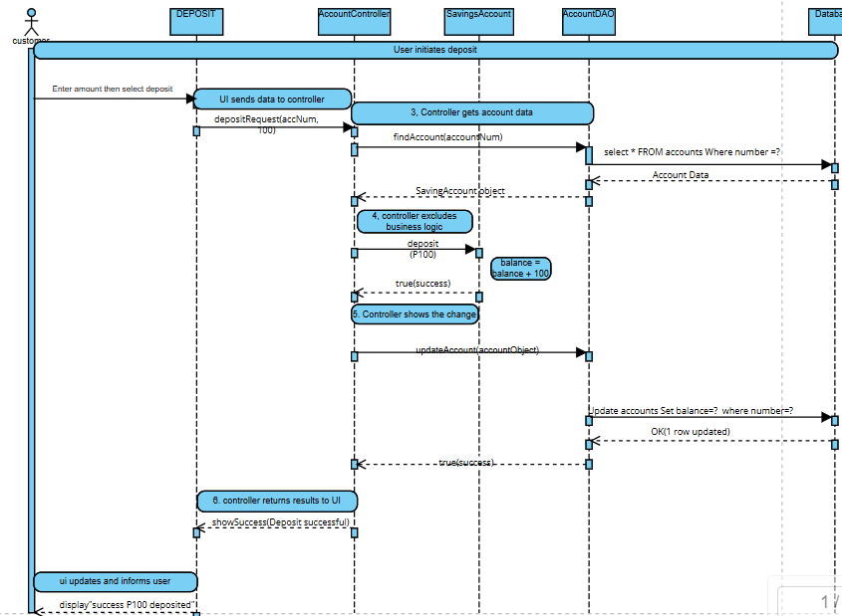

VIEW HISTORY

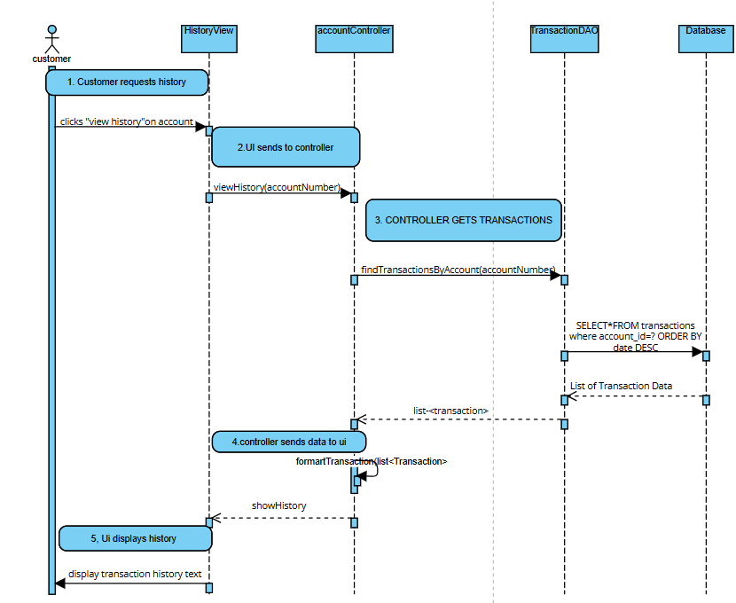

STATE DIAGRAM

