Team_1_Requirement

1. Header Table
Member Name | CWID Number | Crimson Email Address | Hours Contributed
Cayden Pomeroy (Submitter) | 12505958 | cpomeroy1@crimson.ua.edu | 8
Dawson Sconyers | 12329994 | dcsconyers@crimson.ua.edu | 7
Dylan Filmer | 12366351 | dfilmer@crimson.ua.edu | 8
Landon Liles | 12480863 | lmliles1@crimson.ua.edu | 7
Michael Ifeanyichukwu | 12627307 | mcifeanyichukwu@crimson.ua.edu | 7

2. Task Distribution Table
Member Name | Tasks Performed | Contribution %
Cayden Pomeroy | Project coordination; Task 1 Class Diagram design for Boundary and Terminal menu classes; compilation of report; designated project submitter. | 20%
Dawson Sconyers | Task 1 Class Diagram architecture for Controllers and Entity hierarchies; verification of visibility modifiers, full method signatures, and multiplicities. | 20%
Dylan Filmer | Task 2 Sequence Diagrams for Provider workflows (Validate Member Card, Bill ChocAn, Add Optional Comments, Request Provider Directory). | 20%
Landon Liles | Task 2 Sequence Diagrams for Authentication and Administration (Verify Provider, Verify Operator, Verify Manager, Manage Member Records, Manage Provider Records). | 20%
Michael Ifeanyichukwu | Task 2 Sequence Diagrams for Batch Accounting and Acme Sync (Synchronize Accounts, Run Weekly Accounting, Member/Provider/Summary Reports, EFT Data); Task 3 Discussion review. | 20%
Total |  | 100%

Task 1: Complete UML Class Diagram

1.1 Architectural Overview & Design Assumptions
In this detailed design phase, the conceptual models from Projects 1 and 2 are transformed into a concrete, code-ready Object-Oriented Architecture. To enforce strict modularity, the system employs the Model-View-Controller (MVC) / Entity-Control-Boundary (ECB) pattern:
- Boundary & Terminal Classes: Act as the Presentation Layer. Every human actor and external hardware system interacts through a dedicated terminal or console boundary. These boundaries capture raw user input, invoke controller methods, and format screen output.
- Controller Classes: Act as the Application Logic Layer. Controllers orchestrate use case workflows, enforce business rules, coordinate data validation, and prevent UI components from coupling directly to database entities.
- Entity Classes: Act as the Domain/Data Layer. Entities maintain persistent business state, enforce domain constraints, and encapsulate local file persistence operations.

Key Design Decisions & Assumptions:
- Architectural Decoupling of Reporting: TimerDaemon and ManagerTerminal route reporting requests through AccountingControl. System Clock and Manager remain external actors. Our teacher confirmed that these connections need not be direct, provided the communication is clear and consistent with the sequence diagrams.
- Use Case Entry-Point Methods: Each identified system use case is initiated by a distinct, public entry-point method hosted on a boundary or controller class, which coordinates controller and entity operations.
- Data Integrity & Visibility: The class diagram explicitly marks attribute visibility. Controller state is private (-), while several entity data fields are public (+); Member status and Operator passwordHash remain private and use public methods. Lookup results must be checked before entity operations. IDs retain nine digits, service codes six digits, and comments at most 100 characters. Reporting queries filter the reporting week and derive fresh provider totals from persisted services. AcmeInterface methods simulate local input; real communication and bank processing are excluded.

1.2 Comprehensive Class Inventory & Signatures

A. Boundary & Terminal Classes (<<boundary>>)
- ProviderTerminal
  - Attributes:
    - - providerId: String
    - - pendingComments: String
  - Methods:
    - + displayMainMenu(): void
    - + verify(id: String): boolean
    - + validateCard(id: String): String
    - + bill(record: ServiceRecord): boolean
    - + addComments(text: String): boolean
    - + requestDirectory(): boolean
    - + display(text: String): void
    - + confirmService(name: String): boolean
- OperatorConsole
  - Attributes:
    - - loginId: String
  - Methods:
    - + displayMainMenu(): void
    - + login(id: String, password: String): boolean
    - + manageMembers(action: String, member: Member): boolean
    - + manageProviders(action: String, provider: Provider): boolean
    - + display(text: String): void
- ManagerTerminal
  - Attributes:
    - - managerId: String
  - Methods:
    - + displayMainMenu(): void
    - + login(id: String): boolean
    - + memberReport(id: String): boolean
    - + providerReport(id: String): boolean
    - + summaryReport(): boolean
    - + display(text: String): void
- AcmeInterface
  - Methods:
    - + syncAccounts(updates: List<Member>): boolean
- TimerDaemon
  - Attributes:
    - - weeklyTime: Date
  - Methods:
    - + weeklyAccounting(): boolean
    - + eftData(): boolean

B. Controller Classes (<<control>>)
- ProviderControl
  - Attributes:
    - - providerId: String
  - Methods:
    - + verify(id: String): boolean
    - + validateCard(id: String): String
    - + bill(record: ServiceRecord): boolean
    - + addComments(text: String): boolean
    - + requestDirectory(): boolean
- RecordsControl
  - Attributes:
    - - authenticatedStaff: Person
  - Methods:
    - + verifyOperator(id: String, password: String): boolean
    - + verifyManager(id: String): boolean
    - + manageMembers(action: String, member: Member): boolean
    - + manageProviders(action: String, provider: Provider): boolean
    - + syncAccounts(updates: List<Member>): boolean
- AccountingControl
  - Attributes:
    - - weekStart: Date
    - - weekEnd: Date
  - Methods:
    - + weeklyAccounting(): boolean
    - + memberReport(id: String): boolean
    - + providerReport(id: String): boolean
    - + summaryReport(): boolean
    - + eftData(): boolean

C. Entity Classes (<<entity>>)
- Person (Base Class — Satisfies Inheritance Requirement)
  - Attributes:
    - + name: String
    - + number: String
    - + streetAddress: String
    - + city: String
    - + state: String
    - + zipCode: String
- Member(Inherits from Person)
  - Attributes:
    - - status: String
  - Methods:
    - + getStatus(): String
    - + setStatus(status: String): void
    - + isValid(): boolean
- Provider(Inherits from Person)
  - Attributes:
    - + totalFeeOwed: double
    - + consultationCount: int
- Operator(Inherits from Person)
  - Attributes:
    - + loginId: String
    - - passwordHash: String
  - Methods:
    - + authenticate(password: String): boolean
- Manager(Inherits from Person)
  - Attributes:
    - + loginId: String
  - Methods:
    - + verifyAccess(id: String): boolean
- ProviderDirectory(Satisfies Composition Requirement with ServiceOffering)
  - Attributes:
    - - fileName: String
  - Methods:
    - + findOffering(code: String): ServiceOffering
    - + export(): boolean
- ServiceOffering
  - Attributes:
    - + serviceCode: String
    - + serviceName: String
    - + fee: double
- ServiceRecord
  - Attributes:
    - + recordedDateTime: Date
    - + serviceDate: Date
    - + providerNumber: String
    - + memberNumber: String
    - + serviceCode: String
    - + feeToPay: double
    - + comments: String
  - Methods:
    - + save(): boolean
- Report
  - Attributes:
    - + kind: String
    - + generationDate: Date
    - + fileName: String
    - + content: String
  - Methods:
    - + save(): boolean
- EFTRecord
  - Attributes:
    - + providerName: String
    - + providerNumber: String
    - + transferAmount: double
  - Methods:
    - + appendTo(file: String): boolean

1.3 Associations, Multiplicities, & Role Names
- ProviderTerminal [terminal: 1] ↔ ProviderControl [controller: 1]; name: handles; navigation: both directions.
- OperatorConsole [console: 0..*] → RecordsControl [controller: 1]; name: handles; navigation: OperatorConsole to RecordsControl.
- ManagerTerminal [terminal: 0..*] → AccountingControl [controller: 1]; name: requests; navigation: ManagerTerminal to AccountingControl.
- RecordsControl [session: 0..*] → Person [staff: 0..1]; name: authenticates; navigation: RecordsControl to Person.
- ProviderDirectory [directory: 1] ◆→ ServiceOffering [offerings: 1..*]; name: contains; navigation: ProviderDirectory to ServiceOffering. Composition diamond on ProviderDirectory.
- ServiceRecord [services: 0..*] → Member [member: 1]; name: records for; navigation: ServiceRecord to Member.
- ServiceRecord [services: 0..*] → Provider [provider: 1]; name: billed by; navigation: ServiceRecord to Provider.
- ServiceRecord [records: 0..*] → ServiceOffering [offering: 1]; name: identifies; navigation: ServiceRecord to ServiceOffering.
- AcmeInterface ⇢ RecordsControl; dependency: uses; dashed open arrow points to RecordsControl. This temporary collaboration has no association roles or multiplicities.
- TimerDaemon ⇢ AccountingControl; dependency: uses; dashed open arrow points to AccountingControl. This temporary collaboration has no association roles or multiplicities.
- ProviderControl ⇢ ProviderDirectory; dependency: uses; dashed open arrow points to ProviderDirectory. This temporary collaboration has no association roles or multiplicities.
- ProviderControl ⇢ ServiceRecord; dependency: uses; dashed open arrow points to ServiceRecord. This temporary collaboration has no association roles or multiplicities.
- AccountingControl ⇢ ServiceRecord; dependency: uses; dashed open arrow points to ServiceRecord. This temporary collaboration has no association roles or multiplicities.
- AccountingControl ⇢ Report; dependency: uses; dashed open arrow points to Report. This temporary collaboration has no association roles or multiplicities.
- AccountingControl ⇢ EFTRecord; dependency: uses; dashed open arrow points to EFTRecord. This temporary collaboration has no association roles or multiplicities.
- AccountingControl ⇢ ProviderDirectory; dependency: uses; dashed open arrow points to ProviderDirectory. This temporary collaboration has no association roles or multiplicities.
- ManagerTerminal ⇢ RecordsControl; dependency: uses; dashed open arrow points to RecordsControl. This temporary collaboration has no association roles or multiplicities.
- Member, Provider, Operator and Manager inherit Person (open triangle at Person).
- Multiplicity proposal assumes one shared RecordsControl/AccountingControl, one directory and per-terminal provider sessions; document this assumption. Associations reference existing entities; report destruction never deletes service records. Dashed dependencies show principal temporary collaborators; lookup and typed-parameter uses remain defined by operation contracts and signatures without redundant arrows.

1.4 Detailed Class Diagram
(Insert the exported PNG image of your complete UMLetino Class Diagram below).
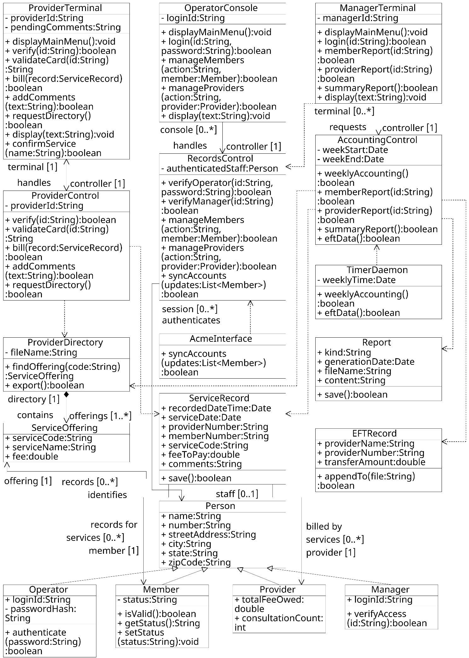

1.5 UMLetino UXF Source Code (Class Diagram)
(Keep the complete native UMLetino UXF datafile for submission; paste its XML below if the team chooses to include it in the report).
<diagram program="umletino" version="15.1"><zoom_level>10</zoom_level><element><id>UMLGeneric</id><coordinates><x>12</x><y>11</y><w>680</w><h>840</h></coordinates><panel_attributes></panel_attributes><additional_attributes></additional_attributes></element><element><id>Text</id><coordinates><x>143</x><y>0</y><w>418</w><h>70</h></coordinates><panel_attributes>ProviderTerminal
fontsize=49</panel_attributes><additional_attributes></additional_attributes></element><element><id>Relation</id><coordinates><x>2</x><y>61</y><w>710</w><h>30</h></coordinates><panel_attributes>lt=-</panel_attributes><additional_attributes>10;10;690;10</additional_attributes></element><element><id>Text</id><coordinates><x>17</x><y>54</y><w>670</w><h>70</h></coordinates><panel_attributes>- providerId:String
fontsize=49</panel_attributes><additional_attributes></additional_attributes></element><element><id>Text</id><coordinates><x>17</x><y>104</y><w>670</w><h>70</h></coordinates><panel_attributes>- pendingComments:String
fontsize=49</panel_attributes><additional_attributes></additional_attributes></element><element><id>Relation</id><coordinates><x>2</x><y>164</y><w>710</w><h>30</h></coordinates><panel_attributes>lt=-</panel_attributes><additional_attributes>10;10;690;10</additional_attributes></element><element><id>Text</id><coordinates><x>17</x><y>181</y><w>670</w><h>70</h></coordinates><panel_attributes>+ displayMainMenu():void
fontsize=49</panel_attributes><additional_attributes></additional_attributes></element><element><id>Text</id><coordinates><x>17</x><y>231</y><w>670</w><h>70</h></coordinates><panel_attributes>+ verify(id:String):boolean
fontsize=49</panel_attributes><additional_attributes></additional_attributes></element><element><id>Text</id><coordinates><x>17</x><y>281</y><w>670</w><h>70</h></coordinates><panel_attributes>+ validateCard(id:String)
fontsize=49</panel_attributes><additional_attributes></additional_attributes></element><element><id>Text</id><coordinates><x>17</x><y>331</y><w>670</w><h>70</h></coordinates><panel_attributes>:String
fontsize=49</panel_attributes><additional_attributes></additional_attributes></element><element><id>Text</id><coordinates><x>17</x><y>381</y><w>670</w><h>70</h></coordinates><panel_attributes>+ bill(record:ServiceRecord)
fontsize=49</panel_attributes><additional_attributes></additional_attributes></element><element><id>Text</id><coordinates><x>17</x><y>431</y><w>670</w><h>70</h></coordinates><panel_attributes>:boolean
fontsize=49</panel_attributes><additional_attributes></additional_attributes></element><element><id>Text</id><coordinates><x>17</x><y>481</y><w>670</w><h>70</h></coordinates><panel_attributes>+ addComments
fontsize=49</panel_attributes><additional_attributes></additional_attributes></element><element><id>Text</id><coordinates><x>17</x><y>531</y><w>670</w><h>70</h></coordinates><panel_attributes>(text:String):boolean
fontsize=49</panel_attributes><additional_attributes></additional_attributes></element><element><id>Text</id><coordinates><x>17</x><y>581</y><w>670</w><h>70</h></coordinates><panel_attributes>+ requestDirectory()
fontsize=49</panel_attributes><additional_attributes></additional_attributes></element><element><id>Text</id><coordinates><x>17</x><y>631</y><w>670</w><h>70</h></coordinates><panel_attributes>:boolean
fontsize=49</panel_attributes><additional_attributes></additional_attributes></element><element><id>Text</id><coordinates><x>17</x><y>681</y><w>670</w><h>70</h></coordinates><panel_attributes>+ display(text:String):void
fontsize=49</panel_attributes><additional_attributes></additional_attributes></element><element><id>Text</id><coordinates><x>17</x><y>731</y><w>670</w><h>70</h></coordinates><panel_attributes>+ confirmService
fontsize=49</panel_attributes><additional_attributes></additional_attributes></element><element><id>Text</id><coordinates><x>17</x><y>781</y><w>670</w><h>70</h></coordinates><panel_attributes>(name:String):boolean
fontsize=49</panel_attributes><additional_attributes></additional_attributes></element><element><id>UMLGeneric</id><coordinates><x>852</x><y>11</y><w>680</w><h>640</h></coordinates><panel_attributes></panel_attributes><additional_attributes></additional_attributes></element><element><id>Text</id><coordinates><x>982</x><y>0</y><w>420</w><h>70</h></coordinates><panel_attributes>OperatorConsole
fontsize=49</panel_attributes><additional_attributes></additional_attributes></element><element><id>Relation</id><coordinates><x>842</x><y>61</y><w>710</w><h>30</h></coordinates><panel_attributes>lt=-</panel_attributes><additional_attributes>10;10;690;10</additional_attributes></element><element><id>Text</id><coordinates><x>857</x><y>54</y><w>670</w><h>70</h></coordinates><panel_attributes>- loginId:String
fontsize=49</panel_attributes><additional_attributes></additional_attributes></element><element><id>Relation</id><coordinates><x>842</x><y>114</y><w>710</w><h>30</h></coordinates><panel_attributes>lt=-</panel_attributes><additional_attributes>10;10;690;10</additional_attributes></element><element><id>Text</id><coordinates><x>857</x><y>131</y><w>670</w><h>70</h></coordinates><panel_attributes>+ displayMainMenu():void
fontsize=49</panel_attributes><additional_attributes></additional_attributes></element><element><id>Text</id><coordinates><x>857</x><y>181</y><w>670</w><h>70</h></coordinates><panel_attributes>+ login(id:String,
fontsize=49</panel_attributes><additional_attributes></additional_attributes></element><element><id>Text</id><coordinates><x>857</x><y>231</y><w>670</w><h>70</h></coordinates><panel_attributes>password:String):boolean
fontsize=49</panel_attributes><additional_attributes></additional_attributes></element><element><id>Text</id><coordinates><x>857</x><y>281</y><w>670</w><h>70</h></coordinates><panel_attributes>+ manageMembers
fontsize=49</panel_attributes><additional_attributes></additional_attributes></element><element><id>Text</id><coordinates><x>857</x><y>331</y><w>670</w><h>70</h></coordinates><panel_attributes>(action:String,
fontsize=49</panel_attributes><additional_attributes></additional_attributes></element><element><id>Text</id><coordinates><x>857</x><y>381</y><w>670</w><h>70</h></coordinates><panel_attributes>member:Member):boolean
fontsize=49</panel_attributes><additional_attributes></additional_attributes></element><element><id>Text</id><coordinates><x>857</x><y>431</y><w>670</w><h>70</h></coordinates><panel_attributes>+ manageProviders
fontsize=49</panel_attributes><additional_attributes></additional_attributes></element><element><id>Text</id><coordinates><x>857</x><y>481</y><w>670</w><h>70</h></coordinates><panel_attributes>(action:String,
fontsize=49</panel_attributes><additional_attributes></additional_attributes></element><element><id>Text</id><coordinates><x>857</x><y>531</y><w>670</w><h>70</h></coordinates><panel_attributes>provider:Provider):boolean
fontsize=49</panel_attributes><additional_attributes></additional_attributes></element><element><id>Text</id><coordinates><x>857</x><y>581</y><w>670</w><h>70</h></coordinates><panel_attributes>+ display(text:String):void
fontsize=49</panel_attributes><additional_attributes></additional_attributes></element><element><id>UMLGeneric</id><coordinates><x>1692</x><y>11</y><w>680</w><h>540</h></coordinates><panel_attributes></panel_attributes><additional_attributes></additional_attributes></element><element><id>Text</id><coordinates><x>1818</x><y>0</y><w>427</w><h>70</h></coordinates><panel_attributes>ManagerTerminal
fontsize=49</panel_attributes><additional_attributes></additional_attributes></element><element><id>Relation</id><coordinates><x>1682</x><y>61</y><w>710</w><h>30</h></coordinates><panel_attributes>lt=-</panel_attributes><additional_attributes>10;10;690;10</additional_attributes></element><element><id>Text</id><coordinates><x>1697</x><y>54</y><w>670</w><h>70</h></coordinates><panel_attributes>- managerId:String
fontsize=49</panel_attributes><additional_attributes></additional_attributes></element><element><id>Relation</id><coordinates><x>1682</x><y>114</y><w>710</w><h>30</h></coordinates><panel_attributes>lt=-</panel_attributes><additional_attributes>10;10;690;10</additional_attributes></element><element><id>Text</id><coordinates><x>1697</x><y>131</y><w>670</w><h>70</h></coordinates><panel_attributes>+ displayMainMenu():void
fontsize=49</panel_attributes><additional_attributes></additional_attributes></element><element><id>Text</id><coordinates><x>1697</x><y>181</y><w>670</w><h>70</h></coordinates><panel_attributes>+ login(id:String):boolean
fontsize=49</panel_attributes><additional_attributes></additional_attributes></element><element><id>Text</id><coordinates><x>1697</x><y>231</y><w>670</w><h>70</h></coordinates><panel_attributes>+ memberReport(id:String)
fontsize=49</panel_attributes><additional_attributes></additional_attributes></element><element><id>Text</id><coordinates><x>1697</x><y>281</y><w>670</w><h>70</h></coordinates><panel_attributes>:boolean
fontsize=49</panel_attributes><additional_attributes></additional_attributes></element><element><id>Text</id><coordinates><x>1697</x><y>331</y><w>670</w><h>70</h></coordinates><panel_attributes>+ providerReport(id:String)
fontsize=49</panel_attributes><additional_attributes></additional_attributes></element><element><id>Text</id><coordinates><x>1697</x><y>381</y><w>670</w><h>70</h></coordinates><panel_attributes>:boolean
fontsize=49</panel_attributes><additional_attributes></additional_attributes></element><element><id>Text</id><coordinates><x>1697</x><y>431</y><w>670</w><h>70</h></coordinates><panel_attributes>+ summaryReport():boolean
fontsize=49</panel_attributes><additional_attributes></additional_attributes></element><element><id>Text</id><coordinates><x>1697</x><y>481</y><w>670</w><h>70</h></coordinates><panel_attributes>+ display(text:String):void
fontsize=49</panel_attributes><additional_attributes></additional_attributes></element><element><id>UMLGeneric</id><coordinates><x>12</x><y>1021</y><w>680</w><h>590</h></coordinates><panel_attributes></panel_attributes><additional_attributes></additional_attributes></element><element><id>Text</id><coordinates><x>159</x><y>1010</y><w>386</w><h>70</h></coordinates><panel_attributes>ProviderControl
fontsize=49</panel_attributes><additional_attributes></additional_attributes></element><element><id>Relation</id><coordinates><x>2</x><y>1071</y><w>710</w><h>30</h></coordinates><panel_attributes>lt=-</panel_attributes><additional_attributes>10;10;690;10</additional_attributes></element><element><id>Text</id><coordinates><x>17</x><y>1064</y><w>670</w><h>70</h></coordinates><panel_attributes>- providerId:String
fontsize=49</panel_attributes><additional_attributes></additional_attributes></element><element><id>Relation</id><coordinates><x>2</x><y>1124</y><w>710</w><h>30</h></coordinates><panel_attributes>lt=-</panel_attributes><additional_attributes>10;10;690;10</additional_attributes></element><element><id>Text</id><coordinates><x>17</x><y>1141</y><w>670</w><h>70</h></coordinates><panel_attributes>+ verify(id:String):boolean
fontsize=49</panel_attributes><additional_attributes></additional_attributes></element><element><id>Text</id><coordinates><x>17</x><y>1191</y><w>670</w><h>70</h></coordinates><panel_attributes>+ validateCard(id:String)
fontsize=49</panel_attributes><additional_attributes></additional_attributes></element><element><id>Text</id><coordinates><x>17</x><y>1241</y><w>670</w><h>70</h></coordinates><panel_attributes>:String
fontsize=49</panel_attributes><additional_attributes></additional_attributes></element><element><id>Text</id><coordinates><x>17</x><y>1291</y><w>670</w><h>70</h></coordinates><panel_attributes>+ bill(record:ServiceRecord)
fontsize=49</panel_attributes><additional_attributes></additional_attributes></element><element><id>Text</id><coordinates><x>17</x><y>1341</y><w>670</w><h>70</h></coordinates><panel_attributes>:boolean
fontsize=49</panel_attributes><additional_attributes></additional_attributes></element><element><id>Text</id><coordinates><x>17</x><y>1391</y><w>670</w><h>70</h></coordinates><panel_attributes>+ addComments
fontsize=49</panel_attributes><additional_attributes></additional_attributes></element><element><id>Text</id><coordinates><x>17</x><y>1441</y><w>670</w><h>70</h></coordinates><panel_attributes>(text:String):boolean
fontsize=49</panel_attributes><additional_attributes></additional_attributes></element><element><id>Text</id><coordinates><x>17</x><y>1491</y><w>670</w><h>70</h></coordinates><panel_attributes>+ requestDirectory()
fontsize=49</panel_attributes><additional_attributes></additional_attributes></element><element><id>Text</id><coordinates><x>17</x><y>1541</y><w>670</w><h>70</h></coordinates><panel_attributes>:boolean
fontsize=49</panel_attributes><additional_attributes></additional_attributes></element><element><id>UMLGeneric</id><coordinates><x>852</x><y>821</y><w>680</w><h>790</h></coordinates><panel_attributes></panel_attributes><additional_attributes></additional_attributes></element><element><id>Text</id><coordinates><x>998</x><y>810</y><w>388</w><h>70</h></coordinates><panel_attributes>RecordsControl
fontsize=49</panel_attributes><additional_attributes></additional_attributes></element><element><id>Relation</id><coordinates><x>842</x><y>871</y><w>710</w><h>30</h></coordinates><panel_attributes>lt=-</panel_attributes><additional_attributes>10;10;690;10</additional_attributes></element><element><id>Text</id><coordinates><x>857</x><y>864</y><w>670</w><h>70</h></coordinates><panel_attributes>- authenticatedStaff:Person
fontsize=49</panel_attributes><additional_attributes></additional_attributes></element><element><id>Relation</id><coordinates><x>842</x><y>924</y><w>710</w><h>30</h></coordinates><panel_attributes>lt=-</panel_attributes><additional_attributes>10;10;690;10</additional_attributes></element><element><id>Text</id><coordinates><x>857</x><y>941</y><w>670</w><h>70</h></coordinates><panel_attributes>+ verifyOperator(id:String,
fontsize=49</panel_attributes><additional_attributes></additional_attributes></element><element><id>Text</id><coordinates><x>857</x><y>991</y><w>670</w><h>70</h></coordinates><panel_attributes>password:String):boolean
fontsize=49</panel_attributes><additional_attributes></additional_attributes></element><element><id>Text</id><coordinates><x>857</x><y>1041</y><w>670</w><h>70</h></coordinates><panel_attributes>+ verifyManager(id:String)
fontsize=49</panel_attributes><additional_attributes></additional_attributes></element><element><id>Text</id><coordinates><x>857</x><y>1091</y><w>670</w><h>70</h></coordinates><panel_attributes>:boolean
fontsize=49</panel_attributes><additional_attributes></additional_attributes></element><element><id>Text</id><coordinates><x>857</x><y>1141</y><w>670</w><h>70</h></coordinates><panel_attributes>+ manageMembers
fontsize=49</panel_attributes><additional_attributes></additional_attributes></element><element><id>Text</id><coordinates><x>857</x><y>1191</y><w>670</w><h>70</h></coordinates><panel_attributes>(action:String,
fontsize=49</panel_attributes><additional_attributes></additional_attributes></element><element><id>Text</id><coordinates><x>857</x><y>1241</y><w>670</w><h>70</h></coordinates><panel_attributes>member:Member):boolean
fontsize=49</panel_attributes><additional_attributes></additional_attributes></element><element><id>Text</id><coordinates><x>857</x><y>1291</y><w>670</w><h>70</h></coordinates><panel_attributes>+ manageProviders
fontsize=49</panel_attributes><additional_attributes></additional_attributes></element><element><id>Text</id><coordinates><x>857</x><y>1341</y><w>670</w><h>70</h></coordinates><panel_attributes>(action:String,
fontsize=49</panel_attributes><additional_attributes></additional_attributes></element><element><id>Text</id><coordinates><x>857</x><y>1391</y><w>670</w><h>70</h></coordinates><panel_attributes>provider:Provider):boolean
fontsize=49</panel_attributes><additional_attributes></additional_attributes></element><element><id>Text</id><coordinates><x>857</x><y>1441</y><w>670</w><h>70</h></coordinates><panel_attributes>+ syncAccounts
fontsize=49</panel_attributes><additional_attributes></additional_attributes></element><element><id>Text</id><coordinates><x>857</x><y>1491</y><w>670</w><h>70</h></coordinates><panel_attributes>(updates:List&lt;Member&gt;)
fontsize=49</panel_attributes><additional_attributes></additional_attributes></element><element><id>Text</id><coordinates><x>857</x><y>1541</y><w>670</w><h>70</h></coordinates><panel_attributes>:boolean
fontsize=49</panel_attributes><additional_attributes></additional_attributes></element><element><id>UMLGeneric</id><coordinates><x>1692</x><y>721</y><w>680</w><h>590</h></coordinates><panel_attributes></panel_attributes><additional_attributes></additional_attributes></element><element><id>Text</id><coordinates><x>1807</x><y>710</y><w>450</w><h>70</h></coordinates><panel_attributes>AccountingControl
fontsize=49</panel_attributes><additional_attributes></additional_attributes></element><element><id>Relation</id><coordinates><x>1682</x><y>771</y><w>710</w><h>30</h></coordinates><panel_attributes>lt=-</panel_attributes><additional_attributes>10;10;690;10</additional_attributes></element><element><id>Text</id><coordinates><x>1697</x><y>764</y><w>670</w><h>70</h></coordinates><panel_attributes>- weekStart:Date
fontsize=49</panel_attributes><additional_attributes></additional_attributes></element><element><id>Text</id><coordinates><x>1697</x><y>814</y><w>670</w><h>70</h></coordinates><panel_attributes>- weekEnd:Date
fontsize=49</panel_attributes><additional_attributes></additional_attributes></element><element><id>Relation</id><coordinates><x>1682</x><y>874</y><w>710</w><h>30</h></coordinates><panel_attributes>lt=-</panel_attributes><additional_attributes>10;10;690;10</additional_attributes></element><element><id>Text</id><coordinates><x>1697</x><y>891</y><w>670</w><h>70</h></coordinates><panel_attributes>+ weeklyAccounting()
fontsize=49</panel_attributes><additional_attributes></additional_attributes></element><element><id>Text</id><coordinates><x>1697</x><y>941</y><w>670</w><h>70</h></coordinates><panel_attributes>:boolean
fontsize=49</panel_attributes><additional_attributes></additional_attributes></element><element><id>Text</id><coordinates><x>1697</x><y>991</y><w>670</w><h>70</h></coordinates><panel_attributes>+ memberReport(id:String)
fontsize=49</panel_attributes><additional_attributes></additional_attributes></element><element><id>Text</id><coordinates><x>1697</x><y>1041</y><w>670</w><h>70</h></coordinates><panel_attributes>:boolean
fontsize=49</panel_attributes><additional_attributes></additional_attributes></element><element><id>Text</id><coordinates><x>1697</x><y>1091</y><w>670</w><h>70</h></coordinates><panel_attributes>+ providerReport(id:String)
fontsize=49</panel_attributes><additional_attributes></additional_attributes></element><element><id>Text</id><coordinates><x>1697</x><y>1141</y><w>670</w><h>70</h></coordinates><panel_attributes>:boolean
fontsize=49</panel_attributes><additional_attributes></additional_attributes></element><element><id>Text</id><coordinates><x>1697</x><y>1191</y><w>670</w><h>70</h></coordinates><panel_attributes>+ summaryReport():boolean
fontsize=49</panel_attributes><additional_attributes></additional_attributes></element><element><id>Text</id><coordinates><x>1697</x><y>1241</y><w>670</w><h>70</h></coordinates><panel_attributes>+ eftData():boolean
fontsize=49</panel_attributes><additional_attributes></additional_attributes></element><element><id>UMLGeneric</id><coordinates><x>852</x><y>1791</y><w>680</w><h>240</h></coordinates><panel_attributes></panel_attributes><additional_attributes></additional_attributes></element><element><id>Text</id><coordinates><x>1011</x><y>1780</y><w>361</w><h>70</h></coordinates><panel_attributes>AcmeInterface
fontsize=49</panel_attributes><additional_attributes></additional_attributes></element><element><id>Relation</id><coordinates><x>842</x><y>1841</y><w>710</w><h>30</h></coordinates><panel_attributes>lt=-</panel_attributes><additional_attributes>10;10;690;10</additional_attributes></element><element><id>Relation</id><coordinates><x>842</x><y>1844</y><w>710</w><h>30</h></coordinates><panel_attributes>lt=-</panel_attributes><additional_attributes>10;10;690;10</additional_attributes></element><element><id>Text</id><coordinates><x>857</x><y>1861</y><w>670</w><h>70</h></coordinates><panel_attributes>+ syncAccounts
fontsize=49</panel_attributes><additional_attributes></additional_attributes></element><element><id>Text</id><coordinates><x>857</x><y>1911</y><w>670</w><h>70</h></coordinates><panel_attributes>(updates:List&lt;Member&gt;)
fontsize=49</panel_attributes><additional_attributes></additional_attributes></element><element><id>Text</id><coordinates><x>857</x><y>1961</y><w>670</w><h>70</h></coordinates><panel_attributes>:boolean
fontsize=49</panel_attributes><additional_attributes></additional_attributes></element><element><id>UMLGeneric</id><coordinates><x>1692</x><y>1421</y><w>680</w><h>290</h></coordinates><panel_attributes></panel_attributes><additional_attributes></additional_attributes></element><element><id>Text</id><coordinates><x>1856</x><y>1410</y><w>352</w><h>70</h></coordinates><panel_attributes>TimerDaemon
fontsize=49</panel_attributes><additional_attributes></additional_attributes></element><element><id>Relation</id><coordinates><x>1682</x><y>1471</y><w>710</w><h>30</h></coordinates><panel_attributes>lt=-</panel_attributes><additional_attributes>10;10;690;10</additional_attributes></element><element><id>Text</id><coordinates><x>1697</x><y>1464</y><w>670</w><h>70</h></coordinates><panel_attributes>- weeklyTime:Date
fontsize=49</panel_attributes><additional_attributes></additional_attributes></element><element><id>Relation</id><coordinates><x>1682</x><y>1524</y><w>710</w><h>30</h></coordinates><panel_attributes>lt=-</panel_attributes><additional_attributes>10;10;690;10</additional_attributes></element><element><id>Text</id><coordinates><x>1697</x><y>1541</y><w>670</w><h>70</h></coordinates><panel_attributes>+ weeklyAccounting()
fontsize=49</panel_attributes><additional_attributes></additional_attributes></element><element><id>Text</id><coordinates><x>1697</x><y>1591</y><w>670</w><h>70</h></coordinates><panel_attributes>:boolean
fontsize=49</panel_attributes><additional_attributes></additional_attributes></element><element><id>Text</id><coordinates><x>1697</x><y>1641</y><w>670</w><h>70</h></coordinates><panel_attributes>+ eftData():boolean
fontsize=49</panel_attributes><additional_attributes></additional_attributes></element><element><id>UMLGeneric</id><coordinates><x>852</x><y>2691</y><w>680</w><h>360</h></coordinates><panel_attributes></panel_attributes><additional_attributes></additional_attributes></element><element><id>Text</id><coordinates><x>1096</x><y>2680</y><w>192</w><h>70</h></coordinates><panel_attributes>Person
fontsize=49</panel_attributes><additional_attributes></additional_attributes></element><element><id>Relation</id><coordinates><x>842</x><y>2741</y><w>710</w><h>30</h></coordinates><panel_attributes>lt=-</panel_attributes><additional_attributes>10;10;690;10</additional_attributes></element><element><id>Text</id><coordinates><x>857</x><y>2734</y><w>670</w><h>70</h></coordinates><panel_attributes>+ name:String
fontsize=49</panel_attributes><additional_attributes></additional_attributes></element><element><id>Text</id><coordinates><x>857</x><y>2784</y><w>670</w><h>70</h></coordinates><panel_attributes>+ number:String
fontsize=49</panel_attributes><additional_attributes></additional_attributes></element><element><id>Text</id><coordinates><x>857</x><y>2834</y><w>670</w><h>70</h></coordinates><panel_attributes>+ streetAddress:String
fontsize=49</panel_attributes><additional_attributes></additional_attributes></element><element><id>Text</id><coordinates><x>857</x><y>2884</y><w>670</w><h>70</h></coordinates><panel_attributes>+ city:String
fontsize=49</panel_attributes><additional_attributes></additional_attributes></element><element><id>Text</id><coordinates><x>857</x><y>2934</y><w>670</w><h>70</h></coordinates><panel_attributes>+ state:String
fontsize=49</panel_attributes><additional_attributes></additional_attributes></element><element><id>Text</id><coordinates><x>857</x><y>2984</y><w>670</w><h>70</h></coordinates><panel_attributes>+ zipCode:String
fontsize=49</panel_attributes><additional_attributes></additional_attributes></element><element><id>UMLGeneric</id><coordinates><x>617</x><y>3141</y><w>500</w><h>340</h></coordinates><panel_attributes></panel_attributes><additional_attributes></additional_attributes></element><element><id>Text</id><coordinates><x>759</x><y>3130</y><w>215</w><h>70</h></coordinates><panel_attributes>Member
fontsize=49</panel_attributes><additional_attributes></additional_attributes></element><element><id>Relation</id><coordinates><x>607</x><y>3191</y><w>530</w><h>30</h></coordinates><panel_attributes>lt=-</panel_attributes><additional_attributes>10;10;510;10</additional_attributes></element><element><id>Text</id><coordinates><x>622</x><y>3184</y><w>490</w><h>70</h></coordinates><panel_attributes>- status:String
fontsize=49</panel_attributes><additional_attributes></additional_attributes></element><element><id>Relation</id><coordinates><x>607</x><y>3244</y><w>530</w><h>30</h></coordinates><panel_attributes>lt=-</panel_attributes><additional_attributes>10;10;510;10</additional_attributes></element><element><id>Text</id><coordinates><x>622</x><y>3261</y><w>490</w><h>70</h></coordinates><panel_attributes>+ isValid():boolean
fontsize=49</panel_attributes><additional_attributes></additional_attributes></element><element><id>Text</id><coordinates><x>622</x><y>3311</y><w>490</w><h>70</h></coordinates><panel_attributes>+ getStatus():String
fontsize=49</panel_attributes><additional_attributes></additional_attributes></element><element><id>Text</id><coordinates><x>622</x><y>3361</y><w>490</w><h>70</h></coordinates><panel_attributes>+ setStatus
fontsize=49</panel_attributes><additional_attributes></additional_attributes></element><element><id>Text</id><coordinates><x>622</x><y>3411</y><w>490</w><h>70</h></coordinates><panel_attributes>(status:String):void
fontsize=49</panel_attributes><additional_attributes></additional_attributes></element><element><id>UMLGeneric</id><coordinates><x>1247</x><y>3141</y><w>500</w><h>260</h></coordinates><panel_attributes></panel_attributes><additional_attributes></additional_attributes></element><element><id>Text</id><coordinates><x>1387</x><y>3130</y><w>220</w><h>70</h></coordinates><panel_attributes>Provider
fontsize=49</panel_attributes><additional_attributes></additional_attributes></element><element><id>Relation</id><coordinates><x>1237</x><y>3191</y><w>530</w><h>30</h></coordinates><panel_attributes>lt=-</panel_attributes><additional_attributes>10;10;510;10</additional_attributes></element><element><id>Text</id><coordinates><x>1252</x><y>3184</y><w>490</w><h>70</h></coordinates><panel_attributes>+ totalFeeOwed:
fontsize=49</panel_attributes><additional_attributes></additional_attributes></element><element><id>Text</id><coordinates><x>1252</x><y>3234</y><w>490</w><h>70</h></coordinates><panel_attributes>double
fontsize=49</panel_attributes><additional_attributes></additional_attributes></element><element><id>Text</id><coordinates><x>1252</x><y>3284</y><w>490</w><h>70</h></coordinates><panel_attributes>+ consultationCount:
fontsize=49</panel_attributes><additional_attributes></additional_attributes></element><element><id>Text</id><coordinates><x>1252</x><y>3334</y><w>490</w><h>70</h></coordinates><panel_attributes>int
fontsize=49</panel_attributes><additional_attributes></additional_attributes></element><element><id>UMLGeneric</id><coordinates><x>12</x><y>3141</y><w>500</w><h>390</h></coordinates><panel_attributes></panel_attributes><additional_attributes></additional_attributes></element><element><id>Text</id><coordinates><x>146</x><y>3130</y><w>232</w><h>70</h></coordinates><panel_attributes>Operator
fontsize=49</panel_attributes><additional_attributes></additional_attributes></element><element><id>Relation</id><coordinates><x>2</x><y>3191</y><w>530</w><h>30</h></coordinates><panel_attributes>lt=-</panel_attributes><additional_attributes>10;10;510;10</additional_attributes></element><element><id>Text</id><coordinates><x>17</x><y>3184</y><w>490</w><h>70</h></coordinates><panel_attributes>+ loginId:String
fontsize=49</panel_attributes><additional_attributes></additional_attributes></element><element><id>Text</id><coordinates><x>17</x><y>3234</y><w>490</w><h>70</h></coordinates><panel_attributes>- passwordHash:
fontsize=49</panel_attributes><additional_attributes></additional_attributes></element><element><id>Text</id><coordinates><x>17</x><y>3284</y><w>490</w><h>70</h></coordinates><panel_attributes>String
fontsize=49</panel_attributes><additional_attributes></additional_attributes></element><element><id>Relation</id><coordinates><x>2</x><y>3344</y><w>530</w><h>30</h></coordinates><panel_attributes>lt=-</panel_attributes><additional_attributes>10;10;510;10</additional_attributes></element><element><id>Text</id><coordinates><x>17</x><y>3361</y><w>490</w><h>70</h></coordinates><panel_attributes>+ authenticate
fontsize=49</panel_attributes><additional_attributes></additional_attributes></element><element><id>Text</id><coordinates><x>17</x><y>3411</y><w>490</w><h>70</h></coordinates><panel_attributes>(password:String)
fontsize=49</panel_attributes><additional_attributes></additional_attributes></element><element><id>Text</id><coordinates><x>17</x><y>3461</y><w>490</w><h>70</h></coordinates><panel_attributes>:boolean
fontsize=49</panel_attributes><additional_attributes></additional_attributes></element><element><id>UMLGeneric</id><coordinates><x>1852</x><y>3141</y><w>500</w><h>240</h></coordinates><panel_attributes></panel_attributes><additional_attributes></additional_attributes></element><element><id>Text</id><coordinates><x>1987</x><y>3130</y><w>230</w><h>70</h></coordinates><panel_attributes>Manager
fontsize=49</panel_attributes><additional_attributes></additional_attributes></element><element><id>Relation</id><coordinates><x>1842</x><y>3191</y><w>530</w><h>30</h></coordinates><panel_attributes>lt=-</panel_attributes><additional_attributes>10;10;510;10</additional_attributes></element><element><id>Text</id><coordinates><x>1857</x><y>3184</y><w>490</w><h>70</h></coordinates><panel_attributes>+ loginId:String
fontsize=49</panel_attributes><additional_attributes></additional_attributes></element><element><id>Relation</id><coordinates><x>1842</x><y>3244</y><w>530</w><h>30</h></coordinates><panel_attributes>lt=-</panel_attributes><additional_attributes>10;10;510;10</additional_attributes></element><element><id>Text</id><coordinates><x>1857</x><y>3261</y><w>490</w><h>70</h></coordinates><panel_attributes>+ verifyAccess
fontsize=49</panel_attributes><additional_attributes></additional_attributes></element><element><id>Text</id><coordinates><x>1857</x><y>3311</y><w>490</w><h>70</h></coordinates><panel_attributes>(id:String):boolean
fontsize=49</panel_attributes><additional_attributes></additional_attributes></element><element><id>UMLGeneric</id><coordinates><x>12</x><y>1811</y><w>680</w><h>290</h></coordinates><panel_attributes></panel_attributes><additional_attributes></additional_attributes></element><element><id>Text</id><coordinates><x>138</x><y>1800</y><w>427</w><h>70</h></coordinates><panel_attributes>ProviderDirectory
fontsize=49</panel_attributes><additional_attributes></additional_attributes></element><element><id>Relation</id><coordinates><x>2</x><y>1861</y><w>710</w><h>30</h></coordinates><panel_attributes>lt=-</panel_attributes><additional_attributes>10;10;690;10</additional_attributes></element><element><id>Text</id><coordinates><x>17</x><y>1854</y><w>670</w><h>70</h></coordinates><panel_attributes>- fileName:String
fontsize=49</panel_attributes><additional_attributes></additional_attributes></element><element><id>Relation</id><coordinates><x>2</x><y>1914</y><w>710</w><h>30</h></coordinates><panel_attributes>lt=-</panel_attributes><additional_attributes>10;10;690;10</additional_attributes></element><element><id>Text</id><coordinates><x>17</x><y>1931</y><w>670</w><h>70</h></coordinates><panel_attributes>+ findOffering(code:String)
fontsize=49</panel_attributes><additional_attributes></additional_attributes></element><element><id>Text</id><coordinates><x>17</x><y>1981</y><w>670</w><h>70</h></coordinates><panel_attributes>:ServiceOffering
fontsize=49</panel_attributes><additional_attributes></additional_attributes></element><element><id>Text</id><coordinates><x>17</x><y>2031</y><w>670</w><h>70</h></coordinates><panel_attributes>+ export():boolean
fontsize=49</panel_attributes><additional_attributes></additional_attributes></element><element><id>UMLGeneric</id><coordinates><x>12</x><y>2271</y><w>680</w><h>210</h></coordinates><panel_attributes></panel_attributes><additional_attributes></additional_attributes></element><element><id>Text</id><coordinates><x>160</x><y>2260</y><w>384</w><h>70</h></coordinates><panel_attributes>ServiceOffering
fontsize=49</panel_attributes><additional_attributes></additional_attributes></element><element><id>Relation</id><coordinates><x>2</x><y>2321</y><w>710</w><h>30</h></coordinates><panel_attributes>lt=-</panel_attributes><additional_attributes>10;10;690;10</additional_attributes></element><element><id>Text</id><coordinates><x>17</x><y>2314</y><w>670</w><h>70</h></coordinates><panel_attributes>+ serviceCode:String
fontsize=49</panel_attributes><additional_attributes></additional_attributes></element><element><id>Text</id><coordinates><x>17</x><y>2364</y><w>670</w><h>70</h></coordinates><panel_attributes>+ serviceName:String
fontsize=49</panel_attributes><additional_attributes></additional_attributes></element><element><id>Text</id><coordinates><x>17</x><y>2414</y><w>670</w><h>70</h></coordinates><panel_attributes>+ fee:double
fontsize=49</panel_attributes><additional_attributes></additional_attributes></element><element><id>UMLGeneric</id><coordinates><x>852</x><y>2111</y><w>680</w><h>490</h></coordinates><panel_attributes></panel_attributes><additional_attributes></additional_attributes></element><element><id>Text</id><coordinates><x>1008</x><y>2100</y><w>367</w><h>70</h></coordinates><panel_attributes>ServiceRecord
fontsize=49</panel_attributes><additional_attributes></additional_attributes></element><element><id>Relation</id><coordinates><x>842</x><y>2161</y><w>710</w><h>30</h></coordinates><panel_attributes>lt=-</panel_attributes><additional_attributes>10;10;690;10</additional_attributes></element><element><id>Text</id><coordinates><x>857</x><y>2154</y><w>670</w><h>70</h></coordinates><panel_attributes>+ recordedDateTime:Date
fontsize=49</panel_attributes><additional_attributes></additional_attributes></element><element><id>Text</id><coordinates><x>857</x><y>2204</y><w>670</w><h>70</h></coordinates><panel_attributes>+ serviceDate:Date
fontsize=49</panel_attributes><additional_attributes></additional_attributes></element><element><id>Text</id><coordinates><x>857</x><y>2254</y><w>670</w><h>70</h></coordinates><panel_attributes>+ providerNumber:String
fontsize=49</panel_attributes><additional_attributes></additional_attributes></element><element><id>Text</id><coordinates><x>857</x><y>2304</y><w>670</w><h>70</h></coordinates><panel_attributes>+ memberNumber:String
fontsize=49</panel_attributes><additional_attributes></additional_attributes></element><element><id>Text</id><coordinates><x>857</x><y>2354</y><w>670</w><h>70</h></coordinates><panel_attributes>+ serviceCode:String
fontsize=49</panel_attributes><additional_attributes></additional_attributes></element><element><id>Text</id><coordinates><x>857</x><y>2404</y><w>670</w><h>70</h></coordinates><panel_attributes>+ feeToPay:double
fontsize=49</panel_attributes><additional_attributes></additional_attributes></element><element><id>Text</id><coordinates><x>857</x><y>2454</y><w>670</w><h>70</h></coordinates><panel_attributes>+ comments:String
fontsize=49</panel_attributes><additional_attributes></additional_attributes></element><element><id>Relation</id><coordinates><x>842</x><y>2514</y><w>710</w><h>30</h></coordinates><panel_attributes>lt=-</panel_attributes><additional_attributes>10;10;690;10</additional_attributes></element><element><id>Text</id><coordinates><x>857</x><y>2531</y><w>670</w><h>70</h></coordinates><panel_attributes>+ save():boolean
fontsize=49</panel_attributes><additional_attributes></additional_attributes></element><element><id>UMLGeneric</id><coordinates><x>1692</x><y>1811</y><w>680</w><h>340</h></coordinates><panel_attributes></panel_attributes><additional_attributes></additional_attributes></element><element><id>Text</id><coordinates><x>1939</x><y>1800</y><w>185</w><h>70</h></coordinates><panel_attributes>Report
fontsize=49</panel_attributes><additional_attributes></additional_attributes></element><element><id>Relation</id><coordinates><x>1682</x><y>1861</y><w>710</w><h>30</h></coordinates><panel_attributes>lt=-</panel_attributes><additional_attributes>10;10;690;10</additional_attributes></element><element><id>Text</id><coordinates><x>1697</x><y>1854</y><w>670</w><h>70</h></coordinates><panel_attributes>+ kind:String
fontsize=49</panel_attributes><additional_attributes></additional_attributes></element><element><id>Text</id><coordinates><x>1697</x><y>1904</y><w>670</w><h>70</h></coordinates><panel_attributes>+ generationDate:Date
fontsize=49</panel_attributes><additional_attributes></additional_attributes></element><element><id>Text</id><coordinates><x>1697</x><y>1954</y><w>670</w><h>70</h></coordinates><panel_attributes>+ fileName:String
fontsize=49</panel_attributes><additional_attributes></additional_attributes></element><element><id>Text</id><coordinates><x>1697</x><y>2004</y><w>670</w><h>70</h></coordinates><panel_attributes>+ content:String
fontsize=49</panel_attributes><additional_attributes></additional_attributes></element><element><id>Relation</id><coordinates><x>1682</x><y>2064</y><w>710</w><h>30</h></coordinates><panel_attributes>lt=-</panel_attributes><additional_attributes>10;10;690;10</additional_attributes></element><element><id>Text</id><coordinates><x>1697</x><y>2081</y><w>670</w><h>70</h></coordinates><panel_attributes>+ save():boolean
fontsize=49</panel_attributes><additional_attributes></additional_attributes></element><element><id>UMLGeneric</id><coordinates><x>1692</x><y>2301</y><w>680</w><h>340</h></coordinates><panel_attributes></panel_attributes><additional_attributes></additional_attributes></element><element><id>Text</id><coordinates><x>1885</x><y>2290</y><w>294</w><h>70</h></coordinates><panel_attributes>EFTRecord
fontsize=49</panel_attributes><additional_attributes></additional_attributes></element><element><id>Relation</id><coordinates><x>1682</x><y>2351</y><w>710</w><h>30</h></coordinates><panel_attributes>lt=-</panel_attributes><additional_attributes>10;10;690;10</additional_attributes></element><element><id>Text</id><coordinates><x>1697</x><y>2344</y><w>670</w><h>70</h></coordinates><panel_attributes>+ providerName:String
fontsize=49</panel_attributes><additional_attributes></additional_attributes></element><element><id>Text</id><coordinates><x>1697</x><y>2394</y><w>670</w><h>70</h></coordinates><panel_attributes>+ providerNumber:String
fontsize=49</panel_attributes><additional_attributes></additional_attributes></element><element><id>Text</id><coordinates><x>1697</x><y>2444</y><w>670</w><h>70</h></coordinates><panel_attributes>+ transferAmount:double
fontsize=49</panel_attributes><additional_attributes></additional_attributes></element><element><id>Relation</id><coordinates><x>1682</x><y>2504</y><w>710</w><h>30</h></coordinates><panel_attributes>lt=-</panel_attributes><additional_attributes>10;10;690;10</additional_attributes></element><element><id>Text</id><coordinates><x>1697</x><y>2521</y><w>670</w><h>70</h></coordinates><panel_attributes>+ appendTo(file:String)
fontsize=49</panel_attributes><additional_attributes></additional_attributes></element><element><id>Text</id><coordinates><x>1697</x><y>2571</y><w>670</w><h>70</h></coordinates><panel_attributes>:boolean
fontsize=49</panel_attributes><additional_attributes></additional_attributes></element><element><id>Text</id><coordinates><x>32</x><y>856</y><w>289</w><h>70</h></coordinates><panel_attributes>terminal [1]
fontsize=49</panel_attributes><additional_attributes></additional_attributes></element><element><id>Text</id><coordinates><x>367</x><y>946</y><w>319</w><h>70</h></coordinates><panel_attributes>controller [1]
fontsize=49</panel_attributes><additional_attributes></additional_attributes></element><element><id>Text</id><coordinates><x>82</x><y>941</y><w>214</w><h>70</h></coordinates><panel_attributes>handles
fontsize=49</panel_attributes><additional_attributes></additional_attributes></element><element><id>Relation</id><coordinates><x>334</x><y>833</y><w>40</w><h>200</h></coordinates><panel_attributes>lt=-</panel_attributes><additional_attributes>28;18;18;188</additional_attributes></element><element><id>Text</id><coordinates><x>852</x><y>656</y><w>336</w><h>70</h></coordinates><panel_attributes>console [0..*]
fontsize=49</panel_attributes><additional_attributes></additional_attributes></element><element><id>Text</id><coordinates><x>1207</x><y>746</y><w>319</w><h>70</h></coordinates><panel_attributes>controller [1]
fontsize=49</panel_attributes><additional_attributes></additional_attributes></element><element><id>Text</id><coordinates><x>922</x><y>741</y><w>214</w><h>70</h></coordinates><panel_attributes>handles
fontsize=49</panel_attributes><additional_attributes></additional_attributes></element><element><id>Relation</id><coordinates><x>1174</x><y>633</y><w>30</w><h>200</h></coordinates><panel_attributes>lt=-</panel_attributes><additional_attributes>18;18;18;188</additional_attributes></element><element><id>Text</id><coordinates><x>1682</x><y>556</y><w>340</w><h>70</h></coordinates><panel_attributes>terminal [0..*]
fontsize=49</panel_attributes><additional_attributes></additional_attributes></element><element><id>Text</id><coordinates><x>2047</x><y>646</y><w>319</w><h>70</h></coordinates><panel_attributes>controller [1]
fontsize=49</panel_attributes><additional_attributes></additional_attributes></element><element><id>Text</id><coordinates><x>1762</x><y>641</y><w>233</w><h>70</h></coordinates><panel_attributes>requests
fontsize=49</panel_attributes><additional_attributes></additional_attributes></element><element><id>Relation</id><coordinates><x>2014</x><y>533</y><w>30</w><h>200</h></coordinates><panel_attributes>lt=-</panel_attributes><additional_attributes>18;18;18;188</additional_attributes></element><element><id>Text</id><coordinates><x>862</x><y>1621</y><w>334</w><h>70</h></coordinates><panel_attributes>session [0..*]
fontsize=49</panel_attributes><additional_attributes></additional_attributes></element><element><id>Text</id><coordinates><x>1152</x><y>2616</y><w>267</w><h>70</h></coordinates><panel_attributes>staff [0..1]
fontsize=49</panel_attributes><additional_attributes></additional_attributes></element><element><id>Text</id><coordinates><x>862</x><y>1681</y><w>342</w><h>70</h></coordinates><panel_attributes>authenticates
fontsize=49</panel_attributes><additional_attributes></additional_attributes></element><element><id>Relation</id><coordinates><x>794</x><y>1503</y><w>190</w><h>1200</h></coordinates><panel_attributes>lt=-</panel_attributes><additional_attributes>58;18;18;18;18;1128;178;1128;178;1188</additional_attributes></element><element><id>Text</id><coordinates><x>32</x><y>2106</y><w>306</w><h>70</h></coordinates><panel_attributes>directory [1]
fontsize=49</panel_attributes><additional_attributes></additional_attributes></element><element><id>Text</id><coordinates><x>362</x><y>2196</y><w>357</w><h>70</h></coordinates><panel_attributes>offerings [1..*]
fontsize=49</panel_attributes><additional_attributes></additional_attributes></element><element><id>Text</id><coordinates><x>82</x><y>2191</y><w>227</w><h>70</h></coordinates><panel_attributes>contains
fontsize=49</panel_attributes><additional_attributes></additional_attributes></element><element><id>Relation</id><coordinates><x>334</x><y>2115</y><w>30</w><h>170</h></coordinates><panel_attributes>lt=-</panel_attributes><additional_attributes>18;18;18;156</additional_attributes></element><element><id>Text</id><coordinates><x>477</x><y>2781</y><w>282</w><h>70</h></coordinates><panel_attributes>records for
fontsize=49</panel_attributes><additional_attributes></additional_attributes></element><element><id>Text</id><coordinates><x>347</x><y>2851</y><w>349</w><h>70</h></coordinates><panel_attributes>services [0..*]
fontsize=49</panel_attributes><additional_attributes></additional_attributes></element><element><id>Text</id><coordinates><x>467</x><y>2921</y><w>293</w><h>70</h></coordinates><panel_attributes>member [1]
fontsize=49</panel_attributes><additional_attributes></additional_attributes></element><element><id>Relation</id><coordinates><x>749</x><y>2583</y><w>170</w><h>570</h></coordinates><panel_attributes>lt=-</panel_attributes><additional_attributes>153;18;153;88;18;88;18;558</additional_attributes></element><element><id>Text</id><coordinates><x>1637</x><y>2791</y><w>223</w><h>70</h></coordinates><panel_attributes>billed by
fontsize=49</panel_attributes><additional_attributes></additional_attributes></element><element><id>Text</id><coordinates><x>1637</x><y>2861</y><w>349</w><h>70</h></coordinates><panel_attributes>services [0..*]
fontsize=49</panel_attributes><additional_attributes></additional_attributes></element><element><id>Text</id><coordinates><x>1637</x><y>2931</y><w>293</w><h>70</h></coordinates><panel_attributes>provider [1]
fontsize=49</panel_attributes><additional_attributes></additional_attributes></element><element><id>Relation</id><coordinates><x>1444</x><y>2583</y><w>190</w><h>570</h></coordinates><panel_attributes>lt=-</panel_attributes><additional_attributes>18;18;18;88;173;88;173;558</additional_attributes></element><element><id>Text</id><coordinates><x>12</x><y>2546</y><w>280</w><h>70</h></coordinates><panel_attributes>offering [1]
fontsize=49</panel_attributes><additional_attributes></additional_attributes></element><element><id>Text</id><coordinates><x>322</x><y>2551</y><w>331</w><h>70</h></coordinates><panel_attributes>records [0..*]
fontsize=49</panel_attributes><additional_attributes></additional_attributes></element><element><id>Text</id><coordinates><x>462</x><y>2621</y><w>239</w><h>70</h></coordinates><panel_attributes>identifies
fontsize=49</panel_attributes><additional_attributes></additional_attributes></element><element><id>Relation</id><coordinates><x>14</x><y>2463</y><w>850</w><h>120</h></coordinates><panel_attributes>lt=-</panel_attributes><additional_attributes>838;108;768;108;768;68;18;68;18;18</additional_attributes></element><element><id>Relation</id><coordinates><x>1324</x><y>1593</y><w>30</w><h>210</h></coordinates><panel_attributes>lt=.
lw=2</panel_attributes><additional_attributes>18;198;18;18</additional_attributes></element><element><id>Relation</id><coordinates><x>2004</x><y>1293</y><w>30</w><h>140</h></coordinates><panel_attributes>lt=.
lw=2</panel_attributes><additional_attributes>18;128;18;18</additional_attributes></element><element><id>Relation</id><coordinates><x>324</x><y>1593</y><w>30</w><h>230</h></coordinates><panel_attributes>lt=.
lw=2</panel_attributes><additional_attributes>18;18;18;218</additional_attributes></element><element><id>Relation</id><coordinates><x>674</x><y>1303</y><w>190</w><h>930</h></coordinates><panel_attributes>lt=.
lw=2</panel_attributes><additional_attributes>18;18;78;18;78;918;178;918</additional_attributes></element><element><id>Relation</id><coordinates><x>1514</x><y>1103</y><w>190</w><h>1130</h></coordinates><panel_attributes>lt=.
lw=2</panel_attributes><additional_attributes>178;18;138;18;138;1118;18;1118</additional_attributes></element><element><id>Relation</id><coordinates><x>2354</x><y>1153</y><w>90</w><h>730</h></coordinates><panel_attributes>lt=.
lw=2</panel_attributes><additional_attributes>18;18;78;18;78;718;18;718</additional_attributes></element><element><id>Relation</id><coordinates><x>2354</x><y>1053</y><w>160</w><h>1330</h></coordinates><panel_attributes>lt=.
lw=2</panel_attributes><additional_attributes>18;18;148;18;148;1318;18;1318</additional_attributes></element><element><id>Relation</id><coordinates><x>674</x><y>1003</y><w>1030</w><h>1080</h></coordinates><panel_attributes>lt=.
lw=2</panel_attributes><additional_attributes>1018;18;918;18;918;1068;18;1068</additional_attributes></element><element><id>Relation</id><coordinates><x>1514</x><y>533</y><w>190</w><h>370</h></coordinates><panel_attributes>lt=.
lw=2</panel_attributes><additional_attributes>178;18;118;18;118;358;18;358</additional_attributes></element><element><id>Relation</id><coordinates><x>849</x><y>3043</y><w>250</w><h>110</h></coordinates><panel_attributes>lt=-</panel_attributes><additional_attributes>18;98;236.717;17.655</additional_attributes></element><element><id>Relation</id><coordinates><x>1280</x><y>3044</y><w>230</w><h>110</h></coordinates><panel_attributes>lt=-</panel_attributes><additional_attributes>217;97;17.997;17.399</additional_attributes></element><element><id>Relation</id><coordinates><x>244</x><y>3037</y><w>700</w><h>120</h></coordinates><panel_attributes>lt=-</panel_attributes><additional_attributes>18;104;680.235;17.621000000000002</additional_attributes></element><element><id>Relation</id><coordinates><x>1442</x><y>3037</y><w>680</w><h>120</h></coordinates><panel_attributes>lt=-</panel_attributes><additional_attributes>660;104;17.751;17.728</additional_attributes></element><element><id>Relation</id><coordinates><x>320</x><y>975</y><w>60</w><h>60</h></coordinates><panel_attributes>lt=-
lw=3</panel_attributes><additional_attributes>46;18;32;46;18;18</additional_attributes></element><element><id>Relation</id><coordinates><x>320</x><y>833</y><w>60</w><h>60</h></coordinates><panel_attributes>lt=-
lw=3</panel_attributes><additional_attributes>18;46;32;18;46;46</additional_attributes></element><element><id>Relation</id><coordinates><x>1160</x><y>775</y><w>60</w><h>60</h></coordinates><panel_attributes>lt=-
lw=3</panel_attributes><additional_attributes>46;18;32;46;18;18</additional_attributes></element><element><id>Relation</id><coordinates><x>2000</x><y>675</y><w>60</w><h>60</h></coordinates><panel_attributes>lt=-
lw=3</panel_attributes><additional_attributes>46;18;32;46;18;18</additional_attributes></element><element><id>Relation</id><coordinates><x>940</x><y>2645</y><w>60</w><h>60</h></coordinates><panel_attributes>lt=-
lw=3</panel_attributes><additional_attributes>46;18;32;46;18;18</additional_attributes></element><element><id>Text</id><coordinates><x>334</x><y>2096</y><w>36</w><h>42</h></coordinates><panel_attributes>customelement=
drawLine(18.0,5.0,18.0,5.0) fg=black lw=2
drawLine(17.188,6.0,18.812,6.0) fg=black lw=2
drawLine(16.375,7.0,19.625,7.0) fg=black lw=2
drawLine(15.562,8.0,20.438,8.0) fg=black lw=2
drawLine(14.75,9.0,21.25,9.0) fg=black lw=2
drawLine(13.938,10.0,22.062,10.0) fg=black lw=2
drawLine(13.125,11.0,22.875,11.0) fg=black lw=2
drawLine(12.312,12.0,23.688,12.0) fg=black lw=2
drawLine(11.5,13.0,24.5,13.0) fg=black lw=2
drawLine(10.688,14.0,25.312,14.0) fg=black lw=2
drawLine(9.875,15.0,26.125,15.0) fg=black lw=2
drawLine(9.062,16.0,26.938,16.0) fg=black lw=2
drawLine(8.25,17.0,27.75,17.0) fg=black lw=2
drawLine(7.438,18.0,28.562,18.0) fg=black lw=2
drawLine(6.625,19.0,29.375,19.0) fg=black lw=2
drawLine(5.812,20.0,30.188,20.0) fg=black lw=2
drawLine(5.0,21.0,31.0,21.0) fg=black lw=2
drawLine(5.812,22.0,30.188,22.0) fg=black lw=2
drawLine(6.625,23.0,29.375,23.0) fg=black lw=2
drawLine(7.438,24.0,28.562,24.0) fg=black lw=2
drawLine(8.25,25.0,27.75,25.0) fg=black lw=2
drawLine(9.062,26.0,26.938,26.0) fg=black lw=2
drawLine(9.875,27.0,26.125,27.0) fg=black lw=2
drawLine(10.688,28.0,25.312,28.0) fg=black lw=2
drawLine(11.5,29.0,24.5,29.0) fg=black lw=2
drawLine(12.312,30.0,23.688,30.0) fg=black lw=2
drawLine(13.125,31.0,22.875,31.0) fg=black lw=2
drawLine(13.938,32.0,22.062,32.0) fg=black lw=2
drawLine(14.75,33.0,21.25,33.0) fg=black lw=2
drawLine(15.562,34.0,20.438,34.0) fg=black lw=2
drawLine(16.375,35.0,19.625,35.0) fg=black lw=2
drawLine(17.188,36.0,18.812,36.0) fg=black lw=2
drawLine(18.0,37.0,18.0,37.0) fg=black lw=2</panel_attributes><additional_attributes></additional_attributes></element><element><id>Relation</id><coordinates><x>320</x><y>2225</y><w>60</w><h>60</h></coordinates><panel_attributes>lt=-
lw=3</panel_attributes><additional_attributes>46;18;32;46;18;18</additional_attributes></element><element><id>Relation</id><coordinates><x>735</x><y>3095</y><w>60</w><h>60</h></coordinates><panel_attributes>lt=-
lw=3</panel_attributes><additional_attributes>46;18;32;46;18;18</additional_attributes></element><element><id>Relation</id><coordinates><x>1585</x><y>3095</y><w>60</w><h>60</h></coordinates><panel_attributes>lt=-
lw=3</panel_attributes><additional_attributes>46;18;32;46;18;18</additional_attributes></element><element><id>Relation</id><coordinates><x>0</x><y>2463</y><w>60</w><h>60</h></coordinates><panel_attributes>lt=-
lw=3</panel_attributes><additional_attributes>18;46;32;18;46;46</additional_attributes></element><element><id>Relation</id><coordinates><x>1310</x><y>1593</y><w>60</w><h>60</h></coordinates><panel_attributes>lt=-
lw=3</panel_attributes><additional_attributes>18;46;32;18;46;46</additional_attributes></element><element><id>Relation</id><coordinates><x>1990</x><y>1293</y><w>60</w><h>60</h></coordinates><panel_attributes>lt=-
lw=3</panel_attributes><additional_attributes>18;46;32;18;46;46</additional_attributes></element><element><id>Relation</id><coordinates><x>310</x><y>1765</y><w>60</w><h>60</h></coordinates><panel_attributes>lt=-
lw=3</panel_attributes><additional_attributes>46;18;32;46;18;18</additional_attributes></element><element><id>Relation</id><coordinates><x>806</x><y>2189</y><w>60</w><h>60</h></coordinates><panel_attributes>lt=-
lw=3</panel_attributes><additional_attributes>18;18;46;32;18;46</additional_attributes></element><element><id>Relation</id><coordinates><x>1514</x><y>2189</y><w>60</w><h>60</h></coordinates><panel_attributes>lt=-
lw=3</panel_attributes><additional_attributes>46;46;18;32;46;18</additional_attributes></element><element><id>Relation</id><coordinates><x>2354</x><y>1839</y><w>60</w><h>60</h></coordinates><panel_attributes>lt=-
lw=3</panel_attributes><additional_attributes>46;46;18;32;46;18</additional_attributes></element><element><id>Relation</id><coordinates><x>2354</x><y>2339</y><w>60</w><h>60</h></coordinates><panel_attributes>lt=-
lw=3</panel_attributes><additional_attributes>46;46;18;32;46;18</additional_attributes></element><element><id>Relation</id><coordinates><x>674</x><y>2039</y><w>60</w><h>60</h></coordinates><panel_attributes>lt=-
lw=3</panel_attributes><additional_attributes>46;46;18;32;46;18</additional_attributes></element><element><id>Relation</id><coordinates><x>1514</x><y>859</y><w>60</w><h>60</h></coordinates><panel_attributes>lt=-
lw=3</panel_attributes><additional_attributes>46;46;18;32;46;18</additional_attributes></element><element><id>Relation</id><coordinates><x>1063</x><y>3030</y><w>70</w><h>60</h></coordinates><panel_attributes>lt=-
lw=3</panel_attributes><additional_attributes>49;21;17.89;17.514;27.545;43.796;49;21</additional_attributes></element><element><id>Relation</id><coordinates><x>1254</x><y>3031</y><w>70</w><h>60</h></coordinates><panel_attributes>lt=-
lw=3</panel_attributes><additional_attributes>18;20;38.798;43.398;49.197;17.4;18;20</additional_attributes></element><element><id>Relation</id><coordinates><x>905</x><y>3023</y><w>60</w><h>60</h></coordinates><panel_attributes>lt=-
lw=3</panel_attributes><additional_attributes>47;28;17.424;17.739;21.046;45.504;47;28</additional_attributes></element><element><id>Relation</id><coordinates><x>1414</x><y>3023</y><w>60</w><h>60</h></coordinates><panel_attributes>lt=-
lw=3</panel_attributes><additional_attributes>18;28;43.887;45.603;47.615;17.852;18;28</additional_attributes></element></diagram>

Task 2: Use Case Sequence Diagrams

2.1 Agile Authentication Sequence Diagrams

A. Use Case: Verify Provider
- Header: sd Verify Provider
- Lifelines: p: Provider, ui: ProviderTerminal, ctrl: ProviderControl
- Execution Flow:
  - p → ui.verify("123456789")
  - ui → ctrl.verify("123456789")
  - ctrl checks the provider ID against stored records internally; lookup is not an additional sequence message.
  - ctrl ⇢ ui: success:boolean
  - Combined Fragment alt:
  - [success]: ui → ui.display("Success"); ui ⇢ ui: completed
  - Successful verification permits the provider menu; failed verification denies access.
  - [else]: ui → ui.display("Failed"); ui ⇢ ui: completed
  - ui ⇢ p: success:boolean
  - End interaction; persistent objects remain alive. Use X only when a temporary object is actually destroyed.
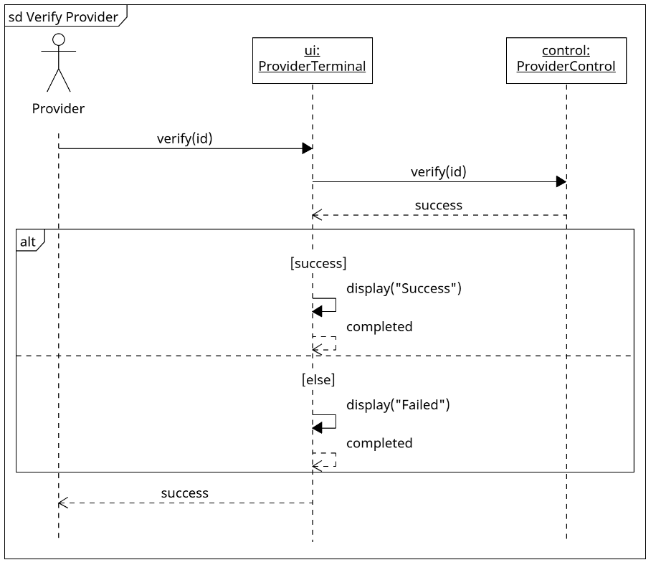

B. Use Case: Verify Operator
- Header: sd Verify Operator
- Lifelines: op: Operator, ui: OperatorConsole, ctrl: RecordsControl, db: Operator
- Execution Flow:
- op → ui.login("admin", password)
- ui → ctrl.verifyOperator("admin", password)
- ctrl locates the operator record internally; success is false if no record is found.
- The found/absent alternative governs whether authentication can be invoked.
- Combined Fragment alt:
- [staff found]: ctrl → db.authenticate(password); db ⇢ ctrl: success:boolean
- [else]: success = false (local result, not a message)
- ctrl ⇢ ui: success:boolean; a separate alt uses [success]: ui → ui.display("Success"); ui ⇢ ui: completed
- [else]: ui → ui.display("Failed"); ui ⇢ ui: completed
- ui ⇢ op: success:boolean
- End interaction; persistent objects remain alive. Use X only when a temporary object is actually destroyed.
- Draw found/absent lookup as one alt, then a separate success/failure alt for the returned Boolean. An absent lookup sets success=false; success permits the operator menu, while failure denies access.
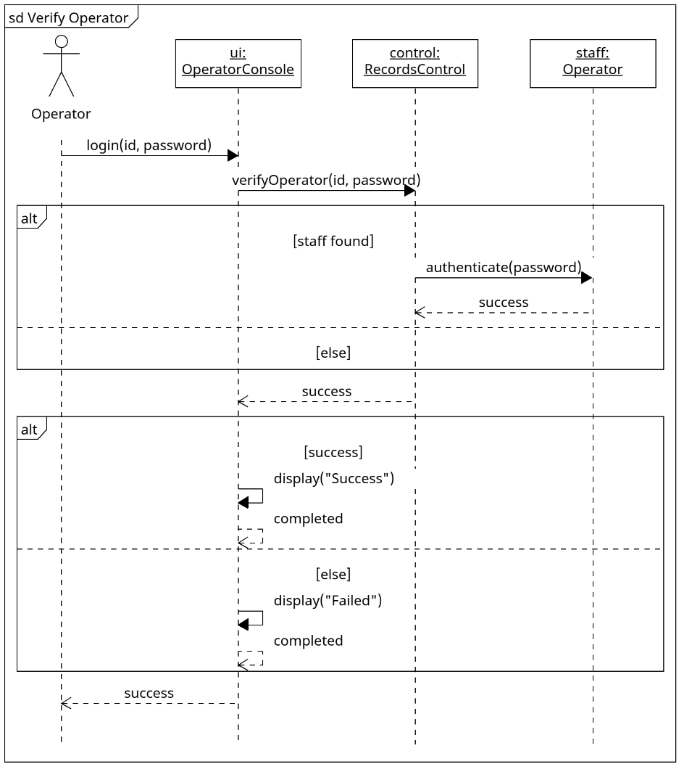

C. Use Case: Verify Manager
- Header: sd Verify Manager
- Lifelines: mgr: Manager, ui: ManagerTerminal, ctrl: RecordsControl, db: Manager
- Execution Flow:
- mgr → ui.login("987654321")
- ui → ctrl.verifyManager("987654321")
- ctrl locates the manager record internally; success is false if no record is found.
- The found/absent alternative governs whether manager-access verification can be invoked.
- Combined Fragment alt:
- [staff found]: ctrl → db.verifyAccess("987654321"); db ⇢ ctrl: success:boolean
- [else]: success = false (local result, not a message)
- ctrl ⇢ ui: success:boolean; a separate alt uses [success]: ui → ui.display("Success"); ui ⇢ ui: completed
- [else]: ui → ui.display("Failed"); ui ⇢ ui: completed
- ui ⇢ mgr: success:boolean
- End interaction; persistent objects remain alive. Use X only when a temporary object is actually destroyed.
- Draw found/absent lookup as one alt, then a separate success/failure alt for the returned Boolean. An absent lookup sets success=false; success permits the manager menu, while failure denies access.
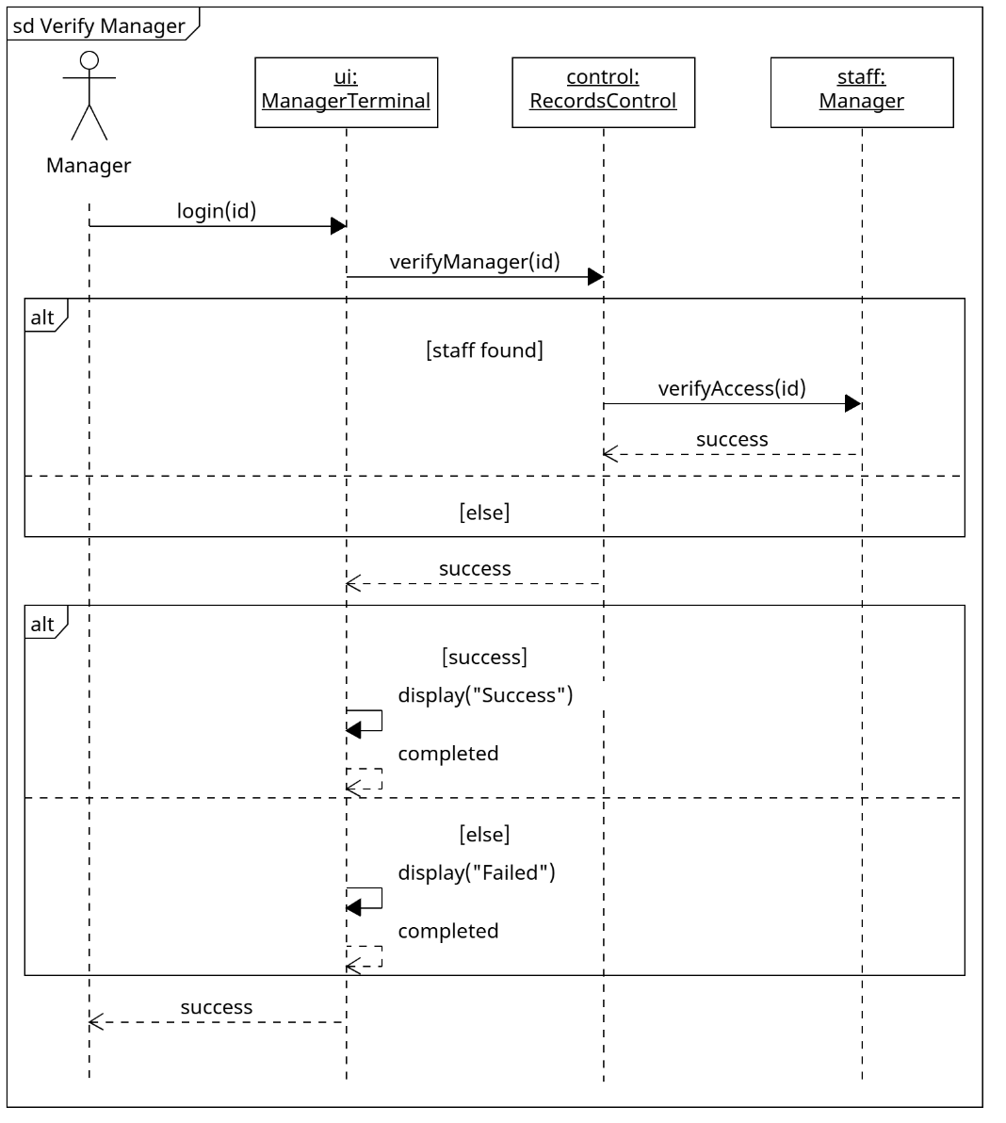

2.2 Provider Workflow Sequence Diagrams

A. Use Case: Validate Member Card
- Header: sd Validate Member Card
- Lifelines: p: Provider, ui: ProviderTerminal, ctrl: ProviderControl, m: Member
- Execution Flow:
- p → ui.validateCard("123456789")
- ui → ctrl.validateCard("123456789")
- ctrl locates the member record internally; absence maps to "Invalid number".
- Combined Fragment alt governs whether the member-status operation can be invoked.
- Combined Fragment alt:
- [member found]: ctrl → m.isValid(); m ⇢ ctrl: active:boolean
- [else]: result = "Invalid number" (local result, not a message)
- ctrl ⇢ ui: result:String; a separate alt uses [result == "Validated"]: ui → ui.display("Validated"); ui ⇢ ui: completed
- [result == "Member suspended"]: ui → ui.display("Member suspended"); ui ⇢ ui: completed
- [else]: ui → ui.display("Invalid number"); ui ⇢ ui: completed
- ui ⇢ p: result:String
- End interaction; persistent objects remain alive. Use X only when a temporary object is actually destroyed.
- For a found member, active=true maps to "Validated" and active=false maps to "Member suspended". An absent member maps to "Invalid number". Keep the found/absent alt separate from the three-outcome display alt.
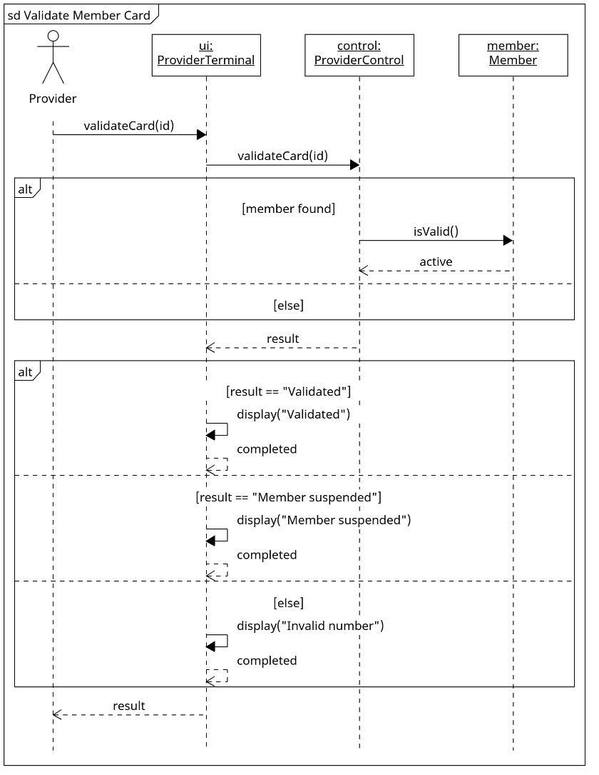

B. Use Case: Bill ChocAn for Service
- Header: sd Bill ChocAn for Service
- Lifelines: p: Provider (external actor), ui: ProviderTerminal, ctrl: ProviderControl, dir: ProviderDirectory, rec: ServiceRecord (collected draft input)
- Execution Flow:
- p → ui.bill(record)
- Combined Fragment ref: Validate Member Card; returns result:String.
- Combined Fragment alt: [result == "Validated"] encloses the billing steps; [else] skips them. The common final response returns false for invalid or suspended members.
- For each new bill, ui resets pendingComments to an empty String and billingSuccess to false. The draft contains the entered member number, service date and six-digit service code.
- Combined Fragment opt [provider supplies comments]: ref Add Optional Comments. Omission leaves empty comments; accepted text is copied from pendingComments into record.comments before the controller call.
- ui → ctrl.bill(record)
- ctrl → dir.findOffering(record.serviceCode); dir ⇢ ctrl: offering or null
- The controller validates the authenticated provider, member status, service date, service code and comment limit internally.
- Combined Fragment alt:
- [draft valid and offering != null]: ctrl → ui.confirmService(offering.serviceName); ui ⇢ ctrl: confirmed:boolean
- Show the service name for provider verification; the domain limit remains 20 characters.
- Nested Combined Fragment alt [confirmed]: ctrl → rec.save(); rec ⇢ ctrl: saved:boolean
- Nested [else] (confirmation declined): ctrl ⇢ ui: false. No service record is written.
- The saved branch returns ctrl ⇢ ui: billingSuccess:boolean, equal to the persistence result.
- Draft [else] (invalid draft or missing offering): ctrl ⇢ ui: false. No service record is written; invalid service code produces an error.
- Before persistence, ctrl stamps the current received date/time, verified nine-digit provider number and authoritative directory fee into the record.
- The record retains service date, member number, six-digit service code and optional comments of at most 100 characters.
- The provider may correct rejected input and retry; no rejected or declined draft is persisted.
- After the member-validation alt closes, ui → ui.display(resultMessage); ui ⇢ ui: completed.
- For a validated member, resultMessage includes the fee and persistence result, or the draft/confirmation failure.
- For an invalid or suspended member, resultMessage is the validation error; the controller billing operation is not invoked.
- ui ⇢ p: (result == "Validated" && billingSuccess), a Boolean. The expression short-circuits to false for invalid or suspended members.
- End interaction; persistent objects remain alive. Use X only when a temporary object is actually destroyed.

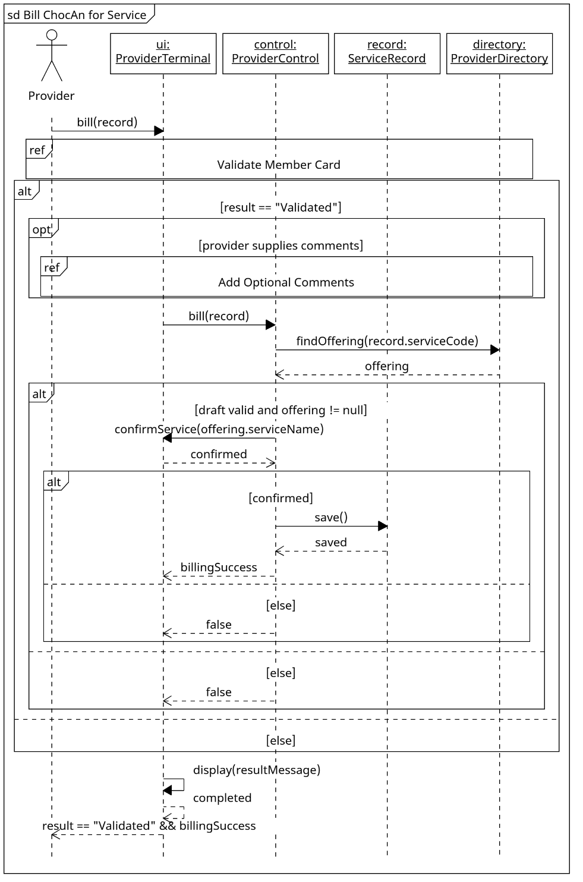

C. Use Case: Add Optional Comments
- Header: sd Add Optional Comments
- Lifelines: p: Provider, ui: ProviderTerminal, ctrl: ProviderControl
- Execution Flow:
- p → ui.addComments(text)
- ui → ctrl.addComments(text); ctrl ⇢ ui: success:boolean
- Combined Fragment alt:
- [text.length <= 100]: ui → ui.display("Comments accepted"); ui ⇢ ui: completed
- [else]: ui → ui.display("Maximum 100 characters"); ui ⇢ ui: completed. Rejected text is not staged; the provider may retry.
- ui ⇢ p: success:boolean
- An empty String omits comments. On success, accepted text is stored in ProviderTerminal.pendingComments for the active bill; rejected input leaves prior accepted text unchanged. The boundary copies accepted comments into the draft before ProviderControl.bill(record).
- End interaction; persistent objects remain alive. Use X only when a temporary object is actually destroyed.
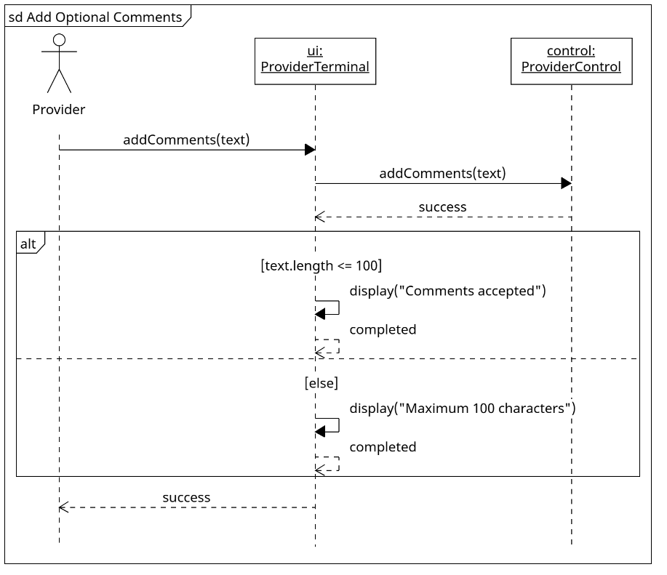

D. Use Case: Request Provider Directory
- Header: sd Request Provider Directory
- Lifelines: p: Provider, ui: ProviderTerminal, ctrl: ProviderControl, dir: ProviderDirectory
- Execution Flow:
- p → ui.requestDirectory()
- ui → ctrl.requestDirectory()
- ProviderDirectory.export() compiles service names, six-digit codes and fees alphabetically by service name; sorting is internal processing, not an additional sequence method.
- ctrl → dir.export(); dir ⇢ ctrl: success:boolean
- ctrl ⇢ ui: success:boolean
- Combined Fragment alt [success]: ui → ui.display("Success"); [else]: ui → ui.display("Failed"). Each display returns completed.
- ui ⇢ p: success:boolean
- File contains service name, six-digit code and fee. No actual email is sent.
- End interaction; persistent objects remain alive. Use X only when a temporary object is actually destroyed.
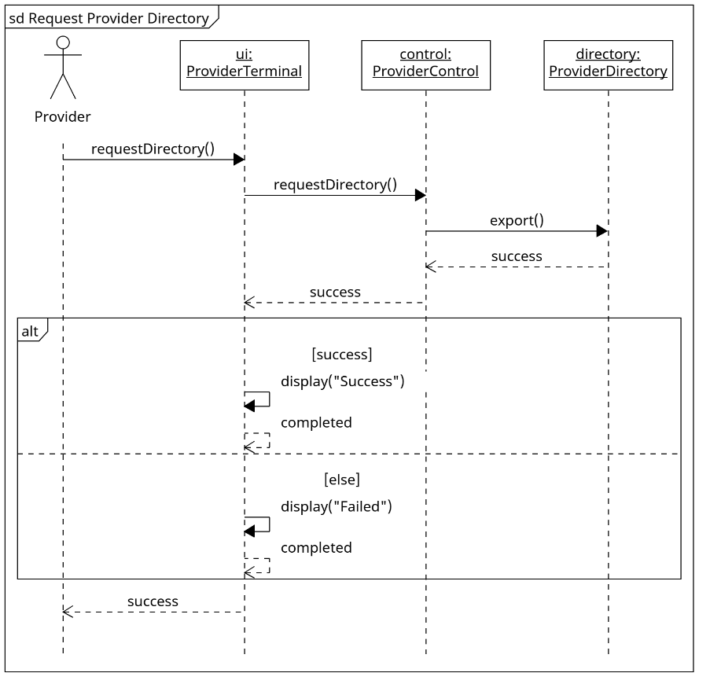

2.3 Operator & Acme Sequence Diagrams

A. Use Case: Manage Member Records
- Header: sd Manage Member Records
- Lifelines: op: Operator (external actor), ui: OperatorConsole, ctrl: RecordsControl
- Execution Flow:
- op → ui.manageMembers(action, member)
- ui → ctrl.manageMembers(action, member)
- ctrl ⇢ ui: success
- Combined Fragment alt:
- [success]
- ui → ui.display("Operation completed")
- ui ⇢ ui: completed
- Alternative operand:
- [else]
- ui → ui.display("Operation failed")
- ui ⇢ ui: completed
- End fragment.
- ui ⇢ op: success
- Use simulated keyboard input and confirmation to collect action and required demographic fields. The controller handles add, update, and delete internally, rejects invalid identities/data or cancelled input, and persists accepted changes. Never send a destroy message to an undeclared method.
- End interaction; persistent objects remain alive. Use X only when a temporary object is actually destroyed.
- Draw one controller dispatch for add/update/delete, followed by a saved/failed alt for the displayed result. A rejected action or failed persistence returns false without a successful persistent change.
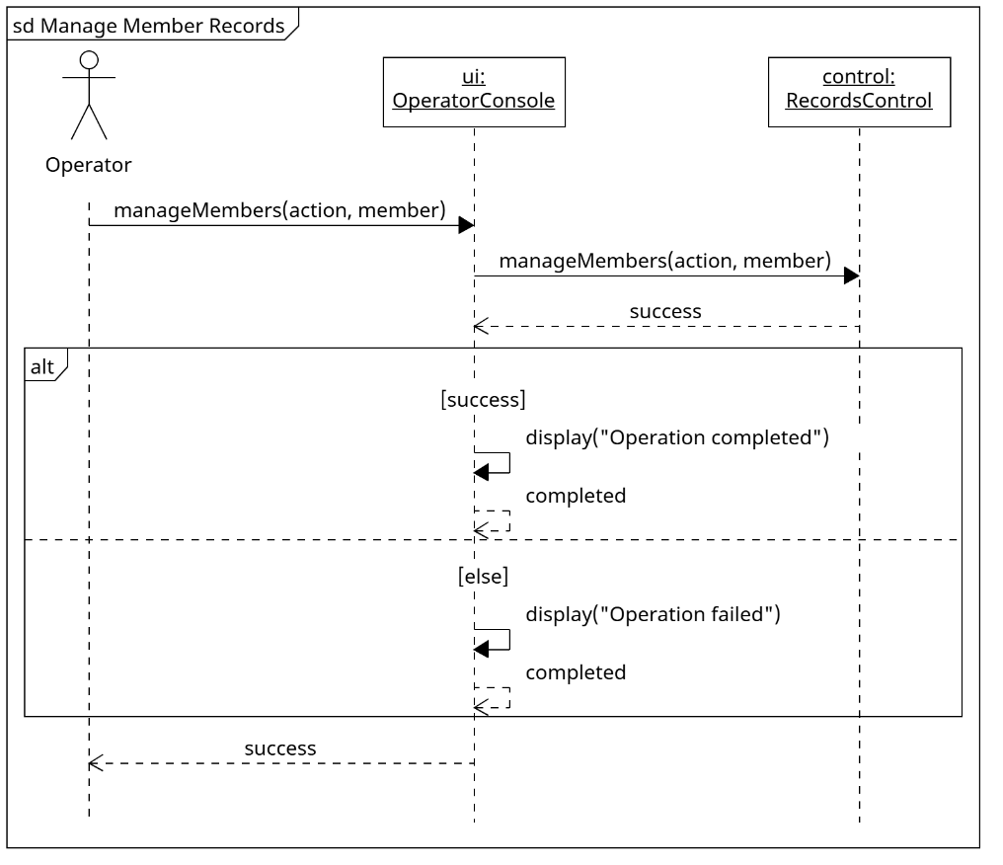

B. Use Case: Manage Provider Records
- Header: sd Manage Provider Records
- Lifelines: op: Operator (external actor), ui: OperatorConsole, ctrl: RecordsControl
- Execution Flow:
- op → ui.manageProviders(action, provider)
- ui → ctrl.manageProviders(action, provider)
- ctrl ⇢ ui: success
- Combined Fragment alt:
- [success]
- ui → ui.display("Operation completed")
- ui ⇢ ui: completed
- Alternative operand:
- [else]
- ui → ui.display("Operation failed")
- ui ⇢ ui: completed
- End fragment.
- ui ⇢ op: success
- Use simulated keyboard input and confirmation to collect action and required demographic fields. The controller handles add, update, and delete internally, rejects invalid identities/data or cancelled input, and persists accepted changes. Never send a destroy message to an undeclared method.
- End interaction; persistent objects remain alive. Use X only when a temporary object is actually destroyed.
- Draw one controller dispatch for add/update/delete, followed by a saved/failed alt for the displayed result. A rejected action or failed persistence returns false without a successful persistent change.
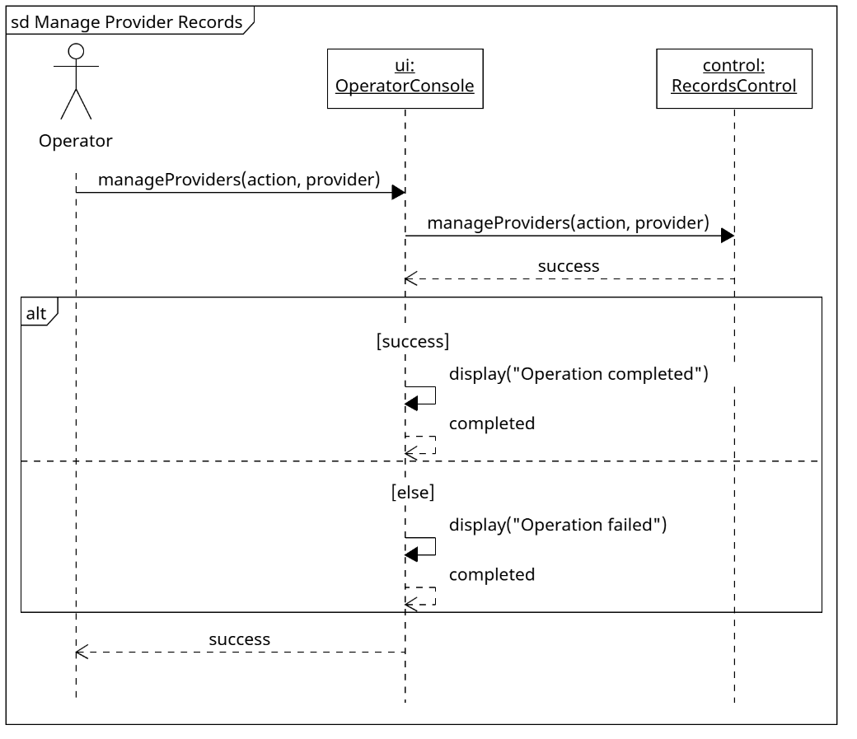

C. Use Case: Synchronize Member Accounts
- Header: sd Synchronize Member Accounts
- Lifelines: acmeActor: Acme Accounting Services (external actor), acme: AcmeInterface, ctrl: RecordsControl, member: Member
- Execution Flow:
- acmeActor → acme.syncAccounts(updates)
- acme → ctrl.syncAccounts(updates)
- Combined Fragment loop:
- [more supplied updates]
- Combined Fragment alt:
- [known member and valid supplied status]
- ctrl → member.setStatus(status)
- member ⇢ ctrl: completed
- Alternative operand:
- [else]
- End fragment.
- End fragment.
- ctrl ⇢ acme: success
- Combined Fragment alt:
- [success]
- acme ⇢ acmeActor: true
- Alternative operand:
- [else]
- acme ⇢ acmeActor: false
- End fragment.
- Acme owns payment and delinquency decisions; ChocAn applies supplied statuses through simulated input, not real network implementation. At 9 PM, valid supplied updates are persisted; invalid updates are skipped and any invalid update or failed persistence makes aggregate success false.
- End interaction; persistent objects remain alive. Use X only when a temporary object is actually destroyed.
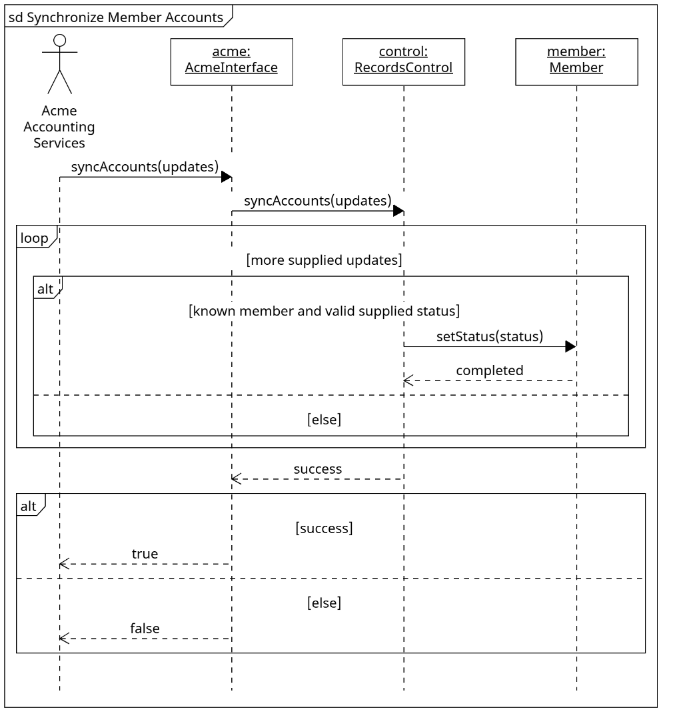

2.4 Batch Accounting & Reporting Sequence Diagrams

A. Use Case: Run Weekly Accounting Procedure
(Rubric Compliance: Triggered by Timer; invokes the existing public report generators directly.)
- Header: sd Run Weekly Accounting Procedure
- Lifelines: clock: System Clock (external actor), timer: TimerDaemon, ctrl: AccountingControl
- Execution Flow:
- clock → timer.weeklyAccounting()
- timer → ctrl.weeklyAccounting()
- Combined Fragment loop:
- [more members with service this week]
- ctrl → ctrl.memberReport(id)
- ctrl ⇢ ctrl: saved
- End fragment.
- Combined Fragment loop:
- [more providers with service this week]
- ctrl → ctrl.providerReport(id)
- ctrl ⇢ ctrl: saved
- End fragment.
- ctrl → ctrl.summaryReport()
- ctrl ⇢ ctrl: summarySaved
- ctrl → ctrl.eftData()
- ctrl ⇢ ctrl: eftSaved
- Combined Fragment alt:
- [all outputs saved]
- ctrl ⇢ timer: true
- Alternative operand:
- [else]
- ctrl ⇢ timer: false
- End fragment.
- timer ⇢ clock: success
- End interaction; persistent objects remain alive. Use X only when a temporary object is actually destroyed.
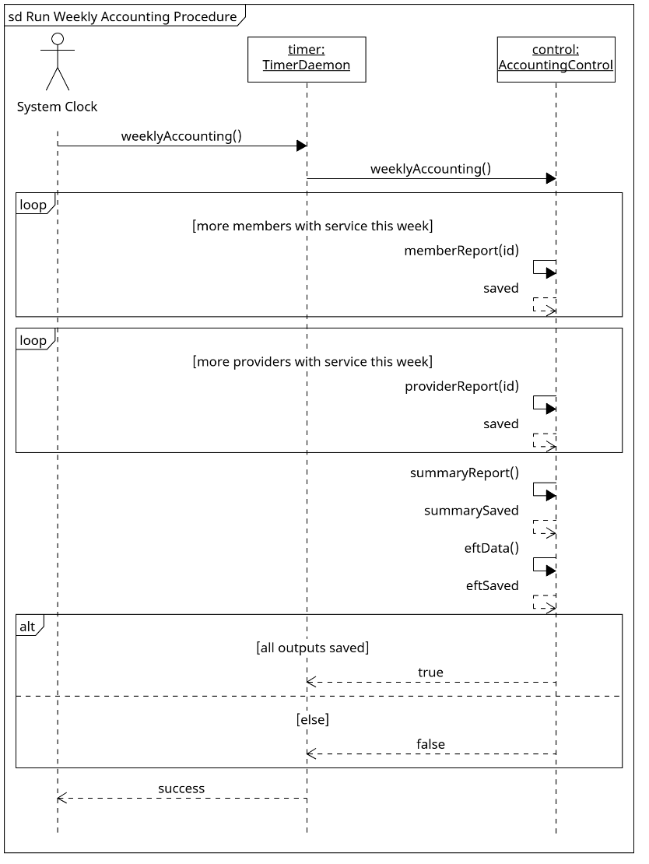

B. Use Case: Generate Member Report
- Header: sd Generate Member Report
- Lifelines: mgr: Manager (external actor), ui: ManagerTerminal, ctrl: AccountingControl, report: Report
- Execution Flow:
- mgr → ui.memberReport(id)
- ui → ctrl.memberReport(id)
- Combined Fragment alt:
- [subject exists]
- ctrl → report.save()
- report ⇢ ctrl: success
- ctrl ⇢ ui: success
- Alternative operand:
- [else]
- ctrl ⇢ ui: false
- End fragment.
- Combined Fragment alt:
- [success]
- ui → ui.display("Success")
- ui ⇢ ui: completed
- Alternative operand:
- [else]
- ui → ui.display("Failed")
- ui ⇢ ui: completed
- End fragment.
- ui ⇢ mgr: success
- Required member demographics, service date, provider name and service name; filename begins member name followed by report date. No actual email. Services are sorted by service date.
- End interaction; persistent objects remain alive. Use X only when a temporary object is actually destroyed.
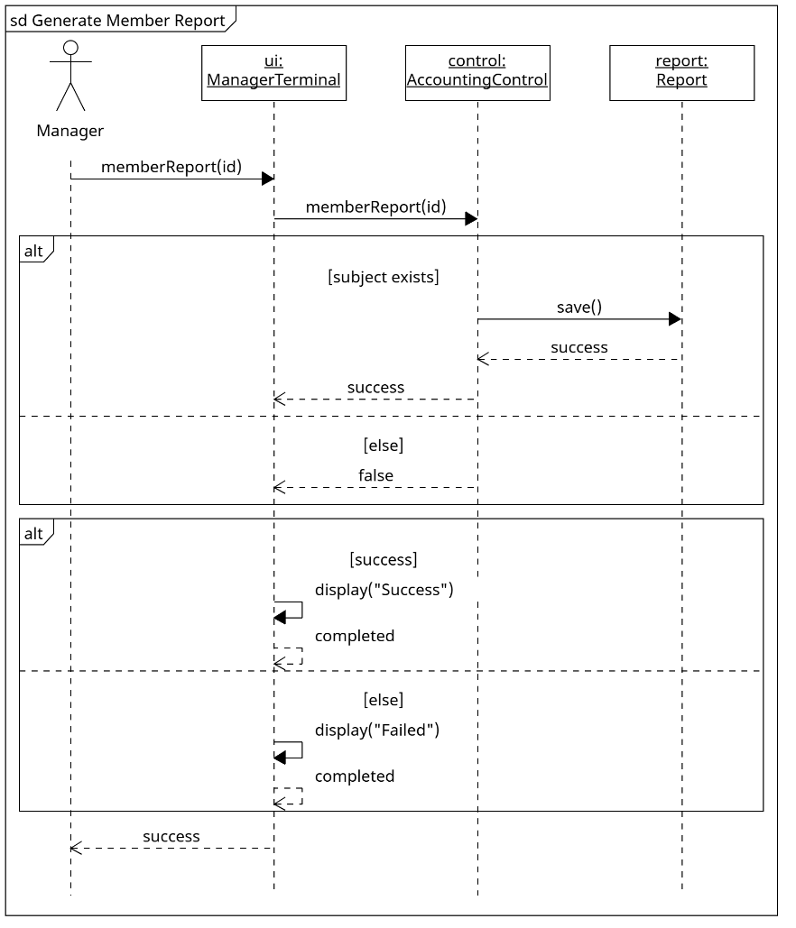

C. Use Case: Generate Provider Report
- Header: sd Generate Provider Report
- Lifelines: mgr: Manager (external actor), ui: ManagerTerminal, ctrl: AccountingControl, report: Report
- Execution Flow:
- mgr → ui.providerReport(id)
- ui → ctrl.providerReport(id)
- Combined Fragment alt:
- [subject exists]
- ctrl → report.save()
- report ⇢ ctrl: success
- ctrl ⇢ ui: success
- Alternative operand:
- [else]
- ctrl ⇢ ui: false
- End fragment.
- Combined Fragment alt:
- [success]
- ui → ui.display("Success")
- ui ⇢ ui: completed
- Alternative operand:
- [else]
- ui → ui.display("Failed")
- ui ⇢ ui: completed
- End fragment.
- ui ⇢ mgr: success
- Required provider demographics, service date, receipt time, member name/number, service code, fee, count and weekly total; filename begins provider name followed by report date. No actual email. Services are sorted by the date/time received.
- End interaction; persistent objects remain alive. Use X only when a temporary object is actually destroyed.
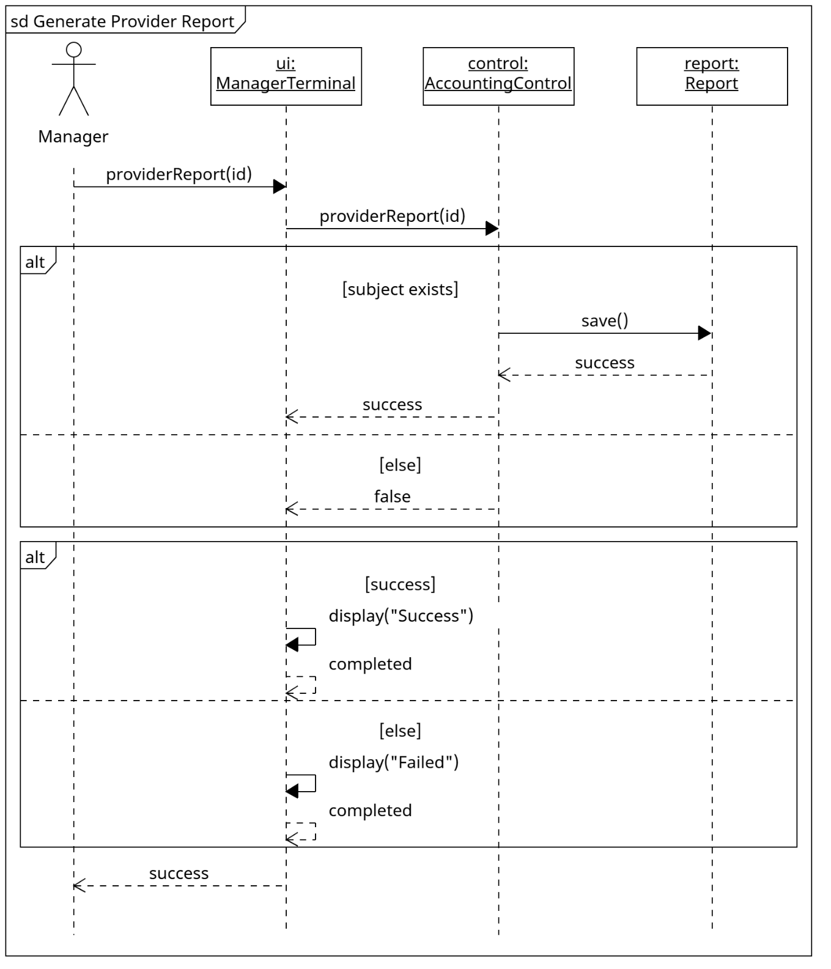

D. Use Case: Generate Summary Report
- Header: sd Generate Summary Report
- Lifelines: mgr: Manager (external actor), ui: ManagerTerminal, ctrl: AccountingControl, report: Report
- Execution Flow:
- mgr → ui.summaryReport()
- ui → ctrl.summaryReport()
- ctrl → report.save()
- report ⇢ ctrl: success
- ctrl ⇢ ui: success
- Combined Fragment alt:
- [success]
- ui → ui.display("Success")
- ui ⇢ ui: completed
- Alternative operand:
- [else]
- ui → ui.display("Failed")
- ui ⇢ ui: completed
- End fragment.
- ui ⇢ mgr: success
- Summary includes each provider to be paid, consultations and total fee; grand provider count, consultation count and fee total. Zero-service period yields zero totals.
- End interaction; persistent objects remain alive. Use X only when a temporary object is actually destroyed.
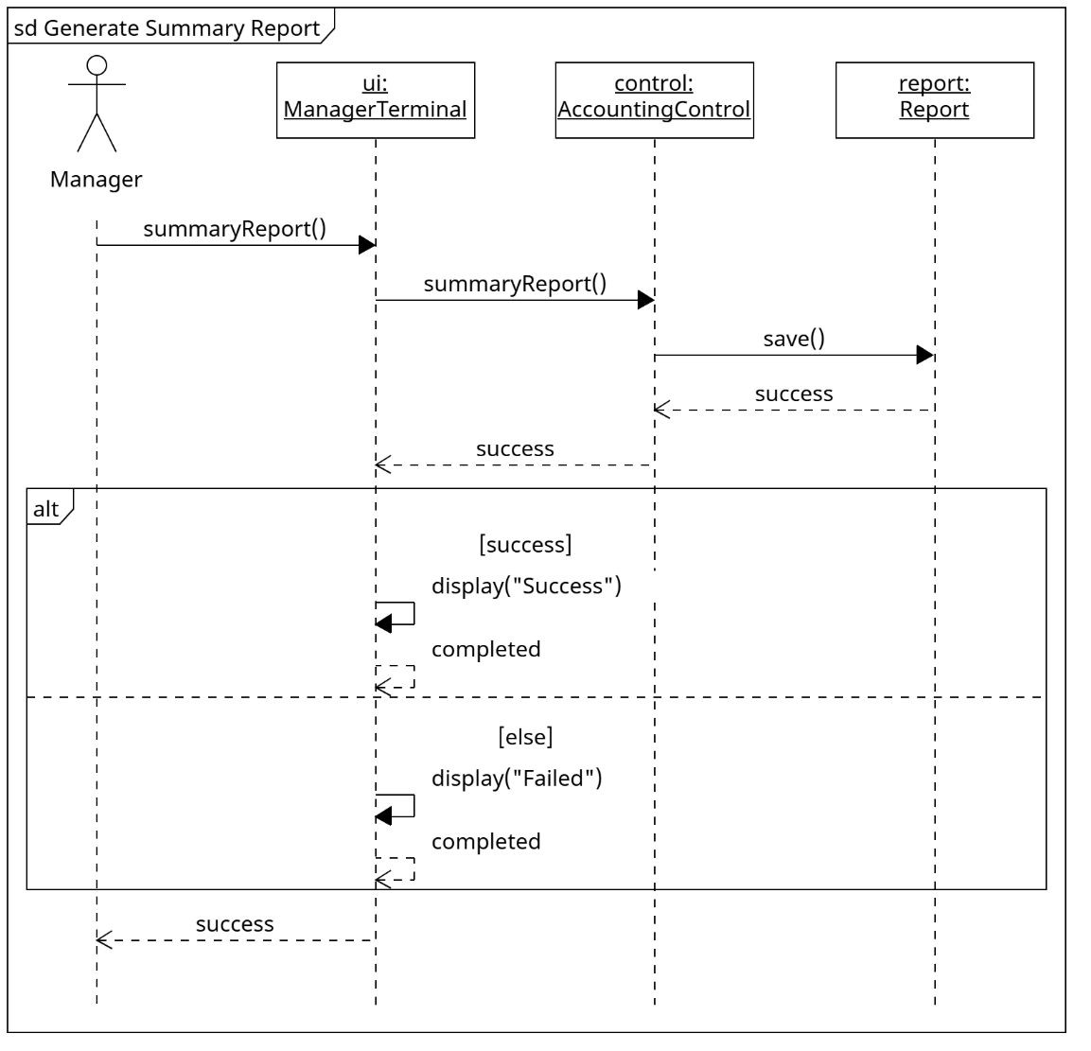

E. Use Case: Generate EFT Data
- Header: sd Generate EFT Data
- Lifelines: clock: System Clock (external actor), timer: TimerDaemon, ctrl: AccountingControl, eft: EFTRecord
- Execution Flow:
- clock → timer.eftData()
- timer → ctrl.eftData()
- Combined Fragment alt:
- [file initialized]
- Combined Fragment loop:
- [more providers with positive weekly fee]
- ctrl → eft.appendTo(file)
- eft ⇢ ctrl: lineSaved
- End fragment.
- Alternative operand:
- [else]
- End fragment.
- Combined Fragment alt:
- [all lines saved and file initialized]
- ctrl ⇢ timer: true
- Alternative operand:
- [else]
- ctrl ⇢ timer: false
- End fragment.
- timer ⇢ clock: success
- File contains name, nine-digit provider number and amount. No actual bank transfer. The controller initializes the file before appending each payable provider; the empty period leaves an initialized empty file. Weekly accounting reuses the same EFT generator after Timer entry.
- End interaction; persistent objects remain alive. Use X only when a temporary object is actually destroyed.
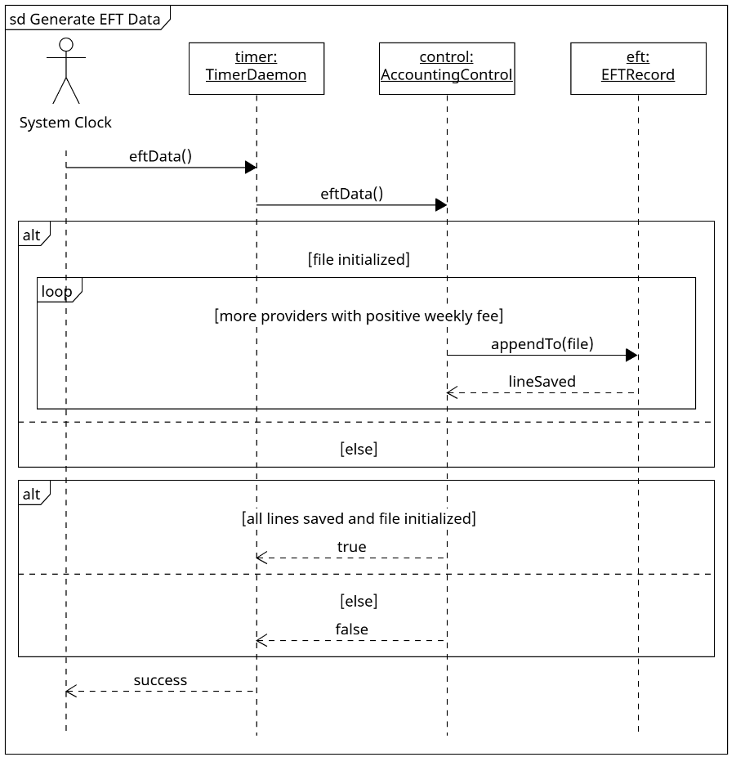

Task 3: Architectural Discussion (Coupling & Cohesion)

3.1 Foundational Concepts & Quality Principles
In software architecture, cohesion and coupling are the twin benchmarks of object-oriented structural quality:
- Cohesion measures the degree of functional focus and single-mindedness within a given module. High cohesion dictates that a class or subsystem should adhere to the Single Responsibility Principle (SRP)—executing one clearly bounded role with tightly correlated operations.
- Coupling measures the degree of interdependent connectivity between different modules. Loose coupling dictates that modules should interact through clean, minimal, and stable interfaces, preventing internal changes in one class from rippling unpredictably across the broader system.
A well-architected design balances both principles to maximize three fundamental non-functional quality attributes:
- Maintainability: The ease with which software defects can be diagnosed, isolated, and repaired without side effects.
- Flexibility: The capability of the system to accommodate evolving business requirements, hardware changes, or new operational workflows with minimal code modification.
- Scalability: The capacity of the architecture to sustain increased transaction throughput, larger data volumes, and expanded user concurrency without architectural degradation.

3.2 Analysis of High Cohesion in the ChocAn Design
The ChocAn design enforces high functional cohesion by structuring the class hierarchy into dedicated, decoupled architectural tiers:

A. Separation of Boundary Interfaces
Terminal and console classes (ProviderTerminal, OperatorConsole, ManagerTerminal, AcmeInterface) exhibit high cohesion because their responsibilities are restricted entirely to user presentation and I/O mediation:
- ProviderTerminal is exclusively concerned with terminal device interactions: reading magnetic card swipes, prompting for numerical inputs, and formatting one-line screen displays. It contains zero knowledge of database persistence, fee lookup algorithms, or member suspension business rules.
- AcmeInterface has the sole responsibility of mediating simulated incoming membership-status data from Acme Accounting Services. Communications hardware and actual networking are outside the contract; Acme determines the status, and RecordsControl applies it.

B. Dedicated Domain Controllers
Business logic is not scattered across UI elements or embedded within data storage objects. Instead, the design utilizes three specialized controllers that group cohesive functional domains:
- ProviderControl: Highly cohesive around clinical provider service workflows (authenticating providers, verifying member cards, processing consultation billing, and extracting service directories).
- RecordsControl: Cohesive around administrative entity lifecycle management (handling operator authentication, CRUD operations for member and provider profiles, and nightly Acme status updates).
- AccountingControl: Dedicated strictly to financial batch processing and reporting routines (orchestrating the Friday midnight accounting run, compiling provider/member report documents, and exporting local EFT data files; actual bank transfers remain outside the contract).

C. Domain Entities
Entity classes (Person, Member, Provider, ServiceRecord, ServiceOffering, ProviderDirectory) represent domain data models. They are highly cohesive because they encapsulate related state and operations, including Member status checks, directory lookup, and ServiceRecord persistence, without taking on responsibilities related to screen rendering, network I/O, or session orchestration.

3.3 Analysis of Loose Coupling in the ChocAn Design
The ChocAn architecture enforces loose coupling through strict layer isolation, interface mediation, and encapsulation:

A. Elimination of UI-to-Database Coupling
A primary failure mode in software design is "spaghetti coupling," where user interfaces directly read and write database entities. In our design:
- Boundaries delegate entity lookup and persistence to controllers. ProviderTerminal supplies a ServiceRecord draft to ProviderControl.bill(record), but does not save it directly; OperatorConsole delegates member and provider maintenance to RecordsControl.
- Boundaries invoke controller methods (e.g., ui calls ctrl.bill(record)). The controller coordinates validation, directory lookup, and persistence; accepting a ServiceRecord draft means the boundary is coupled to that data type.

B. Architectural Decoupling of Reporting from Actors
Our boundary-mediated calls to AccountingControl follow this clarification and match the sequence diagrams.
- The external System Clock and Manager actors use TimerDaemon and ManagerTerminal boundaries; those boundaries call AccountingControl rather than report entities.
- Instead, the TimerDaemon and ManagerTerminal trigger requests through the public methods of AccountingControl (weeklyAccounting() and memberReport(id)).
- This decouples the reporting engine from the trigger mechanism. Whether a report is initiated automatically by a cron timer at Friday midnight or manually by an executive on Tuesday morning, the reporting engine executes identically without depending on the caller's context.

C. Enforcement of the Law of Demeter
Controllers mediate entity operations, following the intent of the Law of Demeter. For example, during service billing, ProviderTerminal calls ProviderControl.bill(record), and ProviderControl calls ProviderDirectory.findOffering(record.serviceCode). ProviderTerminal does not navigate the directory collection; the ServiceRecord draft and returned ServiceOffering still create explicit domain-type dependencies.

3.4 Impact on Maintainability, Flexibility, and Scalability
+------------------------------------------------------------------+
| ARCHITECTURAL QUALITY IMPACT EVALUATION MATRIX |
+------------------------------------------------------------------+
| Quality | Design cause | Benefit / limitation |
| Maintainability | Cohesion | Focused fixes; verify |
| | Encapsulation | shared contracts |
| Flexibility | ECB separation | UI/storage changes can |
| | Stable interfaces | reuse suitable contracts |
| Scalability | Separate routines | Concurrency requires |
| | Controller methods | coordination and testing |
+------------------------------------------------------------------+

1. Maintainability
Because each class exhibits high cohesion and narrow responsibilities, defects are naturally localized:
- If a bug occurs in the way service dates are formatted or validated, developers first inspect ProviderTerminal and ProviderControl. Shared date and persistence contracts must still be checked for effects on synchronization and reports.
- Encapsulation can limit the impact of private attribute changes when public method contracts remain stable. Changes to passwordHash or weekly fee calculations still require verification of affected authentication and reporting behavior.

2. Flexibility
Loose coupling enables the system to absorb environmental and requirements changes seamlessly:
- UI Evolution: In the acceptance test, terminals are simulated via keyboard and screen text. A later hardware or web interface could reuse controller methods if their contracts remain suitable, although new interaction and validation requirements may require changes.
- Storage Independence: Currently, reports and records are written to local disk files per the project contract. A later database migration would concentrate changes in persistence and query operations. Suitable public contracts could remain stable, but storage, transaction and reporting effects would require verification.

3. Scalability
The modular structure directly facilitates horizontal and vertical scaling:
- High Transaction Throughput: Controllers retain providerId, authenticatedStaff, weekStart, and weekEnd, so they are not stateless. Supporting concurrent terminals would require session isolation and coordinated access to shared records and files; the diagram alone does not establish thread safety.
- Batch Optimization: AccountingControl separates reporting responsibilities from RecordsControl. Concurrent or separate-server execution would still require consistent reporting-week data, coordinated file access, and testing; separation alone does not guarantee unchanged terminal response times.

