Team_1_Requirement

1. Header Table

Member Name | CWID Number | Crimson Email Address | Hours Contributed
Dylan Filmer (Submitter) | 12366351 | dfilmer@crimson.ua.edu | 10
Dawson Sconyers | 12329994 | dcsconyers@crimson.ua.edu | 10
Landon Liles | 12480863 | lmliles1@crimson.ua.edu | 13
Cayden Pomeroy | 12505958 | cpomeroy1@crimson.ua.edu | 11
Michael Ifeanyichukwu | 12627307 | mcifeanyichukwu@crimson.ua.edu | 12

2. Task Distribution Table

Member Name | Tasks Performed | Contribution %
Dylan Filmer | Task 1 technical system analysis writeup; verification of word counts; coordination and compilation of final report; designated project submitter. | 20%
Dawson Sconyers | Task 2 Object Model architecture; synthesis and validation of UML Stereotyped Class Diagram (Entities, Controls, Boundaries, Inheritance, Composition). | 20%
Landon Liles | Task 3 Main Activity Diagram (swimlanes/partitions) and credential verification activity diagrams (Verify Provider, Verify Operator, Verify Manager). | 20%
Cayden Pomeroy | Task 3 Provider workflow activity diagrams (Validate Member Card, Bill ChocAn for Service, Add Optional Comments, Request Provider Directory). | 20%
Michael Ifeanyichukwu | Task 3 Administrative and batch accounting activity diagrams (Manage Records, Synchronize Accounts, Run Weekly Accounting Procedure & Reports). | 20%
Total |  | 100%

Task 1: System Analysis Description
The ChocAn Data Processing System computerizes provider service billing, card validation, directory distribution, member and provider administration, and weekly financial reporting through modular software controllers. Transaction, membership, and provider records are stored in a central database at the ChocAn Data Center. System hardware includes standard desktop PCs running simulated provider terminals, operator consoles, and manager workstations. The system interfaces externally with Acme Accounting Services for nightly membership status synchronization at 9 PM and writes batch electronic funds transfer data files to local disk. Users interact with the system via terminal keyboards and console displays using menu selections and numerical inputs to execute workflows.

Task 2: Object Model (Stereotyped Class Diagram)

2.1 Architecture Overview & Stereotype Definitions
To construct the object model of the ChocAn system, analysis classes are categorized using Entity-Control-Boundary (ECB) stereotypes:
- Boundary Classes (<<boundary>>): The user interfaces or hardware communication adapters that mediate interactions between external actors and the internal system:
  - ProviderTerminal: Interfaces with the healthcare provider to accept card swipes, key in service dates, enter 6-digit service codes, view service names, and read fees.
  - OperatorConsole: Interactive administrative console used by data center operators during the day to add, edit, or delete member and provider records.
  - ManagerTerminal: Management workstation interface used to authenticate managers and execute on-demand report requests.
  - AcmeInterface: Automated network interface that establishes connection with Acme Accounting Services at 9:00 PM to ingest membership status updates.
  - ClockInterface: Internal system clock listener that triggers automated temporal events (e.g., Friday midnight batch accounting and 9:00 PM Acme synchronization).
- Control Classes (<<control>>): The business logic coordinators that process inputs, apply business rules, and orchestrate transactions:
  - ProviderControl: Coordinates Verify Provider, member validation, consultation billing, optional comments, and provider-directory requests.
  - RecordsControl: Handles Verify Operator and Verify Manager, operator CRUD operations for member/provider records, and active/suspended status updates supplied by Acme.
  - AccountingControl: Orchestrates the Friday midnight accounting routine, itemizing weekly transactions, generating individual member/provider reports, compiling executive summaries, and generating banking EFT records.
- Entity Classes (<<entity>>): The persistent domain data objects stored in the central database:
  - Person (Abstract Base Class): Encapsulates shared demographic data attributes (name, number, address; address includes street, city, state, and ZIP). Subclasses inherit these fields (Satisfies Inheritance Requirement).
  - Member (Inherits from Person): Adds membership-specific attributes (status: Active/Suspended).
  - Provider (Inherits from Person): Inherits provider identification and address data.
  - Operator (Inherits from Person): Adds administrative login credentials (loginID, password).
  - Manager (Inherits from Person): Adds management login identification (loginID).
  - ServiceRecord: Persistent billing transaction storing current timestamp, service date, provider number, member number, 6-digit service code and optional comments.
  - ServiceOffering: Catalog item storing 6-digit service code, service name, and standard fee.
  - ProviderDirectory: Catalog entity composed of multiple ServiceOffering records (Satisfies Composition Requirement).
  - Report (Abstract Base Class): Shared report metadata (type, date, fileName).
  - EFTRecord: Banking disbursement record storing provider name, 9-digit provider number, and payment amount.

2.2 Conceptual Class Architecture & Collaboration Mapping
The table below illustrates the structural path from external actors through boundary interfaces and business controllers to persistent entity classes:
Interacting Actor | Boundary Interface (<<boundary>>) | Business Logic Controller (<<control>>) | Target Domain Entities (<<entity>>)
Provider | ProviderTerminal | ProviderControl | Provider (verifies 9-digit provider ID)
Provider | ProviderTerminal | ProviderControl | Member (validates status), ServiceOffering (checks service code and fee), ServiceRecord (creates billable entry)
Provider | ProviderTerminal | ProviderControl | ProviderDirectory, ServiceOffering
ChocAn Operator | OperatorConsole | RecordsControl | Operator (authenticates credentials)
ChocAn Operator | OperatorConsole | RecordsControl | Member (adds, updates, deletes profiles)
ChocAn Operator | OperatorConsole | RecordsControl | Provider (adds, updates, deletes profiles)
ChocAn Manager | ManagerTerminal | RecordsControl | Manager (authenticates access)
ChocAn Manager | ManagerTerminal | AccountingControl | Report
Acme Accounting | AcmeInterface | RecordsControl | Member (updates Active / Suspended status)
Timer / System Clock | ClockInterface | AccountingControl | ServiceRecord, Report, EFTRecord
Timer / System Clock | ClockInterface | RecordsControl | Member (starts the nightly 9 PM status update)

2.3 Stereotyped Class Diagram
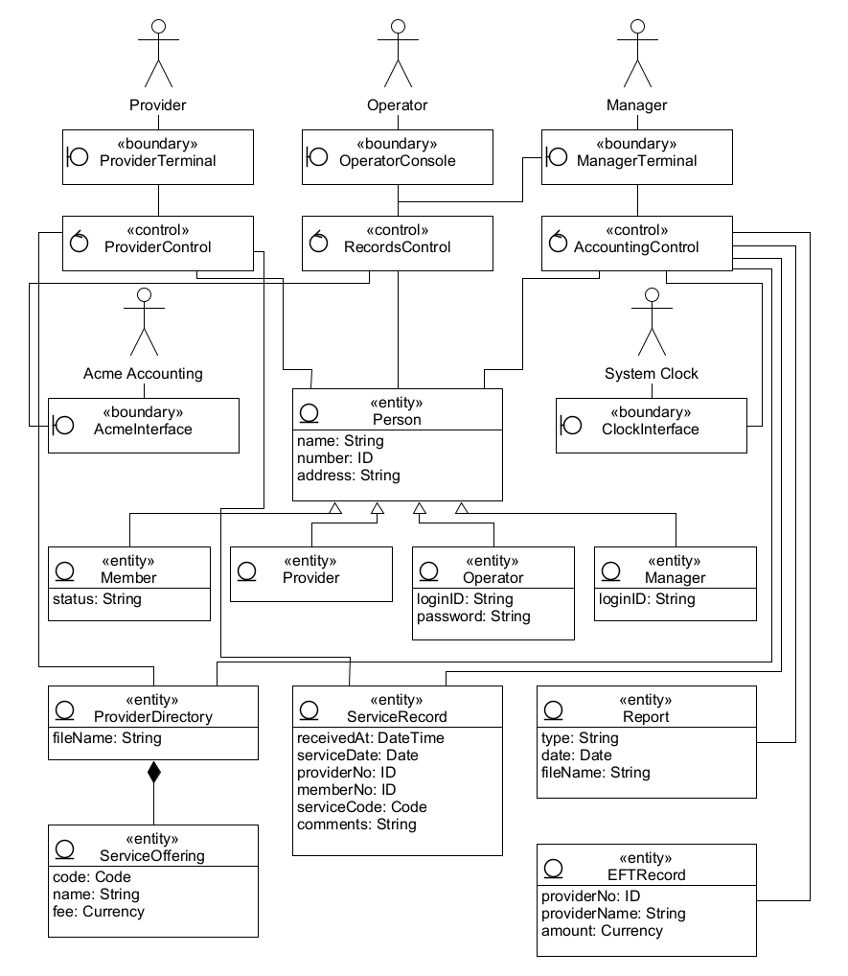

2.4 UMLetino UXF Source Code (Class Diagram)
<diagram program="umletino" version="15.1"><zoom_level>10</zoom_level><element><id>UMLActor</id><coordinates><x>45</x><y>-30</y><w>200</w><h>100</h></coordinates><panel_attributes>Provider
fontsize=16</panel_attributes><additional_attributes></additional_attributes></element><element><id>UMLActor</id><coordinates><x>295</x><y>-30</y><w>200</w><h>100</h></coordinates><panel_attributes>Operator
fontsize=16</panel_attributes><additional_attributes></additional_attributes></element><element><id>UMLClass</id><coordinates><x>45</x><y>85</y><w>200</w><h>58</h></coordinates><panel_attributes>&lt;&lt;boundary&gt;&gt;
ProviderTerminal
fontsize=16</panel_attributes><additional_attributes></additional_attributes></element><element><id>Text</id><coordinates><x>47</x><y>93</y><w>42</w><h>40</h></coordinates><panel_attributes>customelement=
drawCircle(15,20,9) lw=1.5
drawLine(3,20,6,20) lw=1.5
drawLine(3,10,3,30) lw=1.5</panel_attributes><additional_attributes></additional_attributes></element><element><id>UMLClass</id><coordinates><x>295</x><y>85</y><w>200</w><h>58</h></coordinates><panel_attributes>&lt;&lt;boundary&gt;&gt;
OperatorConsole
fontsize=16</panel_attributes><additional_attributes></additional_attributes></element><element><id>Text</id><coordinates><x>297</x><y>93</y><w>42</w><h>40</h></coordinates><panel_attributes>customelement=
drawCircle(15,20,9) lw=1.5
drawLine(3,20,6,20) lw=1.5
drawLine(3,10,3,30) lw=1.5</panel_attributes><additional_attributes></additional_attributes></element><element><id>UMLClass</id><coordinates><x>545</x><y>85</y><w>200</w><h>58</h></coordinates><panel_attributes>&lt;&lt;boundary&gt;&gt;
ManagerTerminal
fontsize=16</panel_attributes><additional_attributes></additional_attributes></element><element><id>Text</id><coordinates><x>547</x><y>93</y><w>42</w><h>40</h></coordinates><panel_attributes>customelement=
drawCircle(15,20,9) lw=1.5
drawLine(3,20,6,20) lw=1.5
drawLine(3,10,3,30) lw=1.5</panel_attributes><additional_attributes></additional_attributes></element><element><id>UMLClass</id><coordinates><x>45</x><y>175</y><w>200</w><h>58</h></coordinates><panel_attributes>&lt;&lt;control&gt;&gt;
ProviderControl
fontsize=16</panel_attributes><additional_attributes></additional_attributes></element><element><id>Text</id><coordinates><x>47</x><y>183</y><w>42</w><h>40</h></coordinates><panel_attributes>customelement=
drawCircle(15,20,9) lw=1.5
drawLine(11,12,16,7) lw=1.5
drawLine(11,12,18,14) lw=1.5</panel_attributes><additional_attributes></additional_attributes></element><element><id>UMLClass</id><coordinates><x>295</x><y>175</y><w>200</w><h>58</h></coordinates><panel_attributes>&lt;&lt;control&gt;&gt;
RecordsControl
fontsize=16</panel_attributes><additional_attributes></additional_attributes></element><element><id>Text</id><coordinates><x>297</x><y>183</y><w>42</w><h>40</h></coordinates><panel_attributes>customelement=
drawCircle(15,20,9) lw=1.5
drawLine(11,12,16,7) lw=1.5
drawLine(11,12,18,14) lw=1.5</panel_attributes><additional_attributes></additional_attributes></element><element><id>UMLClass</id><coordinates><x>545</x><y>175</y><w>200</w><h>58</h></coordinates><panel_attributes>&lt;&lt;control&gt;&gt;
AccountingControl
fontsize=16</panel_attributes><additional_attributes></additional_attributes></element><element><id>Text</id><coordinates><x>547</x><y>183</y><w>42</w><h>40</h></coordinates><panel_attributes>customelement=
drawCircle(15,20,9) lw=1.5
drawLine(11,12,16,7) lw=1.5
drawLine(11,12,18,14) lw=1.5</panel_attributes><additional_attributes></additional_attributes></element><element><id>UMLActor</id><coordinates><x>30</x><y>250</y><w>200</w><h>100</h></coordinates><panel_attributes>Acme Accounting
fontsize=16</panel_attributes><additional_attributes></additional_attributes></element><element><id>UMLActor</id><coordinates><x>560</x><y>250</y><w>200</w><h>100</h></coordinates><panel_attributes>System Clock
fontsize=16</panel_attributes><additional_attributes></additional_attributes></element><element><id>UMLClass</id><coordinates><x>30</x><y>365</y><w>200</w><h>58</h></coordinates><panel_attributes>&lt;&lt;boundary&gt;&gt;
AcmeInterface
fontsize=16</panel_attributes><additional_attributes></additional_attributes></element><element><id>Text</id><coordinates><x>32</x><y>373</y><w>42</w><h>40</h></coordinates><panel_attributes>customelement=
drawCircle(15,20,9) lw=1.5
drawLine(3,20,6,20) lw=1.5
drawLine(3,10,3,30) lw=1.5</panel_attributes><additional_attributes></additional_attributes></element><element><id>UMLClass</id><coordinates><x>560</x><y>365</y><w>200</w><h>58</h></coordinates><panel_attributes>&lt;&lt;boundary&gt;&gt;
ClockInterface
fontsize=16</panel_attributes><additional_attributes></additional_attributes></element><element><id>Text</id><coordinates><x>562</x><y>373</y><w>42</w><h>40</h></coordinates><panel_attributes>customelement=
drawCircle(15,20,9) lw=1.5
drawLine(3,20,6,20) lw=1.5
drawLine(3,10,3,30) lw=1.5</panel_attributes><additional_attributes></additional_attributes></element><element><id>UMLClass</id><coordinates><x>285</x><y>355</y><w>220</w><h>118</h></coordinates><panel_attributes>&lt;&lt;entity&gt;&gt;
Person
--
name: String
number: ID
address: String
fontsize=16</panel_attributes><additional_attributes></additional_attributes></element><element><id>Text</id><coordinates><x>287</x><y>363</y><w>42</w><h>40</h></coordinates><panel_attributes>customelement=
drawCircle(15,17,9) lw=1.5
drawLine(6,27,24,27) lw=1.5</panel_attributes><additional_attributes></additional_attributes></element><element><id>UMLClass</id><coordinates><x>30</x><y>520</y><w>170</w><h>78</h></coordinates><panel_attributes>&lt;&lt;entity&gt;&gt;
Member
--
status: String
fontsize=16</panel_attributes><additional_attributes></additional_attributes></element><element><id>Text</id><coordinates><x>32</x><y>528</y><w>42</w><h>40</h></coordinates><panel_attributes>customelement=
drawCircle(15,17,9) lw=1.5
drawLine(6,27,24,27) lw=1.5</panel_attributes><additional_attributes></additional_attributes></element><element><id>UMLClass</id><coordinates><x>220</x><y>520</y><w>170</w><h>58</h></coordinates><panel_attributes>&lt;&lt;entity&gt;&gt;
Provider
fontsize=16</panel_attributes><additional_attributes></additional_attributes></element><element><id>Text</id><coordinates><x>222</x><y>528</y><w>42</w><h>40</h></coordinates><panel_attributes>customelement=
drawCircle(15,17,9) lw=1.5
drawLine(6,27,24,27) lw=1.5</panel_attributes><additional_attributes></additional_attributes></element><element><id>UMLClass</id><coordinates><x>410</x><y>520</y><w>170</w><h>98</h></coordinates><panel_attributes>&lt;&lt;entity&gt;&gt;
Operator
--
loginID: String
password: String
fontsize=16</panel_attributes><additional_attributes></additional_attributes></element><element><id>Text</id><coordinates><x>412</x><y>528</y><w>42</w><h>40</h></coordinates><panel_attributes>customelement=
drawCircle(15,17,9) lw=1.5
drawLine(6,27,24,27) lw=1.5</panel_attributes><additional_attributes></additional_attributes></element><element><id>UMLClass</id><coordinates><x>600</x><y>520</y><w>170</w><h>78</h></coordinates><panel_attributes>&lt;&lt;entity&gt;&gt;
Manager
--
loginID: String
fontsize=16</panel_attributes><additional_attributes></additional_attributes></element><element><id>Text</id><coordinates><x>602</x><y>528</y><w>42</w><h>40</h></coordinates><panel_attributes>customelement=
drawCircle(15,17,9) lw=1.5
drawLine(6,27,24,27) lw=1.5</panel_attributes><additional_attributes></additional_attributes></element><element><id>UMLClass</id><coordinates><x>30</x><y>665</y><w>220</w><h>78</h></coordinates><panel_attributes>&lt;&lt;entity&gt;&gt;
ProviderDirectory
--
fileName: String
fontsize=16</panel_attributes><additional_attributes></additional_attributes></element><element><id>Text</id><coordinates><x>32</x><y>673</y><w>42</w><h>40</h></coordinates><panel_attributes>customelement=
drawCircle(15,17,9) lw=1.5
drawLine(6,27,24,27) lw=1.5</panel_attributes><additional_attributes></additional_attributes></element><element><id>UMLClass</id><coordinates><x>30</x><y>810</y><w>220</w><h>118</h></coordinates><panel_attributes>&lt;&lt;entity&gt;&gt;
ServiceOffering
--
code: Code
name: String
fee: Currency
fontsize=16</panel_attributes><additional_attributes></additional_attributes></element><element><id>Text</id><coordinates><x>32</x><y>818</y><w>42</w><h>40</h></coordinates><panel_attributes>customelement=
drawCircle(15,17,9) lw=1.5
drawLine(6,27,24,27) lw=1.5</panel_attributes><additional_attributes></additional_attributes></element><element><id>UMLClass</id><coordinates><x>285</x><y>665</y><w>220</w><h>178</h></coordinates><panel_attributes>&lt;&lt;entity&gt;&gt;
ServiceRecord
--
receivedAt: DateTime
serviceDate: Date
providerNo: ID
memberNo: ID
serviceCode: Code
comments: String
fontsize=16</panel_attributes><additional_attributes></additional_attributes></element><element><id>Text</id><coordinates><x>287</x><y>673</y><w>42</w><h>40</h></coordinates><panel_attributes>customelement=
drawCircle(15,17,9) lw=1.5
drawLine(6,27,24,27) lw=1.5</panel_attributes><additional_attributes></additional_attributes></element><element><id>UMLClass</id><coordinates><x>540</x><y>665</y><w>230</w><h>118</h></coordinates><panel_attributes>&lt;&lt;entity&gt;&gt;
Report
--
type: String
date: Date
fileName: String
fontsize=16</panel_attributes><additional_attributes></additional_attributes></element><element><id>Text</id><coordinates><x>542</x><y>673</y><w>42</w><h>40</h></coordinates><panel_attributes>customelement=
drawCircle(15,17,9) lw=1.5
drawLine(6,27,24,27) lw=1.5</panel_attributes><additional_attributes></additional_attributes></element><element><id>UMLClass</id><coordinates><x>540</x><y>830</y><w>230</w><h>118</h></coordinates><panel_attributes>&lt;&lt;entity&gt;&gt;
EFTRecord
--
providerNo: ID
providerName: String
amount: Currency
fontsize=16</panel_attributes><additional_attributes></additional_attributes></element><element><id>Text</id><coordinates><x>542</x><y>838</y><w>42</w><h>40</h></coordinates><panel_attributes>customelement=
drawCircle(15,17,9) lw=1.5
drawLine(6,27,24,27) lw=1.5</panel_attributes><additional_attributes></additional_attributes></element><element><id>Relation</id><coordinates><x>135</x><y>60</y><w>20</w><h>35</h></coordinates><panel_attributes>lt=-</panel_attributes><additional_attributes>10;10;10;25</additional_attributes></element><element><id>Relation</id><coordinates><x>385</x><y>60</y><w>20</w><h>35</h></coordinates><panel_attributes>lt=-</panel_attributes><additional_attributes>10;10;10;25</additional_attributes></element><element><id>Relation</id><coordinates><x>635</x><y>60</y><w>20</w><h>35</h></coordinates><panel_attributes>lt=-</panel_attributes><additional_attributes>10;10;10;25</additional_attributes></element><element><id>Relation</id><coordinates><x>120</x><y>340</y><w>20</w><h>35</h></coordinates><panel_attributes>lt=-</panel_attributes><additional_attributes>10;10;10;25</additional_attributes></element><element><id>Relation</id><coordinates><x>650</x><y>340</y><w>20</w><h>35</h></coordinates><panel_attributes>lt=-</panel_attributes><additional_attributes>10;10;10;25</additional_attributes></element><element><id>Relation</id><coordinates><x>135</x><y>133</y><w>20</w><h>52</h></coordinates><panel_attributes>lt=-</panel_attributes><additional_attributes>10;10;10;42</additional_attributes></element><element><id>Relation</id><coordinates><x>385</x><y>133</y><w>20</w><h>52</h></coordinates><panel_attributes>lt=-</panel_attributes><additional_attributes>10;10;10;42</additional_attributes></element><element><id>Relation</id><coordinates><x>635</x><y>133</y><w>20</w><h>52</h></coordinates><panel_attributes>lt=-</panel_attributes><additional_attributes>10;10;10;42</additional_attributes></element><element><id>Relation</id><coordinates><x>385</x><y>104</y><w>170</w><h>81</h></coordinates><panel_attributes>lt=-</panel_attributes><additional_attributes>160;10;140;10;140;56;10;56;10;71</additional_attributes></element><element><id>Relation</id><coordinates><x>0</x><y>223</y><w>375</w><h>181</h></coordinates><panel_attributes>lt=-</panel_attributes><additional_attributes>30;171;10;171;10;22;365;22;365;10</additional_attributes></element><element><id>Relation</id><coordinates><x>665</x><y>223</y><w>120</w><h>181</h></coordinates><panel_attributes>lt=-</panel_attributes><additional_attributes>95;171;110;171;110;22;10;22;10;10</additional_attributes></element><element><id>Relation</id><coordinates><x>175</x><y>223</y><w>140</w><h>142</h></coordinates><panel_attributes>lt=-</panel_attributes><additional_attributes>10;10;10;17;100;17;100;112;130;112;129;132</additional_attributes></element><element><id>Relation</id><coordinates><x>385</x><y>223</y><w>20</w><h>142</h></coordinates><panel_attributes>lt=-</panel_attributes><additional_attributes>10;10;10;132</additional_attributes></element><element><id>Relation</id><coordinates><x>475</x><y>223</y><w>140</w><h>142</h></coordinates><panel_attributes>lt=-</panel_attributes><additional_attributes>130;10;130;17;50;17;50;112;10;112;10;132</additional_attributes></element><element><id>Relation</id><coordinates><x>105</x><y>463</y><w>234</w><h>67</h></coordinates><panel_attributes>lt=&lt;&lt;-</panel_attributes><additional_attributes>224.0;10.0;224.0;22.0;10.0;22.0;10.0;57.0</additional_attributes></element><element><id>Relation</id><coordinates><x>295</x><y>463</y><w>88</w><h>67</h></coordinates><panel_attributes>lt=&lt;&lt;-</panel_attributes><additional_attributes>78;10;78;32;10;32;10;57</additional_attributes></element><element><id>Relation</id><coordinates><x>407</x><y>463</y><w>98</w><h>67</h></coordinates><panel_attributes>lt=&lt;&lt;-</panel_attributes><additional_attributes>10;10;10;32;88;32;88;57</additional_attributes></element><element><id>Relation</id><coordinates><x>451</x><y>463</y><w>244</w><h>67</h></coordinates><panel_attributes>lt=&lt;&lt;-</panel_attributes><additional_attributes>10.0;10.0;10.0;22.0;234.0;22.0;234.0;57.0</additional_attributes></element><element><id>Relation</id><coordinates><x>10</x><y>182</y><w>140</w><h>493</h></coordinates><panel_attributes>lt=-</panel_attributes><additional_attributes>35;10;10;10;10;463;130;463;130;483</additional_attributes></element><element><id>Relation</id><coordinates><x>200</x><y>202</y><w>155</w><h>473</h></coordinates><panel_attributes>lt=-</panel_attributes><additional_attributes>45;10;55;10;55;278;10;278;10;433;145;433;144;463</additional_attributes></element><element><id>Relation</id><coordinates><x>435</x><y>209</y><w>370</w><h>466</h></coordinates><panel_attributes>lt=-</panel_attributes><additional_attributes>310;10;360;10;360;441;10;441;10;456</additional_attributes></element><element><id>Relation</id><coordinates><x>735</x><y>196</y><w>85</w><h>538</h></coordinates><panel_attributes>lt=-</panel_attributes><additional_attributes>10;10;75;10;75;528;35;528</additional_attributes></element><element><id>Relation</id><coordinates><x>735</x><y>182</y><w>100</w><h>717</h></coordinates><panel_attributes>lt=-</panel_attributes><additional_attributes>10;10;90;10;90;707;35;707</additional_attributes></element><element><id>Relation</id><coordinates><x>196</x><y>220</y><w>599</w><h>455</h></coordinates><panel_attributes>lt=-</panel_attributes><additional_attributes>549;10;589;10;589;420;10;420;10;445</additional_attributes></element><element><id>Relation</id><coordinates><x>130</x><y>733</y><w>20</w><h>87</h></coordinates><panel_attributes>lt=&lt;&lt;&lt;&lt;&lt;-</panel_attributes><additional_attributes>10;10;10;77</additional_attributes></element><element><id>UMLActor</id><coordinates><x>545</x><y>-30</y><w>200</w><h>100</h></coordinates><panel_attributes>Manager
fontsize=16</panel_attributes><additional_attributes></additional_attributes></element></diagram>

Task 3: Dynamic Model (UML Activity Diagrams)

3.1 Main Dispatcher Activity Diagram (Entry Point)
- Purpose: Serves as the top-level workflow router for the system, modeled across architectural swimlanes (Partitions) as demonstrated in lecture.
- Swimlanes / Partitions:
1. Provider Terminal
2. Operator Console
3. ChocAn Data Center (Core Logic)
4. Manager Terminal
5. Acme Accounting Services
- Workflow Summary:
1. Entry node starts the system listener loop.
2. The system checks for scheduled timer triggers:
    - Friday 12:00 Midnight Invokes Run Weekly Accounting Procedure Routes to single exit node.
    - Daily 9:00 PM Invokes Synchronize Member Accounts Routes to single exit node.
3. For daytime interactive usage, user requests access through a terminal boundary:
    - Provider enters 9-digit provider number Calls Verify Provider.
    - Operator opens administrative interface Calls Verify Operator.
    - Manager logs into workstation Calls Verify Manager.
4. Decision diamond evaluates authentication outcome:
    - If credentials are valid Display authorized menu and allow selection of specific use case activities.
    - If credentials are invalid Display error message, log security event, and route to termination.
5. All operational paths, cancellations, and completed batch routines merge into one single final exit node (Bullseye Circle).

Figure 2: Main System Dispatcher Activity Diagram
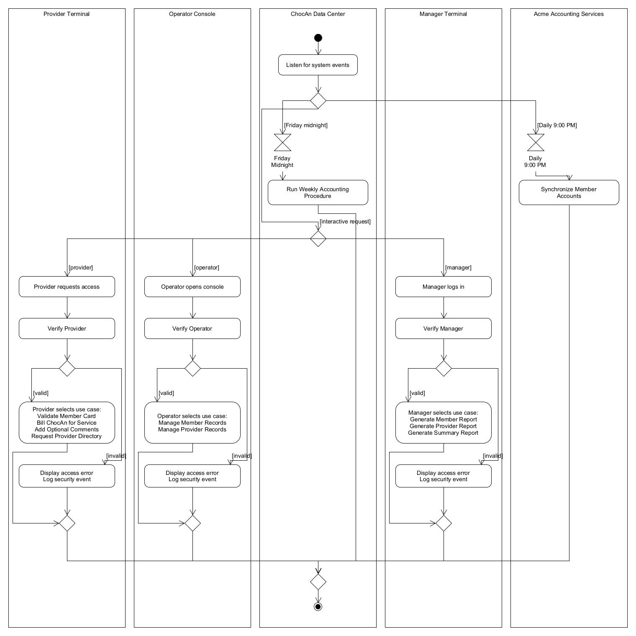

<diagram program="umletino" version="15.1"><zoom_level>10</zoom_level><element><id>UMLObject</id><coordinates><x>20</x><y>0</y><w>280</w><h>1480</h></coordinates><panel_attributes>Provider Terminal
valign=top
</panel_attributes><additional_attributes></additional_attributes></element><element><id>UMLObject</id><coordinates><x>320</x><y>0</y><w>280</w><h>1480</h></coordinates><panel_attributes>Operator Console
valign=top
</panel_attributes><additional_attributes></additional_attributes></element><element><id>UMLObject</id><coordinates><x>620</x><y>0</y><w>280</w><h>1480</h></coordinates><panel_attributes>ChocAn Data Center
valign=top
</panel_attributes><additional_attributes></additional_attributes></element><element><id>UMLObject</id><coordinates><x>920</x><y>0</y><w>280</w><h>1480</h></coordinates><panel_attributes>Manager Terminal
valign=top
</panel_attributes><additional_attributes></additional_attributes></element><element><id>UMLObject</id><coordinates><x>1220</x><y>0</y><w>280</w><h>1480</h></coordinates><panel_attributes>Acme Accounting Services
valign=top
</panel_attributes><additional_attributes></additional_attributes></element><element><id>UMLSpecialState</id><coordinates><x>750</x><y>60</y><w>20</w><h>20</h></coordinates><panel_attributes>type=initial</panel_attributes><additional_attributes></additional_attributes></element><element><id>UMLState</id><coordinates><x>665</x><y>110</y><w>190</w><h>50</h></coordinates><panel_attributes>Listen for system events</panel_attributes><additional_attributes></additional_attributes></element><element><id>UMLSpecialState</id><coordinates><x>740</x><y>200</y><w>40</w><h>40</h></coordinates><panel_attributes>type=decision</panel_attributes><additional_attributes></additional_attributes></element><element><id>Relation</id><coordinates><x>750</x><y>70</y><w>30</w><h>60</h></coordinates><panel_attributes>lt=-&gt;</panel_attributes><additional_attributes>10;10;10;40</additional_attributes></element><element><id>Relation</id><coordinates><x>750</x><y>150</y><w>30</w><h>70</h></coordinates><panel_attributes>lt=-&gt;</panel_attributes><additional_attributes>10;10;10;50</additional_attributes></element><element><id>UMLTimer</id><coordinates><x>635</x><y>300</y><w>80</w><h>90</h></coordinates><panel_attributes>Friday
Midnight
</panel_attributes><additional_attributes></additional_attributes></element><element><id>UMLState</id><coordinates><x>640</x><y>410</y><w>240</w><h>60</h></coordinates><panel_attributes>Run Weekly Accounting
Procedure
</panel_attributes><additional_attributes></additional_attributes></element><element><id>Relation</id><coordinates><x>665</x><y>210</y><w>130</w><h>110</h></coordinates><panel_attributes>lt=-&gt;
m2=[Friday midnight]
</panel_attributes><additional_attributes>75;10;10;10;10;90</additional_attributes></element><element><id>Relation</id><coordinates><x>665</x><y>380</y><w>20</w><h>40</h></coordinates><panel_attributes>lt=-&gt;</panel_attributes><additional_attributes>10;10;10;30</additional_attributes></element><element><id>UMLTimer</id><coordinates><x>1250</x><y>300</y><w>60</w><h>90</h></coordinates><panel_attributes>Daily
9:00 PM
</panel_attributes><additional_attributes></additional_attributes></element><element><id>UMLState</id><coordinates><x>1240</x><y>410</y><w>240</w><h>60</h></coordinates><panel_attributes>Synchronize Member
Accounts
</panel_attributes><additional_attributes></additional_attributes></element><element><id>Relation</id><coordinates><x>770</x><y>210</y><w>610</w><h>110</h></coordinates><panel_attributes>lt=-&gt;
m2=[Daily 9:00 PM]
</panel_attributes><additional_attributes>10;10;510;10;510;90</additional_attributes></element><element><id>Relation</id><coordinates><x>1270</x><y>380</y><w>100</w><h>40</h></coordinates><panel_attributes>lt=-&gt;</panel_attributes><additional_attributes>10;10;10;20;90;20;90;30</additional_attributes></element><element><id>UMLSpecialState</id><coordinates><x>740</x><y>530</y><w>40</w><h>40</h></coordinates><panel_attributes>type=decision</panel_attributes><additional_attributes></additional_attributes></element><element><id>Relation</id><coordinates><x>615</x><y>230</y><w>280</w><h>320</h></coordinates><panel_attributes>lt=-&gt;
m2=[interactive request]
</panel_attributes><additional_attributes>145;10;10;10;10;280;145;280;145;300</additional_attributes></element><element><id>UMLState</id><coordinates><x>45</x><y>640</y><w>230</w><h>50</h></coordinates><panel_attributes>Provider requests access</panel_attributes><additional_attributes></additional_attributes></element><element><id>UMLState</id><coordinates><x>45</x><y>740</y><w>230</w><h>50</h></coordinates><panel_attributes>Verify Provider</panel_attributes><additional_attributes></additional_attributes></element><element><id>UMLSpecialState</id><coordinates><x>140</x><y>840</y><w>40</w><h>40</h></coordinates><panel_attributes>type=decision</panel_attributes><additional_attributes></additional_attributes></element><element><id>UMLState</id><coordinates><x>45</x><y>940</y><w>230</w><h>100</h></coordinates><panel_attributes>Provider selects use case:
Validate Member Card
Bill ChocAn for Service
Add Optional Comments
Request Provider Directory

</panel_attributes><additional_attributes></additional_attributes></element><element><id>UMLState</id><coordinates><x>45</x><y>1090</y><w>230</w><h>55</h></coordinates><panel_attributes>Display access error
Log security event
</panel_attributes><additional_attributes></additional_attributes></element><element><id>Relation</id><coordinates><x>150</x><y>540</y><w>630</w><h>120</h></coordinates><panel_attributes>lt=-&gt;
m2=[provider]
</panel_attributes><additional_attributes>610;10;10;10;10;100</additional_attributes></element><element><id>Relation</id><coordinates><x>150</x><y>680</y><w>30</w><h>80</h></coordinates><panel_attributes>lt=-&gt;</panel_attributes><additional_attributes>10;10;10;60</additional_attributes></element><element><id>Relation</id><coordinates><x>150</x><y>780</y><w>30</w><h>80</h></coordinates><panel_attributes>lt=-&gt;</panel_attributes><additional_attributes>10;10;10;60</additional_attributes></element><element><id>Relation</id><coordinates><x>65</x><y>850</y><w>100</w><h>110</h></coordinates><panel_attributes>lt=-&gt;
m2=[valid]
</panel_attributes><additional_attributes>75;10;10;10;10;90</additional_attributes></element><element><id>Relation</id><coordinates><x>170</x><y>850</y><w>140</w><h>260</h></coordinates><panel_attributes>lt=-&gt;
m2=[invalid]
</panel_attributes><additional_attributes>10;10;120;10;120;230;80;230;80;240</additional_attributes></element><element><id>UMLState</id><coordinates><x>345</x><y>640</y><w>230</w><h>50</h></coordinates><panel_attributes>Operator opens console</panel_attributes><additional_attributes></additional_attributes></element><element><id>UMLState</id><coordinates><x>345</x><y>740</y><w>230</w><h>50</h></coordinates><panel_attributes>Verify Operator</panel_attributes><additional_attributes></additional_attributes></element><element><id>UMLSpecialState</id><coordinates><x>440</x><y>840</y><w>40</w><h>40</h></coordinates><panel_attributes>type=decision</panel_attributes><additional_attributes></additional_attributes></element><element><id>UMLState</id><coordinates><x>345</x><y>940</y><w>230</w><h>100</h></coordinates><panel_attributes>Operator selects use case:
Manage Member Records
Manage Provider Records

</panel_attributes><additional_attributes></additional_attributes></element><element><id>UMLState</id><coordinates><x>345</x><y>1090</y><w>230</w><h>55</h></coordinates><panel_attributes>Display access error
Log security event
</panel_attributes><additional_attributes></additional_attributes></element><element><id>Relation</id><coordinates><x>450</x><y>540</y><w>330</w><h>120</h></coordinates><panel_attributes>lt=-&gt;
m2=[operator]
</panel_attributes><additional_attributes>310;10;10;10;10;100</additional_attributes></element><element><id>Relation</id><coordinates><x>450</x><y>680</y><w>30</w><h>80</h></coordinates><panel_attributes>lt=-&gt;</panel_attributes><additional_attributes>10;10;10;60</additional_attributes></element><element><id>Relation</id><coordinates><x>450</x><y>780</y><w>30</w><h>80</h></coordinates><panel_attributes>lt=-&gt;</panel_attributes><additional_attributes>10;10;10;60</additional_attributes></element><element><id>Relation</id><coordinates><x>365</x><y>850</y><w>100</w><h>110</h></coordinates><panel_attributes>lt=-&gt;
m2=[valid]
</panel_attributes><additional_attributes>75;10;10;10;10;90</additional_attributes></element><element><id>Relation</id><coordinates><x>470</x><y>850</y><w>140</w><h>260</h></coordinates><panel_attributes>lt=-&gt;
m2=[invalid]
</panel_attributes><additional_attributes>10;10;120;10;120;230;80;230;80;240</additional_attributes></element><element><id>UMLState</id><coordinates><x>945</x><y>640</y><w>230</w><h>50</h></coordinates><panel_attributes>Manager logs in</panel_attributes><additional_attributes></additional_attributes></element><element><id>UMLState</id><coordinates><x>945</x><y>740</y><w>230</w><h>50</h></coordinates><panel_attributes>Verify Manager</panel_attributes><additional_attributes></additional_attributes></element><element><id>UMLSpecialState</id><coordinates><x>1040</x><y>840</y><w>40</w><h>40</h></coordinates><panel_attributes>type=decision</panel_attributes><additional_attributes></additional_attributes></element><element><id>UMLState</id><coordinates><x>945</x><y>940</y><w>230</w><h>100</h></coordinates><panel_attributes>Manager selects use case:
Generate Member Report
Generate Provider Report
Generate Summary Report

</panel_attributes><additional_attributes></additional_attributes></element><element><id>UMLState</id><coordinates><x>945</x><y>1090</y><w>230</w><h>55</h></coordinates><panel_attributes>Display access error
Log security event
</panel_attributes><additional_attributes></additional_attributes></element><element><id>Relation</id><coordinates><x>750</x><y>540</y><w>390</w><h>120</h></coordinates><panel_attributes>lt=-&gt;
m2=[manager]
</panel_attributes><additional_attributes>10;10;310;10;310;100</additional_attributes></element><element><id>Relation</id><coordinates><x>1050</x><y>680</y><w>30</w><h>80</h></coordinates><panel_attributes>lt=-&gt;</panel_attributes><additional_attributes>10;10;10;60</additional_attributes></element><element><id>Relation</id><coordinates><x>1050</x><y>780</y><w>30</w><h>80</h></coordinates><panel_attributes>lt=-&gt;</panel_attributes><additional_attributes>10;10;10;60</additional_attributes></element><element><id>Relation</id><coordinates><x>965</x><y>850</y><w>100</w><h>110</h></coordinates><panel_attributes>lt=-&gt;
m2=[valid]
</panel_attributes><additional_attributes>75;10;10;10;10;90</additional_attributes></element><element><id>Relation</id><coordinates><x>1070</x><y>850</y><w>140</w><h>260</h></coordinates><panel_attributes>lt=-&gt;
m2=[invalid]
</panel_attributes><additional_attributes>10;10;120;10;120;230;80;230;80;240</additional_attributes></element><element><id>UMLSpecialState</id><coordinates><x>140</x><y>1210</y><w>40</w><h>40</h></coordinates><panel_attributes>type=decision</panel_attributes><additional_attributes></additional_attributes></element><element><id>Relation</id><coordinates><x>20</x><y>1030</y><w>160</w><h>220</h></coordinates><panel_attributes>lt=-&gt;</panel_attributes><additional_attributes>140;10;140;30;10;30;10;200;120;200</additional_attributes></element><element><id>Relation</id><coordinates><x>150</x><y>1135</y><w>30</w><h>100</h></coordinates><panel_attributes>lt=-&gt;</panel_attributes><additional_attributes>10;10;10;75</additional_attributes></element><element><id>UMLSpecialState</id><coordinates><x>440</x><y>1210</y><w>40</w><h>40</h></coordinates><panel_attributes>type=decision</panel_attributes><additional_attributes></additional_attributes></element><element><id>Relation</id><coordinates><x>320</x><y>1030</y><w>160</w><h>220</h></coordinates><panel_attributes>lt=-&gt;</panel_attributes><additional_attributes>140;10;140;30;10;30;10;200;120;200</additional_attributes></element><element><id>Relation</id><coordinates><x>450</x><y>1135</y><w>30</w><h>100</h></coordinates><panel_attributes>lt=-&gt;</panel_attributes><additional_attributes>10;10;10;75</additional_attributes></element><element><id>UMLSpecialState</id><coordinates><x>1040</x><y>1210</y><w>40</w><h>40</h></coordinates><panel_attributes>type=decision</panel_attributes><additional_attributes></additional_attributes></element><element><id>Relation</id><coordinates><x>920</x><y>1030</y><w>160</w><h>220</h></coordinates><panel_attributes>lt=-&gt;</panel_attributes><additional_attributes>140;10;140;30;10;30;10;200;120;200</additional_attributes></element><element><id>Relation</id><coordinates><x>1050</x><y>1135</y><w>30</w><h>100</h></coordinates><panel_attributes>lt=-&gt;</panel_attributes><additional_attributes>10;10;10;75</additional_attributes></element><element><id>UMLSpecialState</id><coordinates><x>740</x><y>1350</y><w>40</w><h>40</h></coordinates><panel_attributes>type=decision</panel_attributes><additional_attributes></additional_attributes></element><element><id>UMLSpecialState</id><coordinates><x>750</x><y>1420</y><w>20</w><h>20</h></coordinates><panel_attributes>type=final</panel_attributes><additional_attributes></additional_attributes></element><element><id>Relation</id><coordinates><x>150</x><y>1240</y><w>620</w><h>120</h></coordinates><panel_attributes>lt=-&gt;</panel_attributes><additional_attributes>10;10;10;80;610;80;610;110</additional_attributes></element><element><id>Relation</id><coordinates><x>450</x><y>1240</y><w>320</w><h>120</h></coordinates><panel_attributes>lt=-&gt;</panel_attributes><additional_attributes>10;10;10;80;310;80;310;110</additional_attributes></element><element><id>Relation</id><coordinates><x>750</x><y>1240</y><w>320</w><h>120</h></coordinates><panel_attributes>lt=-&gt;</panel_attributes><additional_attributes>310;10;310;80;10;80;10;110</additional_attributes></element><element><id>Relation</id><coordinates><x>750</x><y>460</y><w>110</w><h>900</h></coordinates><panel_attributes>lt=-&gt;</panel_attributes><additional_attributes>10;10;10;30;100;30;100;860;10;860;10;890</additional_attributes></element><element><id>Relation</id><coordinates><x>750</x><y>460</y><w>620</w><h>900</h></coordinates><panel_attributes>lt=-&gt;</panel_attributes><additional_attributes>610;10;610;860;10;860;10;890</additional_attributes></element><element><id>Relation</id><coordinates><x>750</x><y>1380</y><w>30</w><h>60</h></coordinates><panel_attributes>lt=-&gt;</panel_attributes><additional_attributes>10;10;10;40</additional_attributes></element></diagram>

3.2 Authentication Activity Diagrams (Agile Update Use Cases)

A. Use Case: Verify Provider
- Entry: Initial solid black circle (Entry Node).
- Action: Provider inputs 9-digit Provider ID at ProviderTerminal.
- Action: Terminal queries Data Center database via ProviderControl.
- Decision Diamond: [Is 9-digit Provider ID valid?]
  - Branch [Yes]: Action Display "Provider Authenticated" Unlock main billing menu Route to merge node.
  - Branch [No]: Action Display "Invalid Provider ID" Deny access Route to merge node.
- Merge Node: Merge diamond unites both branches.
- Exit: Single final exit node (Bullseye Circle).
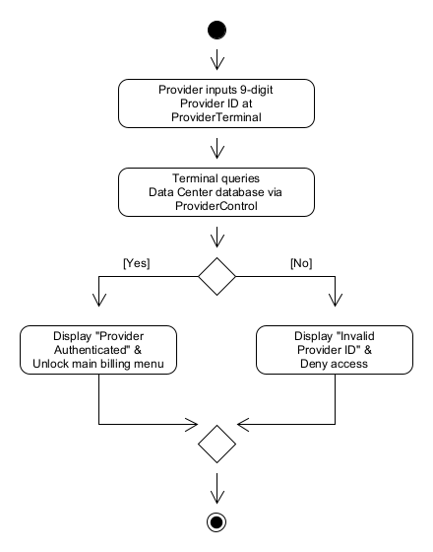

B. Use Case: Verify Operator
- Entry: Initial solid black circle (Entry Node).
- Action: Operator enters administrative credentials at OperatorConsole.
- Action: System checks credentials via RecordsControl.
- Decision Diamond: [Are credentials valid?]
  - Branch [Yes]: Action Display "Operator Logged In" Unlock member/provider maintenance dashboard Route to merge node.
  - Branch [No]: Action Display "Access Denied" Log security attempt Route to merge node.
- Merge Node: Merge diamond unites both branches.
- Exit: Single final exit node (Bullseye Circle).
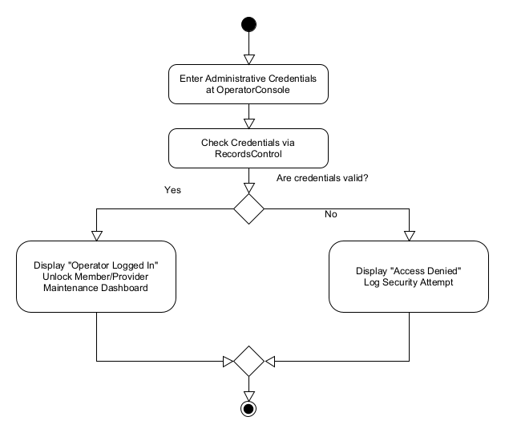

C. Use Case: Verify Manager
- Entry: Initial solid black circle (Entry Node).
- Action: Manager inputs Manager ID at ManagerTerminal.
- Action: System queries database via RecordsControl.
- Decision Diamond: [Is Manager ID authorized?]
  - Branch [Yes]: Action Display "Manager Authorized" Unlock on-demand report menu Route to merge node.
  - Branch [No]: Action Display "Authentication Failed" Route to merge node.
- Merge Node: Merge diamond unites both branches.
- Exit: Single final exit node (Bullseye Circle).
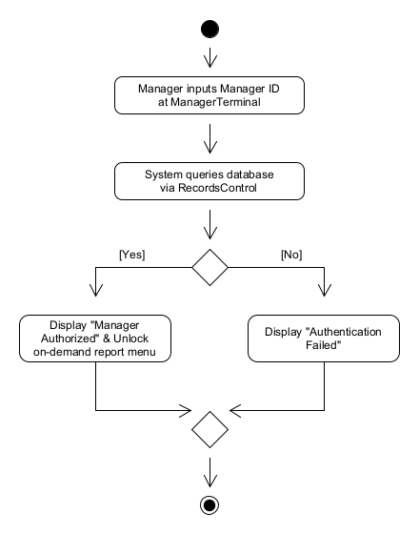

3.3 Provider Workflow Activity Diagrams

A. Use Case: Validate Member Card
- Entry: Initial solid black circle (Entry Node).
- Action: Provider slides card through terminal card reader (or enters 9-digit member number).
- Action: Terminal submits number to Data Center computer.
- Action: System queries active membership database.
- Decision Diamond: [What is account status?]
  - Branch [Active / Valid]: Action Terminal displays "Validated" Provide service, then route to the final exit.
  - Branch [Suspended]: Action Terminal displays "Account is Suspended" Return to member-number entry.
  - Branch [Invalid / Not Found]: Action Terminal displays "Number is Invalid" Return to member-number entry.
- Flow: The valid branch provides service and reaches the final exit; suspended and invalid branches return to member-number entry.
- Exit: Single final exit node (Bullseye Circle).
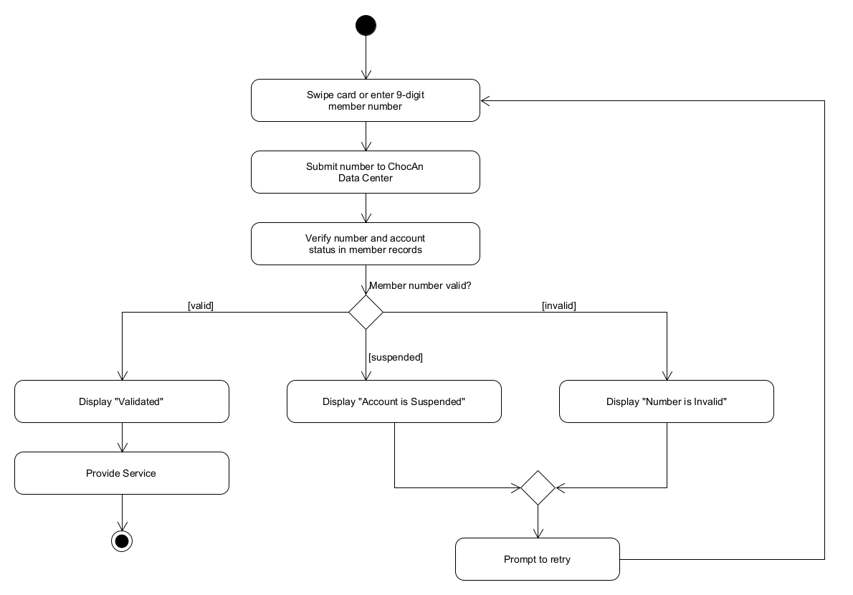

B. Use Case: Bill ChocAn for Service
(Rubric Compliance: Must explicitly contain the member verification step!)
- Entry: Initial solid black circle (Entry Node).
- Action: Provider initiates billing workflow.
- Call Action: Invoke activity Validate Member Card.
- Decision Diamond: [Was member Validated?]
  - Branch [No]: Action Display abort notice Route directly to final merge node.
  - Branch [Yes]: Continue billing workflow
- Action: Provider keys in date of service (MM-DD-YYYY).
- Decision Diamond: [Valid date format and not future?]
  - Branch [No]: Action Display "Invalid Date" Loop back to date entry.
  - Branch [Yes]: Continue workflow
- Action: Provider enters 6-digit service code.
- Decision Diamond: [Code exists in directory?]
  - Branch [No]: Action Display error message Loop back to code entry.
  - Branch [Yes]: Continue workflow
- Action: System retrieves and displays service name (up to 20 chars).
- Decision Diamond: [Provider confirms displayed service matches treatment?]
  - Branch [No]: Action Cancel code Loop back to code entry.
  - Branch [Yes]: Continue workflow
- Decision Diamond: [Provider opts to add comments?]
  - Branch [Yes]: Call Action Invoke Add Optional Comments Route to record creation.
  - Branch [No]: Bypass comments Route to record creation.
- Action: System writes service record to disk file.
- Action: System looks up standard fee and displays on terminal screen.
- Action: Provider copies details to paper verification form.
- Merge Node: Unite aborted path and completed path.
- Exit: Single final exit node (Bullseye Circle).
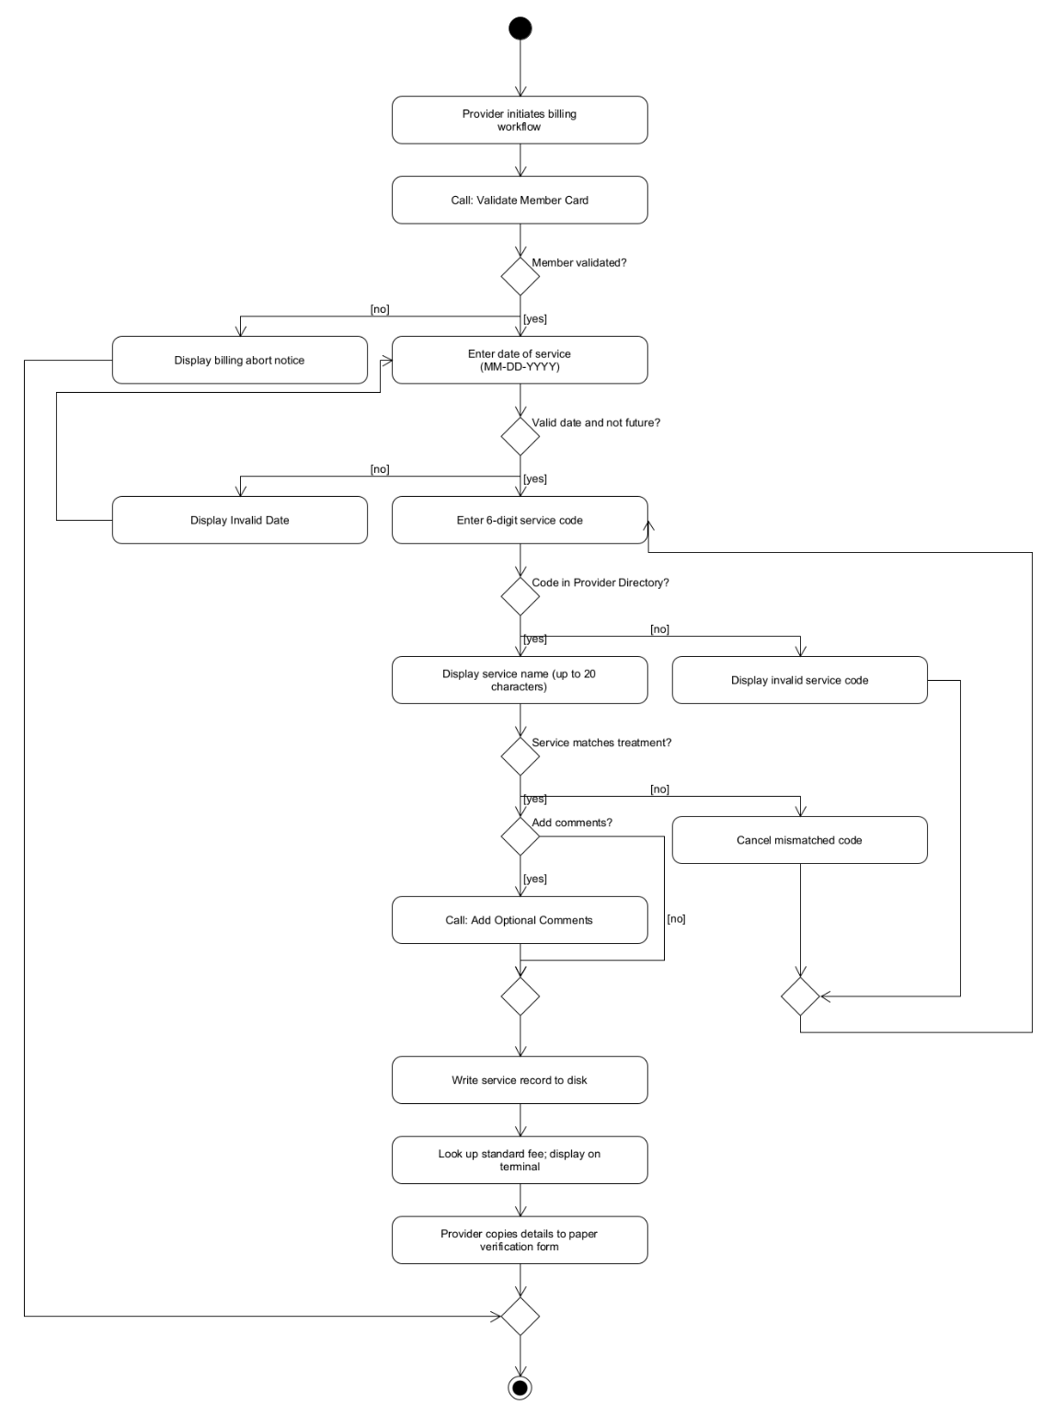

C. Use Case: Add Optional Comments
- Entry: Initial solid black circle (Entry Node).
- Action: Display prompt asking provider for comments.
- Decision Diamond: [Does provider enter text or press skip?]
  - Branch [Skip]: Action Set comment field to null/empty Route to merge node.
  - Branch [Enter Text]: Action Provider inputs notes
- Decision Diamond: [Length <= 100 characters?]
  - Branch [No]: Action Display alert "Max 100 characters" Loop back to text input.
  - Branch [Yes]: Action Attach comment string to active transaction buffer Route to merge node.
- Merge Node: Merge both branches.
- Action: Return control to calling billing procedure.
- Exit: Single final exit node (Bullseye Circle).
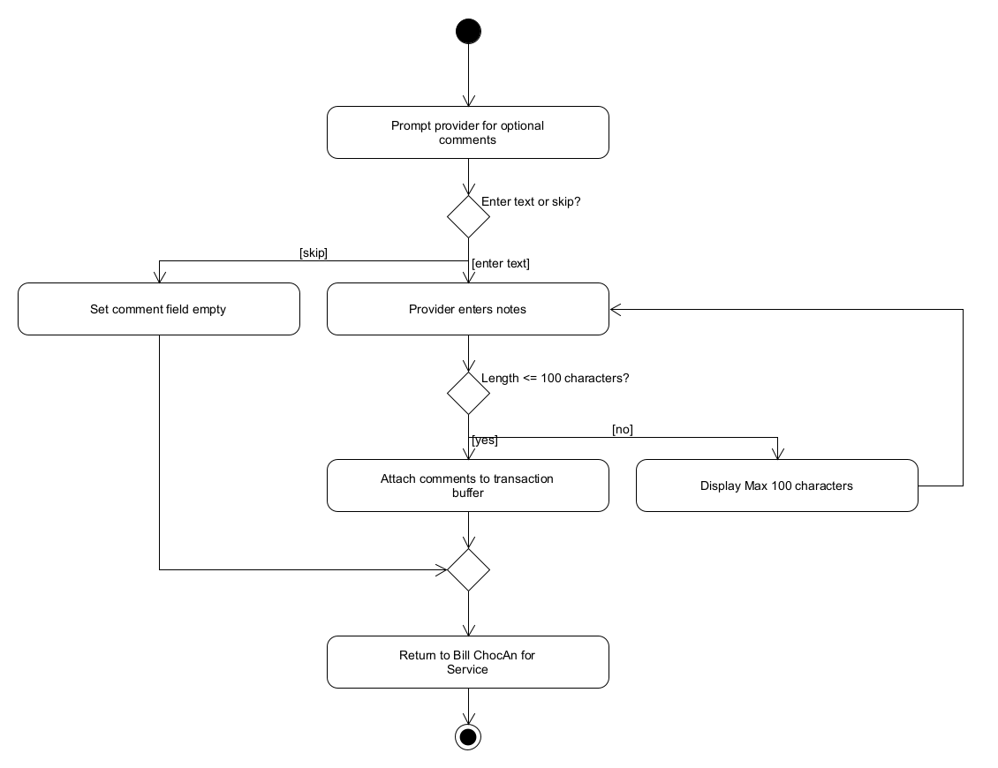

D. Use Case: Request Provider Directory
- Entry: Initial solid black circle (Entry Node).
- Action: Provider selects "Request Provider Directory" on terminal.
- Action: Terminal transmits request with provider ID to Data Center.
- Action: System queries database for all active services.
- Action: System sorts records alphabetically by service name.
- Action: System formats each record with name, 6-digit code, and fee.
- Action: System writes Provider_Directory.txt to disk.
- Action: Terminal displays confirmation message "Provider Directory generated successfully".
- Exit: Single final exit node (Bullseye Circle).
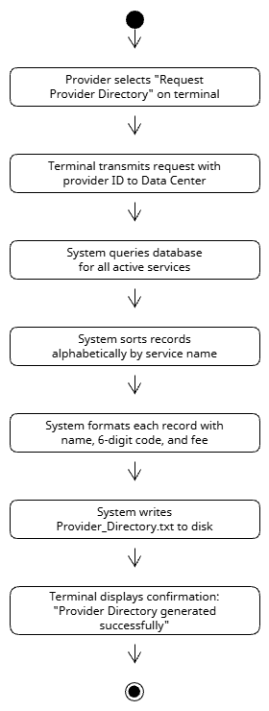

3.4 Operator & Acme Workflow Activity Diagrams

A. Use Case: Manage Member Records
- Entry: Initial solid black circle (Entry Node).
- Action: Operator accesses Member Maintenance menu.
- Decision Diamond: [Select Action: Add, Update, or Delete?]
  - Branch [Add]:
    - Action Input member name, address, city, state, ZIP.
    - Action System generates unique 9-digit member number.
    - Action Set status to Active and save to database Route to merge.
  - Branch [Update]:
    - Action Input 9-digit member number.
    - Decision Diamond: [Member ID found?]
      - [No]: Display error message Route to merge.
      - [Yes]: Display current info Edit demographic fields Save updates Route to merge.
  - Branch [Delete]:
    - Action Input 9-digit member number.
    - Decision Diamond: [Member ID found?]
      - [No]: Display error message Route to merge.
      - [Yes]: Prompt confirmation Confirm Remove profile Route to merge.
- Merge Node: Merge all sub-paths into a single flow.
- Action: Display operational confirmation message.
- Exit: Single final exit node (Bullseye Circle).
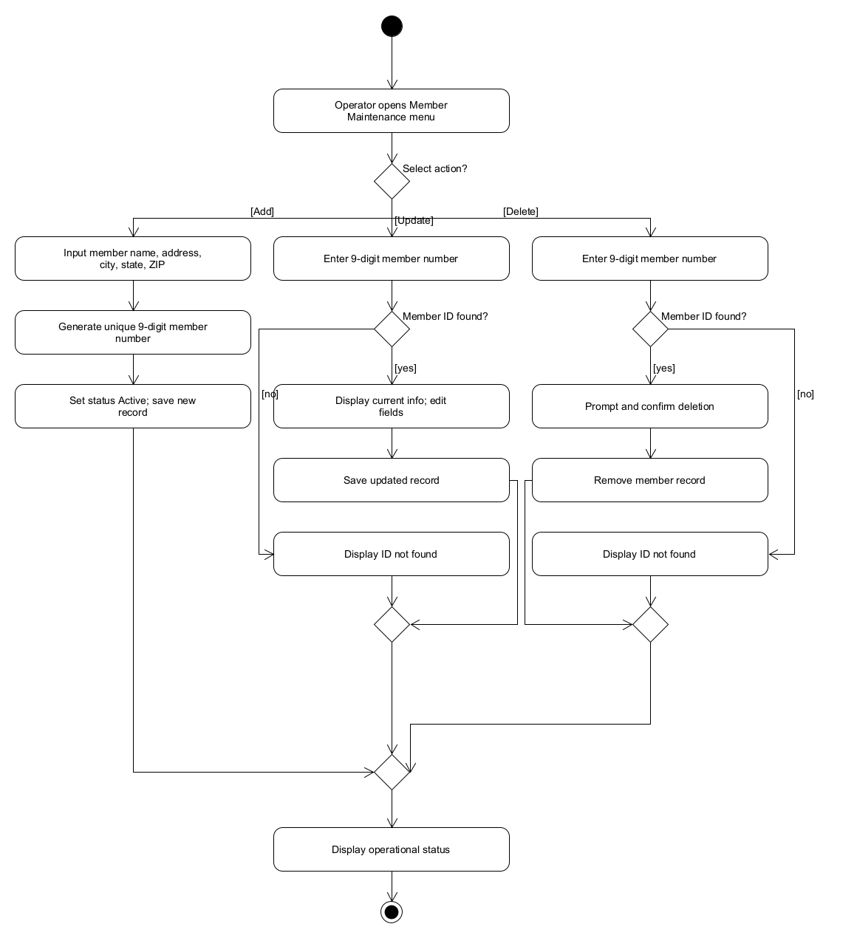

B. Use Case: Manage Provider Records
- Entry: Initial solid black circle (Entry Node).
- Action: Operator accesses Provider Maintenance menu.
- Decision Diamond: [Select Action: Add, Update, or Delete?]
  - Branch [Add]:
    - Action Input provider name, address, city, state, ZIP.
    - Action System generates unique 9-digit provider number.
    - Action Save new provider record to database Route to merge.
  - Branch [Update]:
    - Action Input 9-digit provider number.
    - Decision Diamond: [Provider ID found?]
      - [No]: Display error message Route to merge.
      - [Yes]: Edit contact fields Save changes Route to merge.
  - Branch [Delete]:
    - Action Input 9-digit provider number.
    - Decision Diamond: [Provider ID found?]
      - [No]: Display error message Route to merge.
      - [Yes]: Confirm deletion Remove provider record Route to merge.
- Merge Node: Merge all sub-paths.
- Action: Display status confirmation message.
- Exit: Single final exit node (Bullseye Circle).
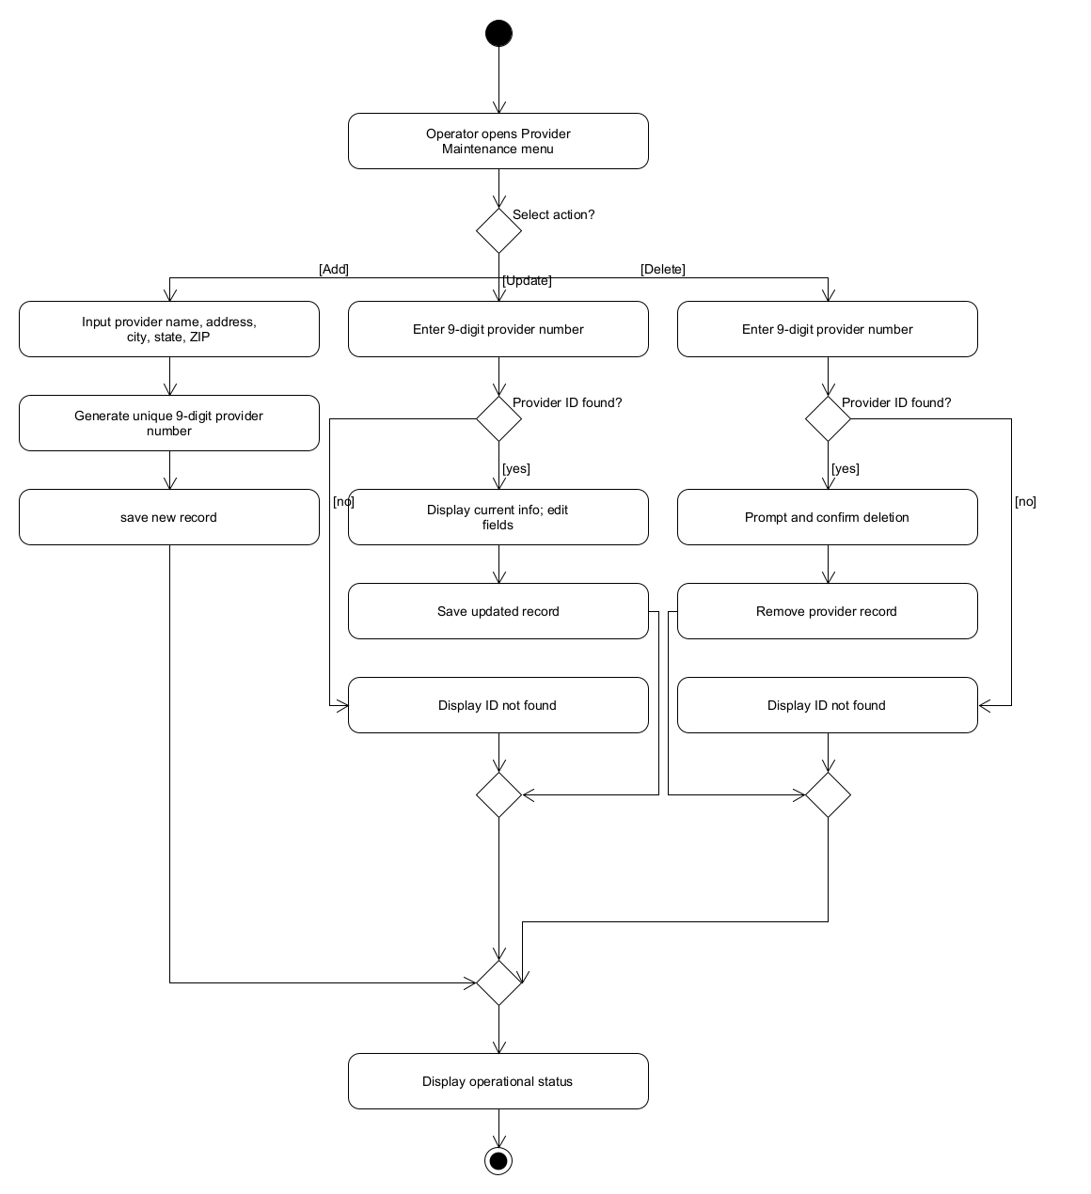

C. Use Case: Synchronize Member Accounts
- Entry: Timer hits 9:00 PM Initial solid black circle (Entry Node).
- Action: Acme Accounting Services establishes secure link to ChocAn Data Center.
- Action: Acme transmits nightly update file containing member numbers and Active/Suspended statuses.
- Action: ChocAn software reads member-status record.
- Decision Diamond: [Status supplied by Acme?]
  - Branch [Active]: Action Update member status to Active Route to merge.
  - Branch [Suspended]: Action Update member status to Suspended Route to merge.
- Merge Node: Join account status update paths.
- Action: Commit updated membership records to disk storage.
- Action: Transmit handshake acknowledgment to Acme and terminate connection.
- Exit: Single final exit node (Bullseye Circle).
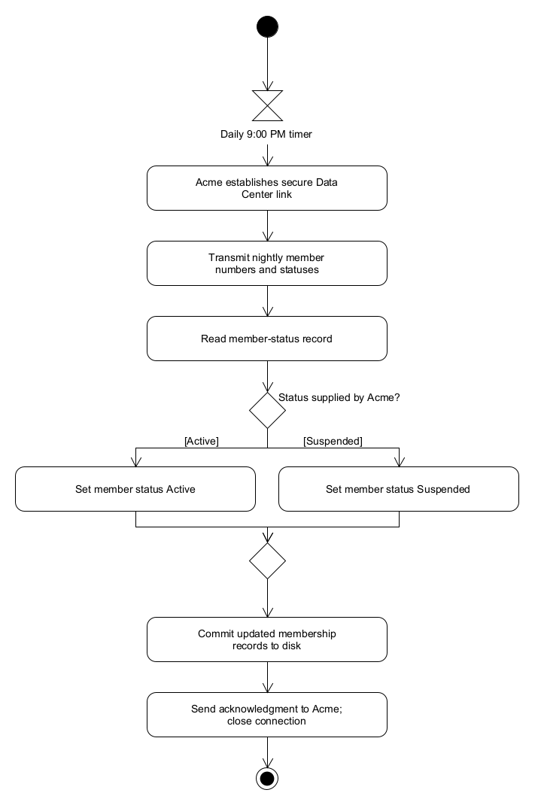

3.5 Batch Accounting & Reporting Activity Diagrams

A. Use Case: Run Weekly Accounting Procedure
- Entry: Timer hits Friday midnight (12:00 AM) Initial solid black circle (Entry Node).
- Action: Open and read the week's file of recorded consultations.
- Decision Diamond: [Were any services logged during the week?]
  - Branch [No]: Action Generate empty zero-activity summary and EFT files Route to merge.
  - Branch [Yes]:
    - Call Action Invoke Generate Member Report (for each member who consulted a provider during that week).
    - Call Action Invoke Generate Provider Report (for each billed provider).
    - Call Action Invoke Generate Summary Report (for Accounts Payable).
    - Call Action Invoke Generate EFT Data (for bank disbursements).
    - Route to merge.
- Merge Node: Join zero-activity and standard reporting flows.
- Action: Log batch completion and close current billing period.
- Exit: Single final exit node (Bullseye Circle).
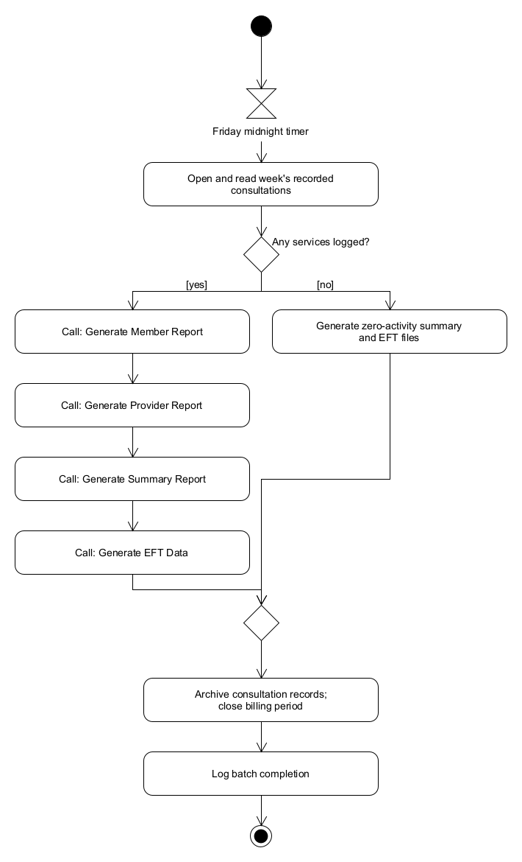

B. Use Case: Generate Member Report
- Entry: Initial solid black circle (Entry Node). (Triggered by Friday batch routine OR on-demand by Manager).
- Action: Identify target member.
- Action: Retrieve member demographic data (name, 9-digit ID, address, city, state, ZIP).
- Action: Query consultation records for target member for the week and sort chronologically by date.
- Decision Diamond: [Any consultations recorded?]
  - Branch [Yes]: Action Format dates, provider names, and service names for each consultation Route to merge.
  - Branch [No]: Action Format report noting zero consultations on record Route to merge.
- Merge Node: Join formatting branches.
- Action: Write compiled report to disk file named <MemberName>_<MM-DD-YYYY>.txt.
- Action: Return control to calling process.
- Exit: Single final exit node (Bullseye Circle).
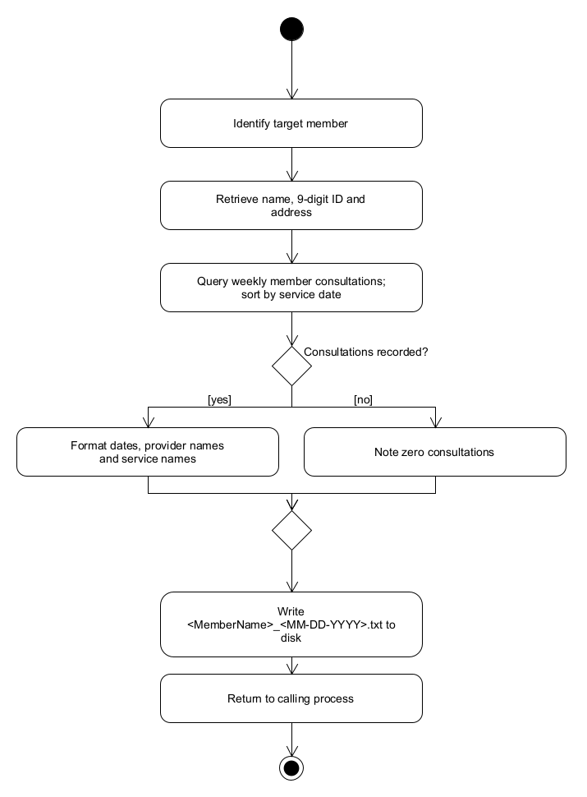

C. Use Case: Generate Provider Report
- Entry: Initial solid black circle (Entry Node). (Triggered by Friday batch routine OR on-demand by Manager).
- Action: Identify target provider.
- Action: Retrieve provider profile info (name, 9-digit ID, address, city, state, ZIP).
- Action: Query all consultations billed by provider for the week, ordered chronologically by computer receipt timestamp.
- Action: Compile transaction lines (service date, receipt timestamp, member name, member number, service code, fee).
- Action: Compute total consultations (up to 3 digits) and total fee payable (up to $99,999.99).
- Action: Write compiled report to disk file named <ProviderName>_<MM-DD-YYYY>.txt.
- Action: Return control to calling process.
- Exit: Single final exit node (Bullseye Circle).
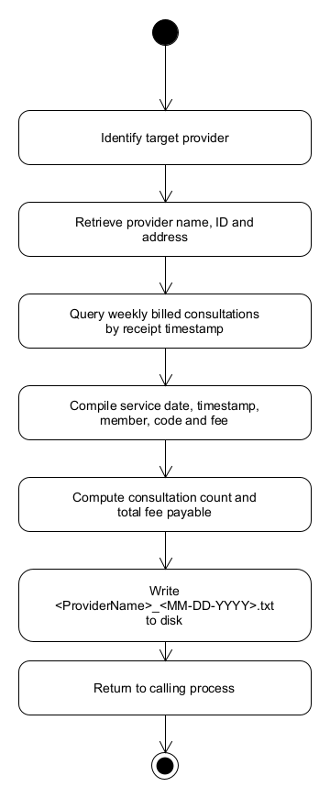

D. Use Case: Generate Summary Report
- Entry: Initial solid black circle (Entry Node). (Triggered by Friday batch routine OR on-demand by Manager).
- Action: Query all active billing transactions recorded across all providers for the week.
- Action: Itemize each provider to be paid, their consultation count, and individual fee total.
- Action: Calculate grand network metrics (total providers, total consultations, overall fee total).
- Action: Write compiled data to disk file named Summary_Report_<MM-DD-YYYY>.txt.
- Action: Return control to calling process.
- Exit: Single final exit node (Bullseye Circle).
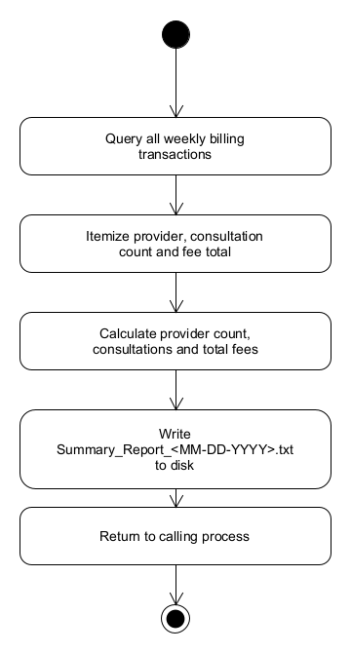

E. Use Case: Generate EFT Data
- Entry: Initial solid black circle (Entry Node). (Triggered by Friday batch routine).
- Action: Read weekly calculated provider fee totals.
- Decision Diamond: [Any providers owed balance > $0.00?]
  - Branch [Yes]: Action Format EFT records (provider name, 9-digit number, transfer amount) Route to merge.
  - Branch [No]: Action Format empty EFT file with zero-transfer header Route to merge.
- Merge Node: Join branches.
- Action: Write electronic funds transfer file to disk named EFT_Data_<MM-DD-YYYY>.txt.
- Action: Return control to batch accounting routine.
- Exit: Single final exit node (Bullseye Circle).

