I. Software Implementation and Demonstration
The selected Attention U-Net–EfficientNetB0 pipeline was implemented in a browser-based Gradio application named Skin Review. The interface provided image upload, preview, analysis and clear controls. The upload panel specified de-identified dermoscopic images in JPG or PNG format, with a maximum file size of 20 MB. The main review outcome was presented first, followed by expandable sections containing technical outputs, processing images, follow-up information, report preparation and melanoma education.
In the demonstrated analysis of ISIC_0000013.jpg, the classifier produced a melanoma model score of 0.3846, exceeding the saved decision cutoff of 0.3088. The application therefore displayed “Review this spot with a clinician”, together with an explanation that the research model had flagged the image and that this output did not establish a melanoma diagnosis (Fig. 13(a)). The technical panel retained the model class, numerical score, decision cutoff and inference configuration. It identified the score as an uncalibrated model output rather than an individual probability of cancer (Appendix A, Fig. A3). The displayed configuration used four-flip averaging for segmentation, a segmentation cutoff of 0.5000 and single-pass classification.
The processing view displayed the original image, predicted lesion mask, mask overlay, padded lesion region of interest (ROI) and ROI-based Grad-CAM visualisation, with a short description accompanying each stage (Fig. 13(b)). This connected the final output to the intermediate images available for inspection. The mask and overlay showed the estimated lesion extent, while the Grad-CAM panel displayed regions associated with the predicted class in the classifier’s ROI branch. The interface explicitly distinguished this activation map from a cancer map or proof of a correct prediction. It also explained that Dice and IoU could not be calculated for a new upload without a reference mask.
Supporting sections explained flagged and unflagged outputs and provided follow-up information, melanoma education and external support resources. The report-preparation form included optional fields for a case reference, lesion location, when the spot was first noticed, and relevant changes or questions. The demonstrated workflow displayed report-creation and PDF-download controls, with instructions for the user to share the report through their usual healthcare channel. Additional interface views are included in Appendix A.
The demonstration documents an integrated software workflow linking image submission, model inference, visual explanation and report preparation. Presenting a concise review message before the technical details implemented the intended layered interface. The screenshots establish the presence and displayed behaviour of these functions; user comprehension, usability and complete application response time were not measured in this demonstration.

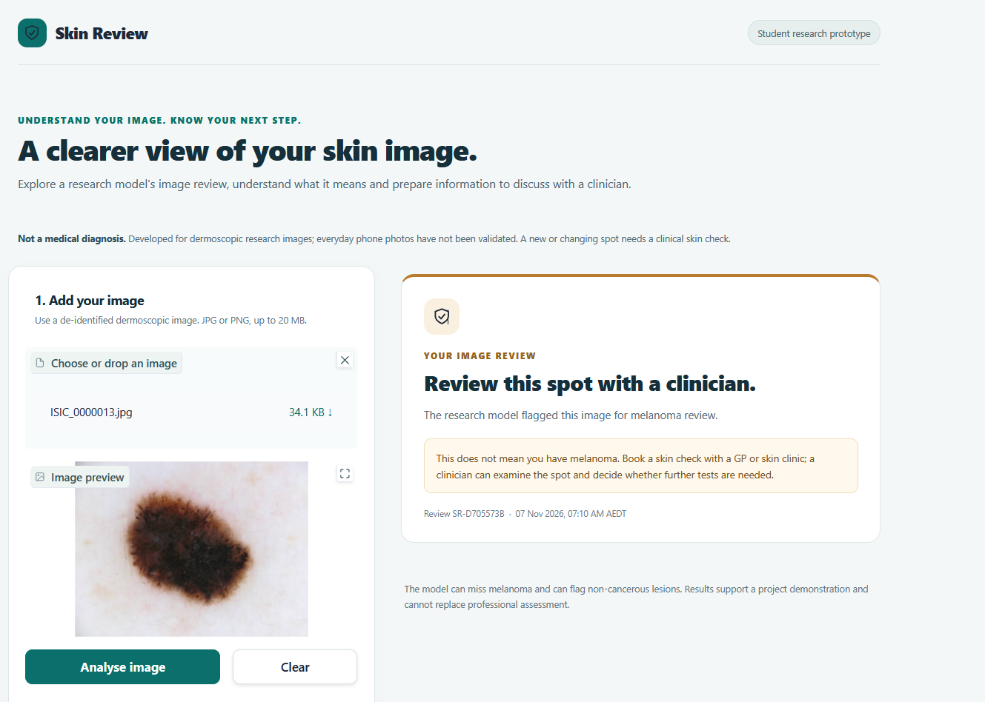
Fig. 13(a). Skin Review result screen for ISIC_0000013.jpg. The application displays a clinician-review recommendation after the melanoma model score exceeds the saved decision cutoff.
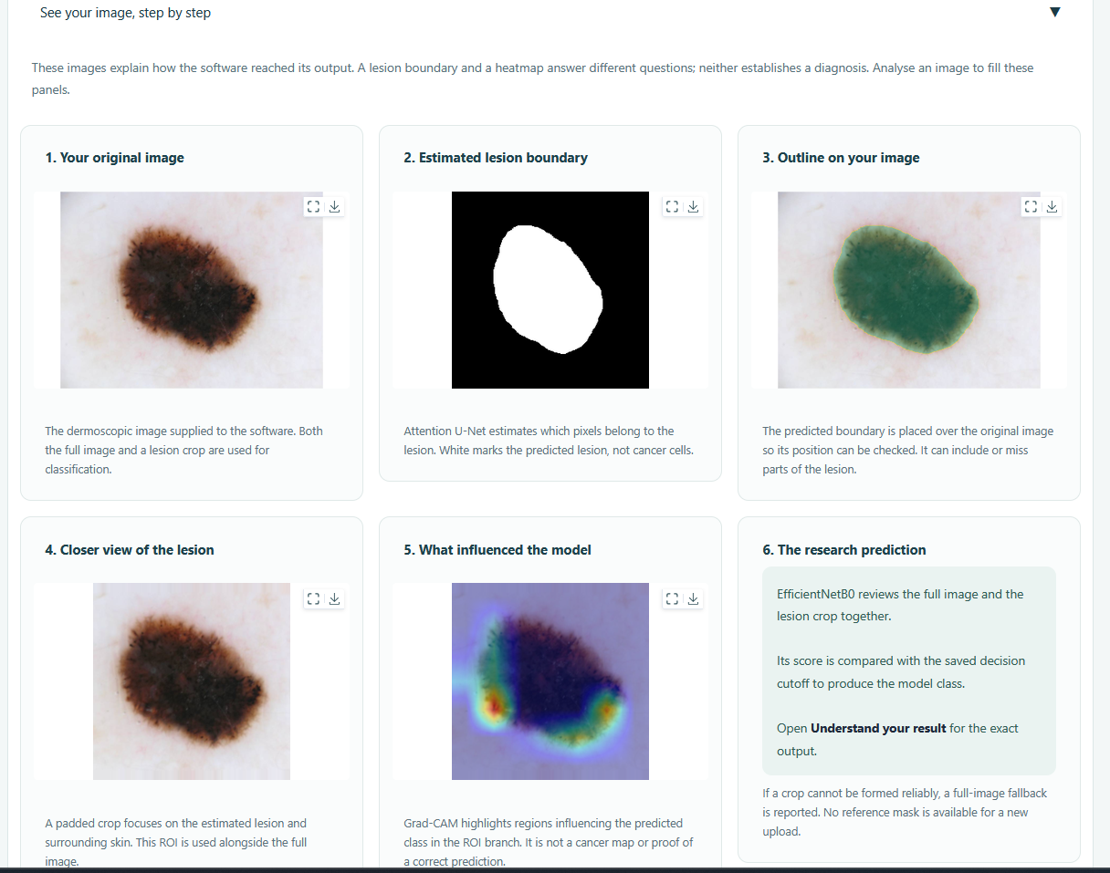
Fig. 13(b). Processing view for the same image, displaying the original image, predicted lesion mask, overlay, padded lesion ROI and ROI-based Grad-CAM visualisation, with descriptions of their roles.

Appendix A — Additional Software Interface Views
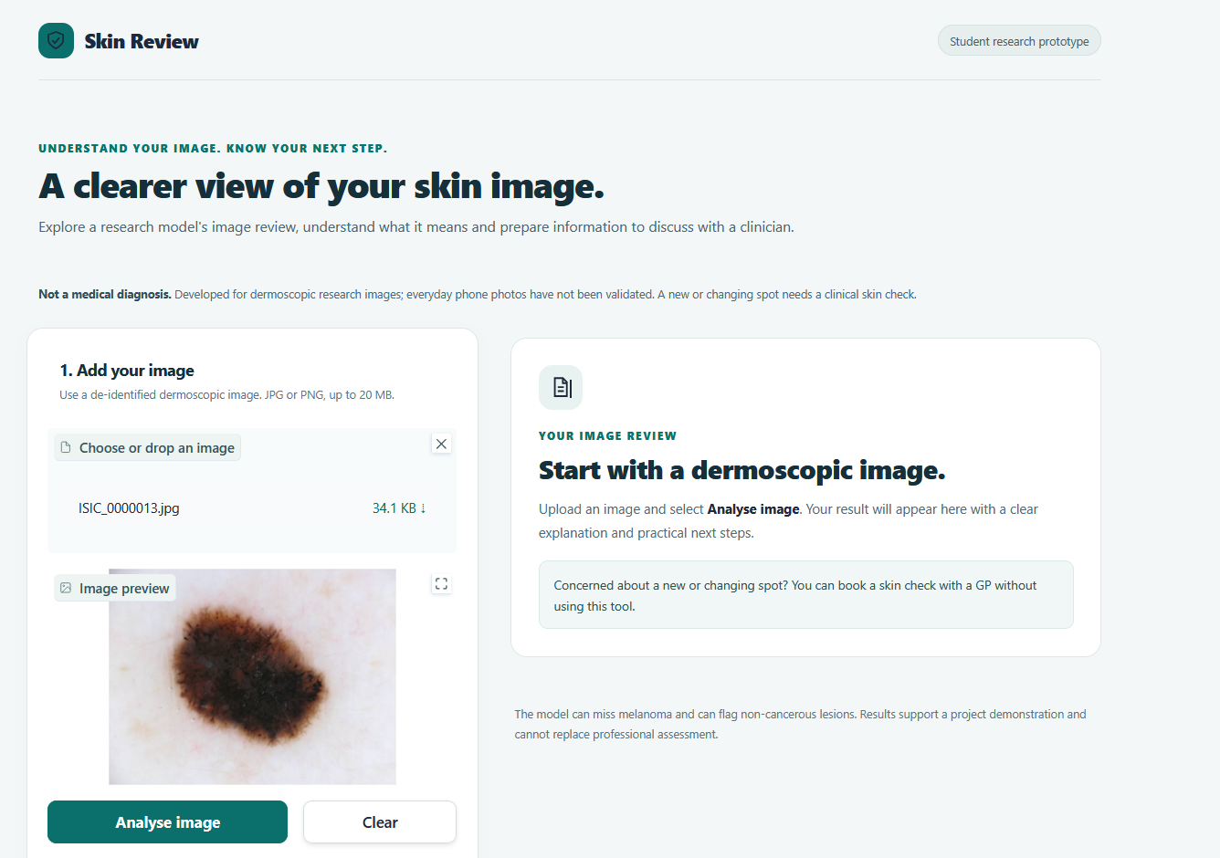
Fig. A1. Image submission interface showing the upload control, dermoscopic image preview and analysis controls before a result is displayed.
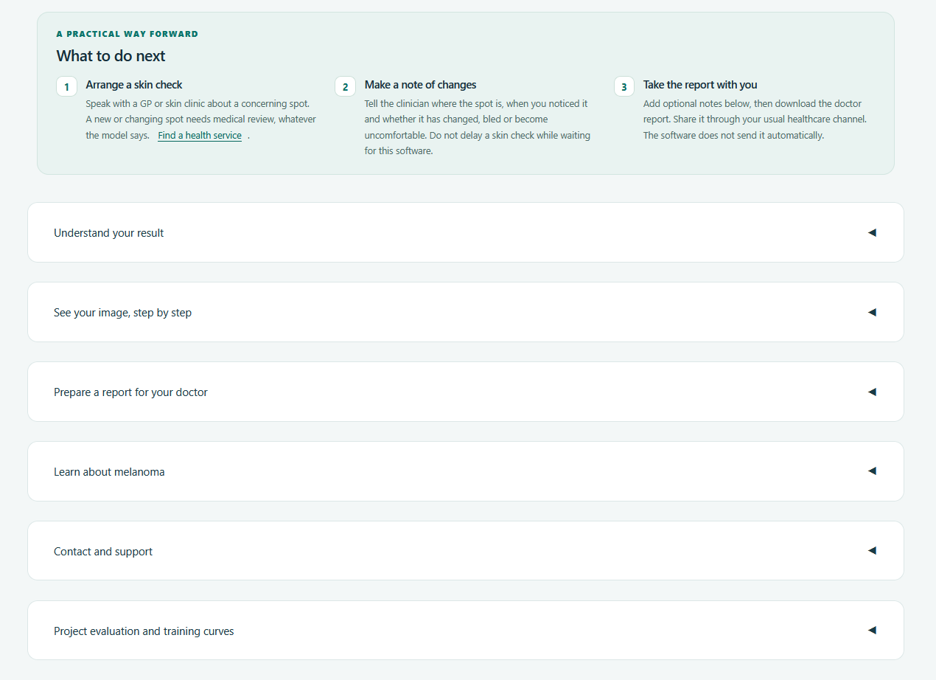
Fig. A2. Follow-up information and expandable sections providing access to result interpretation, processing images, report preparation and supporting information.

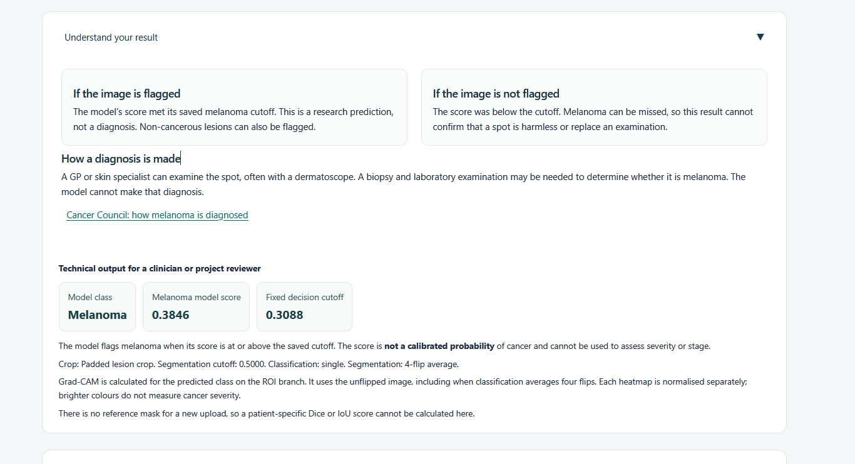
Fig. A3. Result interpretation panel showing explanations of flagged and unflagged outputs, the model score of 0.3846, the decision cutoff of 0.3088 and technical interpretation notes.
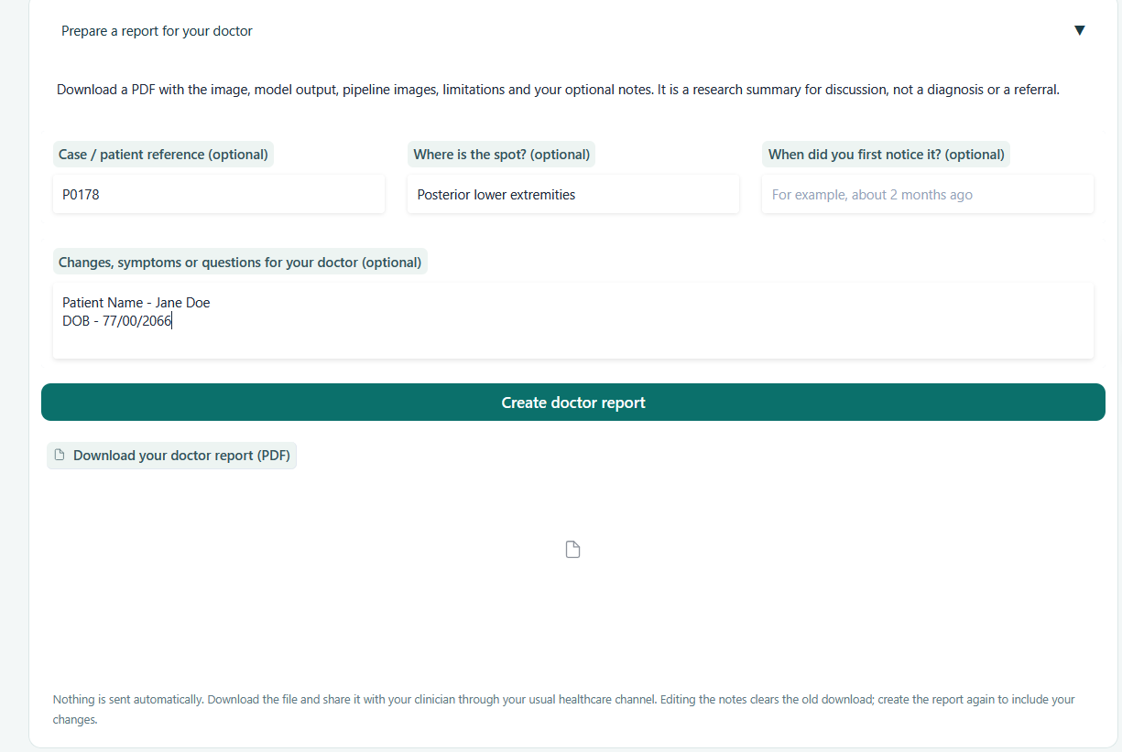
Fig. A4. Report-preparation interface containing optional case details and illustrative notes, together with report-creation and PDF-download controls. The entered details are demonstration entries.

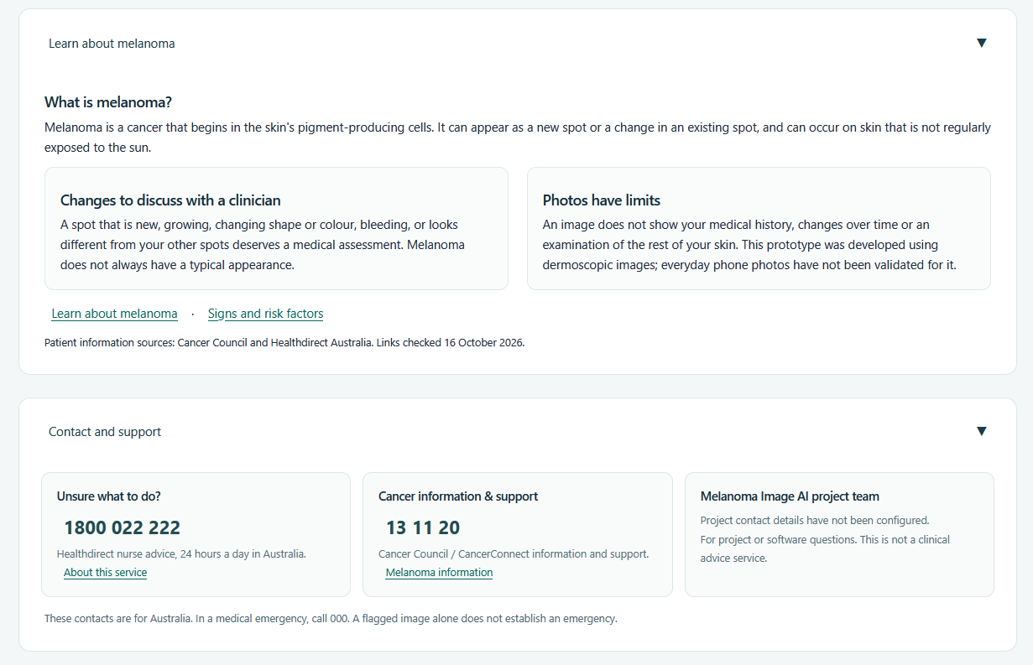
Fig. A5. Educational and support panels displaying melanoma information, external resources and support contacts. The project-team contact details had not been configured in this version.

