Group 27: Huanran Li, Tinghe Zhang, Ruolei Zeng

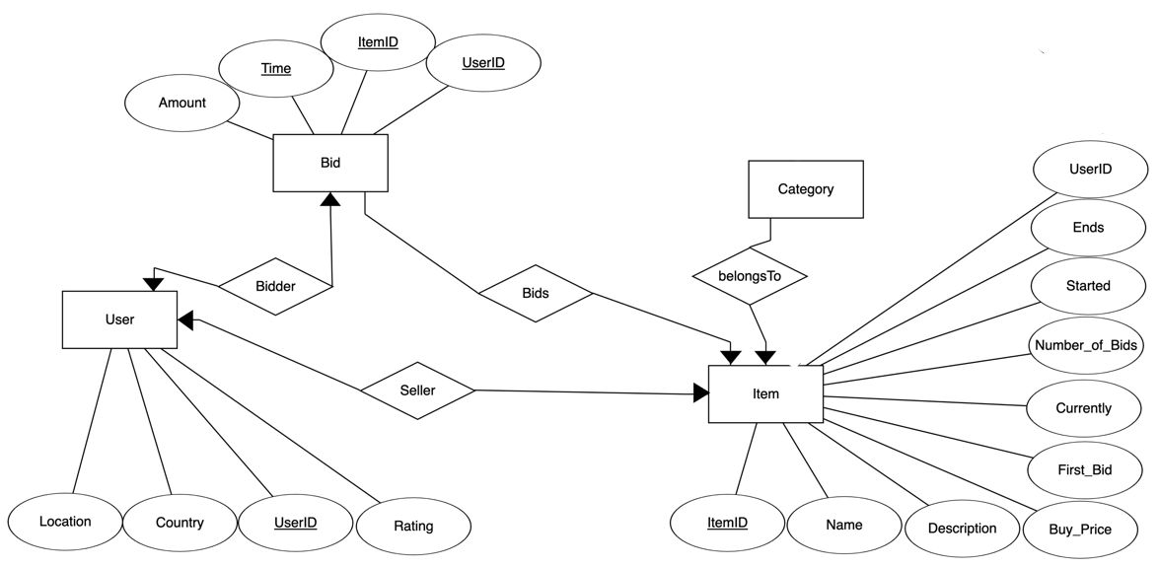

* Table 1:

Bids(UserID, ItemID, Amount, Time)

**Primary Key:** UserID, ItemID, Time

**Foreign Key:** UserID, ItemID

* Table 2:

Users(Location, Country, UserID, Rating)

**Primary Key:** UserID

**Foreign Key:** None

* Table 3:

Items(UserID, ItemID, Name, Description, Buy_Price, First_Bid, Currently, Number_of_Bids, Started, Ends)

**Primary Key:** Item ID

**Foreign Key:** UserID

* Table 4:

Categories(ItemID, Category)

**Primary Key:** Item ID

**Foreign Key:** Item ID