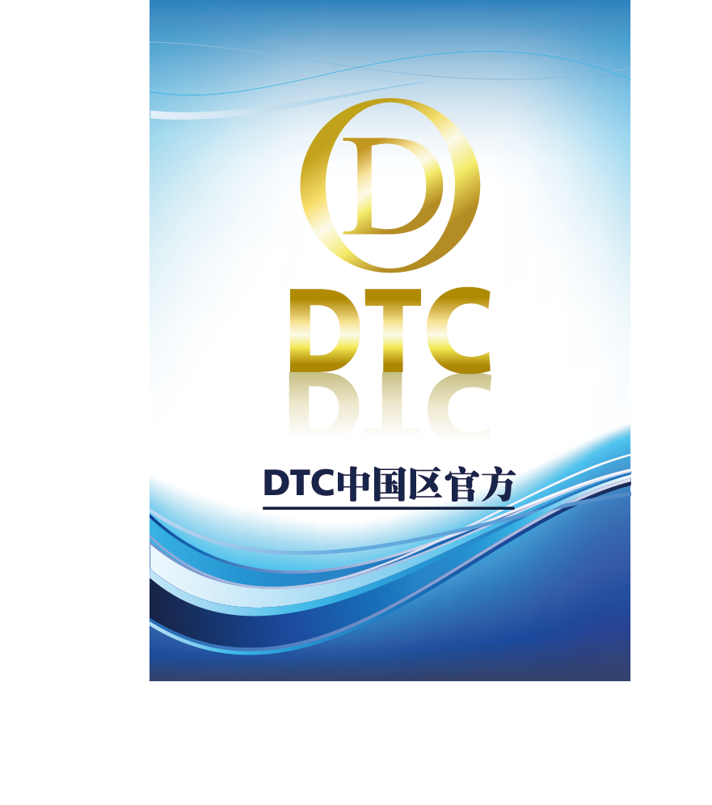

ABSTRACT

Data chain is a block-chain technology integrated application platform, with tree-like layered, three-dimensional multi-chain architecture, while adding regional chain technology 2.0 as the core of the intelligent contract platform, distributed application of the underlying protocol and other innovative technologies .DTC will focus on the data storage, analysis and decision-making of various industries, while working with other application chain to achieve DTC transactions in various types of data and circulation in the future to become the industry data applications .

With the second-generation block-chain technology, such as Ripple, Ethereum and so on, the two-generation technology pushed the block chain to the regional chain 1.0, Application development stage. So that more and more regional chain applications began to flow in the city, resulting in rapid growth in the regional chain of data. DTC can link an application through the side chain, and provide a number of data analysis, the data classification. DTC can handle multiple applications in parallel because of its side chain functions or through intelligent contractual means. The unique non-modifyable records of the block chain can show all the data trajectories of the enterprise application during operation, greatly improving the product's advantages in traceability.
DTC's goal is not only in the application of data processing for the regional chain, in our development strategy, DTC will become the regional chain of circulation media, that is, the regional chain "bit currency." To this end, DTC R & D and community hope that with the like-minded friends together for the development of DTC continue to forge ahead.

Catalog
Chapter One Blockchain Development 1
Chapter two DTC 2
2.1 Design Background 2
2.2 DTC Technology 4
2.1.1 Merge Mining 4
2.1.2 Token Model 5
2.1.3 Sidechain 5

Chapter three application 6
3.1 Data Interaction 6
3.2 Social Governance 6
3.3 Decision-tree Application 6
Chapter FIVE cONCLUSION 8

Chapter One Blockchain Development
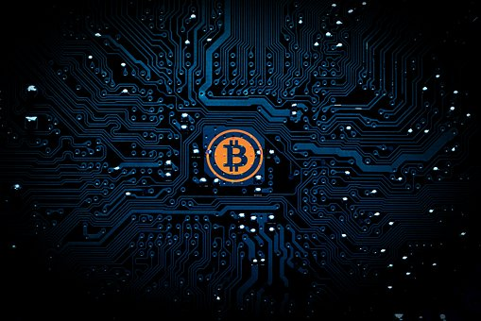

The concept of the block chain inherited the bitcoin, which is what we often say in the regional chain technology 1.0. The concept of Bitcoin was originally proposed by Nakamoto in 2009, according to the idea of the open source of the open source software, Bitcoin is a P2P form of digital currency and its core ideas - point to point transmission. It means that Bitcoin is a decentralized payment system, with the main characteristics.
Bitcoin is the difference between the majority of the currency, the currency does not rely on specific currency institutions issued, it is based on specific algorithms, through a large number of calculations, the total number is very limited, with a strong scarcity. Bit currency economy uses the distributed database of many nodes in the entire P2P network to confirm and record all the transaction behavior, and use the cryptographic design to ensure the security of all aspects of currency circulation. P2P's de-centricity and the algorithm itself can ensure that the currency can not be manipulated by a large number of manufacturing bits. A cryptographic-based design allows a bitcoin to be transferred or paid only by the real owner. This also ensures that the ownership of money and the anonymity of circulation transactions.
And now because of the community and technology to promote, we ushered in the regional chain technology 2.0. One of the representatives is the ether square. Ethernet Square is a chain in the chain to achieve intelligent contract, open source of the underlying system, the ether from the birth of the week to 2017 May, just three and a half years, the world has more than 200 application of the application of the tower. Ethernet is not only a platform, it is a programming language, so that developers can build and publish the next generation of distributed applications. The etherbox can be used to program, publish, and so on, such as voting, domain names, intellectual property, and traditional industries such as agricultural records.

Chapter Two DTC

2.1 Design Background

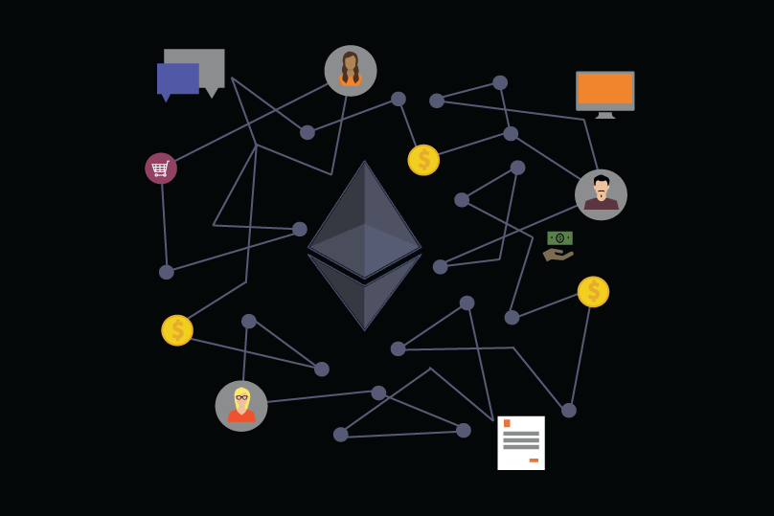

The Ethereum is created by the creation of digital assets, but its Turing complete virtual machine system also provides more imagination, bringing people from the field of digital assets to many other areas. The concept of block chain fire up the reason, but also because we put the bottom of the digital assets of the chain of technology and digital assets itself peeling off, began to discuss the application of the upper layer began to fire up. We know that the block chain is just a bottom of the operating system, a chain of value transmission. On this basis, we can build countless business applications we want, everything and "buy" or "sell" the relationship between the application, can be built in such a block chain, the ether square is actually such a system. It extends the bit-chain concept of Bitcoin: verifies, stores, and replicates transaction data on multiple computers worldwide. The Ethereum goes further on this concept, making it possible to run code on multiple computers around the world. The tomb of the ether is called ether (Ether), or ETH. Similar to BTC, this encrypted currency can be used to trade with other encrypted currencies or other currencies.
In short, Ethereum is an innovation that applies some of the techniques and concepts in Bitcoels to computing. Bitcoin is considered a system that maintains a shared book that safely records all bit currency bills. The Etherhouse uses a number of mechanisms similar to Bitcoels (such as block-chain technology and P2P networks) to maintain a shared computing platform that can be flexible and secure to run any program that users want (and, of course, similar bits Currency block chain program). Block chain technology is considered to be the most disruptive technological innovation since the invention of the Internet. It relies on cryptography and Hash function, game theory and so on. It can not build trust on the Internet without any third party. Intervention can make the participants reach a consensus, at a very low cost to solve the trust and value of the reliable delivery problems. Since the bitcoin, many block chain projects have sprung up, many of which have groundbreaking innovations, or innovation at the bottom of the agreement, or innovation at the application level. These blocks are available from the industry Experimental significance.
DTC is in this context, as before the Internet applications, when the application has sprung up, we believe that the final core is still the data acquisition and understanding. Only to win the data in order to obtain to the user, in order to achieve the value of the application. The DTC is such a vision, is willing to become a regional chain in the application of data flow, in this wave of technology to win their own place.

2.2 DTC Technology

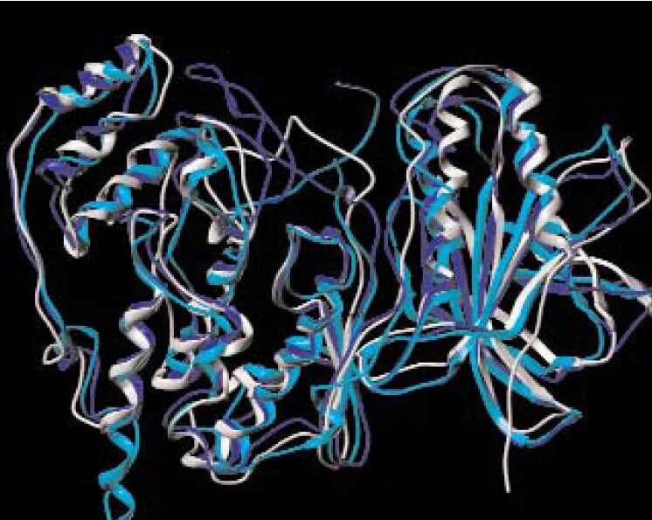

Merge Mining
We have been very clear mining is the beginning of the CPU mining, excessive GPU mining, and ultimately evolved to the current era of ASIC mining. The evolution of mining is the evolution of hardware, but also the evolution of software, especially the hardware and software docking protocol improvement process. The DTC decides to use the POW + POS hybrid consensus mechanism, both of which have equal weights, and the POW and POS blocks in the block chain are designed to be 1: 1. Before the existence of the POW consensus because the proportion of design is too large, resulting in the late mining area of the POS block no one to dig. The DTC team felt that POS + POW should coexist and increase the ecological stability of the DTC mine. The difficulty of these two mechanisms will be constrained to each other, and with the same type of continuous block increases, the difficulty will be an additional increase. This hybrid approach does not weaken the security of any single consensus mechanism. The security of the block chain fully combines the advantages of POW and POS, and the attack on the block chain will become more complicated. On the one hand, due to the existence of POW, Who also need a large number of coins to achieve double payment attack. POW costly, energy consumption, but the system is relatively strong, POS is not a waste of energy, but its safety performance has not yet been recognized, and fairness there are some controversy.

Token Model

An asset issuing entity sends a transaction in the Bitcoin network with a "asset founding" metadata that actually amounts to creating a token that is used to represent an asset. The ownership of these tokens on the bit network, without the need for asset issuer authorization, you can freely flow of transactions. In fact, a token is an asset of the digital, bearer bonds, but this bond is embedded in the assets of the unit coin in the block chain network. In the tokens model, there are two main types, UTXO model and Account model (account model), bit currency and derived block chain system are using UTXO model. But now only the contract is also more and more used in tokens. Intuitive, Account model is more in line with people's daily habits, in most cases, people only care about how much income, how much expenditure, the balance of how much, regardless of the specific consumption of which income. After a comprehensive consideration, DTC uses UTXO mode, you can in a fixed account has been stored DTC token.

Sidechain

The side chain is a special block chain. It uses a technique called "SPV wedge" to achieve asset transfer with other block chains, which allows users to use the existing assets to use the new encrypted money system. People do not have to worry about Bitcoin difficult to adopt innovation and adapt to new needs, as long as the creation of a side chain, and then docked to the bitcoin block chain can be inherited and reuse Bitcoin strong block chain, but also to avoid the new Currency liquidity shortages and market volatility and other issues. And because the side chain is an independent, isolated system, serious problems in the side chain only affect the side chain itself, which greatly reduces the risk and cost of innovation. The flexibility of the side chain is also reflected in the fact that all the block chain parameters can be customized, such as block spacing, block rewards, transaction fees, etc., advanced users can also modify the consensus algorithm. But the most important thing is the business logic, the side chain can be easily developed with your business-related transaction type or smart contract. This is different from the inventor blockstreams of the side chains, the side chains of the blockstreams are just a different currency system, and it is not easy to develop new deals and smart contracts.

Chapter three Application

2.1 Data Interaction
DTC can be used for enterprise data decision-making, for the global small and medium enterprises to provide data sorting, analysis and decision-making. DTC can link an application through the side chain, and provide a number of data analysis, the data classification. In the process of data analysis, through the depth of data mining analysis, you can form a user portrait, will bring a threat to personal privacy. In the circulation, due to the involvement of multi-party, making the data transfer control is poor, the risk of data leakage is intensifying.
The "Action Plan for the Promotion of Big Data Development" issued by the State Council in 2015 clearly pointed out that it was necessary to guide the cultivation of large data exchange market and encourage the market participants in all aspects of the industrial chain to carry out data exchange and transactions and promote the flow of data resources. The regional chain technology in the development of data has a strong advantage, through the regional chain data positioning can determine the data ownership issues, and because of the development and application of encryption technology to ensure that the flow of data to find the two sides of the mutual privacy.

2.2 Social Governance

In the area chain, everyone can see the smart contract, because the code and status of these smart contracts are in the block chain (assuming the block chain is the main chain and open). From a user perspective, a smart contract is usually considered an automatic guarantee account, for example, when a particular condition is met, the program releases and transfers funds. In short, a smart contract is similar to a web server, but unlike a web server, a smart contract does not depend on a particular hardware device. In fact, the code for the smart contract is executed by all the mining equipment. It is precisely because of this feature that is sufficiently transparent, regional chain applications can be used for scenarios such as securities registration and clearing, banking and other high creditworthiness.

2.3 Decision-tree Application

DTC based on the stored enterprise data, through the side-chain multi-level algorithm processing, can form a decision-making decision-making tree decision-making tree. On the basis of the decision tree, it can be developed with enterprise-centric enterprise applications, that is, relying on the main chain of DTC, through the side chain based on the enterprise scene as the core of the application, these applications can be through the main chain of information Interaction, so as to obtain the relevant algorithm of the main chain, from top to bottom, forming a strong expansion of the "neural network system."

Chapter FIVE CONCLUSION
Data chain is a block-chain technology integrated application platform, with tree-like layered, three-dimensional multi-chain architecture, while adding regional chain technology 2.0 as the core of the intelligent contract platform, distributed application of the underlying protocol and other innovative technologies The DTC's goal is not only in the application of data processing for the regional chain, in our development strategy, DTC will become the regional chain of circulation media, that is, the regional chain "bit currency." To this end, DTC R & D and community hope that with the like-minded friends together for the development of DTC continue to forge ahead.

