PENETRATION TESTING REPORT
FOOTPRINTING & NETWORK SCANNING PHASES
W2-PM-FINAL | CYBERSECURITY | NETWORKWALKS

Pentester Name  (Cybersecurity Professional) | Onesime Keya Kabiala
Program/Batch | B084-Networkwalks
Date | 12 November 2026
Modules completed | W2-PM1 (Multiple Kali Tools)  W2-PM5 (Zenmap Scanning)
Client/Target | 1. Networkwalks (secured written permission already)  2. My own local LAN Network
Permission secured from client? | Yes
Phases covered | Phase 1: Reconnaissance & Footprinting  Phase 2: Scanning & Network Discovery  Phase 3-5: In Progress

1. Liability Disclaimer
These activities were performed exclusively on systems I own or for which I have obtained explicit written authorization. This material is strictly for educational and research purposes. The instructor, authors, and Networkwalks assume no responsibility for any misuse of this knowledge. It is your sole responsibility to comply with the law. Unauthorized access is a criminal offense in most jurisdictions, even without resulting damage.

2. Introduction
This report details my Week 2 internship tasks at Networkwalks, focusing on two main phases: footprinting the networkwalks.com domain using Kali Linux (Module W2-PM1), and scanning my local network with Zenmap (Module W2-PM5). Together, these exercises demonstrate the transition from passive information gathering to active network mapping. Every step includes the exact command, observed results, screenshots, and an analysis of the findings from a security perspective.

3. Tools Used

Tool | Purpose
Kali Linux & Windows | Operating systems used for the practical exercises
WHOIS | Retrieve domain registration data (owner, dates, name servers)
WhatWeb | Identify web technologies (server, CMS, plugins)
nslookup | Resolve the target domain name to its IP address
curl -I | Inspect HTTP response headers
wafw00f | Detect the presence of a Web Application Firewall
dnsrecon | Enumerate DNS records (NS, MX, TXT, SRV, etc.)
Zenmap (Nmap GUI) | Scan the local network to discover live hosts and MAC addresses
Windows CMD | Identify local IP and MAC address

4. Activities Performed

4.1 Footprinting & Reconnaissance

I used six Kali Linux tools to gather intelligence on networkwalks.com. First, WHOIS provided public domain registration details and name servers. Next, WhatWeb revealed the site uses WordPress 7.1.4 and WP Download Manager 3.3.76.
I used nslookup to resolve the domain to IP 192.232.216.135. Then, curl -I helped inspect HTTP headers, exposing the WordPress REST API endpoint (/wp-json/). Wafw00f detected a Web Application Firewall (ModSecurity by SpiderLabs). Finally, dnsrecon enumerated DNS records, yielding valuable data on mail servers and SPF/TXT records.

4.2 Network Scanning with Zenmap
For the second part, I scanned my local network using Zenmap. After finding my local IP and subnet via Windows ipconfig, I ran a Ping Scan in Zenmap.
The scan in my practical experience identified three active hosts (e.g., 192.168.56.100, 192.168.56.3, etc.) along with their MAC addresses. I then used Zenmap's Topology feature to generate and export a visual network map in PDF format, fulfilling the practical's requirements.

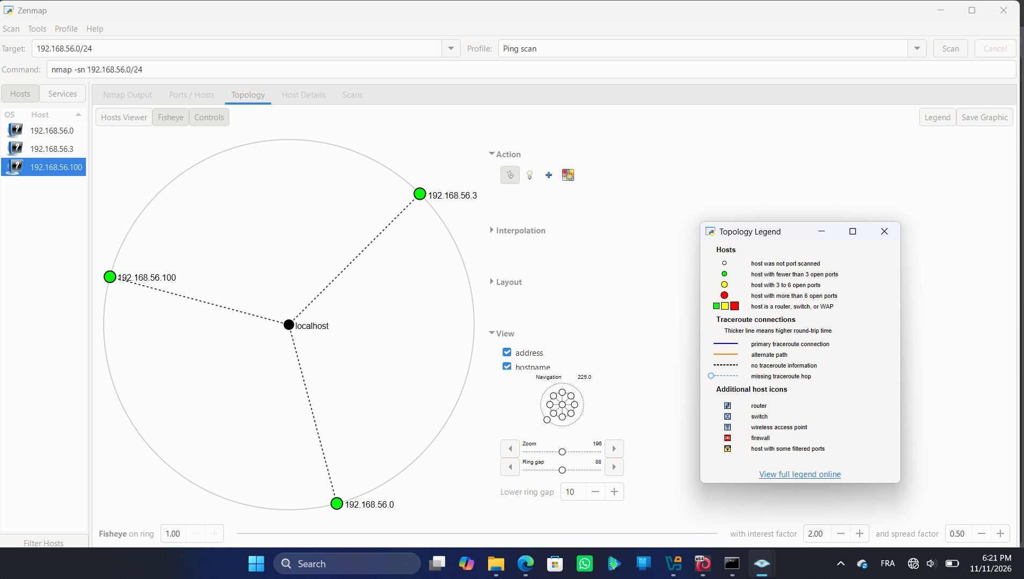

5. Risk Analysis / Impact
# | Risk / Finding | Evidence / Observation | Potential Impact | Risk Level
1 | Exposed web tech | WhatWeb found WordPress and plugins | Attackers can identify specific software versions to target | ● Medium
2 | Server IP exposed | nslookup resolved the domain IP | Reveals the network location of the web service | ● Low
3 | HTTP info exposed | Curl revealed response headers and /wp-json/ | Aids in further technology fingerprinting | ● Low
4 | WAF identified | Wafw00f detected ModSecurity | Reveals the security architecture in place | ● Low
5 | DNS info exposed | DNSRecon found various DNS and mail records | Helps attackers map the broader infrastructure | ● Medium
6 | Live hosts visible | Zenmap found three active local devices | Unauthorized devices could be lurking on the network | ● Medium

Risk level key: ● Critical ● Medium ● Low
Note: These are observational findings, not confirmed vulnerabilities. No exploitation was performed. Technical details alone do not imply a system is vulnerable without further authorized testing.

6. Recommendations

- Minimize public tech exposure: Regularly audit what software and version info is visible publicly.
- Update software: Keep CMS platforms and plugins patched against known advisories.
- Sanitize HTTP headers: Ensure response headers don't leak unnecessary technical details.
- Review DNS records: Periodically check public DNS records and remove unneeded ones.
- Maintain the WAF: Keep ModSecurity enabled and properly tuned.
- Audit internal networks: Perform regular scans to identify all active devices.
- Investigate anomalies: Check any unexpected devices discovered during scans.
- Document the network: Keep network topology and device inventories updated.
- Stay authorized: Always ensure explicit permission is granted before scanning.

7. Conclusion
During Week 2, I completed practical exercises in footprinting and network scanning. Using Kali Linux tools, I learned to gather domain data, identify web technologies, resolve IPs, inspect headers, detect WAFs, and enumerate DNS. Using Zenmap, I successfully mapped active hosts on a local network and generated a topology map.
These exercises highlighted that information gathering is a foundational cybersecurity skill. I also learned the importance of documenting findings clearly, explaining what was done, what was found, the associated risks, and mitigation steps. Finally, I reinforced the absolute necessity of operating strictly within an authorized scope.

8. Evidences Collected
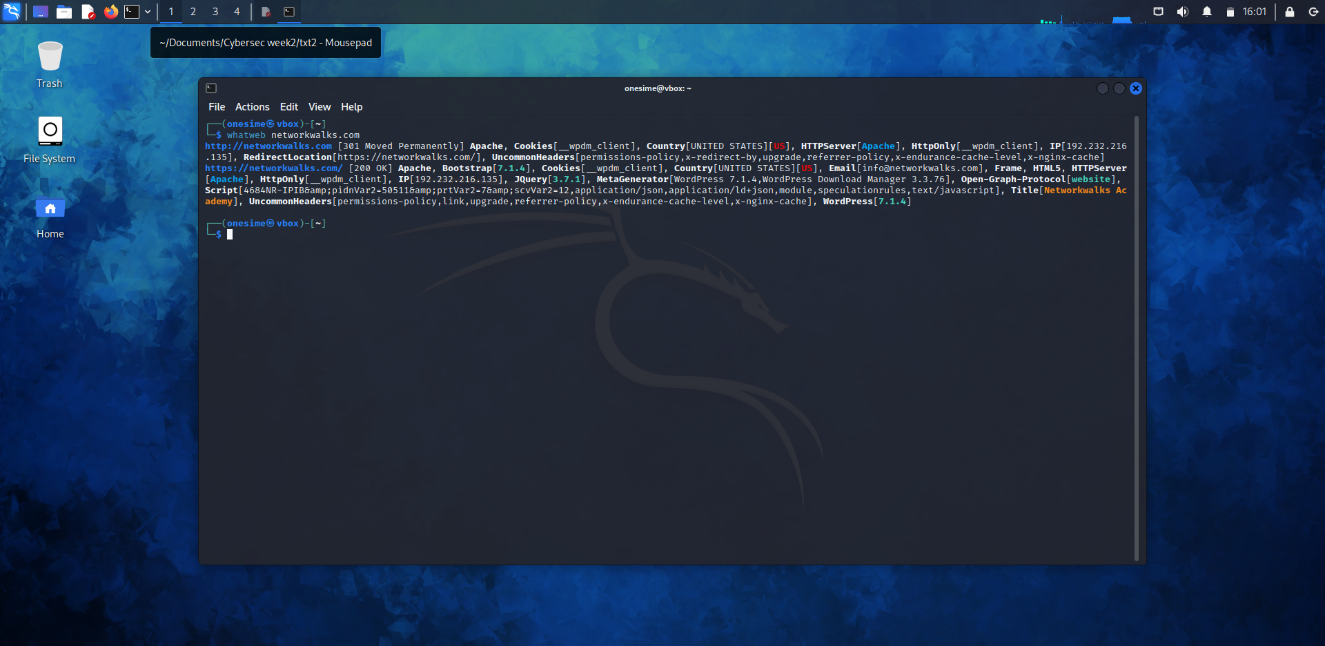
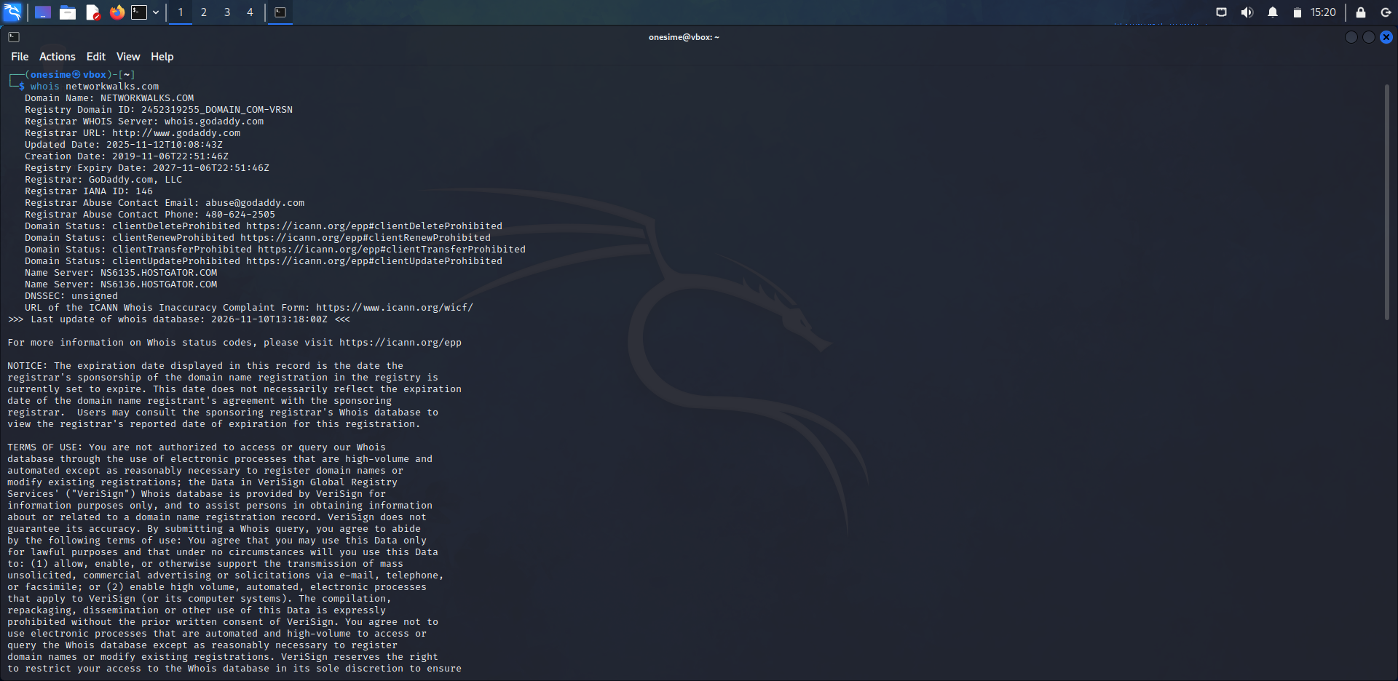

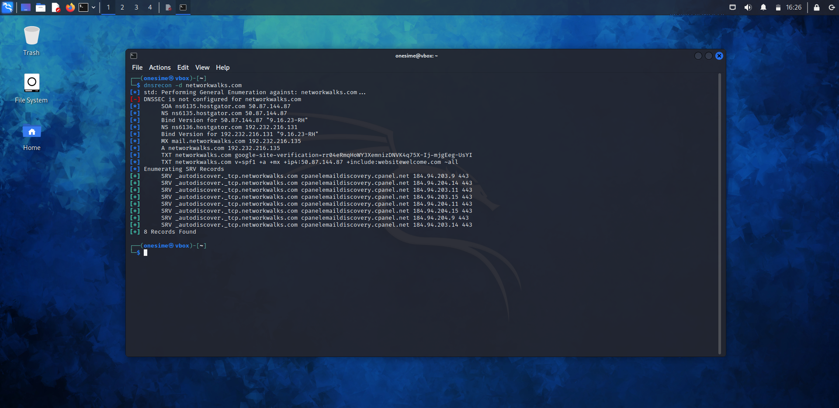

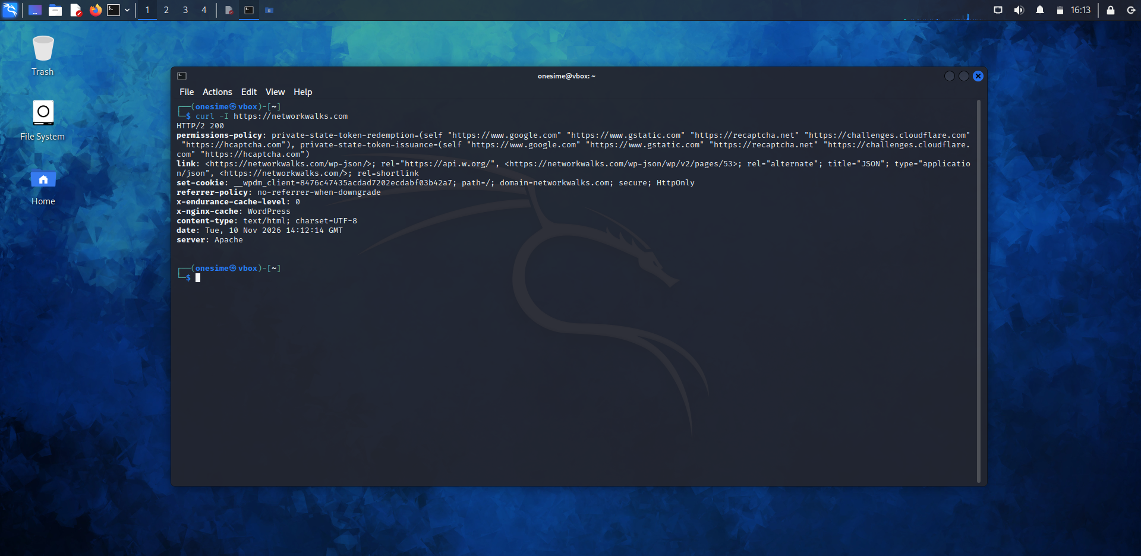

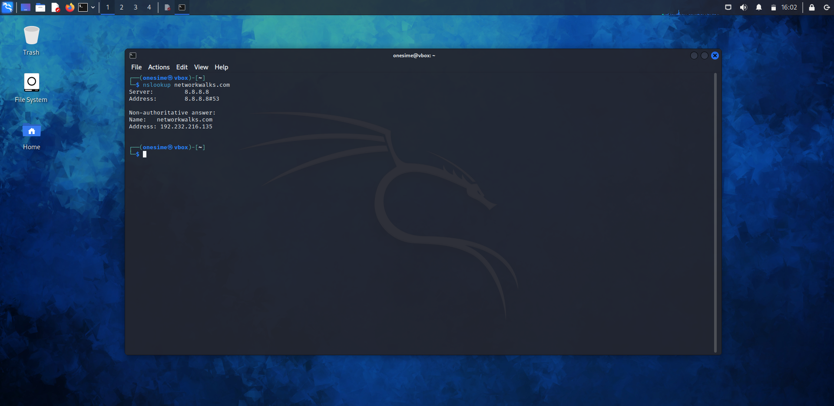

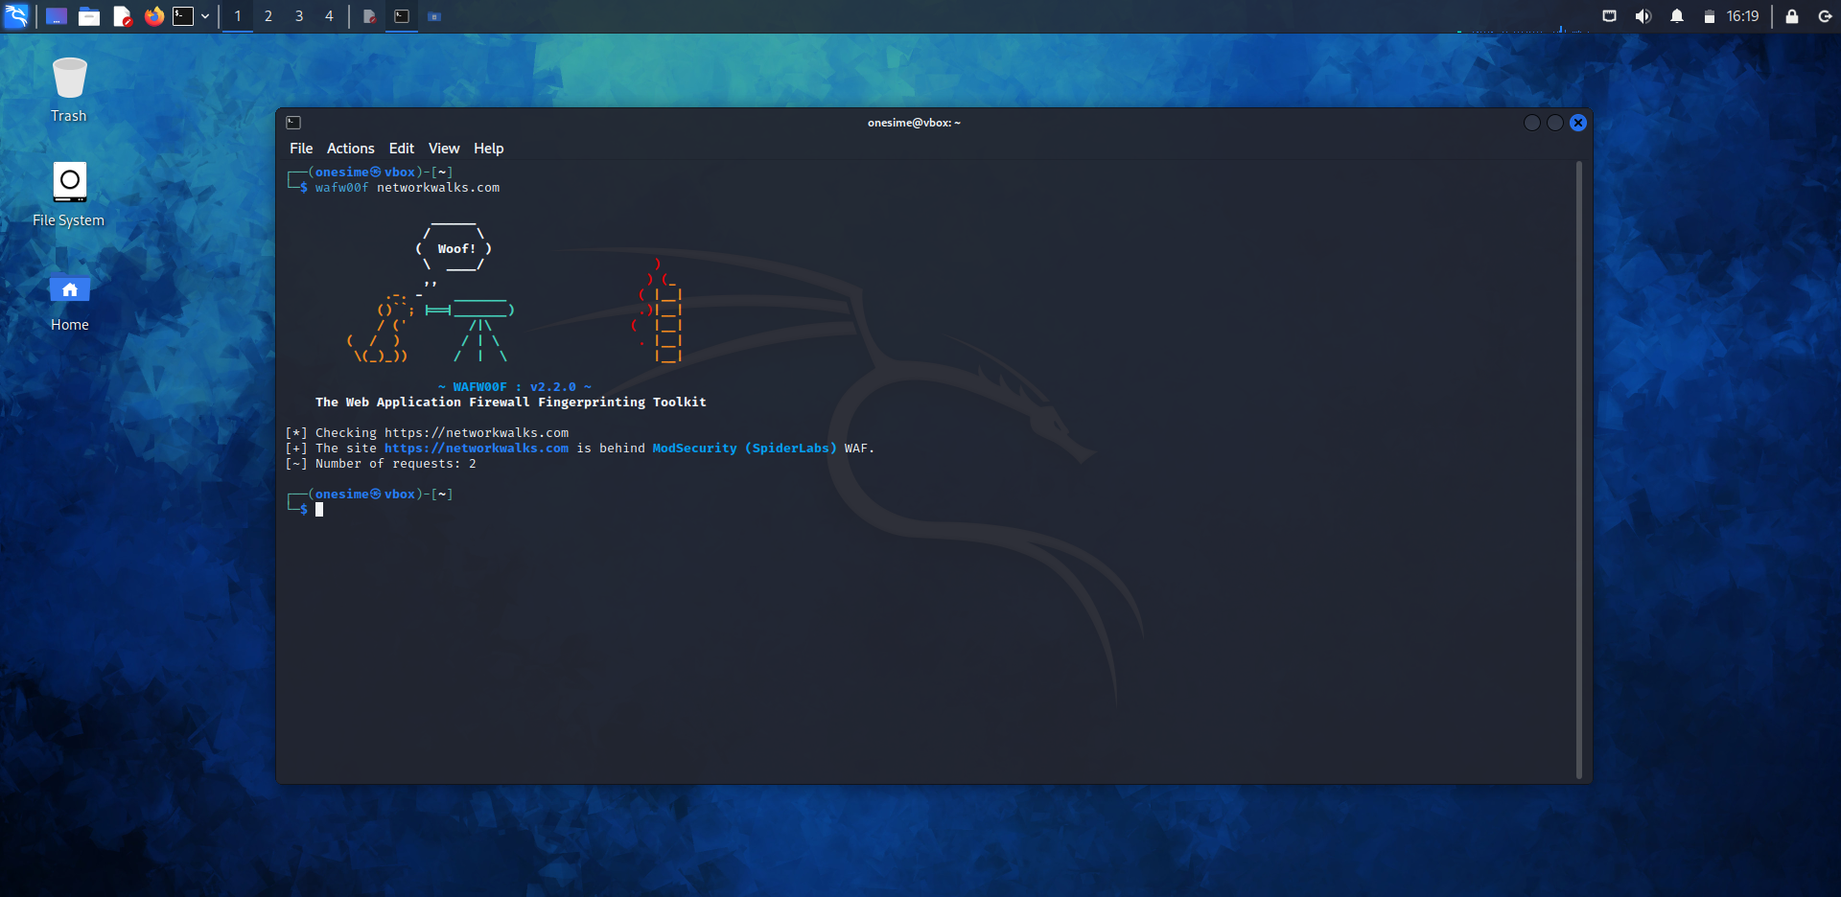

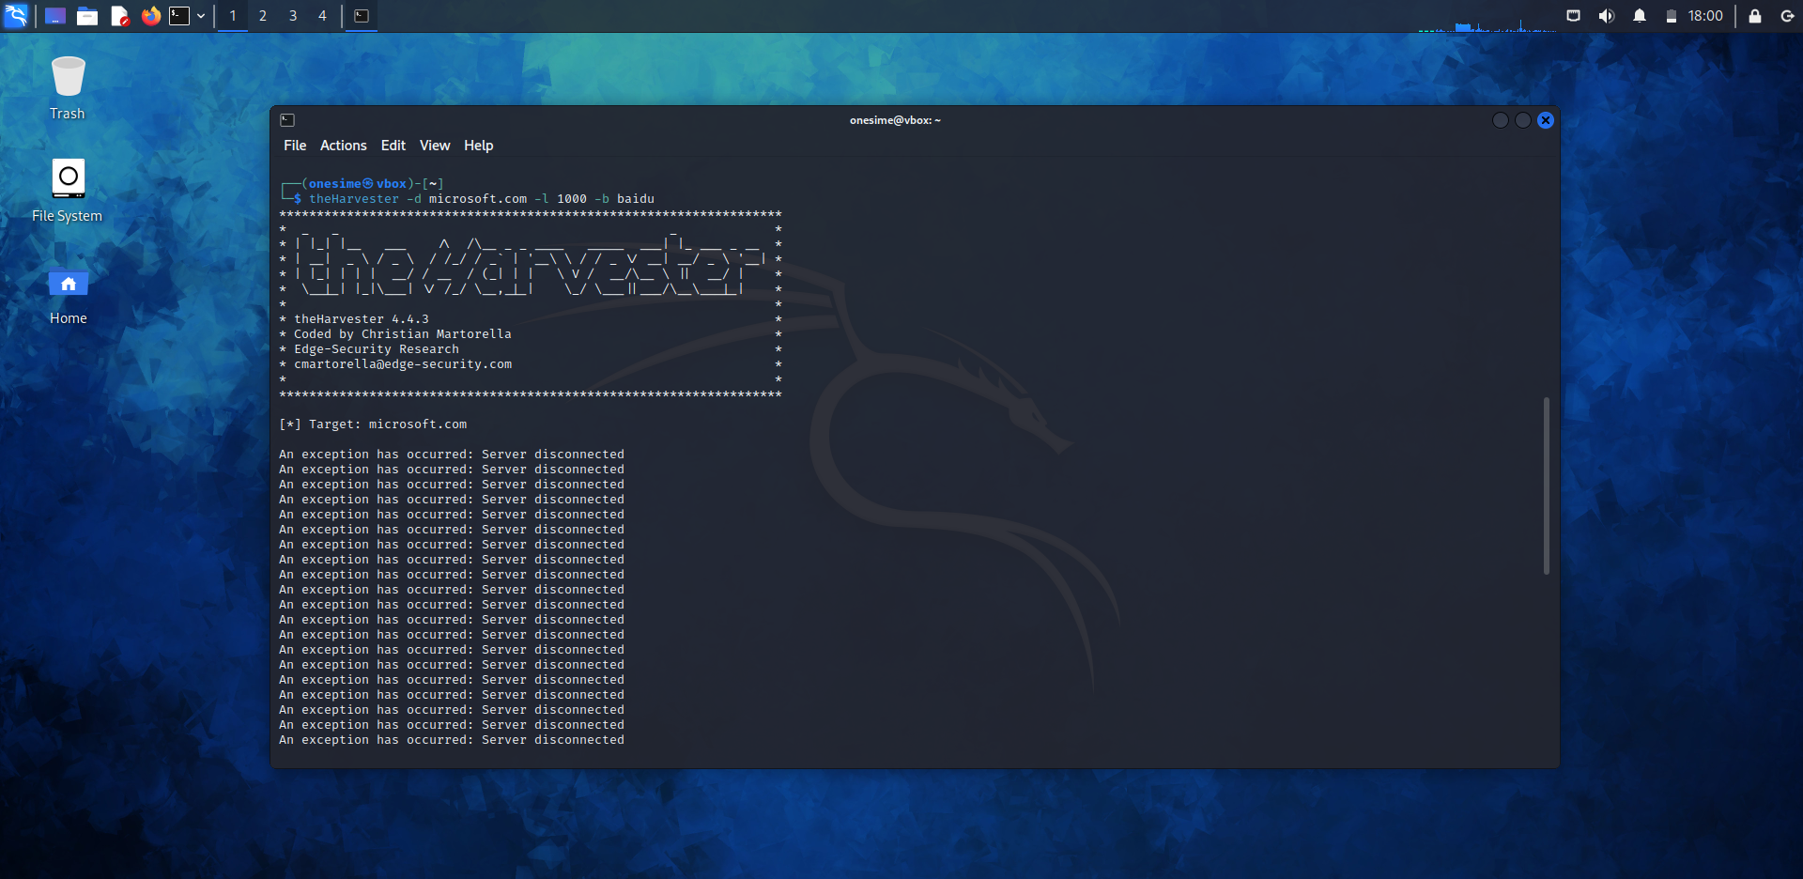

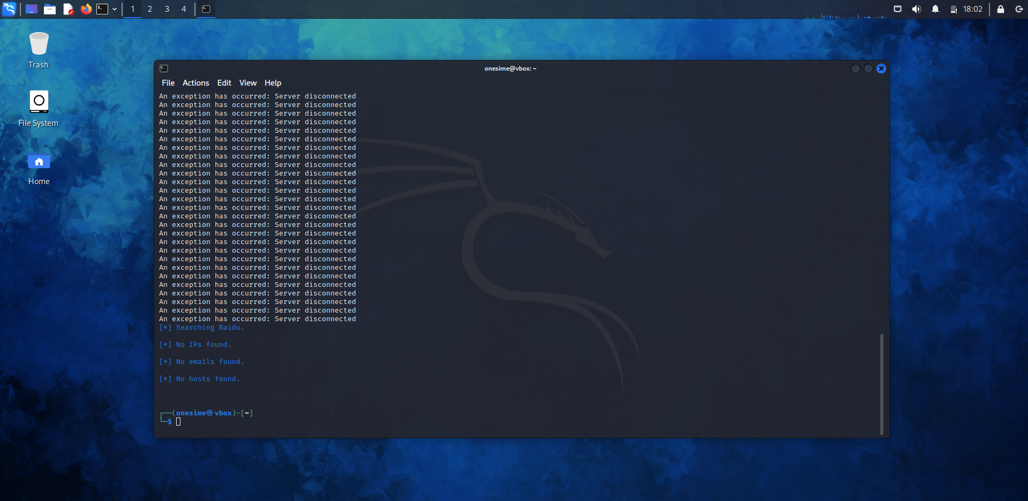

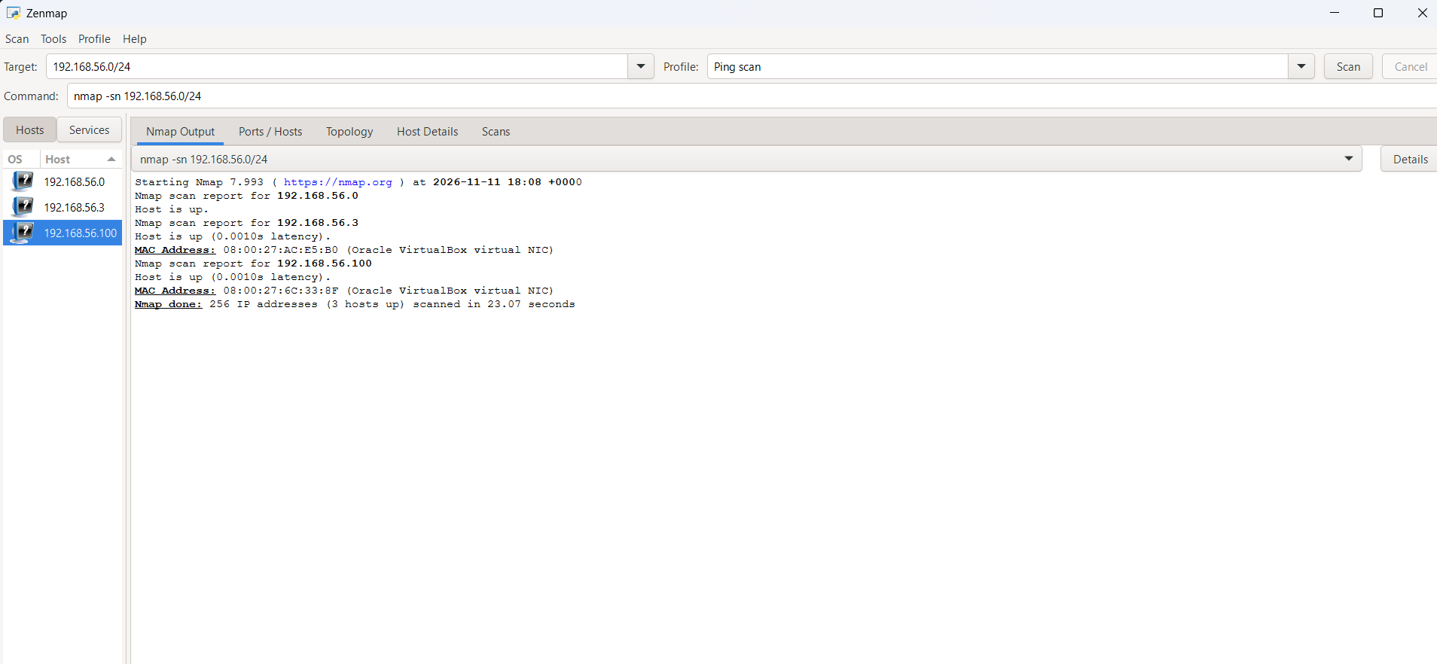

-End-

👤 Author
Onesime Keya Kabiala
Cybersecurity Learner B084
LinkedIn: https://www.linkedin.com/in/onesime-keya-7a7207289

📌 Project Information
Program Name: Cybersecurity program at Networkwalks | Week: 02 | Repository: GitHub

