Determinants of Depression among University Students: An Econometric Analysis using Logit and Probit Models
Report submitted to
Dr. Prantik Bagchi
Department of Humanities and Social Sciences
Indian Institute of Technology Kharagpur
Submitted by
Atharv Lodhi
Sourav Choudhary
Piyush Bisht

Department of Humanities and Social Sciences
Indian Institute of Technology Kharagpur
Kharagpur, West Bengal 721302
© 2026. All rights reserved

Abstract
Depression is one of the most common mental health problems among university students, yet the personal, social and economic factors that separate students who are depressed from those who are not remain unclear. This study examines which student characteristics are associated with a higher or lower probability of depression, with special attention to relationship status, family background, living costs, gender, academic performance and social support.
Using a quantitative cross-sectional design, survey data on 317 university students aged 18–24 with a CGPA above 6.00 on a 10-point scale were analysed, of whom 92 (29.0%) reported depression. After bivariate chi-square and t-tests, a Binary Logistic Regression (logit) model was estimated, followed by a Binary Probit model, average marginal effects, goodness-of-fit diagnostics and a set of robustness checks.
The results show that being single is the strongest risk factor: single students are 36.6 percentage points more likely to be depressed than students in a relationship (p < 0.001). Compared with students whose monthly living expense is low, students with a mid expense (+20.1 percentage points, p = 0.032) or a high expense (+20.0 percentage points, p = 0.024) are more likely to be depressed. Male students are 14.0 percentage points less likely to be depressed than female students (p = 0.007). Students from rich families are less likely to be depressed, but only at the 10% level (-12.0 percentage points, p = 0.074). Surprisingly, CGPA, semester, age, living arrangement and having a friend circle show no significant association once other factors are held constant.
The logit model is jointly significant (LR χ²(11) = 72.01, p < 0.001), fits the data well (Hosmer–Lemeshow p = 0.241) and discriminates reasonably between depressed and non-depressed students (AUC = 0.782). The probit model gives almost identical marginal effects, and a linear probability model confirms the relationship and gender effects. The study concludes that university mental health support should focus on social and relational wellbeing and financial pressure, rather than on academic performance alone.
Keywords: Depression, University students, Binary logit, Probit, Marginal effects, Relationship status, Socioeconomic status

Table of Contents
Abstract ii
Table of Contents iii
List of Figures vi
List of Tables vi
Chapter 1 Introduction 1
1.1 Background of the Study 1
1.2 Problem Statement 1
1.3 Research Objectives 2
1.4 Research Questions 2
1.5 Research Hypotheses 3
1.6 Significance of the Study 3
1.7 Scope and Limitations 3
1.8 Organization of the Paper 3
Chapter 2 Literature Review 4
2.1 Introduction to the Theoretical Framework 4
2.2 Theoretical Underpinnings 4
2.2.1 The Diathesis–Stress Model 4
2.2.2 Social Support and the Stress-Buffering Hypothesis 4
2.3 Academic Pressure and Performance 5
2.4 Socioeconomic Status and Financial Strain 5
2.5 Relationships and Loneliness 5
2.6 Gender Differences in Depression 5
2.7 Physical Health and Depression 6
2.8 Conclusion of Literature Review 6
Chapter 3 Research Methodology 6
3.1 Data Overview 6
3.2 Data Transformation 7
3.3 Data and Types of Variables 8
3.4 Data Analysis 8
3.4.1 Graphs Overview 8
3.5 Econometric Model Specification 9
3.6 Ethical Considerations 10
Chapter 4 Empirical Results 10
4.1 Introduction 10
4.2 Descriptive Analysis of Student Characteristics 10
4.2.1 Prevalence of Depression 10
4.2.2 Social and Demographic Characteristics 11
4.2.3 Self-Reported Health Condition 12
4.2.4 Numerical Variables: CGPA, Age and Semester 12
4.2.5 Age and Semester 13
4.3 Descriptive Statistics of Variables 13
4.4 Bivariate Analysis 15
4.4.1 Chi-Square Tests of Independence 15
4.4.2 Difference in Means Tests 16
4.5 Multicollinearity Check 16
4.6 Inferential Analysis: Binary Logistic Regression 17
4.6.1 Interpretation of Coefficients 18
4.6.2 Odds Ratios 18
4.7 Marginal Effects Analysis (Logit) 19
4.7.1 Interpretation of Marginal Effects 20
4.8 Binary Probit Regression 21
4.8.1 Interpretation of Coefficients 21
4.9 Marginal Effects (Probit) 21
4.10 Goodness of Fit and Model Diagnostics 22
4.11 Hypothesis Testing Summary 24
4.12 Robustness Checks 25
Chapter 5 Findings, Conclusion, and Recommendations 27
5.1 Introduction 27
5.2 Summary of Major Findings 27
5.2.1 Relationships Matter More than Grades 27
5.2.2 Financial Pressure: Living Expenses and Family Background 27
5.2.3 The Gender Gap 28
5.2.4 What Did Not Matter: Grades, Friends and Living Arrangement 28
5.2.5 Health and Depression 28
5.3 Policy Implications for Universities 28
5.3.1 Target Social Isolation, not only Academic Performance 28
5.3.2 Address Financial Pressure 28
5.3.3 Gender-Sensitive Screening and Support 29
5.3.4 Simple Screening Tools 29
5.4 Theoretical Implications 29
5.5 Limitations of the Study 29
5.6 Recommendations for Future Research 30
5.7 Conclusion 30
Appendix 30
A.1 Binary logit model 31
A.2 Binary probit model 31
A.3 Logit model with robust standard errors 31
A.4 Linear probability model (robust standard errors) 32
A.5 Logit model including poor health 32
A.6 Linear probability model: male students 33
A.7 Linear probability model: female students 33
A.8 Marginal effects at the means (logit) 34
A.9 Subsample marginal effects (linear probability model) 34
References 35

List of Figures
Figure 3.1: Distribution of the dependent variable (depression status) 9
Figure 4.1: Depression rate by student characteristics 11
Figure 4.2: Depression by self-reported health condition 12
Figure 4.3: Distribution of CGPA, age and semester by depression status 13
Figure 4.4: Depression rate by age and semester group 13
Figure 4.5: Correlation matrix of coded variables 15
Figure 4.6: Odds ratios with 95% confidence intervals (log scale) 19
Figure 4.7: Average marginal effects after logit with 95% confidence intervals 20
Figure 4.8: ROC curves of the logit and probit models 23
Figure 4.9: Predicted probability of depression by CGPA and relationship status 24
Figure 4.10: Marginal effects across logit, probit and linear probability models 26

List of Tables
Table 3.1: Raw data (first five records) 7
Table 3.2: Description of variables 8
Table 4.1: Summary statistics of coded variables 14
Table 4.2: Chi-square tests of independence with depression 16
Table 4.3: Difference in means between depressed and non-depressed students 16
Table 4.4: Variance inflation factors 17
Table 4.5: Binary logit estimates (N = 317; dependent variable: depression) 17
Table 4.6: Odds ratios from the logit model 18
Table 4.7: Average marginal effects after logit (dy/dx) 19
Table 4.8: Binary probit estimates (N = 317; dependent variable: depression) 21
Table 4.9: Average marginal effects after probit (dy/dx) 22
Table 4.10: Goodness-of-fit statistics 22
Table 4.11: Classification tables at the 0.5 cut-off and at the sample share of depressed students 23
Table 4.12: Summary of hypothesis tests 24
Table 4.13: Robustness checks across model specifications 25
Table A.1: Marginal effects at the means after logit 34
Table A.2: Marginal effects for male and female students (LPM, robust SE) 34

Chapter 1
Introduction

1.1 Background of the Study
University life is a period of rapid change. Within a few years, students move away from home, build new friendships and romantic relationships, manage their own money, and face continuous academic evaluation. For many students these transitions are exciting, but for a large share they are also a source of persistent stress. Depression — a condition marked by low mood, loss of interest, fatigue and feelings of worthlessness — is among the most frequent mental health problems in this age group. A systematic review of university students worldwide reported an average depression prevalence of around 30 percent, far above the rate in the general population (Ibrahim et al., 2013).
Depression among students is not only a personal health issue. It lowers academic productivity, increases the risk of dropping out, and has lasting effects on later employment and wellbeing (Hysenbegasi et al., 2005; Eisenberg et al., 2007). Understanding which students are most at risk therefore matters to universities, families and policymakers who have to decide where to direct limited counselling and support resources.
The factors linked to depression are many and interrelated. Psychological theories stress the role of stressful life events acting on individual vulnerability (Monroe & Simons, 1991). Social theories emphasise the protective role of close relationships and social support (Cohen & Wills, 1985). Economic research shows a clear socioeconomic gradient in depression (Lorant et al., 2003), and a large body of work documents higher depression rates among women (Nolen-Hoeksema, 1987). This study brings these strands together and tests them on a single, well-defined group of university students.

1.2 Problem Statement
Although the high prevalence of depression among university students is well documented, there is less clarity about which student characteristics actually matter once they are considered together. Many studies examine one factor at a time — for example, academic performance or family income — and therefore cannot tell whether an apparent effect is real or simply reflects other, correlated characteristics. For instance, if single students are also more likely to live away from family, a simple comparison cannot separate the effect of relationship status from that of living arrangement.
There is also a common assumption, among students and institutions alike, that poor grades are a main driver of depression. If this assumption is wrong, support programmes that focus mainly on academic help may miss the students who need support most. This study addresses these gaps by estimating multivariate probability models that isolate the contribution of each factor while holding the others constant.

1.3 Research Objectives
The main objectives of this study are:
1. To measure the prevalence of depression in a sample of university students aged 18–24.
2. To examine how depression rates differ across gender, family background, relationship status, living style, living expense, social support (friend circle) and self-reported health.
3. To estimate the effect of each factor on the probability of depression using binary logit and probit models, holding all other factors constant.
4. To express these effects as marginal effects (changes in probability) that can be interpreted directly.
5. To test the robustness of the findings across alternative model specifications and across male and female students.
6. To derive practical recommendations for university mental health support.

1.4 Research Questions
1. What share of university students in the sample report depression?
2. Is academic performance (CGPA) associated with the probability of depression?
3. Does relationship status affect the probability of depression?
4. Do family socioeconomic background and the level of monthly living expense influence depression?
5. Are female students more likely to be depressed than male students?
6. Do social support (having a friend circle) and living with family protect students against depression?

1.5 Research Hypotheses
Based on the literature reviewed in Chapter 2, the following hypotheses are tested:
- H1: Students with higher CGPA are less likely to be depressed (academic stress).
- H2: Students with a friend circle are less likely to be depressed (social support).
- H3: Single students are more likely to be depressed than students in a relationship.
- H4a: Students from lower-middle class families are more likely to be depressed than middle class.
- H4b: Students from rich families are less likely to be depressed than middle class.
- H5: Students with high living expenses are more likely to be depressed than those with low expenses (financial pressure).
- H6: Students living with family are less likely to be depressed than those living as bachelors.
- H7: Female students are more likely to be depressed than male students.

1.6 Significance of the Study
The study contributes in three ways. First, it provides evidence on the relative importance of social, economic and academic factors, measured on the same students and estimated jointly. Second, by reporting marginal effects rather than only coefficients, it translates statistical results into easily interpreted changes in the probability of depression. Third, it offers practical guidance for universities on which groups of students to prioritise for screening and support, and highlights that common assumptions — such as the central role of grades — may not hold.

1.7 Scope and Limitations
The study is based on 317 students aged 18–24 with a CGPA above 6.00 (10-point scale). Depression is measured as a self-reported yes/no indicator rather than a clinical diagnosis. The data are cross-sectional, so the estimated relationships describe associations rather than proven causal effects. These limitations are discussed further in Section 5.5.

1.8 Organization of the Paper
The remainder of the report is organised as follows. Chapter 2 reviews the theoretical and empirical literature. Chapter 3 describes the data, the transformation of variables and the econometric methodology. Chapter 4 presents the descriptive analysis, bivariate tests, logit and probit estimates, marginal effects, diagnostics and robustness checks. Chapter 5 summarises the findings, discusses their implications, and concludes. The appendix reports the full model output, and the Stata code used to replicate the analysis is provided with the report.

Chapter 2
Literature Review

2.1 Introduction to the Theoretical Framework
Depression has no single cause. Modern research views it as the result of an interaction between individual vulnerability and environmental stressors, moderated by the resources a person can draw on. This chapter reviews the main theories that guide the choice of variables in this study and summarises the empirical evidence on each group of factors: academic, social, economic, demographic and health-related.

2.2 Theoretical Underpinnings

2.2.1 The Diathesis–Stress Model
The diathesis–stress model proposes that depression develops when stressful life events act on a pre-existing vulnerability (Monroe & Simons, 1991). University students face a dense cluster of potential stressors — exams, financial obligations, relationship changes and living away from home — so the model predicts that students exposed to more of these stressors, or with fewer buffers, will show higher rates of depression. Beck's (1967) cognitive theory adds that negative interpretations of such events (for example, viewing a poor grade or a breakup as a personal failure) turn stress into depressive symptoms.

2.2.2 Social Support and the Stress-Buffering Hypothesis
Cohen and Wills (1985) showed that social support protects mental health mainly by 'buffering' the impact of stress: people with close, supportive relationships cope better with the same level of adversity. Kawachi and Berkman (2001) further document that social ties — friendships, partners and family — reduce the risk of depression through emotional support, a sense of belonging and practical help. For students, friend circles, romantic partners and living with family are the most direct sources of this support, which motivates hypotheses H2, H3 and H6.

2.3 Academic Pressure and Performance
Academic stress is widely cited as a driver of student depression. Poor results can threaten future career plans and self-esteem, while depression in turn reduces concentration and productivity (Hysenbegasi et al., 2005). Eisenberg et al. (2007) found that depression is associated with lower grade point averages. However, the direction of the relationship is unclear — depression may lower grades rather than grades causing depression — and several studies find only weak links once social and economic variables are included. Hypothesis H1 tests whether CGPA retains an independent association in this sample.

2.4 Socioeconomic Status and Financial Strain
A meta-analysis by Lorant et al. (2003) found that people with lower socioeconomic status have significantly higher odds of depression, with financial strain being one of the main channels. Richardson et al. (2013) show that debt and money worries are strongly linked to poor mental health, including among students. For students, family background shapes both the money available and the expectations placed on them, while the level of monthly living expense is a direct measure of financial pressure. These ideas motivate hypotheses H4a, H4b and H5.

2.5 Relationships and Loneliness
Close relationships are among the strongest protective factors against depression. Being in a stable relationship provides companionship and emotional support, while being single can be associated with loneliness, particularly in early adulthood when peers are forming couples. Whitton and Whisman (2010) show that the quality and stability of romantic relationships are closely tied to depressive symptoms, and Bulloch et al. (2009) find that the link between relationship disruption and depression runs in both directions. Hypothesis H3 tests whether single students face a higher risk.

2.6 Gender Differences in Depression
One of the most consistent findings in psychiatric epidemiology is that women experience depression roughly twice as often as men (Nolen-Hoeksema, 1987; Kessler, 2003). Explanations include differences in stress exposure, coping styles — women are more likely to ruminate, men to distract themselves — and hormonal factors. Among students, the gap is often smaller but usually still present (Eisenberg et al., 2007). Hypothesis H7 tests whether female students in this sample are more likely to be depressed after other factors are controlled for.

2.7 Physical Health and Depression
Physical and mental health are closely intertwined. Using World Health Survey data from 60 countries, Moussavi et al. (2007) showed that chronic physical conditions sharply increase the probability of depression, and that depression worsens health outcomes more than many chronic diseases. Self-reported health is therefore expected to be strongly related to depression. However, when self-reported health partly reflects the same symptoms as depression, it becomes difficult to treat it as an independent cause — an issue that turns out to be important in this study (Section 3.2).

2.8 Conclusion of Literature Review
The literature suggests that depression among students is shaped by academic pressure, social support, relationships, financial conditions, gender and health. However, most studies examine these factors separately or in very different populations. By estimating them jointly in one sample, this study aims to identify which factors carry independent explanatory power and which only appear important when considered in isolation.

Chapter 3
Research Methodology

3.1 Data Overview
The study uses survey data on 317 university students aged 18–24 (155 male and 162 female). The 18–24 range is the typical undergraduate age range. CGPA is measured on a 10-point scale, and every student in the sample has a CGPA above 6.00.
For each student, the survey records gender, age, family background, relationship status, living style, current semester, CGPA, whether the student has a friend circle, self-reported health condition, monthly living expense excluding study costs (in three bands: low, mid, high), and whether the student is depressed. Table 3.1 shows the first five records of the raw data.
Gender | Age | Family background | Relationship | Living | Semester | CGPA | Friends | Health | Expense | Depression
Female | 21 | Middle class | Single | Bachelor | 7 | 8.00 | Yes | Abnormal | High | No
Male | 20 | Middle class | Single | Bachelor | 5 | 9.30 | Yes | Abnormal | Mid | Yes
Male | 23 | Middle class | In a Relationship | Bachelor | 4 | 9.18 | Yes | Good | High | No
Male | 20 | Middle class | Single | Bachelor | 8 | 7.50 | Yes | Good | High | No
Male | 22 | Middle class | Single | Bachelor | 3 | 8.98 | Yes | Good | High | No
Table 3.1: Raw data (first five records)

3.2 Data Transformation
Several preprocessing steps were carried out to make the data accurate, consistent and ready for modelling:
1. Data quality checks. The data contain 0 missing values and 4 duplicate records, so no imputation or deletion was needed. All variables were checked for valid ranges (for example, CGPA between 6 and 10).
2. Encoding of binary variables. Text answers were converted into 0/1 indicators: depression (Yes = 1), gender (Male = 1), living style (with family = 1) and friend circle (Yes = 1).
3. Dummy variables for family background. Family background has three categories. Two dummy variables were created — lower-middle class and rich class — with middle class (the largest group) as the reference category.
4. Merging a very small category. The 'Complicated' relationship group contains only 11 students, none of whom is depressed, which would make its coefficient impossible to estimate (perfect prediction). It was merged with 'In a relationship', so relationship status becomes Single (1) vs Not single (0).
5. Living expense bands. Monthly living expense (excluding study costs) is grouped into three bands cut at the rounded sample thirds: Low (below 10,000), Mid (10,000–14,999) and High (15,000 or more). Two dummy variables (mid, high) enter the models, with low expense as the reference category.
6. Treatment of self-reported health condition. Health condition is almost perfectly aligned with depression in the data: 100% of students in 'critical' health and 0% of students in 'good' health are depressed (Section 4.2.3). Including it in the main model would cause quasi-complete separation, and it very likely captures the same underlying condition as the outcome rather than an independent cause. It is therefore analysed descriptively and entered only in one robustness model (Section 4.12), as a single 'poor health' indicator.
After these steps the final dataset has 317 observations and the variables described in Table 3.2.

3.3 Data and Types of Variables
Variable name | Description and coding | Data type
depression | Whether the student reports depression. 1 = Yes, 0 = No. | Binary (dependent variable)
male | Gender of the student. 1 = Male, 0 = Female. | Binary
age | Age of the student in years (18-24). | Numerical (discrete)
cgpa | Cumulative grade point average on a 10.00 scale (sample restricted to CGPA above 6.00). | Numerical (continuous)
semester | Semester the student is currently in. | Numerical (discrete)
cost_mid | 1 = Mid monthly living cost, 10,000-14,999 excluding study costs (base group: Low, below 10,000). | Binary (dummy)
cost_high | 1 = High monthly living cost, 15,000 or more excluding study costs (base group: Low, below 10,000). | Binary (dummy)
fam_lowermid | 1 = Lower-middle class family (base group: middle class). | Binary (dummy)
fam_rich | 1 = Rich class family (base group: middle class). | Binary (dummy)
single | 1 = Single, 0 = In a relationship or complicated. | Binary
live_family | 1 = Lives with family, 0 = Lives as a bachelor (hostel/mess/shared). | Binary
friend_circle | 1 = Has a friend circle, 0 = Does not. | Binary
health_poor | 1 = Abnormal or critical health, 0 = Good or normal (robustness model only). | Binary
health_level | 1 = Good, 2 = Normal, 3 = Abnormal, 4 = Critical (descriptive only). | Ordinal
Table 3.2: Description of variables

3.4 Data Analysis
The analysis proceeds in four steps. First, descriptive statistics and charts summarise the sample and compare depression rates across groups. Second, bivariate tests check whether each factor is associated with depression on its own: Pearson chi-square tests (with Cramér's V as a measure of strength) for categorical variables, and Welch t-tests and Mann–Whitney U tests for numerical variables. Third, multivariate binary logit and probit models estimate the effect of each factor while holding the others constant. Fourth, diagnostics and robustness checks assess the reliability of the results.

3.4.1 Graphs Overview
Figure 3.1 shows the distribution of the dependent variable. Of the 317 students, 92 (29.0%) report depression and 225 (71.0%) do not. The outcome is therefore reasonably balanced: depression is common enough to be studied with a binary choice model, and there are enough depressed students (events) relative to the number of explanatory variables for stable estimation.
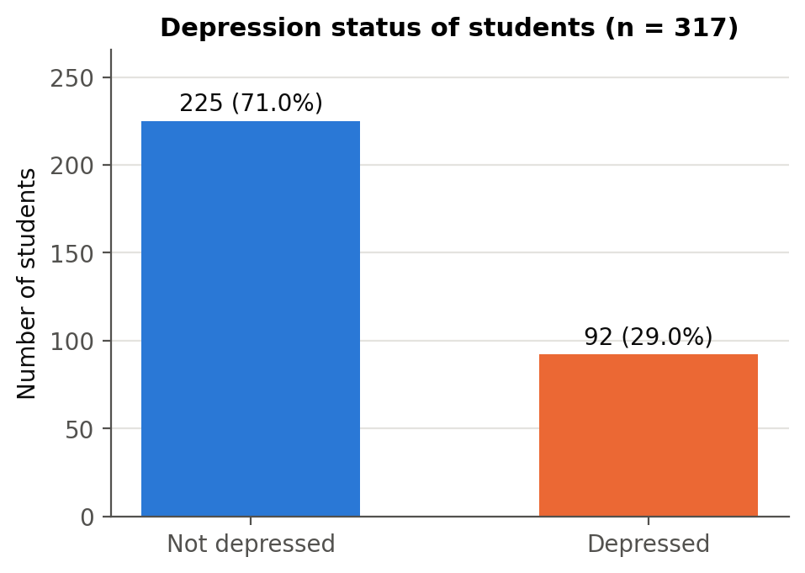
Figure 3.1: Distribution of the dependent variable (depression status)

3.5 Econometric Model Specification
Because the dependent variable is binary (depressed = 1, not depressed = 0), ordinary least squares is not ideal: its predicted values can fall outside the 0–1 range and its error term is heteroskedastic by construction. The study therefore uses binary choice models, which model the probability of depression directly (Wooldridge, 2010; Long & Freese, 2014).
Binary logit model. The probability that student i is depressed is modelled as:
Pr(Depressionᵢ = 1 | xᵢ) = Λ(xᵢ′β) = exp(xᵢ′β) / [1 + exp(xᵢ′β)]
where the vector xᵢ′β is:
β₀ + β₁Maleᵢ + β₂Ageᵢ + β₃CGPAᵢ + β₄Semesterᵢ + β₅MidExpenseᵢ + β₆HighExpenseᵢ + β₇LowerMidᵢ + β₈Richᵢ + β₉Singleᵢ + β₁₀LiveFamilyᵢ + β₁₁FriendCircleᵢ
The coefficients are estimated by maximum likelihood. A positive coefficient means the factor raises the probability of depression. Exponentiated coefficients, exp(β), are odds ratios: an odds ratio above 1 raises the odds of depression, and below 1 lowers them.
Binary probit model. As an alternative, the probit model replaces the logistic function with the standard normal cumulative distribution function Φ:
Pr(Depressionᵢ = 1 | xᵢ) = Φ(xᵢ′β)
Marginal effects. Logit and probit coefficients are not directly comparable, so the main results are reported as average marginal effects (AME): the average change in the probability of depression when a continuous variable rises by one unit, or when a 0/1 variable changes from 0 to 1, computed for every student and then averaged (equivalent to Stata's margins, dydx(*) command).
Diagnostics. Model fit is assessed with the likelihood-ratio (LR) test, McFadden's pseudo-R², the AIC and BIC, classification tables, the area under the ROC curve (AUC) and the Hosmer–Lemeshow test (Hosmer et al., 2013). Multicollinearity is checked using variance inflation factors (VIF). Robustness is assessed with robust standard errors, a linear probability model (LPM), a model that adds health status, and separate models for male and female students.
All estimation was carried out in Python using the pandas, SciPy and statsmodels libraries (Seabold & Perktold, 2010). An equivalent Stata do-file that reproduces every step is provided with this report (StataCorp, 2021).

3.6 Ethical Considerations
The study uses anonymised secondary survey data. The data contain no names, contact details or other personal identifiers; each student is identified only by a sequential number. Because the topic is mental health, results are reported only at group level, and no attempt is made to identify or profile individual students.

Chapter 4
Empirical Results

4.1 Introduction
This chapter presents the results. It begins with a descriptive analysis of depression across student groups, followed by bivariate tests, the multicollinearity check, the logit and probit estimates with their marginal effects, model diagnostics, the hypothesis summary and the robustness checks.

4.2 Descriptive Analysis of Student Characteristics

4.2.1 Prevalence of Depression
Depression is common in the sample: 29.0% of students — almost three in ten — report being depressed. This is in line with the international estimates of around 30% reported by Ibrahim et al. (2013), and confirms that student depression is a widespread rather than a marginal problem.

4.2.2 Social and Demographic Characteristics
Figure 4.1 compares depression rates across the main social and demographic groups. Several patterns stand out:
- Relationship status shows the largest gap: 42.9% of single students are depressed, compared with only 8.7% of students in a relationship and 0% of the 11 students in a complicated relationship.
- Family background: students from middle-class families have the highest rate (35.1%), well above lower-middle class (20.3%) and rich (15.7%) students.
- Living expense: students with a low monthly living expense are less often depressed (19.1%) than those with a mid (35.2%) or high (33.6%) expense.
- Living style: students living as bachelors (hostels, messes or shared housing) are more often depressed (34.0%) than those living with family (21.7%).
- Gender and friend circle show small raw differences: 30.3% of male and 27.8% of female students are depressed, and having a friend circle makes no difference (29.0% vs 29.0%).
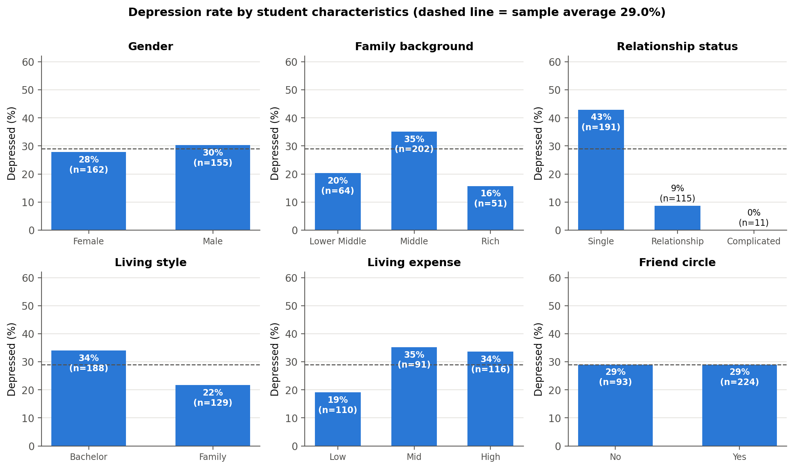
Figure 4.1: Depression rate by student characteristics
These raw comparisons do not control for other factors. For example, single students are more often male and less often live with family, and living expense overlaps with family background, so part of the gap between groups may be due to these overlaps. The regression models in Sections 4.6–4.9 separate these influences.

4.2.3 Self-Reported Health Condition
Figure 4.2 shows a very strong relationship between self-reported health and depression. None of the students in good health and only 2.8% of those in normal health are depressed, compared with 60.0% of students in abnormal health and 100% of those in critical health. The relationship is so close that health condition almost perfectly predicts depression. As explained in Section 3.2, this suggests that the health variable captures the same underlying condition as the outcome, so it is not used as an explanatory variable in the main model.
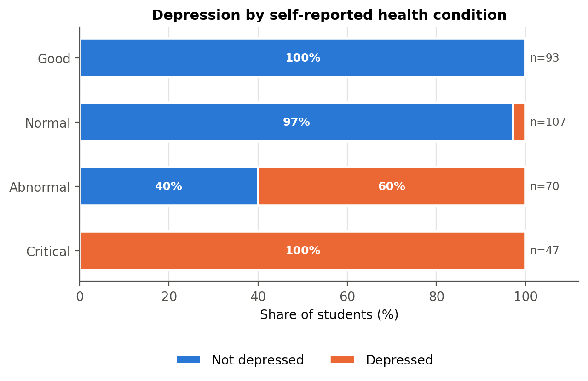
Figure 4.2: Depression by self-reported health condition

4.2.4 Numerical Variables: CGPA, Age and Semester
Figure 4.3 compares the distribution of the numerical variables between depressed and non-depressed students. Mean CGPA on the 10-point scale is almost identical in the two groups (8.76 vs 8.73), and so are mean age (21.6 vs 21.6 years) and mean semester (5.2 vs 5.0).
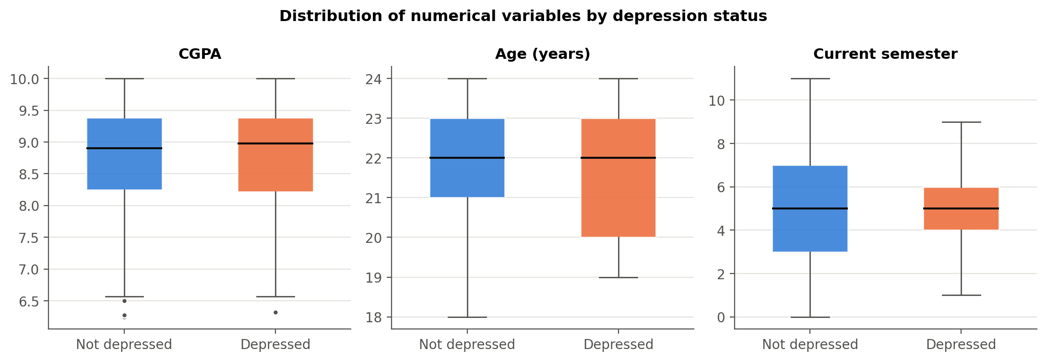
Figure 4.3: Distribution of CGPA, age and semester by depression status

4.2.5 Age and Semester
Figure 4.4 shows depression rates by age and by semester group. Rates vary between ages without a clear upward or downward trend, and the very small groups at ages 18 and 19 should be read with caution. Across the larger semester groups the rate ranges from 22% to 35% without a steady trend (the 10+ group has only 6 students), suggesting that depression is not concentrated at a particular stage of the degree.
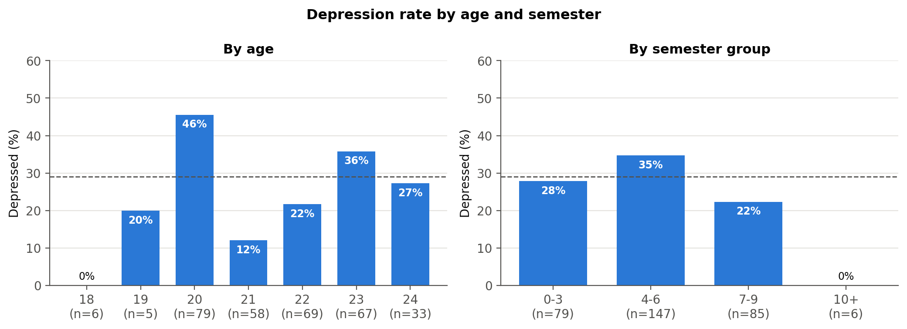
Figure 4.4: Depression rate by age and semester group

4.3 Descriptive Statistics of Variables
Table 4.1 reports summary statistics for the coded variables (equivalent to Stata's summarize command).
Variable | Obs | Mean | Std. dev. | Min | Max
Depression | 317 | 0.290 | 0.455 | 0.000 | 1.000
Male | 317 | 0.489 | 0.501 | 0.000 | 1.000
Age (years) | 317 | 21.615 | 1.453 | 18.000 | 24.000
CGPA | 317 | 8.753 | 0.862 | 6.250 | 10.000
Current semester | 317 | 5.142 | 2.201 | 0.000 | 11.000
Mid living expense | 317 | 0.287 | 0.453 | 0.000 | 1.000
High living expense | 317 | 0.366 | 0.482 | 0.000 | 1.000
Lower-middle class | 317 | 0.202 | 0.402 | 0.000 | 1.000
Rich class | 317 | 0.161 | 0.368 | 0.000 | 1.000
Single | 317 | 0.603 | 0.490 | 0.000 | 1.000
Lives with family | 317 | 0.407 | 0.492 | 0.000 | 1.000
Has friend circle | 317 | 0.707 | 0.456 | 0.000 | 1.000
Poor health | 317 | 0.369 | 0.483 | 0.000 | 1.000
Table 4.1: Summary statistics of coded variables
Students are on average 21.6 years old, with a mean CGPA of 8.75 out of 10. 29% have a mid and 37% a high monthly living expense. 60% are single, 71% have a friend circle and 41% live with their family.
Figure 4.5 shows the correlation matrix. Apart from the very high correlation between depression and health level discussed above, correlations among the explanatory variables are modest. The largest are between the two expense dummies (−0.48, which follows from their construction), between being male and living with family (−0.41) and between high expense and lower-middle class (−0.38), none of which is high enough to cause estimation problems.
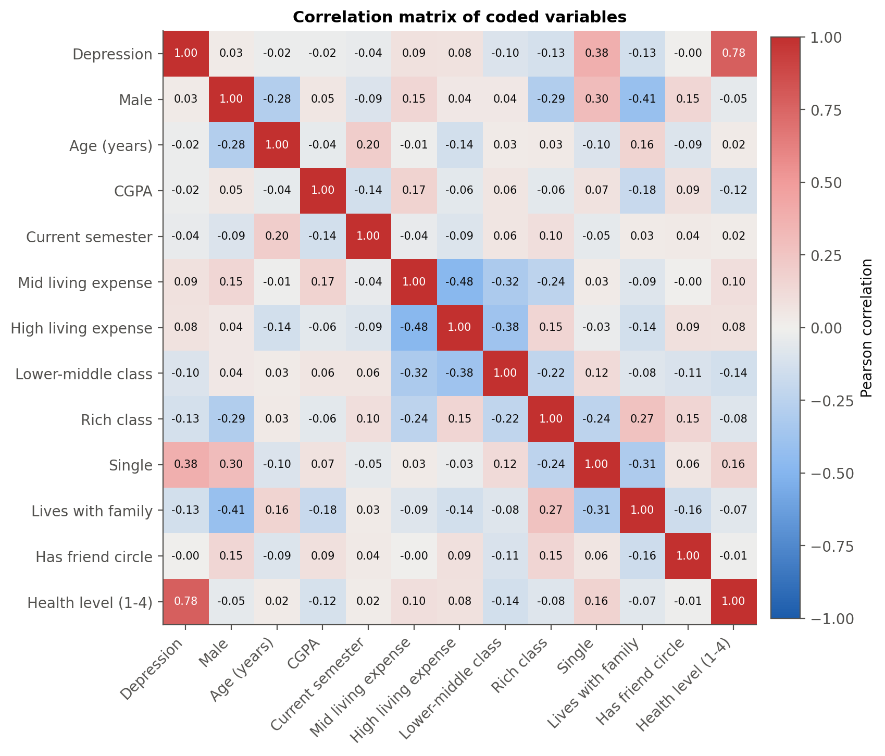
Figure 4.5: Correlation matrix of coded variables

4.4 Bivariate Analysis

4.4.1 Chi-Square Tests of Independence
Table 4.2 tests whether each categorical variable is independent of depression. Relationship status (χ² = 45.50, p < 0.001, Cramér's V = 0.38), family background (χ² = 10.44, p = 0.005), living expense (χ² = 8.12, p = 0.017) and living style (χ² = 5.65, p = 0.017) are significantly associated with depression, as is health condition (Cramér's V = 0.84, a very strong association). Gender and friend circle show no significant association on their own. For relationship status some expected cell counts are below 5, which is one more reason the small 'complicated' group was merged before modelling.
Variable | Chi-square | df | p-value | Cramer's V | Min expected count | Fisher exact p (2x2)
Gender | 0.249 | 1 | 0.618 | 0.028 | 44.980 | 0.623
Family background | 10.440 | 2 | 0.005 | 0.181 | 14.800
Relationship status | 45.504 | 2 | <0.001 | 0.379 | 3.190
Living style | 5.653 | 1 | 0.017 | 0.134 | 37.440 | 0.023
Living expense | 8.125 | 2 | 0.017 | 0.160 | 26.410
Friend circle | 0.000 | 1 | 0.998 | 0.000 | 26.990 | 1.000
Health condition | 221.288 | 3 | <0.001 | 0.836 | 13.640
Table 4.2: Chi-square tests of independence with depression

4.4.2 Difference in Means Tests
Table 4.3 compares the means of the numerical variables. None of the differences is significant: CGPA (p = 0.728), age (p = 0.701) and semester (p = 0.465) show no difference between depressed and non-depressed students, and the Mann–Whitney tests agree.
Variable | Mean (not depressed) | Mean (depressed) | Difference | Welch t | t-test p-value | Mann-Whitney U | Mann-Whitney p-value
CGPA | 8.765 | 8.726 | -0.039 | -0.349 | 0.728 | 10366.000 | 0.983
Age (years) | 21.636 | 21.565 | -0.070 | -0.385 | 0.701 | 9881.500 | 0.518
Current semester | 5.196 | 5.011 | -0.185 | -0.732 | 0.465 | 10066.000 | 0.699
Table 4.3: Difference in means between depressed and non-depressed students

4.5 Multicollinearity Check
Table 4.4 reports the variance inflation factors for the explanatory variables of the main model. The largest VIF is 2.90, below the common warning threshold of 10 and the stricter threshold of 5. The highest values belong to the two living-expense dummies (2.90 and 2.77), as expected for dummies of the same variable that also overlap with family background. Multicollinearity is therefore not a concern.
Variable | VIF | Tolerance (1/VIF)
Male | 1.427 | 0.701
Age (years) | 1.154 | 0.867
CGPA | 1.120 | 0.893
Current semester | 1.089 | 0.918
Mid living expense | 2.896 | 0.345
High living expense | 2.769 | 0.361
Lower-middle class | 2.500 | 0.400
Rich class | 1.411 | 0.709
Single | 1.190 | 0.840
Lives with family | 1.457 | 0.686
Has friend circle | 1.109 | 0.902
Table 4.4: Variance inflation factors

4.6 Inferential Analysis: Binary Logistic Regression
Table 4.5 presents the logit estimates. The model is highly significant overall: the likelihood-ratio test rejects the hypothesis that all coefficients are zero (LR χ²(11) = 72.01, p < 0.001). McFadden's pseudo-R² is 0.189, which is a reasonable value for cross-sectional individual-level data (values of 0.2–0.4 are generally considered a good fit for logit models).
Variable | Coefficient | Std. err. | z | P>|z| | 95% CI lower | 95% CI upper | Sig.
Constant | -1.0825 | 2.6549 | -0.4077 | 0.6835 | -6.2860 | 4.1211
Male | -0.8725 | 0.3447 | -2.5307 | 0.0114 | -1.5481 | -0.1968 | **
Age (years) | 0.0238 | 0.1017 | 0.2344 | 0.8146 | -0.1754 | 0.2231
CGPA | -0.2465 | 0.1745 | -1.4125 | 0.1578 | -0.5886 | 0.0956
Current semester | -0.0200 | 0.0703 | -0.2850 | 0.7756 | -0.1578 | 0.1177
Mid living expense | 1.2083 | 0.5884 | 2.0535 | 0.0400 | 0.0550 | 2.3616 | **
High living expense | 1.2214 | 0.5758 | 2.1214 | 0.0339 | 0.0929 | 2.3500 | **
Lower-middle class | 0.0204 | 0.6015 | 0.0338 | 0.9730 | -1.1587 | 1.1994
Rich class | -0.8066 | 0.5128 | -1.5731 | 0.1157 | -1.8117 | 0.1984
Single | 2.4750 | 0.3995 | 6.1950 | <0.001 | 1.6920 | 3.2581 | ***
Lives with family | -0.2524 | 0.3629 | -0.6953 | 0.4868 | -0.9637 | 0.4590
Has friend circle | -0.0988 | 0.3268 | -0.3023 | 0.7624 | -0.7394 | 0.5418
Table 4.5: Binary logit estimates (N = 317; dependent variable: depression)
Significance levels: *** p < 0.01, ** p < 0.05, * p < 0.10.

4.6.1 Interpretation of Coefficients
- Single (β = 2.475, p < 0.001): the strongest and most significant effect. Holding all other factors constant, single students are much more likely to be depressed than students in a relationship.
- Mid living expense (β = 1.208, p = 0.040) and high living expense (β = 1.221, p = 0.034): students whose monthly living expense is mid or high are significantly more likely to be depressed than students with a low expense. The two coefficients are almost equal.
- Male (β = -0.873, p = 0.011): male students are significantly less likely to be depressed than female students once other factors are controlled.
- Rich class (β = -0.807, p = 0.116): the coefficient is negative, as expected, but not significant once living expense is controlled for.
- CGPA, age, semester, lower-middle class, living with family and friend circle are not statistically significant: once the other variables are held constant, they do not explain differences in depression.

4.6.2 Odds Ratios
Table 4.6 and Figure 4.6 report the odds ratios. The odds of depression for single students are 11.9 times those of students in a relationship (95% CI 5.4–26.0). Students with a mid or high living expense have 3.3 and 3.4 times the odds of students with a low expense, although the confidence intervals are wide. Male students have 58% lower odds than female students.
Variable | Odds ratio | 95% CI lower | 95% CI upper | P>|z| | Sig.
Constant | 0.339 | 0.002 | 61.625 | 0.683
Male | 0.418 | 0.213 | 0.821 | 0.011 | **
Age (years) | 1.024 | 0.839 | 1.250 | 0.815
CGPA | 0.781 | 0.555 | 1.100 | 0.158
Current semester | 0.980 | 0.854 | 1.125 | 0.776
Mid living expense | 3.348 | 1.057 | 10.608 | 0.040 | **
High living expense | 3.392 | 1.097 | 10.485 | 0.034 | **
Lower-middle class | 1.021 | 0.314 | 3.318 | 0.973
Rich class | 0.446 | 0.163 | 1.219 | 0.116
Single | 11.882 | 5.430 | 26.000 | <0.001 | ***
Lives with family | 0.777 | 0.382 | 1.582 | 0.487
Has friend circle | 0.906 | 0.477 | 1.719 | 0.762
Table 4.6: Odds ratios from the logit model
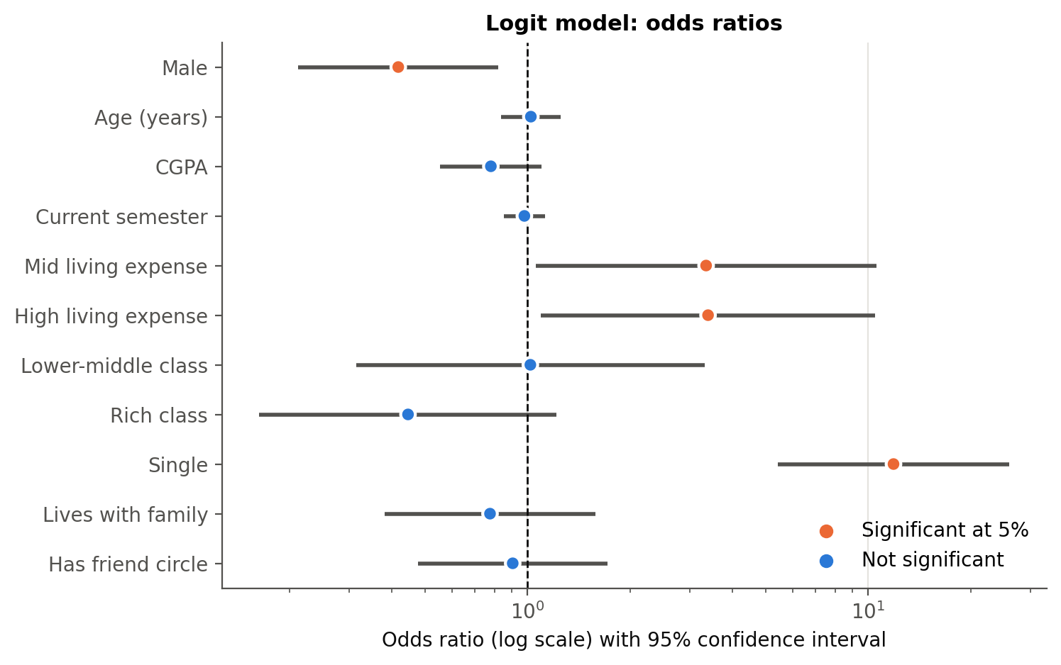
Figure 4.6: Odds ratios with 95% confidence intervals (log scale)

4.7 Marginal Effects Analysis (Logit)
Coefficients and odds ratios show the direction and relative strength of effects, but marginal effects are easier to interpret because they are expressed in probability terms. Table 4.7 and Figure 4.7 report the average marginal effects. For reference, the predicted probability of depression for a student with average characteristics is 22.0%.
Variable | dy/dx | Std. err. | z | P>|z| | 95% CI lower | 95% CI upper | Sig.
Male | -0.1403 | 0.0523 | -2.6851 | 0.0073 | -0.2427 | -0.0379 | ***
Age (years) | 0.0039 | 0.0166 | 0.2345 | 0.8146 | -0.0287 | 0.0365
CGPA | -0.0403 | 0.0282 | -1.4290 | 0.1530 | -0.0956 | 0.0150
Current semester | -0.0033 | 0.0115 | -0.2852 | 0.7755 | -0.0258 | 0.0192
Mid living expense | 0.2014 | 0.0941 | 2.1416 | 0.0322 | 0.0171 | 0.3858 | **
High living expense | 0.1998 | 0.0882 | 2.2646 | 0.0235 | 0.0269 | 0.3728 | **
Lower-middle class | 0.0033 | 0.0985 | 0.0338 | 0.9730 | -0.1898 | 0.1964
Rich class | -0.1202 | 0.0672 | -1.7881 | 0.0738 | -0.2519 | 0.0115 | *
Single | 0.3664 | 0.0425 | 8.6233 | <0.001 | 0.2831 | 0.4496 | ***
Lives with family | -0.0410 | 0.0584 | -0.7026 | 0.4823 | -0.1554 | 0.0734
Has friend circle | -0.0162 | 0.0539 | -0.3013 | 0.7632 | -0.1218 | 0.0893
Table 4.7: Average marginal effects after logit (dy/dx)
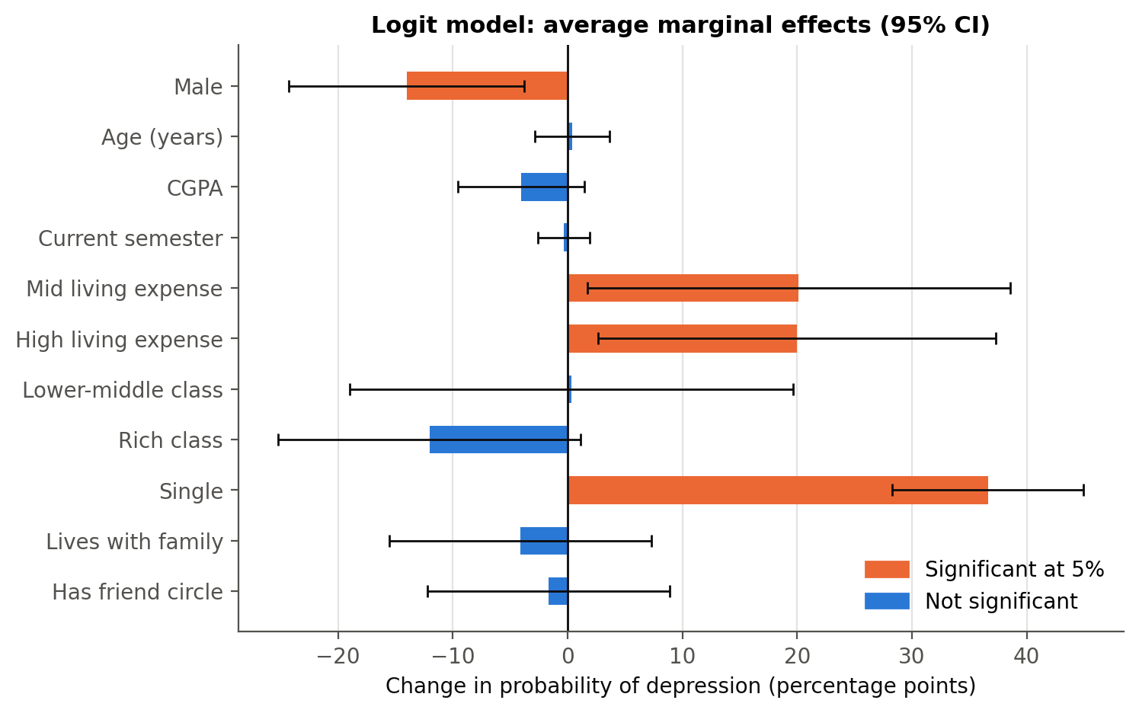
Figure 4.7: Average marginal effects after logit with 95% confidence intervals

4.7.1 Interpretation of Marginal Effects
- Being single raises the probability of depression by 36.6 percentage points (p < 0.001) — by far the largest effect in the model.
- Compared with a low living expense, a mid expense raises the probability by 20.1 percentage points (p = 0.032) and a high expense by 20.0 points (p = 0.024). Because the two effects are almost equal, the risk rises in one step from low to any higher expense rather than increasing steadily.
- Male students are 14.0 percentage points less likely to be depressed than female students (p = 0.007).
- Coming from a rich family lowers the probability by 12.0 percentage points relative to a middle-class family, significant only at the 10% level (p = 0.074); a lower-middle class background makes almost no difference (+0.3 percentage points, p = 0.973).
- A one-point increase in CGPA (on the 10-point scale) changes the probability by only -4.0 percentage points and is not significant (p = 0.153); having a friend circle is also not significant (p = 0.763).
Marginal effects at the means of all variables (equivalent to Stata's older mfx command) give very similar conclusions and are reported in the Excel workbook accompanying this report.

4.8 Binary Probit Regression
Table 4.8 reports the probit estimates. The model is again highly significant (LR χ²(11) = 72.61, p < 0.001) with a pseudo-R² of 0.190, almost identical to the logit model. Probit coefficients are on a different scale (roughly the logit coefficients divided by 1.6–1.8), but the signs and significance pattern are the same.
Variable | Coefficient | Std. err. | z | P>|z| | 95% CI lower | 95% CI upper | Sig.
Constant | -0.7478 | 1.6031 | -0.4665 | 0.6409 | -3.8898 | 2.3942
Male | -0.5496 | 0.2034 | -2.7020 | 0.0069 | -0.9483 | -0.1509 | ***
Age (years) | 0.0177 | 0.0605 | 0.2931 | 0.7695 | -0.1009 | 0.1363
CGPA | -0.1410 | 0.1025 | -1.3761 | 0.1688 | -0.3418 | 0.0598
Current semester | -0.0093 | 0.0405 | -0.2301 | 0.8180 | -0.0887 | 0.0701
Mid living expense | 0.7374 | 0.3536 | 2.0856 | 0.0370 | 0.0444 | 1.4303 | **
High living expense | 0.7417 | 0.3416 | 2.1713 | 0.0299 | 0.0722 | 1.4112 | **
Lower-middle class | 0.0291 | 0.3598 | 0.0810 | 0.9354 | -0.6760 | 0.7343
Rich class | -0.3668 | 0.2833 | -1.2946 | 0.1955 | -0.9221 | 0.1885
Single | 1.4319 | 0.2166 | 6.6114 | <0.001 | 1.0074 | 1.8564 | ***
Lives with family | -0.1806 | 0.2100 | -0.8600 | 0.3898 | -0.5922 | 0.2310
Has friend circle | -0.0621 | 0.1932 | -0.3216 | 0.7478 | -0.4409 | 0.3166
Table 4.8: Binary probit estimates (N = 317; dependent variable: depression)

4.8.1 Interpretation of Coefficients
Single status remains strongly positive and highly significant. Mid and high living expense remain positive and significant (p = 0.037 and p = 0.030), and the male coefficient remains negative and significant (p = 0.007). Rich family background is again negative but not significant (p = 0.196). CGPA, age, semester, lower-middle class, living with family and friend circle remain insignificant.

4.9 Marginal Effects (Probit)
Table 4.9 reports the average marginal effects after probit.
Variable | dy/dx | Std. err. | z | P>|z| | 95% CI lower | 95% CI upper | Sig.
Male | -0.1481 | 0.0517 | -2.8665 | 0.0041 | -0.2493 | -0.0468 | ***
Age (years) | 0.0049 | 0.0166 | 0.2933 | 0.7693 | -0.0277 | 0.0374
CGPA | -0.0387 | 0.0279 | -1.3874 | 0.1653 | -0.0934 | 0.0160
Current semester | -0.0026 | 0.0111 | -0.2302 | 0.8180 | -0.0244 | 0.0192
Mid living expense | 0.2077 | 0.0963 | 2.1568 | 0.0310 | 0.0190 | 0.3964 | **
High living expense | 0.2051 | 0.0893 | 2.2964 | 0.0217 | 0.0300 | 0.3802 | **
Lower-middle class | 0.0080 | 0.0992 | 0.0809 | 0.9355 | -0.1863 | 0.2024
Rich class | -0.0946 | 0.0677 | -1.3971 | 0.1624 | -0.2273 | 0.0381
Single | 0.3689 | 0.0430 | 8.5863 | <0.001 | 0.2847 | 0.4531 | ***
Lives with family | -0.0493 | 0.0567 | -0.8697 | 0.3845 | -0.1605 | 0.0618
Has friend circle | -0.0171 | 0.0535 | -0.3205 | 0.7486 | -0.1219 | 0.0877
Table 4.9: Average marginal effects after probit (dy/dx)
The probit marginal effects are almost identical to the logit ones: being single raises the probability of depression by 36.9 percentage points (logit: 36.6), a mid expense by 20.8 points (logit: 20.1), a high expense by 20.5 points (logit: 20.0), and being male lowers it by 14.8 points (logit: 14.0). The choice of link function therefore makes no practical difference to the conclusions.

4.10 Goodness of Fit and Model Diagnostics
Table 4.10 summarises the fit statistics of both models.
Statistic | Logit | Probit
Observations | 317.0000 | 317.0000
Log likelihood | -154.9392 | -154.6391
Log likelihood (null) | -190.9447 | -190.9447
LR chi2 | 72.0110 | 72.6112
LR df | 11.0000 | 11.0000
Prob > chi2 | 0.0000 | 0.0000
Pseudo R2 (McFadden) | 0.1886 | 0.1901
AIC | 333.8784 | 333.2783
BIC | 378.9853 | 378.3851
AUC (ROC) | 0.7825 | 0.7820
Hosmer-Lemeshow chi2 | 10.3476 | 19.4084
HL df | 8.0000 | 8.0000
HL p-value | 0.2415 | 0.0128
Table 4.10: Goodness-of-fit statistics
Both models have almost the same likelihood, AIC and AUC. The Hosmer–Lemeshow test does not reject the logit model (χ² = 10.35, p = 0.241), meaning that its predicted and observed depression rates agree across risk groups. For the probit model the test is rejected (p = 0.013), which supports keeping the logit as the main model. The AIC values of the two models ({R['logit_aic']:.2f} for logit, 333.28 for probit) differ only negligibly.
Table 4.11 shows the classification performance (equivalent to Stata's estat classification).
Model | Cutoff | True positives | False positives | False negatives | True negatives | Sensitivity | Specificity | Correctly classified
Logit | 0.500 | 23 | 27 | 69 | 198 | 0.250 | 0.880 | 0.697
Logit | 0.290 | 78 | 74 | 14 | 151 | 0.848 | 0.671 | 0.722
Probit | 0.500 | 24 | 29 | 68 | 196 | 0.261 | 0.871 | 0.694
Probit | 0.290 | 78 | 78 | 14 | 147 | 0.848 | 0.653 | 0.710
Table 4.11: Classification tables at the 0.5 cut-off and at the sample share of depressed students
At the conventional 0.5 cut-off the logit model classifies 69.7% of students correctly, with a specificity of 88.0% but a sensitivity of only 25.0%. Because depression affects fewer than half of the students, a lower cut-off equal to the sample share of depressed students (0.290) is more appropriate for screening: it identifies 84.8% of depressed students while still correctly classifying 67.1% of non-depressed students.
Figure 4.8 plots the ROC curves. The area under the curve is 0.782 for the logit and 0.782 for the probit model, indicating acceptable discrimination: a randomly chosen depressed student has a 78% chance of receiving a higher predicted probability than a randomly chosen non-depressed student.
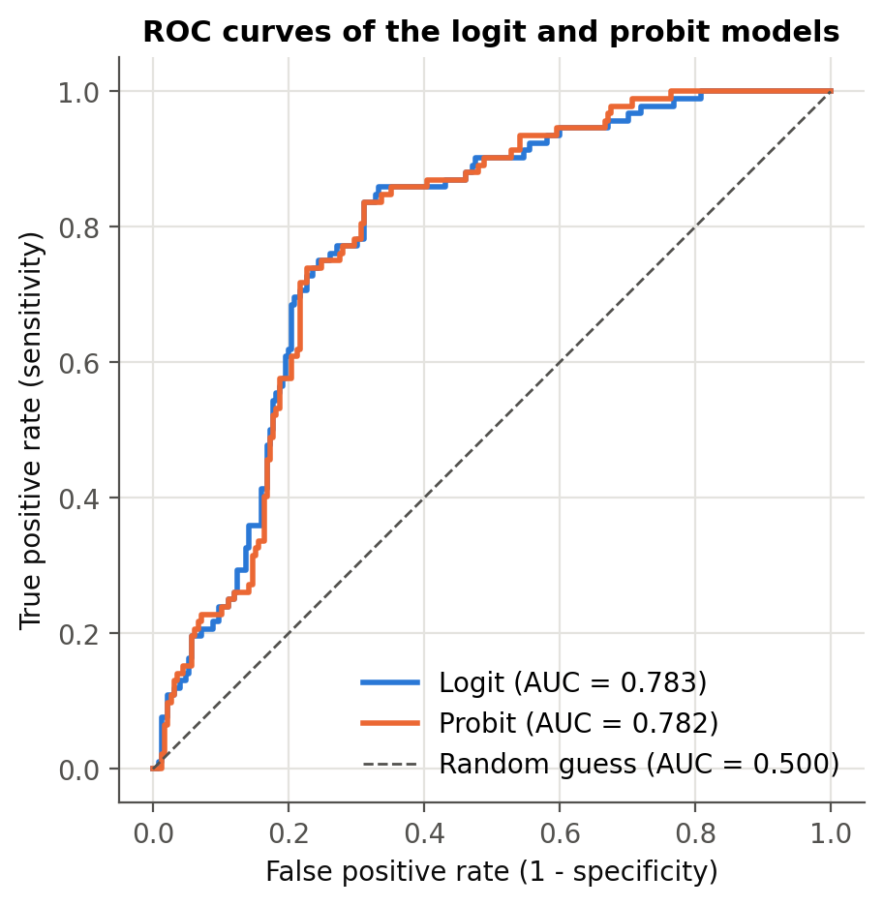
Figure 4.8: ROC curves of the logit and probit models
Figure 4.9 illustrates the size of the relationship-status effect. Holding all other variables at their means, the predicted probability of depression for single students ranges from 36% to 58% across the CGPA range, compared with 4–11% for students who are not single. Both lines slope gently downward, but the CGPA effect is not statistically significant.
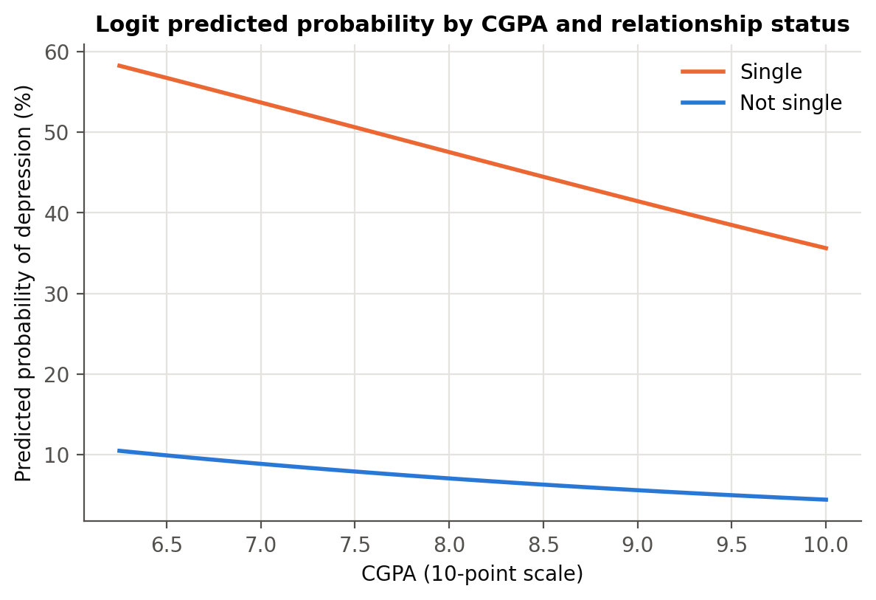
Figure 4.9: Predicted probability of depression by CGPA and relationship status

4.11 Hypothesis Testing Summary
Table 4.12 summarises the outcome of each hypothesis using the logit model.
Hypothesis | Variable | Expected sign | Logit coefficient | AME | P>|z| | Result
H1 | CGPA | - | -0.2465 | -0.0403 | 0.1578 | Not supported (not significant)
H2 | Has friend circle | - | -0.0988 | -0.0162 | 0.7624 | Not supported (not significant)
H3 | Single | + | 2.4750 | 0.3664 | <0.001 | Supported
H4a | Lower-middle class | + | 0.0204 | 0.0033 | 0.9730 | Not supported (not significant)
H4b | Rich class | - | -0.8066 | -0.1202 | 0.1157 | Not supported (not significant)
H5 | High living expense | + | 1.2214 | 0.1998 | 0.0339 | Supported
H6 | Lives with family | - | -0.2524 | -0.0410 | 0.4868 | Not supported (not significant)
H7 | Male | - | -0.8725 | -0.1403 | 0.0114 | Supported
Table 4.12: Summary of hypothesis tests
Hypotheses H3 (single students), H5 (high living expense) and H7 (female students) are supported at the 5% level. Hypotheses H1, H2, H4a, H4b, H6 are not supported: academic performance, friend circle, family background and living with family do not have a significant independent effect on depression at the 5% level. The rich-family effect (H4b) has the expected sign and its marginal effect is significant at the 10% level.

4.12 Robustness Checks
Table 4.13 compares the main logit model with six alternative specifications. Coefficients are shown with standard errors in parentheses.
Variable | 1 Logit | 2 Logit rob. | 3 Probit | 4 LPM rob. | 5 Logit+health | 6 LPM male | 7 LPM female
Constant | -1.082  (2.655) | -1.082  (2.552) | -0.748  (1.603) | 0.365  (0.477) | -2.025  (7.074) | 0.218  (0.625) | 0.177  (0.762)
Male | -0.872**  (0.345) | -0.872***  (0.329) | -0.550***  (0.203) | -0.135**  (0.054) | -1.935**  (0.956)
Age (years) | 0.024  (0.102) | 0.024  (0.099) | 0.018  (0.061) | 0.002  (0.017) | -0.212  (0.241) | -0.029  (0.023) | 0.028  (0.029)
CGPA | -0.247  (0.175) | -0.247  (0.179) | -0.141  (0.102) | -0.034  (0.029) | -0.024  (0.420) | 0.029  (0.047) | -0.080**  (0.040)
Current semester | -0.020  (0.070) | -0.020  (0.074) | -0.009  (0.041) | -0.003  (0.011) | -0.091  (0.161) | 0.002  (0.017) | -0.012  (0.015)
Mid living expense | 1.208**  (0.588) | 1.208**  (0.505) | 0.737**  (0.354) | 0.135*  (0.082) | -1.010  (1.207) | 0.278***  (0.094) | 0.167  (0.113)
High living expense | 1.221**  (0.576) | 1.221**  (0.503) | 0.742**  (0.342) | 0.129*  (0.072) | -0.721  (1.068) | 0.298***  (0.096) | 0.145  (0.094)
Lower-middle class | 0.020  (0.602) | 0.020  (0.546) | 0.029  (0.360) | -0.065  (0.087) | -1.311  (1.319) | 0.004  (0.103) | 0.056  (0.122)
Rich class | -0.807  (0.513) | -0.807  (0.568) | -0.367  (0.283) | -0.082  (0.077) | 0.932  (0.848) | -0.445***  (0.097) | -0.002  (0.104)
Single | 2.475***  (0.400) | 2.475***  (0.390) | 1.432***  (0.217) | 0.376***  (0.046) | 5.981***  (1.144) | 0.394***  (0.059) | 0.342***  (0.071)
Lives with family | -0.252  (0.363) | -0.252  (0.358) | -0.181  (0.210) | -0.036  (0.055) | -0.991  (0.759) | 0.011  (0.074) | -0.024  (0.075)
Has friend circle | -0.099  (0.327) | -0.099  (0.311) | -0.062  (0.193) | -0.009  (0.053) | -1.074  (0.751) | -0.072  (0.079) | 0.017  (0.072)
Poor health |  |  |  |  | 8.479***  (1.261)
Observations | 317 | 317 | 317 | 317 | 317 | 155 | 162
Pseudo R2 / R2 | 0.189 | 0.189 | 0.190 | 0.192 | 0.794 | 0.247 | 0.205
Table 4.13: Robustness checks across model specifications
Significance levels: *** p < 0.01, ** p < 0.05, * p < 0.10. Standard errors in parentheses.
Figure 4.10 compares the marginal effects of the logit, probit and linear probability models side by side. The logit and probit effects are almost identical for every variable; the linear probability model agrees on relationship status and gender but gives smaller living-expense effects.
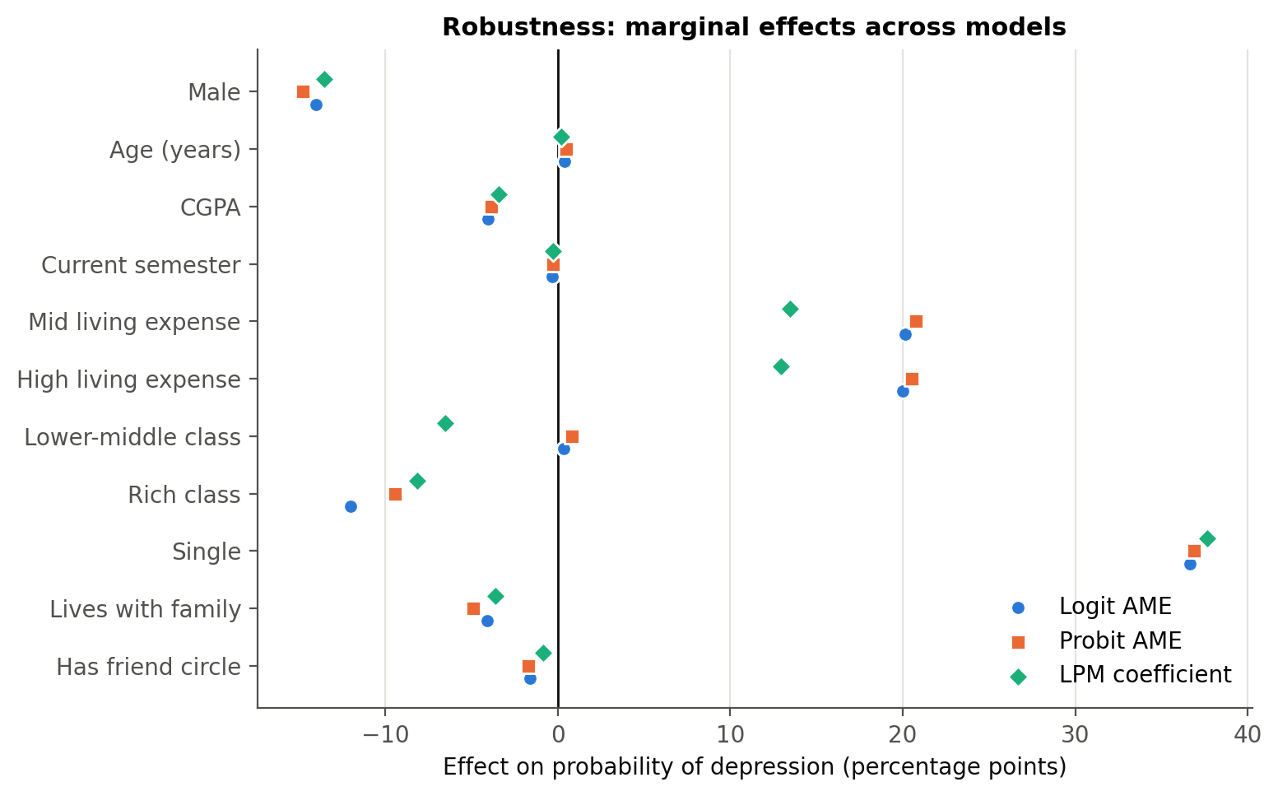
Figure 4.10: Marginal effects across logit, probit and linear probability models
- Robust standard errors (model 2): using heteroskedasticity-robust standard errors changes the standard errors only slightly; every variable keeps its sign and its significance at the 5% level.
- Linear probability model (model 4): the OLS coefficients, which are directly marginal effects (R² = 0.192), are very close to the logit and probit AMEs for being single (+37.6 percentage points) and male (-13.6 percentage points). The living-expense effects are smaller (+13.5 percentage points for mid and +12.9 percentage points for high) and significant only at the 10% level (p = 0.100 and 0.074), so the expense result is somewhat less robust than the relationship and gender results.
- Adding poor health (model 5): including the health indicator raises the pseudo-R² from 0.189 to 0.794 and the AUC to 0.986 (LR χ²(1) = 231.3, p < 0.001). Health status alone explains most of the variation in depression, and the estimation software flags quasi-complete separation (a fraction 0.16 of the observations is predicted perfectly), which confirms that it largely measures the same condition as the outcome. Being single and being male remain significant even in this model; the living-expense and rich-family coefficients lose significance.
- Male and female students (models 6 and 7): a separate logit cannot be estimated for male students because none of the 38 male students who are not single is depressed — being single predicts depression perfectly within this group. The gender subsamples are therefore estimated as linear probability models. Being single is a strong risk factor for both men (+39.4 percentage points, p < 0.001) and women (+34.2 percentage points, p < 0.001). Among men, a mid (+27.8 percentage points, p = 0.003) or high living expense (+29.8 percentage points, p = 0.002) raises the risk and a rich family lowers it (-44.5 percentage points, p < 0.001). Among women these effects are smaller and not significant (p = 0.14, 0.12 and 0.99), while a higher CGPA is associated with a lower risk (-8.0 points per grade point, p = 0.044). Each subsample has fewer than 50 depressed students, so these differences are indicative only.

Chapter 5
Findings, Conclusion, and Recommendations

5.1 Introduction
This chapter summarises the main findings, discusses what they mean for universities and for theory, sets out the limitations of the study, and suggests directions for future research.

5.2 Summary of Major Findings

5.2.1 Relationships Matter More than Grades
The single most important factor in this study is relationship status. Single students are 37 percentage points more likely to be depressed than students in a relationship, an effect that is large, highly significant and stable across every model specification and for both men and women. This strongly supports the stress-buffering view of close relationships (Cohen & Wills, 1985).

5.2.2 Financial Pressure: Living Expenses and Family Background
Students whose monthly living expense is mid or high are about 20 percentage points more likely to be depressed than students with a low expense, after controlling for family background and the other factors. The risk rises in one step from low to any higher expense rather than increasing steadily. Family background matters less once expenses are taken into account: middle-class students have the highest raw rate, and rich students are less likely to be depressed, but only at the 10% level. A possible explanation is that higher day-to-day costs create financial pressure that students from middle-class families cannot easily absorb, consistent with research linking financial strain to poor mental health (Lorant et al., 2003; Richardson et al., 2013).

5.2.3 The Gender Gap
Once other factors are held constant, female students are about 14 percentage points more likely to be depressed than male students. This gap is hidden in the raw data, where male students actually show a slightly higher rate, because male students are more often single. The adjusted result is consistent with the well-established gender difference in depression (Nolen-Hoeksema, 1987; Kessler, 2003).

5.2.4 What Did Not Matter: Grades, Friends and Living Arrangement
Contrary to common expectations, CGPA has no significant relationship with depression, and neither does the stage of study (semester) or age. Because every student in the sample has a CGPA above 6.00, this means that grades make little difference within this range; it does not show that very low grades are harmless. Having a friend circle and living with family also show no independent effect. Living with family appears protective in the raw data, but this disappears once relationship status and gender are controlled for. The kind of social support that matters most in this sample seems to be a close, intimate relationship rather than a wider friend group.

5.2.5 Health and Depression
Self-reported health condition is almost a mirror image of depression: all students in critical health are depressed and none in good health are. This shows how closely physical and mental health are linked, but also warns that self-reported health measures can overlap with the outcome they are meant to explain.

5.3 Policy Implications for Universities

5.3.1 Target Social Isolation, not only Academic Performance
Since academic performance does not predict depression in this sample, support services that focus mainly on academic difficulties will miss many depressed students. Universities should invest in programmes that reduce loneliness and build close connections — peer mentoring, small-group activities, residential community programmes and relationship and emotional-skills workshops.

5.3.2 Address Financial Pressure
Because students with higher living expenses are more often depressed, universities should combine mental health support with financial guidance: budgeting support, affordable housing and meal options, and need-based assistance that also reaches middle-income students, who may fall outside traditional aid schemes.

5.3.3 Gender-Sensitive Screening and Support
Female students face a higher adjusted risk, while male students may be less likely to seek help. Screening campaigns and counselling services should be designed to reach both groups — for example, confidential online screening, counsellors of both genders, and awareness campaigns that reduce stigma among men.

5.3.4 Simple Screening Tools
The model shows that a few easily collected characteristics can identify a large share of students at risk: using a cut-off equal to the sample share of depressed students, the logit model identifies 85% of depressed students. Such risk scores should never replace clinical assessment, but they can help universities decide whom to invite for further screening.

5.4 Theoretical Implications
The results support the diathesis–stress and stress-buffering frameworks: stressors such as financial pressure raise the probability of depression, while close relationships protect against it. They also suggest a refinement of social support theory for young adults — the protective effect appears to come from intimate relationships rather than from the size of the wider social network. Finally, the step pattern of living expenses, with mid and high expenses carrying the same extra risk, suggests that moving beyond a low cost of living — rather than the exact amount spent — is what adds pressure.

5.5 Limitations of the Study
- Cross-sectional design: the data capture one point in time, so the results show associations, not causal effects. Depression may itself affect relationship status (for example, by making it harder to form relationships).
- Self-reported measures: depression and health condition are self-reported yes/no or categorical indicators, not clinical diagnoses or validated symptom scales.
- Sample size: with 317 students and 92 depressed cases, the small 'complicated' relationship group had to be merged, and the gender subsample results are indicative only.
- Banded living expense: living expense is recorded in three bands, which loses detail within each band, and the expense effects are weaker in the linear probability model.
- Restricted sample: the sample covers only students with a CGPA above 6.00 and is not representative of all university students, which limits how far the results can be generalised.
- Omitted variables: factors such as family history of mental illness, substance use, sleep, physical activity and exposure to traumatic events are not available in the data.

5.6 Recommendations for Future Research
- Longitudinal studies following students over several semesters to establish whether changes in relationships and finances precede changes in depression.
- Validated depression scales such as the PHQ-9, which would allow depression severity to be modelled with ordered or count models rather than a simple yes/no outcome.
- Larger and more diverse samples covering the full range of grades, to estimate separate effects for small groups.
- Richer measures of social support, distinguishing the quality of friendships and family relationships from their mere presence.

5.7 Conclusion
Depression affects almost three in ten students in this sample. The analysis shows that it is driven less by grades and more by students' relationships and financial circumstances. Being single is the strongest risk factor; a mid or high living expense raises the risk compared with a low one; and male students are less likely to be depressed than female students, while a rich family background is only weakly protective. These findings are consistent across the logit and probit models, and the relationship and gender effects also hold in the linear probability model. For universities, the message is clear: protecting student mental health requires attention to social connection and financial wellbeing, not only to academic support.

Appendix
This appendix reports the full estimation output produced by the analysis notebook (notebooks/student_depression_analysis.ipynb), computed with Python statsmodels. The Stata do-file stata/student_depression_analysis.do contains the equivalent Stata commands (summarize, tabulate, logit, probit, margins, estat classification, estat gof, lroc, regress) and reproduces the same models. All tables are also available in the Excel workbook results/Student_Depression_Analysis_Results.xlsx.

A.1 Binary logit model
Logit Regression Results
==============================================================================
Dep. Variable: depression No. Observations: 317
Model: Logit Df Residuals: 305
Method: MLE Df Model: 11
Date: Wed, 07 Oct 2026 Pseudo R-squ.: 0.1886
Time: 22:07:04 Log-Likelihood: -154.94
converged: True LL-Null: -190.94
Covariance Type: nonrobust LLR p-value: 5.058e-11
=================================================================================
coef std err z P>|z| [0.025 0.975]
---------------------------------------------------------------------------------
const -1.0825 2.655 -0.408 0.683 -6.286 4.121
male -0.8725 0.345 -2.531 0.011 -1.548 -0.197
age 0.0238 0.102 0.234 0.815 -0.175 0.223
cgpa -0.2465 0.175 -1.412 0.158 -0.589 0.096
semester -0.0200 0.070 -0.285 0.776 -0.158 0.118
cost_mid 1.2083 0.588 2.054 0.040 0.055 2.362
cost_high 1.2214 0.576 2.121 0.034 0.093 2.350
fam_lowermid 0.0204 0.602 0.034 0.973 -1.159 1.199
fam_rich -0.8066 0.513 -1.573 0.116 -1.812 0.198
single 2.4750 0.400 6.195 0.000 1.692 3.258
live_family -0.2524 0.363 -0.695 0.487 -0.964 0.459
friend_circle -0.0988 0.327 -0.302 0.762 -0.739 0.542
=================================================================================

A.2 Binary probit model
Probit Regression Results
==============================================================================
Dep. Variable: depression No. Observations: 317
Model: Probit Df Residuals: 305
Method: MLE Df Model: 11
Date: Wed, 07 Oct 2026 Pseudo R-squ.: 0.1901
Time: 22:07:05 Log-Likelihood: -154.64
converged: True LL-Null: -190.94
Covariance Type: nonrobust LLR p-value: 3.885e-11
=================================================================================
coef std err z P>|z| [0.025 0.975]
---------------------------------------------------------------------------------
const -0.7478 1.603 -0.466 0.641 -3.890 2.394
male -0.5496 0.203 -2.702 0.007 -0.948 -0.151
age 0.0177 0.061 0.293 0.769 -0.101 0.136
cgpa -0.1410 0.102 -1.376 0.169 -0.342 0.060
semester -0.0093 0.041 -0.230 0.818 -0.089 0.070
cost_mid 0.7374 0.354 2.086 0.037 0.044 1.430
cost_high 0.7417 0.342 2.171 0.030 0.072 1.411
fam_lowermid 0.0291 0.360 0.081 0.935 -0.676 0.734
fam_rich -0.3668 0.283 -1.295 0.195 -0.922 0.189
single 1.4319 0.217 6.611 0.000 1.007 1.856
live_family -0.1806 0.210 -0.860 0.390 -0.592 0.231
friend_circle -0.0621 0.193 -0.322 0.748 -0.441 0.317
=================================================================================

A.3 Logit model with robust standard errors
Logit Regression Results
==============================================================================
Dep. Variable: depression No. Observations: 317
Model: Logit Df Residuals: 305
Method: MLE Df Model: 11
Date: Wed, 07 Oct 2026 Pseudo R-squ.: 0.1886
Time: 22:07:06 Log-Likelihood: -154.94
converged: True LL-Null: -190.94
Covariance Type: HC1 LLR p-value: 5.058e-11
=================================================================================
coef std err z P>|z| [0.025 0.975]
---------------------------------------------------------------------------------
const -1.0825 2.552 -0.424 0.671 -6.085 3.920
male -0.8725 0.329 -2.652 0.008 -1.517 -0.228
age 0.0238 0.099 0.240 0.810 -0.171 0.218
cgpa -0.2465 0.179 -1.380 0.168 -0.597 0.104
semester -0.0200 0.074 -0.270 0.787 -0.165 0.125
cost_mid 1.2083 0.505 2.393 0.017 0.219 2.198
cost_high 1.2214 0.503 2.430 0.015 0.236 2.207
fam_lowermid 0.0204 0.546 0.037 0.970 -1.050 1.091
fam_rich -0.8066 0.568 -1.421 0.155 -1.919 0.306
single 2.4750 0.390 6.338 0.000 1.710 3.240
live_family -0.2524 0.358 -0.705 0.481 -0.954 0.449
friend_circle -0.0988 0.311 -0.318 0.750 -0.708 0.510
=================================================================================

A.4 Linear probability model (robust standard errors)
OLS Regression Results
==============================================================================
Dep. Variable: depression R-squared: 0.192
Model: OLS Adj. R-squared: 0.163
Method: Least Squares F-statistic: 9.124
Date: Wed, 07 Oct 2026 Prob (F-statistic): 4.08e-14
Time: 22:07:06 Log-Likelihood: -165.59
No. Observations: 317 AIC: 355.2
Df Residuals: 305 BIC: 400.3
Df Model: 11
Covariance Type: HC1
=================================================================================
coef std err z P>|z| [0.025 0.975]
---------------------------------------------------------------------------------
const 0.3646 0.477 0.765 0.444 -0.570 1.299
male -0.1355 0.054 -2.491 0.013 -0.242 -0.029
age 0.0018 0.017 0.102 0.919 -0.032 0.036
cgpa -0.0341 0.029 -1.173 0.241 -0.091 0.023
semester -0.0026 0.011 -0.236 0.813 -0.024 0.019
cost_mid 0.1347 0.082 1.647 0.100 -0.026 0.295
cost_high 0.1292 0.072 1.788 0.074 -0.012 0.271
fam_lowermid -0.0654 0.087 -0.754 0.451 -0.235 0.105
fam_rich -0.0816 0.077 -1.066 0.287 -0.232 0.068
single 0.3764 0.046 8.114 0.000 0.285 0.467
live_family -0.0363 0.055 -0.658 0.510 -0.144 0.072
friend_circle -0.0087 0.053 -0.165 0.869 -0.112 0.095
==============================================================================
Omnibus: 74.383 Durbin-Watson: 2.110
Prob(Omnibus): 0.000 Jarque-Bera (JB): 26.867
Skew: 0.504 Prob(JB): 1.47e-06
Kurtosis: 1.991 Cond. No. 480.
==============================================================================

Notes:
[1] Standard Errors are heteroscedasticity robust (HC1)

A.5 Logit model including poor health
Logit Regression Results
==============================================================================
Dep. Variable: depression No. Observations: 317
Model: Logit Df Residuals: 304
Method: MLE Df Model: 12
Date: Wed, 07 Oct 2026 Pseudo R-squ.: 0.7941
Time: 22:07:06 Log-Likelihood: -39.314
converged: True LL-Null: -190.94
Covariance Type: nonrobust LLR p-value: 9.699e-58
=================================================================================
coef std err z P>|z| [0.025 0.975]
---------------------------------------------------------------------------------
const -2.0254 7.074 -0.286 0.775 -15.891 11.840
male -1.9351 0.956 -2.023 0.043 -3.810 -0.061
age -0.2116 0.241 -0.877 0.381 -0.685 0.262
cgpa -0.0242 0.420 -0.057 0.954 -0.848 0.799
semester -0.0913 0.161 -0.568 0.570 -0.406 0.224
cost_mid -1.0101 1.207 -0.837 0.403 -3.375 1.355
cost_high -0.7208 1.068 -0.675 0.500 -2.814 1.372
fam_lowermid -1.3113 1.319 -0.994 0.320 -3.897 1.274
fam_rich 0.9323 0.848 1.099 0.272 -0.731 2.595
single 5.9807 1.144 5.227 0.000 3.738 8.223
live_family -0.9914 0.759 -1.305 0.192 -2.480 0.497
friend_circle -1.0736 0.751 -1.430 0.153 -2.545 0.398
health_poor 8.4788 1.261 6.722 0.000 6.006 10.951
=================================================================================

Possibly complete quasi-separation: A fraction 0.16 of observations can be
perfectly predicted. This might indicate that there is complete
quasi-separation. In this case some parameters will not be identified.

A.6 Linear probability model: male students
OLS Regression Results
==============================================================================
Dep. Variable: depression R-squared: 0.247
Model: OLS Adj. R-squared: 0.195
Method: Least Squares F-statistic: 7.434
Date: Wed, 07 Oct 2026 Prob (F-statistic): 1.86e-09
Time: 22:07:06 Log-Likelihood: -77.438
No. Observations: 155 AIC: 176.9
Df Residuals: 144 BIC: 210.4
Df Model: 10
Covariance Type: HC1
=================================================================================
coef std err z P>|z| [0.025 0.975]
---------------------------------------------------------------------------------
const 0.2184 0.625 0.349 0.727 -1.007 1.444
age -0.0291 0.023 -1.273 0.203 -0.074 0.016
cgpa 0.0290 0.047 0.618 0.537 -0.063 0.121
semester 0.0020 0.017 0.117 0.907 -0.031 0.035
cost_mid 0.2783 0.094 2.976 0.003 0.095 0.462
cost_high 0.2983 0.096 3.123 0.002 0.111 0.486
fam_lowermid 0.0042 0.103 0.040 0.968 -0.199 0.207
fam_rich -0.4449 0.097 -4.566 0.000 -0.636 -0.254
single 0.3938 0.059 6.717 0.000 0.279 0.509
live_family 0.0106 0.074 0.143 0.886 -0.134 0.155
friend_circle -0.0716 0.079 -0.902 0.367 -0.227 0.084
==============================================================================
Omnibus: 56.852 Durbin-Watson: 2.221
Prob(Omnibus): 0.000 Jarque-Bera (JB): 11.309
Skew: 0.311 Prob(JB): 0.00350
Kurtosis: 1.832 Cond. No. 437.
==============================================================================

Notes:
[1] Standard Errors are heteroscedasticity robust (HC1)

A.7 Linear probability model: female students
OLS Regression Results
==============================================================================
Dep. Variable: depression R-squared: 0.205
Model: OLS Adj. R-squared: 0.153
Method: Least Squares F-statistic: 4.770
Date: Wed, 07 Oct 2026 Prob (F-statistic): 6.07e-06
Time: 22:07:06 Log-Likelihood: -81.134
No. Observations: 162 AIC: 184.3
Df Residuals: 151 BIC: 218.2
Df Model: 10
Covariance Type: HC1
=================================================================================
coef std err z P>|z| [0.025 0.975]
---------------------------------------------------------------------------------
const 0.1772 0.762 0.233 0.816 -1.316 1.670
age 0.0277 0.029 0.953 0.340 -0.029 0.085
cgpa -0.0800 0.040 -2.010 0.044 -0.158 -0.002
semester -0.0117 0.015 -0.787 0.431 -0.041 0.017
cost_mid 0.1670 0.113 1.474 0.141 -0.055 0.389
cost_high 0.1446 0.094 1.536 0.125 -0.040 0.329
fam_lowermid 0.0565 0.122 0.464 0.643 -0.182 0.295
fam_rich -0.0015 0.104 -0.015 0.988 -0.205 0.202
single 0.3423 0.071 4.799 0.000 0.203 0.482
live_family -0.0245 0.075 -0.327 0.743 -0.171 0.122
friend_circle 0.0166 0.072 0.231 0.817 -0.124 0.158
==============================================================================
Omnibus: 14.992 Durbin-Watson: 1.918
Prob(Omnibus): 0.001 Jarque-Bera (JB): 13.025
Skew: 0.612 Prob(JB): 0.00148
Kurtosis: 2.342 Cond. No. 554.
==============================================================================

Notes:
[1] Standard Errors are heteroscedasticity robust (HC1)

A.8 Marginal effects at the means (logit)
Variable | dy/dx | Std. err. | z | P>|z| | 95% CI lower | 95% CI upper | Sig.
Male | -0.1486 | 0.0577 | -2.5756 | 0.0100 | -0.2616 | -0.0355 | **
Age (years) | 0.0041 | 0.0174 | 0.2346 | 0.8145 | -0.0300 | 0.0382
CGPA | -0.0423 | 0.0297 | -1.4225 | 0.1549 | -0.1005 | 0.0160
Current semester | -0.0034 | 0.0120 | -0.2852 | 0.7755 | -0.0270 | 0.0202
Mid living expense | 0.2338 | 0.1216 | 1.9226 | 0.0545 | -0.0045 | 0.4722 | *
High living expense | 0.2265 | 0.1104 | 2.0513 | 0.0402 | 0.0101 | 0.4430 | **
Lower-middle class | 0.0035 | 0.1038 | 0.0337 | 0.9731 | -0.1999 | 0.2069
Rich class | -0.1175 | 0.0609 | -1.9301 | 0.0536 | -0.2369 | 0.0018 | *
Single | 0.3699 | 0.0448 | 8.2479 | <0.001 | 0.2820 | 0.4577 | ***
Lives with family | -0.0427 | 0.0604 | -0.7064 | 0.4799 | -0.1611 | 0.0757
Has friend circle | -0.0171 | 0.0572 | -0.2993 | 0.7647 | -0.1293 | 0.0950
Table A.1: Marginal effects at the means after logit

A.9 Subsample marginal effects (linear probability model)
Variable | Female students: dy/dx | Male students: dy/dx | Female students: P>|z| | Male students: P>|z|
Age (years) | 0.0277 | -0.0291 | 0.3404 | 0.2031
CGPA | -0.0800 | 0.0290 | 0.0444 | 0.5368
Current semester | -0.0117 | 0.0020 | 0.4311 | 0.9067
Has friend circle | 0.0166 | -0.0716 | 0.8171 | 0.3670
High living expense | 0.1446 | 0.2983 | 0.1246 | 0.0018
Lives with family | -0.0245 | 0.0106 | 0.7433 | 0.8864
Lower-middle class | 0.0565 | 0.0042 | 0.6429 | 0.9679
Mid living expense | 0.1670 | 0.2783 | 0.1405 | 0.0029
Rich class | -0.0015 | -0.4449 | 0.9884 | <0.001
Single | 0.3423 | 0.3938 | <0.001 | <0.001
Table A.2: Marginal effects for male and female students (LPM, robust SE)

References
Beck, A. T. (1967). Depression: Clinical, experimental, and theoretical aspects. New York: Harper & Row.
Bulloch, A. G., Williams, J. V., Lavorato, D. H., & Patten, S. B. (2009). The relationship between major depression and marital disruption is bidirectional. Depression and Anxiety, 26(12), 1172–1177.
Cohen, S., & Wills, T. A. (1985). Stress, social support, and the buffering hypothesis. Psychological Bulletin, 98(2), 310–357.
Eisenberg, D., Gollust, S. E., Golberstein, E., & Hefner, J. L. (2007). Prevalence and correlates of depression, anxiety, and suicidality among university students. American Journal of Orthopsychiatry, 77(4), 534–542.
Hosmer, D. W., Lemeshow, S., & Sturdivant, R. X. (2013). Applied logistic regression (3rd ed.). Hoboken, NJ: Wiley.
Hysenbegasi, A., Hass, S. L., & Rowland, C. R. (2005). The impact of depression on the academic productivity of university students. Journal of Mental Health Policy and Economics, 8(3), 145–151.
Ibrahim, A. K., Kelly, S. J., Adams, C. E., & Glazebrook, C. (2013). A systematic review of studies of depression prevalence in university students. Journal of Psychiatric Research, 47(3), 391–400.
Kawachi, I., & Berkman, L. F. (2001). Social ties and mental health. Journal of Urban Health, 78(3), 458–467.
Kessler, R. C. (2003). Epidemiology of women and depression. Journal of Affective Disorders, 74(1), 5–13.
Long, J. S., & Freese, J. (2014). Regression models for categorical dependent variables using Stata (3rd ed.). College Station, TX: Stata Press.
Lorant, V., Deliège, D., Eaton, W., Robert, A., Philippot, P., & Ansseau, M. (2003). Socioeconomic inequalities in depression: A meta-analysis. American Journal of Epidemiology, 157(2), 98–112.
Monroe, S. M., & Simons, A. D. (1991). Diathesis–stress theories in the context of life stress research: Implications for the depressive disorders. Psychological Bulletin, 110(3), 406–425.
Moussavi, S., Chatterji, S., Verdes, E., Tandon, A., Patel, V., & Ustun, B. (2007). Depression, chronic diseases, and decrements in health: Results from the World Health Surveys. The Lancet, 370(9590), 851–858.
Nolen-Hoeksema, S. (1987). Sex differences in unipolar depression: Evidence and theory. Psychological Bulletin, 101(2), 259–282.
Richardson, T., Elliott, P., & Roberts, R. (2013). The relationship between personal unsecured debt and mental and physical health: A systematic review and meta-analysis. Clinical Psychology Review, 33(8), 1148–1162.
Seabold, S., & Perktold, J. (2010). Statsmodels: Econometric and statistical modeling with Python. Proceedings of the 9th Python in Science Conference, 92–96.
StataCorp. (2021). Stata statistical software: Release 17. College Station, TX: StataCorp LLC.
Whitton, S. W., & Whisman, M. A. (2010). Relationship satisfaction instability and depression. Journal of Family Psychology, 24(6), 791–794.
Wooldridge, J. M. (2010). Econometric analysis of cross section and panel data (2nd ed.). Cambridge, MA: MIT Press.

