Determinants of Depression among University Students: An Econometric Analysis using Logit and Probit Models
Report submitted to
Dr. Prantik Bagchi
Department of Humanities and Social Sciences
Indian Institute of Technology Kharagpur
Submitted by
Atharv Lodhi
Sourav Choudhary
Piyush Bisht

Department of Humanities and Social Sciences
Indian Institute of Technology Kharagpur
Kharagpur, West Bengal 721302
© 2026. All rights reserved

Contents
I. Introduction 1
A. Background 1
B. Problem Statement 1
C. Objectives and Research Questions 1
D. Hypotheses 1
E. Contributions and Organization 2
II. Literature Review 2
A. The Diathesis–Stress Model 2
B. Social Support and the Stress-Buffering Hypothesis 2
C. Academic Pressure and Performance 2
D. Socioeconomic Status and Financial Strain 2
E. Relationships and Gender 2
F. Physical Health and Summary 2
III. Data and Methodology 2
A. Data 2
B. Data Transformation 2
C. Econometric Models 3
D. Diagnostics, Robustness and Software 3
IV. Empirical Results 3
A. Descriptive Analysis 3
B. Bivariate Tests 6
C. Multicollinearity 6
D. Binary Logit Model 7
E. Marginal Effects 8
F. Binary Probit Model 9
G. Goodness of Fit 9
H. Hypothesis Tests 10
I. Robustness Checks 11
V. Discussion 12
A. Key Findings 12
B. Implications for Universities 12
C. Theoretical Implications 12
VI. Limitations and Future Research 12
VII. Conclusion 12
References 12
Appendix: Full Model Output 13

List of Figures
Fig. 1. Distribution of the dependent variable (depression status). 3
Fig. 2. Depression rate by student characteristics (dashed line: sample average). 4
Fig. 3. Depression by self-reported health condition. 4
Fig. 4. Distribution of CGPA, age and semester by depression status. 4
Fig. 5. Depression rate by age and semester group. 5
Fig. 6. Correlation matrix of coded variables. 6
Fig. 7. Logit odds ratios with 95% confidence intervals (log scale). 8
Fig. 8. Average marginal effects after logit with 95% confidence intervals. 8
Fig. 9. ROC curves of the logit and probit models. 10
Fig. 10. Predicted probability of depression by CGPA and relationship status. 10
Fig. 11. Marginal effects across logit, probit and linear probability models. 11

List of Tables
Table I Raw Data (First Five Records) 2
Table II Description of Variables 3
Table III Summary Statistics of Coded Variables 5
Table IV Chi-Square Tests of Independence with Depression 6
Table V Difference in Means Between Depressed and Non-Depressed Students 6
Table VI Variance Inflation Factors 7
Table VII Binary Logit Estimates (N = 317; Dependent Variable: Depression) 7
Table VIII Odds Ratios from the Logit Model 7
Table IX Average Marginal Effects after Logit (dy/dx) 8
Table X Binary Probit Estimates (N = 317; Dependent Variable: Depression) 9
Table XI Average Marginal Effects after Probit (dy/dx) 9
Table XII Goodness-of-Fit Statistics 10
Table XIII Classification Tables (Cut-off 0.5 and Sample Share) 10
Table XIV Summary of Hypothesis Tests 10
Table XV Robustness Checks Across Model Specifications 11
Table XVI Marginal Effects at the Means after Logit 16
Table XVII Marginal Effects for Male and Female Students (LPM, Robust SE) 16

Determinants of Depression among University Students: An Econometric Analysis using Logit and Probit Models
Atharv Lodhi | Sourav Choudhary | Piyush Bisht
Dept. of Humanities and Social Sciences  IIT Kharagpur | Dept. of Humanities and Social Sciences  IIT Kharagpur | Dept. of Humanities and Social Sciences  IIT Kharagpur

Abstract—Depression is one of the most common mental health problems among university students, yet it is unclear which personal, social and economic characteristics separate depressed students from others once they are considered together. Using survey data on 317 university students aged 18–24 with a CGPA above 6.00 on a 10-point scale, of whom 92 (29.0%) report depression, this paper estimates binary logit and probit models with average marginal effects, supported by chi-square and t-tests, multicollinearity, goodness-of-fit and robustness checks. Being single is the strongest risk factor (+36.6 percentage points, p < 0.001). Compared with students whose monthly living expense is low, students with mid (+20.1 percentage points) and high (+20.0 percentage points) expenses are more likely to be depressed, and male students are 14.0 points less likely to be depressed than female students (p = 0.007). A rich family background is protective only at the 10% level, and CGPA, semester, age, living arrangement and having a friend circle show no significant effect. The logit model is jointly significant (LR χ²(11) = 72.01, p < 0.001), well calibrated (Hosmer–Lemeshow p = 0.241) and has an AUC of 0.782; the probit model gives almost identical effects. The results suggest that student mental health support should prioritise social connection and financial pressure rather than academic performance alone.
Index Terms—Depression, university students, binary logit, probit, marginal effects, relationship status, socioeconomic status, mental health.

I. Introduction

A. Background
University life combines several major transitions within a few years: students move away from home, form new friendships and romantic relationships, manage their own money and face continuous academic evaluation. For many students these changes are a source of persistent stress, and depression—marked by low mood, loss of interest, fatigue and feelings of worthlessness—is among the most frequent mental health problems in this group. A systematic review of university students reported an average depression prevalence of about 30%, well above the general population [1]. Student depression also lowers academic productivity and raises the risk of dropping out [2], [3], so knowing which students are most at risk matters to universities deciding where to direct limited counselling resources.
Theory points to many interrelated causes: stressful life events acting on individual vulnerability [4], the protective role of social support [5], a socioeconomic gradient in depression [6] and higher depression among women [7]. This paper brings these strands together and tests them jointly on one well-defined group of students.

B. Problem Statement
Many studies examine one factor at a time—for example grades or family income—and therefore cannot tell whether an apparent effect is real or reflects other, correlated characteristics. If single students are also more likely to live away from family, a simple comparison cannot separate the two. There is also a widespread assumption that poor grades are a main driver of depression; if this is wrong, support programmes focused on academic help will miss many students in need. This study estimates multivariate probability models that isolate the contribution of each factor while holding the others constant.

C. Objectives and Research Questions
The study aims to (i) measure the prevalence of depression in the sample; (ii) compare depression across gender, family background, relationship status, living style, social support and health; (iii) estimate the effect of each factor with logit and probit models; (iv) express the effects as changes in probability; (v) test their robustness; and (vi) derive recommendations for universities. It asks whether academic performance, relationship status, family background and living costs, gender, and social support are associated with the probability of depression.

D. Hypotheses
Based on the literature in Section II, the following hypotheses are tested:
- H1: Students with higher CGPA are less likely to be depressed (academic stress).
- H2: Students with a friend circle are less likely to be depressed (social support).
- H3: Single students are more likely to be depressed than students in a relationship.
- H4a: Students from lower-middle class families are more likely to be depressed than middle class.
- H4b: Students from rich families are less likely to be depressed than middle class.
- H5: Students with high living expenses are more likely to be depressed than those with low expenses (financial pressure).
- H6: Students living with family are less likely to be depressed than those living as bachelors.
- H7: Female students are more likely to be depressed than male students.

E. Contributions and Organization
The paper contributes evidence on the relative importance of social, economic and academic factors measured on the same students, reports marginal effects that translate results into probability changes, and offers practical guidance for student support services. Section II reviews the literature, Section III describes the data and methodology, Section IV presents the results, Section V discusses them, Section VI covers limitations and future research, and Section VII concludes. The appendix reports the full model output.

II. Literature Review

A. The Diathesis–Stress Model
The diathesis–stress model holds that depression develops when stressful events act on a pre-existing vulnerability [4]. Students face a dense cluster of stressors—examinations, financial obligations, relationship changes and living away from home—so the model predicts higher depression among students exposed to more stressors or with fewer buffers. Beck's cognitive theory adds that negative interpretations of such events turn stress into depressive symptoms [8].

B. Social Support and the Stress-Buffering Hypothesis
Social support protects mental health mainly by buffering the impact of stress: people with close, supportive relationships cope better with the same adversity [5]. Friendships, partners and family reduce the risk of depression through emotional support and a sense of belonging [9]. For students, friend circles, partners and living with family are the most direct sources of such support (H2, H3, H6).

C. Academic Pressure and Performance
Academic stress is widely cited as a driver of student depression, and depression is associated with lower grade point averages [2], [3]. The direction of causality is unclear, however, and links often weaken once social and economic variables are included. H1 tests whether CGPA has an independent association.

D. Socioeconomic Status and Financial Strain
People with lower socioeconomic status have significantly higher odds of depression, with financial strain a main channel [6]. Debt and money worries are strongly linked to poor mental health [10]. Family background shapes both resources and expectations, while a student's monthly living expense is a direct measure of financial pressure (H4a, H4b, H5).

E. Relationships and Gender
The quality and stability of romantic relationships are closely tied to depressive symptoms [11], and the link between relationship disruption and depression runs in both directions [12]. Being single can bring loneliness in early adulthood (H3). Women experience depression roughly twice as often as men [7], [13], a gap attributed to differences in stress exposure, coping styles and biology (H7).

F. Physical Health and Summary
Chronic physical conditions sharply increase the probability of depression [14], so self-reported health is expected to be strongly related to depression. When a health measure partly reflects the same symptoms, however, it cannot be treated as an independent cause—an issue that proves important here. Overall, the literature identifies academic, social, economic, demographic and health factors, but rarely estimates them jointly in one sample; this paper addresses that gap.

III. Data and Methodology

A. Data
The study uses survey data on 317 university students aged 18–24 (155 male, 162 female). The 18–24 range covers the typical undergraduate age. CGPA is measured on a 10-point scale, and every student in the sample has a CGPA above 6.00. For each student the data record gender, age, family background, relationship status, living style, current semester, CGPA, friend circle, self-reported health, monthly living expense excluding study costs (recorded in three bands) and depression status. Table I shows the first five records.

Table I
Raw Data (First Five Records)
Gender | Age | Family background | Relationship | Living | Semester | CGPA | Friends | Health | Expense | Depression
Female | 21 | Middle class | Single | Bachelor | 7 | 8.00 | Yes | Abnormal | High | No
Male | 20 | Middle class | Single | Bachelor | 5 | 9.30 | Yes | Abnormal | Mid | Yes
Male | 23 | Middle class | In a Relationship | Bachelor | 4 | 9.18 | Yes | Good | High | No
Male | 20 | Middle class | Single | Bachelor | 8 | 7.50 | Yes | Good | High | No
Male | 22 | Middle class | Single | Bachelor | 3 | 8.98 | Yes | Good | High | No

B. Data Transformation
The data contain 0 missing values and 4 duplicate records. Text answers were converted to 0/1 indicators (depression, male, living with family, friend circle). Family background was coded as two dummies (lower-middle class, rich class) with middle class as the base. The very small 'complicated' relationship group (11 students, none depressed) would be predicted perfectly, so it was merged and relationship status became single vs. not single. Monthly living expense (excluding study costs) is grouped into three bands cut at the rounded sample thirds: low (below 10,000), mid (10,000–14,999) and high (15,000 or more); it enters the models as two dummies (mid, high) with low as the base.
Self-reported health is almost perfectly aligned with depression: 100% of students in critical health and 0% in good health are depressed. Including it in the main model would cause quasi-complete separation, and it very likely measures the same condition as the outcome. It is therefore analysed descriptively and entered only in one robustness model. Table II describes the final variables.

Table II
Description of Variables
Variable name | Description and coding | Data type
depression | Whether the student reports depression. 1 = Yes, 0 = No. | Binary (dependent variable)
male | Gender of the student. 1 = Male, 0 = Female. | Binary
age | Age of the student in years (18-24). | Numerical (discrete)
cgpa | Cumulative grade point average on a 10.00 scale (sample restricted to CGPA above 6.00). | Numerical (continuous)
semester | Semester the student is currently in. | Numerical (discrete)
cost_mid | 1 = Mid monthly living cost, 10,000-14,999 excluding study costs (base group: Low, below 10,000). | Binary (dummy)
cost_high | 1 = High monthly living cost, 15,000 or more excluding study costs (base group: Low, below 10,000). | Binary (dummy)
fam_lowermid | 1 = Lower-middle class family (base group: middle class). | Binary (dummy)
fam_rich | 1 = Rich class family (base group: middle class). | Binary (dummy)
single | 1 = Single, 0 = In a relationship or complicated. | Binary
live_family | 1 = Lives with family, 0 = Lives as a bachelor (hostel/mess/shared). | Binary
friend_circle | 1 = Has a friend circle, 0 = Does not. | Binary
health_poor | 1 = Abnormal or critical health, 0 = Good or normal (robustness model only). | Binary
health_level | 1 = Good, 2 = Normal, 3 = Abnormal, 4 = Critical (descriptive only). | Ordinal

C. Econometric Models
Because the outcome is binary, ordinary least squares can predict values outside 0–1 and is heteroskedastic by construction, so binary choice models are used [15], [16]. The logit model is
Pr(yᵢ = 1 | xᵢ) = Λ(xᵢ′β) = exp(xᵢ′β) / [1 + exp(xᵢ′β)] (1)
with xᵢ′β = β₀ + β₁Male + β₂Age + β₃CGPA + β₄Semester + β₅MidExpense + β₆HighExpense + β₇LowerMid + β₈Rich + β₉Single + β₁₀LiveFamily + β₁₁FriendCircle. Coefficients are estimated by maximum likelihood; exp(β) is the odds ratio. The probit model replaces Λ with the standard normal CDF Φ:
Pr(yᵢ = 1 | xᵢ) = Φ(xᵢ′β) (2)
Because coefficients of the two models are on different scales, results are reported mainly as average marginal effects (AME): the average change in Pr(y = 1) when a continuous variable rises by one unit, or when a 0/1 variable changes from 0 to 1 (Stata: margins, dydx(*)).

D. Diagnostics, Robustness and Software
Fit is assessed with the likelihood-ratio test, McFadden's pseudo-R², AIC/BIC, classification tables, the area under the ROC curve and the Hosmer–Lemeshow test [17]; multicollinearity with variance inflation factors. Robustness checks use robust standard errors, a linear probability model (LPM), a model adding health status, and separate models for male and female students. Estimation used Python (pandas, SciPy, statsmodels [18]); an equivalent Stata do-file reproduces every step [19]. The data are anonymised, contain no personal identifiers, and results are reported only at group level.

IV. Empirical Results

A. Descriptive Analysis
Depression is common: 29.0% of students—almost three in ten—report it (Fig. 1), in line with international estimates of around 30% [1]. The outcome is balanced enough for a binary choice model, with enough depressed students relative to the number of regressors for stable estimation.
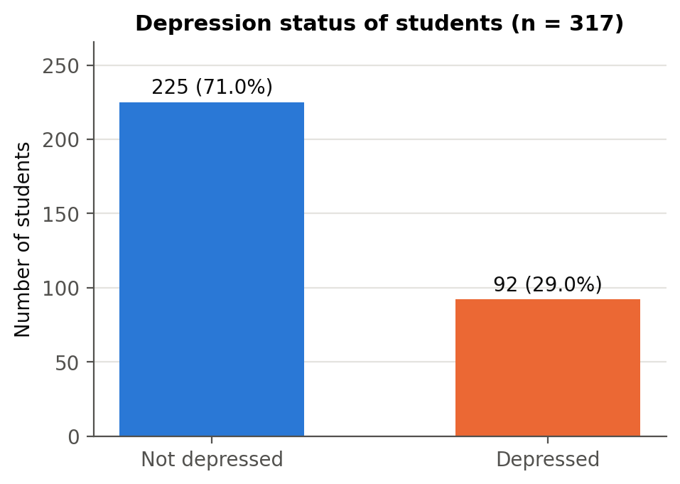
Fig. 1. Distribution of the dependent variable (depression status).
Fig. 2 compares depression rates across groups. Relationship status shows the largest gap: 42.9% of single students are depressed versus 8.7% of students in a relationship and none of the 11 in a complicated relationship. Middle-class students have the highest rate (35.1%), above lower-middle class (20.3%) and rich students (15.7%). Students living as bachelors are more often depressed (34.0%) than those living with family (21.7%). Students with a low living expense are less often depressed (19.1%) than those with a mid (35.2%) or high (33.6%) expense. Gender and friend circle show small raw differences (male 30.3%, female 27.8%; friend circle 29.0% vs. 29.0%). These raw comparisons ignore overlaps between characteristics—single students are more often male and less often live with family—which the regression models separate.

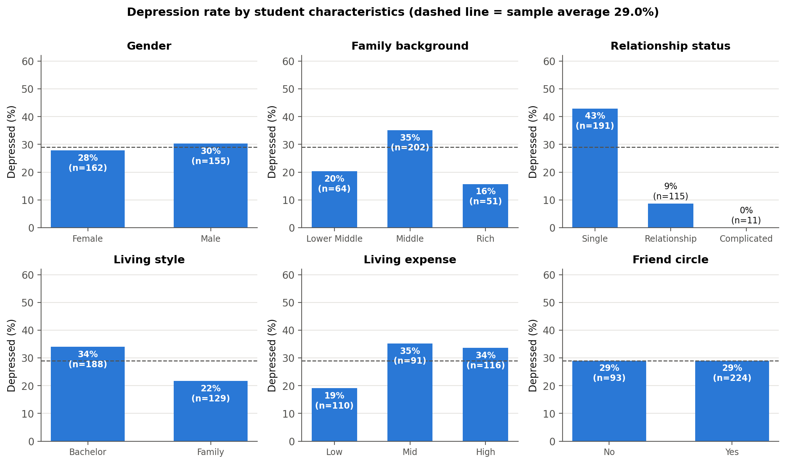
Fig. 2. Depression rate by student characteristics (dashed line: sample average).

Fig. 3 shows how closely self-reported health tracks depression: none of the students in good health and only 2.8% in normal health are depressed, against 60.0% in abnormal and 100% in critical health. Health therefore nearly predicts the outcome and is not used as a regressor in the main model.
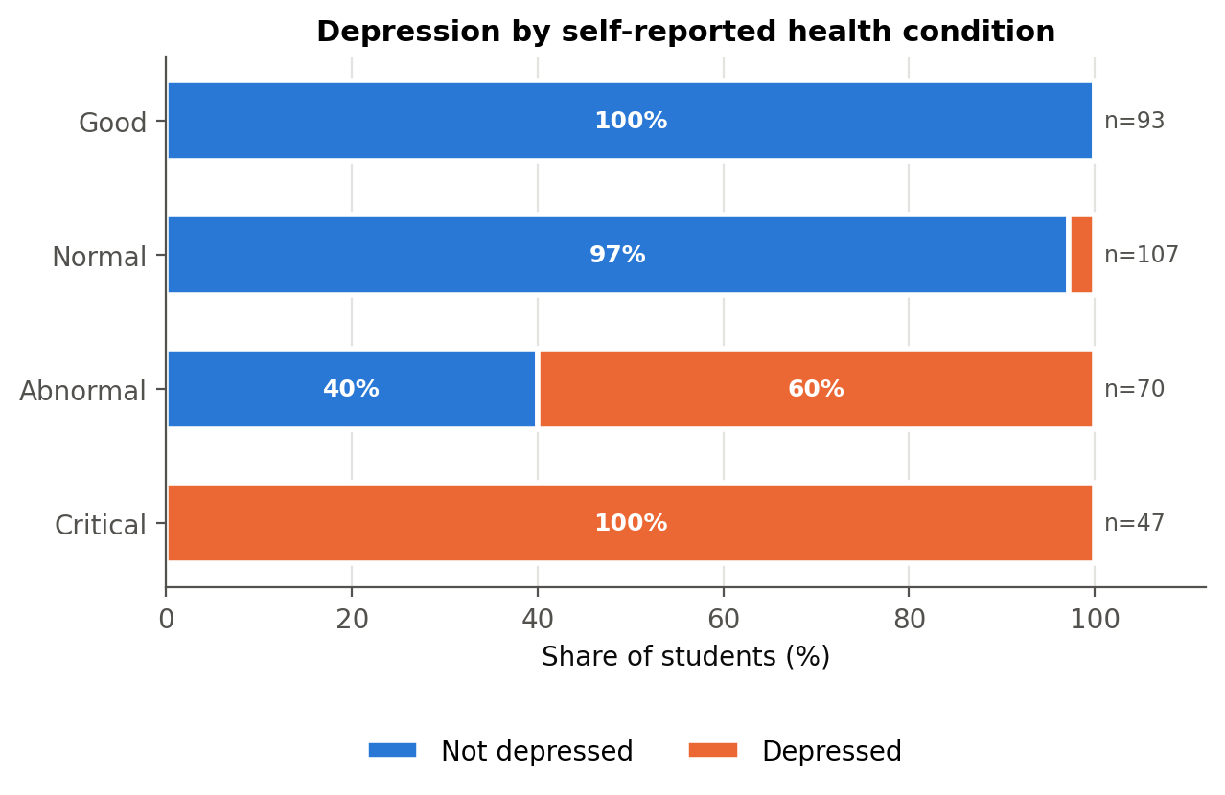
Fig. 3. Depression by self-reported health condition.
Fig. 4 compares the numerical variables. Mean CGPA (8.76 vs. 8.73), age (21.6 vs. 21.6) and semester (5.2 vs. 5.0) are almost identical for non-depressed and depressed students. Depression rates by age and semester (Fig. 5) show no clear trend; the very small groups at ages 18 and 19 should be read with caution.

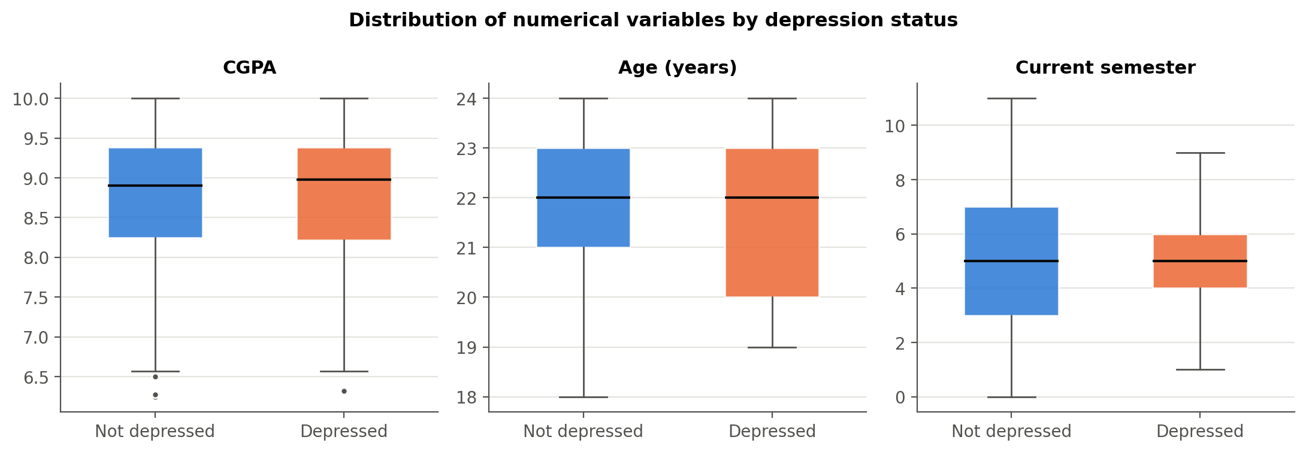
Fig. 4. Distribution of CGPA, age and semester by depression status.

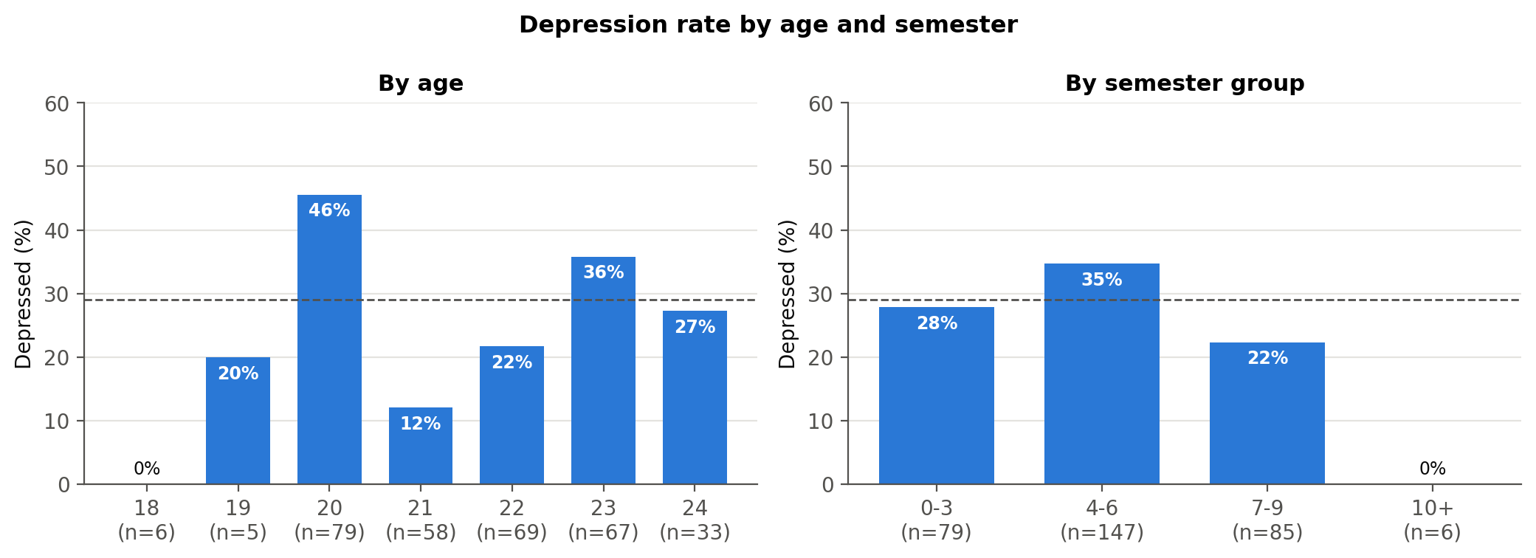
Fig. 5. Depression rate by age and semester group.

Table III reports summary statistics. Students are on average 21.6 years old with a mean CGPA of 8.75 out of 10; 29% have a mid and 37% a high living expense; 60% are single, 71% have a friend circle and 41% live with family.
Table III
Summary Statistics of Coded Variables
Variable | Obs | Mean | Std. dev. | Min | Max
Depression | 317 | 0.290 | 0.455 | 0.000 | 1.000
Male | 317 | 0.489 | 0.501 | 0.000 | 1.000
Age (years) | 317 | 21.615 | 1.453 | 18.000 | 24.000
CGPA | 317 | 8.753 | 0.862 | 6.250 | 10.000
Current semester | 317 | 5.142 | 2.201 | 0.000 | 11.000
Mid living expense | 317 | 0.287 | 0.453 | 0.000 | 1.000
High living expense | 317 | 0.366 | 0.482 | 0.000 | 1.000
Lower-middle class | 317 | 0.202 | 0.402 | 0.000 | 1.000
Rich class | 317 | 0.161 | 0.368 | 0.000 | 1.000
Single | 317 | 0.603 | 0.490 | 0.000 | 1.000
Lives with family | 317 | 0.407 | 0.492 | 0.000 | 1.000
Has friend circle | 317 | 0.707 | 0.456 | 0.000 | 1.000
Poor health | 317 | 0.369 | 0.483 | 0.000 | 1.000

The correlation matrix (Fig. 6) shows modest correlations among the regressors; the largest are between the two expense dummies (−0.48, by construction), between male and living with family (−0.41) and between high expense and lower-middle class (−0.38). The very high correlation between depression and health level (0.78) confirms the separation issue.

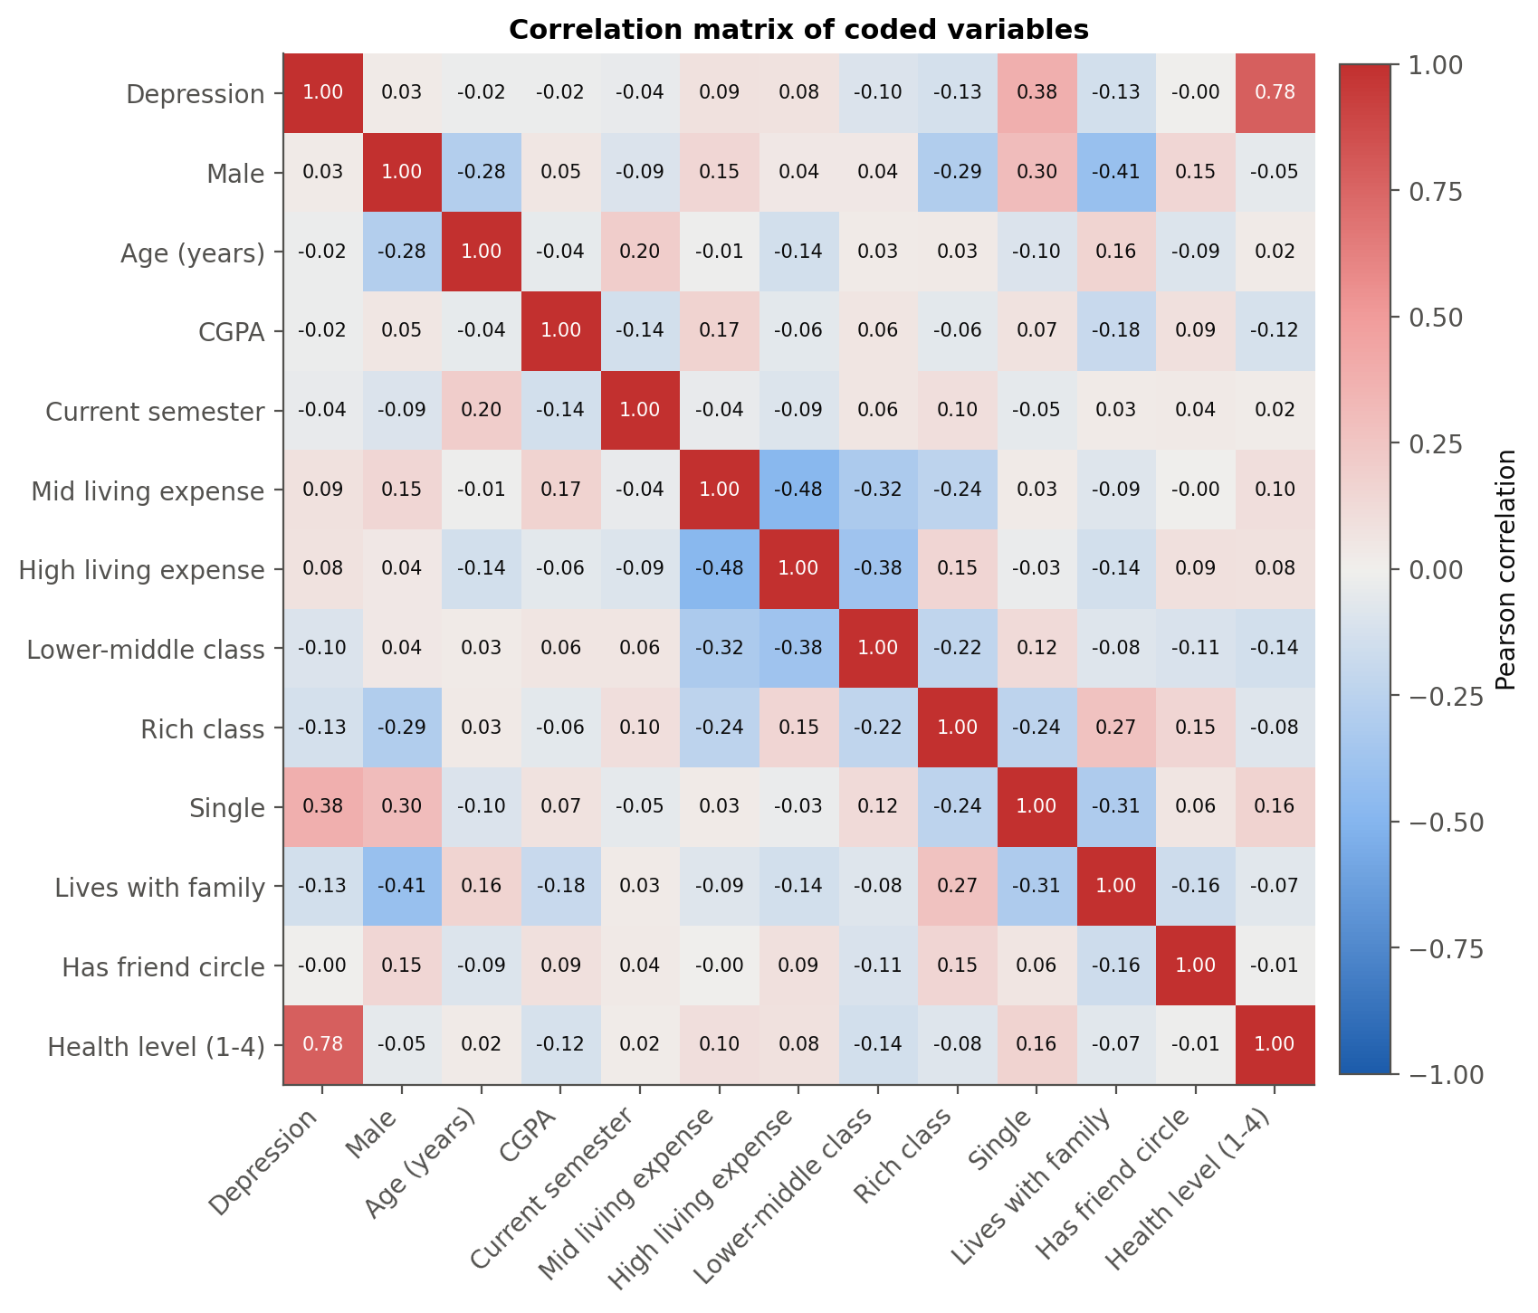
Fig. 6. Correlation matrix of coded variables.

B. Bivariate Tests
Table IV reports chi-square tests of independence. Relationship status (χ² = 45.50, p < 0.001, Cramér's V = 0.38) and family background (χ² = 10.44, p = 0.005) are significantly associated with depression, as are living style (p = 0.017) and health (V = 0.84). Living expense is also associated with depression (χ² = 8.12, p = 0.017); gender and friend circle are not significant. Table V shows that none of the numerical variables differs significantly: CGPA (p = 0.728), age (p = 0.701) and semester (p = 0.465).

Table IV
Chi-Square Tests of Independence with Depression
Variable | Chi-square | df | p-value | Cramer's V | Min expected count | Fisher exact p (2x2)
Gender | 0.249 | 1 | 0.618 | 0.028 | 44.980 | 0.623
Family background | 10.440 | 2 | 0.005 | 0.181 | 14.800
Relationship status | 45.504 | 2 | <0.001 | 0.379 | 3.190
Living style | 5.653 | 1 | 0.017 | 0.134 | 37.440 | 0.023
Living expense | 8.125 | 2 | 0.017 | 0.160 | 26.410
Friend circle | 0.000 | 1 | 0.998 | 0.000 | 26.990 | 1.000
Health condition | 221.288 | 3 | <0.001 | 0.836 | 13.640

Table V
Difference in Means Between Depressed and Non-Depressed Students
Variable | Mean (not depressed) | Mean (depressed) | Difference | Welch t | t-test p-value | Mann-Whitney U | Mann-Whitney p-value
CGPA | 8.765 | 8.726 | -0.039 | -0.349 | 0.728 | 10366.000 | 0.983
Age (years) | 21.636 | 21.565 | -0.070 | -0.385 | 0.701 | 9881.500 | 0.518
Current semester | 5.196 | 5.011 | -0.185 | -0.732 | 0.465 | 10066.000 | 0.699

C. Multicollinearity
The largest variance inflation factor is 2.90 (Table VI), below the common threshold of 10 and the stricter 5, so multicollinearity is not a concern. The highest values belong to the two living-expense dummies (2.90 and 2.77), as expected for dummies of the same variable that also overlap with family background.
Table VI
Variance Inflation Factors
Variable | VIF | Tolerance (1/VIF)
Male | 1.427 | 0.701
Age (years) | 1.154 | 0.867
CGPA | 1.120 | 0.893
Current semester | 1.089 | 0.918
Mid living expense | 2.896 | 0.345
High living expense | 2.769 | 0.361
Lower-middle class | 2.500 | 0.400
Rich class | 1.411 | 0.709
Single | 1.190 | 0.840
Lives with family | 1.457 | 0.686
Has friend circle | 1.109 | 0.902

D. Binary Logit Model
Table VII presents the logit estimates. The model is highly significant (LR χ²(11) = 72.01, p < 0.001) with McFadden's pseudo-R² = 0.189, a reasonable value for individual cross-sectional data.

Table VII
Binary Logit Estimates (N = 317; Dependent Variable: Depression)
Variable | Coefficient | Std. err. | z | P>|z| | 95% CI lower | 95% CI upper | Sig.
Constant | -1.0825 | 2.6549 | -0.4077 | 0.6835 | -6.2860 | 4.1211
Male | -0.8725 | 0.3447 | -2.5307 | 0.0114 | -1.5481 | -0.1968 | **
Age (years) | 0.0238 | 0.1017 | 0.2344 | 0.8146 | -0.1754 | 0.2231
CGPA | -0.2465 | 0.1745 | -1.4125 | 0.1578 | -0.5886 | 0.0956
Current semester | -0.0200 | 0.0703 | -0.2850 | 0.7756 | -0.1578 | 0.1177
Mid living expense | 1.2083 | 0.5884 | 2.0535 | 0.0400 | 0.0550 | 2.3616 | **
High living expense | 1.2214 | 0.5758 | 2.1214 | 0.0339 | 0.0929 | 2.3500 | **
Lower-middle class | 0.0204 | 0.6015 | 0.0338 | 0.9730 | -1.1587 | 1.1994
Rich class | -0.8066 | 0.5128 | -1.5731 | 0.1157 | -1.8117 | 0.1984
Single | 2.4750 | 0.3995 | 6.1950 | <0.001 | 1.6920 | 3.2581 | ***
Lives with family | -0.2524 | 0.3629 | -0.6953 | 0.4868 | -0.9637 | 0.4590
Has friend circle | -0.0988 | 0.3268 | -0.3023 | 0.7624 | -0.7394 | 0.5418

Holding other factors constant, being single has the strongest effect (β = 2.475, p < 0.001). Mid (β = 1.208, p = 0.040) and high living expense (β = 1.221, p = 0.034) raise the probability relative to low expense, and male students are less likely to be depressed (β = -0.873, p = 0.011). The rich-family coefficient is negative but not significant (β = -0.807, p = 0.116). CGPA, age, semester, lower-middle class, living with family and friend circle are not significant.
In odds-ratio terms (Table VIII, Fig. 7), single students have 11.9 times the odds of depression of students in a relationship (95% CI 5.4–26.0); students with a mid or high living expense have 3.3 and 3.4 times the odds of those with a low expense; and male students have 58% lower odds than female students. The wide confidence intervals of the expense odds ratios reflect the modest size of each band.
Table VIII
Odds Ratios from the Logit Model
Variable | Odds ratio | 95% CI lower | 95% CI upper | P>|z| | Sig.
Constant | 0.339 | 0.002 | 61.625 | 0.683
Male | 0.418 | 0.213 | 0.821 | 0.011 | **
Age (years) | 1.024 | 0.839 | 1.250 | 0.815
CGPA | 0.781 | 0.555 | 1.100 | 0.158
Current semester | 0.980 | 0.854 | 1.125 | 0.776
Mid living expense | 3.348 | 1.057 | 10.608 | 0.040 | **
High living expense | 3.392 | 1.097 | 10.485 | 0.034 | **
Lower-middle class | 1.021 | 0.314 | 3.318 | 0.973
Rich class | 0.446 | 0.163 | 1.219 | 0.116
Single | 11.882 | 5.430 | 26.000 | <0.001 | ***
Lives with family | 0.777 | 0.382 | 1.582 | 0.487
Has friend circle | 0.906 | 0.477 | 1.719 | 0.762

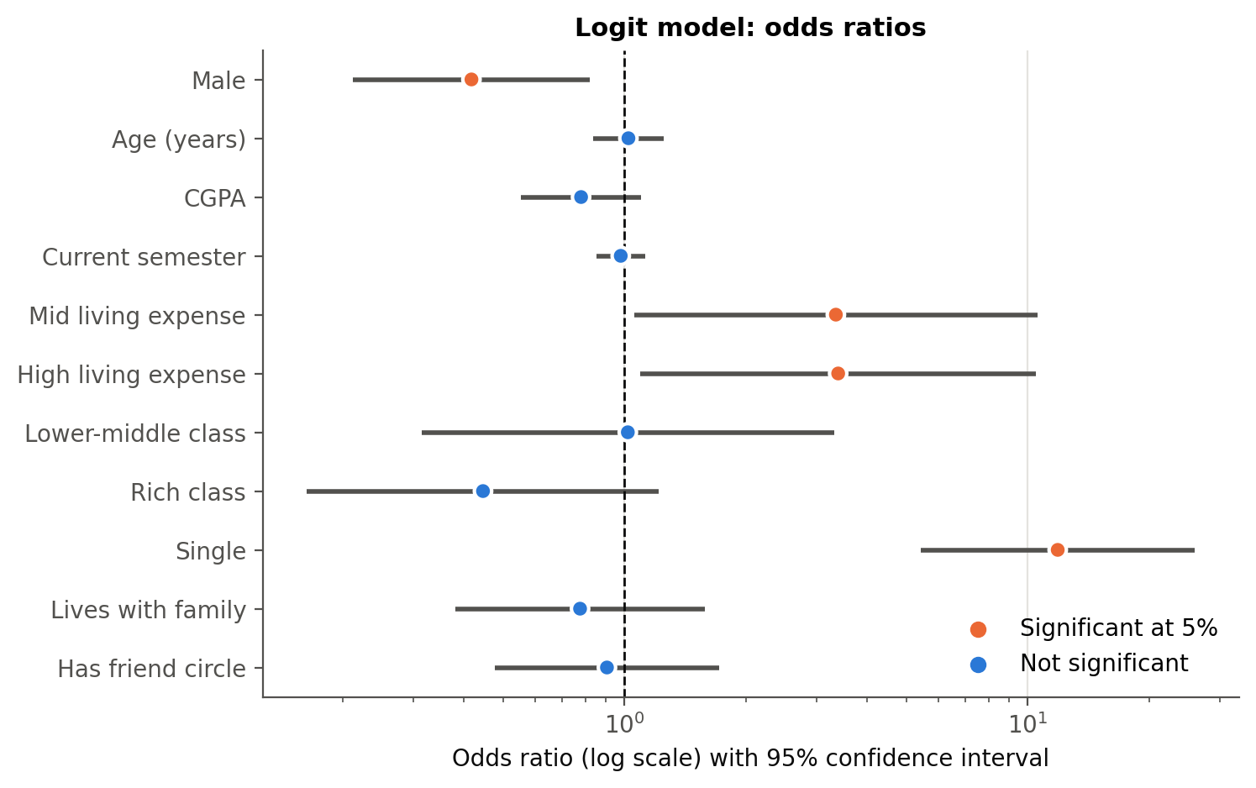
Fig. 7. Logit odds ratios with 95% confidence intervals (log scale).

E. Marginal Effects
Table IX and Fig. 8 report the average marginal effects. For a student with average characteristics the predicted probability of depression is 22.0%.

Table IX
Average Marginal Effects after Logit (dy/dx)
Variable | dy/dx | Std. err. | z | P>|z| | 95% CI lower | 95% CI upper | Sig.
Male | -0.1403 | 0.0523 | -2.6851 | 0.0073 | -0.2427 | -0.0379 | ***
Age (years) | 0.0039 | 0.0166 | 0.2345 | 0.8146 | -0.0287 | 0.0365
CGPA | -0.0403 | 0.0282 | -1.4290 | 0.1530 | -0.0956 | 0.0150
Current semester | -0.0033 | 0.0115 | -0.2852 | 0.7755 | -0.0258 | 0.0192
Mid living expense | 0.2014 | 0.0941 | 2.1416 | 0.0322 | 0.0171 | 0.3858 | **
High living expense | 0.1998 | 0.0882 | 2.2646 | 0.0235 | 0.0269 | 0.3728 | **
Lower-middle class | 0.0033 | 0.0985 | 0.0338 | 0.9730 | -0.1898 | 0.1964
Rich class | -0.1202 | 0.0672 | -1.7881 | 0.0738 | -0.2519 | 0.0115 | *
Single | 0.3664 | 0.0425 | 8.6233 | <0.001 | 0.2831 | 0.4496 | ***
Lives with family | -0.0410 | 0.0584 | -0.7026 | 0.4823 | -0.1554 | 0.0734
Has friend circle | -0.0162 | 0.0539 | -0.3013 | 0.7632 | -0.1218 | 0.0893

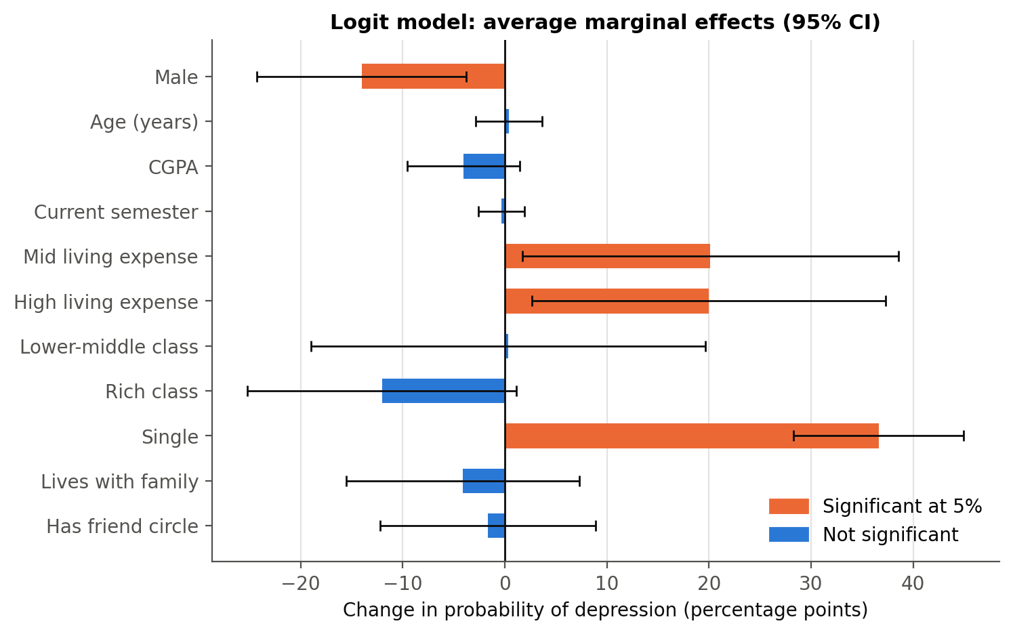
Fig. 8. Average marginal effects after logit with 95% confidence intervals.

- Being single raises the probability of depression by 36.6 percentage points (p < 0.001)—by far the largest effect.
- Compared with a low living expense, a mid expense raises it by 20.1 points (p = 0.032) and a high expense by 20.0 points (p = 0.024). The two effects are almost equal, so the step is between low and any higher expense rather than a steady rise.
- Male students are 14.0 points less likely to be depressed (p = 0.007).
- A rich family lowers the probability by 12.0 points relative to middle class, significant only at 10% (p = 0.074); the lower-middle class effect is close to zero (+0.3 percentage points, p = 0.973).
- CGPA (-4.0 points per grade point on the 10-point scale, p = 0.153) and friend circle (p = 0.763) have no significant effect.
Marginal effects at the means (Stata's older mfx) lead to the same conclusions (see Appendix).

F. Binary Probit Model
The probit model (Table X) is equally significant (LR χ²(11) = 72.61, pseudo-R² = 0.190) with the same signs and significance pattern: single, mid and high expense and male are significant at 5%, rich class is not (p = 0.196). Its marginal effects (Table XI) are almost identical to the logit ones: single +36.9 percentage points (logit 36.6), mid expense +20.8 percentage points, high expense +20.5 percentage points, male -14.8 percentage points. The choice of link function makes no practical difference.

Table X
Binary Probit Estimates (N = 317; Dependent Variable: Depression)
Variable | Coefficient | Std. err. | z | P>|z| | 95% CI lower | 95% CI upper | Sig.
Constant | -0.7478 | 1.6031 | -0.4665 | 0.6409 | -3.8898 | 2.3942
Male | -0.5496 | 0.2034 | -2.7020 | 0.0069 | -0.9483 | -0.1509 | ***
Age (years) | 0.0177 | 0.0605 | 0.2931 | 0.7695 | -0.1009 | 0.1363
CGPA | -0.1410 | 0.1025 | -1.3761 | 0.1688 | -0.3418 | 0.0598
Current semester | -0.0093 | 0.0405 | -0.2301 | 0.8180 | -0.0887 | 0.0701
Mid living expense | 0.7374 | 0.3536 | 2.0856 | 0.0370 | 0.0444 | 1.4303 | **
High living expense | 0.7417 | 0.3416 | 2.1713 | 0.0299 | 0.0722 | 1.4112 | **
Lower-middle class | 0.0291 | 0.3598 | 0.0810 | 0.9354 | -0.6760 | 0.7343
Rich class | -0.3668 | 0.2833 | -1.2946 | 0.1955 | -0.9221 | 0.1885
Single | 1.4319 | 0.2166 | 6.6114 | <0.001 | 1.0074 | 1.8564 | ***
Lives with family | -0.1806 | 0.2100 | -0.8600 | 0.3898 | -0.5922 | 0.2310
Has friend circle | -0.0621 | 0.1932 | -0.3216 | 0.7478 | -0.4409 | 0.3166

Table XI
Average Marginal Effects after Probit (dy/dx)
Variable | dy/dx | Std. err. | z | P>|z| | 95% CI lower | 95% CI upper | Sig.
Male | -0.1481 | 0.0517 | -2.8665 | 0.0041 | -0.2493 | -0.0468 | ***
Age (years) | 0.0049 | 0.0166 | 0.2933 | 0.7693 | -0.0277 | 0.0374
CGPA | -0.0387 | 0.0279 | -1.3874 | 0.1653 | -0.0934 | 0.0160
Current semester | -0.0026 | 0.0111 | -0.2302 | 0.8180 | -0.0244 | 0.0192
Mid living expense | 0.2077 | 0.0963 | 2.1568 | 0.0310 | 0.0190 | 0.3964 | **
High living expense | 0.2051 | 0.0893 | 2.2964 | 0.0217 | 0.0300 | 0.3802 | **
Lower-middle class | 0.0080 | 0.0992 | 0.0809 | 0.9355 | -0.1863 | 0.2024
Rich class | -0.0946 | 0.0677 | -1.3971 | 0.1624 | -0.2273 | 0.0381
Single | 0.3689 | 0.0430 | 8.5863 | <0.001 | 0.2847 | 0.4531 | ***
Lives with family | -0.0493 | 0.0567 | -0.8697 | 0.3845 | -0.1605 | 0.0618
Has friend circle | -0.0171 | 0.0535 | -0.3205 | 0.7486 | -0.1219 | 0.0877

G. Goodness of Fit
Both models have almost the same likelihood, AIC and AUC (Table XII). The Hosmer–Lemeshow test does not reject the logit model (χ² = 10.35, p = 0.241), so its predicted and observed rates agree across risk groups; for the probit model the test is rejected (p = 0.013), which is one reason the logit is kept as the main model. At a 0.5 cut-off the logit model classifies {100 * R['logit_correct_05']:.1f}% of students correctly, with specificity 88.0% but sensitivity only 25.0% (Table XIII). Using the sample share of depressed students (0.290) as cut-off identifies 84.8% of depressed students while correctly classifying 67.1% of the others.
Table XII
Goodness-of-Fit Statistics
Statistic | Logit | Probit
Observations | 317.000 | 317.000
Log likelihood | -154.939 | -154.639
Log likelihood (null) | -190.945 | -190.945
LR chi2 | 72.011 | 72.611
LR df | 11.000 | 11.000
Prob > chi2 | 0.000 | 0.000
Pseudo R2 (McFadden) | 0.189 | 0.190
AIC | 333.878 | 333.278
BIC | 378.985 | 378.385
AUC (ROC) | 0.782 | 0.782
Hosmer-Lemeshow chi2 | 10.348 | 19.408
HL df | 8.000 | 8.000
HL p-value | 0.241 | 0.013

Table XIII
Classification Tables (Cut-off 0.5 and Sample Share)
Model | Cutoff | True positives | False positives | False negatives | True negatives | Sensitivity | Specificity | Correctly classified
Logit | 0.500 | 23 | 27 | 69 | 198 | 0.250 | 0.880 | 0.697
Logit | 0.290 | 78 | 74 | 14 | 151 | 0.848 | 0.671 | 0.722
Probit | 0.500 | 24 | 29 | 68 | 196 | 0.261 | 0.871 | 0.694
Probit | 0.290 | 78 | 78 | 14 | 147 | 0.848 | 0.653 | 0.710

The ROC curves (Fig. 9) give an AUC of 0.782 (logit) and 0.782 (probit): a randomly chosen depressed student has a 78% chance of a higher predicted probability than a randomly chosen non-depressed student. Fig. 10 shows the size of the relationship effect: with other variables at their means, the predicted probability for single students ranges from 36% to 58% across the CGPA range, versus 4–11% for other students. The downward slope of both lines is not statistically significant.
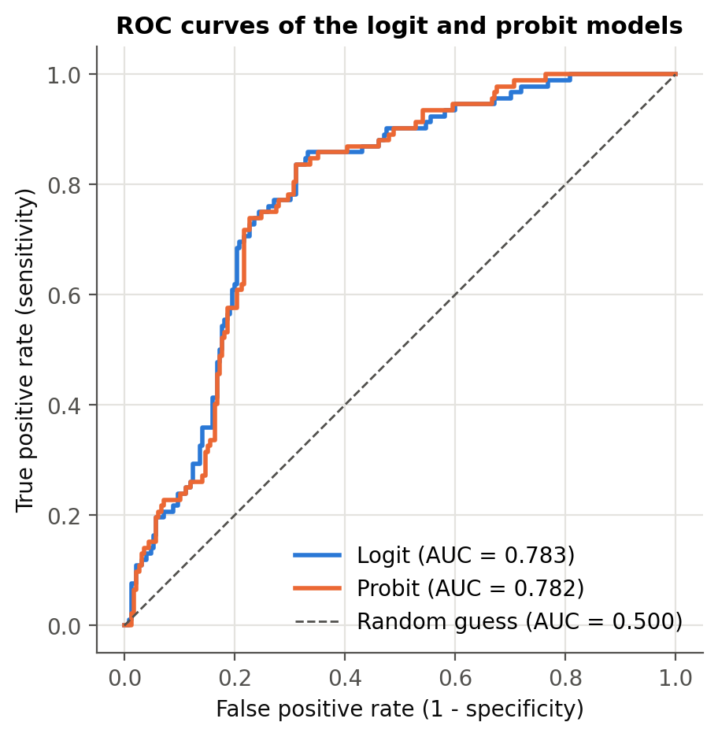
Fig. 9. ROC curves of the logit and probit models.
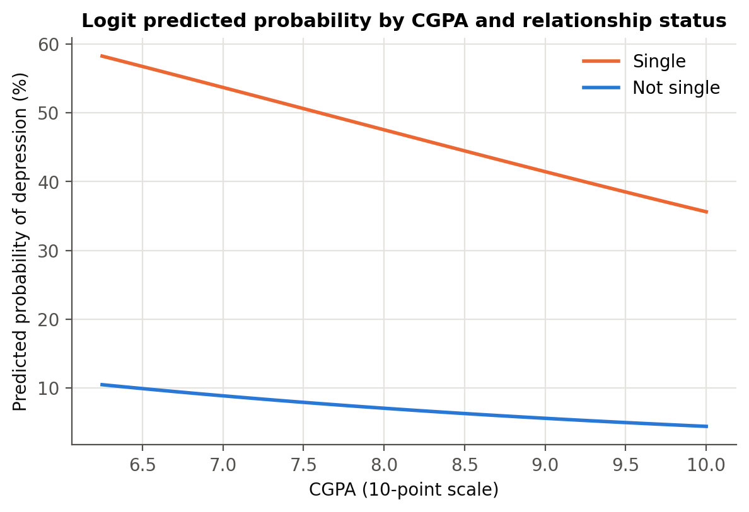
Fig. 10. Predicted probability of depression by CGPA and relationship status.

H. Hypothesis Tests
Table XIV summarises the hypothesis tests (logit model; supported if the expected sign holds with p < 0.05). H3, H5 and H7 are supported: single students, students with a high living expense and female students are more likely to be depressed. H1, H2, H4a, H4b and H6 are not supported: academic performance, friend circle, family background and living with family have no significant independent effect at 5%, although the rich-family marginal effect is significant at 10%.

Table XIV
Summary of Hypothesis Tests
Hypothesis | Variable | Expected sign | Logit coefficient | AME | P>|z| | Result
H1 | CGPA | - | -0.2465 | -0.0403 | 0.1578 | Not supported (not significant)
H2 | Has friend circle | - | -0.0988 | -0.0162 | 0.7624 | Not supported (not significant)
H3 | Single | + | 2.4750 | 0.3664 | <0.001 | Supported
H4a | Lower-middle class | + | 0.0204 | 0.0033 | 0.9730 | Not supported (not significant)
H4b | Rich class | - | -0.8066 | -0.1202 | 0.1157 | Not supported (not significant)
H5 | High living expense | + | 1.2214 | 0.1998 | 0.0339 | Supported
H6 | Lives with family | - | -0.2524 | -0.0410 | 0.4868 | Not supported (not significant)
H7 | Male | - | -0.8725 | -0.1403 | 0.0114 | Supported

I. Robustness Checks
Table XV compares the main model with six alternatives, and Fig. 11 compares the marginal effects of the logit, probit and linear probability models.

Table XV
Robustness Checks Across Model Specifications
Variable | 1 Logit | 2 Logit rob. | 3 Probit | 4 LPM rob. | 5 Logit+health | 6 LPM male | 7 LPM female
Constant | -1.082  (2.655) | -1.082  (2.552) | -0.748  (1.603) | 0.365  (0.477) | -2.025  (7.074) | 0.218  (0.625) | 0.177  (0.762)
Male | -0.872**  (0.345) | -0.872***  (0.329) | -0.550***  (0.203) | -0.135**  (0.054) | -1.935**  (0.956)
Age (years) | 0.024  (0.102) | 0.024  (0.099) | 0.018  (0.061) | 0.002  (0.017) | -0.212  (0.241) | -0.029  (0.023) | 0.028  (0.029)
CGPA | -0.247  (0.175) | -0.247  (0.179) | -0.141  (0.102) | -0.034  (0.029) | -0.024  (0.420) | 0.029  (0.047) | -0.080**  (0.040)
Current semester | -0.020  (0.070) | -0.020  (0.074) | -0.009  (0.041) | -0.003  (0.011) | -0.091  (0.161) | 0.002  (0.017) | -0.012  (0.015)
Mid living expense | 1.208**  (0.588) | 1.208**  (0.505) | 0.737**  (0.354) | 0.135*  (0.082) | -1.010  (1.207) | 0.278***  (0.094) | 0.167  (0.113)
High living expense | 1.221**  (0.576) | 1.221**  (0.503) | 0.742**  (0.342) | 0.129*  (0.072) | -0.721  (1.068) | 0.298***  (0.096) | 0.145  (0.094)
Lower-middle class | 0.020  (0.602) | 0.020  (0.546) | 0.029  (0.360) | -0.065  (0.087) | -1.311  (1.319) | 0.004  (0.103) | 0.056  (0.122)
Rich class | -0.807  (0.513) | -0.807  (0.568) | -0.367  (0.283) | -0.082  (0.077) | 0.932  (0.848) | -0.445***  (0.097) | -0.002  (0.104)
Single | 2.475***  (0.400) | 2.475***  (0.390) | 1.432***  (0.217) | 0.376***  (0.046) | 5.981***  (1.144) | 0.394***  (0.059) | 0.342***  (0.071)
Lives with family | -0.252  (0.363) | -0.252  (0.358) | -0.181  (0.210) | -0.036  (0.055) | -0.991  (0.759) | 0.011  (0.074) | -0.024  (0.075)
Has friend circle | -0.099  (0.327) | -0.099  (0.311) | -0.062  (0.193) | -0.009  (0.053) | -1.074  (0.751) | -0.072  (0.079) | 0.017  (0.072)
Poor health |  |  |  |  | 8.479***  (1.261)
Observations | 317 | 317 | 317 | 317 | 317 | 155 | 162
Pseudo R2 / R2 | 0.189 | 0.189 | 0.190 | 0.192 | 0.794 | 0.247 | 0.205

Significance levels: *** p < 0.01, ** p < 0.05, * p < 0.10. Standard errors in parentheses. Models 6–7 are linear probability models with robust standard errors.

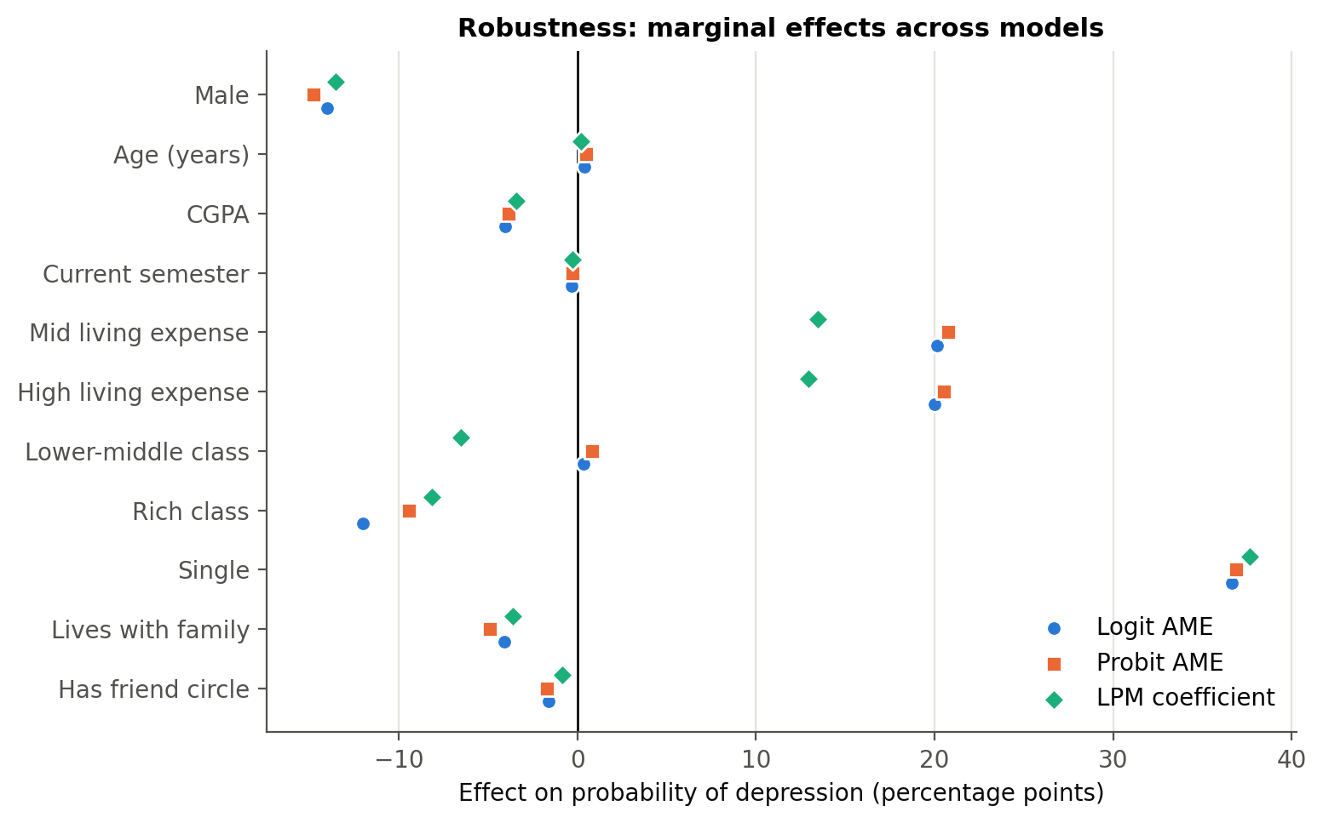
Fig. 11. Marginal effects across logit, probit and linear probability models.

- Robust standard errors change the standard errors only slightly; every variable keeps its sign and its significance at the 5% level.
- The LPM (R² = 0.192) gives almost the same effects for single (+37.6 percentage points) and male (-13.6 percentage points). Its living-expense effects are smaller (+13.5 percentage points and +12.9 percentage points) and significant only at 10% (p = 0.100 and 0.074), so the expense result is somewhat less robust than the others.
- Adding poor health raises the pseudo-R² from 0.189 to 0.794 and the AUC to 0.986 (LR χ²(1) = 231.3, p < 0.001); the software flags quasi-complete separation (a fraction 0.16 of observations predicted perfectly), confirming that health largely measures the outcome itself. Single and male remain significant; the living-expense and rich-class coefficients lose significance.
- By gender, a logit cannot be estimated for men because none of the 38 non-single male students is depressed, so LPMs are used. Being single is a strong risk factor for men (+39.4 percentage points, p < 0.001) and women (+34.2 percentage points, p < 0.001). Among men, mid (+27.8 percentage points, p = 0.003) and high living expense (+29.8 percentage points, p = 0.002) raise the risk and a rich family lowers it (-44.5 percentage points, p < 0.001); among women the expense effects are smaller and not significant (p = 0.14, 0.12), while a higher CGPA is associated with lower risk (-8.0 points per grade point, p = 0.044). With fewer than 50 depressed students per subsample, these differences are indicative.

V. Discussion

A. Key Findings
Relationships matter more than grades. Single students are 37 percentage points more likely to be depressed, an effect that is large, highly significant and stable across every specification and for both men and women. This strongly supports the stress-buffering view of close relationships [5].
Financial pressure. Students whose monthly living expense is mid or high are about 20 points more likely to be depressed than students with a low expense, after controlling for family background. The effect appears as a step from low to any higher expense rather than a steady rise, consistent with research linking money worries to poor mental health [10]. Family background itself matters less once expenses are controlled: rich students are less likely to be depressed, but only at the 10% level, and middle-class students—who have the highest raw rate—may face high costs without the cushion of richer families [6].
The gender gap. After controls, female students are about 14 points more likely to be depressed. The gap is hidden in the raw data—where men show a slightly higher rate—because male students are more often single. The adjusted result matches the established gender difference [7], [13].
What did not matter. CGPA, semester and age have no significant relationship with depression, and neither do a friend circle or living with family. Because every student in the sample has a CGPA above 6.00, the result says that grades do not matter much within this range, not that very low grades are harmless. Living with family looks protective in the raw data, but the effect disappears once relationship status and gender are controlled. The support that matters most here seems to be an intimate relationship rather than a wider friend group.

B. Implications for Universities
Since grades do not predict depression in this sample, services focused mainly on academic difficulty will miss many depressed students. Universities should (i) invest in programmes that reduce loneliness and build close connections—peer mentoring, small-group and residential community activities; (ii) combine mental health support with financial guidance—budgeting help, affordable housing and meals—that reaches students with higher living costs, including middle-income students; (iii) design gender-sensitive outreach, since women face higher adjusted risk while men may be less likely to seek help; and (iv) use simple risk scores to prioritise screening—the logit model identifies 85% of depressed students at the sample-share cut-off—without replacing clinical assessment.

C. Theoretical Implications
The results support the diathesis–stress and stress-buffering frameworks [4], [5]: financial pressure raises the probability of depression while close relationships protect against it. They suggest that for young adults the protective effect comes from intimate relationships more than from the size of the social network, and the step pattern of living expenses suggests that moving from a low to a higher cost of living—rather than the exact amount—is what adds pressure.

VI. Limitations and Future Research
The data are cross-sectional, so the estimates are associations rather than causal effects; depression may itself affect relationship status. Depression and health are self-reported indicators rather than clinical diagnoses or validated scales. With 317 students and 92 depressed cases, small categories had to be merged and the gender subsample results are indicative. Living expense is measured in three bands, which loses detail within each band, and the expense effects are weaker in the linear probability model. The sample covers only students with a CGPA above 6.00 and is not representative of all university students, which limits generalisation; factors such as family history, sleep, physical activity and substance use are not observed. Future work should follow students over several semesters, use validated severity scales such as the PHQ-9 with ordered models, draw larger and more diverse samples covering the full grade range, and measure the quality—not only the presence—of social support.

VII. Conclusion
Depression affects almost three in ten students in this sample. It is driven less by grades and more by students' relationships and financial circumstances: being single is the strongest risk factor, a mid or high living expense raises the risk compared with a low one, and male students are less likely to be depressed than female students; a rich family background is protective only weakly. These findings are consistent across the logit and probit models, and the relationship and gender effects also hold in the linear probability model. Protecting student mental health therefore requires attention to social connection and financial wellbeing, not only to academic support.

References
[1] A. K. Ibrahim, S. J. Kelly, C. E. Adams, and C. Glazebrook, "A systematic review of studies of depression prevalence in university students," J. Psychiatric Res., vol. 47, no. 3, pp. 391–400, 2013.
[2] A. Hysenbegasi, S. L. Hass, and C. R. Rowland, "The impact of depression on the academic productivity of university students," J. Mental Health Policy Econ., vol. 8, no. 3, pp. 145–151, 2005.
[3] D. Eisenberg, S. E. Gollust, E. Golberstein, and J. L. Hefner, "Prevalence and correlates of depression, anxiety, and suicidality among university students," Amer. J. Orthopsychiatry, vol. 77, no. 4, pp. 534–542, 2007.
[4] S. M. Monroe and A. D. Simons, "Diathesis–stress theories in the context of life stress research: Implications for the depressive disorders," Psychol. Bull., vol. 110, no. 3, pp. 406–425, 1991.
[5] S. Cohen and T. A. Wills, "Stress, social support, and the buffering hypothesis," Psychol. Bull., vol. 98, no. 2, pp. 310–357, 1985.
[6] V. Lorant, D. Deliège, W. Eaton, A. Robert, P. Philippot, and M. Ansseau, "Socioeconomic inequalities in depression: A meta-analysis," Amer. J. Epidemiol., vol. 157, no. 2, pp. 98–112, 2003.
[7] S. Nolen-Hoeksema, "Sex differences in unipolar depression: Evidence and theory," Psychol. Bull., vol. 101, no. 2, pp. 259–282, 1987.
[8] A. T. Beck, Depression: Clinical, Experimental, and Theoretical Aspects. New York, NY, USA: Harper & Row, 1967.
[9] I. Kawachi and L. F. Berkman, "Social ties and mental health," J. Urban Health, vol. 78, no. 3, pp. 458–467, 2001.
[10] T. Richardson, P. Elliott, and R. Roberts, "The relationship between personal unsecured debt and mental and physical health: A systematic review and meta-analysis," Clin. Psychol. Rev., vol. 33, no. 8, pp. 1148–1162, 2013.
[11] S. W. Whitton and M. A. Whisman, "Relationship satisfaction instability and depression," J. Family Psychol., vol. 24, no. 6, pp. 791–794, 2010.
[12] A. G. Bulloch, J. V. Williams, D. H. Lavorato, and S. B. Patten, "The relationship between major depression and marital disruption is bidirectional," Depression Anxiety, vol. 26, no. 12, pp. 1172–1177, 2009.
[13] R. C. Kessler, "Epidemiology of women and depression," J. Affective Disorders, vol. 74, no. 1, pp. 5–13, 2003.
[14] S. Moussavi, S. Chatterji, E. Verdes, A. Tandon, V. Patel, and B. Ustun, "Depression, chronic diseases, and decrements in health: Results from the World Health Surveys," Lancet, vol. 370, no. 9590, pp. 851–858, 2007.
[15] J. M. Wooldridge, Econometric Analysis of Cross Section and Panel Data, 2nd ed. Cambridge, MA, USA: MIT Press, 2010.
[16] J. S. Long and J. Freese, Regression Models for Categorical Dependent Variables Using Stata, 3rd ed. College Station, TX, USA: Stata Press, 2014.
[17] D. W. Hosmer, S. Lemeshow, and R. X. Sturdivant, Applied Logistic Regression, 3rd ed. Hoboken, NJ, USA: Wiley, 2013.
[18] S. Seabold and J. Perktold, "Statsmodels: Econometric and statistical modeling with Python," in Proc. 9th Python in Science Conf., 2010, pp. 92–96.
[19] StataCorp, Stata Statistical Software: Release 17. College Station, TX, USA: StataCorp LLC, 2021.

Appendix: Full Model Output
Full estimation output from the analysis notebook (notebooks/student_depression_analysis.ipynb, Python statsmodels). The Stata do-file stata/student_depression_analysis.do contains the equivalent commands (summarize, tabulate, logit, probit, margins, estat classification, estat gof, lroc, regress). All tables are also in results/Student_Depression_Analysis_Results.xlsx.
A. Binary logit model
Logit Regression Results
==============================================================================
Dep. Variable: depression No. Observations: 317
Model: Logit Df Residuals: 305
Method: MLE Df Model: 11
Date: Wed, 07 Oct 2026 Pseudo R-squ.: 0.1886
Time: 22:07:04 Log-Likelihood: -154.94
converged: True LL-Null: -190.94
Covariance Type: nonrobust LLR p-value: 5.058e-11
=================================================================================
coef std err z P>|z| [0.025 0.975]
---------------------------------------------------------------------------------
const -1.0825 2.655 -0.408 0.683 -6.286 4.121
male -0.8725 0.345 -2.531 0.011 -1.548 -0.197
age 0.0238 0.102 0.234 0.815 -0.175 0.223
cgpa -0.2465 0.175 -1.412 0.158 -0.589 0.096
semester -0.0200 0.070 -0.285 0.776 -0.158 0.118
cost_mid 1.2083 0.588 2.054 0.040 0.055 2.362
cost_high 1.2214 0.576 2.121 0.034 0.093 2.350
fam_lowermid 0.0204 0.602 0.034 0.973 -1.159 1.199
fam_rich -0.8066 0.513 -1.573 0.116 -1.812 0.198
single 2.4750 0.400 6.195 0.000 1.692 3.258
live_family -0.2524 0.363 -0.695 0.487 -0.964 0.459
friend_circle -0.0988 0.327 -0.302 0.762 -0.739 0.542
=================================================================================

B. Binary probit model
Probit Regression Results
==============================================================================
Dep. Variable: depression No. Observations: 317
Model: Probit Df Residuals: 305
Method: MLE Df Model: 11
Date: Wed, 07 Oct 2026 Pseudo R-squ.: 0.1901
Time: 22:07:05 Log-Likelihood: -154.64
converged: True LL-Null: -190.94
Covariance Type: nonrobust LLR p-value: 3.885e-11
=================================================================================
coef std err z P>|z| [0.025 0.975]
---------------------------------------------------------------------------------
const -0.7478 1.603 -0.466 0.641 -3.890 2.394
male -0.5496 0.203 -2.702 0.007 -0.948 -0.151
age 0.0177 0.061 0.293 0.769 -0.101 0.136
cgpa -0.1410 0.102 -1.376 0.169 -0.342 0.060
semester -0.0093 0.041 -0.230 0.818 -0.089 0.070
cost_mid 0.7374 0.354 2.086 0.037 0.044 1.430
cost_high 0.7417 0.342 2.171 0.030 0.072 1.411
fam_lowermid 0.0291 0.360 0.081 0.935 -0.676 0.734
fam_rich -0.3668 0.283 -1.295 0.195 -0.922 0.189
single 1.4319 0.217 6.611 0.000 1.007 1.856
live_family -0.1806 0.210 -0.860 0.390 -0.592 0.231
friend_circle -0.0621 0.193 -0.322 0.748 -0.441 0.317
=================================================================================

C. Logit model with robust standard errors
Logit Regression Results
==============================================================================
Dep. Variable: depression No. Observations: 317
Model: Logit Df Residuals: 305
Method: MLE Df Model: 11
Date: Wed, 07 Oct 2026 Pseudo R-squ.: 0.1886
Time: 22:07:06 Log-Likelihood: -154.94
converged: True LL-Null: -190.94
Covariance Type: HC1 LLR p-value: 5.058e-11
=================================================================================
coef std err z P>|z| [0.025 0.975]
---------------------------------------------------------------------------------
const -1.0825 2.552 -0.424 0.671 -6.085 3.920
male -0.8725 0.329 -2.652 0.008 -1.517 -0.228
age 0.0238 0.099 0.240 0.810 -0.171 0.218
cgpa -0.2465 0.179 -1.380 0.168 -0.597 0.104
semester -0.0200 0.074 -0.270 0.787 -0.165 0.125
cost_mid 1.2083 0.505 2.393 0.017 0.219 2.198
cost_high 1.2214 0.503 2.430 0.015 0.236 2.207
fam_lowermid 0.0204 0.546 0.037 0.970 -1.050 1.091
fam_rich -0.8066 0.568 -1.421 0.155 -1.919 0.306
single 2.4750 0.390 6.338 0.000 1.710 3.240
live_family -0.2524 0.358 -0.705 0.481 -0.954 0.449
friend_circle -0.0988 0.311 -0.318 0.750 -0.708 0.510
=================================================================================

D. Linear probability model (robust standard errors)
OLS Regression Results
==============================================================================
Dep. Variable: depression R-squared: 0.192
Model: OLS Adj. R-squared: 0.163
Method: Least Squares F-statistic: 9.124
Date: Wed, 07 Oct 2026 Prob (F-statistic): 4.08e-14
Time: 22:07:06 Log-Likelihood: -165.59
No. Observations: 317 AIC: 355.2
Df Residuals: 305 BIC: 400.3
Df Model: 11
Covariance Type: HC1
=================================================================================
coef std err z P>|z| [0.025 0.975]
---------------------------------------------------------------------------------
const 0.3646 0.477 0.765 0.444 -0.570 1.299
male -0.1355 0.054 -2.491 0.013 -0.242 -0.029
age 0.0018 0.017 0.102 0.919 -0.032 0.036
cgpa -0.0341 0.029 -1.173 0.241 -0.091 0.023
semester -0.0026 0.011 -0.236 0.813 -0.024 0.019
cost_mid 0.1347 0.082 1.647 0.100 -0.026 0.295
cost_high 0.1292 0.072 1.788 0.074 -0.012 0.271
fam_lowermid -0.0654 0.087 -0.754 0.451 -0.235 0.105
fam_rich -0.0816 0.077 -1.066 0.287 -0.232 0.068
single 0.3764 0.046 8.114 0.000 0.285 0.467
live_family -0.0363 0.055 -0.658 0.510 -0.144 0.072
friend_circle -0.0087 0.053 -0.165 0.869 -0.112 0.095
==============================================================================
Omnibus: 74.383 Durbin-Watson: 2.110
Prob(Omnibus): 0.000 Jarque-Bera (JB): 26.867
Skew: 0.504 Prob(JB): 1.47e-06
Kurtosis: 1.991 Cond. No. 480.
==============================================================================

Notes:
[1] Standard Errors are heteroscedasticity robust (HC1)

E. Logit model including poor health
Logit Regression Results
==============================================================================
Dep. Variable: depression No. Observations: 317
Model: Logit Df Residuals: 304
Method: MLE Df Model: 12
Date: Wed, 07 Oct 2026 Pseudo R-squ.: 0.7941
Time: 22:07:06 Log-Likelihood: -39.314
converged: True LL-Null: -190.94
Covariance Type: nonrobust LLR p-value: 9.699e-58
=================================================================================
coef std err z P>|z| [0.025 0.975]
---------------------------------------------------------------------------------
const -2.0254 7.074 -0.286 0.775 -15.891 11.840
male -1.9351 0.956 -2.023 0.043 -3.810 -0.061
age -0.2116 0.241 -0.877 0.381 -0.685 0.262
cgpa -0.0242 0.420 -0.057 0.954 -0.848 0.799
semester -0.0913 0.161 -0.568 0.570 -0.406 0.224
cost_mid -1.0101 1.207 -0.837 0.403 -3.375 1.355
cost_high -0.7208 1.068 -0.675 0.500 -2.814 1.372
fam_lowermid -1.3113 1.319 -0.994 0.320 -3.897 1.274
fam_rich 0.9323 0.848 1.099 0.272 -0.731 2.595
single 5.9807 1.144 5.227 0.000 3.738 8.223
live_family -0.9914 0.759 -1.305 0.192 -2.480 0.497
friend_circle -1.0736 0.751 -1.430 0.153 -2.545 0.398
health_poor 8.4788 1.261 6.722 0.000 6.006 10.951
=================================================================================

Possibly complete quasi-separation: A fraction 0.16 of observations can be
perfectly predicted. This might indicate that there is complete
quasi-separation. In this case some parameters will not be identified.

F. Linear probability model: male students
OLS Regression Results
==============================================================================
Dep. Variable: depression R-squared: 0.247
Model: OLS Adj. R-squared: 0.195
Method: Least Squares F-statistic: 7.434
Date: Wed, 07 Oct 2026 Prob (F-statistic): 1.86e-09
Time: 22:07:06 Log-Likelihood: -77.438
No. Observations: 155 AIC: 176.9
Df Residuals: 144 BIC: 210.4
Df Model: 10
Covariance Type: HC1
=================================================================================
coef std err z P>|z| [0.025 0.975]
---------------------------------------------------------------------------------
const 0.2184 0.625 0.349 0.727 -1.007 1.444
age -0.0291 0.023 -1.273 0.203 -0.074 0.016
cgpa 0.0290 0.047 0.618 0.537 -0.063 0.121
semester 0.0020 0.017 0.117 0.907 -0.031 0.035
cost_mid 0.2783 0.094 2.976 0.003 0.095 0.462
cost_high 0.2983 0.096 3.123 0.002 0.111 0.486
fam_lowermid 0.0042 0.103 0.040 0.968 -0.199 0.207
fam_rich -0.4449 0.097 -4.566 0.000 -0.636 -0.254
single 0.3938 0.059 6.717 0.000 0.279 0.509
live_family 0.0106 0.074 0.143 0.886 -0.134 0.155
friend_circle -0.0716 0.079 -0.902 0.367 -0.227 0.084
==============================================================================
Omnibus: 56.852 Durbin-Watson: 2.221
Prob(Omnibus): 0.000 Jarque-Bera (JB): 11.309
Skew: 0.311 Prob(JB): 0.00350
Kurtosis: 1.832 Cond. No. 437.
==============================================================================

Notes:
[1] Standard Errors are heteroscedasticity robust (HC1)

G. Linear probability model: female students
OLS Regression Results
==============================================================================
Dep. Variable: depression R-squared: 0.205
Model: OLS Adj. R-squared: 0.153
Method: Least Squares F-statistic: 4.770
Date: Wed, 07 Oct 2026 Prob (F-statistic): 6.07e-06
Time: 22:07:06 Log-Likelihood: -81.134
No. Observations: 162 AIC: 184.3
Df Residuals: 151 BIC: 218.2
Df Model: 10
Covariance Type: HC1
=================================================================================
coef std err z P>|z| [0.025 0.975]
---------------------------------------------------------------------------------
const 0.1772 0.762 0.233 0.816 -1.316 1.670
age 0.0277 0.029 0.953 0.340 -0.029 0.085
cgpa -0.0800 0.040 -2.010 0.044 -0.158 -0.002
semester -0.0117 0.015 -0.787 0.431 -0.041 0.017
cost_mid 0.1670 0.113 1.474 0.141 -0.055 0.389
cost_high 0.1446 0.094 1.536 0.125 -0.040 0.329
fam_lowermid 0.0565 0.122 0.464 0.643 -0.182 0.295
fam_rich -0.0015 0.104 -0.015 0.988 -0.205 0.202
single 0.3423 0.071 4.799 0.000 0.203 0.482
live_family -0.0245 0.075 -0.327 0.743 -0.171 0.122
friend_circle 0.0166 0.072 0.231 0.817 -0.124 0.158
==============================================================================
Omnibus: 14.992 Durbin-Watson: 1.918
Prob(Omnibus): 0.001 Jarque-Bera (JB): 13.025
Skew: 0.612 Prob(JB): 0.00148
Kurtosis: 2.342 Cond. No. 554.
==============================================================================

Notes:
[1] Standard Errors are heteroscedasticity robust (HC1)

Table XVI
Marginal Effects at the Means after Logit
Variable | dy/dx | Std. err. | z | P>|z| | 95% CI lower | 95% CI upper | Sig.
Male | -0.1486 | 0.0577 | -2.5756 | 0.0100 | -0.2616 | -0.0355 | **
Age (years) | 0.0041 | 0.0174 | 0.2346 | 0.8145 | -0.0300 | 0.0382
CGPA | -0.0423 | 0.0297 | -1.4225 | 0.1549 | -0.1005 | 0.0160
Current semester | -0.0034 | 0.0120 | -0.2852 | 0.7755 | -0.0270 | 0.0202
Mid living expense | 0.2338 | 0.1216 | 1.9226 | 0.0545 | -0.0045 | 0.4722 | *
High living expense | 0.2265 | 0.1104 | 2.0513 | 0.0402 | 0.0101 | 0.4430 | **
Lower-middle class | 0.0035 | 0.1038 | 0.0337 | 0.9731 | -0.1999 | 0.2069
Rich class | -0.1175 | 0.0609 | -1.9301 | 0.0536 | -0.2369 | 0.0018 | *
Single | 0.3699 | 0.0448 | 8.2479 | <0.001 | 0.2820 | 0.4577 | ***
Lives with family | -0.0427 | 0.0604 | -0.7064 | 0.4799 | -0.1611 | 0.0757
Has friend circle | -0.0171 | 0.0572 | -0.2993 | 0.7647 | -0.1293 | 0.0950

Table XVII
Marginal Effects for Male and Female Students (LPM, Robust SE)
Variable | Female students: dy/dx | Male students: dy/dx | Female students: P>|z| | Male students: P>|z|
Age (years) | 0.0277 | -0.0291 | 0.3404 | 0.2031
CGPA | -0.0800 | 0.0290 | 0.0444 | 0.5368
Current semester | -0.0117 | 0.0020 | 0.4311 | 0.9067
Has friend circle | 0.0166 | -0.0716 | 0.8171 | 0.3670
High living expense | 0.1446 | 0.2983 | 0.1246 | 0.0018
Lives with family | -0.0245 | 0.0106 | 0.7433 | 0.8864
Lower-middle class | 0.0565 | 0.0042 | 0.6429 | 0.9679
Mid living expense | 0.1670 | 0.2783 | 0.1405 | 0.0029
Rich class | -0.0015 | -0.4449 | 0.9884 | <0.001
Single | 0.3423 | 0.3938 | <0.001 | <0.001

