Determinants of Depression among University Students: An Econometric Analysis using Logit and Probit Models
Report submitted to
Dr. Prantik Bagchi
Department of Humanities and Social Sciences
Indian Institute of Technology Kharagpur
Submitted by
[Team member 1 name] ([Roll number])
[Team member 2 name] ([Roll number])
[Team member 3 name] ([Roll number])
[Team member 4 name] ([Roll number])
[Team member 5 name] ([Roll number])
[Team member 6 name] ([Roll number])

Department of Humanities and Social Sciences
Indian Institute of Technology Kharagpur
Kharagpur, West Bengal 721302
© 2026. All rights reserved

Abstract
Depression is one of the most common mental health problems among university students, yet the personal, social and economic factors that separate students who are depressed from those who are not remain unclear. This study examines which student characteristics are associated with a higher or lower probability of depression, with special attention to relationship status, family background, living costs, gender, academic performance and social support.
Using a quantitative cross-sectional design, survey data on 300 university students aged 18–24 were analysed, of whom 89 (29.7%) reported depression. After bivariate chi-square and t-tests, a Binary Logistic Regression (logit) model was estimated, followed by a Binary Probit model, average marginal effects, goodness-of-fit diagnostics and a set of robustness checks.
The results show that being single is the strongest risk factor: single students are 36.4 percentage points more likely to be depressed than students in a relationship (p < 0.001). Students from rich families (-17.2 percentage points, p = 0.011) and students who have ever been married (-16.4 percentage points, p = 0.003) are less likely to be depressed, while each additional thousand units of monthly living cost raises the probability by 1.15 percentage points (p = 0.045). Male students are 10.7 percentage points less likely to be depressed than female students (p = 0.050). Surprisingly, CGPA, semester, age, living arrangement and having a friend circle show no significant association once other factors are held constant.
The logit model is jointly significant (LR χ²(11) = 69.57, p < 0.001), fits the data well (Hosmer–Lemeshow p = 0.314) and discriminates reasonably between depressed and non-depressed students (AUC = 0.781). The probit model and a linear probability model give almost identical marginal effects. The study concludes that university mental health support should focus on social and relational wellbeing and financial pressure, rather than on academic performance alone.
Keywords: Depression, University students, Binary logit, Probit, Marginal effects, Relationship status, Socioeconomic status

Table of Contents
Abstract ii
Table of Contents iii
List of Figures vi
List of Tables vi
Chapter 1 Introduction 1
1.1 Background of the Study 1
1.2 Problem Statement 1
1.3 Research Objectives 2
1.4 Research Questions 2
1.5 Research Hypotheses 3
1.6 Significance of the Study 3
1.7 Scope and Limitations 3
1.8 Organization of the Paper 3
Chapter 2 Literature Review 5
2.1 Introduction to the Theoretical Framework 5
2.2 Theoretical Underpinnings 5
2.2.1 The Diathesis–Stress Model 5
2.2.2 Social Support and the Stress-Buffering Hypothesis 5
2.3 Academic Pressure and Performance 5
2.4 Socioeconomic Status and Financial Strain 6
2.5 Relationships, Marriage and Loneliness 6
2.6 Gender Differences in Depression 6
2.7 Physical Health and Depression 7
2.8 Conclusion of Literature Review 7
Chapter 3 Research Methodology 8
3.1 Data Overview 8
3.2 Data Transformation 8
3.3 Data and Types of Variables 10
3.4 Data Analysis 10
3.4.1 Graphs Overview 10
3.5 Econometric Model Specification 11
3.6 Ethical Considerations 12
Chapter 4 Empirical Results 13
4.1 Introduction 13
4.2 Descriptive Analysis of Student Characteristics 13
4.2.1 Prevalence of Depression 13
4.2.2 Social and Demographic Characteristics 13
4.2.3 Self-Reported Health Condition 14
4.2.4 Numerical Variables: CGPA, Monthly Cost and Age 15
4.2.5 Age and Semester 15
4.3 Descriptive Statistics of Variables 16
4.4 Bivariate Analysis 17
4.4.1 Chi-Square Tests of Independence 17
4.4.2 Difference in Means Tests 18
4.5 Multicollinearity Check 18
4.6 Inferential Analysis: Binary Logistic Regression 19
4.6.1 Interpretation of Coefficients 20
4.6.2 Odds Ratios 20
4.7 Marginal Effects Analysis (Logit) 21
4.7.1 Interpretation of Marginal Effects 22
4.8 Binary Probit Regression 22
4.8.1 Interpretation of Coefficients 23
4.9 Marginal Effects (Probit) 23
4.10 Goodness of Fit and Model Diagnostics 24
4.11 Hypothesis Testing Summary 26
4.12 Robustness Checks 27
Chapter 5 Findings, Conclusion, and Recommendations 30
5.1 Introduction 30
5.2 Summary of Major Findings 30
5.2.1 Relationships Matter More than Grades 30
5.2.2 The 'Squeezed Middle': Family Background and Living Costs 30
5.2.3 The Gender Gap 30
5.2.4 What Did Not Matter: Grades, Friends and Living Arrangement 31
5.2.5 Health and Depression 31
5.3 Policy Implications for Universities 31
5.3.1 Target Social Isolation, not only Academic Performance 31
5.3.2 Address Financial Pressure 31
5.3.3 Gender-Sensitive Screening and Support 31
5.3.4 Simple Screening Tools 32
5.4 Theoretical Implications 32
5.5 Limitations of the Study 32
5.6 Recommendations for Future Research 32
5.7 Conclusion 33
Appendix 34
A.1 Binary logit model 34
A.2 Binary probit model 34
A.3 Logit model with robust standard errors 35
A.4 Linear probability model (robust standard errors) 35
A.5 Logit model including poor health 36
A.6 Linear probability model: male students 36
A.7 Linear probability model: female students 37
A.8 Marginal effects at the means (logit) 37
A.9 Subsample marginal effects (linear probability model) 38
References 39

List of Figures
Figure 3.1: Distribution of the dependent variable (depression status) 11
Figure 4.1: Depression rate by student characteristics 14
Figure 4.2: Depression by self-reported health condition 15
Figure 4.3: Distribution of CGPA, monthly cost and age by depression status 15
Figure 4.4: Depression rate by age and semester group 16
Figure 4.5: Correlation matrix of coded variables 17
Figure 4.6: Odds ratios with 95% confidence intervals (log scale) 21
Figure 4.7: Average marginal effects after logit with 95% confidence intervals 22
Figure 4.8: ROC curves of the logit and probit models 25
Figure 4.9: Predicted probability of depression by CGPA and relationship status 26
Figure 4.10: Marginal effects across logit, probit and linear probability models 28

List of Tables
Table 3.1: Raw data (first five records) 8
Table 3.2: Description of variables 10
Table 4.1: Summary statistics of coded variables 16
Table 4.2: Chi-square tests of independence with depression 18
Table 4.3: Difference in means between depressed and non-depressed students 18
Table 4.4: Variance inflation factors 19
Table 4.5: Binary logit estimates (N = 300; dependent variable: depression) 19
Table 4.6: Odds ratios from the logit model 20
Table 4.7: Average marginal effects after logit (dy/dx) 21
Table 4.8: Binary probit estimates (N = 300; dependent variable: depression) 23
Table 4.9: Average marginal effects after probit (dy/dx) 24
Table 4.10: Goodness-of-fit statistics 24
Table 4.11: Classification tables at the 0.5 cut-off and at the sample share of depressed students 25
Table 4.12: Summary of hypothesis tests 26
Table 4.13: Robustness checks across model specifications 27
Table A.1: Marginal effects at the means after logit 37
Table A.2: Marginal effects for male and female students (LPM, robust SE) 38

Chapter 1
Introduction

1.1 Background of the Study
University life is a period of rapid change. Within a few years, students move away from home, build new friendships and romantic relationships, manage their own money, and face continuous academic evaluation. For many students these transitions are exciting, but for a large share they are also a source of persistent stress. Depression — a condition marked by low mood, loss of interest, fatigue and feelings of worthlessness — is among the most frequent mental health problems in this age group. A systematic review of university students worldwide reported an average depression prevalence of around 30 percent, far above the rate in the general population (Ibrahim et al., 2013).
Depression among students is not only a personal health issue. It lowers academic productivity, increases the risk of dropping out, and has lasting effects on later employment and wellbeing (Hysenbegasi et al., 2005; Eisenberg et al., 2007). Understanding which students are most at risk therefore matters to universities, families and policymakers who have to decide where to direct limited counselling and support resources.
The factors linked to depression are many and interrelated. Psychological theories stress the role of stressful life events acting on individual vulnerability (Monroe & Simons, 1991). Social theories emphasise the protective role of close relationships and social support (Cohen & Wills, 1985). Economic research shows a clear socioeconomic gradient in depression (Lorant et al., 2003), and a large body of work documents higher depression rates among women (Nolen-Hoeksema, 1987). This study brings these strands together and tests them on a single, well-defined group of university students.

1.2 Problem Statement
Although the high prevalence of depression among university students is well documented, there is less clarity about which student characteristics actually matter once they are considered together. Many studies examine one factor at a time — for example, academic performance or family income — and therefore cannot tell whether an apparent effect is real or simply reflects other, correlated characteristics. For instance, if single students are also more likely to live away from family, a simple comparison cannot separate the effect of relationship status from that of living arrangement.
There is also a common assumption, among students and institutions alike, that poor grades are a main driver of depression. If this assumption is wrong, support programmes that focus mainly on academic help may miss the students who need support most. This study addresses these gaps by estimating multivariate probability models that isolate the contribution of each factor while holding the others constant.

1.3 Research Objectives
The main objectives of this study are:
1. To measure the prevalence of depression in a sample of university students aged 18–24.
2. To examine how depression rates differ across gender, family background, relationship status, marital status, living style, social support (friend circle) and self-reported health.
3. To estimate the effect of each factor on the probability of depression using binary logit and probit models, holding all other factors constant.
4. To express these effects as marginal effects (changes in probability) that can be interpreted directly.
5. To test the robustness of the findings across alternative model specifications and across male and female students.
6. To derive practical recommendations for university mental health support.

1.4 Research Questions
1. What share of university students in the sample report depression?
2. Is academic performance (CGPA) associated with the probability of depression?
3. Do relationship status and marital status affect the probability of depression?
4. Does family socioeconomic background, and the monthly cost of living, influence depression?
5. Are female students more likely to be depressed than male students?
6. Do social support (having a friend circle) and living with family protect students against depression?

1.5 Research Hypotheses
Based on the literature reviewed in Chapter 2, the following hypotheses are tested:
- H1: Students with higher CGPA are less likely to be depressed (academic stress).
- H2: Students with a friend circle are less likely to be depressed (social support).
- H3: Single students are more likely to be depressed than students in a relationship.
- H4a: Students from lower-middle class families are more likely to be depressed than middle class.
- H4b: Students from rich families are less likely to be depressed than middle class.
- H5: Higher monthly living cost is associated with higher depression (financial pressure).
- H6: Students living with family are less likely to be depressed than those living as bachelors.
- H7: Female students are more likely to be depressed than male students.

1.6 Significance of the Study
The study contributes in three ways. First, it provides evidence on the relative importance of social, economic and academic factors, measured on the same students and estimated jointly. Second, by reporting marginal effects rather than only coefficients, it translates statistical results into easily interpreted changes in the probability of depression. Third, it offers practical guidance for universities on which groups of students to prioritise for screening and support, and highlights that common assumptions — such as the central role of grades — may not hold.

1.7 Scope and Limitations
The study is based on 300 students aged 18–24, drawn at random from a single home region within a larger student survey, so that regional differences do not confound the results. Depression is measured as a self-reported yes/no indicator rather than a clinical diagnosis. The data are cross-sectional, so the estimated relationships describe associations rather than proven causal effects. These limitations are discussed further in Section 5.5.

1.8 Organization of the Paper
The remainder of the report is organised as follows. Chapter 2 reviews the theoretical and empirical literature. Chapter 3 describes the data, the transformation of variables and the econometric methodology. Chapter 4 presents the descriptive analysis, bivariate tests, logit and probit estimates, marginal effects, diagnostics and robustness checks. Chapter 5 summarises the findings, discusses their implications, and concludes. The appendix reports the full model output, and the Stata code used to replicate the analysis is provided with the report.

Chapter 2
Literature Review

2.1 Introduction to the Theoretical Framework
Depression has no single cause. Modern research views it as the result of an interaction between individual vulnerability and environmental stressors, moderated by the resources a person can draw on. This chapter reviews the main theories that guide the choice of variables in this study and summarises the empirical evidence on each group of factors: academic, social, economic, demographic and health-related.

2.2 Theoretical Underpinnings

2.2.1 The Diathesis–Stress Model
The diathesis–stress model proposes that depression develops when stressful life events act on a pre-existing vulnerability (Monroe & Simons, 1991). University students face a dense cluster of potential stressors — exams, financial obligations, relationship changes and living away from home — so the model predicts that students exposed to more of these stressors, or with fewer buffers, will show higher rates of depression. Beck's (1967) cognitive theory adds that negative interpretations of such events (for example, viewing a poor grade or a breakup as a personal failure) turn stress into depressive symptoms.

2.2.2 Social Support and the Stress-Buffering Hypothesis
Cohen and Wills (1985) showed that social support protects mental health mainly by 'buffering' the impact of stress: people with close, supportive relationships cope better with the same level of adversity. Kawachi and Berkman (2001) further document that social ties — friendships, partners and family — reduce the risk of depression through emotional support, a sense of belonging and practical help. For students, friend circles, romantic partners and living with family are the most direct sources of this support, which motivates hypotheses H2, H3 and H6.

2.3 Academic Pressure and Performance
Academic stress is widely cited as a driver of student depression. Poor results can threaten future career plans and self-esteem, while depression in turn reduces concentration and productivity (Hysenbegasi et al., 2005). Eisenberg et al. (2007) found that depression is associated with lower grade point averages. However, the direction of the relationship is unclear — depression may lower grades rather than grades causing depression — and several studies find only weak links once social and economic variables are included. Hypothesis H1 tests whether CGPA retains an independent association in this sample.

2.4 Socioeconomic Status and Financial Strain
A meta-analysis by Lorant et al. (2003) found that people with lower socioeconomic status have significantly higher odds of depression, with financial strain being one of the main channels. Richardson et al. (2013) show that debt and money worries are strongly linked to poor mental health, including among students. For students, family background shapes both the money available and the expectations placed on them, while the monthly cost of living is a direct measure of financial pressure. These ideas motivate hypotheses H4a, H4b and H5.

2.5 Relationships, Marriage and Loneliness
Close relationships are among the strongest protective factors against depression. Being in a stable relationship provides companionship and emotional support, while being single can be associated with loneliness, particularly in early adulthood when peers are forming couples. Whitton and Whisman (2010) show that the quality and stability of romantic relationships are closely tied to depressive symptoms, and Bulloch et al. (2009) find that the link between marital status and depression runs in both directions. Hypothesis H3 tests whether single students face a higher risk.

2.6 Gender Differences in Depression
One of the most consistent findings in psychiatric epidemiology is that women experience depression roughly twice as often as men (Nolen-Hoeksema, 1987; Kessler, 2003). Explanations include differences in stress exposure, coping styles — women are more likely to ruminate, men to distract themselves — and hormonal factors. Among students, the gap is often smaller but usually still present (Eisenberg et al., 2007). Hypothesis H7 tests whether female students in this sample are more likely to be depressed after other factors are controlled for.

2.7 Physical Health and Depression
Physical and mental health are closely intertwined. Using World Health Survey data from 60 countries, Moussavi et al. (2007) showed that chronic physical conditions sharply increase the probability of depression, and that depression worsens health outcomes more than many chronic diseases. Self-reported health is therefore expected to be strongly related to depression. However, when self-reported health partly reflects the same symptoms as depression, it becomes difficult to treat it as an independent cause — an issue that turns out to be important in this study (Section 3.2).

2.8 Conclusion of Literature Review
The literature suggests that depression among students is shaped by academic pressure, social support, relationships, financial conditions, gender and health. However, most studies examine these factors separately or in very different populations. By estimating them jointly in one sample, this study aims to identify which factors carry independent explanatory power and which only appear important when considered in isolation.

Chapter 3
Research Methodology

3.1 Data Overview
The study uses survey data on university students. The analysis sample consists of 300 students aged 18–24 (144 male and 156 female), drawn by simple random sampling with a fixed random seed from the students of one home region in a larger student survey. Restricting the sample to one region removes regional differences that could otherwise confound the comparison, and restricting it to ages 18–24 focuses the analysis on the typical undergraduate age range. The region identifier was removed after sampling.
For each student, the survey records gender, age, family background, relationship status, marital status, living style, current semester, CGPA, whether the student has a friend circle, self-reported health condition, monthly living cost excluding study costs, and whether the student is depressed. Table 3.1 shows the first five records of the raw data.
Gender | Age | Family background | Relationship | Marital status | Living | Semester | CGPA | Friends | Health | Monthly cost | Depression
Female | 23 | Middle class | Single | Unmarried | Family | 4 | 2.92 | No | Good | 7400 | No
Male | 20 | Lower Middle class | Single | Unmarried | Bachelor | 5 | 3.10 | Yes | Normal | 5896 | No
Male | 20 | Middle class | Single | Unmarried | Bachelor | 5 | 3.59 | Yes | Abnormal | 14815 | Yes
Male | 23 | Middle class | In a Relationship | Unmarried | Family | 2 | 3.00 | Yes | Normal | 19681 | No
Male | 22 | Middle class | In a Relationship | Unmarried | Family | 3 | 3.00 | Yes | Normal | 15750 | No
Table 3.1: Raw data (first five records)

3.2 Data Transformation
Several preprocessing steps were carried out to make the data accurate, consistent and ready for modelling:
1. Data quality checks. The data contain 0 missing values and 0 duplicate records, so no imputation or deletion was needed. All variables were checked for valid ranges (for example, CGPA between 0 and 4).
2. Encoding of binary variables. Text answers were converted into 0/1 indicators: depression (Yes = 1), gender (Male = 1), living style (with family = 1) and friend circle (Yes = 1).
3. Dummy variables for family background. Family background has three categories. Two dummy variables were created — lower-middle class and rich class — with middle class (the largest group) as the reference category.
4. Merging very small categories. Two categories were too small to estimate reliably. The 'Complicated' relationship group contains only 11 students, none of whom is depressed, which would make its coefficient impossible to estimate (perfect prediction). It was merged with 'In a relationship', so relationship status becomes Single (1) vs Not single (0). Similarly, the 'Separated' group has only 6 students and was merged with 'Married' into an Ever married indicator.
5. Rescaling monthly cost. Monthly living cost (excluding study costs) was divided by 1,000 so that its coefficient refers to a change of one thousand currency units.
6. Treatment of self-reported health condition. Health condition is almost perfectly aligned with depression in the data: 100% of students in 'critical' health and 0% of students in 'good' health are depressed (Section 4.2.3). Including it in the main model would cause quasi-complete separation, and it very likely captures the same underlying condition as the outcome rather than an independent cause. It is therefore analysed descriptively and entered only in one robustness model (Section 4.12), as a single 'poor health' indicator.
After these steps the final dataset has 300 observations and the variables described in Table 3.2.

3.3 Data and Types of Variables
Variable name | Description and coding | Data type
depression | Whether the student reports depression. 1 = Yes, 0 = No. | Binary (dependent variable)
male | Gender of the student. 1 = Male, 0 = Female. | Binary
age | Age of the student in years (18-24). | Numerical (discrete)
cgpa | Cumulative grade point average on a 4.00 scale. | Numerical (continuous)
semester | Semester the student is currently in. | Numerical (discrete)
cost_k | Monthly living cost excluding study costs, in thousands of local currency units. | Numerical (continuous)
fam_lowermid | 1 = Lower-middle class family (base group: middle class). | Binary (dummy)
fam_rich | 1 = Rich class family (base group: middle class). | Binary (dummy)
single | 1 = Single, 0 = In a relationship or complicated. | Binary
ever_married | 1 = Married or separated, 0 = Unmarried. | Binary
live_family | 1 = Lives with family, 0 = Lives as a bachelor (hostel/mess/shared). | Binary
friend_circle | 1 = Has a friend circle, 0 = Does not. | Binary
health_poor | 1 = Abnormal or critical health, 0 = Good or normal (robustness model only). | Binary
health_level | 1 = Good, 2 = Normal, 3 = Abnormal, 4 = Critical (descriptive only). | Ordinal
Table 3.2: Description of variables

3.4 Data Analysis
The analysis proceeds in four steps. First, descriptive statistics and charts summarise the sample and compare depression rates across groups. Second, bivariate tests check whether each factor is associated with depression on its own: Pearson chi-square tests (with Cramér's V as a measure of strength) for categorical variables, and Welch t-tests and Mann–Whitney U tests for numerical variables. Third, multivariate binary logit and probit models estimate the effect of each factor while holding the others constant. Fourth, diagnostics and robustness checks assess the reliability of the results.

3.4.1 Graphs Overview
Figure 3.1 shows the distribution of the dependent variable. Of the 300 students, 89 (29.7%) report depression and 211 (70.3%) do not. The outcome is therefore reasonably balanced: depression is common enough to be studied with a binary choice model, and there are enough depressed students (events) relative to the number of explanatory variables for stable estimation.
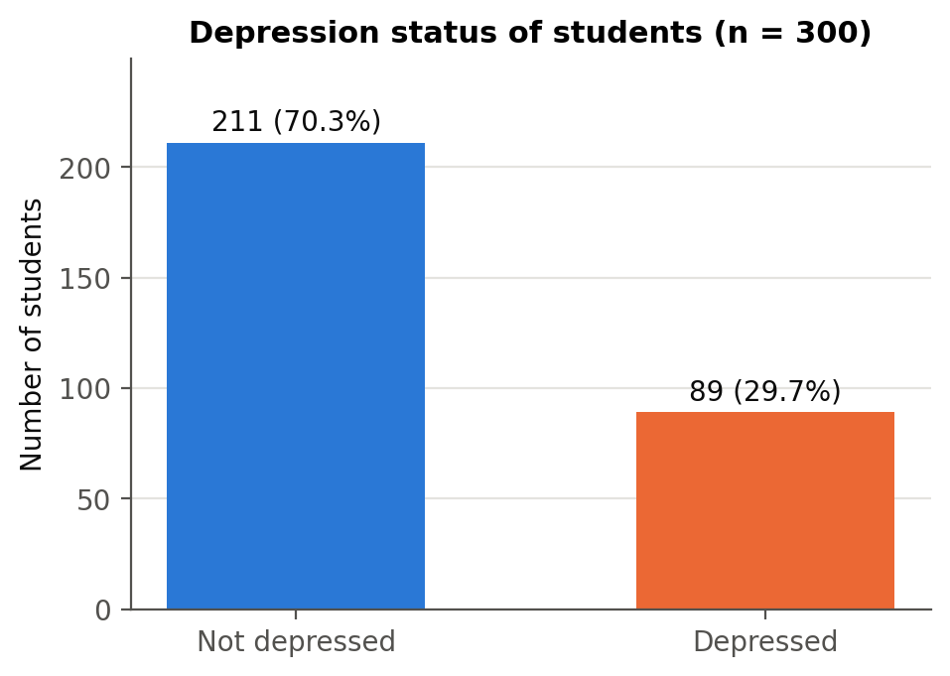
Figure 3.1: Distribution of the dependent variable (depression status)

3.5 Econometric Model Specification
Because the dependent variable is binary (depressed = 1, not depressed = 0), ordinary least squares is not ideal: its predicted values can fall outside the 0–1 range and its error term is heteroskedastic by construction. The study therefore uses binary choice models, which model the probability of depression directly (Wooldridge, 2010; Long & Freese, 2014).
Binary logit model. The probability that student i is depressed is modelled as:
Pr(Depressionᵢ = 1 | xᵢ) = Λ(xᵢ′β) = exp(xᵢ′β) / [1 + exp(xᵢ′β)]
where the vector xᵢ′β is:
β₀ + β₁Maleᵢ + β₂Ageᵢ + β₃CGPAᵢ + β₄Semesterᵢ + β₅Costᵢ + β₆LowerMidᵢ + β₇Richᵢ + β₈Singleᵢ + β₉EverMarriedᵢ + β₁₀LiveFamilyᵢ + β₁₁FriendCircleᵢ
The coefficients are estimated by maximum likelihood. A positive coefficient means the factor raises the probability of depression. Exponentiated coefficients, exp(β), are odds ratios: an odds ratio above 1 raises the odds of depression, and below 1 lowers them.
Binary probit model. As an alternative, the probit model replaces the logistic function with the standard normal cumulative distribution function Φ:
Pr(Depressionᵢ = 1 | xᵢ) = Φ(xᵢ′β)
Marginal effects. Logit and probit coefficients are not directly comparable, so the main results are reported as average marginal effects (AME): the average change in the probability of depression when a continuous variable rises by one unit, or when a 0/1 variable changes from 0 to 1, computed for every student and then averaged (equivalent to Stata's margins, dydx(*) command).
Diagnostics. Model fit is assessed with the likelihood-ratio (LR) test, McFadden's pseudo-R², the AIC and BIC, classification tables, the area under the ROC curve (AUC) and the Hosmer–Lemeshow test (Hosmer et al., 2013). Multicollinearity is checked using variance inflation factors (VIF). Robustness is assessed with robust standard errors, a linear probability model (LPM), a model that adds health status, and separate models for male and female students.
All estimation was carried out in Python using the pandas, SciPy and statsmodels libraries (Seabold & Perktold, 2010). An equivalent Stata do-file that reproduces every step is provided with this report (StataCorp, 2021).

3.6 Ethical Considerations
The study uses anonymised secondary survey data. The data contain no names, contact details or other personal identifiers; each student is identified only by a sequential number. The geographic identifier was removed after sampling. Because the topic is mental health, results are reported only at group level, and no attempt is made to identify or profile individual students.

Chapter 4
Empirical Results

4.1 Introduction
This chapter presents the results. It begins with a descriptive analysis of depression across student groups, followed by bivariate tests, the multicollinearity check, the logit and probit estimates with their marginal effects, model diagnostics, the hypothesis summary and the robustness checks.

4.2 Descriptive Analysis of Student Characteristics

4.2.1 Prevalence of Depression
Depression is common in the sample: 29.7% of students — almost three in ten — report being depressed. This is in line with the international estimates of around 30% reported by Ibrahim et al. (2013), and confirms that student depression is a widespread rather than a marginal problem.

4.2.2 Social and Demographic Characteristics
Figure 4.1 compares depression rates across the main social and demographic groups. Several patterns stand out:
- Relationship status shows the largest gap: 42.2% of single students are depressed, compared with only 8.2% of students in a relationship and 0% of the 11 students in a complicated relationship.
- Family background: students from middle-class families have the highest rate (35.8%), well above lower-middle class (19.3%) and rich (18.0%) students.
- Living style: students living as bachelors (hostels, messes or shared housing) are more often depressed (33.7%) than those living with family (23.3%).
- Marital status: unmarried students (31.4%) are more often depressed than married students (20.5%).
- Gender and friend circle show small raw differences: 31.9% of male and 27.6% of female students are depressed, and having a friend circle makes almost no difference (30.0% vs 28.7%).
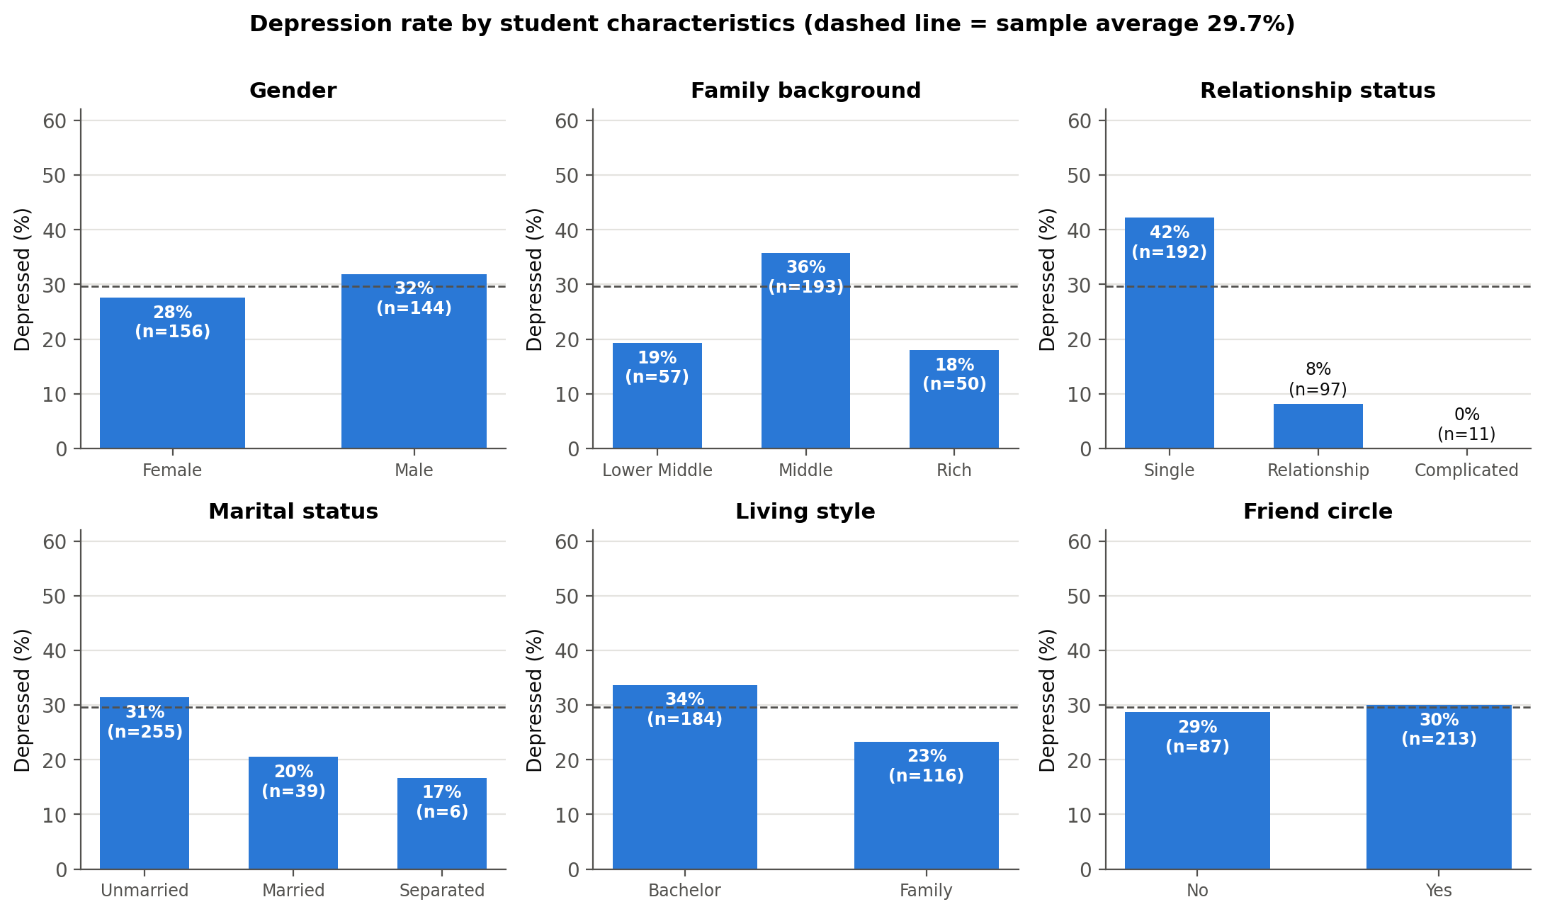
Figure 4.1: Depression rate by student characteristics
These raw comparisons do not control for other factors. For example, single students are more often male and less often live with family, so part of the gap between groups may be due to these overlaps. The regression models in Sections 4.6–4.9 separate these influences.

4.2.3 Self-Reported Health Condition
Figure 4.2 shows a very strong relationship between self-reported health and depression. None of the students in good health and only 2.9% of those in normal health are depressed, compared with 59.4% of students in abnormal health and 100% of those in critical health. The relationship is so close that health condition almost perfectly predicts depression. As explained in Section 3.2, this suggests that the health variable captures the same underlying condition as the outcome, so it is not used as an explanatory variable in the main model.
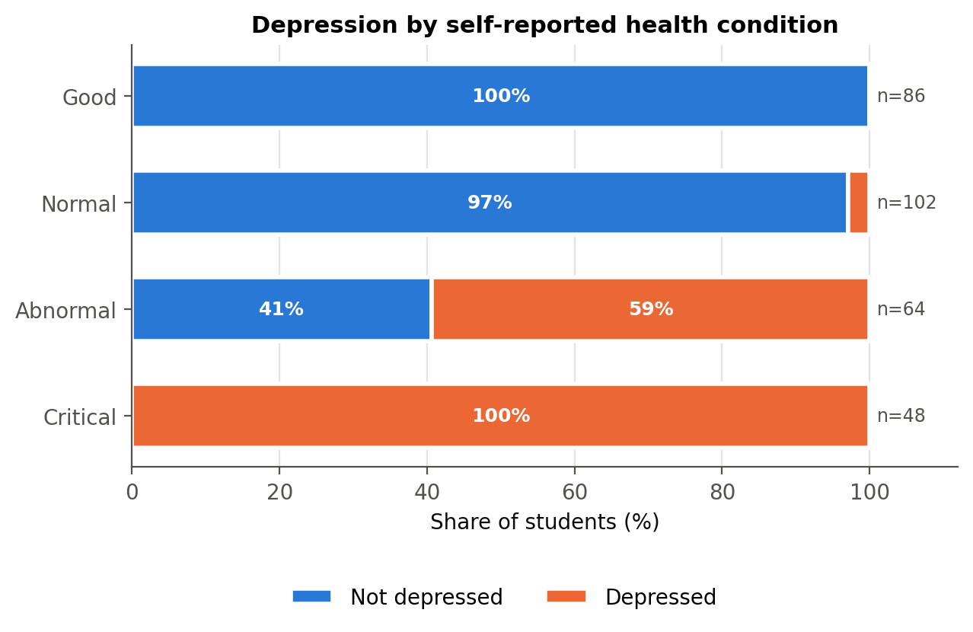
Figure 4.2: Depression by self-reported health condition

4.2.4 Numerical Variables: CGPA, Monthly Cost and Age
Figure 4.3 compares the distribution of the numerical variables between depressed and non-depressed students. Mean CGPA is almost identical in the two groups (3.48 vs 3.51), and so is mean age (21.7 vs 21.7 years). Depressed students report a somewhat higher monthly living cost (14.43 thousand vs 12.96 thousand).
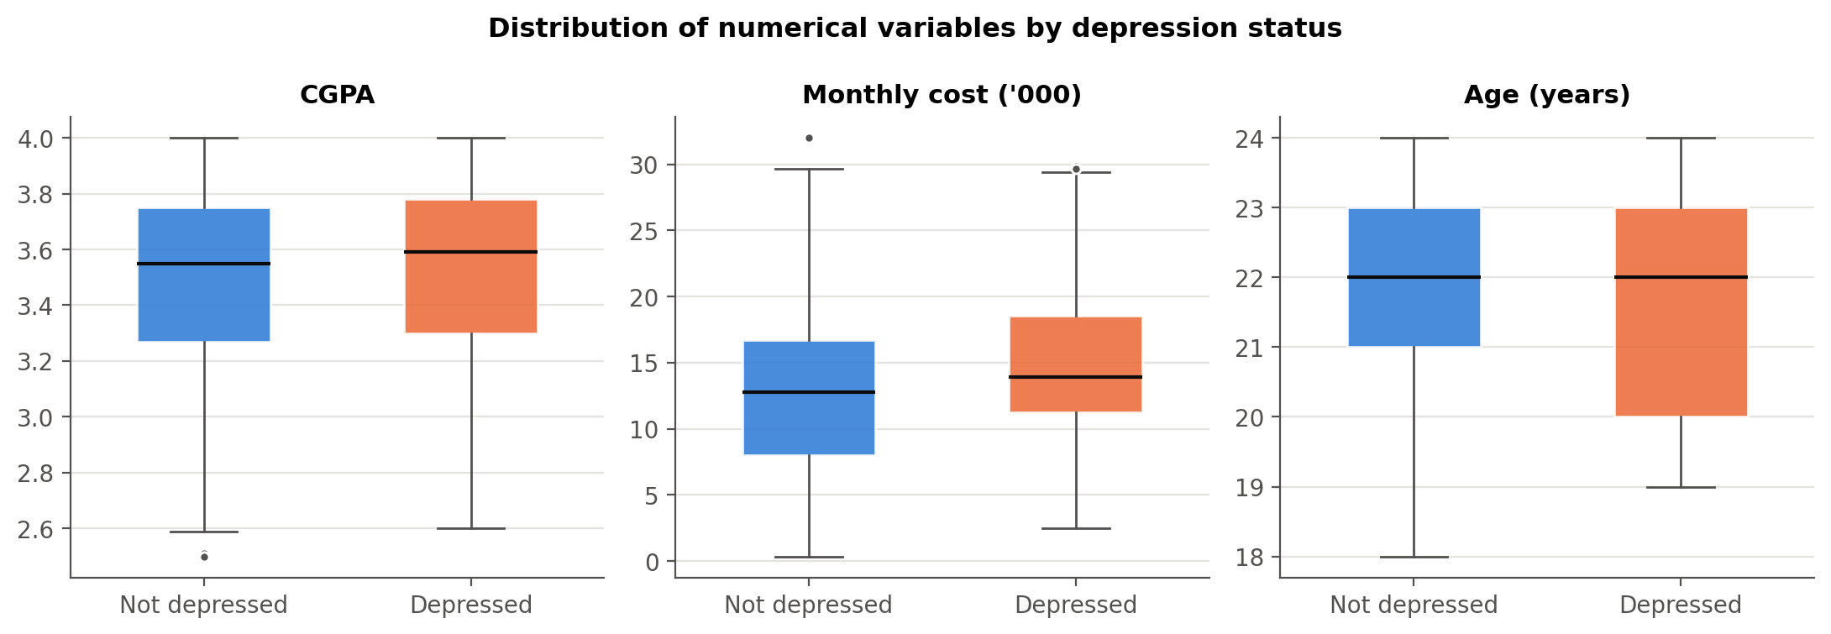
Figure 4.3: Distribution of CGPA, monthly cost and age by depression status

4.2.5 Age and Semester
Figure 4.4 shows depression rates by age and by semester group. Rates vary between ages without a clear upward or downward trend, and the very small groups at ages 18 and 19 should be read with caution. Across semester groups the rate is broadly stable at around 26–33%, suggesting that depression is not concentrated at a particular stage of the degree.
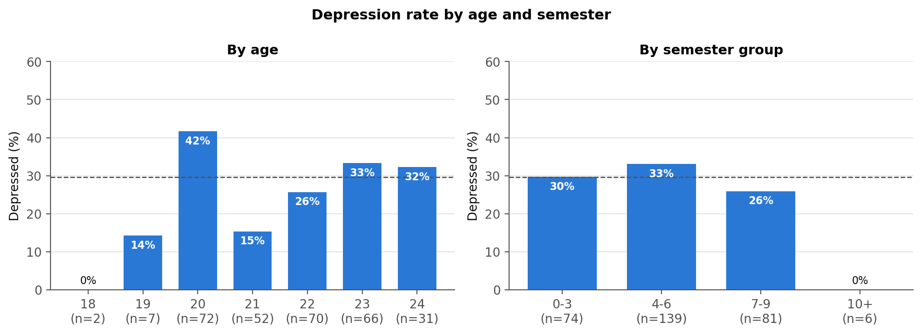
Figure 4.4: Depression rate by age and semester group

4.3 Descriptive Statistics of Variables
Table 4.1 reports summary statistics for the coded variables (equivalent to Stata's summarize command).
Variable | Obs | Mean | Std. dev. | Min | Max
Depression | 300 | 0.297 | 0.458 | 0.000 | 1.000
Male | 300 | 0.480 | 0.500 | 0.000 | 1.000
Age (years) | 300 | 21.677 | 1.409 | 18.000 | 24.000
CGPA | 300 | 3.486 | 0.352 | 2.500 | 4.000
Current semester | 300 | 5.193 | 2.204 | 0.000 | 11.000
Monthly cost ('000) | 300 | 13.398 | 6.182 | 0.342 | 32.000
Lower-middle class | 300 | 0.190 | 0.393 | 0.000 | 1.000
Rich class | 300 | 0.167 | 0.373 | 0.000 | 1.000
Single | 300 | 0.640 | 0.481 | 0.000 | 1.000
Ever married | 300 | 0.150 | 0.358 | 0.000 | 1.000
Lives with family | 300 | 0.387 | 0.488 | 0.000 | 1.000
Has friend circle | 300 | 0.710 | 0.455 | 0.000 | 1.000
Poor health | 300 | 0.373 | 0.484 | 0.000 | 1.000
Table 4.1: Summary statistics of coded variables
Students are on average 21.7 years old, with a mean CGPA of 3.49 and a mean monthly living cost of 13.4 thousand. 64% are single, 71% have a friend circle and 39% live with their family.
Figure 4.5 shows the correlation matrix. Apart from the very high correlation between depression and health level discussed above, correlations among the explanatory variables are modest. The largest are between monthly cost and lower-middle class (−0.50) and between being male and living with family (−0.41), neither of which is high enough to cause estimation problems.
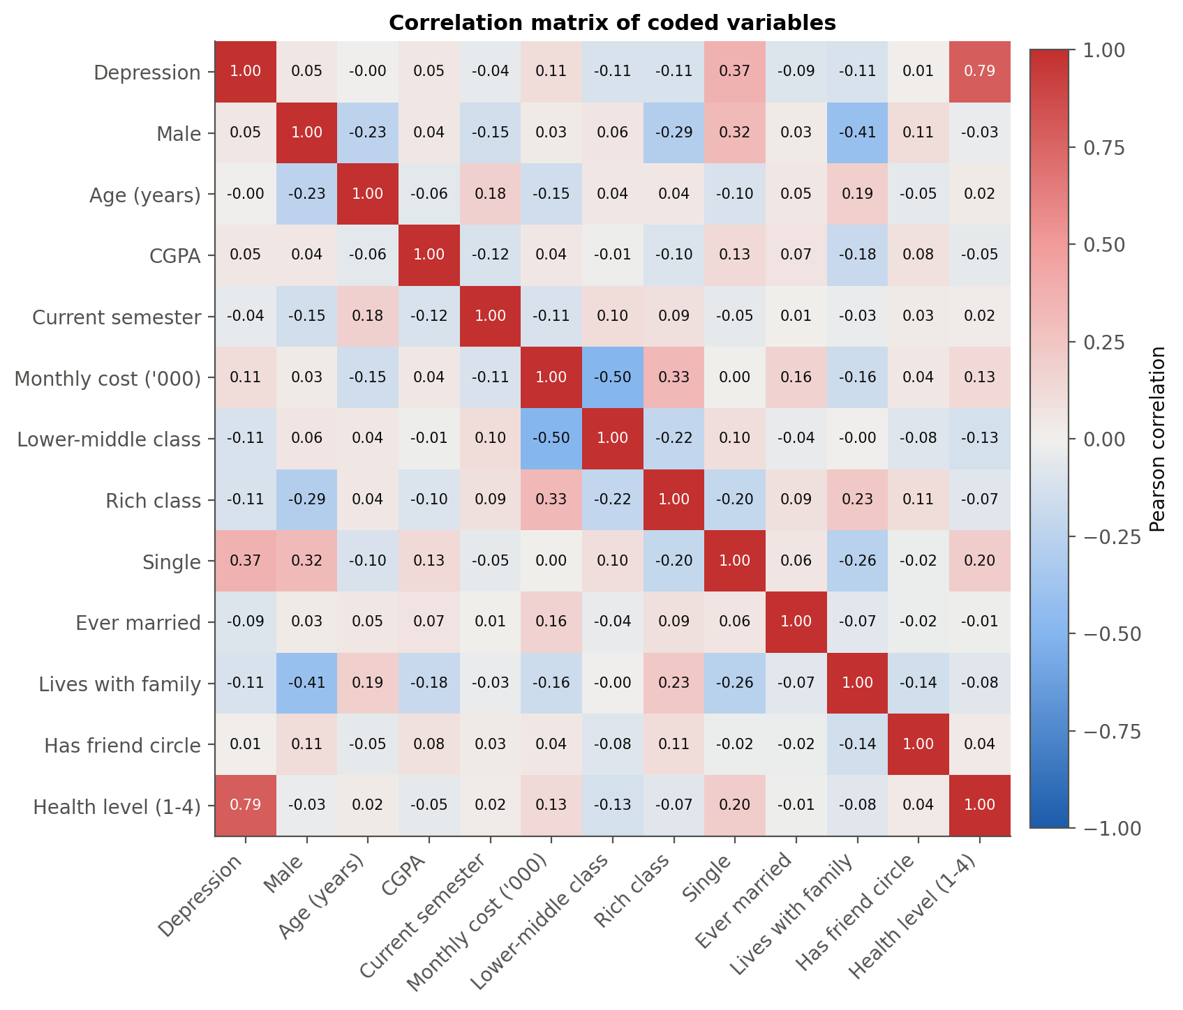
Figure 4.5: Correlation matrix of coded variables

4.4 Bivariate Analysis

4.4.1 Chi-Square Tests of Independence
Table 4.2 tests whether each categorical variable is independent of depression. Relationship status (χ² = 40.39, p < 0.001, Cramér's V = 0.37) and family background (χ² = 9.62, p = 0.008) are significantly associated with depression, as is health condition (Cramér's V = 0.84, a very strong association). Living style is borderline (p = 0.054). Gender, marital status and friend circle show no significant association on their own. For marital and relationship status some expected cell counts are below 5, which is one more reason the small categories were merged before modelling.
Variable | Chi-square | df | p-value | Cramer's V | Min expected count | Fisher exact p (2x2)
Gender | 0.689 | 1 | 0.407 | 0.048 | 42.720 | 0.449
Family background | 9.623 | 2 | 0.008 | 0.179 | 14.830
Relationship status | 40.394 | 2 | <0.001 | 0.367 | 3.260
Marital status | 2.408 | 2 | 0.300 | 0.090 | 1.780
Living style | 3.702 | 1 | 0.054 | 0.111 | 34.410 | 0.069
Friend circle | 0.051 | 1 | 0.821 | 0.013 | 25.810 | 0.890
Health condition | 212.060 | 3 | <0.001 | 0.841 | 14.240
Table 4.2: Chi-square tests of independence with depression

4.4.2 Difference in Means Tests
Table 4.3 compares the means of the numerical variables. None of the differences is significant at the 5% level. Monthly cost comes closest (Welch t-test p = 0.067, Mann–Whitney p = 0.051), while CGPA (p = 0.388) and age (p = 0.984) show no difference at all.
Variable | Mean (not depressed) | Mean (depressed) | Difference | Welch t | t-test p-value | Mann-Whitney U | Mann-Whitney p-value
CGPA | 3.475 | 3.513 | 0.038 | 0.865 | 0.388 | 10211.500 | 0.231
Monthly cost ('000) | 12.960 | 14.434 | 1.473 | 1.848 | 0.067 | 10726.500 | 0.051
Age (years) | 21.678 | 21.674 | -0.004 | -0.019 | 0.984 | 9312.000 | 0.909
Current semester | 5.256 | 5.045 | -0.211 | -0.800 | 0.424 | 9060.500 | 0.628
Table 4.3: Difference in means between depressed and non-depressed students

4.5 Multicollinearity Check
Table 4.4 reports the variance inflation factors for the explanatory variables of the main model. The largest VIF is 1.61, far below the common warning threshold of 10 (and even the stricter threshold of 5). Multicollinearity is therefore not a concern, and the coefficients can be interpreted separately.
Variable | VIF | Tolerance (1/VIF)
Male | 1.410 | 0.709
Age (years) | 1.127 | 0.887
CGPA | 1.077 | 0.929
Current semester | 1.110 | 0.901
Monthly cost ('000) | 1.614 | 0.620
Lower-middle class | 1.378 | 0.726
Rich class | 1.371 | 0.729
Single | 1.176 | 0.850
Ever married | 1.053 | 0.950
Lives with family | 1.405 | 0.712
Has friend circle | 1.076 | 0.929
Table 4.4: Variance inflation factors

4.6 Inferential Analysis: Binary Logistic Regression
Table 4.5 presents the logit estimates. The model is highly significant overall: the likelihood-ratio test rejects the hypothesis that all coefficients are zero (LR χ²(11) = 69.57, p < 0.001). McFadden's pseudo-R² is 0.191, which is a reasonable value for cross-sectional individual-level data (values of 0.2–0.4 are generally considered a good fit for logit models).
Variable | Coefficient | Std. err. | z | P>|z| | 95% CI lower | 95% CI upper | Sig.
Constant | -5.1987 | 2.9172 | -1.7821 | 0.0747 | -10.9163 | 0.5190 | *
Male | -0.6574 | 0.3472 | -1.8936 | 0.0583 | -1.3378 | 0.0230 | *
Age (years) | 0.1244 | 0.1061 | 1.1727 | 0.2409 | -0.0835 | 0.3324
CGPA | -0.0885 | 0.4290 | -0.2062 | 0.8366 | -0.9292 | 0.7523
Current semester | -0.0373 | 0.0718 | -0.5188 | 0.6039 | -0.1781 | 0.1035
Monthly cost ('000) | 0.0699 | 0.0357 | 1.9584 | 0.0502 | -0.0001 | 0.1398 | *
Lower-middle class | -0.7071 | 0.4649 | -1.5210 | 0.1283 | -1.6183 | 0.2041
Rich class | -1.2038 | 0.5899 | -2.0405 | 0.0413 | -2.3600 | -0.0475 | **
Single | 2.5285 | 0.4285 | 5.9005 | <0.001 | 1.6886 | 3.3684 | ***
Ever married | -1.1145 | 0.4516 | -2.4681 | 0.0136 | -1.9995 | -0.2295 | **
Lives with family | -0.2743 | 0.3726 | -0.7361 | 0.4617 | -1.0046 | 0.4561
Has friend circle | 0.1859 | 0.3323 | 0.5592 | 0.5760 | -0.4655 | 0.8372
Table 4.5: Binary logit estimates (N = 300; dependent variable: depression)
Significance levels: *** p < 0.01, ** p < 0.05, * p < 0.10.

4.6.1 Interpretation of Coefficients
- Single (β = 2.529, p < 0.001): the strongest and most significant effect. Holding all other factors constant, single students are much more likely to be depressed than students in a relationship.
- Ever married (β = -1.115, p = 0.014): students who are or have been married are significantly less likely to be depressed.
- Rich class (β = -1.204, p = 0.041): students from rich families are significantly less likely to be depressed than middle-class students.
- Monthly cost (β = 0.070, p = 0.050): higher living costs raise the probability of depression; the effect is at the edge of the 5% significance level.
- Male (β = -0.657, p = 0.058): male students are less likely to be depressed than female students once other factors are controlled; the effect is significant at the 10% level.
- CGPA, age, semester, lower-middle class, living with family and friend circle are not statistically significant: once the other variables are held constant, they do not explain differences in depression.

4.6.2 Odds Ratios
Table 4.6 and Figure 4.6 report the odds ratios. The odds of depression for single students are 12.5 times those of students in a relationship (95% CI 5.4–29.0). Students from rich families have 70% lower odds than middle-class students, and ever-married students have 67% lower odds than unmarried students. Each additional thousand units of monthly cost raises the odds by 7.2%.
Variable | Odds ratio | 95% CI lower | 95% CI upper | P>|z| | Sig.
Constant | 0.005 | 0.000 | 1.680 | 0.075 | *
Male | 0.518 | 0.262 | 1.023 | 0.058 | *
Age (years) | 1.133 | 0.920 | 1.394 | 0.241
CGPA | 0.915 | 0.395 | 2.122 | 0.837
Current semester | 0.963 | 0.837 | 1.109 | 0.604
Monthly cost ('000) | 1.072 | 1.000 | 1.150 | 0.050 | *
Lower-middle class | 0.493 | 0.198 | 1.226 | 0.128
Rich class | 0.300 | 0.094 | 0.954 | 0.041 | **
Single | 12.535 | 5.412 | 29.033 | <0.001 | ***
Ever married | 0.328 | 0.135 | 0.795 | 0.014 | **
Lives with family | 0.760 | 0.366 | 1.578 | 0.462
Has friend circle | 1.204 | 0.628 | 2.310 | 0.576
Table 4.6: Odds ratios from the logit model
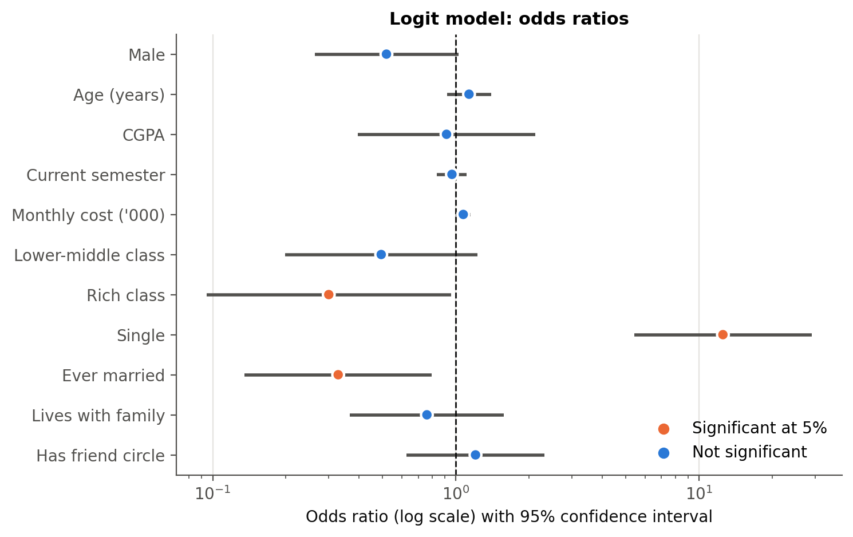
Figure 4.6: Odds ratios with 95% confidence intervals (log scale)

4.7 Marginal Effects Analysis (Logit)
Coefficients and odds ratios show the direction and relative strength of effects, but marginal effects are easier to interpret because they are expressed in probability terms. Table 4.7 and Figure 4.7 report the average marginal effects. For reference, the predicted probability of depression for a student with average characteristics is 22.4%.
Variable | dy/dx | Std. err. | z | P>|z| | 95% CI lower | 95% CI upper | Sig.
Male | -0.1070 | 0.0545 | -1.9633 | 0.0496 | -0.2139 | -0.0002 | **
Age (years) | 0.0205 | 0.0174 | 1.1825 | 0.2370 | -0.0135 | 0.0546
CGPA | -0.0146 | 0.0708 | -0.2062 | 0.8366 | -0.1533 | 0.1241
Current semester | -0.0061 | 0.0118 | -0.5196 | 0.6033 | -0.0293 | 0.0170
Monthly cost ('000) | 0.0115 | 0.0058 | 2.0042 | 0.0451 | 0.0003 | 0.0228 | **
Lower-middle class | -0.1118 | 0.0685 | -1.6335 | 0.1024 | -0.2460 | 0.0224
Rich class | -0.1716 | 0.0671 | -2.5587 | 0.0105 | -0.3030 | -0.0401 | **
Single | 0.3643 | 0.0425 | 8.5802 | <0.001 | 0.2811 | 0.4475 | ***
Ever married | -0.1643 | 0.0557 | -2.9497 | 0.0032 | -0.2735 | -0.0551 | ***
Lives with family | -0.0448 | 0.0600 | -0.7468 | 0.4552 | -0.1623 | 0.0727
Has friend circle | 0.0304 | 0.0538 | 0.5654 | 0.5718 | -0.0750 | 0.1358
Table 4.7: Average marginal effects after logit (dy/dx)
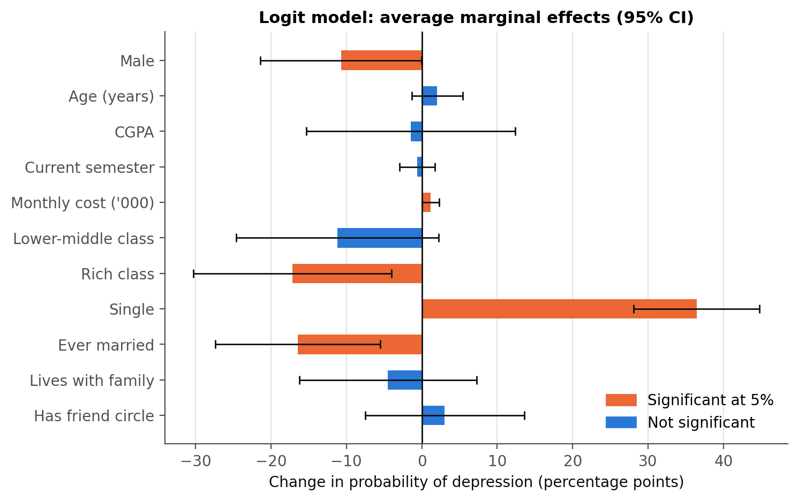
Figure 4.7: Average marginal effects after logit with 95% confidence intervals

4.7.1 Interpretation of Marginal Effects
- Being single raises the probability of depression by 36.4 percentage points (p < 0.001) — by far the largest effect in the model.
- Coming from a rich family lowers the probability by 17.2 percentage points relative to a middle-class family (p = 0.011).
- Being ever married lowers the probability by 16.4 percentage points (p = 0.003).
- Each additional thousand units of monthly cost raises the probability by 1.15 percentage points (p = 0.045); a difference of 10 thousand therefore corresponds to about 12 percentage points.
- Male students are 10.7 percentage points less likely to be depressed than female students (p = 0.050).
- A one-point increase in CGPA changes the probability by only -1.5 percentage points and is not significant (p = 0.837); having a friend circle is also not significant (p = 0.572).
Marginal effects at the means of all variables (equivalent to Stata's older mfx command) give very similar conclusions and are reported in the Excel workbook accompanying this report.

4.8 Binary Probit Regression
Table 4.8 reports the probit estimates. The model is again highly significant (LR χ²(11) = 69.87, p < 0.001) with a pseudo-R² of 0.192, almost identical to the logit model. Probit coefficients are on a different scale (roughly the logit coefficients divided by 1.6–1.8), but the signs and significance pattern are the same.
Variable | Coefficient | Std. err. | z | P>|z| | 95% CI lower | 95% CI upper | Sig.
Constant | -3.0986 | 1.7439 | -1.7769 | 0.0756 | -6.5166 | 0.3193 | *
Male | -0.4204 | 0.2043 | -2.0578 | 0.0396 | -0.8207 | -0.0200 | **
Age (years) | 0.0673 | 0.0630 | 1.0681 | 0.2855 | -0.0562 | 0.1907
CGPA | -0.0210 | 0.2538 | -0.0828 | 0.9340 | -0.5185 | 0.4765
Current semester | -0.0159 | 0.0418 | -0.3810 | 0.7032 | -0.0978 | 0.0659
Monthly cost ('000) | 0.0436 | 0.0209 | 2.0833 | 0.0372 | 0.0026 | 0.0847 | **
Lower-middle class | -0.3983 | 0.2750 | -1.4486 | 0.1475 | -0.9373 | 0.1406
Rich class | -0.7000 | 0.3404 | -2.0566 | 0.0397 | -1.3671 | -0.0329 | **
Single | 1.4643 | 0.2306 | 6.3495 | <0.001 | 1.0123 | 1.9163 | ***
Ever married | -0.5894 | 0.2532 | -2.3278 | 0.0199 | -1.0856 | -0.0931 | **
Lives with family | -0.1586 | 0.2139 | -0.7417 | 0.4583 | -0.5778 | 0.2606
Has friend circle | 0.1344 | 0.1976 | 0.6802 | 0.4964 | -0.2529 | 0.5217
Table 4.8: Binary probit estimates (N = 300; dependent variable: depression)

4.8.1 Interpretation of Coefficients
Single status remains strongly positive and highly significant; rich family background and ever being married remain negative and significant; and monthly cost remains positive and significant (p = 0.037). In the probit model the male coefficient is significant at the 5% level (p = 0.040), slightly stronger than in the logit model. CGPA, age, semester, lower-middle class, living with family and friend circle remain insignificant.

4.9 Marginal Effects (Probit)
Table 4.9 reports the average marginal effects after probit.
Variable | dy/dx | Std. err. | z | P>|z| | 95% CI lower | 95% CI upper | Sig.
Male | -0.1149 | 0.0537 | -2.1397 | 0.0324 | -0.2201 | -0.0096 | **
Age (years) | 0.0187 | 0.0174 | 1.0731 | 0.2832 | -0.0154 | 0.0527
CGPA | -0.0058 | 0.0704 | -0.0828 | 0.9340 | -0.1439 | 0.1322
Current semester | -0.0044 | 0.0116 | -0.3810 | 0.7032 | -0.0271 | 0.0183
Monthly cost ('000) | 0.0121 | 0.0057 | 2.1320 | 0.0330 | 0.0010 | 0.0232 | **
Lower-middle class | -0.1060 | 0.0689 | -1.5387 | 0.1239 | -0.2411 | 0.0290
Rich class | -0.1706 | 0.0680 | -2.5074 | 0.0122 | -0.3039 | -0.0372 | **
Single | 0.3676 | 0.0426 | 8.6251 | <0.001 | 0.2841 | 0.4512 | ***
Ever married | -0.1487 | 0.0560 | -2.6560 | 0.0079 | -0.2584 | -0.0390 | ***
Lives with family | -0.0437 | 0.0582 | -0.7499 | 0.4533 | -0.1578 | 0.0705
Has friend circle | 0.0369 | 0.0535 | 0.6895 | 0.4905 | -0.0680 | 0.1418
Table 4.9: Average marginal effects after probit (dy/dx)
The probit marginal effects are almost identical to the logit ones: being single raises the probability of depression by 36.8 percentage points (logit: 36.4), a rich family lowers it by 17.1 points (logit: 17.2), and ever being married lowers it by 14.9 points (logit: 16.4). The choice of link function therefore makes no practical difference to the conclusions.

4.10 Goodness of Fit and Model Diagnostics
Table 4.10 summarises the fit statistics of both models.
Statistic | Logit | Probit
Observations | 300.0000 | 300.0000
Log likelihood | -147.6186 | -147.4713
Log likelihood (null) | -182.4040 | -182.4040
LR chi2 | 69.5708 | 69.8655
LR df | 11.0000 | 11.0000
Prob > chi2 | 0.0000 | 0.0000
Pseudo R2 (McFadden) | 0.1907 | 0.1915
AIC | 319.2373 | 318.9426
BIC | 363.6827 | 363.3880
AUC (ROC) | 0.7814 | 0.7809
Hosmer-Lemeshow chi2 | 9.3428 | 12.1604
HL df | 8.0000 | 8.0000
HL p-value | 0.3142 | 0.1442
Table 4.10: Goodness-of-fit statistics
Both models fit the data well and almost equally. The Hosmer–Lemeshow test does not reject the logit model (χ² = 9.34, p = 0.314), meaning that predicted and observed depression rates agree across risk groups. The probit model has a marginally lower AIC (318.94 vs 319.24), but the difference is negligible.
Table 4.11 shows the classification performance (equivalent to Stata's estat classification).
Model | Cutoff | True positives | False positives | False negatives | True negatives | Sensitivity | Specificity | Correctly classified
Logit | 0.500 | 39 | 30 | 50 | 181 | 0.438 | 0.858 | 0.733
Logit | 0.297 | 71 | 73 | 18 | 138 | 0.798 | 0.654 | 0.697
Probit | 0.500 | 37 | 28 | 52 | 183 | 0.416 | 0.867 | 0.733
Probit | 0.297 | 74 | 74 | 15 | 137 | 0.832 | 0.649 | 0.703
Table 4.11: Classification tables at the 0.5 cut-off and at the sample share of depressed students
At the conventional 0.5 cut-off the logit model classifies 73.3% of students correctly, with a specificity of 85.8% but a sensitivity of only 43.8%. Because depression affects fewer than half of the students, a lower cut-off equal to the sample share of depressed students (0.297) is more appropriate for screening: it identifies 79.8% of depressed students while still correctly classifying 65.4% of non-depressed students.
Figure 4.8 plots the ROC curves. The area under the curve is 0.781 for the logit and 0.781 for the probit model, indicating acceptable discrimination: a randomly chosen depressed student has a 78% chance of receiving a higher predicted probability than a randomly chosen non-depressed student.
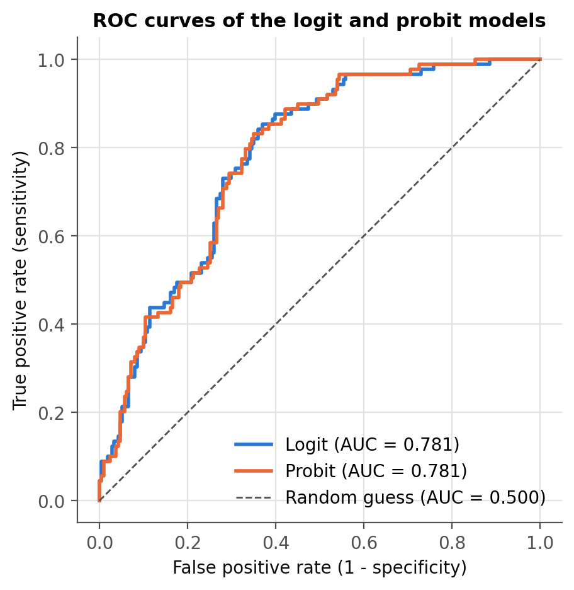
Figure 4.8: ROC curves of the logit and probit models
Figure 4.9 illustrates the size of the relationship-status effect. Holding all other variables at their means, the predicted probability of depression is above 40% for single students across the whole CGPA range, compared with around 5–6% for students who are not single. The lines are almost flat, confirming visually that CGPA has very little influence on depression in this sample.
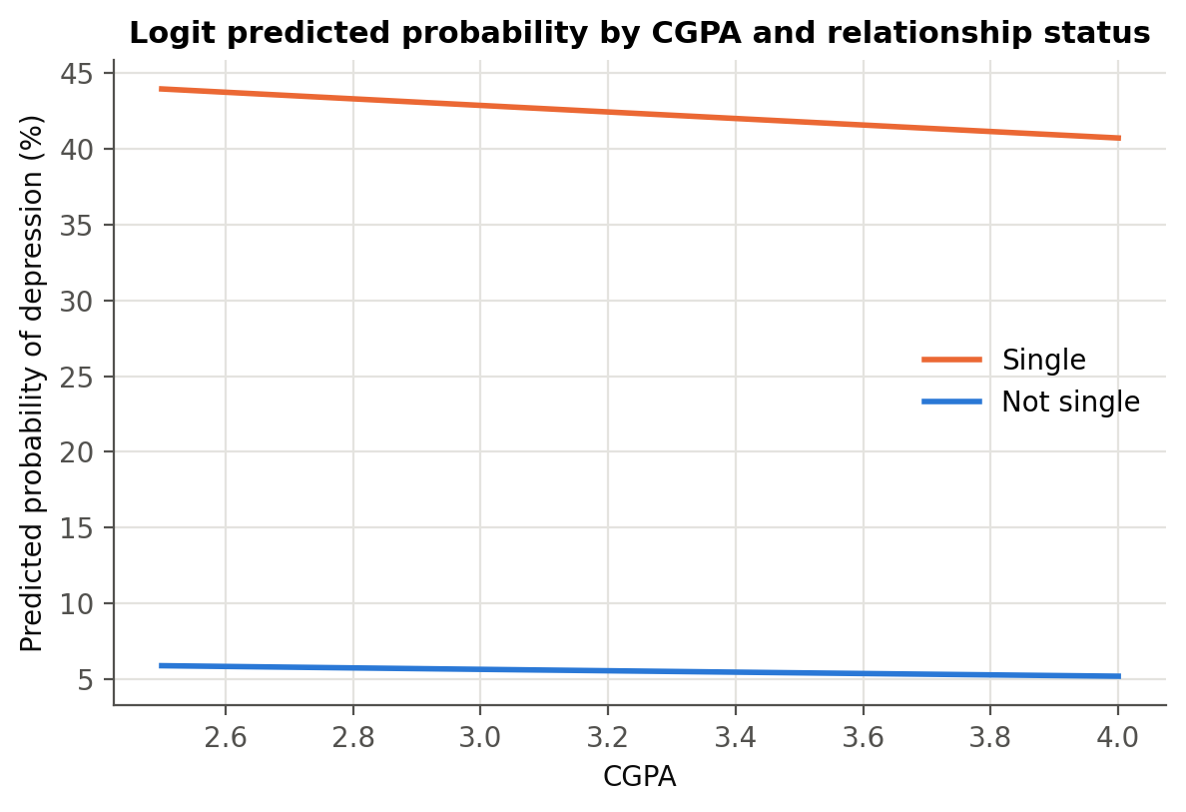
Figure 4.9: Predicted probability of depression by CGPA and relationship status

4.11 Hypothesis Testing Summary
Table 4.12 summarises the outcome of each hypothesis using the logit model.
Hypothesis | Variable | Expected sign | Logit coefficient | AME | P>|z| | Result
H1 | CGPA | - | -0.0885 | -0.0146 | 0.8366 | Not supported (not significant)
H2 | Has friend circle | - | 0.1859 | 0.0304 | 0.5760 | Not supported (not significant)
H3 | Single | + | 2.5285 | 0.3643 | <0.001 | Supported
H4a | Lower-middle class | + | -0.7071 | -0.1118 | 0.1283 | Not supported (not significant)
H4b | Rich class | - | -1.2038 | -0.1716 | 0.0413 | Supported
H5 | Monthly cost ('000) | + | 0.0699 | 0.0115 | 0.0502 | Weakly supported (10% level)
H6 | Lives with family | - | -0.2743 | -0.0448 | 0.4617 | Not supported (not significant)
H7 | Male | - | -0.6574 | -0.1070 | 0.0583 | Weakly supported (10% level)
Table 4.12: Summary of hypothesis tests
Hypotheses H3, H4b are supported at the 5% level, and H5 and H7 are supported at the 10% level in the logit model (both are significant at 5% when measured by the marginal effect, and in the probit model). Hypotheses H1, H2, H4a, H6 are not supported: academic performance, friend circle, lower-middle class background and living with family do not have a significant independent effect on depression.

4.12 Robustness Checks
Table 4.13 compares the main logit model with six alternative specifications. Coefficients are shown with standard errors in parentheses.
Variable | 1 Logit | 2 Logit rob. | 3 Probit | 4 LPM rob. | 5 Logit+health | 6 LPM male | 7 LPM female
Constant | -5.199*  (2.917) | -5.199*  (2.757) | -3.099*  (1.744) | -0.297  (0.477) | -7.915  (6.957) | -0.219  (0.690) | -0.521  (0.752)
Male | -0.657*  (0.347) | -0.657*  (0.340) | -0.420**  (0.204) | -0.095*  (0.057) | -1.153  (0.823)
Age (years) | 0.124  (0.106) | 0.124  (0.104) | 0.067  (0.063) | 0.018  (0.019) | -0.247  (0.253) | -0.004  (0.029) | 0.045  (0.030)
CGPA | -0.088  (0.429) | -0.088  (0.432) | -0.021  (0.254) | -0.011  (0.070) | 1.477  (1.016) | 0.097  (0.123) | -0.109  (0.096)
Current semester | -0.037  (0.072) | -0.037  (0.075) | -0.016  (0.042) | -0.003  (0.012) | 0.080  (0.163) | 0.005  (0.020) | -0.013  (0.015)
Monthly cost ('000) | 0.070*  (0.036) | 0.070**  (0.033) | 0.044**  (0.021) | 0.009*  (0.005) | 0.001  (0.069) | 0.004  (0.011) | 0.010*  (0.005)
Lower-middle class | -0.707  (0.465) | -0.707  (0.441) | -0.398  (0.275) | -0.131*  (0.068) | -0.831  (1.126) | -0.234**  (0.113) | -0.013  (0.099)
Rich class | -1.204**  (0.590) | -1.204**  (0.511) | -0.700**  (0.340) | -0.139**  (0.061) | 0.868  (1.053) | -0.322**  (0.159) | -0.101  (0.077)
Single | 2.529***  (0.429) | 2.529***  (0.413) | 1.464***  (0.231) | 0.376***  (0.049) | 5.356***  (1.004) | 0.390***  (0.071) | 0.320***  (0.070)
Ever married | -1.115**  (0.452) | -1.115**  (0.505) | -0.589**  (0.253) | -0.163**  (0.071) | -2.710***  (1.045) | -0.251***  (0.093) | -0.049  (0.118)
Lives with family | -0.274  (0.373) | -0.274  (0.378) | -0.159  (0.214) | -0.022  (0.057) | -1.058  (0.770) | 0.028  (0.091) | -0.028  (0.073)
Has friend circle | 0.186  (0.332) | 0.186  (0.317) | 0.134  (0.198) | 0.029  (0.053) | -0.636  (0.714) | -0.004  (0.085) | 0.013  (0.074)
Poor health |  |  |  |  | 7.958***  (1.122)
Observations | 300 | 300 | 300 | 300 | 300 | 144 | 156
Pseudo R2 / R2 | 0.191 | 0.191 | 0.192 | 0.192 | 0.791 | 0.233 | 0.202
Table 4.13: Robustness checks across model specifications
Significance levels: *** p < 0.01, ** p < 0.05, * p < 0.10. Standard errors in parentheses.
Figure 4.10 compares the marginal effects of the logit, probit and linear probability models side by side. The three models agree closely on every variable, so the results do not depend on the functional form.
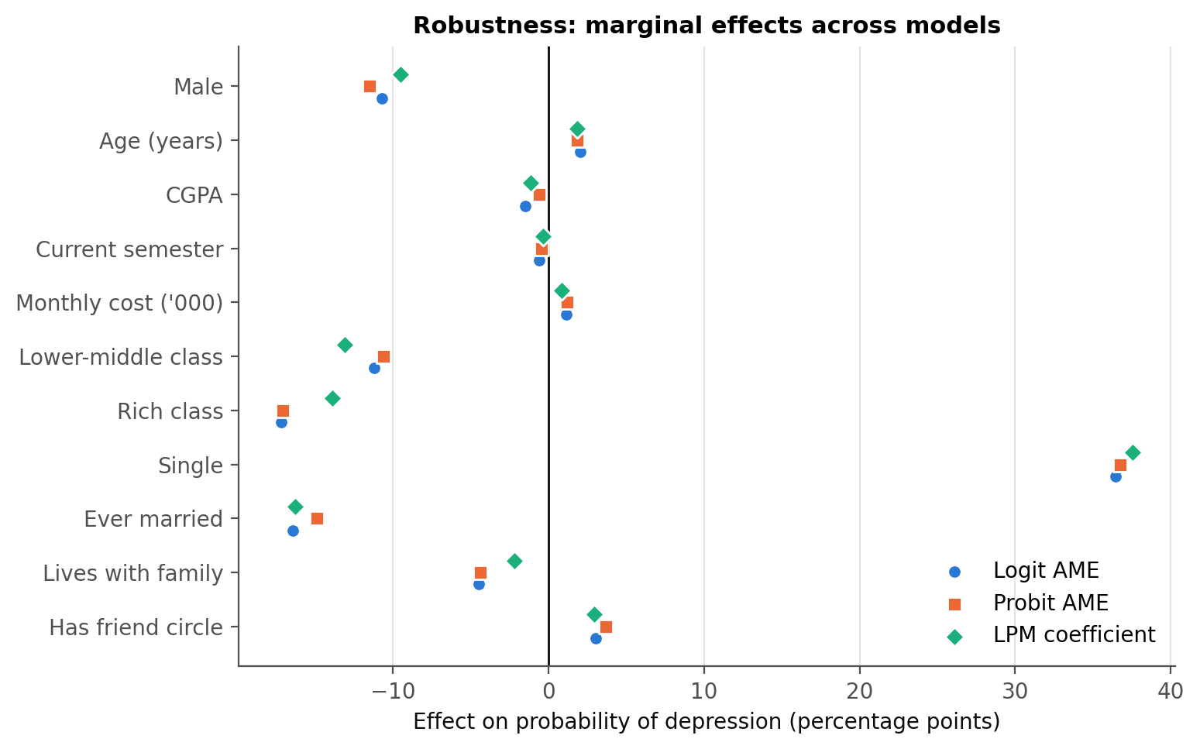
Figure 4.10: Marginal effects across logit, probit and linear probability models
- Robust standard errors (model 2): using heteroskedasticity-robust standard errors changes the standard errors only slightly; every variable keeps its sign and significance level, except monthly cost, which becomes significant at the 5% level.
- Linear probability model (model 4): the OLS coefficients, which are directly marginal effects, are very close to the logit and probit AMEs (R² = 0.192).
- Adding poor health (model 5): including the health indicator raises the pseudo-R² from 0.191 to 0.791 and the AUC to 0.986 (LR χ²(1) = 218.8, p < 0.001). Health status alone explains most of the variation in depression, and the estimation software flags quasi-complete separation (a fraction 0.12 of the observations is predicted perfectly), which confirms that it largely measures the same condition as the outcome. Being single and ever being married remain significant even in this model.
- Male and female students (models 6 and 7): a separate logit cannot be estimated for male students because none of the 29 male students who are not single is depressed — being single predicts depression perfectly within this group. The gender subsamples are therefore estimated as linear probability models. Being single is a strong risk factor for both men (+39.0 percentage points, p < 0.001) and women (+32.0 percentage points, p < 0.001). The protective effects of a rich family (-32.2 percentage points, p = 0.043), ever being married (-25.1 percentage points, p = 0.007) and a lower-middle class background (-23.4 percentage points, p = 0.040) appear among men but are not significant among women (p = 0.19, 0.68 and 0.89). Monthly cost matters mainly for women (+1.03 points per thousand, p = 0.058; men p = 0.710). Each subsample has fewer than 50 depressed students, so these differences are indicative only.

Chapter 5
Findings, Conclusion, and Recommendations

5.1 Introduction
This chapter summarises the main findings, discusses what they mean for universities and for theory, sets out the limitations of the study, and suggests directions for future research.

5.2 Summary of Major Findings

5.2.1 Relationships Matter More than Grades
The single most important factor in this study is relationship status. Single students are 36 percentage points more likely to be depressed than students in a relationship, an effect that is large, highly significant and stable across every model specification and for both men and women. Students who are or have been married are also less likely to be depressed. These results strongly support the stress-buffering view of close relationships (Cohen & Wills, 1985).

5.2.2 The 'Squeezed Middle': Family Background and Living Costs
Students from middle-class families are the most likely to be depressed — more so than both lower-middle class and rich students. After controlling for other factors, rich students are 17 percentage points less likely to be depressed than middle-class students. At the same time, higher monthly living costs raise the probability of depression. A possible explanation is that middle-class students face high expectations and rising costs without the financial cushion of richer families, consistent with research linking financial strain to poor mental health (Richardson et al., 2013).

5.2.3 The Gender Gap
Once other factors are held constant, female students are about 11 percentage points more likely to be depressed than male students. This gap is hidden in the raw data, where male students actually show a slightly higher rate, because male students are more often single. The adjusted result is consistent with the well-established gender difference in depression (Nolen-Hoeksema, 1987; Kessler, 2003).

5.2.4 What Did Not Matter: Grades, Friends and Living Arrangement
Contrary to common expectations, CGPA has no significant relationship with depression, and neither does the stage of study (semester) or age. Having a friend circle and living with family also show no independent effect. Living with family appears protective in the raw data, but this disappears once relationship status and gender are controlled for. The kind of social support that matters most in this sample seems to be a close, intimate relationship rather than a wider friend group.

5.2.5 Health and Depression
Self-reported health condition is almost a mirror image of depression: all students in critical health are depressed and none in good health are. This shows how closely physical and mental health are linked, but also warns that self-reported health measures can overlap with the outcome they are meant to explain.

5.3 Policy Implications for Universities

5.3.1 Target Social Isolation, not only Academic Performance
Since academic performance does not predict depression in this sample, support services that focus mainly on academic difficulties will miss many depressed students. Universities should invest in programmes that reduce loneliness and build close connections — peer mentoring, small-group activities, residential community programmes and relationship and emotional-skills workshops.

5.3.2 Address Financial Pressure
Because higher living costs and a middle-class background are associated with more depression, universities should combine mental health support with financial guidance: budgeting support, affordable housing and meal options, and need-based assistance that also reaches middle-income students, who may fall outside traditional aid schemes.

5.3.3 Gender-Sensitive Screening and Support
Female students face a higher adjusted risk, while male students may be less likely to seek help. Screening campaigns and counselling services should be designed to reach both groups — for example, confidential online screening, counsellors of both genders, and awareness campaigns that reduce stigma among men.

5.3.4 Simple Screening Tools
The model shows that a few easily collected characteristics can identify a large share of students at risk: using a cut-off equal to the sample share of depressed students, the logit model identifies 80% of depressed students. Such risk scores should never replace clinical assessment, but they can help universities decide whom to invite for further screening.

5.4 Theoretical Implications
The results support the diathesis–stress and stress-buffering frameworks: stressors such as financial pressure raise the probability of depression, while close relationships protect against it. They also suggest a refinement of social support theory for young adults — the protective effect appears to come from intimate relationships rather than from the size of the wider social network. Finally, the non-linear pattern of family background, with the middle class most at risk, suggests that relative pressure and expectations may matter as much as absolute income.

5.5 Limitations of the Study
- Cross-sectional design: the data capture one point in time, so the results show associations, not causal effects. Depression may itself affect relationship status (for example, by making it harder to form relationships).
- Self-reported measures: depression and health condition are self-reported yes/no or categorical indicators, not clinical diagnoses or validated symptom scales.
- Sample size: with 300 students and 89 depressed cases, some small groups (for example, separated or complicated-relationship students) had to be merged, and the gender subsample results are indicative only.
- Single region: the sample comes from one home region, which removes regional confounding but limits how far the results can be generalised to other regions or countries.
- Omitted variables: factors such as family history of mental illness, substance use, sleep, physical activity and exposure to traumatic events are not available in the data.

5.6 Recommendations for Future Research
- Longitudinal studies following students over several semesters to establish whether changes in relationships and finances precede changes in depression.
- Validated depression scales such as the PHQ-9, which would allow depression severity to be modelled with ordered or count models rather than a simple yes/no outcome.
- Larger and multi-region samples to estimate separate effects for small groups and to compare regions.
- Richer measures of social support, distinguishing the quality of friendships and family relationships from their mere presence.

5.7 Conclusion
Depression affects almost three in ten students in this sample. The analysis shows that it is driven less by grades and more by students' relationships and financial circumstances. Being single is the strongest risk factor, while being married, coming from a rich family and being male are associated with lower risk; higher living costs raise the risk. These findings are consistent across logit, probit and linear probability models. For universities, the message is clear: protecting student mental health requires attention to social connection and financial wellbeing, not only to academic support.

Appendix
This appendix reports the full estimation output produced by the analysis notebook (notebooks/student_depression_analysis.ipynb), computed with Python statsmodels. The Stata do-file stata/student_depression_analysis.do contains the equivalent Stata commands (summarize, tabulate, logit, probit, margins, estat classification, estat gof, lroc, regress) and reproduces the same models. All tables are also available in the Excel workbook results/Student_Depression_Analysis_Results.xlsx.

A.1 Binary logit model
Logit Regression Results
==============================================================================
Dep. Variable: depression No. Observations: 300
Model: Logit Df Residuals: 288
Method: MLE Df Model: 11
Date: Tue, 06 Oct 2026 Pseudo R-squ.: 0.1907
Time: 16:23:08 Log-Likelihood: -147.62
converged: True LL-Null: -182.40
Covariance Type: nonrobust LLR p-value: 1.474e-10
=================================================================================
coef std err z P>|z| [0.025 0.975]
---------------------------------------------------------------------------------
const -5.1987 2.917 -1.782 0.075 -10.916 0.519
male -0.6574 0.347 -1.894 0.058 -1.338 0.023
age 0.1244 0.106 1.173 0.241 -0.084 0.332
cgpa -0.0885 0.429 -0.206 0.837 -0.929 0.752
semester -0.0373 0.072 -0.519 0.604 -0.178 0.104
cost_k 0.0699 0.036 1.958 0.050 -5.5e-05 0.140
fam_lowermid -0.7071 0.465 -1.521 0.128 -1.618 0.204
fam_rich -1.2038 0.590 -2.041 0.041 -2.360 -0.048
single 2.5285 0.429 5.900 0.000 1.689 3.368
ever_married -1.1145 0.452 -2.468 0.014 -2.000 -0.229
live_family -0.2743 0.373 -0.736 0.462 -1.005 0.456
friend_circle 0.1859 0.332 0.559 0.576 -0.466 0.837
=================================================================================

A.2 Binary probit model
Probit Regression Results
==============================================================================
Dep. Variable: depression No. Observations: 300
Model: Probit Df Residuals: 288
Method: MLE Df Model: 11
Date: Tue, 06 Oct 2026 Pseudo R-squ.: 0.1915
Time: 16:23:09 Log-Likelihood: -147.47
converged: True LL-Null: -182.40
Covariance Type: nonrobust LLR p-value: 1.296e-10
=================================================================================
coef std err z P>|z| [0.025 0.975]
---------------------------------------------------------------------------------
const -3.0986 1.744 -1.777 0.076 -6.517 0.319
male -0.4204 0.204 -2.058 0.040 -0.821 -0.020
age 0.0673 0.063 1.068 0.285 -0.056 0.191
cgpa -0.0210 0.254 -0.083 0.934 -0.519 0.476
semester -0.0159 0.042 -0.381 0.703 -0.098 0.066
cost_k 0.0436 0.021 2.083 0.037 0.003 0.085
fam_lowermid -0.3983 0.275 -1.449 0.147 -0.937 0.141
fam_rich -0.7000 0.340 -2.057 0.040 -1.367 -0.033
single 1.4643 0.231 6.349 0.000 1.012 1.916
ever_married -0.5894 0.253 -2.328 0.020 -1.086 -0.093
live_family -0.1586 0.214 -0.742 0.458 -0.578 0.261
friend_circle 0.1344 0.198 0.680 0.496 -0.253 0.522
=================================================================================

A.3 Logit model with robust standard errors
Logit Regression Results
==============================================================================
Dep. Variable: depression No. Observations: 300
Model: Logit Df Residuals: 288
Method: MLE Df Model: 11
Date: Tue, 06 Oct 2026 Pseudo R-squ.: 0.1907
Time: 16:23:10 Log-Likelihood: -147.62
converged: True LL-Null: -182.40
Covariance Type: HC1 LLR p-value: 1.474e-10
=================================================================================
coef std err z P>|z| [0.025 0.975]
---------------------------------------------------------------------------------
const -5.1987 2.757 -1.885 0.059 -10.603 0.206
male -0.6574 0.340 -1.931 0.053 -1.325 0.010
age 0.1244 0.104 1.200 0.230 -0.079 0.328
cgpa -0.0885 0.432 -0.205 0.838 -0.935 0.758
semester -0.0373 0.075 -0.499 0.618 -0.184 0.109
cost_k 0.0699 0.033 2.138 0.033 0.006 0.134
fam_lowermid -0.7071 0.441 -1.602 0.109 -1.572 0.158
fam_rich -1.2038 0.511 -2.356 0.018 -2.205 -0.202
single 2.5285 0.413 6.126 0.000 1.720 3.337
ever_married -1.1145 0.505 -2.207 0.027 -2.104 -0.125
live_family -0.2743 0.378 -0.725 0.468 -1.016 0.467
friend_circle 0.1859 0.317 0.586 0.558 -0.435 0.807
=================================================================================

A.4 Linear probability model (robust standard errors)
OLS Regression Results
==============================================================================
Dep. Variable: depression R-squared: 0.192
Model: OLS Adj. R-squared: 0.161
Method: Least Squares F-statistic: 9.377
Date: Tue, 06 Oct 2026 Prob (F-statistic): 2.09e-14
Time: 16:23:10 Log-Likelihood: -158.73
No. Observations: 300 AIC: 341.5
Df Residuals: 288 BIC: 385.9
Df Model: 11
Covariance Type: HC1
=================================================================================
coef std err z P>|z| [0.025 0.975]
---------------------------------------------------------------------------------
const -0.2966 0.477 -0.622 0.534 -1.231 0.638
male -0.0952 0.057 -1.656 0.098 -0.208 0.017
age 0.0185 0.019 0.996 0.319 -0.018 0.055
cgpa -0.0113 0.070 -0.162 0.871 -0.148 0.125
semester -0.0033 0.012 -0.284 0.776 -0.026 0.019
cost_k 0.0085 0.005 1.822 0.068 -0.001 0.018
fam_lowermid -0.1307 0.068 -1.929 0.054 -0.264 0.002
fam_rich -0.1387 0.061 -2.261 0.024 -0.259 -0.018
single 0.3755 0.049 7.670 0.000 0.280 0.471
ever_married -0.1625 0.071 -2.292 0.022 -0.301 -0.024
live_family -0.0219 0.057 -0.384 0.701 -0.134 0.090
friend_circle 0.0295 0.053 0.553 0.580 -0.075 0.134
==============================================================================
Omnibus: 86.457 Durbin-Watson: 1.936
Prob(Omnibus): 0.000 Jarque-Bera (JB): 26.568
Skew: 0.500 Prob(JB): 1.70e-06
Kurtosis: 1.939 Cond. No. 540.
==============================================================================

Notes:
[1] Standard Errors are heteroscedasticity robust (HC1)

A.5 Logit model including poor health
Logit Regression Results
==============================================================================
Dep. Variable: depression No. Observations: 300
Model: Logit Df Residuals: 287
Method: MLE Df Model: 12
Date: Tue, 06 Oct 2026 Pseudo R-squ.: 0.7905
Time: 16:23:10 Log-Likelihood: -38.209
converged: True LL-Null: -182.40
Covariance Type: nonrobust LLR p-value: 1.281e-54
=================================================================================
coef std err z P>|z| [0.025 0.975]
---------------------------------------------------------------------------------
const -7.9152 6.957 -1.138 0.255 -21.550 5.720
male -1.1528 0.823 -1.400 0.162 -2.767 0.461
age -0.2471 0.253 -0.978 0.328 -0.742 0.248
cgpa 1.4769 1.016 1.453 0.146 -0.515 3.468
semester 0.0799 0.163 0.489 0.625 -0.240 0.400
cost_k 0.0009 0.069 0.013 0.990 -0.135 0.137
fam_lowermid -0.8308 1.126 -0.738 0.460 -3.037 1.375
fam_rich 0.8678 1.053 0.824 0.410 -1.196 2.931
single 5.3555 1.004 5.333 0.000 3.387 7.324
ever_married -2.7102 1.045 -2.594 0.009 -4.758 -0.663
live_family -1.0582 0.770 -1.375 0.169 -2.567 0.450
friend_circle -0.6355 0.714 -0.890 0.374 -2.035 0.764
health_poor 7.9576 1.122 7.091 0.000 5.758 10.157
=================================================================================

Possibly complete quasi-separation: A fraction 0.12 of observations can be
perfectly predicted. This might indicate that there is complete
quasi-separation. In this case some parameters will not be identified.

A.6 Linear probability model: male students
OLS Regression Results
==============================================================================
Dep. Variable: depression R-squared: 0.233
Model: OLS Adj. R-squared: 0.175
Method: Least Squares F-statistic: 6.216
Date: Tue, 06 Oct 2026 Prob (F-statistic): 9.33e-08
Time: 16:23:10 Log-Likelihood: -75.366
No. Observations: 144 AIC: 172.7
Df Residuals: 133 BIC: 205.4
Df Model: 10
Covariance Type: HC1
=================================================================================
coef std err z P>|z| [0.025 0.975]
---------------------------------------------------------------------------------
const -0.2187 0.690 -0.317 0.751 -1.570 1.133
age -0.0040 0.029 -0.137 0.891 -0.061 0.053
cgpa 0.0966 0.123 0.786 0.432 -0.144 0.337
semester 0.0050 0.020 0.252 0.801 -0.034 0.044
cost_k 0.0041 0.011 0.372 0.710 -0.017 0.026
fam_lowermid -0.2336 0.113 -2.058 0.040 -0.456 -0.011
fam_rich -0.3216 0.159 -2.019 0.043 -0.634 -0.009
single 0.3902 0.071 5.526 0.000 0.252 0.529
ever_married -0.2512 0.093 -2.706 0.007 -0.433 -0.069
live_family 0.0276 0.091 0.305 0.761 -0.150 0.205
friend_circle -0.0045 0.085 -0.053 0.958 -0.170 0.161
==============================================================================
Omnibus: 55.260 Durbin-Watson: 1.945
Prob(Omnibus): 0.000 Jarque-Bera (JB): 11.188
Skew: 0.343 Prob(JB): 0.00372
Kurtosis: 1.819 Cond. No. 523.
==============================================================================

Notes:
[1] Standard Errors are heteroscedasticity robust (HC1)

A.7 Linear probability model: female students
OLS Regression Results
==============================================================================
Dep. Variable: depression R-squared: 0.202
Model: OLS Adj. R-squared: 0.147
Method: Least Squares F-statistic: 5.236
Date: Tue, 06 Oct 2026 Prob (F-statistic): 1.50e-06
Time: 16:23:11 Log-Likelihood: -78.048
No. Observations: 156 AIC: 178.1
Df Residuals: 145 BIC: 211.6
Df Model: 10
Covariance Type: HC1
=================================================================================
coef std err z P>|z| [0.025 0.975]
---------------------------------------------------------------------------------
const -0.5214 0.752 -0.693 0.488 -1.996 0.953
age 0.0453 0.030 1.526 0.127 -0.013 0.103
cgpa -0.1085 0.096 -1.131 0.258 -0.296 0.079
semester -0.0133 0.015 -0.873 0.383 -0.043 0.017
cost_k 0.0103 0.005 1.895 0.058 -0.000 0.021
fam_lowermid -0.0134 0.099 -0.135 0.893 -0.208 0.181
fam_rich -0.1006 0.077 -1.306 0.192 -0.252 0.050
single 0.3199 0.070 4.557 0.000 0.182 0.457
ever_married -0.0485 0.118 -0.413 0.680 -0.279 0.182
live_family -0.0276 0.073 -0.377 0.706 -0.171 0.116
friend_circle 0.0126 0.074 0.169 0.866 -0.133 0.159
==============================================================================
Omnibus: 17.043 Durbin-Watson: 1.679
Prob(Omnibus): 0.000 Jarque-Bera (JB): 13.073
Skew: 0.602 Prob(JB): 0.00145
Kurtosis: 2.251 Cond. No. 591.
==============================================================================

Notes:
[1] Standard Errors are heteroscedasticity robust (HC1)

A.8 Marginal effects at the means (logit)
Variable | dy/dx | Std. err. | z | P>|z| | 95% CI lower | 95% CI upper | Sig.
Male | -0.1135 | 0.0589 | -1.9279 | 0.0539 | -0.2288 | 0.0019 | *
Age (years) | 0.0217 | 0.0184 | 1.1773 | 0.2391 | -0.0144 | 0.0577
CGPA | -0.0154 | 0.0746 | -0.2063 | 0.8366 | -0.1616 | 0.1308
Current semester | -0.0065 | 0.0125 | -0.5197 | 0.6032 | -0.0309 | 0.0180
Monthly cost ('000) | 0.0122 | 0.0061 | 1.9975 | 0.0458 | 0.0002 | 0.0241 | **
Lower-middle class | -0.1083 | 0.0626 | -1.7309 | 0.0835 | -0.2310 | 0.0143 | *
Rich class | -0.1653 | 0.0599 | -2.7598 | 0.0058 | -0.2826 | -0.0479 | ***
Single | 0.3639 | 0.0443 | 8.2150 | <0.001 | 0.2771 | 0.4508 | ***
Ever married | -0.1539 | 0.0482 | -3.1933 | 0.0014 | -0.2484 | -0.0594 | ***
Lives with family | -0.0469 | 0.0623 | -0.7531 | 0.4514 | -0.1690 | 0.0752
Has friend circle | 0.0316 | 0.0554 | 0.5716 | 0.5676 | -0.0769 | 0.1401
Table A.1: Marginal effects at the means after logit

A.9 Subsample marginal effects (linear probability model)
Variable | Female students: dy/dx | Male students: dy/dx | Female students: P>|z| | Male students: P>|z|
Age (years) | 0.0453 | -0.0040 | 0.1271 | 0.8910
CGPA | -0.1085 | 0.0966 | 0.2579 | 0.4319
Current semester | -0.0133 | 0.0050 | 0.3827 | 0.8011
Ever married | -0.0485 | -0.2512 | 0.6799 | 0.0068
Has friend circle | 0.0126 | -0.0045 | 0.8660 | 0.9576
Lives with family | -0.0276 | 0.0276 | 0.7065 | 0.7607
Lower-middle class | -0.0134 | -0.2336 | 0.8927 | 0.0396
Monthly cost ('000) | 0.0103 | 0.0041 | 0.0581 | 0.7096
Rich class | -0.1006 | -0.3216 | 0.1917 | 0.0435
Single | 0.3199 | 0.3902 | <0.001 | <0.001
Table A.2: Marginal effects for male and female students (LPM, robust SE)

References
Beck, A. T. (1967). Depression: Clinical, experimental, and theoretical aspects. New York: Harper & Row.
Bulloch, A. G., Williams, J. V., Lavorato, D. H., & Patten, S. B. (2009). The relationship between major depression and marital disruption is bidirectional. Depression and Anxiety, 26(12), 1172–1177.
Cohen, S., & Wills, T. A. (1985). Stress, social support, and the buffering hypothesis. Psychological Bulletin, 98(2), 310–357.
Eisenberg, D., Gollust, S. E., Golberstein, E., & Hefner, J. L. (2007). Prevalence and correlates of depression, anxiety, and suicidality among university students. American Journal of Orthopsychiatry, 77(4), 534–542.
Hosmer, D. W., Lemeshow, S., & Sturdivant, R. X. (2013). Applied logistic regression (3rd ed.). Hoboken, NJ: Wiley.
Hysenbegasi, A., Hass, S. L., & Rowland, C. R. (2005). The impact of depression on the academic productivity of university students. Journal of Mental Health Policy and Economics, 8(3), 145–151.
Ibrahim, A. K., Kelly, S. J., Adams, C. E., & Glazebrook, C. (2013). A systematic review of studies of depression prevalence in university students. Journal of Psychiatric Research, 47(3), 391–400.
Kawachi, I., & Berkman, L. F. (2001). Social ties and mental health. Journal of Urban Health, 78(3), 458–467.
Kessler, R. C. (2003). Epidemiology of women and depression. Journal of Affective Disorders, 74(1), 5–13.
Long, J. S., & Freese, J. (2014). Regression models for categorical dependent variables using Stata (3rd ed.). College Station, TX: Stata Press.
Lorant, V., Deliège, D., Eaton, W., Robert, A., Philippot, P., & Ansseau, M. (2003). Socioeconomic inequalities in depression: A meta-analysis. American Journal of Epidemiology, 157(2), 98–112.
Monroe, S. M., & Simons, A. D. (1991). Diathesis–stress theories in the context of life stress research: Implications for the depressive disorders. Psychological Bulletin, 110(3), 406–425.
Moussavi, S., Chatterji, S., Verdes, E., Tandon, A., Patel, V., & Ustun, B. (2007). Depression, chronic diseases, and decrements in health: Results from the World Health Surveys. The Lancet, 370(9590), 851–858.
Nolen-Hoeksema, S. (1987). Sex differences in unipolar depression: Evidence and theory. Psychological Bulletin, 101(2), 259–282.
Richardson, T., Elliott, P., & Roberts, R. (2013). The relationship between personal unsecured debt and mental and physical health: A systematic review and meta-analysis. Clinical Psychology Review, 33(8), 1148–1162.
Seabold, S., & Perktold, J. (2010). Statsmodels: Econometric and statistical modeling with Python. Proceedings of the 9th Python in Science Conference, 92–96.
StataCorp. (2021). Stata statistical software: Release 17. College Station, TX: StataCorp LLC.
Whitton, S. W., & Whisman, M. A. (2010). Relationship satisfaction instability and depression. Journal of Family Psychology, 24(6), 791–794.
Wooldridge, J. M. (2010). Econometric analysis of cross section and panel data (2nd ed.). Cambridge, MA: MIT Press.

