Determinants of Depression among University Students: An Econometric Analysis using Logit and Probit Models
Report submitted to
Dr. Prantik Bagchi
Department of Humanities and Social Sciences
Indian Institute of Technology Kharagpur
Submitted by
Atharv Lodhi
Sourav Choudhary
Piyush Bisht

Department of Humanities and Social Sciences
Indian Institute of Technology Kharagpur
Kharagpur, West Bengal 721302
© 2026. All rights reserved

Contents
I. Introduction 1
A. Background 1
B. Problem Statement 1
C. Objectives and Research Questions 1
D. Hypotheses 1
E. Contributions and Organization 1
II. Literature Review 2
A. The Diathesis–Stress Model 2
B. Social Support and the Stress-Buffering Hypothesis 2
C. Academic Pressure and Performance 2
D. Socioeconomic Status and Financial Strain 2
E. Relationships, Marriage and Gender 2
F. Physical Health and Summary 2
III. Data and Methodology 2
A. Data 2
B. Data Transformation 2
C. Econometric Models 3
D. Diagnostics, Robustness and Software 3
IV. Empirical Results 3
A. Descriptive Analysis 3
B. Bivariate Tests 6
C. Multicollinearity 6
D. Binary Logit Model 6
E. Marginal Effects 7
F. Binary Probit Model 8
G. Goodness of Fit 9
H. Hypothesis Tests 10
I. Robustness Checks 10
V. Discussion 11
A. Key Findings 11
B. Implications for Universities 11
C. Theoretical Implications 11
VI. Limitations and Future Research 12
VII. Conclusion 12
References 12
Appendix: Full Model Output 12

List of Figures
Fig. 1. Distribution of the dependent variable (depression status). 3
Fig. 2. Depression rate by student characteristics (dashed line: sample average). 4
Fig. 3. Depression by self-reported health condition. 4
Fig. 4. Distribution of CGPA, monthly cost and age by depression status. 4
Fig. 5. Depression rate by age and semester group. 5
Fig. 6. Correlation matrix of coded variables. 5
Fig. 7. Logit odds ratios with 95% confidence intervals (log scale). 7
Fig. 8. Average marginal effects after logit with 95% confidence intervals. 8
Fig. 9. ROC curves of the logit and probit models. 9
Fig. 10. Predicted probability of depression by CGPA and relationship status. 10
Fig. 11. Marginal effects across logit, probit and linear probability models. 11

List of Tables
Table I Raw Data (First Five Records) 2
Table II Description of Variables 3
Table III Summary Statistics of Coded Variables 5
Table IV Chi-Square Tests of Independence with Depression 6
Table V Difference in Means Between Depressed and Non-Depressed Students 6
Table VI Variance Inflation Factors 6
Table VII Binary Logit Estimates (N = 300; Dependent Variable: Depression) 6
Table VIII Odds Ratios from the Logit Model 7
Table IX Average Marginal Effects after Logit (dy/dx) 7
Table X Binary Probit Estimates (N = 300; Dependent Variable: Depression) 8
Table XI Average Marginal Effects after Probit (dy/dx) 9
Table XII Goodness-of-Fit Statistics 9
Table XIII Classification Tables (Cut-off 0.5 and Sample Share) 9
Table XIV Summary of Hypothesis Tests 10
Table XV Robustness Checks Across Model Specifications 10
Table XVI Marginal Effects at the Means after Logit 15
Table XVII Marginal Effects for Male and Female Students (LPM, Robust SE) 15

Determinants of Depression among University Students: An Econometric Analysis using Logit and Probit Models
Atharv Lodhi | Sourav Choudhary | Piyush Bisht
Dept. of Humanities and Social Sciences  IIT Kharagpur | Dept. of Humanities and Social Sciences  IIT Kharagpur | Dept. of Humanities and Social Sciences  IIT Kharagpur

Abstract—Depression is one of the most common mental health problems among university students, yet it is unclear which personal, social and economic characteristics separate depressed students from others once they are considered together. Using survey data on 300 university students aged 18–24, of whom 89 (29.7%) report depression, this paper estimates binary logit and probit models with average marginal effects, supported by chi-square and t-tests, multicollinearity, goodness-of-fit and robustness checks. Being single is the strongest risk factor (+36.4 percentage points, p < 0.001). A rich family background (-17.2 percentage points) and ever being married (-16.4 percentage points) are protective, while each additional thousand units of monthly living cost raises the probability by 1.15 points. Male students are 10.7 points less likely to be depressed than female students. CGPA, semester, age, living arrangement and having a friend circle show no significant effect. The logit model is jointly significant (LR χ²(11) = 69.57, p < 0.001), well calibrated (Hosmer–Lemeshow p = 0.314) and has an AUC of 0.781; probit and linear probability models give almost identical effects. The results suggest that student mental health support should prioritise social connection and financial pressure rather than academic performance alone.
Index Terms—Depression, university students, binary logit, probit, marginal effects, relationship status, socioeconomic status, mental health.

I. Introduction

A. Background
University life combines several major transitions within a few years: students move away from home, form new friendships and romantic relationships, manage their own money and face continuous academic evaluation. For many students these changes are a source of persistent stress, and depression—marked by low mood, loss of interest, fatigue and feelings of worthlessness—is among the most frequent mental health problems in this group. A systematic review of university students reported an average depression prevalence of about 30%, well above the general population [1]. Student depression also lowers academic productivity and raises the risk of dropping out [2], [3], so knowing which students are most at risk matters to universities deciding where to direct limited counselling resources.
Theory points to many interrelated causes: stressful life events acting on individual vulnerability [4], the protective role of social support [5], a socioeconomic gradient in depression [6] and higher depression among women [7]. This paper brings these strands together and tests them jointly on one well-defined group of students.

B. Problem Statement
Many studies examine one factor at a time—for example grades or family income—and therefore cannot tell whether an apparent effect is real or reflects other, correlated characteristics. If single students are also more likely to live away from family, a simple comparison cannot separate the two. There is also a widespread assumption that poor grades are a main driver of depression; if this is wrong, support programmes focused on academic help will miss many students in need. This study estimates multivariate probability models that isolate the contribution of each factor while holding the others constant.

C. Objectives and Research Questions
The study aims to (i) measure the prevalence of depression in the sample; (ii) compare depression across gender, family background, relationship and marital status, living style, social support and health; (iii) estimate the effect of each factor with logit and probit models; (iv) express the effects as changes in probability; (v) test their robustness; and (vi) derive recommendations for universities. It asks whether academic performance, relationship and marital status, family background and living costs, gender, and social support are associated with the probability of depression.

D. Hypotheses
Based on the literature in Section II, the following hypotheses are tested:
- H1: Students with higher CGPA are less likely to be depressed (academic stress).
- H2: Students with a friend circle are less likely to be depressed (social support).
- H3: Single students are more likely to be depressed than students in a relationship.
- H4a: Students from lower-middle class families are more likely to be depressed than middle class.
- H4b: Students from rich families are less likely to be depressed than middle class.
- H5: Higher monthly living cost is associated with higher depression (financial pressure).
- H6: Students living with family are less likely to be depressed than those living as bachelors.
- H7: Female students are more likely to be depressed than male students.

E. Contributions and Organization
The paper contributes evidence on the relative importance of social, economic and academic factors measured on the same students, reports marginal effects that translate results into probability changes, and offers practical guidance for student support services. Section II reviews the literature, Section III describes the data and methodology, Section IV presents the results, Section V discusses them, Section VI covers limitations and future research, and Section VII concludes. The appendix reports the full model output.

II. Literature Review

A. The Diathesis–Stress Model
The diathesis–stress model holds that depression develops when stressful events act on a pre-existing vulnerability [4]. Students face a dense cluster of stressors—examinations, financial obligations, relationship changes and living away from home—so the model predicts higher depression among students exposed to more stressors or with fewer buffers. Beck's cognitive theory adds that negative interpretations of such events turn stress into depressive symptoms [8].

B. Social Support and the Stress-Buffering Hypothesis
Social support protects mental health mainly by buffering the impact of stress: people with close, supportive relationships cope better with the same adversity [5]. Friendships, partners and family reduce the risk of depression through emotional support and a sense of belonging [9]. For students, friend circles, partners and living with family are the most direct sources of such support (H2, H3, H6).

C. Academic Pressure and Performance
Academic stress is widely cited as a driver of student depression, and depression is associated with lower grade point averages [2], [3]. The direction of causality is unclear, however, and links often weaken once social and economic variables are included. H1 tests whether CGPA has an independent association.

D. Socioeconomic Status and Financial Strain
People with lower socioeconomic status have significantly higher odds of depression, with financial strain a main channel [6]. Debt and money worries are strongly linked to poor mental health [10]. Family background shapes both resources and expectations, while monthly living cost directly measures financial pressure (H4a, H4b, H5).

E. Relationships, Marriage and Gender
The quality and stability of romantic relationships are closely tied to depressive symptoms [11], and the link between marital status and depression runs in both directions [12]. Being single can bring loneliness in early adulthood (H3). Women experience depression roughly twice as often as men [7], [13], a gap attributed to differences in stress exposure, coping styles and biology (H7).

F. Physical Health and Summary
Chronic physical conditions sharply increase the probability of depression [14], so self-reported health is expected to be strongly related to depression. When a health measure partly reflects the same symptoms, however, it cannot be treated as an independent cause—an issue that proves important here. Overall, the literature identifies academic, social, economic, demographic and health factors, but rarely estimates them jointly in one sample; this paper addresses that gap.

III. Data and Methodology

A. Data
The study uses survey data on university students. The analysis sample consists of 300 students aged 18–24 (144 male, 156 female), drawn by simple random sampling with a fixed seed from the students of one home region in a larger student survey. Using one region removes regional differences that could confound the comparison, and the 18–24 range covers the typical undergraduate age. The region identifier was removed after sampling. For each student the data record gender, age, family background, relationship status, marital status, living style, current semester, CGPA, friend circle, self-reported health, monthly living cost excluding study costs and depression status. Table I shows the first five records.

Table I
Raw Data (First Five Records)
Gender | Age | Family background | Relationship | Marital status | Living | Semester | CGPA | Friends | Health | Monthly cost | Depression
Female | 23 | Middle class | Single | Unmarried | Family | 4 | 2.92 | No | Good | 7400 | No
Male | 20 | Lower Middle class | Single | Unmarried | Bachelor | 5 | 3.10 | Yes | Normal | 5896 | No
Male | 20 | Middle class | Single | Unmarried | Bachelor | 5 | 3.59 | Yes | Abnormal | 14815 | Yes
Male | 23 | Middle class | In a Relationship | Unmarried | Family | 2 | 3.00 | Yes | Normal | 19681 | No
Male | 22 | Middle class | In a Relationship | Unmarried | Family | 3 | 3.00 | Yes | Normal | 15750 | No

B. Data Transformation
The data contain 0 missing values and 0 duplicate records. Text answers were converted to 0/1 indicators (depression, male, living with family, friend circle). Family background was coded as two dummies (lower-middle class, rich class) with middle class as the base. Two very small categories were merged: the 'complicated' relationship group (11 students, none depressed) would be predicted perfectly, so relationship status became single vs. not single; the 'separated' group (6 students) was merged with married into ever married. Monthly cost was divided by 1,000.
Self-reported health is almost perfectly aligned with depression: 100% of students in critical health and 0% in good health are depressed. Including it in the main model would cause quasi-complete separation, and it very likely measures the same condition as the outcome. It is therefore analysed descriptively and entered only in one robustness model. Table II describes the final variables.

Table II
Description of Variables
Variable name | Description and coding | Data type
depression | Whether the student reports depression. 1 = Yes, 0 = No. | Binary (dependent variable)
male | Gender of the student. 1 = Male, 0 = Female. | Binary
age | Age of the student in years (18-24). | Numerical (discrete)
cgpa | Cumulative grade point average on a 4.00 scale. | Numerical (continuous)
semester | Semester the student is currently in. | Numerical (discrete)
cost_k | Monthly living cost excluding study costs, in thousands of local currency units. | Numerical (continuous)
fam_lowermid | 1 = Lower-middle class family (base group: middle class). | Binary (dummy)
fam_rich | 1 = Rich class family (base group: middle class). | Binary (dummy)
single | 1 = Single, 0 = In a relationship or complicated. | Binary
ever_married | 1 = Married or separated, 0 = Unmarried. | Binary
live_family | 1 = Lives with family, 0 = Lives as a bachelor (hostel/mess/shared). | Binary
friend_circle | 1 = Has a friend circle, 0 = Does not. | Binary
health_poor | 1 = Abnormal or critical health, 0 = Good or normal (robustness model only). | Binary
health_level | 1 = Good, 2 = Normal, 3 = Abnormal, 4 = Critical (descriptive only). | Ordinal

C. Econometric Models
Because the outcome is binary, ordinary least squares can predict values outside 0–1 and is heteroskedastic by construction, so binary choice models are used [15], [16]. The logit model is
Pr(yᵢ = 1 | xᵢ) = Λ(xᵢ′β) = exp(xᵢ′β) / [1 + exp(xᵢ′β)] (1)
with xᵢ′β = β₀ + β₁Male + β₂Age + β₃CGPA + β₄Semester + β₅Cost + β₆LowerMid + β₇Rich + β₈Single + β₉EverMarried + β₁₀LiveFamily + β₁₁FriendCircle. Coefficients are estimated by maximum likelihood; exp(β) is the odds ratio. The probit model replaces Λ with the standard normal CDF Φ:
Pr(yᵢ = 1 | xᵢ) = Φ(xᵢ′β) (2)
Because coefficients of the two models are on different scales, results are reported mainly as average marginal effects (AME): the average change in Pr(y = 1) when a continuous variable rises by one unit, or when a 0/1 variable changes from 0 to 1 (Stata: margins, dydx(*)).

D. Diagnostics, Robustness and Software
Fit is assessed with the likelihood-ratio test, McFadden's pseudo-R², AIC/BIC, classification tables, the area under the ROC curve and the Hosmer–Lemeshow test [17]; multicollinearity with variance inflation factors. Robustness checks use robust standard errors, a linear probability model (LPM), a model adding health status, and separate models for male and female students. Estimation used Python (pandas, SciPy, statsmodels [18]); an equivalent Stata do-file reproduces every step [19]. The data are anonymised, contain no personal identifiers, and results are reported only at group level.

IV. Empirical Results

A. Descriptive Analysis
Depression is common: 29.7% of students—almost three in ten—report it (Fig. 1), in line with international estimates of around 30% [1]. The outcome is balanced enough for a binary choice model, with enough depressed students relative to the number of regressors for stable estimation.
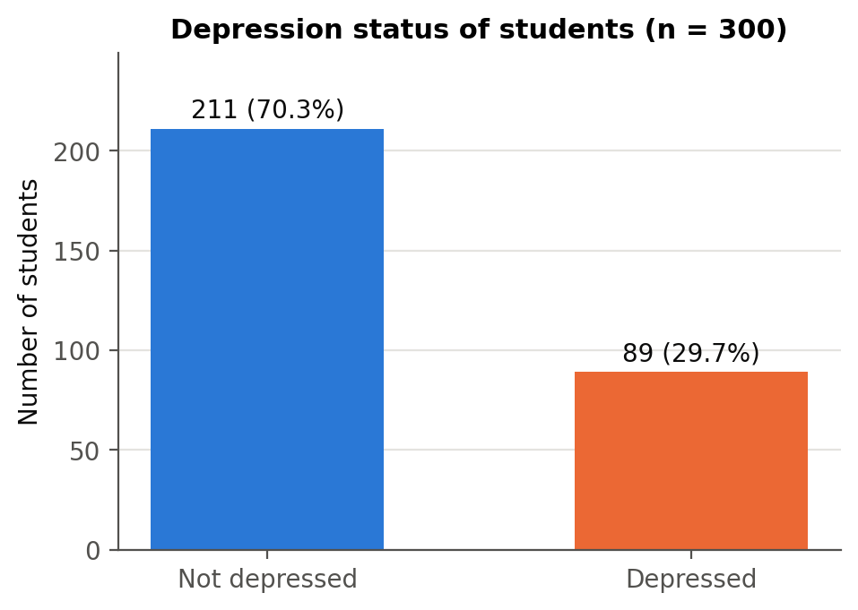
Fig. 1. Distribution of the dependent variable (depression status).
Fig. 2 compares depression rates across groups. Relationship status shows the largest gap: 42.2% of single students are depressed versus 8.2% of students in a relationship and none of the 11 in a complicated relationship. Middle-class students have the highest rate (35.8%), above lower-middle class (19.3%) and rich students (18.0%). Students living as bachelors are more often depressed (33.7%) than those living with family (23.3%). Gender and friend circle show small raw differences (male 31.9%, female 27.6%; friend circle 30.0% vs. 28.7%). These raw comparisons ignore overlaps between characteristics—single students are more often male and less often live with family—which the regression models separate.

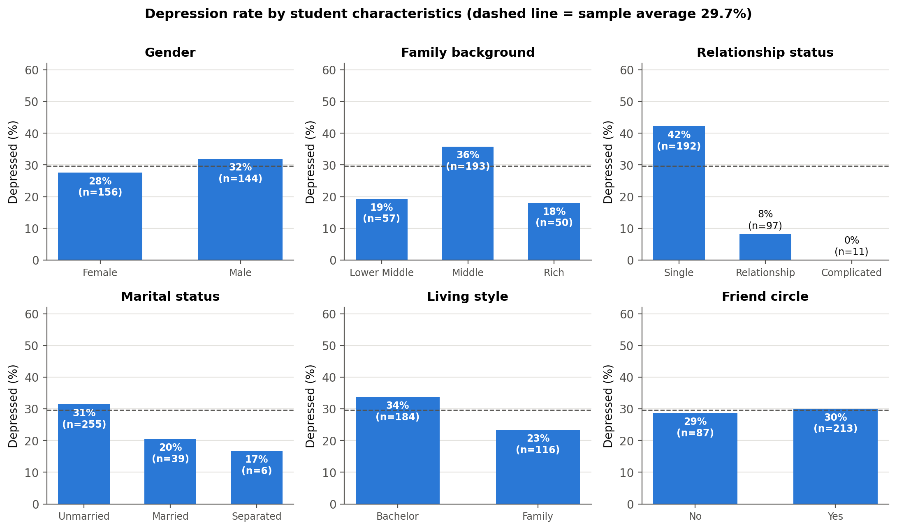
Fig. 2. Depression rate by student characteristics (dashed line: sample average).

Fig. 3 shows how closely self-reported health tracks depression: none of the students in good health and only 2.9% in normal health are depressed, against 59.4% in abnormal and 100% in critical health. Health therefore nearly predicts the outcome and is not used as a regressor in the main model.
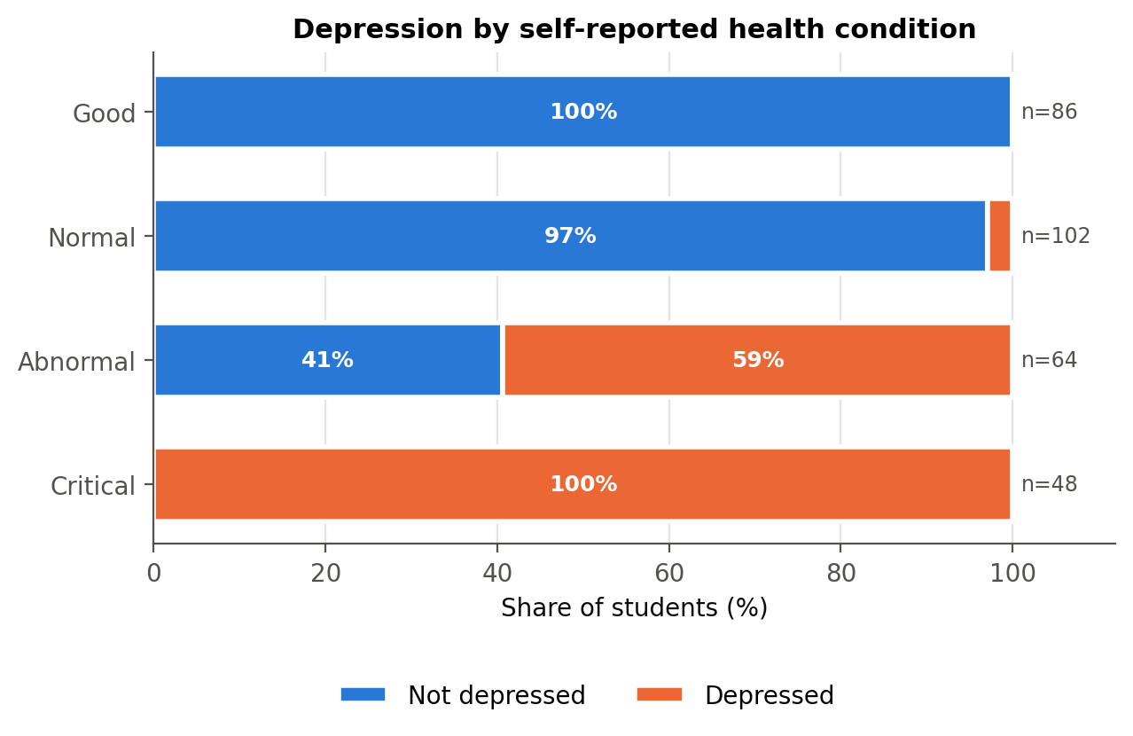
Fig. 3. Depression by self-reported health condition.
Fig. 4 compares the numerical variables. Mean CGPA (3.48 vs. 3.51) and age (21.7 vs. 21.7) are almost identical for non-depressed and depressed students, while depressed students report a somewhat higher monthly cost (14.43 vs. 12.96 thousand). Depression rates by age and semester (Fig. 5) show no clear trend; the very small groups at ages 18 and 19 should be read with caution.

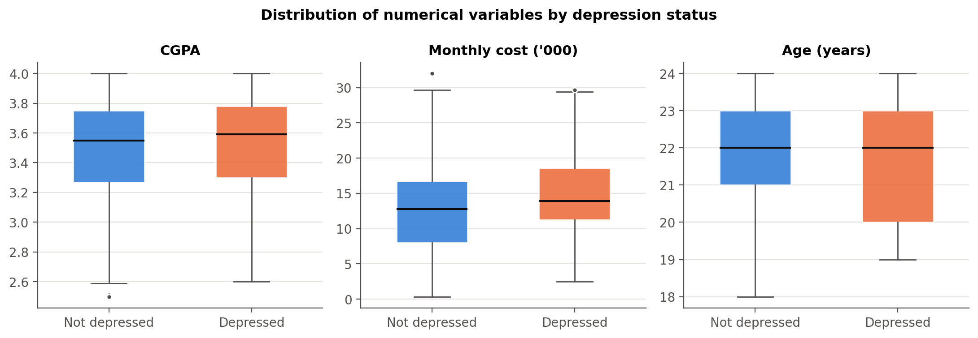
Fig. 4. Distribution of CGPA, monthly cost and age by depression status.

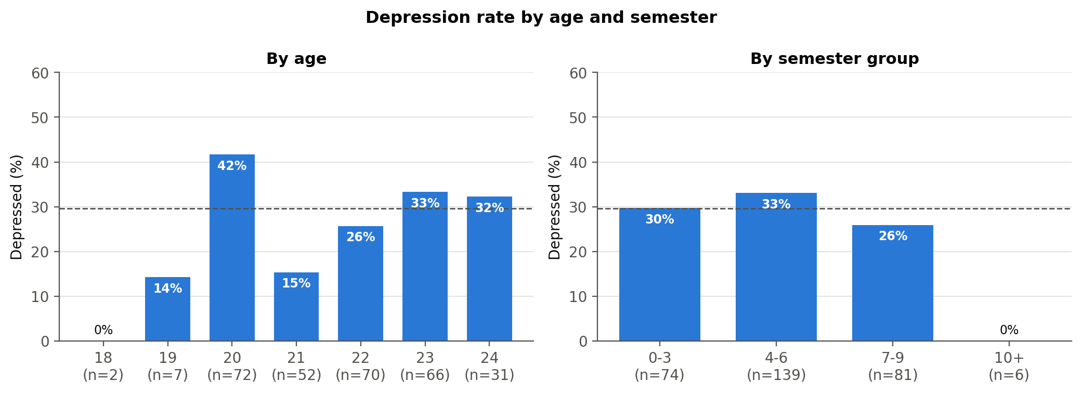
Fig. 5. Depression rate by age and semester group.

Table III reports summary statistics. Students are on average 21.7 years old with a mean CGPA of 3.49 and a mean monthly cost of 13.4 thousand; 64% are single, 71% have a friend circle and 39% live with family.
Table III
Summary Statistics of Coded Variables
Variable | Obs | Mean | Std. dev. | Min | Max
Depression | 300 | 0.297 | 0.458 | 0.000 | 1.000
Male | 300 | 0.480 | 0.500 | 0.000 | 1.000
Age (years) | 300 | 21.677 | 1.409 | 18.000 | 24.000
CGPA | 300 | 3.486 | 0.352 | 2.500 | 4.000
Current semester | 300 | 5.193 | 2.204 | 0.000 | 11.000
Monthly cost ('000) | 300 | 13.398 | 6.182 | 0.342 | 32.000
Lower-middle class | 300 | 0.190 | 0.393 | 0.000 | 1.000
Rich class | 300 | 0.167 | 0.373 | 0.000 | 1.000
Single | 300 | 0.640 | 0.481 | 0.000 | 1.000
Ever married | 300 | 0.150 | 0.358 | 0.000 | 1.000
Lives with family | 300 | 0.387 | 0.488 | 0.000 | 1.000
Has friend circle | 300 | 0.710 | 0.455 | 0.000 | 1.000
Poor health | 300 | 0.373 | 0.484 | 0.000 | 1.000

The correlation matrix (Fig. 6) shows modest correlations among the regressors; the largest are between monthly cost and lower-middle class (−0.50) and between male and living with family (−0.41). The very high correlation between depression and health level (0.79) confirms the separation issue.

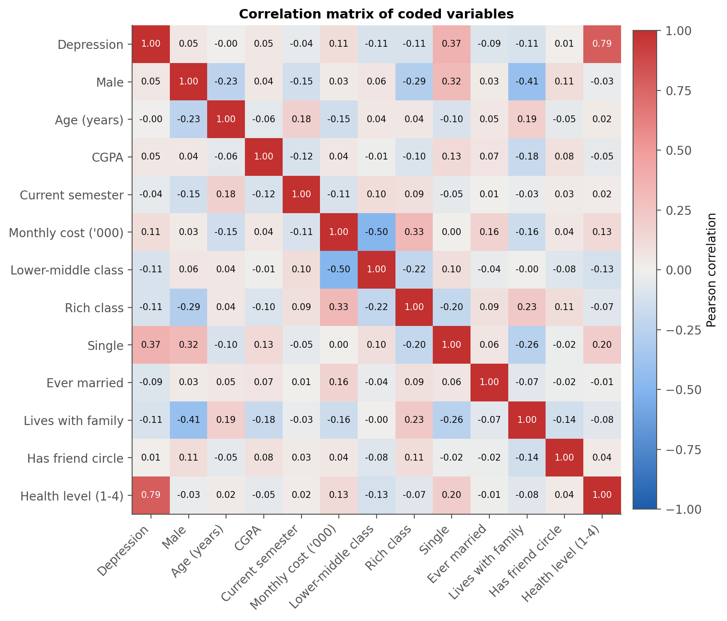
Fig. 6. Correlation matrix of coded variables.

B. Bivariate Tests
Table IV reports chi-square tests of independence. Relationship status (χ² = 40.39, p < 0.001, Cramér's V = 0.37) and family background (χ² = 9.62, p = 0.008) are significantly associated with depression, as is health (V = 0.84). Living style is borderline (p = 0.054); gender, marital status and friend circle are not significant. Table V shows that no numerical variable differs significantly at 5%; monthly cost comes closest (Welch p = 0.067, Mann–Whitney p = 0.051), while CGPA (p = 0.388) shows no difference.

Table IV
Chi-Square Tests of Independence with Depression
Variable | Chi-square | df | p-value | Cramer's V | Min expected count | Fisher exact p (2x2)
Gender | 0.689 | 1 | 0.407 | 0.048 | 42.720 | 0.449
Family background | 9.623 | 2 | 0.008 | 0.179 | 14.830
Relationship status | 40.394 | 2 | <0.001 | 0.367 | 3.260
Marital status | 2.408 | 2 | 0.300 | 0.090 | 1.780
Living style | 3.702 | 1 | 0.054 | 0.111 | 34.410 | 0.069
Friend circle | 0.051 | 1 | 0.821 | 0.013 | 25.810 | 0.890
Health condition | 212.060 | 3 | <0.001 | 0.841 | 14.240

Table V
Difference in Means Between Depressed and Non-Depressed Students
Variable | Mean (not depressed) | Mean (depressed) | Difference | Welch t | t-test p-value | Mann-Whitney U | Mann-Whitney p-value
CGPA | 3.475 | 3.513 | 0.038 | 0.865 | 0.388 | 10211.500 | 0.231
Monthly cost ('000) | 12.960 | 14.434 | 1.473 | 1.848 | 0.067 | 10726.500 | 0.051
Age (years) | 21.678 | 21.674 | -0.004 | -0.019 | 0.984 | 9312.000 | 0.909
Current semester | 5.256 | 5.045 | -0.211 | -0.800 | 0.424 | 9060.500 | 0.628

C. Multicollinearity
The largest variance inflation factor is 1.61 (Table VI), far below the common threshold of 10 (and the stricter 5), so multicollinearity is not a concern.
Table VI
Variance Inflation Factors
Variable | VIF | Tolerance (1/VIF)
Male | 1.410 | 0.709
Age (years) | 1.127 | 0.887
CGPA | 1.077 | 0.929
Current semester | 1.110 | 0.901
Monthly cost ('000) | 1.614 | 0.620
Lower-middle class | 1.378 | 0.726
Rich class | 1.371 | 0.729
Single | 1.176 | 0.850
Ever married | 1.053 | 0.950
Lives with family | 1.405 | 0.712
Has friend circle | 1.076 | 0.929

D. Binary Logit Model
Table VII presents the logit estimates. The model is highly significant (LR χ²(11) = 69.57, p < 0.001) with McFadden's pseudo-R² = 0.191, a reasonable value for individual cross-sectional data.

Table VII
Binary Logit Estimates (N = 300; Dependent Variable: Depression)
Variable | Coefficient | Std. err. | z | P>|z| | 95% CI lower | 95% CI upper | Sig.
Constant | -5.1987 | 2.9172 | -1.7821 | 0.0747 | -10.9163 | 0.5190 | *
Male | -0.6574 | 0.3472 | -1.8936 | 0.0583 | -1.3378 | 0.0230 | *
Age (years) | 0.1244 | 0.1061 | 1.1727 | 0.2409 | -0.0835 | 0.3324
CGPA | -0.0885 | 0.4290 | -0.2062 | 0.8366 | -0.9292 | 0.7523
Current semester | -0.0373 | 0.0718 | -0.5188 | 0.6039 | -0.1781 | 0.1035
Monthly cost ('000) | 0.0699 | 0.0357 | 1.9584 | 0.0502 | -0.0001 | 0.1398 | *
Lower-middle class | -0.7071 | 0.4649 | -1.5210 | 0.1283 | -1.6183 | 0.2041
Rich class | -1.2038 | 0.5899 | -2.0405 | 0.0413 | -2.3600 | -0.0475 | **
Single | 2.5285 | 0.4285 | 5.9005 | <0.001 | 1.6886 | 3.3684 | ***
Ever married | -1.1145 | 0.4516 | -2.4681 | 0.0136 | -1.9995 | -0.2295 | **
Lives with family | -0.2743 | 0.3726 | -0.7361 | 0.4617 | -1.0046 | 0.4561
Has friend circle | 0.1859 | 0.3323 | 0.5592 | 0.5760 | -0.4655 | 0.8372

Holding other factors constant, being single has the strongest effect (β = 2.529, p < 0.001). Ever being married (β = -1.115, p = 0.014) and a rich family (β = -1.204, p = 0.041) lower the probability; monthly cost raises it (β = 0.070, p = 0.050); male students are less likely to be depressed (β = -0.657, p = 0.058). CGPA, age, semester, lower-middle class, living with family and friend circle are not significant.
In odds-ratio terms (Table VIII, Fig. 7), single students have 12.5 times the odds of depression of students in a relationship (95% CI 5.4–29.0); rich students have 70% lower odds than middle-class students; ever-married students have 67% lower odds; and each thousand units of monthly cost raises the odds by 7.2%.
Table VIII
Odds Ratios from the Logit Model
Variable | Odds ratio | 95% CI lower | 95% CI upper | P>|z| | Sig.
Constant | 0.005 | 0.000 | 1.680 | 0.075 | *
Male | 0.518 | 0.262 | 1.023 | 0.058 | *
Age (years) | 1.133 | 0.920 | 1.394 | 0.241
CGPA | 0.915 | 0.395 | 2.122 | 0.837
Current semester | 0.963 | 0.837 | 1.109 | 0.604
Monthly cost ('000) | 1.072 | 1.000 | 1.150 | 0.050 | *
Lower-middle class | 0.493 | 0.198 | 1.226 | 0.128
Rich class | 0.300 | 0.094 | 0.954 | 0.041 | **
Single | 12.535 | 5.412 | 29.033 | <0.001 | ***
Ever married | 0.328 | 0.135 | 0.795 | 0.014 | **
Lives with family | 0.760 | 0.366 | 1.578 | 0.462
Has friend circle | 1.204 | 0.628 | 2.310 | 0.576

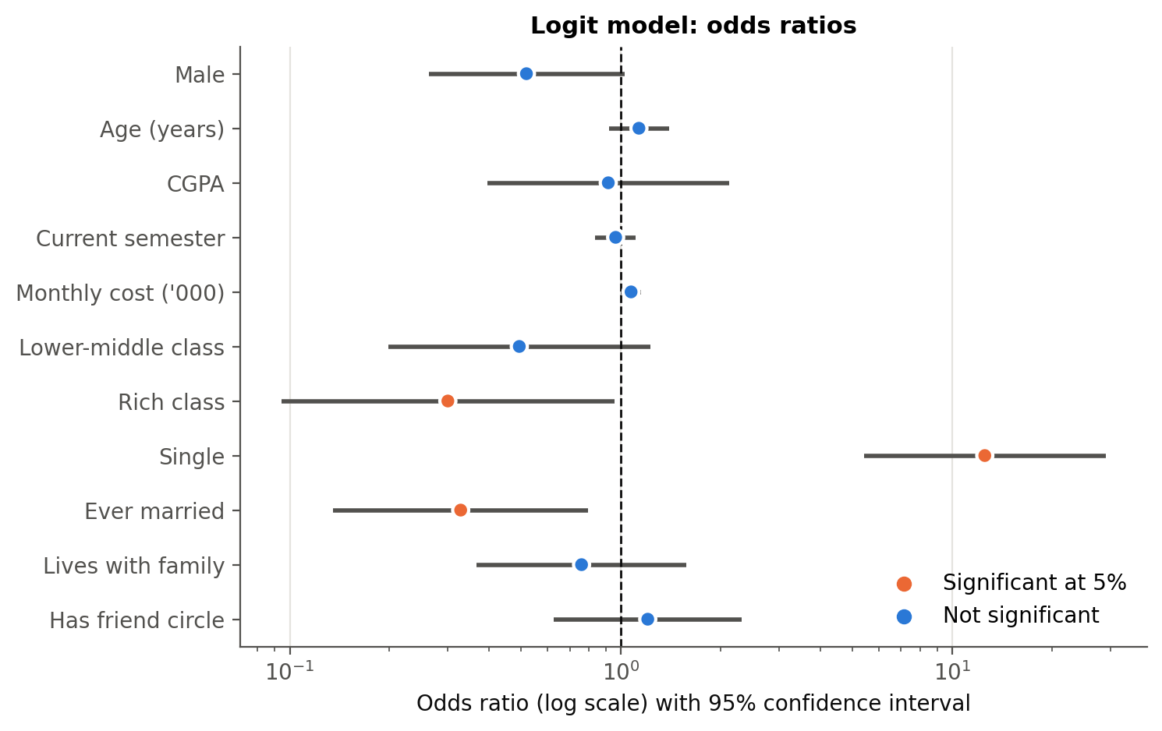
Fig. 7. Logit odds ratios with 95% confidence intervals (log scale).

E. Marginal Effects
Table IX and Fig. 8 report the average marginal effects. For a student with average characteristics the predicted probability of depression is 22.4%.

Table IX
Average Marginal Effects after Logit (dy/dx)
Variable | dy/dx | Std. err. | z | P>|z| | 95% CI lower | 95% CI upper | Sig.
Male | -0.1070 | 0.0545 | -1.9633 | 0.0496 | -0.2139 | -0.0002 | **
Age (years) | 0.0205 | 0.0174 | 1.1825 | 0.2370 | -0.0135 | 0.0546
CGPA | -0.0146 | 0.0708 | -0.2062 | 0.8366 | -0.1533 | 0.1241
Current semester | -0.0061 | 0.0118 | -0.5196 | 0.6033 | -0.0293 | 0.0170
Monthly cost ('000) | 0.0115 | 0.0058 | 2.0042 | 0.0451 | 0.0003 | 0.0228 | **
Lower-middle class | -0.1118 | 0.0685 | -1.6335 | 0.1024 | -0.2460 | 0.0224
Rich class | -0.1716 | 0.0671 | -2.5587 | 0.0105 | -0.3030 | -0.0401 | **
Single | 0.3643 | 0.0425 | 8.5802 | <0.001 | 0.2811 | 0.4475 | ***
Ever married | -0.1643 | 0.0557 | -2.9497 | 0.0032 | -0.2735 | -0.0551 | ***
Lives with family | -0.0448 | 0.0600 | -0.7468 | 0.4552 | -0.1623 | 0.0727
Has friend circle | 0.0304 | 0.0538 | 0.5654 | 0.5718 | -0.0750 | 0.1358

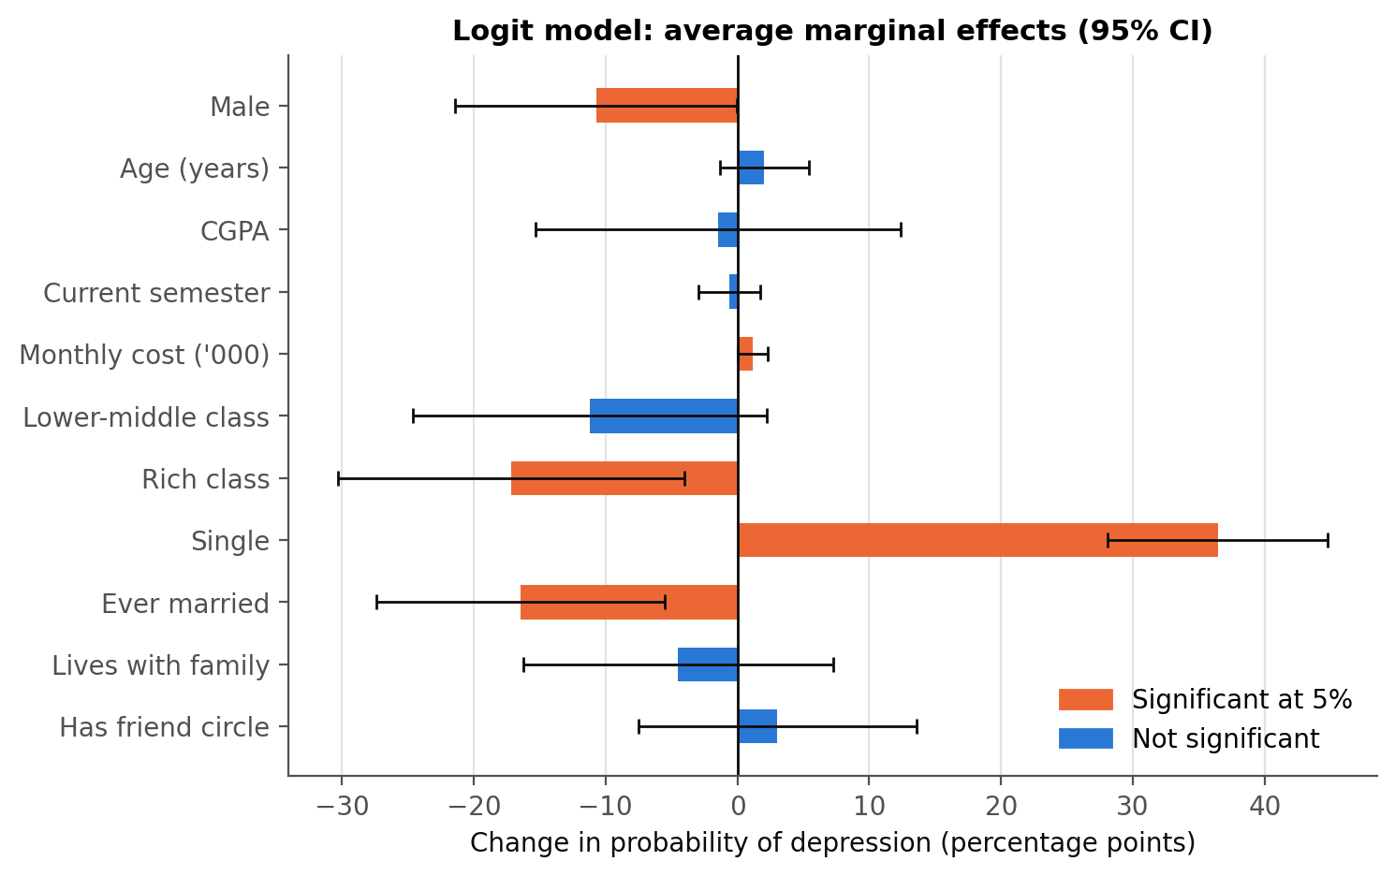
Fig. 8. Average marginal effects after logit with 95% confidence intervals.

- Being single raises the probability of depression by 36.4 percentage points (p < 0.001)—by far the largest effect.
- A rich family lowers it by 17.2 points relative to middle class (p = 0.011); ever married lowers it by 16.4 points (p = 0.003).
- Each thousand units of monthly cost adds 1.15 points (p = 0.045), about 12 points for a difference of 10 thousand.
- Male students are 10.7 points less likely to be depressed (p = 0.050).
- CGPA (-1.5 points per grade point, p = 0.837) and friend circle (p = 0.572) have no significant effect.
Marginal effects at the means (Stata's older mfx) lead to the same conclusions (see Appendix).

F. Binary Probit Model
The probit model (Table X) is equally significant (LR χ²(11) = 69.87, pseudo-R² = 0.192) with the same signs and significance pattern; the male coefficient is significant at 5% (p = 0.040). Its marginal effects (Table XI) are almost identical to the logit ones: single +36.8 percentage points (logit 36.4), rich -17.1 percentage points, ever married -14.9 percentage points. The choice of link function makes no practical difference.

Table X
Binary Probit Estimates (N = 300; Dependent Variable: Depression)
Variable | Coefficient | Std. err. | z | P>|z| | 95% CI lower | 95% CI upper | Sig.
Constant | -3.0986 | 1.7439 | -1.7769 | 0.0756 | -6.5166 | 0.3193 | *
Male | -0.4204 | 0.2043 | -2.0578 | 0.0396 | -0.8207 | -0.0200 | **
Age (years) | 0.0673 | 0.0630 | 1.0681 | 0.2855 | -0.0562 | 0.1907
CGPA | -0.0210 | 0.2538 | -0.0828 | 0.9340 | -0.5185 | 0.4765
Current semester | -0.0159 | 0.0418 | -0.3810 | 0.7032 | -0.0978 | 0.0659
Monthly cost ('000) | 0.0436 | 0.0209 | 2.0833 | 0.0372 | 0.0026 | 0.0847 | **
Lower-middle class | -0.3983 | 0.2750 | -1.4486 | 0.1475 | -0.9373 | 0.1406
Rich class | -0.7000 | 0.3404 | -2.0566 | 0.0397 | -1.3671 | -0.0329 | **
Single | 1.4643 | 0.2306 | 6.3495 | <0.001 | 1.0123 | 1.9163 | ***
Ever married | -0.5894 | 0.2532 | -2.3278 | 0.0199 | -1.0856 | -0.0931 | **
Lives with family | -0.1586 | 0.2139 | -0.7417 | 0.4583 | -0.5778 | 0.2606
Has friend circle | 0.1344 | 0.1976 | 0.6802 | 0.4964 | -0.2529 | 0.5217

Table XI
Average Marginal Effects after Probit (dy/dx)
Variable | dy/dx | Std. err. | z | P>|z| | 95% CI lower | 95% CI upper | Sig.
Male | -0.1149 | 0.0537 | -2.1397 | 0.0324 | -0.2201 | -0.0096 | **
Age (years) | 0.0187 | 0.0174 | 1.0731 | 0.2832 | -0.0154 | 0.0527
CGPA | -0.0058 | 0.0704 | -0.0828 | 0.9340 | -0.1439 | 0.1322
Current semester | -0.0044 | 0.0116 | -0.3810 | 0.7032 | -0.0271 | 0.0183
Monthly cost ('000) | 0.0121 | 0.0057 | 2.1320 | 0.0330 | 0.0010 | 0.0232 | **
Lower-middle class | -0.1060 | 0.0689 | -1.5387 | 0.1239 | -0.2411 | 0.0290
Rich class | -0.1706 | 0.0680 | -2.5074 | 0.0122 | -0.3039 | -0.0372 | **
Single | 0.3676 | 0.0426 | 8.6251 | <0.001 | 0.2841 | 0.4512 | ***
Ever married | -0.1487 | 0.0560 | -2.6560 | 0.0079 | -0.2584 | -0.0390 | ***
Lives with family | -0.0437 | 0.0582 | -0.7499 | 0.4533 | -0.1578 | 0.0705
Has friend circle | 0.0369 | 0.0535 | 0.6895 | 0.4905 | -0.0680 | 0.1418

G. Goodness of Fit
Both models fit well and almost equally (Table XII). The Hosmer–Lemeshow test does not reject the logit model (χ² = 9.34, p = 0.314), so predicted and observed rates agree across risk groups. At a 0.5 cut-off the logit model classifies 73.3% of students correctly, with specificity 85.8% but sensitivity only 43.8% (Table XIII). Using the sample share of depressed students (0.297) as cut-off identifies 79.8% of depressed students while correctly classifying 65.4% of the others.
Table XII
Goodness-of-Fit Statistics
Statistic | Logit | Probit
Observations | 300.000 | 300.000
Log likelihood | -147.619 | -147.471
Log likelihood (null) | -182.404 | -182.404
LR chi2 | 69.571 | 69.865
LR df | 11.000 | 11.000
Prob > chi2 | 0.000 | 0.000
Pseudo R2 (McFadden) | 0.191 | 0.192
AIC | 319.237 | 318.943
BIC | 363.683 | 363.388
AUC (ROC) | 0.781 | 0.781
Hosmer-Lemeshow chi2 | 9.343 | 12.160
HL df | 8.000 | 8.000
HL p-value | 0.314 | 0.144

Table XIII
Classification Tables (Cut-off 0.5 and Sample Share)
Model | Cutoff | True positives | False positives | False negatives | True negatives | Sensitivity | Specificity | Correctly classified
Logit | 0.500 | 39 | 30 | 50 | 181 | 0.438 | 0.858 | 0.733
Logit | 0.297 | 71 | 73 | 18 | 138 | 0.798 | 0.654 | 0.697
Probit | 0.500 | 37 | 28 | 52 | 183 | 0.416 | 0.867 | 0.733
Probit | 0.297 | 74 | 74 | 15 | 137 | 0.832 | 0.649 | 0.703

The ROC curves (Fig. 9) give an AUC of 0.781 (logit) and 0.781 (probit): a randomly chosen depressed student has a 78% chance of a higher predicted probability than a randomly chosen non-depressed student. Fig. 10 shows the size of the relationship effect: with other variables at their means, the predicted probability is above 40% for single students across the whole CGPA range versus about 5–6% for other students, and the nearly flat lines confirm that CGPA matters little.
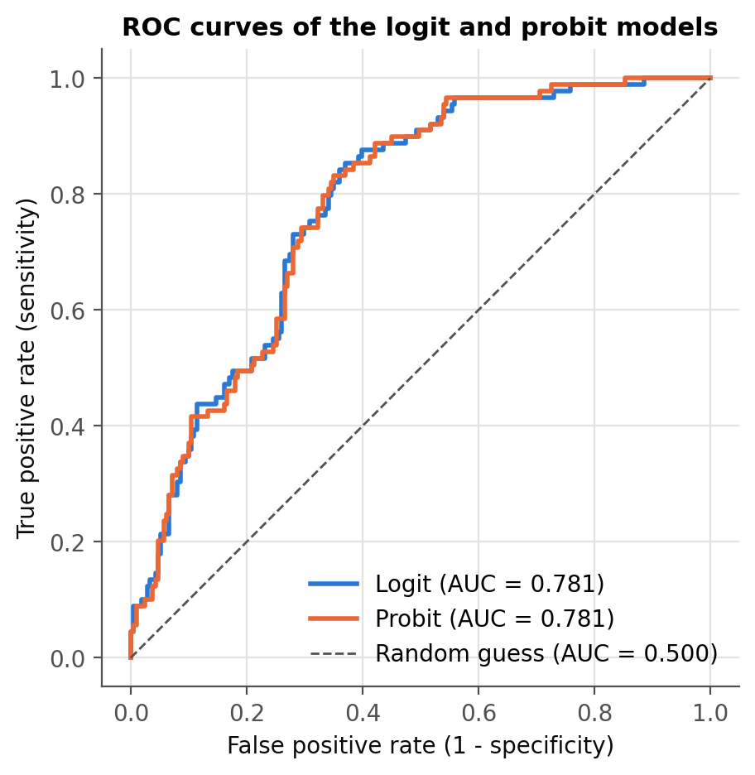
Fig. 9. ROC curves of the logit and probit models.
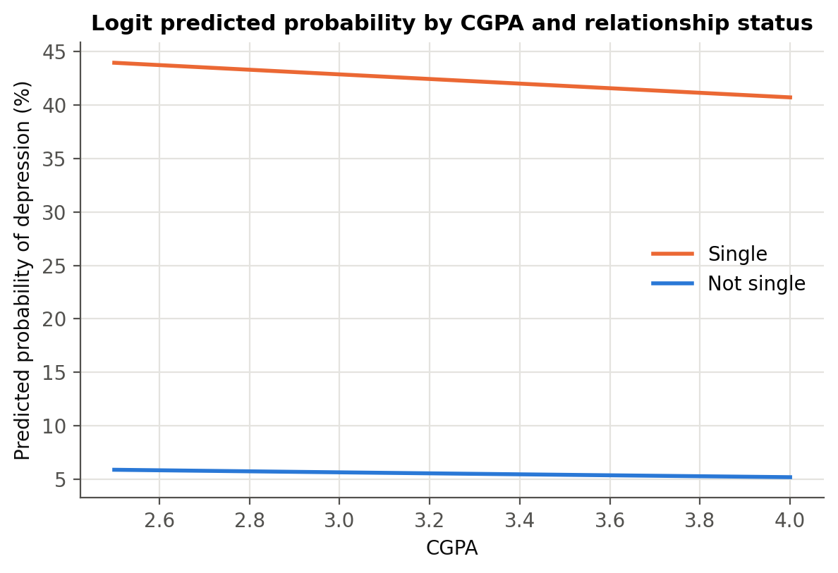
Fig. 10. Predicted probability of depression by CGPA and relationship status.

H. Hypothesis Tests
Table XIV summarises the hypothesis tests (logit model; supported if the expected sign holds with p < 0.05). H3 and H4b are supported; H5 and H7 are supported at 10% in the logit coefficients and at 5% in their marginal effects and in the probit model. H1, H2, H4a, H6 are not supported: academic performance, friend circle, lower-middle class background and living with family have no significant independent effect.

Table XIV
Summary of Hypothesis Tests
Hypothesis | Variable | Expected sign | Logit coefficient | AME | P>|z| | Result
H1 | CGPA | - | -0.0885 | -0.0146 | 0.8366 | Not supported (not significant)
H2 | Has friend circle | - | 0.1859 | 0.0304 | 0.5760 | Not supported (not significant)
H3 | Single | + | 2.5285 | 0.3643 | <0.001 | Supported
H4a | Lower-middle class | + | -0.7071 | -0.1118 | 0.1283 | Not supported (not significant)
H4b | Rich class | - | -1.2038 | -0.1716 | 0.0413 | Supported
H5 | Monthly cost ('000) | + | 0.0699 | 0.0115 | 0.0502 | Weakly supported (10% level)
H6 | Lives with family | - | -0.2743 | -0.0448 | 0.4617 | Not supported (not significant)
H7 | Male | - | -0.6574 | -0.1070 | 0.0583 | Weakly supported (10% level)

I. Robustness Checks
Table XV compares the main model with six alternatives, and Fig. 11 compares the marginal effects of the logit, probit and linear probability models, which agree closely on every variable.

Table XV
Robustness Checks Across Model Specifications
Variable | 1 Logit | 2 Logit rob. | 3 Probit | 4 LPM rob. | 5 Logit+health | 6 LPM male | 7 LPM female
Constant | -5.199*  (2.917) | -5.199*  (2.757) | -3.099*  (1.744) | -0.297  (0.477) | -7.915  (6.957) | -0.219  (0.690) | -0.521  (0.752)
Male | -0.657*  (0.347) | -0.657*  (0.340) | -0.420**  (0.204) | -0.095*  (0.057) | -1.153  (0.823)
Age (years) | 0.124  (0.106) | 0.124  (0.104) | 0.067  (0.063) | 0.018  (0.019) | -0.247  (0.253) | -0.004  (0.029) | 0.045  (0.030)
CGPA | -0.088  (0.429) | -0.088  (0.432) | -0.021  (0.254) | -0.011  (0.070) | 1.477  (1.016) | 0.097  (0.123) | -0.109  (0.096)
Current semester | -0.037  (0.072) | -0.037  (0.075) | -0.016  (0.042) | -0.003  (0.012) | 0.080  (0.163) | 0.005  (0.020) | -0.013  (0.015)
Monthly cost ('000) | 0.070*  (0.036) | 0.070**  (0.033) | 0.044**  (0.021) | 0.009*  (0.005) | 0.001  (0.069) | 0.004  (0.011) | 0.010*  (0.005)
Lower-middle class | -0.707  (0.465) | -0.707  (0.441) | -0.398  (0.275) | -0.131*  (0.068) | -0.831  (1.126) | -0.234**  (0.113) | -0.013  (0.099)
Rich class | -1.204**  (0.590) | -1.204**  (0.511) | -0.700**  (0.340) | -0.139**  (0.061) | 0.868  (1.053) | -0.322**  (0.159) | -0.101  (0.077)
Single | 2.529***  (0.429) | 2.529***  (0.413) | 1.464***  (0.231) | 0.376***  (0.049) | 5.356***  (1.004) | 0.390***  (0.071) | 0.320***  (0.070)
Ever married | -1.115**  (0.452) | -1.115**  (0.505) | -0.589**  (0.253) | -0.163**  (0.071) | -2.710***  (1.045) | -0.251***  (0.093) | -0.049  (0.118)
Lives with family | -0.274  (0.373) | -0.274  (0.378) | -0.159  (0.214) | -0.022  (0.057) | -1.058  (0.770) | 0.028  (0.091) | -0.028  (0.073)
Has friend circle | 0.186  (0.332) | 0.186  (0.317) | 0.134  (0.198) | 0.029  (0.053) | -0.636  (0.714) | -0.004  (0.085) | 0.013  (0.074)
Poor health |  |  |  |  | 7.958***  (1.122)
Observations | 300 | 300 | 300 | 300 | 300 | 144 | 156
Pseudo R2 / R2 | 0.191 | 0.191 | 0.192 | 0.192 | 0.791 | 0.233 | 0.202

Significance levels: *** p < 0.01, ** p < 0.05, * p < 0.10. Standard errors in parentheses. Models 6–7 are linear probability models with robust standard errors.

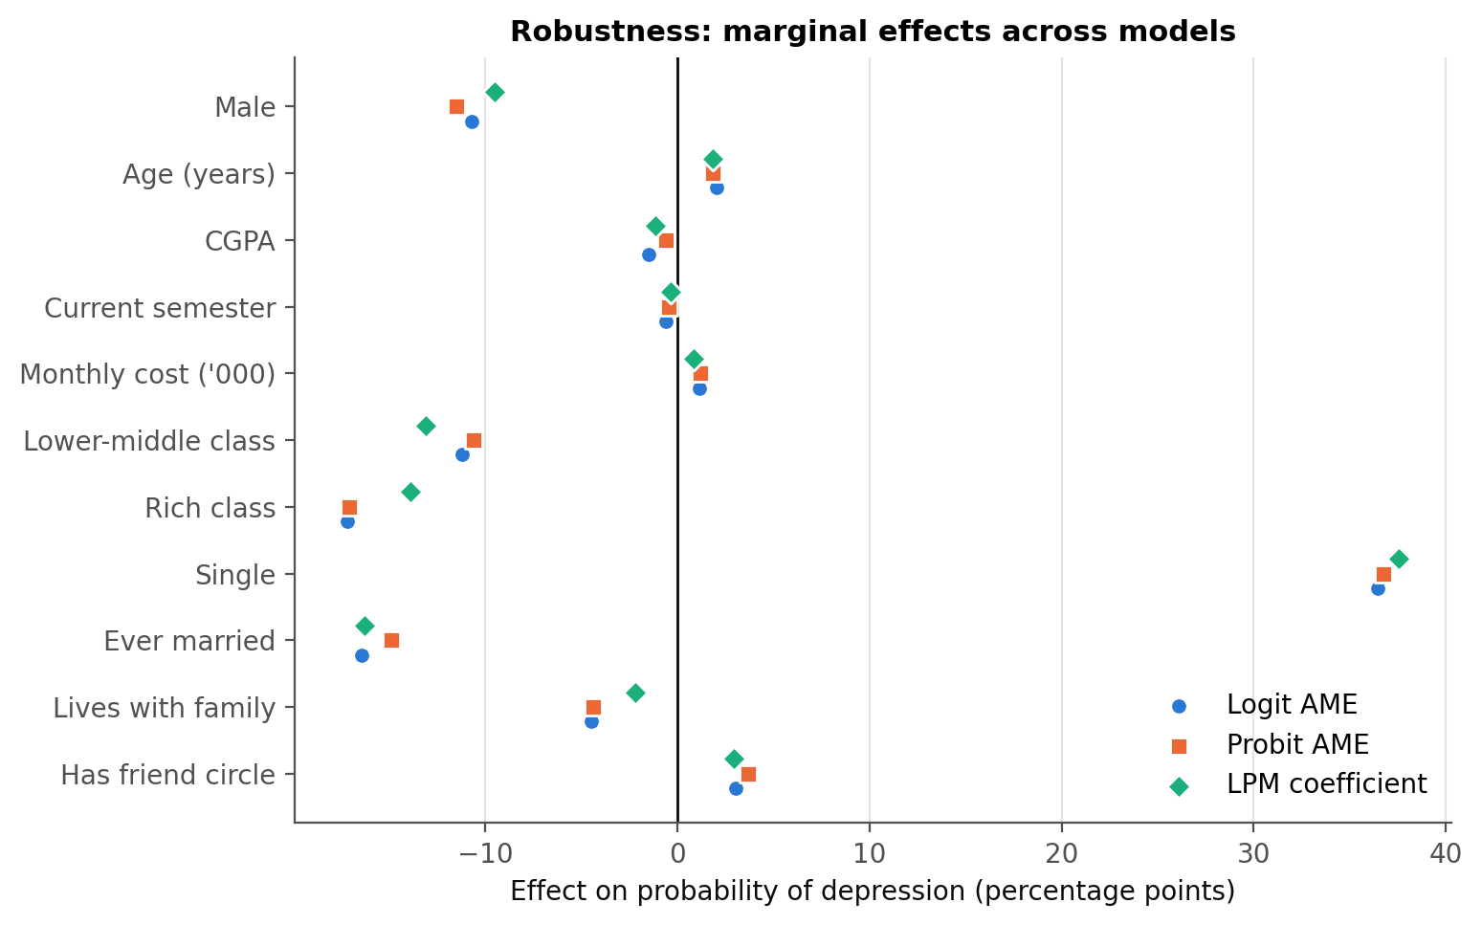
Fig. 11. Marginal effects across logit, probit and linear probability models.

- Robust standard errors change the standard errors only slightly; every variable keeps its sign and significance level, except monthly cost, which becomes significant at 5%.
- The LPM coefficients, which are marginal effects directly, are very close to the logit and probit AMEs (R² = 0.192).
- Adding poor health raises the pseudo-R² from 0.191 to 0.791 and the AUC to 0.986 (LR χ²(1) = 218.8, p < 0.001); the software flags quasi-complete separation (a fraction 0.12 of observations predicted perfectly), confirming that health largely measures the outcome itself. Single and ever married remain significant.
- By gender, a logit cannot be estimated for men because none of the 29 non-single male students is depressed, so LPMs are used. Being single is a strong risk factor for men (+39.0 percentage points, p < 0.001) and women (+32.0 percentage points, p < 0.001). Rich family (-32.2 percentage points), ever married (-25.1 percentage points) and lower-middle class (-23.4 percentage points) are protective among men but not significant among women (p = 0.19, 0.68, 0.89); monthly cost matters mainly for women (+1.03 points per thousand, p = 0.058). With fewer than 50 depressed students per subsample, these differences are indicative.

V. Discussion

A. Key Findings
Relationships matter more than grades. Single students are 36 percentage points more likely to be depressed, an effect that is large, highly significant and stable across every specification and for both men and women; ever-married students are less likely to be depressed. This strongly supports the stress-buffering view of close relationships [5].
The 'squeezed middle'. Middle-class students are the most likely to be depressed, and after controls rich students are 17 points less likely to be. Higher living costs raise the probability. Middle-class students may face high expectations and rising costs without the cushion of richer families, consistent with research on financial strain [10].
The gender gap. After controls, female students are about 11 points more likely to be depressed. The gap is hidden in the raw data—where men show a slightly higher rate—because male students are more often single. The adjusted result matches the established gender difference [7], [13].
What did not matter. CGPA, semester and age have no significant relationship with depression, and neither do a friend circle or living with family. Living with family looks protective in the raw data, but the effect disappears once relationship status and gender are controlled. The support that matters most here seems to be an intimate relationship rather than a wider friend group.

B. Implications for Universities
Since grades do not predict depression in this sample, services focused mainly on academic difficulty will miss many depressed students. Universities should (i) invest in programmes that reduce loneliness and build close connections—peer mentoring, small-group and residential community activities; (ii) combine mental health support with financial guidance and need-based help that also reaches middle-income students; (iii) design gender-sensitive outreach, since women face higher adjusted risk while men may be less likely to seek help; and (iv) use simple risk scores to prioritise screening—the logit model identifies 80% of depressed students at the sample-share cut-off—without replacing clinical assessment.

C. Theoretical Implications
The results support the diathesis–stress and stress-buffering frameworks [4], [5]: financial pressure raises the probability of depression while close relationships protect against it. They suggest that for young adults the protective effect comes from intimate relationships more than from the size of the social network, and the non-linear pattern of family background suggests that relative pressure and expectations may matter as much as absolute income.

VI. Limitations and Future Research
The data are cross-sectional, so the estimates are associations rather than causal effects; depression may itself affect relationship status. Depression and health are self-reported indicators rather than clinical diagnoses or validated scales. With 300 students and 89 depressed cases, small categories had to be merged and the gender subsample results are indicative. The sample comes from one region, which removes regional confounding but limits generalisation, and factors such as family history, sleep, physical activity and substance use are not observed. Future work should follow students over several semesters, use validated severity scales such as the PHQ-9 with ordered models, draw larger multi-region samples, and measure the quality—not only the presence—of social support.

VII. Conclusion
Depression affects almost three in ten students in this sample. It is driven less by grades and more by students' relationships and financial circumstances: being single is the strongest risk factor, while being married, coming from a rich family and being male are associated with lower risk, and higher living costs raise the risk. These findings are consistent across logit, probit and linear probability models. Protecting student mental health therefore requires attention to social connection and financial wellbeing, not only to academic support.

References
[1] A. K. Ibrahim, S. J. Kelly, C. E. Adams, and C. Glazebrook, "A systematic review of studies of depression prevalence in university students," J. Psychiatric Res., vol. 47, no. 3, pp. 391–400, 2013.
[2] A. Hysenbegasi, S. L. Hass, and C. R. Rowland, "The impact of depression on the academic productivity of university students," J. Mental Health Policy Econ., vol. 8, no. 3, pp. 145–151, 2005.
[3] D. Eisenberg, S. E. Gollust, E. Golberstein, and J. L. Hefner, "Prevalence and correlates of depression, anxiety, and suicidality among university students," Amer. J. Orthopsychiatry, vol. 77, no. 4, pp. 534–542, 2007.
[4] S. M. Monroe and A. D. Simons, "Diathesis–stress theories in the context of life stress research: Implications for the depressive disorders," Psychol. Bull., vol. 110, no. 3, pp. 406–425, 1991.
[5] S. Cohen and T. A. Wills, "Stress, social support, and the buffering hypothesis," Psychol. Bull., vol. 98, no. 2, pp. 310–357, 1985.
[6] V. Lorant, D. Deliège, W. Eaton, A. Robert, P. Philippot, and M. Ansseau, "Socioeconomic inequalities in depression: A meta-analysis," Amer. J. Epidemiol., vol. 157, no. 2, pp. 98–112, 2003.
[7] S. Nolen-Hoeksema, "Sex differences in unipolar depression: Evidence and theory," Psychol. Bull., vol. 101, no. 2, pp. 259–282, 1987.
[8] A. T. Beck, Depression: Clinical, Experimental, and Theoretical Aspects. New York, NY, USA: Harper & Row, 1967.
[9] I. Kawachi and L. F. Berkman, "Social ties and mental health," J. Urban Health, vol. 78, no. 3, pp. 458–467, 2001.
[10] T. Richardson, P. Elliott, and R. Roberts, "The relationship between personal unsecured debt and mental and physical health: A systematic review and meta-analysis," Clin. Psychol. Rev., vol. 33, no. 8, pp. 1148–1162, 2013.
[11] S. W. Whitton and M. A. Whisman, "Relationship satisfaction instability and depression," J. Family Psychol., vol. 24, no. 6, pp. 791–794, 2010.
[12] A. G. Bulloch, J. V. Williams, D. H. Lavorato, and S. B. Patten, "The relationship between major depression and marital disruption is bidirectional," Depression Anxiety, vol. 26, no. 12, pp. 1172–1177, 2009.
[13] R. C. Kessler, "Epidemiology of women and depression," J. Affective Disorders, vol. 74, no. 1, pp. 5–13, 2003.
[14] S. Moussavi, S. Chatterji, E. Verdes, A. Tandon, V. Patel, and B. Ustun, "Depression, chronic diseases, and decrements in health: Results from the World Health Surveys," Lancet, vol. 370, no. 9590, pp. 851–858, 2007.
[15] J. M. Wooldridge, Econometric Analysis of Cross Section and Panel Data, 2nd ed. Cambridge, MA, USA: MIT Press, 2010.
[16] J. S. Long and J. Freese, Regression Models for Categorical Dependent Variables Using Stata, 3rd ed. College Station, TX, USA: Stata Press, 2014.
[17] D. W. Hosmer, S. Lemeshow, and R. X. Sturdivant, Applied Logistic Regression, 3rd ed. Hoboken, NJ, USA: Wiley, 2013.
[18] S. Seabold and J. Perktold, "Statsmodels: Econometric and statistical modeling with Python," in Proc. 9th Python in Science Conf., 2010, pp. 92–96.
[19] StataCorp, Stata Statistical Software: Release 17. College Station, TX, USA: StataCorp LLC, 2021.

Appendix: Full Model Output
Full estimation output from the analysis notebook (notebooks/student_depression_analysis.ipynb, Python statsmodels). The Stata do-file stata/student_depression_analysis.do contains the equivalent commands (summarize, tabulate, logit, probit, margins, estat classification, estat gof, lroc, regress). All tables are also in results/Student_Depression_Analysis_Results.xlsx.
A. Binary logit model
Logit Regression Results
==============================================================================
Dep. Variable: depression No. Observations: 300
Model: Logit Df Residuals: 288
Method: MLE Df Model: 11
Date: Tue, 06 Oct 2026 Pseudo R-squ.: 0.1907
Time: 16:44:00 Log-Likelihood: -147.62
converged: True LL-Null: -182.40
Covariance Type: nonrobust LLR p-value: 1.474e-10
=================================================================================
coef std err z P>|z| [0.025 0.975]
---------------------------------------------------------------------------------
const -5.1987 2.917 -1.782 0.075 -10.916 0.519
male -0.6574 0.347 -1.894 0.058 -1.338 0.023
age 0.1244 0.106 1.173 0.241 -0.084 0.332
cgpa -0.0885 0.429 -0.206 0.837 -0.929 0.752
semester -0.0373 0.072 -0.519 0.604 -0.178 0.104
cost_k 0.0699 0.036 1.958 0.050 -5.5e-05 0.140
fam_lowermid -0.7071 0.465 -1.521 0.128 -1.618 0.204
fam_rich -1.2038 0.590 -2.041 0.041 -2.360 -0.048
single 2.5285 0.429 5.900 0.000 1.689 3.368
ever_married -1.1145 0.452 -2.468 0.014 -2.000 -0.229
live_family -0.2743 0.373 -0.736 0.462 -1.005 0.456
friend_circle 0.1859 0.332 0.559 0.576 -0.466 0.837
=================================================================================

B. Binary probit model
Probit Regression Results
==============================================================================
Dep. Variable: depression No. Observations: 300
Model: Probit Df Residuals: 288
Method: MLE Df Model: 11
Date: Tue, 06 Oct 2026 Pseudo R-squ.: 0.1915
Time: 16:44:01 Log-Likelihood: -147.47
converged: True LL-Null: -182.40
Covariance Type: nonrobust LLR p-value: 1.296e-10
=================================================================================
coef std err z P>|z| [0.025 0.975]
---------------------------------------------------------------------------------
const -3.0986 1.744 -1.777 0.076 -6.517 0.319
male -0.4204 0.204 -2.058 0.040 -0.821 -0.020
age 0.0673 0.063 1.068 0.285 -0.056 0.191
cgpa -0.0210 0.254 -0.083 0.934 -0.519 0.476
semester -0.0159 0.042 -0.381 0.703 -0.098 0.066
cost_k 0.0436 0.021 2.083 0.037 0.003 0.085
fam_lowermid -0.3983 0.275 -1.449 0.147 -0.937 0.141
fam_rich -0.7000 0.340 -2.057 0.040 -1.367 -0.033
single 1.4643 0.231 6.349 0.000 1.012 1.916
ever_married -0.5894 0.253 -2.328 0.020 -1.086 -0.093
live_family -0.1586 0.214 -0.742 0.458 -0.578 0.261
friend_circle 0.1344 0.198 0.680 0.496 -0.253 0.522
=================================================================================

C. Logit model with robust standard errors
Logit Regression Results
==============================================================================
Dep. Variable: depression No. Observations: 300
Model: Logit Df Residuals: 288
Method: MLE Df Model: 11
Date: Tue, 06 Oct 2026 Pseudo R-squ.: 0.1907
Time: 16:44:01 Log-Likelihood: -147.62
converged: True LL-Null: -182.40
Covariance Type: HC1 LLR p-value: 1.474e-10
=================================================================================
coef std err z P>|z| [0.025 0.975]
---------------------------------------------------------------------------------
const -5.1987 2.757 -1.885 0.059 -10.603 0.206
male -0.6574 0.340 -1.931 0.053 -1.325 0.010
age 0.1244 0.104 1.200 0.230 -0.079 0.328
cgpa -0.0885 0.432 -0.205 0.838 -0.935 0.758
semester -0.0373 0.075 -0.499 0.618 -0.184 0.109
cost_k 0.0699 0.033 2.138 0.033 0.006 0.134
fam_lowermid -0.7071 0.441 -1.602 0.109 -1.572 0.158
fam_rich -1.2038 0.511 -2.356 0.018 -2.205 -0.202
single 2.5285 0.413 6.126 0.000 1.720 3.337
ever_married -1.1145 0.505 -2.207 0.027 -2.104 -0.125
live_family -0.2743 0.378 -0.725 0.468 -1.016 0.467
friend_circle 0.1859 0.317 0.586 0.558 -0.435 0.807
=================================================================================

D. Linear probability model (robust standard errors)
OLS Regression Results
==============================================================================
Dep. Variable: depression R-squared: 0.192
Model: OLS Adj. R-squared: 0.161
Method: Least Squares F-statistic: 9.377
Date: Tue, 06 Oct 2026 Prob (F-statistic): 2.09e-14
Time: 16:44:01 Log-Likelihood: -158.73
No. Observations: 300 AIC: 341.5
Df Residuals: 288 BIC: 385.9
Df Model: 11
Covariance Type: HC1
=================================================================================
coef std err z P>|z| [0.025 0.975]
---------------------------------------------------------------------------------
const -0.2966 0.477 -0.622 0.534 -1.231 0.638
male -0.0952 0.057 -1.656 0.098 -0.208 0.017
age 0.0185 0.019 0.996 0.319 -0.018 0.055
cgpa -0.0113 0.070 -0.162 0.871 -0.148 0.125
semester -0.0033 0.012 -0.284 0.776 -0.026 0.019
cost_k 0.0085 0.005 1.822 0.068 -0.001 0.018
fam_lowermid -0.1307 0.068 -1.929 0.054 -0.264 0.002
fam_rich -0.1387 0.061 -2.261 0.024 -0.259 -0.018
single 0.3755 0.049 7.670 0.000 0.280 0.471
ever_married -0.1625 0.071 -2.292 0.022 -0.301 -0.024
live_family -0.0219 0.057 -0.384 0.701 -0.134 0.090
friend_circle 0.0295 0.053 0.553 0.580 -0.075 0.134
==============================================================================
Omnibus: 86.457 Durbin-Watson: 1.936
Prob(Omnibus): 0.000 Jarque-Bera (JB): 26.568
Skew: 0.500 Prob(JB): 1.70e-06
Kurtosis: 1.939 Cond. No. 540.
==============================================================================

Notes:
[1] Standard Errors are heteroscedasticity robust (HC1)

E. Logit model including poor health
Logit Regression Results
==============================================================================
Dep. Variable: depression No. Observations: 300
Model: Logit Df Residuals: 287
Method: MLE Df Model: 12
Date: Tue, 06 Oct 2026 Pseudo R-squ.: 0.7905
Time: 16:44:01 Log-Likelihood: -38.209
converged: True LL-Null: -182.40
Covariance Type: nonrobust LLR p-value: 1.281e-54
=================================================================================
coef std err z P>|z| [0.025 0.975]
---------------------------------------------------------------------------------
const -7.9152 6.957 -1.138 0.255 -21.550 5.720
male -1.1528 0.823 -1.400 0.162 -2.767 0.461
age -0.2471 0.253 -0.978 0.328 -0.742 0.248
cgpa 1.4769 1.016 1.453 0.146 -0.515 3.468
semester 0.0799 0.163 0.489 0.625 -0.240 0.400
cost_k 0.0009 0.069 0.013 0.990 -0.135 0.137
fam_lowermid -0.8308 1.126 -0.738 0.460 -3.037 1.375
fam_rich 0.8678 1.053 0.824 0.410 -1.196 2.931
single 5.3555 1.004 5.333 0.000 3.387 7.324
ever_married -2.7102 1.045 -2.594 0.009 -4.758 -0.663
live_family -1.0582 0.770 -1.375 0.169 -2.567 0.450
friend_circle -0.6355 0.714 -0.890 0.374 -2.035 0.764
health_poor 7.9576 1.122 7.091 0.000 5.758 10.157
=================================================================================

Possibly complete quasi-separation: A fraction 0.12 of observations can be
perfectly predicted. This might indicate that there is complete
quasi-separation. In this case some parameters will not be identified.

F. Linear probability model: male students
OLS Regression Results
==============================================================================
Dep. Variable: depression R-squared: 0.233
Model: OLS Adj. R-squared: 0.175
Method: Least Squares F-statistic: 6.216
Date: Tue, 06 Oct 2026 Prob (F-statistic): 9.33e-08
Time: 16:44:02 Log-Likelihood: -75.366
No. Observations: 144 AIC: 172.7
Df Residuals: 133 BIC: 205.4
Df Model: 10
Covariance Type: HC1
=================================================================================
coef std err z P>|z| [0.025 0.975]
---------------------------------------------------------------------------------
const -0.2187 0.690 -0.317 0.751 -1.570 1.133
age -0.0040 0.029 -0.137 0.891 -0.061 0.053
cgpa 0.0966 0.123 0.786 0.432 -0.144 0.337
semester 0.0050 0.020 0.252 0.801 -0.034 0.044
cost_k 0.0041 0.011 0.372 0.710 -0.017 0.026
fam_lowermid -0.2336 0.113 -2.058 0.040 -0.456 -0.011
fam_rich -0.3216 0.159 -2.019 0.043 -0.634 -0.009
single 0.3902 0.071 5.526 0.000 0.252 0.529
ever_married -0.2512 0.093 -2.706 0.007 -0.433 -0.069
live_family 0.0276 0.091 0.305 0.761 -0.150 0.205
friend_circle -0.0045 0.085 -0.053 0.958 -0.170 0.161
==============================================================================
Omnibus: 55.260 Durbin-Watson: 1.945
Prob(Omnibus): 0.000 Jarque-Bera (JB): 11.188
Skew: 0.343 Prob(JB): 0.00372
Kurtosis: 1.819 Cond. No. 523.
==============================================================================

Notes:
[1] Standard Errors are heteroscedasticity robust (HC1)

G. Linear probability model: female students
OLS Regression Results
==============================================================================
Dep. Variable: depression R-squared: 0.202
Model: OLS Adj. R-squared: 0.147
Method: Least Squares F-statistic: 5.236
Date: Tue, 06 Oct 2026 Prob (F-statistic): 1.50e-06
Time: 16:44:02 Log-Likelihood: -78.048
No. Observations: 156 AIC: 178.1
Df Residuals: 145 BIC: 211.6
Df Model: 10
Covariance Type: HC1
=================================================================================
coef std err z P>|z| [0.025 0.975]
---------------------------------------------------------------------------------
const -0.5214 0.752 -0.693 0.488 -1.996 0.953
age 0.0453 0.030 1.526 0.127 -0.013 0.103
cgpa -0.1085 0.096 -1.131 0.258 -0.296 0.079
semester -0.0133 0.015 -0.873 0.383 -0.043 0.017
cost_k 0.0103 0.005 1.895 0.058 -0.000 0.021
fam_lowermid -0.0134 0.099 -0.135 0.893 -0.208 0.181
fam_rich -0.1006 0.077 -1.306 0.192 -0.252 0.050
single 0.3199 0.070 4.557 0.000 0.182 0.457
ever_married -0.0485 0.118 -0.413 0.680 -0.279 0.182
live_family -0.0276 0.073 -0.377 0.706 -0.171 0.116
friend_circle 0.0126 0.074 0.169 0.866 -0.133 0.159
==============================================================================
Omnibus: 17.043 Durbin-Watson: 1.679
Prob(Omnibus): 0.000 Jarque-Bera (JB): 13.073
Skew: 0.602 Prob(JB): 0.00145
Kurtosis: 2.251 Cond. No. 591.
==============================================================================

Notes:
[1] Standard Errors are heteroscedasticity robust (HC1)

Table XVI
Marginal Effects at the Means after Logit
Variable | dy/dx | Std. err. | z | P>|z| | 95% CI lower | 95% CI upper | Sig.
Male | -0.1135 | 0.0589 | -1.9279 | 0.0539 | -0.2288 | 0.0019 | *
Age (years) | 0.0217 | 0.0184 | 1.1773 | 0.2391 | -0.0144 | 0.0577
CGPA | -0.0154 | 0.0746 | -0.2063 | 0.8366 | -0.1616 | 0.1308
Current semester | -0.0065 | 0.0125 | -0.5197 | 0.6032 | -0.0309 | 0.0180
Monthly cost ('000) | 0.0122 | 0.0061 | 1.9975 | 0.0458 | 0.0002 | 0.0241 | **
Lower-middle class | -0.1083 | 0.0626 | -1.7309 | 0.0835 | -0.2310 | 0.0143 | *
Rich class | -0.1653 | 0.0599 | -2.7598 | 0.0058 | -0.2826 | -0.0479 | ***
Single | 0.3639 | 0.0443 | 8.2150 | <0.001 | 0.2771 | 0.4508 | ***
Ever married | -0.1539 | 0.0482 | -3.1933 | 0.0014 | -0.2484 | -0.0594 | ***
Lives with family | -0.0469 | 0.0623 | -0.7531 | 0.4514 | -0.1690 | 0.0752
Has friend circle | 0.0316 | 0.0554 | 0.5716 | 0.5676 | -0.0769 | 0.1401

Table XVII
Marginal Effects for Male and Female Students (LPM, Robust SE)
Variable | Female students: dy/dx | Male students: dy/dx | Female students: P>|z| | Male students: P>|z|
Age (years) | 0.0453 | -0.0040 | 0.1271 | 0.8910
CGPA | -0.1085 | 0.0966 | 0.2579 | 0.4319
Current semester | -0.0133 | 0.0050 | 0.3827 | 0.8011
Ever married | -0.0485 | -0.2512 | 0.6799 | 0.0068
Has friend circle | 0.0126 | -0.0045 | 0.8660 | 0.9576
Lives with family | -0.0276 | 0.0276 | 0.7065 | 0.7607
Lower-middle class | -0.0134 | -0.2336 | 0.8927 | 0.0396
Monthly cost ('000) | 0.0103 | 0.0041 | 0.0581 | 0.7096
Rich class | -0.1006 | -0.3216 | 0.1917 | 0.0435
Single | 0.3199 | 0.3902 | <0.001 | <0.001

