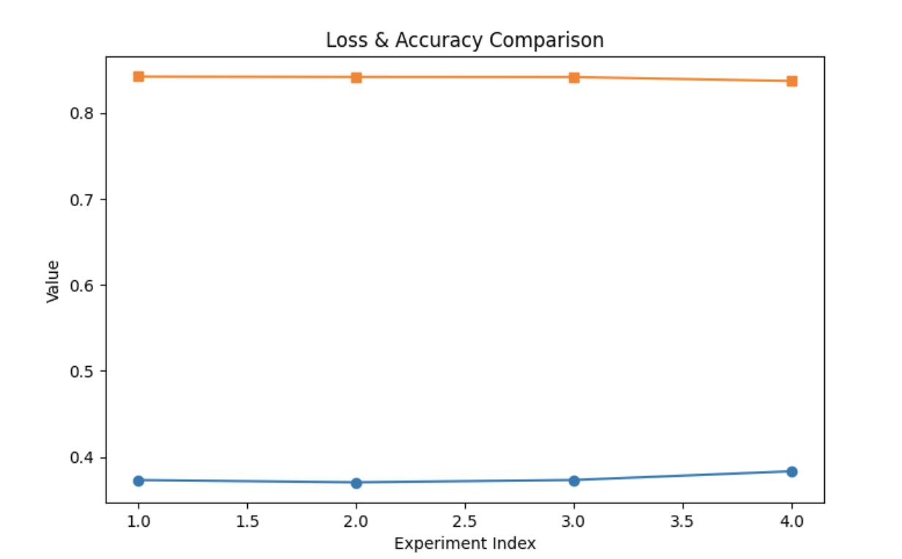
Two hidden batch size = 4, epochs = 30, Learning Rate = 0.01

One hidden batch size = 4, epochs = 30, Learning Rate = 0.01

Two hidden batch size = 32, epochs = 10, Learning Rate = 0.0001

One hidden batch size = 32, epochs = 10, Learning Rate = 0.0001

Results (Loss, Accuracy)
Mapping res in order of experiments:
- (8, 0) + (lr=0.0001, batch=32, epochs=10) → Loss 0.3731, Accuracy 84.24%
- (8, 0) + (lr=0.01, batch=4, epochs=30) → Loss 0.3704, Accuracy 84.20%
- (8, 5) + (lr=0.0001, batch=32, epochs=10) → Loss 0.3731, Accuracy 84.19%
- (8, 5) + (lr=0.01, batch=4, epochs=30) → Loss 0.3833, Accuracy 83.73%
Summary
- All four configurations gave very similar accuracy (~84%).
- The best result was (8, 0) with lr=0.0001, batch=32, epochs=10 → Accuracy 84.24% and stable low loss.
- The two-layer model (8, 5) didn’t outperform the simpler one-layer model—in fact, with a higher learning rate (0.01), its accuracy slightly dropped.

