Microservice Project – E-Commerce Website

Project Structure –

1. App
2. Entity/Model
3. Controller
4. Repository

All services are maven based.  
  
Initial Project Testings :   
  
  
Dependencies & Purpose :

1. Spring Web
2. H2 Database
3. Spring Data JPA
4. Spring Initializr

**Product Catalog Service**  
  
Important Learnings -   
1. How repository fetches data according to the attributes created.

2. Custom requests can be made in repository , the method name and the parameter must be a declared attribute inside entity , datatype and the attribute name are important while defining a new method.

3.While making mapping , if 2 mapping are similar it can give illegal exception of unable to handle ambiguous mappings

JSON data format :

{

"id": 1,

"product": "phone",

"cost": 800000,

"category": "eletronics"

}

**Order Processing Service**

**Issue while creating order service -  
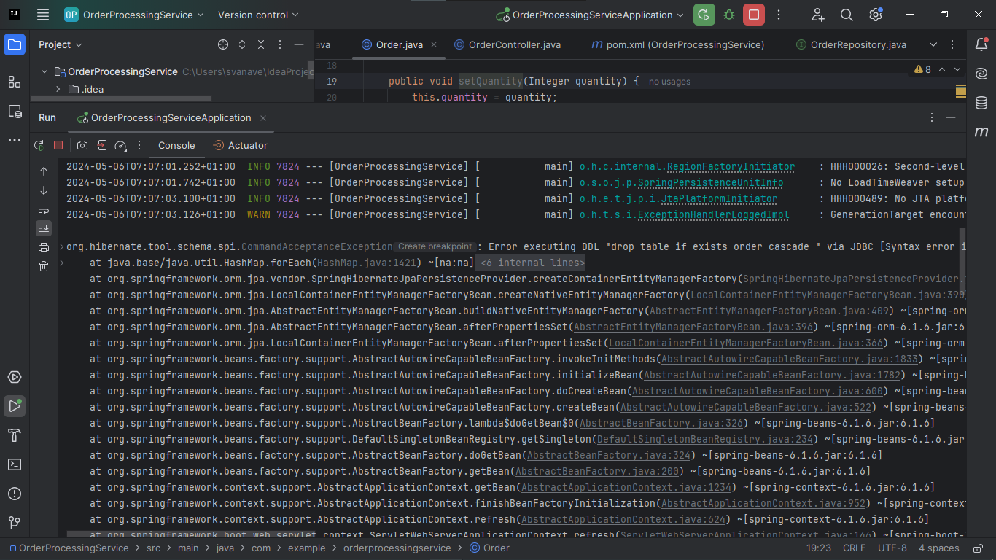**SpringBoot derives table name from entity class name , its shows :  
Error executing DDL "drop table if exists order cascade " via JDBC [Syntax error in SQL statement

"drop table if exists [*]order cascade "; expected "identifier";]  
 **Tried Solutions :**1.checked if Id is declared correctly

**  
  
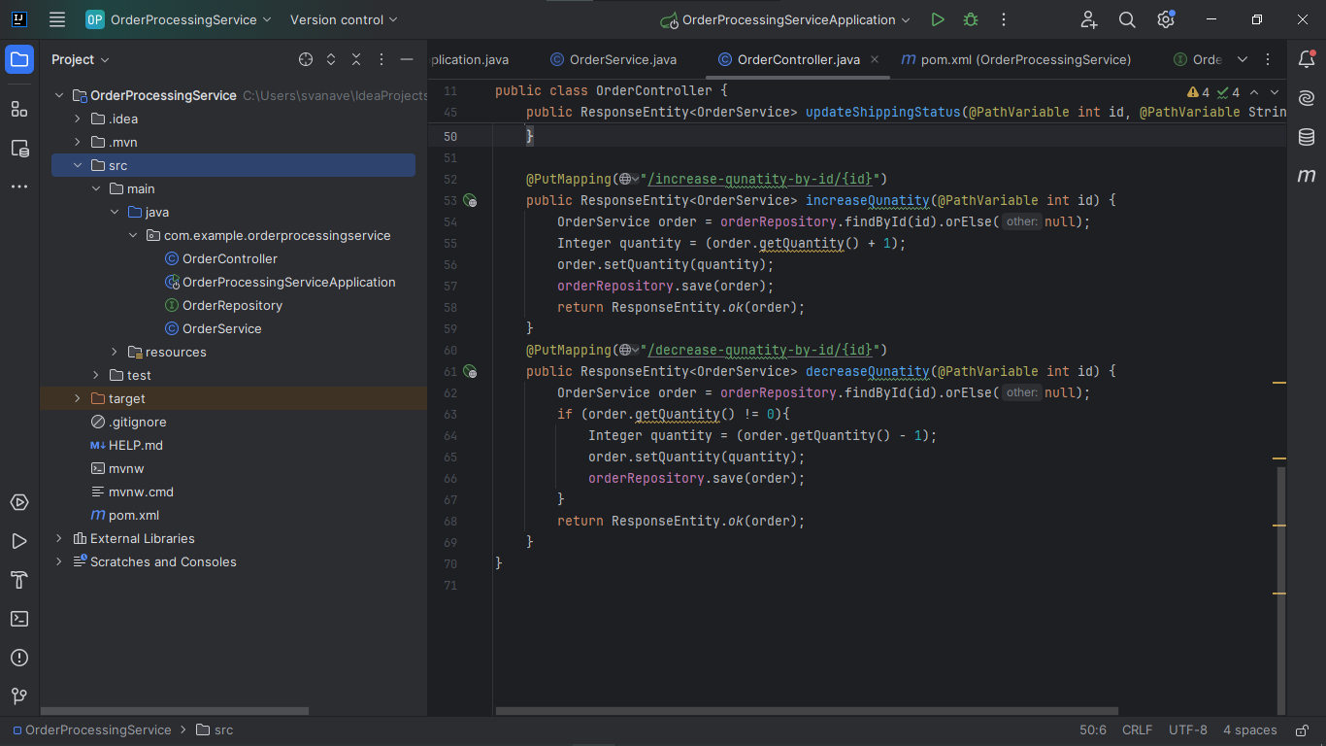  
  
**Customer Service**

**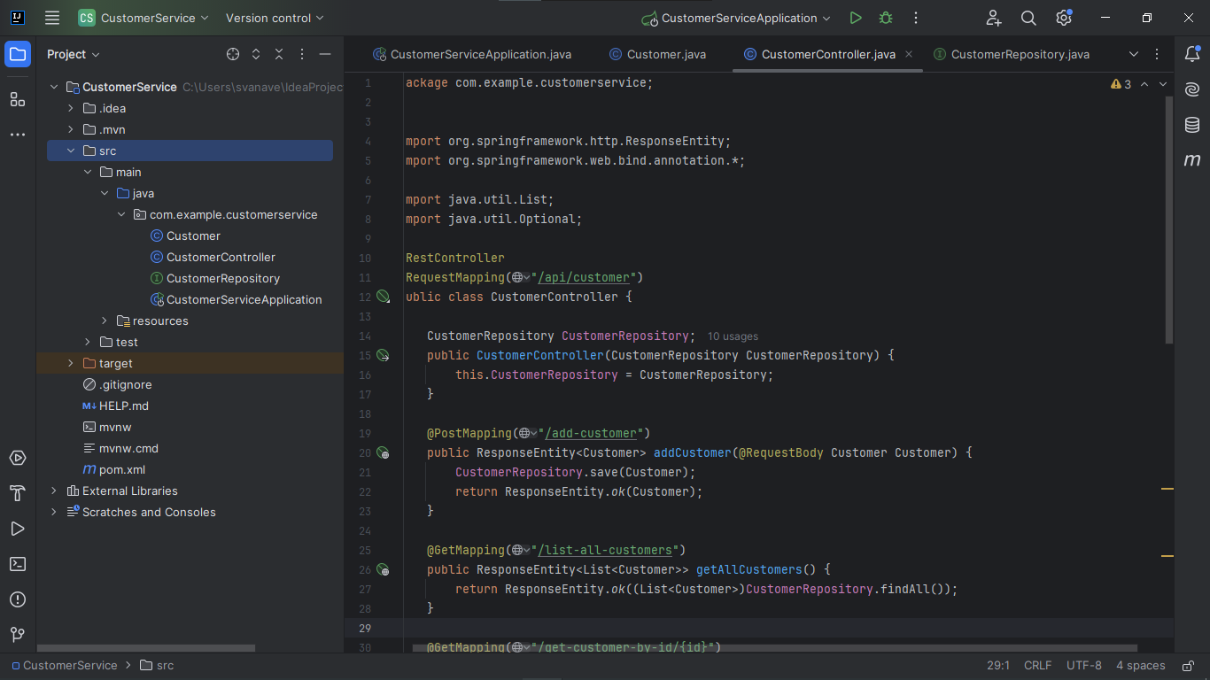  
  
Inventory Service**

1. **Remember to save the data into repository after updating**

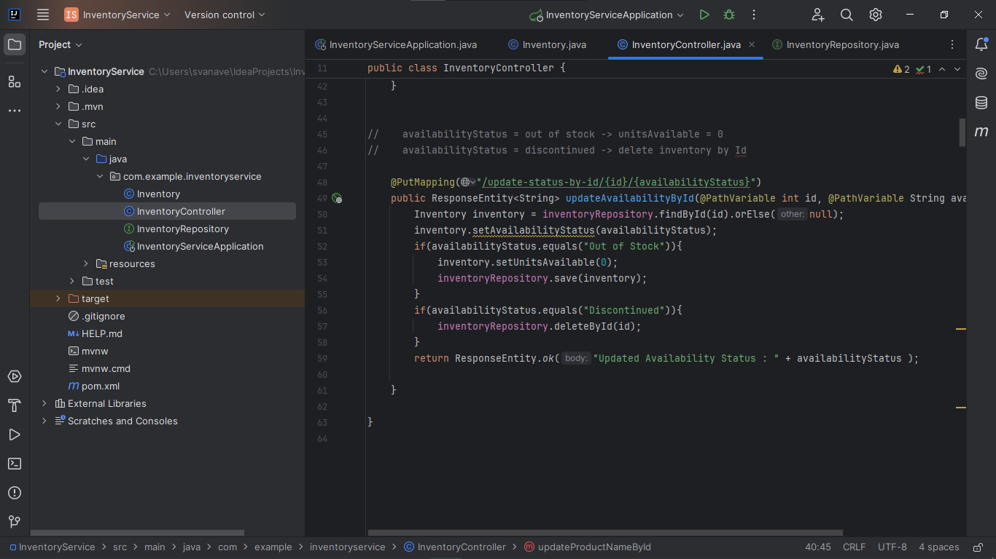

**Payment Service**

**  
  
