CPU实验设计报告

1110310419
万佳林

0.指令格式设计 3
1.操作码定义 4
2.微操作的定义 4
3.节拍的划分 6
4.处理器详细结构设计框图 6
4.1接口定义 6
4.2功能描述 7
4.3波形仿真 7
5.各功能模块结构设计框图 15
5.1时钟模块 15
5.1.1接口定义 15
5.1.2功能描述 15
5.1.3波形仿真 15
5.2取指模块 18
5.2.1接口定义 18
5.2.2功能描述 19
5.2.3波形仿真 19
5.3 ALU模块 21
5.3.1接口定义 21
5.3.2功能描述 22
5.3.3波形仿真 22
5.4存储模块 27
5.4.1接口定义 27
5.4.2功能描述 27
5.4.3波形仿真 28
5.5访存控制模块 31
5.5.1接口定义 31
5.5.2功能描述 32
5.5.3波形仿真 32
5.6回写模块 37
5.6.1接口定义 37
5.6.2功能描述 38
5.6.3波形仿真 38
6.VHDL代码 41
7.UCF文件 53
8.测试指令序列 56
9.调试和下载过程中遇到的问题 57
10.实验总结 58

0.指令格式设计
0.1.
MOV Ri,[MA] (直接寻址)
MOV Ri,#X （立即数寻址）
ADC Ri,#X
SBB Ri,#X
AND Ri,#X
OR Ri,#X
MOV Ri,[MA+R6] (变址寻址)
OP（5位） | 寄存器地址（3位） | 数据或地址（8位）

0.2.
MOV [MA],Ri （直接寻址）
OP（5位） | 主存地址（8位） | 寄存器地址（3位）

0.3.
MOV Ri,[Rj] （寄存器间接寻址）
MOV Ri,Rj （寄存器寻址）
ADC Ri,Rj
SBB Ri,Rj
AND Ri,Rj
OR Ri,Rj
OP（5位） | 寄存器地址（3位） | 5位 | 寄存器地址（3位）

0.4.
CLC
STC
OP（5位） | 11位

0.5.
JMP MA （无条件直接跳转）
JZ *sign （相对跳转）
JC *sign （相对跳转）
OP（5位） | 3位 | 数据或地址（8位）

1.操作码定义

操作码 | 指令
00000 | MOV Ri,#X
00001 | MOV [MA],Ri
00010 | MOV Ri,[MA]
00011 | MOV Ri,Rj
00100 | ADC Ri,#X
00101 | ADC Ri,Rj
00110 | SBB Ri,#X
00111 | SBB Ri,Rj
01000 | AND Ri,#X
01001 | AND Ri,Rj
01010 | OR Ri,#X
01011 | OR Ri,Rj
01100 | CLC
01101 | STC
01110 | JMP MA
01111 | JZ *sign
10000 | JC *sign
10001 | MOV Ri,[MA+R6]
10010 | MOV Ri,[Rj]

2.微操作的定义

指令 | T0 | T1 | T2 | T3 | T4
MOV Ri,#X | M(PC)→IR  1→R | PC+1→PC | #X→ALU | ALU→Rtemp | Rtemp→Ri
MOV [MA],Ri | M(PC)→IR  1→R | PC+1→PC | R7//MA→addr  Ri→regdata | 1→W
MOV Ri,[MA] | M(PC)→IR  1→R | PC+1→PC | R7//MA→addr | 1→R  MDR→Rtemp | Rtemp→Ri
MOV Ri,Rj | M(PC)→IR  1→R | PC+1→PC | Rj→ALU | ALU→Rtemp | Rtemp→Ri
ADC Ri,#X | M(PC)→IR  1→R | PC+1→PC | Ri+#X+cy→ALU | ALU→Rtemp | Rtemp→Ri
ADC Ri,Rj | M(PC)→IR  1→R | PC+1→PC | Ri+Rj+cy→ALU | ALU→Rtemp | Rtemp→Ri
SBB Ri,#X | M(PC)→IR  1→R | PC+1→PC | Ri-#X-cy→ALU | ALU→Rtemp | Rtemp→Ri
SBB Ri,Rj | M(PC)→IR  1→R | PC+1→PC | Ri-Rj-cy→ALU | ALU→Rtemp | Rtemp→Ri
AND Ri,#X | M(PC)→IR  1→R | PC+1→PC | Ri and #X→ALU | ALU→Rtemp | Rtemp→Ri
AND Ri,Rj | M(PC)→IR  1→R | PC+1→PC | Ri and Rj→ALU | ALU→Rtemp | Rtemp→Ri
OR Ri,#X | M(PC)→IR  1→R | PC+1→PC | Ri or #X→ALU | ALU→Rtemp | Rtemp→Ri
OR Ri,Rj | M(PC)→IR  1→R | PC+1→PC | Ri or Rj→ALU | ALU→Rtemp | Rtemp→Ri
CLC | M(PC)→IR  1→R | PC+1→PC |  | 0→cy
STC | M(PC)→IR  1→R | PC+1→PC |  | 1→cy
JMP MA | M(PC)→IR  1→R | PC+1→PC | R7//MA→pnewout |  | pnewout→PC
JZ *sign | M(PC)→IR  1→R | PC+1→PC | z·(PC+sign)+nz·PC→pnewout |  | pnewout→PC
JC *sign | M(PC)→IR  1→R | PC+1→PC | cy·(PC+sign)+ncy·PC→pnewout |  | pnewout→PC
MOV Ri,[MA+R6] | M(PC)→IR  1→R | PC+1→PC | R7//(MA+R6)→addr | 1→R  MDR→Rtemp | Rtemp→Ri
MOV Ri,[Rj] | M(PC)→IR  1→R | PC+1→PC | R7//Rj→addr | 1→R  MDR→Rtemp | Rtemp→Ri

3.节拍的划分
节拍 | 操作
T0 | 取指
T1 | 执行PC+1
T2 | 运算
T3 | 访存，写Cy、Z标志位
T4 | 回写

4.处理器详细结构设计框图
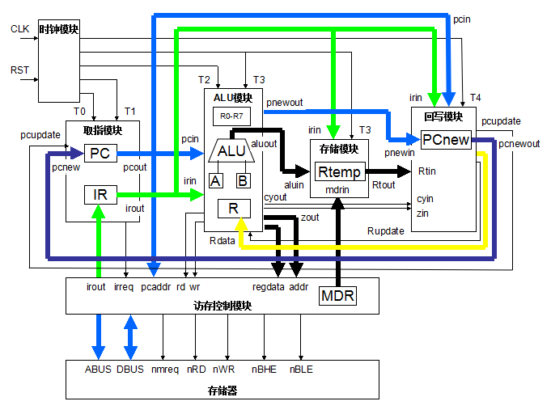

4.1接口定义
信号名 | 位数 | 方向 | 来源/去向 | 意义
RST | 1 | I | 处理器板 | 高电平复位
CLK | 1 | IN | 处理器板 | 系统时钟
ABUS | 16 | OUT | 存储器 | 地址总线
DBUS | 16 | INOUT | 存储器 | 数据总线
nMREQ | 1 | OUT | 存储器 | 存储器片选
nRD | 1 | OUT | 存储器 | 存储器读
nWR | 1 | OUT | 存储器 | 存储器写
nBHE | 1 | OUT | 存储器 | 高字节使能
nBLE | 1 | OUT | 存储器 | 低字节使能

4.2功能描述
本CPU分为时钟、取指、ALU、存储、访存控制和回写等6个模块，CLK和RST由外部信号控制，ABUS、DBUS、nMREQ、nRD、nWR、nBHE和nBLE信号与存储器连接。RST为复位信号，CPU在CLK时钟的控制下，从存储器取指并执行，与存储器进行数据交换。

4.3波形仿真

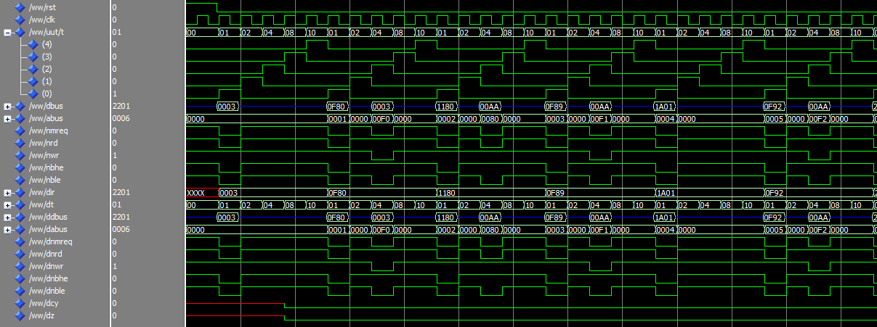

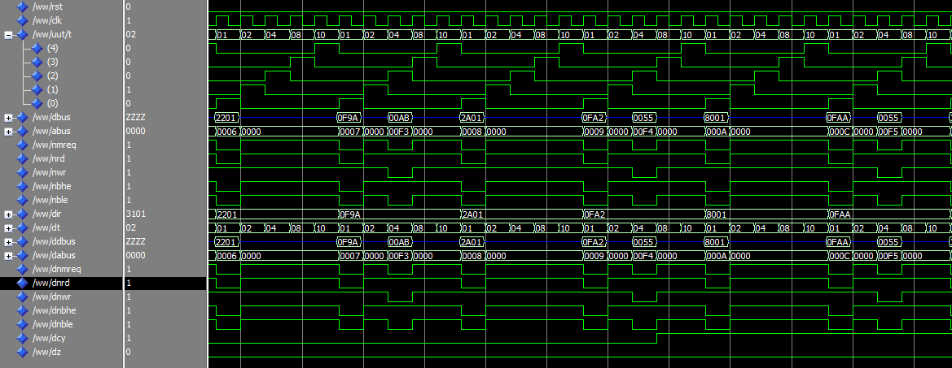

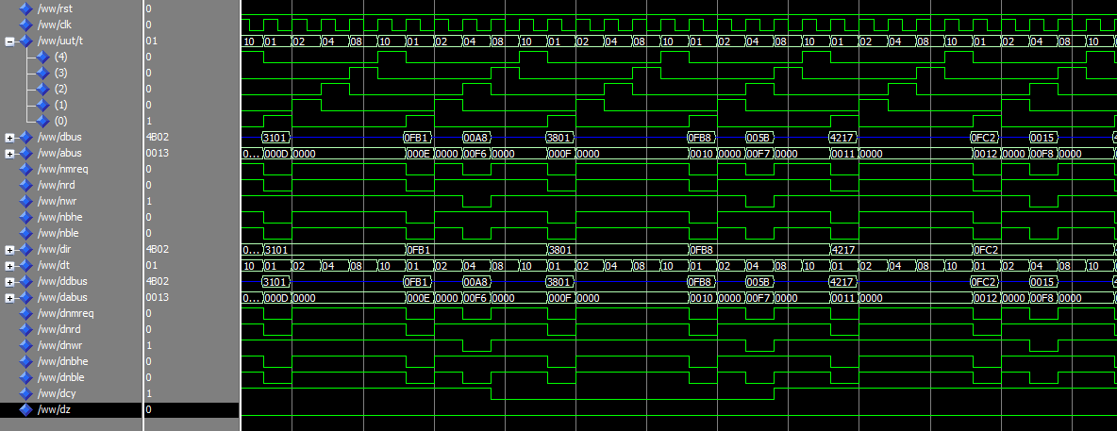

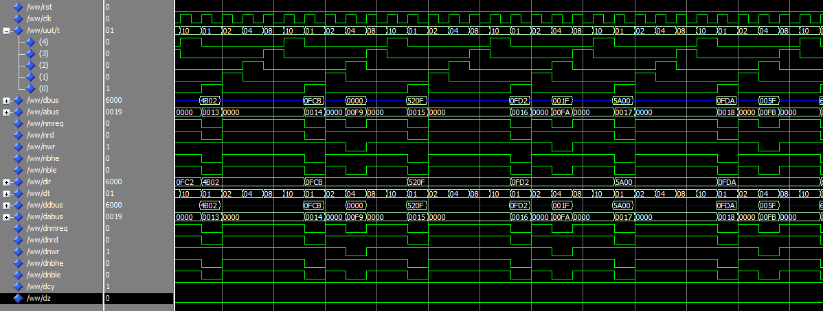
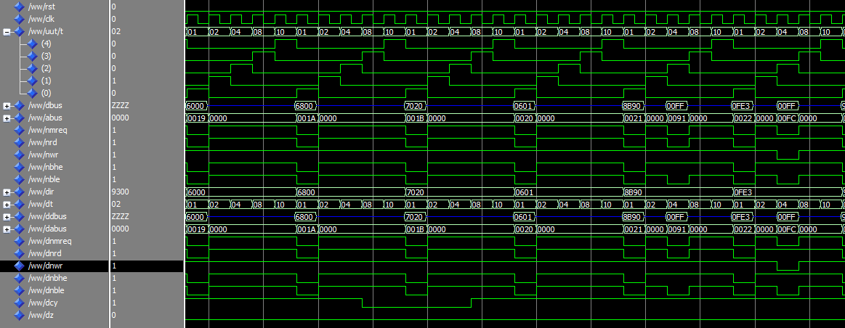
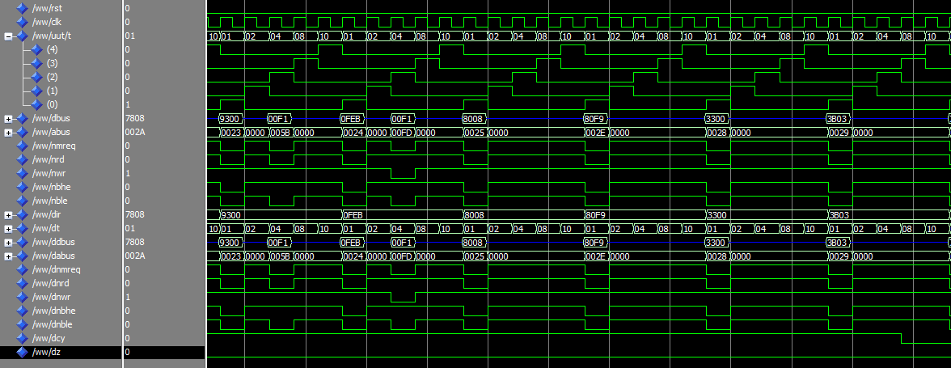
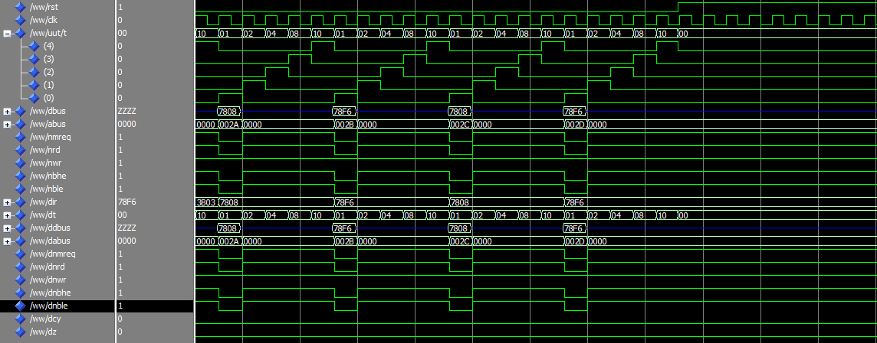

5.各功能模块结构设计框图

5.1时钟模块
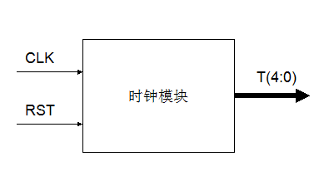

5.1.1接口定义
信号名 | 位数 | 方向 | 来源/去向 | 意义
CLK | 1 | IN | 处理器板 | 系统时钟
RST | 1 | IN | 处理器板 | 系统复位
T | 5 | OUT | 各模块输入 | 节拍

5.1.2功能描述
本CPU采用5个节拍的形式，时钟模块是一个5节拍的计数器，由CLK时钟控制，循环输出T0-T4的节拍，控制其他模块的执行。

5.1.3波形仿真

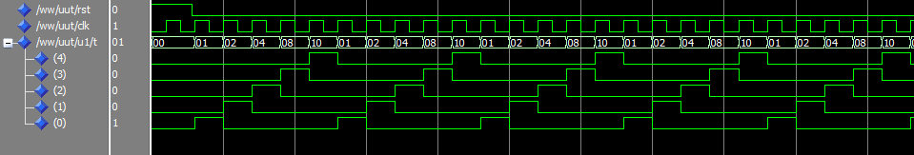

5.2取指模块
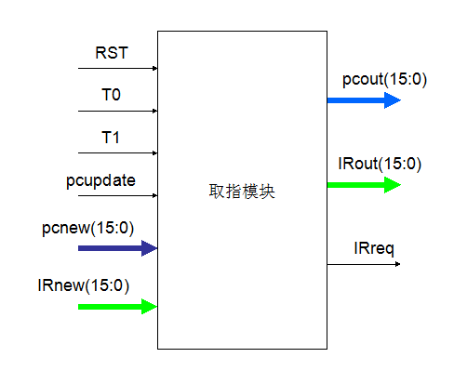

5.2.1接口定义
信号名 | 位数 | 方向 | 来源/去向 | 意义
T0 | 1 | IN | 时钟模块T | 节拍信号
T1 | 1 | IN | 时钟模块T | 节拍信号
RST | 1 | IN | 处理器板 | 系统复位
pupdate | 1 | IN | 回写模块pcupdate | 回写pc使能
pcnew | 16 | IN | 回写模块pcnewout | pc回写值
irnew | 16 | IN | 访存控制模块IR | 新取出的指令
pcout | 16 | OUT | ALU和回写模块 | 输出PC
irout | 16 | OUT | ALU、存储和回写模块 | 输出IR
irreq | 1 | OUT | 访存控制模块IRreq | 取指使能

5.2.2功能描述
取指模块执行取指和PC+1的操作，并向其他模块输出PC和IR。T0节拍向存储器发出取指请求并获得IR，T1节拍执行PC+1。

5.2.3波形仿真
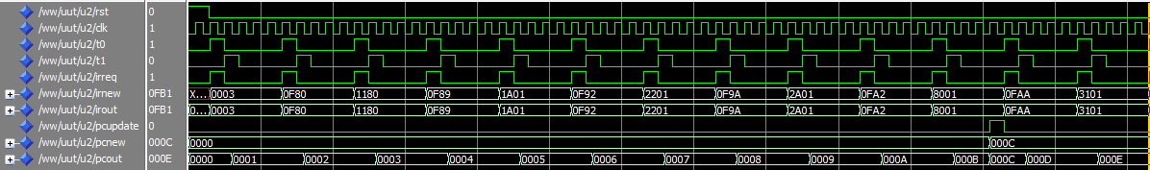

5.3 ALU模块
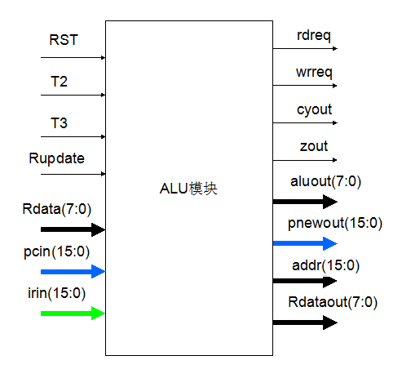

5.3.1接口定义
信号名 | 位数 | 方向 | 来源/去向 | 意义
T2 | 1 | IN | 时钟模块T | 节拍信号
T3 | 1 | IN | 时钟模块T | 节拍信号
RST | 1 | IN | 处理器板 | 系统复位
Irin | 16 | IN | 取指模块irout | 当前ir
pcin | 16 | IN | 取指模块 pcout | 当前指令ir对应的pc
Rupdate | 1 | IN | 回写模块 Rupdate | 寄存器回写使能
Rdata | 8 | IN | 回写模块 Rdataout | 要回写到寄存器的值
aluout | 8 | OUT | 存储管理模块 aluin | 输出给存储模块要回写到寄存器的值
pnewout | 16 | OUT | 回写模块 pcnewin | 要回写的pc值
addr | 16 | OUT | 访存控制模块 addr | 存数、取数的主存地址
Regout | 8 | OUT | 访存控制模块 regdata | 写到存储器的数值
rdreq | 1 | OUT | 访存控制 rd | 取数使能
wrreq | 1 | OUT | 访存控制 wr | 存数使能
cyout | 1 | OUT | 回写模块 cyin | Cy输出至回写模块
zout | 1 | OUT | 回写模块 zin | z输出至回写模块

5.3.2功能描述
ALU模块主要负责执行运算任务。模块内包含8个通用寄存器R0-R7，1个用于与访存控制模块交互的寄存器，2个用于计算的寄存器A和B。当更新寄存器信号Rupdate有效时，Rdata回写到指令码IR(10 downto 8)对应的寄存器（000-111，即R0到R7）。寄存器A和B存放当前指令码中IR(10 downto 8)和IR(2 downto 0)所对应的寄存器值，用于算术和逻辑运算。T2节拍判断当前指令是否需要写存储器，如需要，则置wrreq=1并且addr(15:0)给出存储器地址，Rdataout(7:0)给出待写数据；如需要读存储器，则置rdreq=1。T2节拍还需要将运算结果送至aluout。T3节拍根据运算结果写cy和z的值。

5.3.3波形仿真
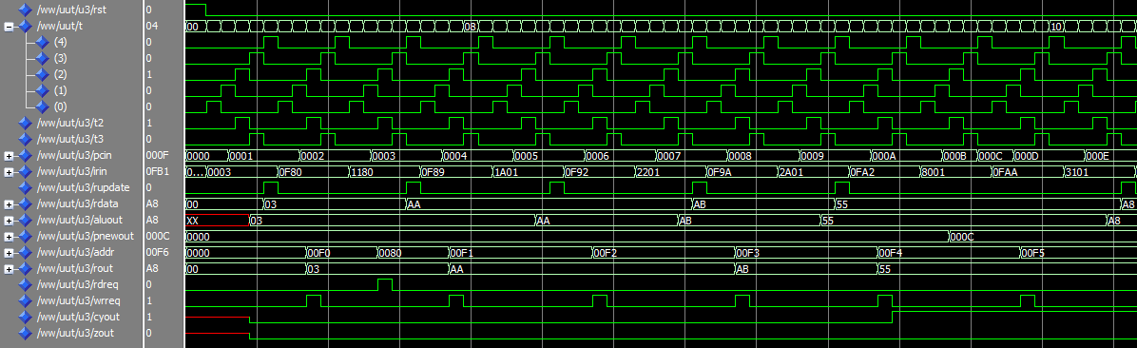
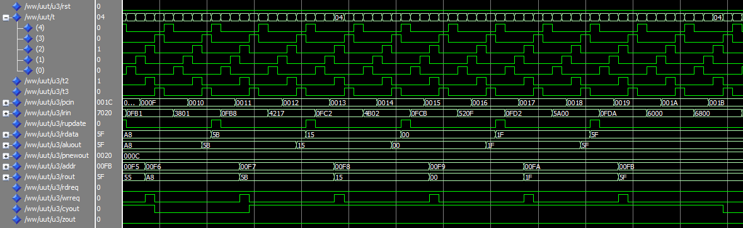
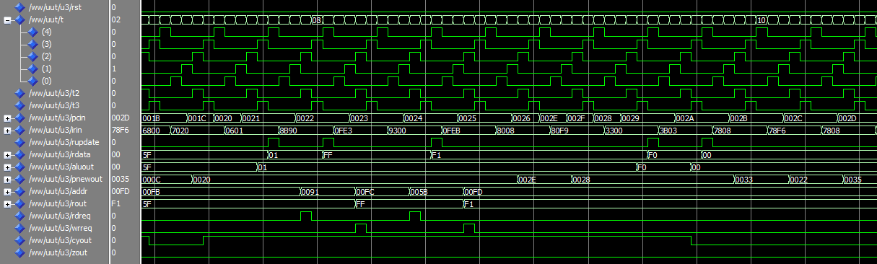
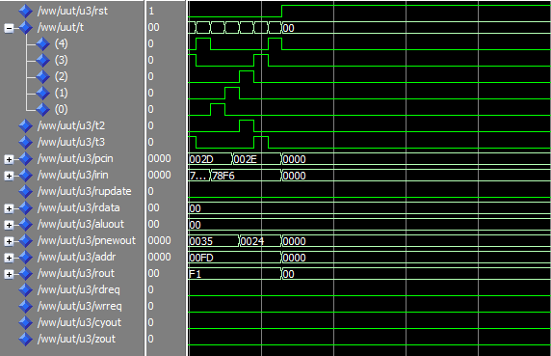

5.4存储模块
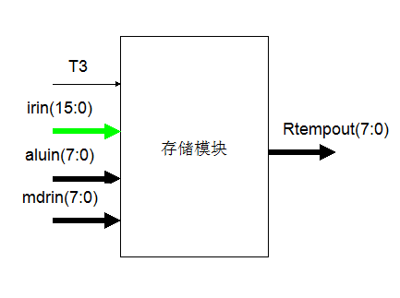

5.4.1接口定义
信号名 | 位数 | 方向 | 来源/去向 | 意义
T3 | 1 | IN | 时钟模块T | 节拍信号
Irin | 16 | IN | 取指模块irout | 当前ir
aluin | 8 | IN | ALU模块aluout | 接收alu的值
MDRin | 8 | IN | 访存控制MDR | 接收取数数据
Rtempout | 8 | OUT | 回写模块Rtempin | 待回写值

5.4.2功能描述
存储模块负责管理从存储器取出的值mdrin以及ALU模块送过来的aluout。T3节拍，次模块根据当前操作码IR(15 downto 11)来判断需要回写至寄存器的值，或者为mdrin，或者为aluout，并输出至Rtempout(7:0)。

5.4.3波形仿真
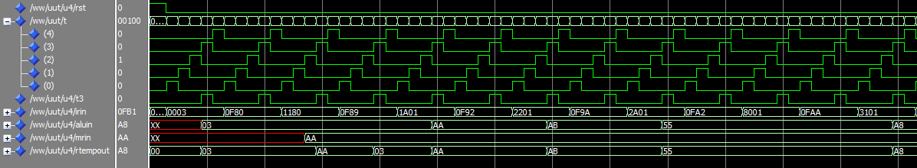
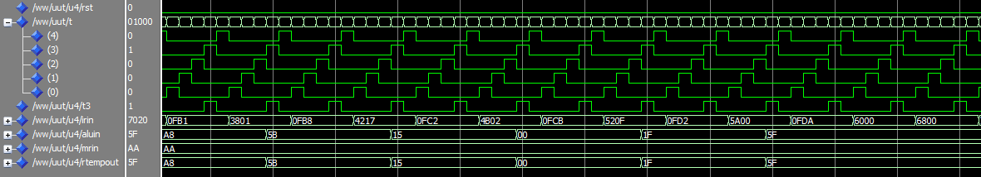
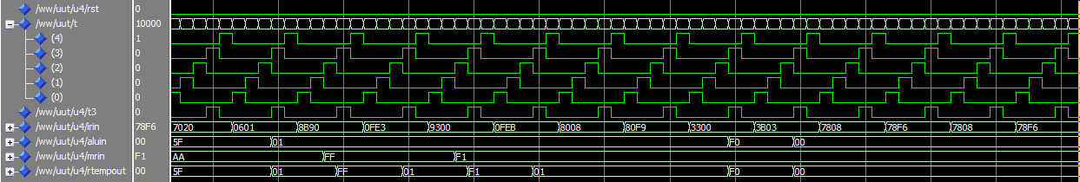
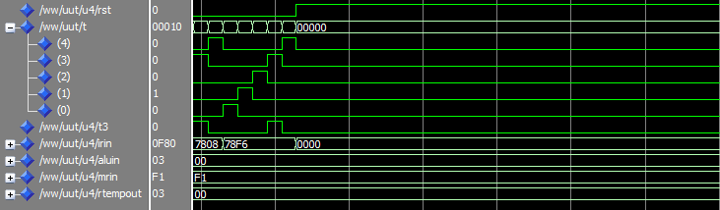

5.5访存控制模块
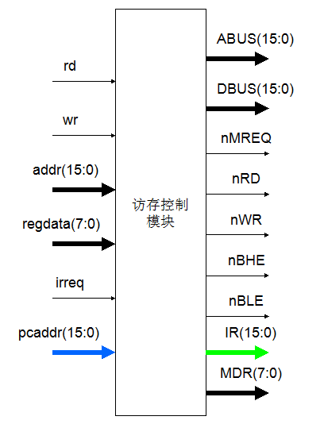

5.5.1接口定义
信号名 | 位数 | 方向 | 来源/去向 | 意义
rd | 1 | IN | ALU模块rdreq | 取数使能
wr | 1 | IN | ALU模块wrreq | 存数使能
addr | 16 | IN | ALU模块addr | 存数地址
regdata | 8 | IN | ALU模块Regout | 待写到存储器的数据
IRreq | 1 | IN | 取指模块irreq | 取指请求
pcaddr | 16 | IN | 取指模块pcout | 当前pc值
ABUS | 16 | OUT | 存储器ABUS | 地址总线
DBUS | 16 | IN/OUT | 存储器DBUS | 数据总线
nMREQ | 1 | OUT | 存储器nmreq | 片选信号
nRD | 1 | OUT | 存储器nrd | 读使能
nWR | 1 | OUT | 存储器nwr | 写使能
nBHE | 1 | OUT | 存储器nbhe | 高字节使能
nBLE | 1 | OUT | 存储器nble | 低字节使能
IR | 16 | OUT | 取指模块IRin | 当前取出的指令
MDR | 8 | OUT | 存储模块MDRin | 从存储器取出的数据

5.5.2功能描述
访存控制模块直接与存储器连接，主要负责取指、取数、存数等操作。当T0节拍取指请求irreq=1时，此模块在ABUS给出指令地址（PC值），令nMREQ、nRD、nBHE和nBLE有效，在DBUS上得到对应指令并存放在IR寄存器中。T2节拍，若取数请求rd=1，则此模块在ABUS给出相应地址，令nMREQ、nRD和nBLE有效，在DBUS上得到对应数据并存放在MDR寄存器中；若存数请求wr=1，则此模块在ABUS给出相应地址，regdata给出待写数据，令nMREQ、nWR和nBLE有效，通过DBUS将数据写入存储器相应地址。

5.5.3波形仿真
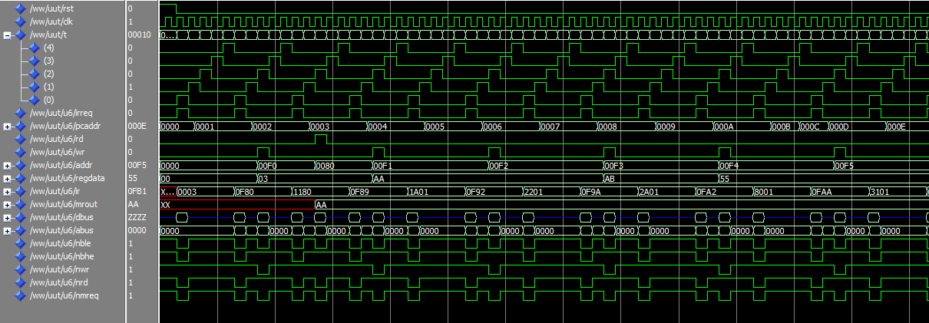
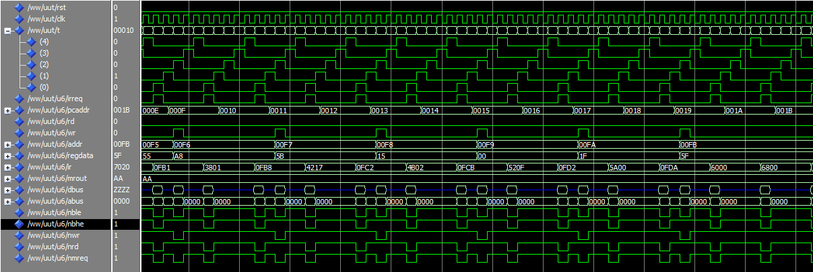
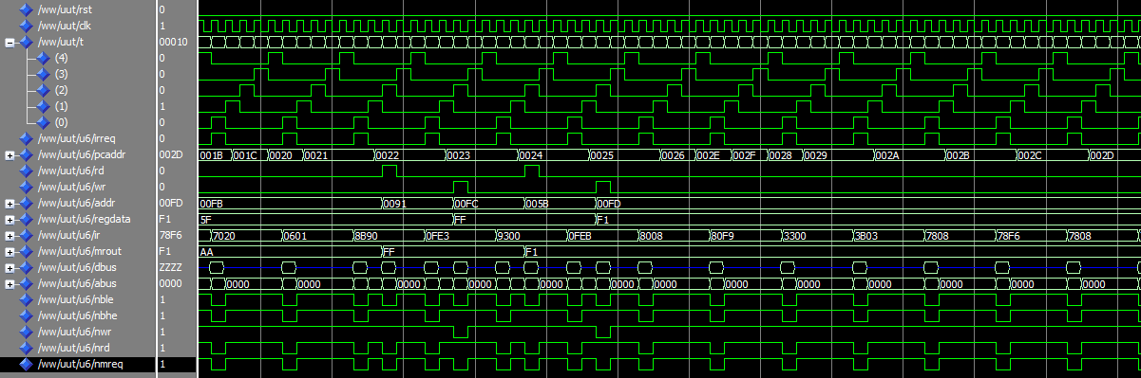
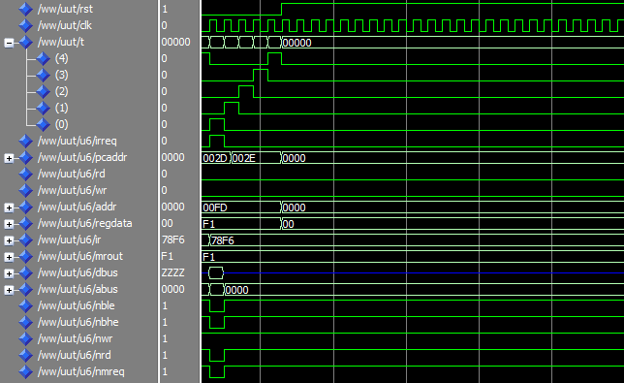

5.6回写模块
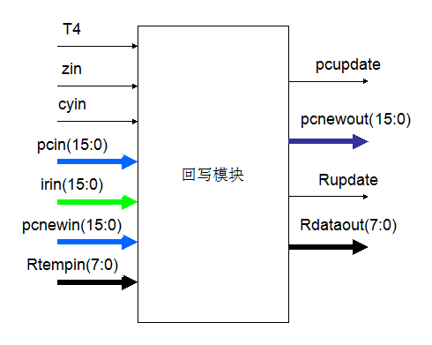

5.6.1接口定义
信号名 | 位数 | 方向 | 来源/去向 | 意义
T4 | 1 | IN | 时钟模块T | 节拍信号
cyin | 1 | IN | ALU模块cyout | Cy值用于判断jc
zin | 1 | IN | ALU模块zout | z值用于判断jz
Irin | 16 | IN | 取指模块irout | 当前ir
pcin | 16 | IN | 取指模块 pcout | 当前指令ir对应的pc
pcnewin | 16 | IN | ALU模块pnewout | 待回写pc值
Rtempin | 8 | IN | 存储模块Rtempout | 待回写寄存器值
pcupdate | 1 | OUT | 取指模块pcupdate | Pc回写使能
pcnewout | 16 | OUT | 取指模块pcnewin | Pc回写值
Rupdate | 1 | OUT | ALU模块Rupdate | 寄存器回写使能
Rdataout | 16 | OUT | ALU模块Rdata | 寄存器回写值

5.6.2功能描述
回写模块主要执行PC或通用寄存器的回写操作。T4节拍，次模块根据当前操作码IR(15 downto 11)判断是否需要回写PC和通用寄存器。若需要回写PC，则置pcupdate=1，并在pcnewout给出要回写的PC值，输出至取指模块；若需要回写通用寄存器，则置Rupdate=1，并在Rdataout给出要回写的值，输出至ALU模块。

5.6.3波形仿真
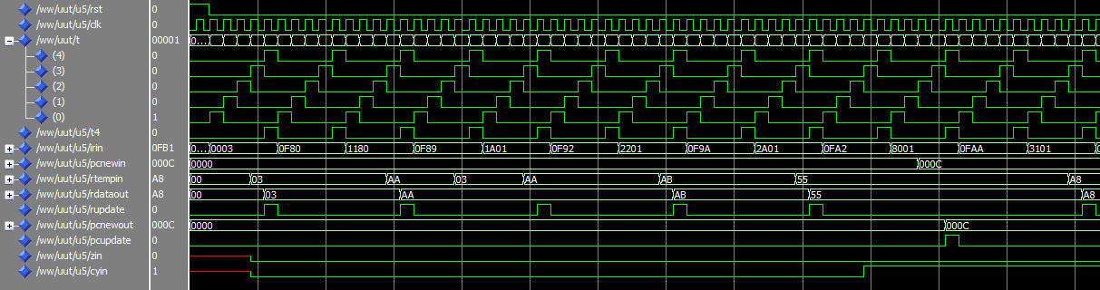
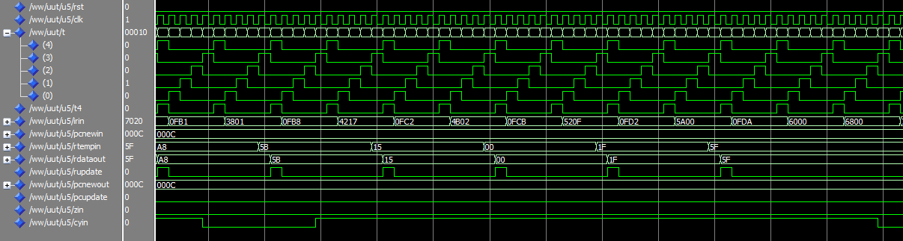
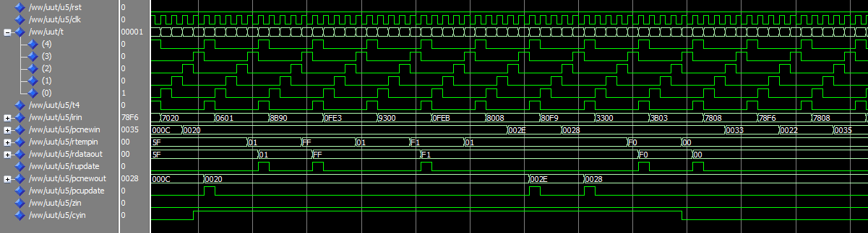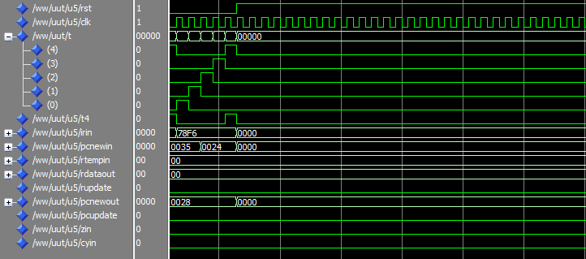

6.VHDL代码

library IEEE;
use IEEE.STD_LOGIC_1164.ALL;
use IEEE.STD_LOGIC_ARITH.ALL;
use IEEE.STD_LOGIC_UNSIGNED.ALL;

entity clock is
Port ( clk : in STD_LOGIC;
rst : in STD_LOGIC;
t : out STD_LOGIC_VECTOR (4 downto 0));
end clock;

architecture Behavioral of clock is
signal tmp : std_logic_vector(4 downto 0);
begin
process(rst,clk)
begin
if rst='1' then t<="00000";tmp<="00001";
elsif clk' event and clk='1' then
case tmp is
when "00001" => tmp<="00010";
when "00010" => tmp<="00100";
when "00100" => tmp<="01000";
when "01000" => tmp<="10000";
when "10000" => tmp<="00001";
when others => null;
end case;
t<=tmp;
end if;
end process;
end Behavioral;

library IEEE;
use IEEE.STD_LOGIC_1164.ALL;
use IEEE.STD_LOGIC_ARITH.ALL;
use IEEE.STD_LOGIC_UNSIGNED.ALL;

entity ir_get is
Port ( clk : in STD_LOGIC;
rst : in STD_LOGIC;
t0 : in STD_LOGIC;
t1 : in STD_LOGIC;
pcupdate : in STD_LOGIC;
pcnew : in STD_LOGIC_VECTOR (15 downto 0);
irnew : in STD_LOGIC_VECTOR (15 downto 0);
irout : out STD_LOGIC_VECTOR (15 downto 0);
pcout : out STD_LOGIC_VECTOR (15 downto 0);
irreq : out STD_LOGIC);
end ir_get;

architecture Behavioral of ir_get is
signal IR,PC : STD_LOGIC_VECTOR (15 downto 0);
begin
process(clk,rst,t0,t1,pcupdate,pcnew,irnew)
begin
if(rst='1') then irreq<='0';
IR<="0000000000000000";PC<="0000000000000000";
elsif(t0='1') then irreq<='1';IR<=irnew;
elsif(t1='1') then irreq<='0';
if(clk' event and clk='0') then PC<=PC+1;
end if;
--PC<=PC+1;
elsif(pcupdate='1') then
--if(clk' event and clk='0') then PC<=pcnew;
--end if;
PC<=pcnew;
end if;
end process;
pcout<=PC;
irout<=IR;
end Behavioral;

library IEEE;
use IEEE.STD_LOGIC_1164.ALL;
use IEEE.STD_LOGIC_ARITH.ALL;
use IEEE.STD_LOGIC_UNSIGNED.ALL;

entity alu is
Port ( Rseven : out STD_LOGIC_VECTOR (7 downto 0);
rst : in STD_LOGIC;
t2 : in STD_LOGIC;
t3 : in STD_LOGIC;
pcin : in STD_LOGIC_VECTOR (15 downto 0);
irin : in STD_LOGIC_VECTOR (15 downto 0);
Rupdate : in STD_LOGIC;
Rdata : in STD_LOGIC_VECTOR (7 downto 0);
Raddr : in STD_LOGIC_VECTOR (2 downto 0);
aluout : out STD_LOGIC_VECTOR (7 downto 0);
pnewout : out STD_LOGIC_VECTOR (15 downto 0);
addr : out STD_LOGIC_VECTOR (15 downto 0);
Rout : out STD_LOGIC_VECTOR (7 downto 0);
rdreq : out STD_LOGIC;
wrreq : out STD_LOGIC;
cyout : out STD_LOGIC;
zout : out STD_LOGIC);
end alu;

architecture Behavioral of alu is
type regtype IS array(0 to 7) of std_logic_vector(7 downto 0);
signal R:regtype;
signal A,B:std_logic_vector(7 downto 0);
signal alutmp:std_logic_vector(8 downto 0);
signal cy:std_logic;
signal z:std_logic;
begin
--process(rst,t2,t3,irin,Rupdate,Rdata,Raddr)
process(rst,t2,t3,irin,Rupdate,Rdata)
begin
A<=R(conv_integer(irin(10 downto 8)));
B<=R(conv_integer(irin(2 downto 0)));
--case irin(15 downto 11) is
--when "00001" => addr<=R(7)&irin(10 downto 3);
--when "00010" => addr<=R(7)&irin(7 downto 0);
--when "10001" => addr<=R(7)&(R(6)+irin(7 downto 0));
--when "10010" => addr<=R(7)&R(conv_integer(irin(2 downto 0)));
--when others => null;
--end case;
rdreq<='0';
wrreq<='0';
if(rst='1') then
for i in 0 to 7 loop
R(i)<="00000000";
end loop;
pnewout<="0000000000000000";
addr<="0000000000000000";
Rout<="00000000";
alutmp<="000000000";
cy<='0';
z<='0';
--end if;
elsif(t2='1') then
case irin(15 downto 11) is
when "00000" => alutmp(7 downto 0)<=irin(7 downto 0);
when "00001" => addr<=R(7)&irin(10 downto 3);rdreq<='0';wrreq<='1';Rout<=R(conv_integer(irin(2 downto 0)));
when "00010" => addr<=R(7)&irin(7 downto 0);rdreq<='1';wrreq<='0';
when "00011" => alutmp(7 downto 0)<=R(conv_integer(irin(2 downto 0)));
when "00100" => alutmp<='0'&A+irin(7 downto 0)+cy;
if(alutmp="000000000") then z<='1';
else z<='0';
end if;
--cy<=alutmp(8);
when "00101" => alutmp<='0'&A+B+cy;
if(alutmp="000000000") then z<='1';
else z<='0';
end if;
--cy<=alutmp(8);
when "00110" => alutmp<='0'&A-irin(7 downto 0)-cy;
if(alutmp="000000000") then z<='1';
else z<='0';
end if;
--cy<=alutmp(8);
when "00111" => alutmp<='0'&A-B-cy;
if(alutmp="000000000") then z<='1';
else z<='0';
end if;
--cy<=alutmp(8);
when "01000" => alutmp(7 downto 0)<=A and irin(7 downto 0);
when "01001" => alutmp(7 downto 0)<=A and B;
when "01010" => alutmp(7 downto 0)<=A or irin(7 downto 0);
when "01011" => alutmp(7 downto 0)<=A or B;
when "01100" => --cy<='0';
alutmp(8)<='0';
when "01101" => --cy<='1';
alutmp(8)<='1';
when "01110" => pnewout<=R(7)&irin(7 downto 0);
when "01111" => if(irin(7)='1') then pnewout<=pcin+irin(6 downto 0)-"10000000";
else pnewout<=pcin+irin(6 downto 0);
end if;
when "10000" => if(irin(7)='1') then pnewout<=pcin+irin(6 downto 0)-"10000000";
else pnewout<=pcin+irin(6 downto 0);
end if;
when "10001" => addr<=R(7)&(R(6)+irin(7 downto 0));rdreq<='1';wrreq<='0';
when "10010" => addr<=R(7)&R(conv_integer(irin(2 downto 0)));rdreq<='1';wrreq<='0';
when others => null;
end case;
--aluout<=alutmp(7 downto 0);
--end if;
elsif(t3='1') then
cy<=alutmp(8);
aluout<=alutmp(7 downto 0);
cyout<=cy;
zout<=z;
--cy<=alutmp(8);----------------------------------------
--if(alutmp="000000000") then z<='1';
--else z<='0';
--end if;-----------------------------------------------
--end if;
elsif(Rupdate='1') then
--R(conv_integer(irin(10 downto 8)))<=Rdata;
R(conv_integer(Raddr))<=Rdata;
end if;
--aluout<=alutmp(7 downto 0);
--cyout<=cy;
--zout<=z;
end process;
Rseven<=R(7);
end Behavioral;

library IEEE;
use IEEE.STD_LOGIC_1164.ALL;
use IEEE.STD_LOGIC_ARITH.ALL;
use IEEE.STD_LOGIC_UNSIGNED.ALL;

entity memory is
Port ( rst : in STD_LOGIC;
t3 : in STD_LOGIC;
irin : in STD_LOGIC_VECTOR (15 downto 0);
aluin : in STD_LOGIC_VECTOR (7 downto 0);
mrin : in STD_LOGIC_VECTOR (7 downto 0);
Rtempout : out STD_LOGIC_VECTOR (7 downto 0));
end memory;

architecture Behavioral of memory is
signal Rtemp : std_logic_vector(7 downto 0);
begin
process(rst,t3,irin,aluin,mrin)
begin
if(rst='1') then Rtemp<="00000000";
elsif(t3='1') then
case irin(15 downto 11) is
when "00010" => Rtemp<=mrin;
when "10001" => Rtemp<=mrin;
when "10010" => Rtemp<=mrin;
when others => Rtemp<=aluin;
end case;
end if;
end process;
Rtempout<=Rtemp;
end Behavioral;

library IEEE;
use IEEE.STD_LOGIC_1164.ALL;
use IEEE.STD_LOGIC_ARITH.ALL;
use IEEE.STD_LOGIC_UNSIGNED.ALL;

entity mem_ctrl is
Port ( irreq : in STD_LOGIC;
pcaddr : in STD_LOGIC_VECTOR (15 downto 0);
rd : in STD_LOGIC;
wr : in STD_LOGIC;
addr : in STD_LOGIC_VECTOR (15 downto 0);
regdata : in STD_LOGIC_VECTOR (7 downto 0);
ir : out STD_LOGIC_VECTOR (15 downto 0);
mrout : out STD_LOGIC_VECTOR (7 downto 0);
DBUS : inout STD_LOGIC_VECTOR (15 downto 0);
ABUS : out STD_LOGIC_VECTOR (15 downto 0);
nmreq : out STD_LOGIC;
nrd : out STD_LOGIC;
nwr : out STD_LOGIC;
nbhe : out STD_LOGIC;
nble : out STD_LOGIC);
end mem_ctrl;

architecture Behavioral of mem_ctrl is
begin
process(irreq,pcaddr,rd,wr,addr,regdata)
begin
if(irreq='1') then
nmreq<='0';nrd<='0';nwr<='1';nbhe<='0';nble<='0';
ABUS<=pcaddr;ir<=DBUS;DBUS<="ZZZZZZZZZZZZZZZZ";
elsif(rd='1') then
nmreq<='0';nrd<='0';nwr<='1';nbhe<='1';nble<='0';
ABUS<=addr;mrout<=DBUS(7 downto 0);DBUS<="ZZZZZZZZZZZZZZZZ";
elsif(wr='1') then
nmreq<='0';nrd<='1';nwr<='0';nbhe<='1';nble<='0';
ABUS<=addr;--DBUS<="ZZZZZZZZ"&regdata;
--DBUS(15 downto 8)<="ZZZZZZZZ";DBUS(7 downto 0)<=regdata;
DBUS<="00000000"&regdata;
else
nmreq<='1';nrd<='1';nwr<='1';nbhe<='1';nble<='1';
DBUS<="ZZZZZZZZZZZZZZZZ";
end if;
end process;
end Behavioral;

library IEEE;
use IEEE.STD_LOGIC_1164.ALL;
use IEEE.STD_LOGIC_ARITH.ALL;
use IEEE.STD_LOGIC_UNSIGNED.ALL;

entity wrback is
Port ( rst : in STD_LOGIC;
clk : in STD_LOGIC;
t4 : in STD_LOGIC;
irin : in STD_LOGIC_VECTOR (15 downto 0);
--pcin : in STD_LOGIC_VECTOR (15 downto 0);
pcnewin : in STD_LOGIC_VECTOR (15 downto 0);
cyin : in STD_LOGIC;
zin : in STD_LOGIC;
Rtempin : in STD_LOGIC_VECTOR (7 downto 0);
Rupdate : out STD_LOGIC;
Raddrout : out STD_LOGIC_VECTOR (2 downto 0);
Rdataout : out STD_LOGIC_VECTOR (7 downto 0);
pcupdate : out STD_LOGIC;
pcnewout : out STD_LOGIC_VECTOR (15 downto 0));
end wrback;

architecture Behavioral of wrback is
signal pcnewtmp : std_logic_vector(15 downto 0);
begin
process(rst,clk,t4,irin,pcnewin,cyin,zin,Rtempin)
begin
if(rst='1') then Rupdate<='0';pcupdate<='0';
Raddrout<="000";Rdataout<="00000000";
pcnewtmp<="0000000000000000";
elsif(t4='1') then
case irin(15 downto 11) is
when "00000" => Raddrout<=irin(10 downto 8);Rdataout<=Rtempin;Rupdate<='1';pcupdate<='0';
when "00001" => Rupdate<='0';pcupdate<='0';
when "00010" => Raddrout<=irin(10 downto 8);Rdataout<=Rtempin;Rupdate<='1';pcupdate<='0';
when "00011" => Raddrout<=irin(10 downto 8);Rdataout<=Rtempin;Rupdate<='1';pcupdate<='0';
when "00100" => Raddrout<=irin(10 downto 8);Rdataout<=Rtempin;Rupdate<='1';pcupdate<='0';
when "00101" => Raddrout<=irin(10 downto 8);Rdataout<=Rtempin;Rupdate<='1';pcupdate<='0';
when "00110" => Raddrout<=irin(10 downto 8);Rdataout<=Rtempin;Rupdate<='1';pcupdate<='0';
when "00111" => Raddrout<=irin(10 downto 8);Rdataout<=Rtempin;Rupdate<='1';pcupdate<='0';
when "01000" => Raddrout<=irin(10 downto 8);Rdataout<=Rtempin;Rupdate<='1';pcupdate<='0';
when "01001" => Raddrout<=irin(10 downto 8);Rdataout<=Rtempin;Rupdate<='1';pcupdate<='0';
when "01010" => Raddrout<=irin(10 downto 8);Rdataout<=Rtempin;Rupdate<='1';pcupdate<='0';
when "01011" => Raddrout<=irin(10 downto 8);Rdataout<=Rtempin;Rupdate<='1';pcupdate<='0';
when "01100" => Rupdate<='0';pcupdate<='0';
when "01101" => Rupdate<='0';pcupdate<='0';
when "01110" => pcnewtmp<=pcnewin;pcupdate<='1';Rupdate<='0';
when "01111" => if(zin='1') then pcnewtmp<=pcnewin;pcupdate<='1';
else pcupdate<='0';
end if;
Rupdate<='0';
when "10000" => if(cyin='1') then pcnewtmp<=pcnewin;pcupdate<='1';
else pcupdate<='0';
end if;
Rupdate<='0';
when "10001" => Raddrout<=irin(10 downto 8);Rdataout<=Rtempin;Rupdate<='1';pcupdate<='0';
when "10010" => Raddrout<=irin(10 downto 8);Rdataout<=Rtempin;Rupdate<='1';pcupdate<='0';
when others => null;
end case;
else Rupdate<='0';pcupdate<='0';
--else pcupdate<='0';
end if;
end process;
pcnewout<=pcnewtmp;
end Behavioral;

library IEEE;
use IEEE.STD_LOGIC_1164.ALL;
use IEEE.STD_LOGIC_ARITH.ALL;
use IEEE.STD_LOGIC_UNSIGNED.ALL;

entity cpu is
Port ( rst : in STD_LOGIC;
clk : in STD_LOGIC;
DBUS : inout STD_LOGIC_VECTOR (15 downto 0);
ABUS : out STD_LOGIC_VECTOR (15 downto 0);
nmreq : out STD_LOGIC;
nrd : out STD_LOGIC;
nwr : out STD_LOGIC;
nbhe : out STD_LOGIC;
nble : out STD_LOGIC;

DRupdate : out STD_LOGIC;
Rseven : out STD_LOGIC_VECTOR (7 downto 0);

--Drst : out STD_LOGIC;
DIR : out STD_LOGIC_VECTOR (15 downto 0);
DT : out STD_LOGIC_VECTOR (4 downto 0);
DDBUS : out STD_LOGIC_VECTOR (15 downto 0);
DABUS : out STD_LOGIC_VECTOR (15 downto 0);
Dnmreq : out STD_LOGIC;
Dnrd : out STD_LOGIC;
Dnwr : out STD_LOGIC;
Dnbhe : out STD_LOGIC;
Dnble : out STD_LOGIC;
Dcy : out STD_LOGIC;
Dz : out STD_LOGIC);

end cpu;

architecture Behavioral of cpu is
component clock is
port( clk: in std_logic;
rst:in std_logic;
t: out std_logic_vector(4 downto 0));
end component;
component ir_get is
Port ( clk : in STD_LOGIC;
rst : in STD_LOGIC;
t0 : in STD_LOGIC;
t1 : in STD_LOGIC;
pcupdate : in STD_LOGIC;
pcnew : in STD_LOGIC_VECTOR (15 downto 0);
irnew : in STD_LOGIC_VECTOR (15 downto 0);
irout : out STD_LOGIC_VECTOR (15 downto 0);
pcout : out STD_LOGIC_VECTOR (15 downto 0);
irreq : out STD_LOGIC);
end component;
component alu is
Port ( Rseven : out STD_LOGIC_VECTOR (7 downto 0);
rst : in STD_LOGIC;
t2 : in STD_LOGIC;
t3 : in STD_LOGIC;
pcin : in STD_LOGIC_VECTOR (15 downto 0);
irin : in STD_LOGIC_VECTOR (15 downto 0);
Rupdate : in STD_LOGIC;
Rdata : in STD_LOGIC_VECTOR (7 downto 0);
Raddr : in STD_LOGIC_VECTOR (2 downto 0);
aluout : out STD_LOGIC_VECTOR (7 downto 0);
pnewout : out STD_LOGIC_VECTOR (15 downto 0);
addr : out STD_LOGIC_VECTOR (15 downto 0);
Rout : out STD_LOGIC_VECTOR (7 downto 0);
rdreq : out STD_LOGIC;
wrreq : out STD_LOGIC;
cyout : out STD_LOGIC;
zout : out STD_LOGIC);
end component;
component memory is
Port ( rst : in STD_LOGIC;
t3 : in STD_LOGIC;
irin : in STD_LOGIC_VECTOR (15 downto 0);
aluin : in STD_LOGIC_VECTOR (7 downto 0);
mrin : in STD_LOGIC_VECTOR (7 downto 0);
Rtempout : out STD_LOGIC_VECTOR (7 downto 0));
end component;
component wrback is
Port ( rst : in STD_LOGIC;
clk : in STD_LOGIC;
t4 : in STD_LOGIC;
irin : in STD_LOGIC_VECTOR (15 downto 0);
--pcin : in STD_LOGIC_VECTOR (15 downto 0);
pcnewin : in STD_LOGIC_VECTOR (15 downto 0);
cyin : in STD_LOGIC;
zin : in STD_LOGIC;
Rtempin : in STD_LOGIC_VECTOR (7 downto 0);
Rupdate : out STD_LOGIC;
Raddrout : out STD_LOGIC_VECTOR (2 downto 0);
Rdataout : out STD_LOGIC_VECTOR (7 downto 0);
pcupdate : out STD_LOGIC;
pcnewout : out STD_LOGIC_VECTOR (15 downto 0));
end component;
component mem_ctrl is
Port ( irreq : in STD_LOGIC;
pcaddr : in STD_LOGIC_VECTOR (15 downto 0);
rd : in STD_LOGIC;
wr : in STD_LOGIC;
addr : in STD_LOGIC_VECTOR (15 downto 0);
regdata : in STD_LOGIC_VECTOR (7 downto 0);
ir : out STD_LOGIC_VECTOR (15 downto 0);
mrout : out STD_LOGIC_VECTOR (7 downto 0);
DBUS : inout STD_LOGIC_VECTOR (15 downto 0);
ABUS : out STD_LOGIC_VECTOR (15 downto 0);
nmreq : out STD_LOGIC;
nrd : out STD_LOGIC;
nwr : out STD_LOGIC;
nbhe : out STD_LOGIC;
nble : out STD_LOGIC);
end component;

signal PCNEW,PCOUT,IROUT,IRNEW,PNEWOUT,ADDR : std_logic_vector(15 downto 0);
signal ALUOUT,REGDATA,RDATA,MRIN,RTEMPOUT : std_logic_vector(7 downto 0);
signal T : std_logic_vector(4 downto 0);
signal RADDR : std_logic_vector(2 downto 0);
signal PCUPDATE,IRREQ,CYOUT,ZOUT,RD,WR,RUPDATE : std_logic;
signal tmpABUS : std_logic_vector(15 downto 0);
signal tmpnmreq,tmpnrd,tmpnwr,tmpnbhe,tmpnble : std_logic;
signal R7 : std_logic_vector(7 downto 0);
begin
U1: clock port map(clk,rst,T);
U2: ir_get port map(clk,rst,T(0),T(1),PCUPDATE,PCNEW,IRNEW,IROUT,PCOUT,IRREQ);
U3: alu port map(R7,rst,T(2),T(3),PCOUT,IROUT,RUPDATE,RDATA,RADDR,ALUOUT,PNEWOUT,ADDR,REGDATA,RD,WR,CYOUT,ZOUT);
U4: memory port map(rst,T(3),IROUT,ALUOUT,MRIN,RTEMPOUT);
U5: wrback port map(rst,clk,T(4),IROUT,PNEWOUT,CYOUT,ZOUT,RTEMPOUT,RUPDATE,RADDR,RDATA,PCUPDATE,PCNEW);
U6: mem_ctrl port map(IRREQ,PCOUT,RD,WR,ADDR,REGDATA,IRNEW,MRIN,DBUS,tmpABUS,tmpnmreq,tmpnrd,tmpnwr,tmpnbhe,tmpnble);

--Drst<=rst;
DIR<=IRNEW;
DT<=T;
DDBUS<=DBUS;
DABUS<=tmpABUS;
Dnmreq<=tmpnmreq;
Dnrd<=tmpnrd;
Dnwr<=tmpnwr;
Dnbhe<=tmpnbhe;
Dnble<=tmpnble;
Dcy<=CYOUT;
Dz<=ZOUT;
DRupdate<=RUPDATE;
Rseven<=R7;

ABUS<=tmpABUS;
nmreq<=tmpnmreq;
nrd<=tmpnrd;
nwr<=tmpnwr;
nbhe<=tmpnbhe;
nble<=tmpnble;

end Behavioral;

7.UCF文件

#PACE: Start of Constraints generated by PACE

#PACE: Start of PACE I/O Pin Assignments
NET "ABUS<0>" LOC = "P179" ;
NET "ABUS<10>" LOC = "P115" ;
NET "ABUS<11>" LOC = "P116" ;
NET "ABUS<12>" LOC = "P119" ;
NET "ABUS<13>" LOC = "P140" ;
NET "ABUS<14>" LOC = "P144" ;
NET "ABUS<15>" LOC = "P145" ;
NET "ABUS<1>" LOC = "P178" ;
NET "ABUS<2>" LOC = "P177" ;
NET "ABUS<3>" LOC = "P172" ;
NET "ABUS<4>" LOC = "P171" ;
NET "ABUS<5>" LOC = "P151" ;
NET "ABUS<6>" LOC = "P150" ;
NET "ABUS<7>" LOC = "P147" ;
NET "ABUS<8>" LOC = "P146" ;
NET "ABUS<9>" LOC = "P113" ;
NET "clk" LOC = "P75" ;
NET "DABUS<0>" LOC = "P60" ;
NET "DABUS<10>" LOC = "P129" ;
NET "DABUS<11>" LOC = "P202" ;
NET "DABUS<12>" LOC = "P203" ;
NET "DABUS<13>" LOC = "P205" ;
NET "DABUS<14>" LOC = "P206" ;
NET "DABUS<15>" LOC = "P103" ;
NET "DABUS<1>" LOC = "P61" ;
NET "DABUS<2>" LOC = "P62" ;
NET "DABUS<3>" LOC = "P63" ;
NET "DABUS<4>" LOC = "P2" ;
NET "DABUS<5>" LOC = "P108" ;
NET "DABUS<6>" LOC = "P109" ;
NET "DABUS<7>" LOC = "P112" ;
NET "DABUS<8>" LOC = "P126" ;
NET "DABUS<9>" LOC = "P127" ;
NET "DBUS<0>" LOC = "P167" ;
NET "DBUS<10>" LOC = "P123" ;
NET "DBUS<11>" LOC = "P128" ;
NET "DBUS<12>" LOC = "P132" ;
NET "DBUS<13>" LOC = "P133" ;
NET "DBUS<14>" LOC = "P134" ;
NET "DBUS<15>" LOC = "P135" ;
NET "DBUS<1>" LOC = "P165" ;
NET "DBUS<2>" LOC = "P164" ;
NET "DBUS<3>" LOC = "P163" ;
NET "DBUS<4>" LOC = "P162" ;
NET "DBUS<5>" LOC = "P161" ;
NET "DBUS<6>" LOC = "P160" ;
NET "DBUS<7>" LOC = "P153" ;
NET "DBUS<8>" LOC = "P120" ;
NET "DBUS<9>" LOC = "P122" ;
NET "Dcy" LOC = "P100" ;
NET "DDBUS<0>" LOC = "P31" ;
NET "DDBUS<10>" LOC = "P47" ;
NET "DDBUS<11>" LOC = "P48" ;
NET "DDBUS<12>" LOC = "P49" ;
NET "DDBUS<13>" LOC = "P50" ;
NET "DDBUS<14>" LOC = "P55" ;
NET "DDBUS<15>" LOC = "P56" ;
NET "DDBUS<1>" LOC = "P33" ;
NET "DDBUS<2>" LOC = "P34" ;
NET "DDBUS<3>" LOC = "P35" ;
NET "DDBUS<4>" LOC = "P36" ;
NET "DDBUS<5>" LOC = "P39" ;
NET "DDBUS<6>" LOC = "P40" ;
NET "DDBUS<7>" LOC = "P41" ;
NET "DDBUS<8>" LOC = "P42" ;
NET "DDBUS<9>" LOC = "P45" ;
NET "DIR<0>" LOC = "P4" ;
NET "DIR<10>" LOC = "P22" ;
NET "DIR<11>" LOC = "P23" ;
NET "DIR<12>" LOC = "P24" ;
NET "DIR<13>" LOC = "P25" ;
NET "DIR<14>" LOC = "P28" ;
NET "DIR<15>" LOC = "P29" ;
NET "DIR<1>" LOC = "P5" ;
NET "DIR<2>" LOC = "P8" ;
NET "DIR<3>" LOC = "P9" ;
NET "DIR<4>" LOC = "P11" ;
NET "DIR<5>" LOC = "P12" ;
NET "DIR<6>" LOC = "P15" ;
NET "DIR<7>" LOC = "P16" ;
NET "DIR<8>" LOC = "P18" ;
NET "DIR<9>" LOC = "P19" ;
NET "Dnbhe" LOC = "P83" ;
NET "Dnble" LOC = "P98" ;
NET "Dnmreq" LOC = "P185" ;
NET "Dnrd" LOC = "P82" ;
NET "Dnwr" LOC = "P77" ;
NET "DT<0>" LOC = "P196" ;
NET "DT<1>" LOC = "P193" ;
NET "DT<2>" LOC = "P192" ;
NET "DT<3>" LOC = "P190" ;
NET "DT<4>" LOC = "P3" ;
NET "Dz" LOC = "P102" ;
NET "nbhe" LOC = "P138" ;
NET "nble" LOC = "P137" ;
NET "nmreq" LOC = "P168" ;
NET "nrd" LOC = "P139" ;
NET "nwr" LOC = "P152" ;
NET "rst" LOC = "P51" ;

#PACE: Start of PACE Area Constraints

#PACE: Start of PACE Prohibit Constraints

#PACE: End of Constraints generated by PACE

8.测试指令序列

PC | IR | Assembly Language | cy | z | R0 | R1 | R2 | R3 | R6 | R7
0000 | 0003 | MOV R0,00000011 | 0 | 0 | 03 | 00 | 00 | 00 | 00 | 00
0001 | 0F80 | MOV [11110000],R0 | 0 | 0 | 03 | 00 | 00 | 00 | 00 | 00
0002 | 1180 | MOV R1,[10000000] | 0 | 0 | 03 | AA | 00 | 00 | 00 | 00
0003 | 0F89 | MOV [11110001],R1 | 0 | 0 | 03 | AA | 00 | 00 | 00 | 00
0004 | 1A01 | MOV R2,R1 | 0 | 0 | 03 | AA | AA | 00 | 00 | 00
0005 | 0F92 | MOV [11110010],R2 | 0 | 0 | 03 | AA | AA | 00 | 00 | 00
0006 | 2201 | ADC R2,00000001 | 0 | 0 | 03 | AA | AB | 00 | 00 | 00
0007 | 0F9A | MOV [11110011],R2 | 0 | 0 | 03 | AA | AB | 00 | 00 | 00
0008 | 2A01 | ADC R2,R1 | 1 | 0 | 03 | AA | 55 | 00 | 00 | 00
0009 | 0FA2 | MOV [11110100],R2 | 1 | 0 | 03 | AA | 55 | 00 | 00 | 00
000A | 8001 | JC 00000001 | 1 | 0 | 03 | AA | 55 | 00 | 00 | 00
000C | 0FAA | MOV [11110101],R2 | 1 | 0 | 03 | AA | 55 | 00 | 00 | 00
000D | 3101 | SBB R1,00000001 | 0 | 0 | 03 | A8 | 55 | 00 | 00 | 00
000E | 0FB1 | MOV [11110110],R1 | 0 | 0 | 03 | A8 | 55 | 00 | 00 | 00
000F | 3801 | SBB R0,R1 | 1 | 0 | 5B | A8 | 55 | 00 | 00 | 00
0010 | 0FB8 | MOV [11110111],R0 | 1 | 0 | 5B | A8 | 55 | 00 | 00 | 00
0011 | 4217 | AND R2,00010111 | 1 | 0 | 5B | A8 | 15 | 00 | 00 | 00
0012 | 0FC2 | MOV [11111000],R2 | 1 | 0 | 5B | A8 | 15 | 00 | 00 | 00
0013 | 4B02 | AND R3,R2 | 1 | 0 | 5B | A8 | 15 | 00 | 00 | 00
0014 | 0FCB | MOV [11111001],R3 | 1 | 0 | 5B | A8 | 15 | 00 | 00 | 00
0015 | 520F | OR R2,00001111 | 1 | 0 | 5B | A8 | 1F | 00 | 00 | 00
0016 | 0FD2 | MOV [11111010],R2 | 1 | 0 | 5B | A8 | 1F | 00 | 00 | 00
0017 | 5A00 | OR R2,R0 | 1 | 0 | 5B | A8 | 5F | 00 | 00 | 00
0018 | 0FDA | MOV [11111011],R2 | 1 | 0 | 5B | A8 | 5F | 00 | 00 | 00
0019 | 6000 | CLC | 0 | 0 | 5B | A8 | 5F | 00 | 00 | 00
001A | 6800 | STC | 1 | 0 | 5B | A8 | 5F | 00 | 00 | 00
001B | 7020 | JMP 00100000 | 1 | 0 | 5B | A8 | 5F | 00 | 00 | 00
0020 | 0601 | MOV R6,00000001 | 1 | 0 | 5B | A8 | 5F | 00 | 01 | 00
0021 | 8B90 | MOV R3,[10010000+R6] | 1 | 0 | 5B | A8 | 5F | FF | 01 | 00
0022 | 0FE3 | MOV [11111100],R3 | 1 | 0 | 5B | A8 | 5F | FF | 01 | 00
0023 | 9300 | MOV R3,[R0] | 1 | 0 | 5B | A8 | 5F | F1 | 01 | 00
0024 | 0FEB | MOV [11111101],R3 | 1 | 0 | 5B | A8 | 5F | F1 | 01 | 00
0025 | 8008 | JC 00001000 | 1 | 0 | 5B | A8 | 5F | F1 | 01 | 00
002E | 80F9 | JC 11111001 | 1 | 0 | 5B | A8 | 5F | F1 | 01 | 00
0028 | 3300 | SBB R3,00000000 | 0 | 0 | 5B | A8 | 5F | F0 | 01 | 00
0029 | 3B03 | SBB R3,R3 | 0 | 1 | 5B | A8 | 5F | 00 | 01 | 00
002A | 7808 | JZ 00001000 | 0 | 1 | 5B | A8 | 5F | 00 | 01 | 00
0033 | 78F6 | JZ 11110110 | 0 | 1 | 5B | A8 | 5F | 00 | 01 | 00

9.调试和下载过程中遇到的问题
①调试代码时，pc的更新出现过问题。起初我在用到了这样的语句：
if(clk’ event and clk=’1’) then …
elsif(clk’ event and clk=’0’) then …
end if；
发现编译器会报错。在查询资料之后，我知道了“不可在同一条if语句中描述两个及以上的边沿触发”，而且“不同的边沿触发下不可对同一个信号赋值”。我不再像这样使用两个下降沿了，于是问题解决。
②实验下载时，指令码会出错，存储器中所有指令的高8位均被置为0。在请教了冯学姐和徐晓华老师之后，才发现cop2000+软件向存储器写指令码时，竟然和我自己写的CPU代码是有关的！（这是徐老师告诉我的，而且实验出错的过程也证实了这一点！）
在访存控制模块中，当写数请求wr=1有效时，我起初是这样实现的：
后来在老师的指导下改成了：
原来的实现中，DBUS的高8位被置为高阻，当我在cop2000+中向存储器写数据时，高8位均被过滤掉，维持原来的00000000不变，故出现这个错误。
③实验下载后，数据总线上的值出现混乱。因为去下载调试的时候舒老师不在实验室，所以这个问题也是在徐老师的指导下解决的。问题还是出在访存控制模块中，整体设计是这样的：
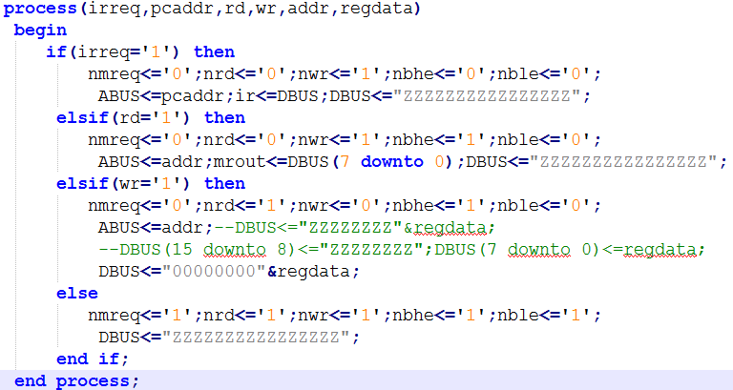
起初的编码中，每次取走DBUS上的值至对应的寄存器后，我没有对DBUS进行后续处理，这样就导致了后面的节拍可能会对DBUS进行重复赋值，导致DBUS出现混乱。在老师的指导下，我在每次取完DBUS的值之后，马上将其赋高阻，从而避免了这个错误。
④在下载试验台后，每次当Rupdate有效时，相应的值回写到Ri（由当前指令IR(10 downto 8)确定）的同时，也回写到下一个周期的Rj中，导致整体出错。后来发现Rupdate有效期为一整个周期，而不是预想中的一个特定的节拍。于是我在Rupdate变化的节拍中，令其在系统时钟CLK的下降沿复位（即变为无效），使其只延续一个节拍，终于解决这个问题。
实验中还碰到过很多小问题，不过都在发现后不久就解决了，且错误比较低端，这里不再赘述。

10.实验总结
本次CPU设计实验中，我认真回顾了上学期所学的VHDL编程知识和计算机组成原理的相关内容，并完成了实验的设计、编码和下载调试工作，总的来说还比较顺利。不过在实验的后期，在各模块仿真波形和总波形都出来的情况下，出现了一些下载时的问题，花了相当长时间才解决。实验结束后，我感觉自己更加明白CPU的工作原理了，而且对VHDL语言的掌控能力也有了实质性的提高，自我感觉收获很大。另外，实验中老师和助教帮我解决了很多问题，谨在这里感谢老师和助教。实验报告若有不足之处，还请老师批评指正。

