**SCHEDULE**

|  |  |  |  |  |  |  |  |
| --- | --- | --- | --- | --- | --- | --- | --- |
| **Activity** | **Time** | | | | | | |
|  | **9:00 am – 9:30 am** | **9:30 am -11:00 am** | **11:00 am -12:00noon** | **12:00 noon –**  **1:00pm** | **1:30 pm- 12**  **midnight** | **4:00am-6:00am** |  |
| Understanding the problem domain |  |  |  |  |  |  |  |
| Designing (Database and UI) |  |  |  |  |  |  |  |
| Coding |  |  |  |  |  |  |  |
| Testing |  |  |  |  |  |  |  |
| Documentation |  |  |  |  |  |  |  |

**Screenshots:**

**Index.php**

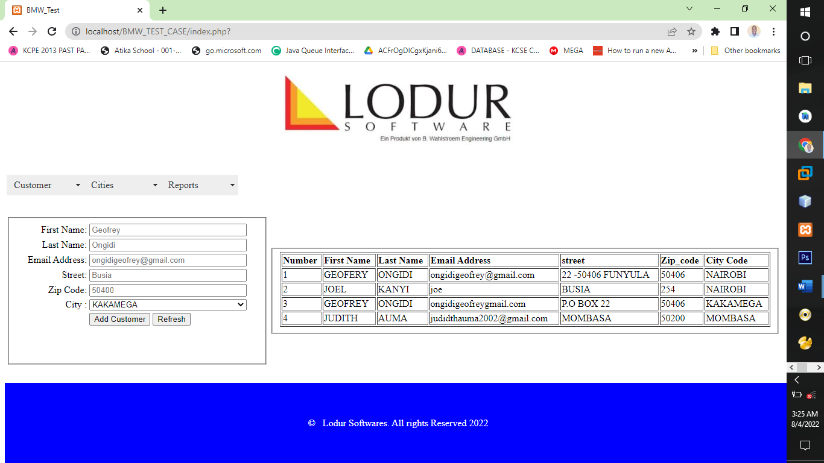

**viewCustomers.php**

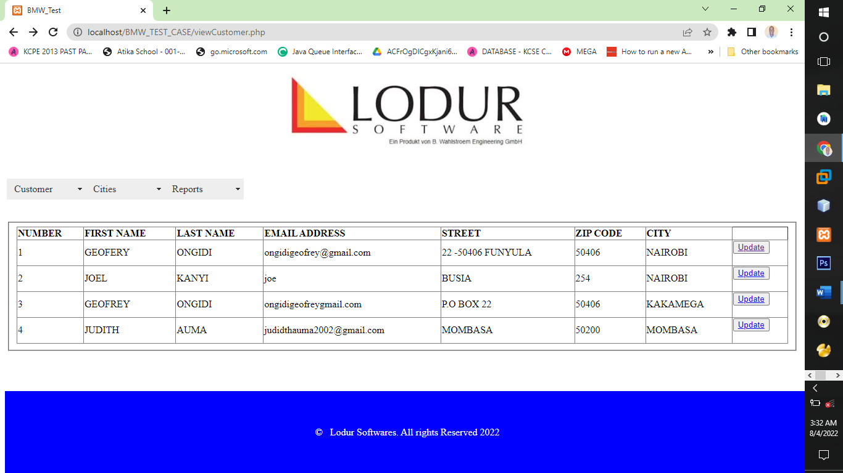

**updateCustomer.php**

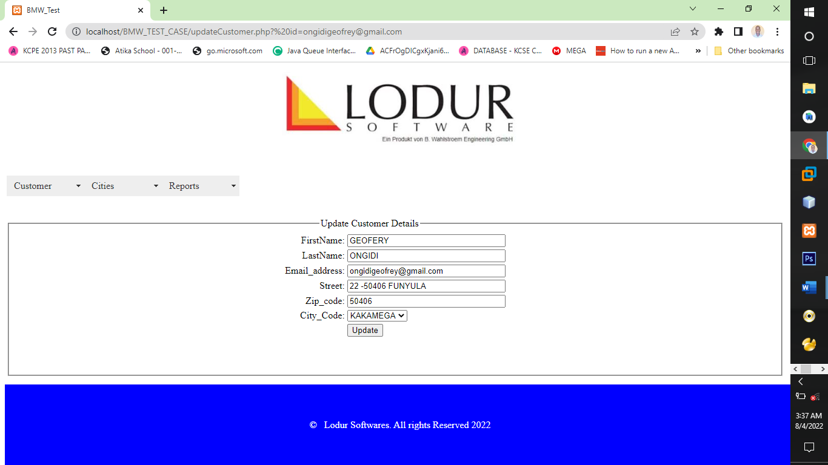

**AddCity.php:**

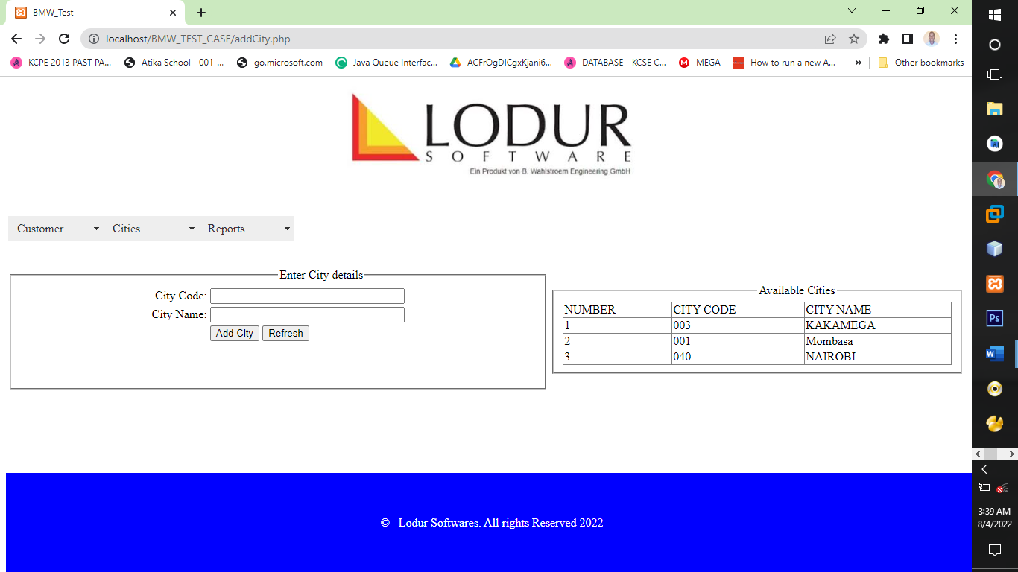

**UpdateCity.php**

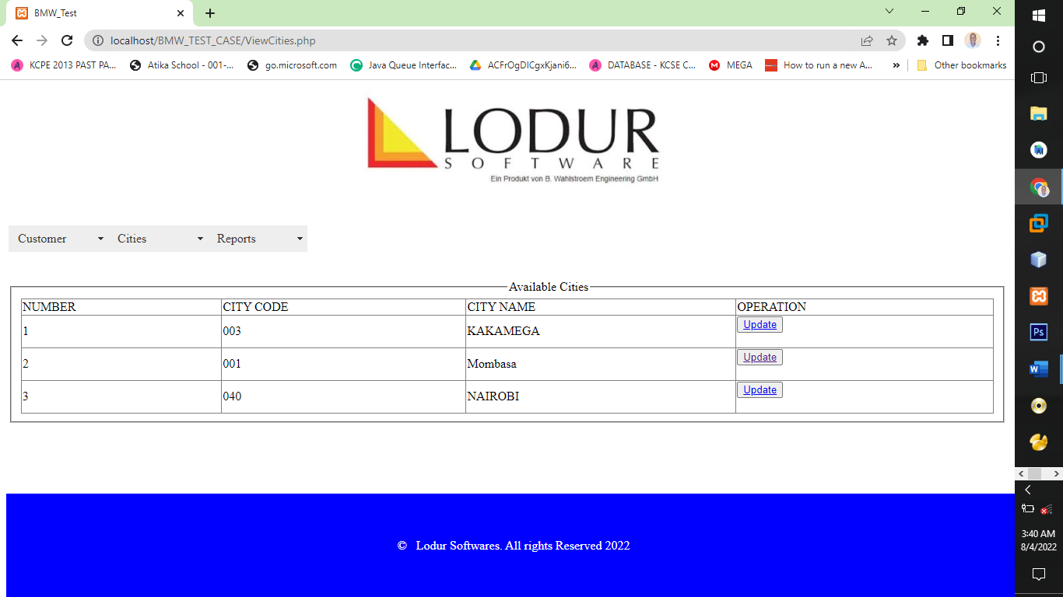

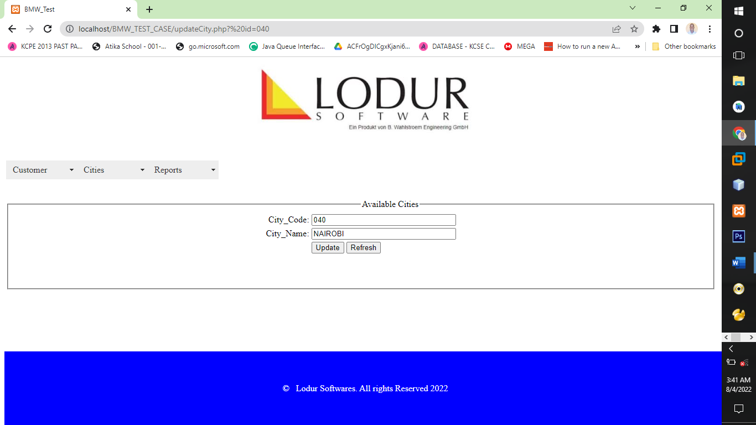

**Reports:**

**NOTE: Press Ctr+p and select print to pdf to convert the report to pdf on a browser**

**viewCustomers.php**

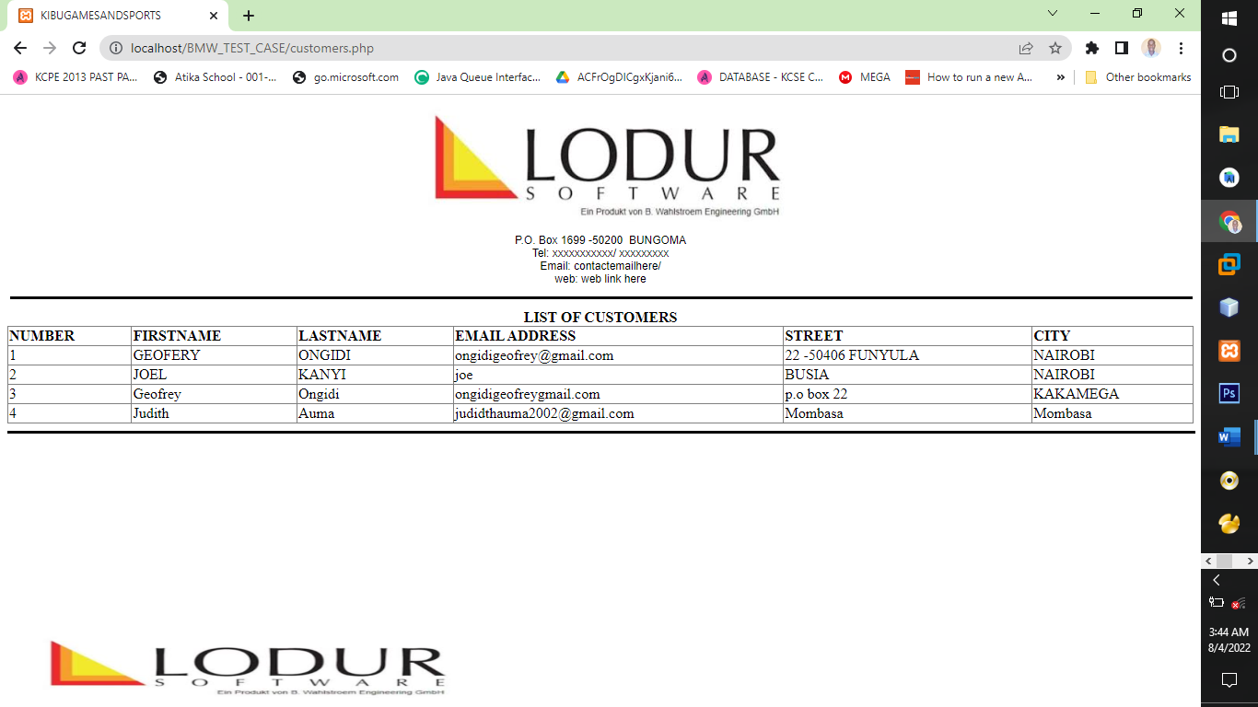

**After pressing Ctrl +p you will see such like a view, select save as pdf then click save to save it to your computer for future reference**

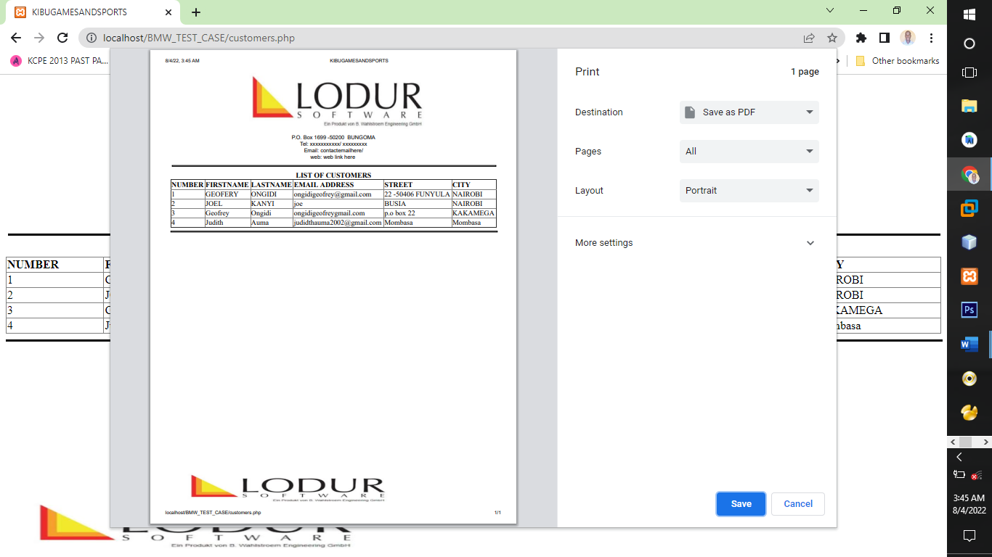

**ReportCities.php**

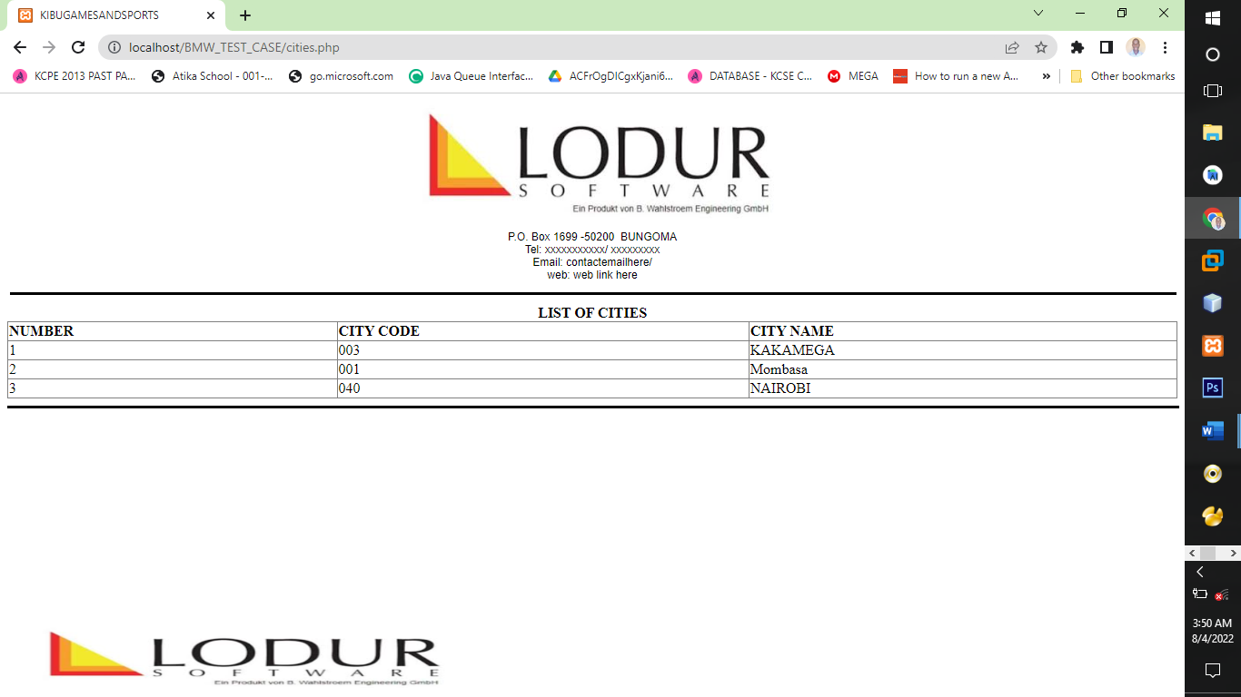

**After pressing Ctrl +p you will see such like a view, select save as pdf then click save to save it to your computer for future reference**

