Angelica Rodriguez  
Ben Paul  
Corey Alexander  
Lindsey Watterson  
March 27, 2013

**Coding Standards, Development Timeline, and Class Diagram –Betrayal at House on the Hill**

**Coding Standards:**

This program will follow the standard Java coding standards located at: <http://www.oracle.com/technetwork/java/codeconv-138413.html>

**Code Coverage:**

We have decided to use Clover as our code coverage tool.

**Features Completion Dates:**

End of 5th week : Die rolling functionality for player and that methods that involve dice are working in all classes, being able to arrange rooms for a game (setup map)

End of 6th week : Basic GUI implementation (For displaying map), all card methods should be done

End of 7th week: Player movements completed and displaying players on GUI

End of 8th week: GUI is in final and finishing stages, begin integration testing

End of 9th week: Network interface done, full integration testing

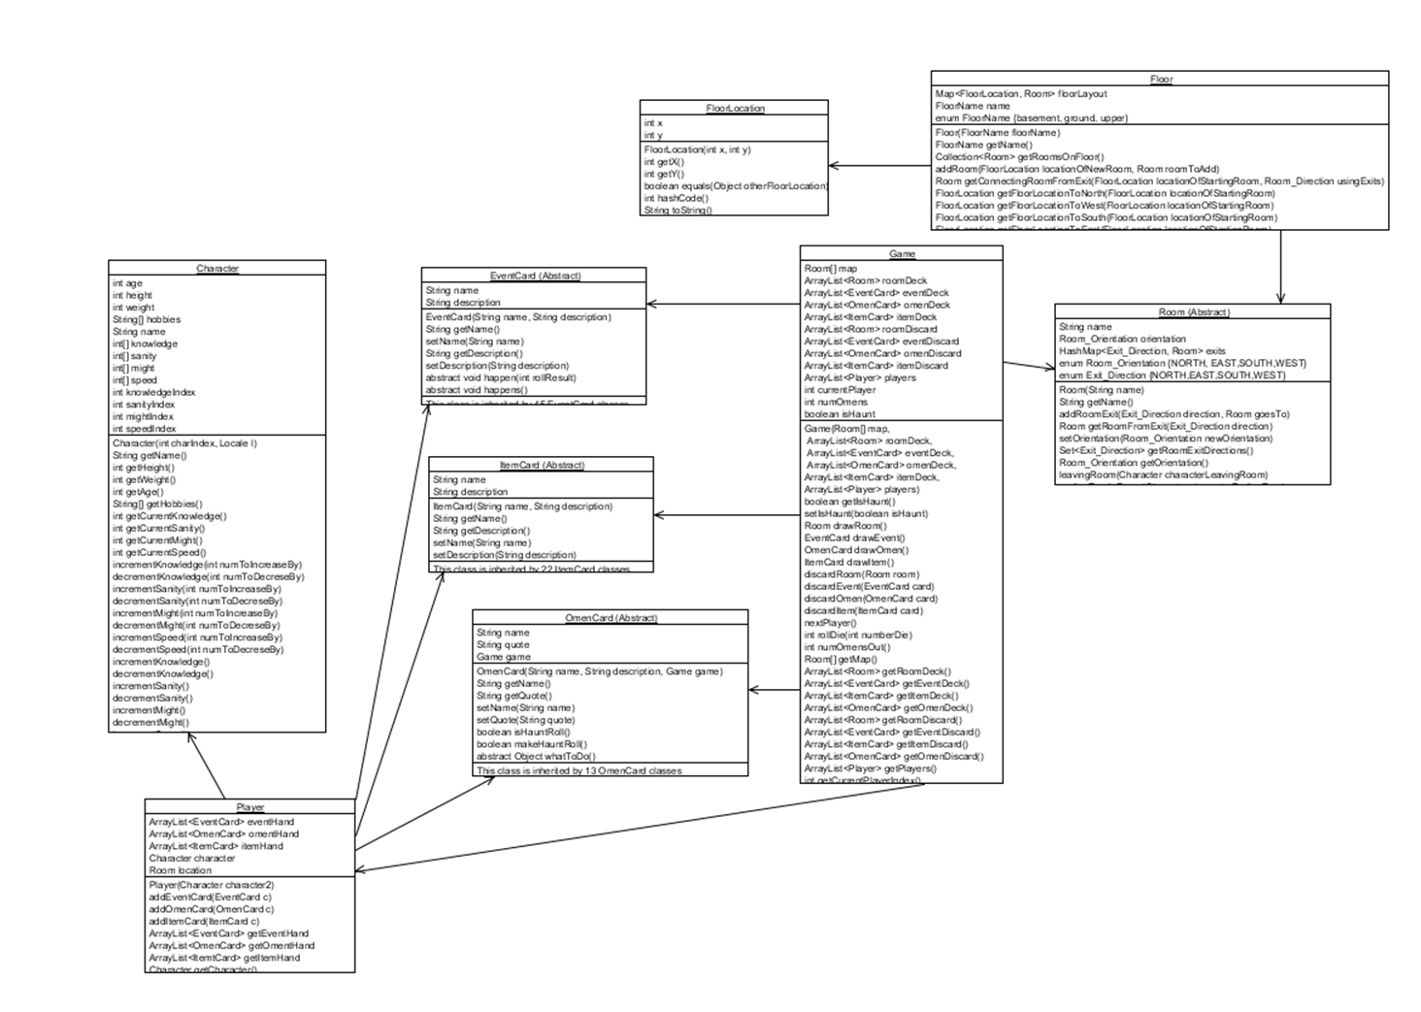**Class Diagram:**