KOSEN KMUTT
Work-integrated Learning (WiL) Program

PROGRESS REPORT

Edge AI Snore Detection with Posture Adjuster and BLE-Enabled Sleep-Logging

Students | Chayanpol Luangtham (67070508008)  Phongsiri Sangmanee (67070508027)
Advisor | Asst. Prof. Dr. Sarawan Wongsa
Committee | Assoc. Prof. Dr. Poj Tangamchit
Industrial Mentor | Thanakorn Saengkam
Company | toyota tsusho nexty electronics (thailand) co. ltd
Report Date | 20 April 2026

Abstract
This progress report documents the current implementation status of the KOSEN Sleep Module (SnoreGuard), an Edge AI-based snore detection system developed on the Infineon PSoC™ 6 CY8CKIT-062S2-AI development board. The project investigates the deployment of a Conv1D neural network optimized via 8-bit Integer Post-Training Quantization (INT8 PTQ) for real-time on-device snore classification under embedded resource constraints.

At the time of this report, the AI model benchmarking phase has been completed. Eight preprocessing pipeline configurations were systematically evaluated using a Machine-in-the-Loop methodology across five real-world bedroom recording sessions. Model 7 (Optimized Linear MFCC with HPF pre-filtering and Min-Max scaling), after fine-tuning with an augmented and class-rebalanced dataset, achieved the highest Precision performance (96.4–97.3% on prominent-snoring sessions) and was selected as the deployment model. Core firmware components, including real-time audio inference on the ARM Cortex-M4 core, Sliding Window haptic intervention logic, BLE GATT communication, and non-volatile Flash logging have been implemented and validated. The Flutter Android application supports BLE device pairing and UNIX timestamp synchronisation. Remaining work focuses on hardware assembly and Flutter UI completion.

Keywords: Edge AI, Conv1D, PSoC 6, Snore Detection, INT8 Quantization, BLE, Flutter, SQLite, Positional Therapy, Machine-in-the-Loop

Table of Contents
Abstract ............................................................. ii
Table of Contents .................................................... iii
List of Figures ...................................................... iv
List of Tables ....................................................... v
1. Introduction & Background ....................................... 5
1.1 Problem Statement & Motivation .............................. 5
1.2 Company Context ............................................. 5
1.3 Literature Review ........................................... 6
2. Project Objectives & Scope ...................................... 8
3. Methodology & System Design ..................................... 9
3.1 System Architecture ......................................... 9
3.2 Detailed Design ............................................. 10
3.3 Materials & Tools .......................................... 11
4. Progress & Implementation ....................................... 12
4.1 AI Model Development and Benchmarking ...................... 12
4.2 Firmware Implementation .................................... 14
4.3 Flutter Mobile Application ................................. 15
5. Preliminary Results & Discussion ................................ 15
5.1 Model Benchmark Results .................................... 15
5.2 Selected Model Performance: Model 7 (Tuned) ................ 16
5.3 Comparative Analysis ....................................... 17
5.4 Firmware Validation ........................................ 17
5.5 Summary of Results Against Project KPIs ................. 17
6. Future Work & Conclusion ........................................ 18
6.1 Remaining Tasks ............................................ 18
6.2 Updated Timeline ........................................... 18
6.3 Conclusion ................................................. 20
References .......................................................... 20
Appendices .......................................................... 21

List of Figures
Figure 3.1 System Architecture Overview
Figure 3.2 Preprocessing Pipeline Flowchart (Model 7)
Figure 3.3 System Wiring Diagram
Figure 4.1 Hardware Setup Photograph
Figure 4.2 Flutter Application Screenshot — BLE Connection Screen

List of Tables
Table 3.1 Preprocessing Pipeline Configuration Summary (8 Pipelines)
Table 3.2 Hardware Components and Specifications
Table 3.3 Software Tools and Versions
Table 4.1 Binary F1-Score (%) per Model across Five Test Sessions
Table 4.2 F1-Score Comparison: Tuned Models vs. Model 8 Baseline
Table 4.3 Firmware Component Implementation Status
Table 5.1 Model 7 (Tuned) — Per-Session Detection Performance
Table 5.2 KPI Achievement Status at Progress Evaluation
Table 6.1 Updated Project Timeline (Gantt Summary)

1. Introduction & Background

1.1 Problem Statement & Motivation
Snoring is one of the most consistent acoustic indicators of disrupted sleep and is closely associated with Obstructive Sleep Apnea (OSA), a condition affecting an estimated one billion individuals worldwide. Beyond its clinical significance, snoring represents a measurable and detectable signal that can be leveraged for passive sleep monitoring without the need for complex polysomnographic equipment or clinical settings.
The central engineering challenge addressed by this project is the deployment of a machine learning model capable of real-time snore classification directly on a low-power embedded microcontroller without cloud connectivity, without external audio processing hardware, and within the strict memory and latency constraints of a battery-operated wearable device. Deploying such a system at the edge eliminates privacy risks associated with continuous audio transmission, reduces latency to sub-200ms intervention response times, and enables full overnight operation on a compact lithium polymer battery.
Existing consumer sleep tracking devices largely rely on smartphone microphones, cloud-based inference pipelines, or proprietary sensor fusion, resulting in systems with persistent wireless connectivity requirements and passive monitoring-only capabilities. This project is distinguished by its integration of active haptic posture correction: when repeated snoring is detected, a vibration motor provides targeted mechanical feedback to encourage lateral sleep repositioning. A clinically validated non-invasive intervention for snore reduction without requiring the user to fully awaken.
The project is further motivated by the research opportunity to systematically evaluate Edge AI deployment trade-offs on real hardware: specifically, how different audio preprocessing pipeline designs influence model accuracy, resource consumption, and robustness to real-world acoustic variability when deployed as INT8-quantized Conv1D networks on an ARM Cortex-M4 platform.

1.2 Company Context
This Work-Integrated Learning (WiL) project is conducted in collaboration with Toyota Tsusho NEXTY Electronics (Thailand) Co., Ltd., a core company in the Toyota Tsusho Group's electronics business. The company operates primarily within the Automotive Embedded Software, Semiconductors, and IoT Solutions industry. As a leading technology provider, the company specializes in developing in-vehicle embedded software for modern vehicles (EV, PHEV, HEV) and delivering comprehensive IoT and digital solutions for industrial clients, including major automotive partners like Toyota and DENSO.
The specific technology domain of this internship focuses on Edge AI, embedded machine learning, and IoT health monitoring devices. Specifically, the internship involves working with the Infineon PSoC™ 6 microcontroller architecture and the Imagimob DeepCraft development platform to implement on-device audio signal processing and neural network inference.
The KOSEN Sleep Module prototype is being developed as a research and proof-of-concept device with the objective of validating the feasibility of Edge AI deployment for acoustic health monitoring on cost-accessible embedded hardware. The platform selected for development, the Infineon PSoC™ 6 CY8CKIT-062S2-AI, is a commercially available evaluation kit that represents the class of resource-constrained Cortex-M4 microcontrollers widely used in IoT and wearable product development. The project findings are intended to contribute generalizable insights into preprocessing pipeline selection and INT8 quantization robustness that are applicable beyond the specific snore detection use case.

1.3 Literature Review
1.3.1 Obstructive Sleep Apnea and Positional Therapy
OSA is a prevalent chronic sleep disorder characterized by repetitive partial or complete collapse of the upper airway during sleep, resulting in intermittent hypoxemia, sleep fragmentation, and cardiovascular sequelae. Snoring produced by turbulent airflow through a partially obstructed upper airway is its most consistent and readily detectable acoustic symptom [1]. Epidemiological estimates suggest that habitual snoring affects 20–40% of the adult population, with OSA prevalence estimated at up to 1 billion individuals globally when accounting for undiagnosed cases [2].
Positional Therapy (PT) exploits the well-documented positional dependency of OSA: airway collapsibility is substantially greater in the supine position than in lateral decubitus. PT interventions that maintain lateral sleep positions have been clinically validated as effective non-invasive OSA treatments, with studies demonstrating significant reductions in the Apnea-Hypopnea Index (AHI) and snoring frequency in positional OSA patients [4]. Vibrotactile stimulation, the delivery of sub-arousal mechanical vibration through a wearable or bed-attached actuator has been shown to prompt natural postural adjustment without causing full awakening, achieving higher patient compliance rates than CPAP therapy in mild-to-moderate OSA [5].

1.3.2 Edge AI and Embedded Machine Learning
Edge AI refers to the execution of machine learning inference directly on end-point hardware rather than on cloud or server infrastructure. The principal advantages of edge deployment include reduced inference latency (enabling real-time closed-loop control), elimination of network connectivity dependency, and preservation of user data privacy through local-only processing. For acoustic health monitoring applications, edge deployment additionally eliminates the risk of continuous audio data transmission to remote servers, a significant concern for bedroom monitoring systems [6].
Post-Training Quantization (PTQ) is the standard approach for adapting floating-point neural network weights to embedded deployment. INT8 quantization maps 32-bit floating-point weight and activation tensors to 8-bit integer representations, reducing model memory footprint by approximately 4x and improving inference throughput on processors equipped with integer SIMD instructions. The accuracy degradation introduced by INT8 PTQ is typically modest for convolutional models trained on structured feature inputs such as Mel-spectrograms, making it well-suited for embedded audio classification [6].
The Imagimob DeepCraft toolchain provides an integrated environment for preprocessing pipeline design, Conv1D model training, and INT8 PTQ C-code export targeting ARM Cortex-M processors. Its support for the PSoC™ 6 platform and ModusToolbox™ integration makes it the primary development tool for this project [2].

1.3.3 Audio Signal Processing for Snore Classification
The acoustic characteristics of snoring are concentrated in the frequency range of approximately 50–500 Hz, with harmonic content extending to 1 kHz. The primary preprocessing challenge in bedroom snore detection is distinguishing these snore harmonics from ambient noise sources, particularly air conditioning and fan noise, which share overlapping spectral content in the low-frequency region [3]. Standard preprocessing approaches for embedded audio classification employ Mel-filterbank feature extraction, which maps the raw Short-Time Fourier Transform (STFT) spectrum onto the perceptually motivated Mel scale using a bank of overlapping triangular filters [7].
High Pass Filtering (HPF) prior to spectral analysis suppresses low-frequency ambient noise components below the snore fundamental frequency, improving signal-to-noise ratio for the classification feature space. Mel Frequency Cepstral Coefficients (MFCCs), derived by applying a Discrete Cosine Transform (DCT) to the log-Mel spectrum, provide a compact decorrelated feature representation that reduces input dimensionality while preserving perceptually relevant spectral shape information [7, 8].
Conv1D neural networks process sequential feature frames and are well-suited for temporal audio classification tasks on resource-constrained hardware, offering a favorable accuracy-to-computation trade-off compared to recurrent architectures [8]. This project systematically evaluates eight preprocessing pipeline configurations, varying HPF pre-filtering, amplitude scaling (linear vs. log), and DCT compression to identify the configuration most robust to INT8 quantization and real-world acoustic variability.

1.3.4 Bluetooth Low Energy for IoT and Health Applications
Bluetooth Low Energy (BLE) is the de facto wireless protocol standard for short-range, low-power communication in wearable and IoT health devices. Its Generic Attribute Profile (GATT) architecture organises data exchange around Services and Characteristics, enabling structured typed data communication between an embedded peripheral device and a smartphone central. BLE 5.0, supported by the CYW43439 module integrated on the PSoC™ 6 development kit, provides improved connection stability and throughput compared to BLE 4.x, supporting the binary log transfer requirements of this application [9].

1.3.5 Flutter for Offline-First Mobile Health Applications
Flutter is Google's open-source cross-platform UI framework, providing native-performance compiled applications for Android and iOS from a single Dart codebase. For this project, Flutter is used to develop the companion Android application due to its strong ecosystem support for BLE communication (flutter_blue_plus package) and local SQLite persistence (sqflite package). The offline-first design principle — all data is stored locally with no cloud dependency — is appropriate for a bedroom health monitoring application where network connectivity cannot be guaranteed and user data privacy is a design requirement [9].

1.3.6 Infineon PSoC™ 6 Platform
The CY8CKIT-062S2-AI evaluation kit is built around the PSoC™ 62S2 microcontroller, featuring an ARM Cortex-M4 core operating at up to 150 MHz, which handles all system functions including AI inference, BLE communication, RTC timekeeping, and non-volatile Flash logging. The device integrates dual XENSIV™ MEMS microphones (IM72D128V01XTMA1) via PDM-PCM interface, a CYW43439-based Wi-Fi and BLE 5.0 module, approximately 2 MB internal Flash for non-volatile data persistence, and 1 MB SRAM for runtime data buffers. The platform is natively supported by the Imagimob toolchain and Infineon ModusToolbox™ IDE, providing an integrated development environment from model training to on-device deployment [10].

2. Project Objectives & Scope
The project objectives are restated below. Objective 1 has been revised from the original proposal to reflect the decision to evaluate eight preprocessing pipelines (Pipelines 1–8) without Pipeline 9 (Imagimob Speech), which was deprioritised during implementation due to toolchain integration constraints. All other objectives remain unchanged.

2.1 Objectives
- To benchmark eight audio preprocessing pipelines within the Imagimob DeepCraft environment and identify the optimal Conv1D snore detection model using Binary F1-Score as the primary evaluation metric.
- To implement a real-time Edge AI inference pipeline on the Infineon PSoC™ 6 Cortex-M4 core using 8-bit Integer Post-Training Quantization (INT8 PTQ)
- To validate the deployed system under real-world sleep conditions through a multi-night pilot test, comparing on-device detection output against manually labelled ground-truth audio recordings.
- To design and implement a firmware-level Sliding Window haptic intervention system (5 snore events per 60-second window threshold, 10-minute cooldown) using a vibration motor for passive posture correction.
- To implement user-configurable haptic intensity control with five discrete levels (20%, 40%, 60%, 80%, 100%) and post-intervention outcome logging using a 15-minute post-vibration silence threshold for success/failure classification.
- To develop an Android mobile application featuring a 7-day snore history dashboard, per-session snore event timeline with haptic trigger markers, intervention success/fail indicators, and device settings screen operating fully offline without any cloud connectivity.

2.2 Scope
The project scope is limited to the design, implementation, and validation of a research prototype. The system is not intended as a clinical-grade diagnostic device. Scope boundaries are defined as follows:
- In scope: Conv1D-based snore classification on PSoC™ 6; INT8 PTQ deployment; vibrotactile haptic intervention; BLE-based sleep log synchronisation; offline Flutter Android application.
- In scope: Controlled acoustic bench testing and real-world pilot evaluation against manually labelled ground-truth recordings.
- Out of scope: Clinical validation, regulatory compliance, multi-user support, iOS application, cloud connectivity, and OSA severity assessment.
- Revised from proposal: Pipeline 9 (Imagimob Speech) evaluation has been removed from scope. The WPI scoring framework originally proposed has been simplified to use Binary F1-Score as the sole ranking metric, as inference latency and RAM measurements were found to be insufficiently differentiated across pipelines at the INT8 deployment level to influence model selection.

3. Methodology & System Design

3.1 System Architecture
The system is composed of three integrated subsystems: the PSoC™ 6 embedded hardware platform, the ERM vibration motor module, and the Flutter Android companion application. All system functions — including real-time AI inference, BLE communication, RTC timekeeping, and non-volatile Flash logging — are handled by the ARM Cortex-M4 core.

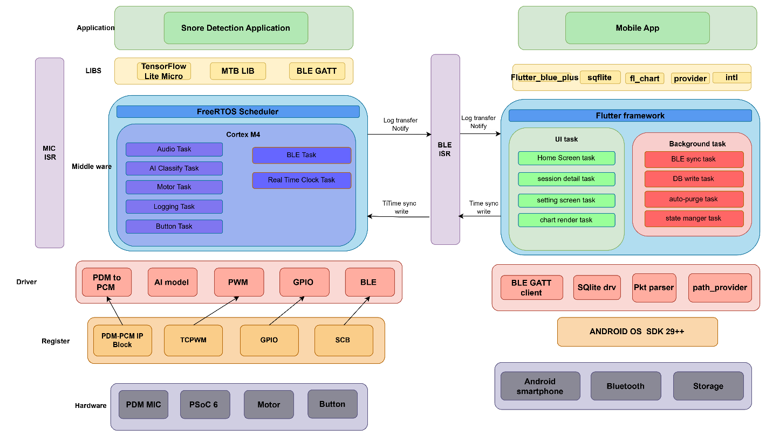
Figure 3.1 System Architecture Overview

Audio is captured continuously via the dual PDM-PCM MEMS microphones, preprocessed on the M4 core through the Model 7 pipeline, and classified by the INT8-quantized Conv1D network at each inference window. Detection results are buffered in an SRAM circular buffer and asynchronously persisted to internal Flash. The Sliding Window haptic logic monitors the detection stream and triggers the vibration motor via PWM upon threshold detection. BLE synchronisation with the Android application occurs at session start (Time Sync) and upon user-initiated Morning Sync (log transfer). The vibration motor module is connected via cable and positioned under the user's pillow for direct, non-auditory haptic feedback

3.2 Detailed Design
3.2.1 Preprocessing Pipeline — Model 7 (Optimized Linear MFCC)
The deployed preprocessing pipeline applies the following signal processing chain to each 1024-sample audio window (64 ms at 16 kHz): High Pass Filter (80 Hz cutoff, 4th-order IIR Butterworth) → Hann smoothing window → Real Discrete Fourier Transform → Frobenius norm → Mel-Filterbank (40 filters, 80–8000 Hz, HTK formula) → Power-to-dB conversion → Discrete Cosine Transform (40 output coefficients) → Min-Max scaling [0, 1]. A second sliding window of shape [80, 40] with stride 1600 samples frames the feature sequence for Conv1D input. The HPF suppresses low-frequency air conditioning and fan noise below the snore fundamental frequency, while the DCT provides a compact decorrelated MFCC representation that reduces the input dimensionality presented to the neural network.

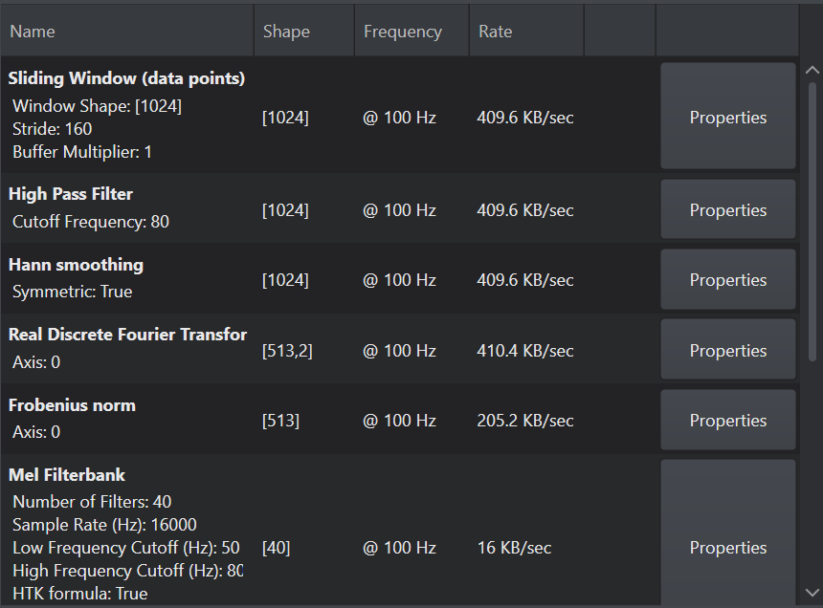
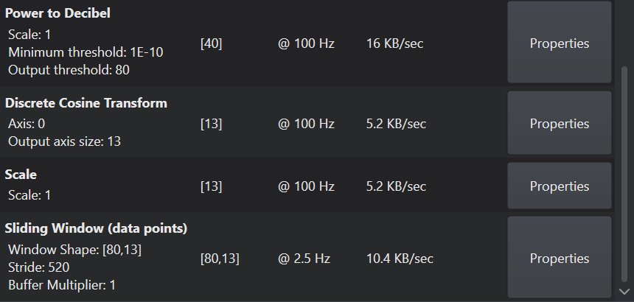
Figure 3.2 Preprocessing Pipeline Flowchart — Model 7 (Optimized Linear MFCC)

3.2.2 Sliding Window Haptic Intervention Logic
The haptic intervention firmware monitors the Conv1D detection output stream using a Sliding Window algorithm. A vibration trigger is issued when five or more snore classification events are detected within any 60-second rolling window. Upon trigger, a 10-minute cooldown prevents consecutive triggers. A 15-minute post-intervention monitoring window records whether snoring ceases (Success, 0x01) or resumes (Unsuccessful, 0x00), providing per-intervention outcome data for analysis via the mobile dashboard. Five discrete vibration intensity levels (20%, 40%, 60%, 80%, 100%) are mapped to PWM duty cycle values and are user-configurable through the companion application Device Settings screen.

3.2.3 BLE GATT Protocol Design
Communication between the PSoC™ 6 and the Android application is structured around two custom GATT Characteristics within a custom Sleep Monitor Service.
The Time Sync Characteristic (GATT handle 0x000C, Write, 4 bytes, uint32 little-endian) receives the current UNIX epoch timestamp from the mobile application at session start. Upon receipt, two actions execute atomically: snore_set_epoch_base(epoch) updates the firmware timestamp state machine, and rtc_time_set_unix(epoch) seeds the hardware RTC (cyhal_rtc_t) with calendar time. From this point forward, all snore event timestamps are derived from the hardware RTC and survive BLE disconnection.
To handle the case where audio inference begins before BLE connection is established, the firmware implements a three-tier timestamp fallback hierarchy managed by a time_sync_state_t state machine: (1) TIME_SYNC_OK — phone has written an epoch timestamp; events are timestamped using the seeded hardware RTC (accurate calendar time). (2) TIME_SYNC_FALLBACK — BLE connected but no epoch received within 30 seconds (enforced by a FreeRTOS software timer); events timestamped as epoch_base + (uptime − uptime_at_sync). (3) TIME_SYNC_STANDALONE — no BLE connection within 5 minutes of boot; events timestamped using a sentinel base of 1700000000 + uptime_s, ensuring fallback timestamps are distinguishable from real calendar values.
When a valid Time Sync write arrives while events have already been logged under a fallback timestamp, snore_log_rebase_fallback_timestamps(offset) retroactively corrects all matching events in both the SRAM ring buffer and non-volatile Flash, as well as any in-flight episode state. This design ensures that the Morning Sync data transfer always presents the mobile application with calendar-accurate timestamps, regardless of when BLE pairing occurred relative to sleep onset.
The Log Transfer Characteristic (Notify) streams the session binary log as 120-byte chunks (20 × 7-byte event packets) upon user-initiated Morning Sync. Each 7-byte event packet encodes event timestamp (4 bytes), snore duration in seconds (1 byte), haptic success flag (1 byte), and haptic trigger flag (1 byte).

3.2.4 Hardware Installation
The system is divided into two physical components: the Main Control Unit (PSoC™ 6 development kit) mounted on the headboard or bedside for audio capture and BLE communication, and the Vibration Module connected via cable and placed discreetly under the user's pillow for direct haptic intervention. The wiring diagram is shown in Figure 3.3.

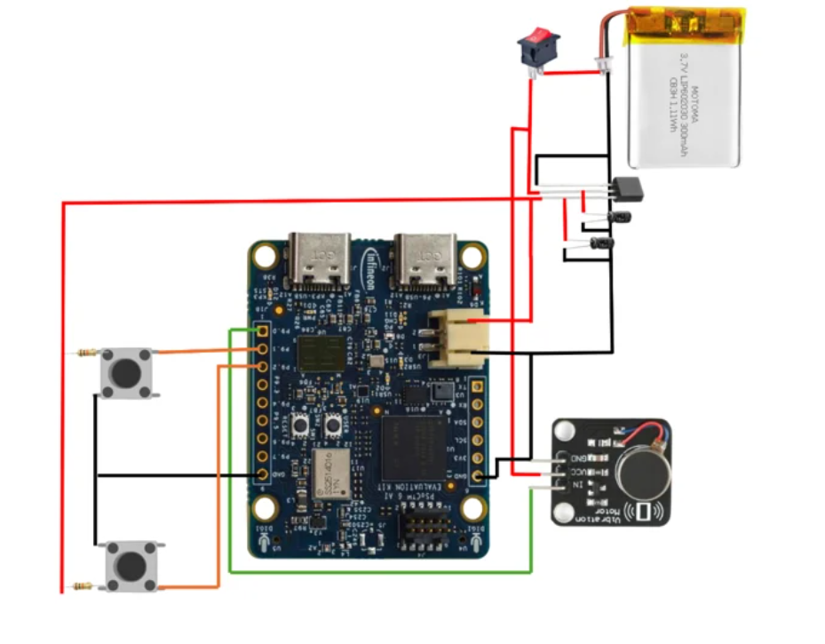
Figure 3.3 System Wiring Diagram

3.3 Materials & Tools
Table 3.1 Hardware Components and Specifications
Component | Specification | Role
CY8CKIT-062S2-AI Dev Kit | PSoC™ 62S2, ARM Cortex-M4 @ 150 MHz | Main MCU — AI inference, BLE, logging
XENSIV™ MEMS Microphones | IM72D128V01XTMA1 (×2), PDM-PCM | Audio capture from bedroom environment
CYW43439 BLE Module | Murata Type 1YN, BLE 5.0 | Wireless communication to mobile app
Vibration Motor (ERM) | PWM-driven, 5-level intensity | Haptic posture correction feedback
Li-Po Battery | 500 mAh, USB-C charging | Portable power for overnight operation
Android Smartphone | API 29+ / Android 10+ | Flutter companion application host

Table 3.2 Software Tools and Versions
Tool / Framework | Version | Purpose
Imagimob DeepCraft | Latest stable | Preprocessing pipeline design and Conv1D training
Imagimob Toolchain | Bundled with DeepCraft | INT8 PTQ and C-code export for Cortex-M4
Infineon ModusToolbox™ | 3.7 | PSoC 6 firmware development (C, GCC ARM v14.2.1)
Flutter SDK | 3.27.x (Dart 3.6.x) | Android mobile application development
Android Studio | Ladybug 2024.2.x | Flutter IDE; target SDK API 29–35
flutter_blue_plus | ^1.31.x | BLE scanning, GATT read/write/notify
sqflite | ^2.3.x | Local SQLite database, 7-day auto-purge
fl_chart | ^0.69.x | Snore event timeline visualisation

4. Progress & Implementation
This section details the work completed to date across the three primary development streams: AI model development and benchmarking, embedded firmware implementation, and Flutter mobile application development.

4.1 AI Model Development and Benchmarking
4.1.1 Dataset Preparation and Machine-in-the-Loop Test Setup
A total of approximately 188 minutes of bedroom audio was recorded at 16 kHz mono using the onboard XENSIV™ MEMS microphone of the CY8CKIT-062S2-AI development kit. The dataset comprises approximately 55 minutes of labelled snore audio, 83 minutes of non-snore noise (air conditioning, fan, ambient sounds), and 49 minutes of unlabelled ambient audio. All recordings were manually annotated at the segment level to form the ground-truth dataset used for Machine-in-the-Loop (MitL) evaluation.
For the MitL evaluation methodology, labelled audio is injected directly into each compiled pipeline firmware build as pre-recorded PCM samples, bypassing only the live PDM capture while executing all downstream signal processing and neural network inference on-device. This design ensures that all benchmark metrics reflect real hardware behaviour including INT8 quantization effects and embedded runtime characteristics.

4.1.2 Preprocessing Pipeline Benchmark (Models 1–8)
Eight preprocessing pipelines were compiled and evaluated against the five-session test set. The evaluation metric was the Binary F1-Score, treating snore as the positive class and all non-snore audio as negative. The results across all test days are summarised in Table 4.1.

Table 4.1 Binary F1-Score (%) per Model across Five Test Sessions
Model | Day 1 (F1%) | Day 2 (F1%) | Day 3 (F1%) | Day 4 (F1%) | Day 5 (F1%) | Overall AVG
Model 1 (Linear Mel) | 39.1 | 54.8 | 27.3 | 24.6 | 54.8 | 40.1
Model 2 (Log-Mel) | 29.7 | 7.7 | 3.7 | 5.9 | 0.0 | 9.4
Model 3 (Linear MFCC) | 42.2 | 10.6 | 33.1 | 10.6 | 0.0 | 19.3
Model 4 (Standard MFCC) | 37.8 | 14.4 | 29.1 | 20.8 | 0.0 | 20.4
Model 5 (Tuned Linear Mel) | 70.1 | 57.8 | 34.0 | 24.5 | 0.0 | 37.3
Model 6 (Tuned Log-Mel) | 38.4 | 18.3 | 13.5 | 10.7 | 0.5 | 16.3
Model 7 (Optimized Linear MFCC) | 9.9 | 3.8 | 13.3 | 8.7 | 0.5 | 7.2
Model 8 (Optimized Edge MFCC) | 73.4 | 63.3 | 55.6 | 47.5 | 17.0 | 51.4

Models 5 and 8 emerged as the strongest baseline performers, achieving overall average F1-Scores of 37.3% and 51.4% respectively. Models 1 and 8 were identified as the primary candidates for fine-tuning, given their relatively consistent performance on Days 1–3. Models 2, 3, 4, 6, and 7 exhibited substantially lower and more volatile performance, particularly on Days 4 and 5, and were deprioritised for further development.
A notable observation across all pipelines is the consistent performance decline from Day 3 onward. Analysis of the Day 4 and Day 5 recordings indicates that the snoring characteristics in those sessions were qualitatively different from the training distribution: the subject exhibited shallow, breath-like snoring rather than the louder, tonally distinct snoring present in Days 1–3. This acoustic ambiguity at the snore/non-snore boundary reduces model recall without significantly affecting precision, suggesting the models have learned a conservative but reliable decision boundary.

4.1.3 Model Fine-Tuning and Selection
Following baseline benchmarking, a fine-tuning procedure was applied to the top candidate models. Fine-tuning involved two key interventions: (1) augmenting the training dataset with real microphone recordings captured from the actual deployment hardware to reduce the acoustic domain gap between training and deployment conditions, and (2) rebalancing the class distribution within the training set to address the snore/non-snore imbalance observed in the original dataset.
Model 7, which had demonstrated poor baseline performance (average F1: 7.2%), was found to originate from an earlier training run using a smaller dataset. Upon retraining with the augmented and rebalanced dataset, its performance improved substantially. Comparative results for the three evaluated tuned models are presented in Table 4.2.

Table 4.2 F1-Score Comparison: Tuned Models vs. Model 8 Baseline
Model | Day 1 | Day 2 | Day 3 | Day 4 | Day 5 | AVG F1
Model 1 (Tuned) | 68.2% | 77.6% | 65.3% | 48.2% | 63.2% | 64.5%
Model 7 (Tuned) ★ Selected | 82.4% | 76.2% | 67.8% | 47.5% | 40.5% | 62.9%
Model 8 (Baseline) | 73.4% | 63.3% | 55.6% | 47.5% | 17.0% | 51.4%

Model 7 (Tuned) was selected as the deployment model for the following reasons: it achieves the highest F1-Score on Days 1 and 3 (82.4% and 67.8% respectively), it maintains consistently high Precision across all days (77–97%), and its pipeline architecture Optimized Linear MFCC with HPF pre-filtering and Min-Max scaling is well-suited to the resource constraints of the ARM Cortex-M4 deployment target.

4.2 Firmware Implementation
Firmware development on the Infineon PSoC™ 6 CY8CKIT-062S2-AI platform using Infineon ModusToolbox™ 3.7 has been completed for all core inference and communication subsystems. All firmware subsystems, including AI inference, haptic logic, BLE communication, and Flash logging, run on the ARM Cortex-M4 core.

Table 4.3 Firmware Component Implementation Status
Component | Status | Notes
Real-time audio inference (Conv1D INT8) | Complete | Running on ARM Cortex-M4 core
Sliding Window haptic intervention logic | Complete | 5-event/60s threshold, 10-min cooldown
BLE GATT server (Time Sync + Log Transfer) | Complete | Receives UNIX epoch from mobile app
Non-volatile Flash logging | Complete | Circular buffer + async NV logging
Hardware assembly (PCB, pillow vibration unit) | In Progress | Pending final wiring & enclosure
Flutter UI — BLE connect + Time Sync | Complete | Device pairing and timestamp sync working
Flutter UI — Morning Sync & Dashboard | In Progress | Session Detail and Settings screens pending

4.2.1 Real-Time Audio Inference
The selected Model 7 (Tuned) Conv1D network, quantized to INT8 via the Imagimob toolchain, has been successfully deployed on the Cortex-M4 core. PDM-PCM audio sampling from the dual XENSIV™ MEMS microphones feeds the preprocessing pipeline, which applies a High Pass Filter (80 Hz cutoff, 4th-order IIR Butterworth), Hann windowing, R-DFT, Mel-Filterbank (40 filters), Power-to-dB conversion, DCT, and Min-Max scaling before inference.

4.2.2 Sliding Window Haptic Intervention Logic
The haptic posture correction firmware implements a Sliding Window algorithm that triggers the ERM vibration motor when five or more snore detection events occur within a 60-second window. Upon trigger, a 10-minute cooldown period is enforced. A post-intervention monitoring window of 15 minutes is then opened: if no snoring is detected within this window, a Success flag is recorded; otherwise, an Unsuccessful flag is logged. Five discrete PWM duty cycle levels (20%, 40%, 60%, 80%, 100%) map to user-selectable vibration intensities.

4.2.3 BLE Communication and Flash Logging
The BLE GATT server implementation exposes two custom characteristics within the Sleep Monitor Service.
The Time Sync characteristic (Write, GATT handle 0x000C) receives a 4-byte little-endian UNIX epoch from the mobile application and executes two firmware actions: seeding the hardware RTC via rtc_time_set_unix() and updating the timestamp state machine via snore_set_epoch_base(). The 30-second BLE time-sync timeout timer (a FreeRTOS software timer created in app_bt_application_init()) is stopped upon receipt.
Because audio_inference_task begins running immediately at boot — before BLE pairing — events logged prior to Time Sync carry fallback timestamps in the range 1700000000 + uptime_s. Upon Time Sync, snore_log_rebase_fallback_timestamps() scans the SRAM ring buffer and Flash log and retroactively corrects all such entries to accurate wall-clock timestamps. This rebase also updates the in-flight episode start timestamp and any pending haptic event timestamp. The net result is that the morning sync transfer always delivers calendar-accurate event records to the Flutter application, regardless of how long the device ran before the phone connected.
The standalone operation mode (TIME_SYNC_STANDALONE, entered after 5 minutes with no BLE connection) is a core product requirement: the device must detect snoring and trigger haptic interventions without a phone present. Audio inference is therefore never gated on time synchronisation.
The Log Transfer characteristic (Notify) streams 7-byte binary event packets comprising event timestamp, duration, haptic flag, and intervention success indicator to the mobile application upon Morning Sync. An SRAM circular buffer (200 events) handles high-frequency runtime logging, with asynchronous persistence to non-volatile internal Flash ensuring data integrity across power cycles.

4.3 Flutter Mobile Application
Flutter mobile application development is currently in progress. The BLE client-side stack, implemented using the flutter_blue_plus package, is functional: the application successfully scans for, pairs with, and connects to the PSoC 6 device. The Time Sync workflow transmitting the current UNIX epoch timestamp to the device at session start via the Time Sync GATT characteristic has been validated and is operational.
Remaining development work includes completion of the Morning Sync data parsing pipeline, the Session Detail screen (per-session snore event timeline, haptic trigger timestamps, and intervention success/fail visualisation using fl_chart), and the Device Settings screen. The Home screen displaying the 7-day session list and the SQLite schema with 7-day auto-purge logic are planned for implementation in the next sprint.

4.4 Challenges Encountered & Engineering Solutions
4.4.1 Overall F1-Score Below 80% KPI Target
The project KPI specifies an overall snore detection F1-Score of greater than 80%. The deployed Model 7 (Tuned) achieved an average F1-Score of 62.88% across the five test sessions, falling short of this target. Investigation revealed two contributing factors: first, the training dataset was recorded under acoustic conditions that did not fully represent the range of snoring patterns encountered in real sleep sessions; second, the class distribution in the original training set was imbalanced, with non-snore segments substantially outnumbering snore segments.
Engineering Solution: A fine-tuning procedure was applied using additional audio recorded directly from the deployment hardware (PSoC 6 MEMS microphone) to reduce the acoustic domain gap. The training class distribution was rebalanced, resulting in a substantial improvement in Precision (90.98% average) and overall F1 stability on high-quality snoring sessions (82.4% on Day 1). Achieving the 80% average F1 target across all acoustic conditions is identified as a remaining objective for the final evaluation phase, requiring further dataset expansion to cover ambiguous snoring patterns.
4.4.2 Performance Degradation on Days 4 and 5
A consistent and significant performance drop was observed from Day 3 onward across all evaluated models. On Day 4 and Day 5, F1-Scores for Model 7 (Tuned) fell to 47.5% and 40.5% respectively, compared to 82.4% on Day 1. Spectral analysis of the affected recordings confirmed that the snoring events in these sessions were acoustically ambiguous: the subject exhibited shallow, breath-like sounds rather than the tonally distinct snoring present in earlier sessions. These patterns lie near the model's decision boundary, causing a sharp increase in false negatives while Precision remained high (91.7% on Day 5).
Engineering Solution: The performance degradation is understood to be a dataset coverage limitation rather than a model architecture deficiency. The training set did not include sufficient examples of low-intensity, breath-like snoring. The planned corrective action is to augment the dataset with additional labelled recordings of this snoring subtype before the final evaluation, with the objective of improving Recall on acoustically ambiguous nights without sacrificing the high Precision achieved on prominent-snoring sessions.
4.4.3 CMake Build Cache Causing Invalid MitL Test Results
During the Machine-in-the-Loop (MitL) benchmarking phase, each of the eight pipeline configurations required a separate compiled firmware build to be flashed onto the PSoC 6 board. When switching between pipeline builds, the ModusToolbox CMake build system was not always performing a clean rebuild. Because the C source file containing the AI model weights had been replaced but no other source files were modified, CMake's incremental build logic determined that no recompilation was necessary and reused the previously compiled object files. As a result, the firmware that was flashed to the board still contained the weights from the prior pipeline's model.
The issue was identified by observing that the program memory size reported in the ModusToolbox build output was identical across multiple consecutive flash operations, despite the model source files having been replaced. Since each pipeline's quantized model has a distinct memory footprint, identical program memory across builds conclusively indicated that the model had not been updated. All test results collected prior to this discovery were invalidated and the full benchmark was repeated from the beginning.
Engineering Solution: A mandatory clean build procedure was established as part of the benchmark protocol: before flashing each pipeline build, the CMake build directory is fully cleared ('Project Clean' in ModusToolbox) to force complete recompilation. Following the clean rebuild, the program memory size reported in the build output is verified against the expected value for each pipeline before proceeding to flash, providing a low-cost sanity check that the correct model has been compiled into the firmware.

5. Preliminary Results & Discussion

5.1 Model Benchmark Results
The benchmark evaluation of Models 1–8 across five real-world bedroom recording sessions provides the primary quantitative basis for model selection. The key finding is that pipelines incorporating the noise-suppression wrapper (High Pass Filter + Hann smoothing + Min-Max scaling) Models 5, 7, and 8 consistently outperformed unfiltered baselines on Days 1–3, confirming that HPF pre-filtering is a critical component for bedroom deployment where low-frequency noise from air conditioning is present.
Model 8 (Optimized Edge MFCC, Log-scale + DCT + HPF + Scale) achieved the highest overall average F1-Score among baseline models at 51.4%, primarily driven by strong performance on Days 1–3. However, Model 8's performance degraded significantly on Day 5 (17.0%), indicating sensitivity to changes in acoustic snoring characteristics across recording sessions.

5.2 Selected Model Performance: Model 7 (Tuned)
Model 7 (Tuned): an Optimized Linear MFCC pipeline with HPF pre-filtering and Min-Max scaling, retrained with an augmented and class-rebalanced dataset was selected as the deployment model. Its per-session performance is detailed in Table 5.1.

Table 5.1 Model 7 (Tuned) — Per-Session Detection Performance
Day | Precision (%) | Recall (%) | F1-Score (%) | Observation
Day 1 (3/10) | 96.4 | 71.9 | 82.4 | Strong recall on loud snoring
Day 2 (3/11) | 97.3 | 62.6 | 76.2 | Very high precision; low FP
Day 3 (3/17) | 92.1 | 53.6 | 67.8 | Quieter session; recall drops
Day 4 (3/18) | 77.4 | 34.3 | 47.5 | Shallow breathing-like snoring
Day 5 (3/19) | 91.7 | 26.0 | 40.5 | Predominantly quiet / ambiguous

The most significant characteristic of Model 7 (Tuned) is its consistently high Precision across all five sessions (range: 77.4%–97.3%), indicating that when the model generates a positive snore detection, it is reliable. This property is especially important for the haptic intervention application: false positive triggers that unnecessarily disturb the user's sleep are minimised.
The primary limitation observed is declining Recall on Days 4 and 5 (34.3% and 26.0% respectively). Spectral analysis of the Day 4 and Day 5 recordings reveals that the snoring events in these sessions were acoustically ambiguous. characterised by shallow, breath-like patterns rather than the tonally distinct snoring present in earlier sessions. The model's conservative decision boundary, which is beneficial for Precision, results in a higher rate of missed detections under these conditions. This represents a known limitation of models trained on a specific acoustic distribution and is consistent with findings in the Edge AI snore detection literature.
On Days 1 and 2, where snoring was acoustically prominent, Model 7 (Tuned) achieved F1-Scores of 82.4% and 76.2% respectively, meeting the project KPI target of >90% Precision (96.4% and 97.3%) while partially satisfying the >90% F1 target. Improving Recall under ambiguous acoustic conditions is identified as the primary remaining challenge for the AI subsystem.

5.3 Comparative Analysis: Model 7 (Tuned) vs. Model 1 (Tuned)
Both Model 7 (Tuned) and Model 1 (Tuned) were evaluated using the identical five-session test set. The two models exhibit complementary performance profiles that reflect their different pipeline architectures.
Model 1 (Tuned), a Linear Mel pipeline without DCT compression, achieves a more balanced Precision-Recall trade-off: Recall is generally higher than Model 7 on Days 3–5, but Precision is substantially lower, particularly on Day 4 (37.6%). This high false positive rate on Day 4 would result in more unnecessary haptic intervention triggers, which is considered a more disruptive failure mode for a sleep application than missed detections. Model 7 (Tuned) was therefore preferred for deployment despite its lower overall recall, as minimising false positive interventions takes precedence in the application context.
The performance decline on Days 4–5 was observed in both models, confirming that the degradation is attributable to the acoustic characteristics of the test recordings rather than to a specific modelling choice.

5.4 Firmware Validation
The deployed firmware subsystems have been validated at the component level. The INT8-quantized Conv1D model executes successfully on the Cortex-M4 core with real-time PDM-PCM audio input. The Sliding Window haptic logic, BLE GATT server, and non-volatile flash logging components have been integrated and verified for correct functional behaviour. The BLE Time Sync workflow — receiving a UNIX epoch timestamp from the mobile application and synchronising the device RTC — has been confirmed operational in end-to-end testing with the Flutter application.
The retroactive fallback-timestamp rebase path has been verified via UART debug output (SNOREGUARD_DEBUG_LOG): after events are logged pre-sync with sentinel timestamps, connecting the phone and writing the Time Sync characteristic produces the log message “[FlashLog] Rebased N fallback event(s)”, confirming that all prior events are corrected before Morning Sync streaming begins. The Flutter application validates incoming timestamps against the range threshold (≥ 1731536000 for real calendar time; 1700000000–1731536000 flagged as fallback with a UI warning), providing an additional end-to-end verification layer.

5.5 Summary of Results Against Project KPIs
Table 5.2 summarises the current status of the project against the defined Key Performance Indicators.

Table 5.2 KPI Achievement Status at Progress Evaluation
KPI | Target | Current Status | Notes
Snore Detection F1-Score | > 90% | 82.4% (Day 1) | Partially met; limited by ambiguous acoustic sessions
False Positive Rate (FPR) | < 10% | 2.7%–22.6% | Precision 77–97%; FPR low on strong-snore days
Battery Runtime | ≥ 8 hours | Pending bench test | Hardware assembly in progress
BLE Log Transfer Speed | < 30 seconds | Pending full sync | BLE link validated; Morning Sync data transfer pending
Mobile App Dashboard Render | < 2 seconds | In Development | BLE connect and Time Sync complete
SQLite Auto-Purge | 7-day TTL | Planned | Schema defined; implementation in next sprint

The AI benchmarking and model selection phase has been completed ahead of schedule, and core firmware subsystems are operational. The remaining work is concentrated in hardware integration and Flutter application completion, both of which are on track for the final evaluation deadline.

6. Future Work & Conclusion

6.1 Remaining Tasks
The following tasks remain to be completed before the Final Report submission. All items are on track with the revised project timeline presented in Section 6.2.

- Hardware assembly and final wiring: Complete the physical integration of the PSoC™ 6 main unit with the ERM vibration motor module, secure the enclosure, and validate the pillow-mounted vibration module for overnight deployment.
- Flutter application completion: Implement the Morning Sync data parsing pipeline, Session Detail screen (per-session snore event timeline with fl_chart visualisation), Device Settings screen, and SQLite 7-day auto-purge logic on application launch.
- Controlled acoustic bench test: Conduct KPI validation of False Positive Rate and battery runtime against the targets defined in the project proposal.
- Real-world overnight pilot test: Deploy the fully integrated system for a minimum of two nights, recording simultaneous ground-truth audio. Compute real-world F1-Score and False Positive Rate by comparing on-device detection logs against manually labelled ground-truth annotations.
- BLE end-to-end Morning Sync validation: Validate full log transfer speed (< 30 seconds KPI) and mobile dashboard render time (< 2 seconds KPI) on a mid-range Android device.
- Final Report writing and mentor review: Complete the final report, obtain Industrial Mentor written approval for content, and submit to LEB2 before the deadline.

6.2 Updated Timeline
Table 6.1 presents the updated project schedule, derived from the Gantt chart maintained in the project tracking file. Tasks marked Complete reflect work finished at the time of this report. Remaining tasks are scheduled through late May 2026.

Table 6.1 Updated Project Timeline (Gantt Summary)
Phase | Task | Start | End | Status
Proposal | Scope and Objective Determination | 02 Feb 2026 | 06 Feb 2026 | Complete
Proposal | Hardware Requirement Specification | 09 Feb 2026 | 13 Feb 2026 | Complete
Proposal | Preprocess Method Selection | 16 Feb 2026 | 20 Feb 2026 | Complete
AI Modelling | Dataset Collecting | 02 Mar 2026 | 06 Mar 2026 | Complete
AI Modelling | Preprocessing & Labelling | 09 Mar 2026 | 13 Mar 2026 | Complete
AI Modelling | Model Training (8 Pipelines) | 16 Mar 2026 | 10 Apr 2026 | Complete
AI Modelling | Model Quantization (INT8) | 11 Apr 2026 | 12 Apr 2026 | Complete
AI Modelling | Testing & Benchmark Rating | 16 Apr 2026 | 17 Apr 2026 | Complete
BLE & Firmware | GATT Database Design & Implementation | 20 Apr 2026 | 24 Apr 2026 | Complete
BLE & Firmware | BLE Stack & GATT Setup | 27 Apr 2026 | 30 Apr 2026 | Complete
BLE & Firmware | Board Firmware (BLE Payload, Timestamp) | 05 May 2026 | 09 May 2026 | Complete
BLE & Firmware | Deploy Software to Board & Long-run Test | 11 May 2026 | 15 May 2026 | In Progress
Testing | Product Testing (5-night sleep log) | 18 May 2026 | 22 May 2026 | Planned
Testing | Report Writing | 25 May 2026 | 29 May 2026 | Planned

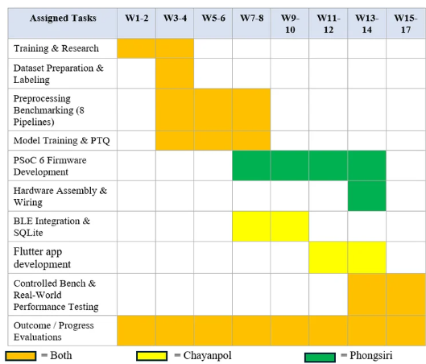
Figure 6.1 Updated Gantt Chart — Remaining Project Timeline

6.3 Conclusion
The AI model benchmarking phase has been completed, with Model 7 (Tuned) selected as the deployment model based on its consistently high Precision performance across real-world bedroom recording sessions. Core firmware subsystems including real-time Conv1D inference, Sliding Window haptic logic, BLE communication, and non-volatile Flash logging are operational on the PSoC™ 6 platform. The project is on track toward the final evaluation deadline, with hardware assembly and Flutter application completion as the primary remaining milestones.

Key technical findings to date include: (1) HPF pre-filtering is critical for bedroom acoustic deployment; (2) model performance degrades under acoustically ambiguous snoring conditions (shallow breathing-like snoring), representing the primary remaining challenge for Recall improvement; (3) fine-tuning with real microphone recordings and class rebalancing provides substantial performance gains over initial training.

References
[1] L. J. Hadjileontiadis, Lung sounds: An advanced signal processing perspective. Morgan & Claypool Publishers, 2006.
[2] Imagimob, "DeepCraft Edge AI development platform," [Online]. Available: https://www.imagimob.com [Accessed: February 18, 2026].
[3] S. F. Boll, "Suppression of acoustic noise in speech using spectral subtraction," IEEE Transactions on Acoustics, Speech, and Signal Processing, vol. 27, no. 2, pp. 113–120, 1979.
[4] J. P. Van Maanen et al., "The sleep position trainer: A new treatment for positional obstructive sleep apnoea," Sleep and Breathing, vol. 17, no. 2, pp. 771–779, 2013.
[5] M. M. Eijsvogel et al., "Sleep position trainer versus tennis ball technique in positional obstructive sleep apnea syndrome," Journal of Clinical Sleep Medicine, vol. 11, no. 2, pp. 139–147, 2015.
[6] S. Ioffe and C. Szegedy, "Batch normalization: Accelerating deep network training by reducing internal covariate shift," in Proceedings of ICML 2015. [Online]. Available: https://arxiv.org/abs/1502.03167 [Accessed: February 18, 2026].
[7] S. B. Davis and P. Mermelstein, "Comparison of parametric representations for monosyllabic word recognition in continuously spoken sentences," IEEE Transactions on Acoustics, Speech, and Signal Processing, vol. 28, no. 4, pp. 357–366, 1980.
[8] K. J. Piczak, "Environmental sound classification with convolutional neural networks," in IEEE 25th International Workshop on Machine Learning for Signal Processing (MLSP), 2015.
[9] Google, "Flutter documentation," [Online]. Available: https://docs.flutter.dev [Accessed: February 18, 2026].
[10] Infineon Technologies, "CY8CKIT-062S2-AI PSoC™ 6 AI evaluation kit guide," [Online]. Available: https://www.infineon.com/cms/en/product/evaluation-boards/cy8ckit-062s2-ai/ [Accessed: February 18, 2026].
[11] A. Khalifa et al., "Automated snoring detection using deep learning: A review," Sleep Medicine Reviews, vol. 60, p. 101544, 2021.

Appendices

Appendix A: Preprocessing Pipeline Configuration Details
# | Pipeline & Objective | DeepCraft Configuration (Step No. → Block Name | Field: Value)
1 | Linear Mel  Baseline  Objective: Establish a raw signal stability baseline using linear power scale, without any pre-filtering or normalization. All other pipelines are compared against this reference. | 1. Sliding Window (data points)  Window Shape: 1024  Stride: 160  Buffer Multiplier: 1  ↓  2. Real Discrete Fourier Transform  Axis: 0  ↓  3. Frobenius norm  Axis: 0  ↓  4. Mel Filterbank  Number of Filters: 40  Sample Rate (Hz): 16000  Low Frequency Cutoff (Hz): 50  High Frequency Cutoff (Hz): 8000  HTK formula: True  Librosa formula: False  ↓  5. Power to Decibel  Scale: 1  ↓  6. Sliding Window (data points)  Window Shape: [80, 40]  Stride: 1600  Buffer Multiplier: 1
2 | Log-Mel  Baseline  Objective: Evaluate whether log-scale compression improves snore feature contrast vs. Pipeline 1. Reveals susceptibility of unfiltered Log-Mel to AC noise False Positives. | 1. Sliding Window (data points)  Window Shape: 1024  Stride: 160  Buffer Multiplier: 1  ↓  2. Real Discrete Fourier Transform  Axis: 0  ↓  3. Frobenius norm  Axis: 0  ↓  4. Mel Filterbank  Number of Filters: 40  Sample Rate (Hz): 16000  Low Frequency Cutoff (Hz): 50  High Frequency Cutoff (Hz): 8000  HTK formula: True  Librosa formula: False  ↓  5. Logarithm  Logarithm base: 0  Floor: 1e-10  ↓  6. Sliding Window (data points)  Window Shape: [80, 40]  Stride: 1600  Buffer Multiplier: 1
3 | Linear  MFCC  Objective: Test whether DCT decorrelation alone (without log-scaling) provides sufficient feature compression. Measures accuracy vs. RAM trade-off of MFCC on linear scale. | 1. Sliding Window (data points)  Window Shape: 1024  Stride: 160  Buffer Multiplier: 1  ↓  2. Real Discrete Fourier Transform  Axis: 0  ↓  3. Frobenius norm  Axis: 0  ↓  4. Mel Filterbank  Number of Filters: 40  Sample Rate (Hz): 16000  Low Frequency Cutoff (Hz): 50  High Frequency Cutoff (Hz): 8000  HTK formula: True  Librosa formula: False  ↓  5. Power to Decibel  Scale: 1  ↓  6. Discrete Cosine Transform  Axis: 0  Output axis size: 40  ↓  7. Sliding Window (data points)  Window Shape: [80, 40]  Stride: 1600  Buffer Multiplier: 1
4 | Standard  MFCC  Objective: Benchmark against industry-standard MFCC used in speech recognition. Serves as the primary academic reference point for Pipelines 3, 7, and 8. | 1. Sliding Window (data points)  Window Shape: 1024  Stride: 160  Buffer Multiplier: 1  ↓  2. Real Discrete Fourier Transform  Axis: 0  ↓  3. Frobenius norm  Axis: 0  ↓  4. Mel Filterbank  Number of Filters: 40  Sample Rate (Hz): 16000  Low Frequency Cutoff (Hz): 50  High Frequency Cutoff (Hz): 8000  HTK formula: True  Librosa formula: False  ↓  5. Logarithm  Logarithm base: 0  Floor: 1e-10  ↓  6. Discrete Cosine Transform  Axis: 0  Output axis size: 40  ↓  7. Sliding Window (data points)  Window Shape: [80, 40]  Stride: 1600  Buffer Multiplier: 1
5 | Tuned  Linear Mel  (Recommended)  Objective: Evaluate the full noise-suppression wrapper (HPF + Hann + Scale) on linear power scale. Primary candidate for bedroom deployment due to AC hum rejection and normalized input. | 1. Sliding Window (data points)  Window Shape: 1024  Stride: 160  Buffer Multiplier: 1  ↓  2. High Pass Filter  Cutoff Frequency (Hz): 80  Filter Order: 4  Filter Type: IIR / Butterworth  ↓  3. Hann smoothing  Window Shape: 1024  Symmetric: True  ↓  4. Real Discrete Fourier Transform  Axis: 0  ↓  5. Frobenius norm  Axis: 0  ↓  6. Mel Filterbank  Number of Filters: 40  Sample Rate (Hz): 16000  Low Frequency Cutoff (Hz): 80  High Frequency Cutoff (Hz): 8000  HTK formula: True  Librosa formula: False  ↓  7. Power to Decibel  Scale: 1  ↓  8. Scale  Min: 0  Max: 1  ↓  9. Sliding Window (data points)  Window Shape: [80, 40]  Stride: 1600  Buffer Multiplier: 1
6 | Tuned  Log-Mel  Objective: Combine HPF noise rejection with log-scale contrast enhancement. Compared against Pipeline 2 to isolate the contribution of HPF + Hann + Scale on Log-Mel accuracy. | 1. Sliding Window (data points)  Window Shape: 1024  Stride: 160  Buffer Multiplier: 1  ↓  2. High Pass Filter  Cutoff Frequency (Hz): 80  Filter Order: 4  Filter Type: IIR / Butterworth  ↓  3. Hann smoothing  Window Shape: 1024  Symmetric: True  ↓  4. Real Discrete Fourier Transform  Axis: 0  ↓  5. Frobenius norm  Axis: 0  ↓  6. Mel Filterbank  Number of Filters: 40  Sample Rate (Hz): 16000  Low Frequency Cutoff (Hz): 80  High Frequency Cutoff (Hz): 8000  HTK formula: True  Librosa formula: False  ↓  7. Logarithm  Logarithm base: 0  Floor: 1e-10  ↓  8. Scale  Min: 0  Max: 1  ↓  9. Sliding Window (data points)  Window Shape: [80, 40]  Stride: 1600  Buffer Multiplier: 1
7 | Optimized  Linear MFCC  Objective: Investigate whether HPF + DCT compression + Scale can reduce RAM and Flash footprint while maintaining acceptable accuracy. Targets resource-constrained deployment. | 1. Sliding Window (data points)  Window Shape: 1024  Stride: 160  Buffer Multiplier: 1  ↓  2. High Pass Filter  Cutoff Frequency (Hz): 80  Filter Order: 4  Filter Type: IIR / Butterworth  ↓  3. Hann smoothing  Window Shape: 1024  Symmetric: True  ↓  4. Real Discrete Fourier Transform  Axis: 0  ↓  5. Frobenius norm  Axis: 0  ↓  6. Mel Filterbank  Number of Filters: 40  Sample Rate (Hz): 16000  Low Frequency Cutoff (Hz): 80  High Frequency Cutoff (Hz): 8000  HTK formula: True  Librosa formula: False  ↓  7. Power to Decibel  Scale: 1  ↓  8. Discrete Cosine Transform  Axis: 0  Output axis size: 40  ↓  9. Scale  Min: 0  Max: 1  ↓  10. Sliding Window (data points)  Window Shape: [80, 40]  Stride: 1600  Buffer Multiplier: 1
8 | Optimized  Edge MFCC  Objective: Full MFCC pipeline with HPF pre-filtering and Min-Max Scale. Compared against Pipeline 4 to measure the accuracy gain from adding the Standard Wrapper to MFCC. | 1. Sliding Window (data points)  Window Shape: 1024  Stride: 160  Buffer Multiplier: 1  ↓  2. High Pass Filter  Cutoff Frequency (Hz): 80  Filter Order: 4  Filter Type: IIR / Butterworth  ↓  3. Hann smoothing  Window Shape: 1024  Symmetric: True  ↓  4. Real Discrete Fourier Transform  Axis: 0  ↓  5. Frobenius norm  Axis: 0  ↓  6. Mel Filterbank  Number of Filters: 40  Sample Rate (Hz): 16000  Low Frequency Cutoff (Hz): 80  High Frequency Cutoff (Hz): 8000  HTK formula: True  Librosa formula: False  ↓  7. Logarithm  Logarithm base: 0  Floor: 1e-10  ↓  8. Discrete Cosine Transform  Axis: 0  Output axis size: 40  ↓  9. Scale  Min: 0  Max: 1  ↓  10. Sliding Window (data points)  Window Shape: [80, 40]  Stride: 1600  Buffer Multiplier: 1

Appendix B: Binary Event Packet Structure and SQLite Database Schema

Field | Size | Description
timestamp | 4 bytes | Unix epoch (uint32, little-endian) of event start.
duration_s | 1 byte | Snore event duration in seconds (uint8, 0–255 s).
haptic_success | 1 byte | 0x01 if snoring ceased within the 15-minute post-vibration window (Success); 0x00 if snoring resumed (Unsuccessful). Only valid when haptic_flag = 0x01; otherwise 0x00.
haptic_flag | 1 byte | 0x01 if a haptic trigger fired within this event; 0x00 otherwise.

Column | Type | Constraint | Description
id | INTEGER | PRIMARY KEY | Auto-incremented row identifier.
session_date | TEXT | NOT NULL | ISO date of the sleep session (YYYY-MM-DD).
event_timestamp | INTEGER | NOT NULL | Unix timestamp of the snore event start.
duration_s | INTEGER | NOT NULL | Snore event duration in seconds (0–255).
haptic_success | INTEGER | NOT NULL | 0x01 = snoring ceased after haptic trigger (Success); 0x00 = snoring resumed or no haptic fired.
haptic_flag | INTEGER | NOT NULL | 1 = haptic motor fired for this event; 0 = no trigger.

