






DO THE RIGHT THING
improve your life

Trust Polybius Biotech to provide you with the life you deserve. From cybernetic enhancements to genetically modified organisms, tailored to your needs, our expertise and quality is unparalleled.
Polybius Biotech – Improving Life.

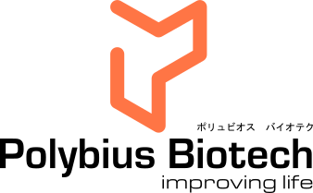
Polybius Biotech Ltd is a wholly owned subsidiary of the Polybius Biotech International group of companies.

