1. (1) If u is the mean particle size, then the null hypothesis is u=100, and the alternative u=/=100.
2. (i)>>diameter=[99.6 92.1 103.8 95.3 101.6 102.8 100.9 100.5 102.7 96.9 101.5 96.7 96.8 97.8 104.7 103.2 97.5 98.3 105.8 100.6 102.3 93.8 102.7 94.9 94.9]

>>normplot(diameter) diameter = Columns 1 through 8: 99.600 92.100 103.800 95.300 101.600 102.800 100.900 100.500 Columns 9 through 16: 102.700 96.900 101.500 96.700 96.800 97.800 104.700 103.200 Columns 17 through 24: 97.500 98.300 105.800 100.600 102.300 93.800 102.700 94.900 Column 25: 94.900

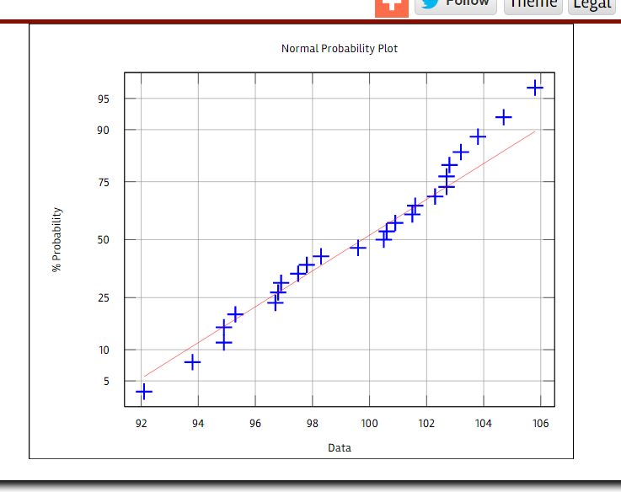

This is the data and the plot I got by Online-matlab.

(ii)The point in the graph should be linear so the assumption appears valid.

(c)[x,y,z,sta]=ttest(diameter,100) x = 0 y = 0.51221 z = -2.0183 1.0343 51221 sta = scalar structure containing the fields: tstat = -0.66529 df = 24 sd = 3.6976

From the data above we get the value of the test statistic is -0.66529

Value of degrees of freedom is 24;

P-value is 0.51221

95% confidence interval is from -2.0183 to 1.0343.

1. (a)In 120 sttempts 65 was successful so we set n=120 x=65 x~B(n,p),

So p=x/n=13=24=0.54167

SE=sqrt(p(1-p))/n)=0.04548

For 95% confidence z\*=norminv(0.975)=1.96

pIz\*SE=(0.4525,0.6308)

(b)p=0.7 z=-3.7848

P-value=2\*(normcdf(-3.7848))=1.9998>0.05

So H0 is accepted .

1. (a)Pi1=5/50=0.1,pi2=19/70=0.2714,pit=(5+19)/(50+70)=0.20

Z=(Pi1-pi2)/(sqrt(pit(1-Pit)\*(1/n1+1/n2))=-2.3146

Pvalue=2\*(normcdf(-2.3146))=0.02064

(b) z\*(sqrt(pi1(1-Pi2)/n1+pi2(1-Pi1)/n2)+pi1-pi2=0.0381

-z\*(sqrt(pi1(1-Pi2)/n1+pi2(1-Pi1)/n2)+pi1-pi2=-0.3050

So the result is (-0.3050,0.0381)

4 hardness =Columns 1 through 16:
45 55 61 66 71 71 81 86 53 60 64 68 79 81 56 68
Columns 17 through 30:
75 83 88 59 71 80 82 89 51 59 65 74 81 86

Loss =Columns 1 through 16: 372 206 175 154 136 112 55 45 221 166 164 113 82 32 228 196

Columns 17 through 30: 128 97 64 249 219 186 155 114 341 340 283 267 215 148

（b)scatter(hardness,Loss)

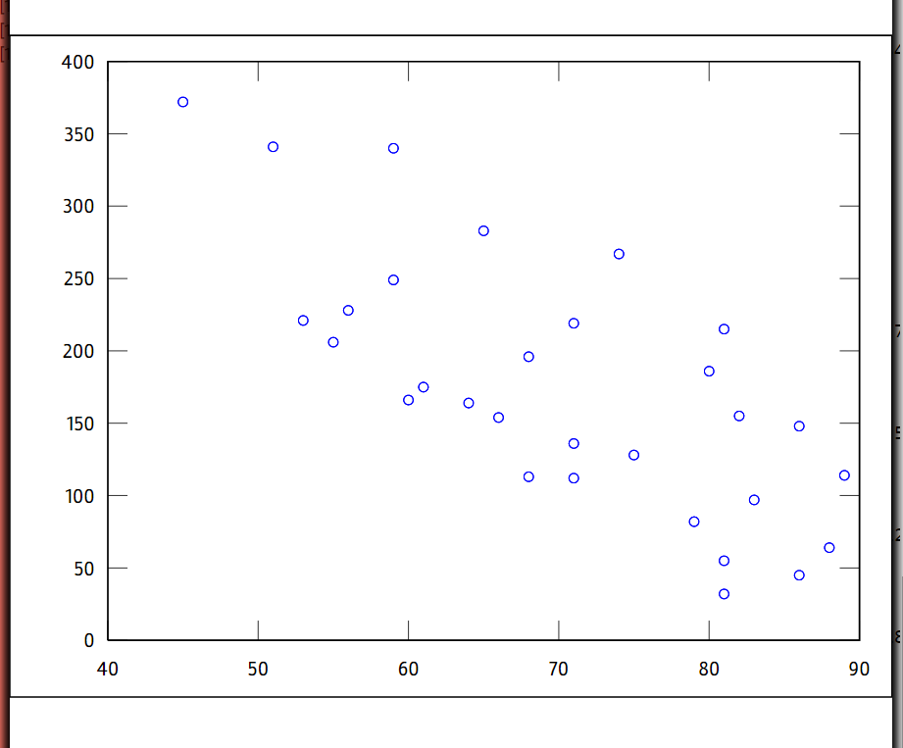

(c)