DEWAN SAJAL

**1997/08/20**

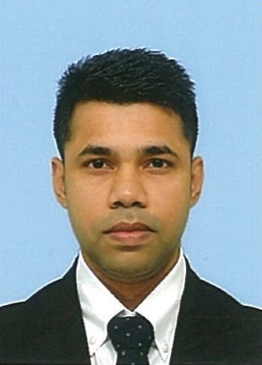

070-3243-3351

[sjldewn@gmail.com](mailto:sjldewn@gmail.com)

website:

[http://sajaldewan.net](http://i-site.s3-website-ap-southeast-2.amazonaws.com/)

Tokyo-to Setagaya, Soshigaya

4-17-5 El Sombra 102

# PROFILE

Proactive, capable to take many responsibilities. I can anticipate many  
situations even the most difficult situations. Calm and smiling, opened to all  
opportunities. Determined and motivated. I do not give up achieving the set  
goals. Good sense of communication.

# EXPERIENCE

**Kitchen staff, Mc Donald’s; Tokyo-to Odaiba city — 2017-2018**

Burger maker

**Hall staff, Miraizaka; Tokyo-to Ginza city — 2018-2020**

Service, communication with customers.

**General operations related to Lawson store management, Iwasaki Kikaku Co.Ltd; Tokyo -to Chôfu city Senkawa 7-22-2 — Oct2020- June2024**

Sales, leadership, management

**B-cause.Inc : Tokyo-to Hamamatsu-cho — June 2024 - Now**

Maintaining and updating b-cause.co.jp and various related web pages

Working on front-end development hiwork.jp project

Manage the team work with the subsidiary in Bangladesh

# EDUCATION

**Louhojong university & college, Dhaka,Bangladesh** — Intermediate-2015

**Louhojong pilot high school, Dhaka,Bangladesh—** High school certificate-2013

**Tokyo Nihongo center, Tokyo-to, Minatu-ku** — Japanese language N2-2019

# SKILLS

* Good communication
* Computer skills: HTML, CSS Bootstrap Javascript, Version Control, Front-End development, Front-End Coding, Git, GitHub, GitHub Copilot, Microsoft Excel, Office, Word, Powerpoint
* Anticipation
* Calm
* Reflexion

# LANGUAGES

* Japanese : spoken written (hiragana katakana kanji little) | Intermediate
* English : spoken and written | Advanced
* Bangla : spoken and written | Native

# AWARDS

From Lawson : staff leadership.