Overview

Overview

Alerts

**9**

Reproduction

Dataset statistics

**Number of variables**

10

**Number of observations**

17414

**Missing cells**

0

**Missing cells (%)**

0.0

%

**Duplicate rows**

0

**Duplicate rows (%)**

0.0

%

**Total size in memory**

1.3

MiB

**Average record size in memory**

80.0

B

Variable types

**Categorical**

4

**Numeric**

6



Select Columns

timestamp

Categorical

HIGH CARDINALITY

UNIFORM

UNIQUE

**Distinct**

**Distinct**

17414

17414

**Distinct (%)**

**Distinct (%)**

100.0

%

100.0

%

**Missing**

0

**Missing (%)**

0.0

%

**Memory size**

136.2

KiB

17409

2015-01-04 00:00:00

1

2016-05-04 12:00:00

1

2016-05-04 18:00:00

1

2016-05-04 17:00:00

1

2016-05-04 16:00:00

1

Other values (17409)



Toggle details

Toggle details



Test

Test

Variables

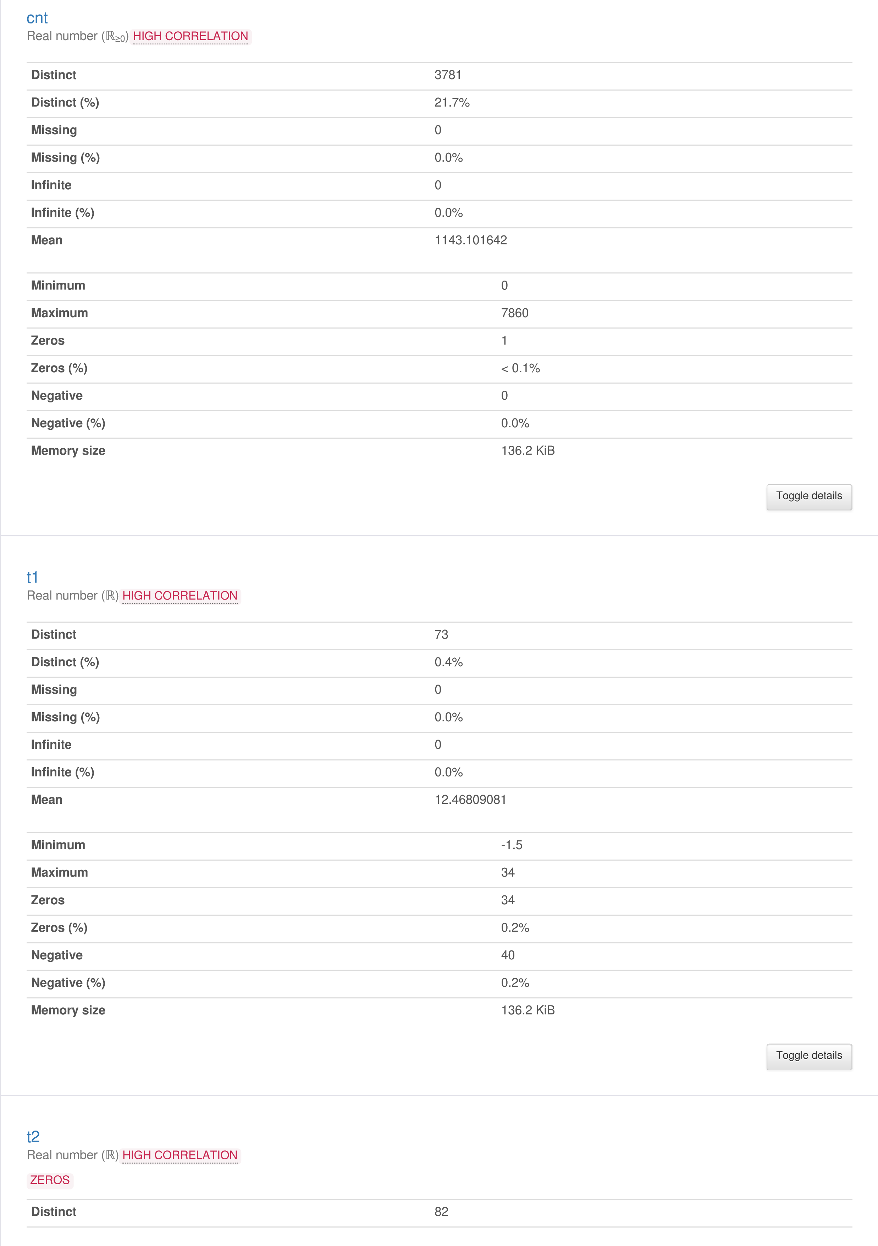

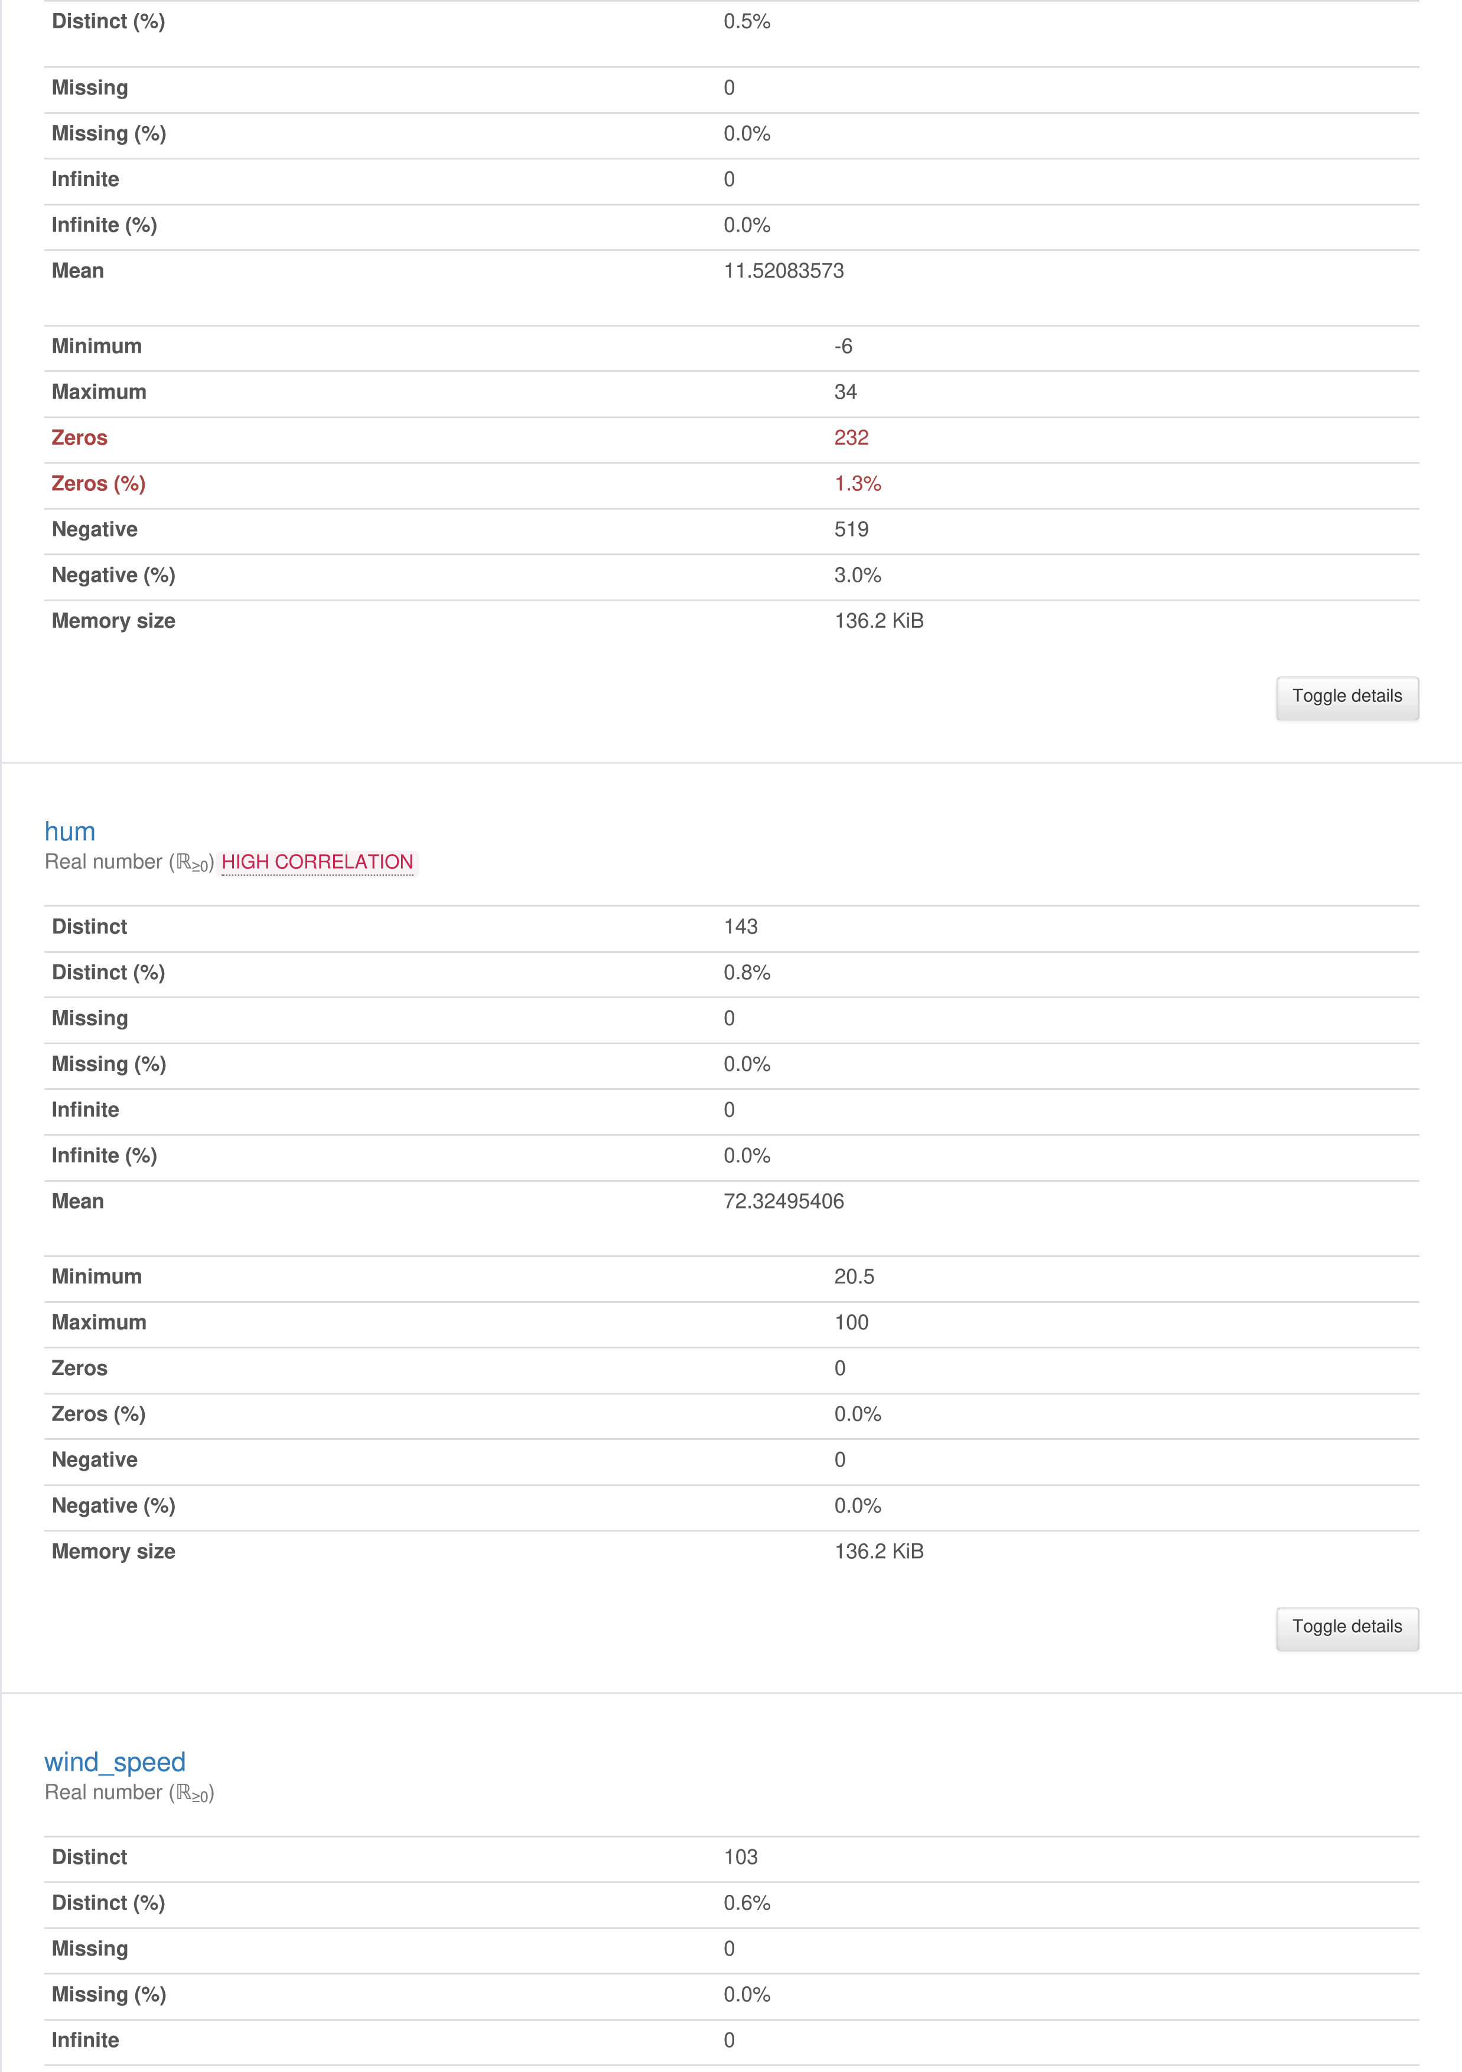

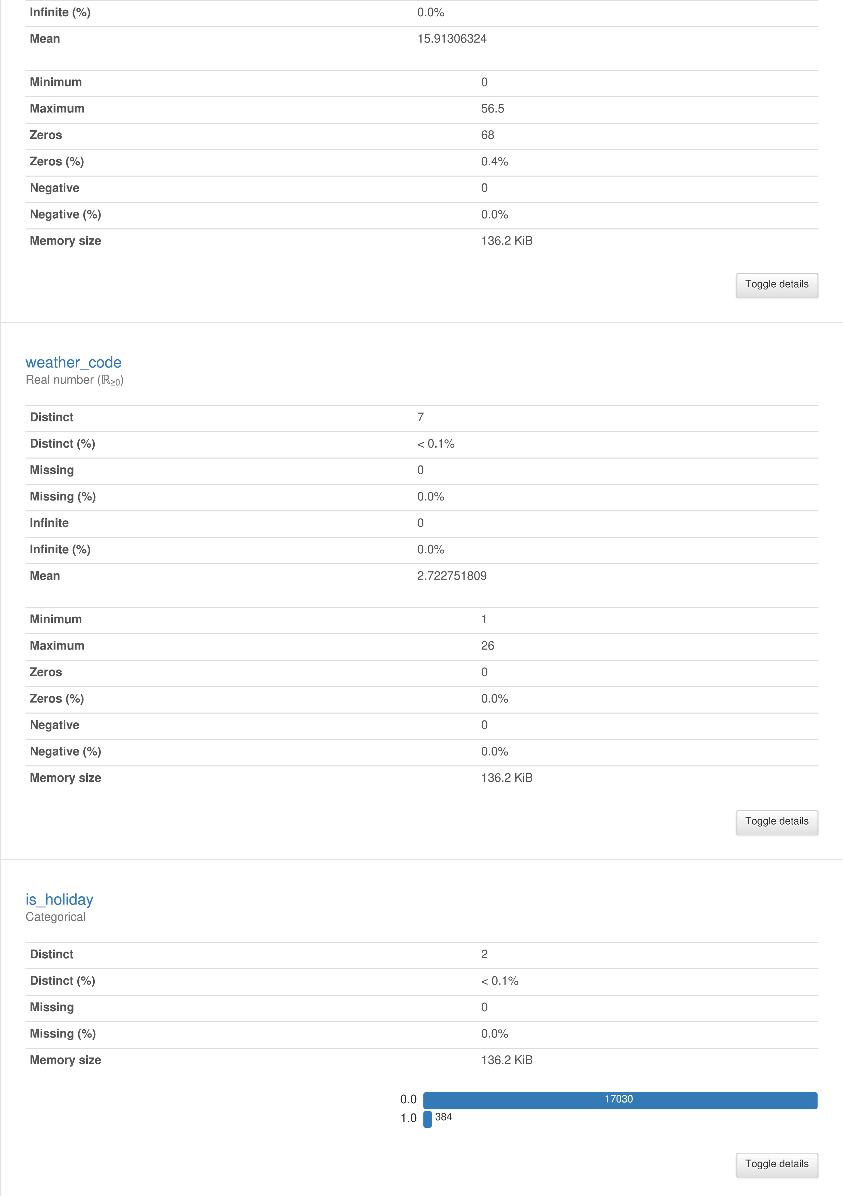

Interactions

is_weekend

Categorical

**Distinct**

2

**Distinct (%)**

<

0.1%

**Missing**

0

**Missing (%)**

%

0.0

**Memory size**

KiB

136.2

12444

4970

0.0

1.0



Toggle details

Toggle details

season

Categorical

HIGH CORRELATION

**Distinct**

4

**Distinct (%)**

<

0.1%

**Missing**

0

**Missing (%)**

0.0

%

**Memory size**

136.2

KiB

4394

4387

4330

4303

0.0

1.0

3.0

2.0



Toggle details

Toggle details



cnt

t1

t2

hum

wind_speed

weather_code



weather_code

cnt

t1

t2

hum

wind_speed



Toggle correlation descriptions

Toggle correlation descriptions



Auto

Spearman's ρ

Pearson's r

Kendall's τ

Cramér's V (φc)

Phik (φk)

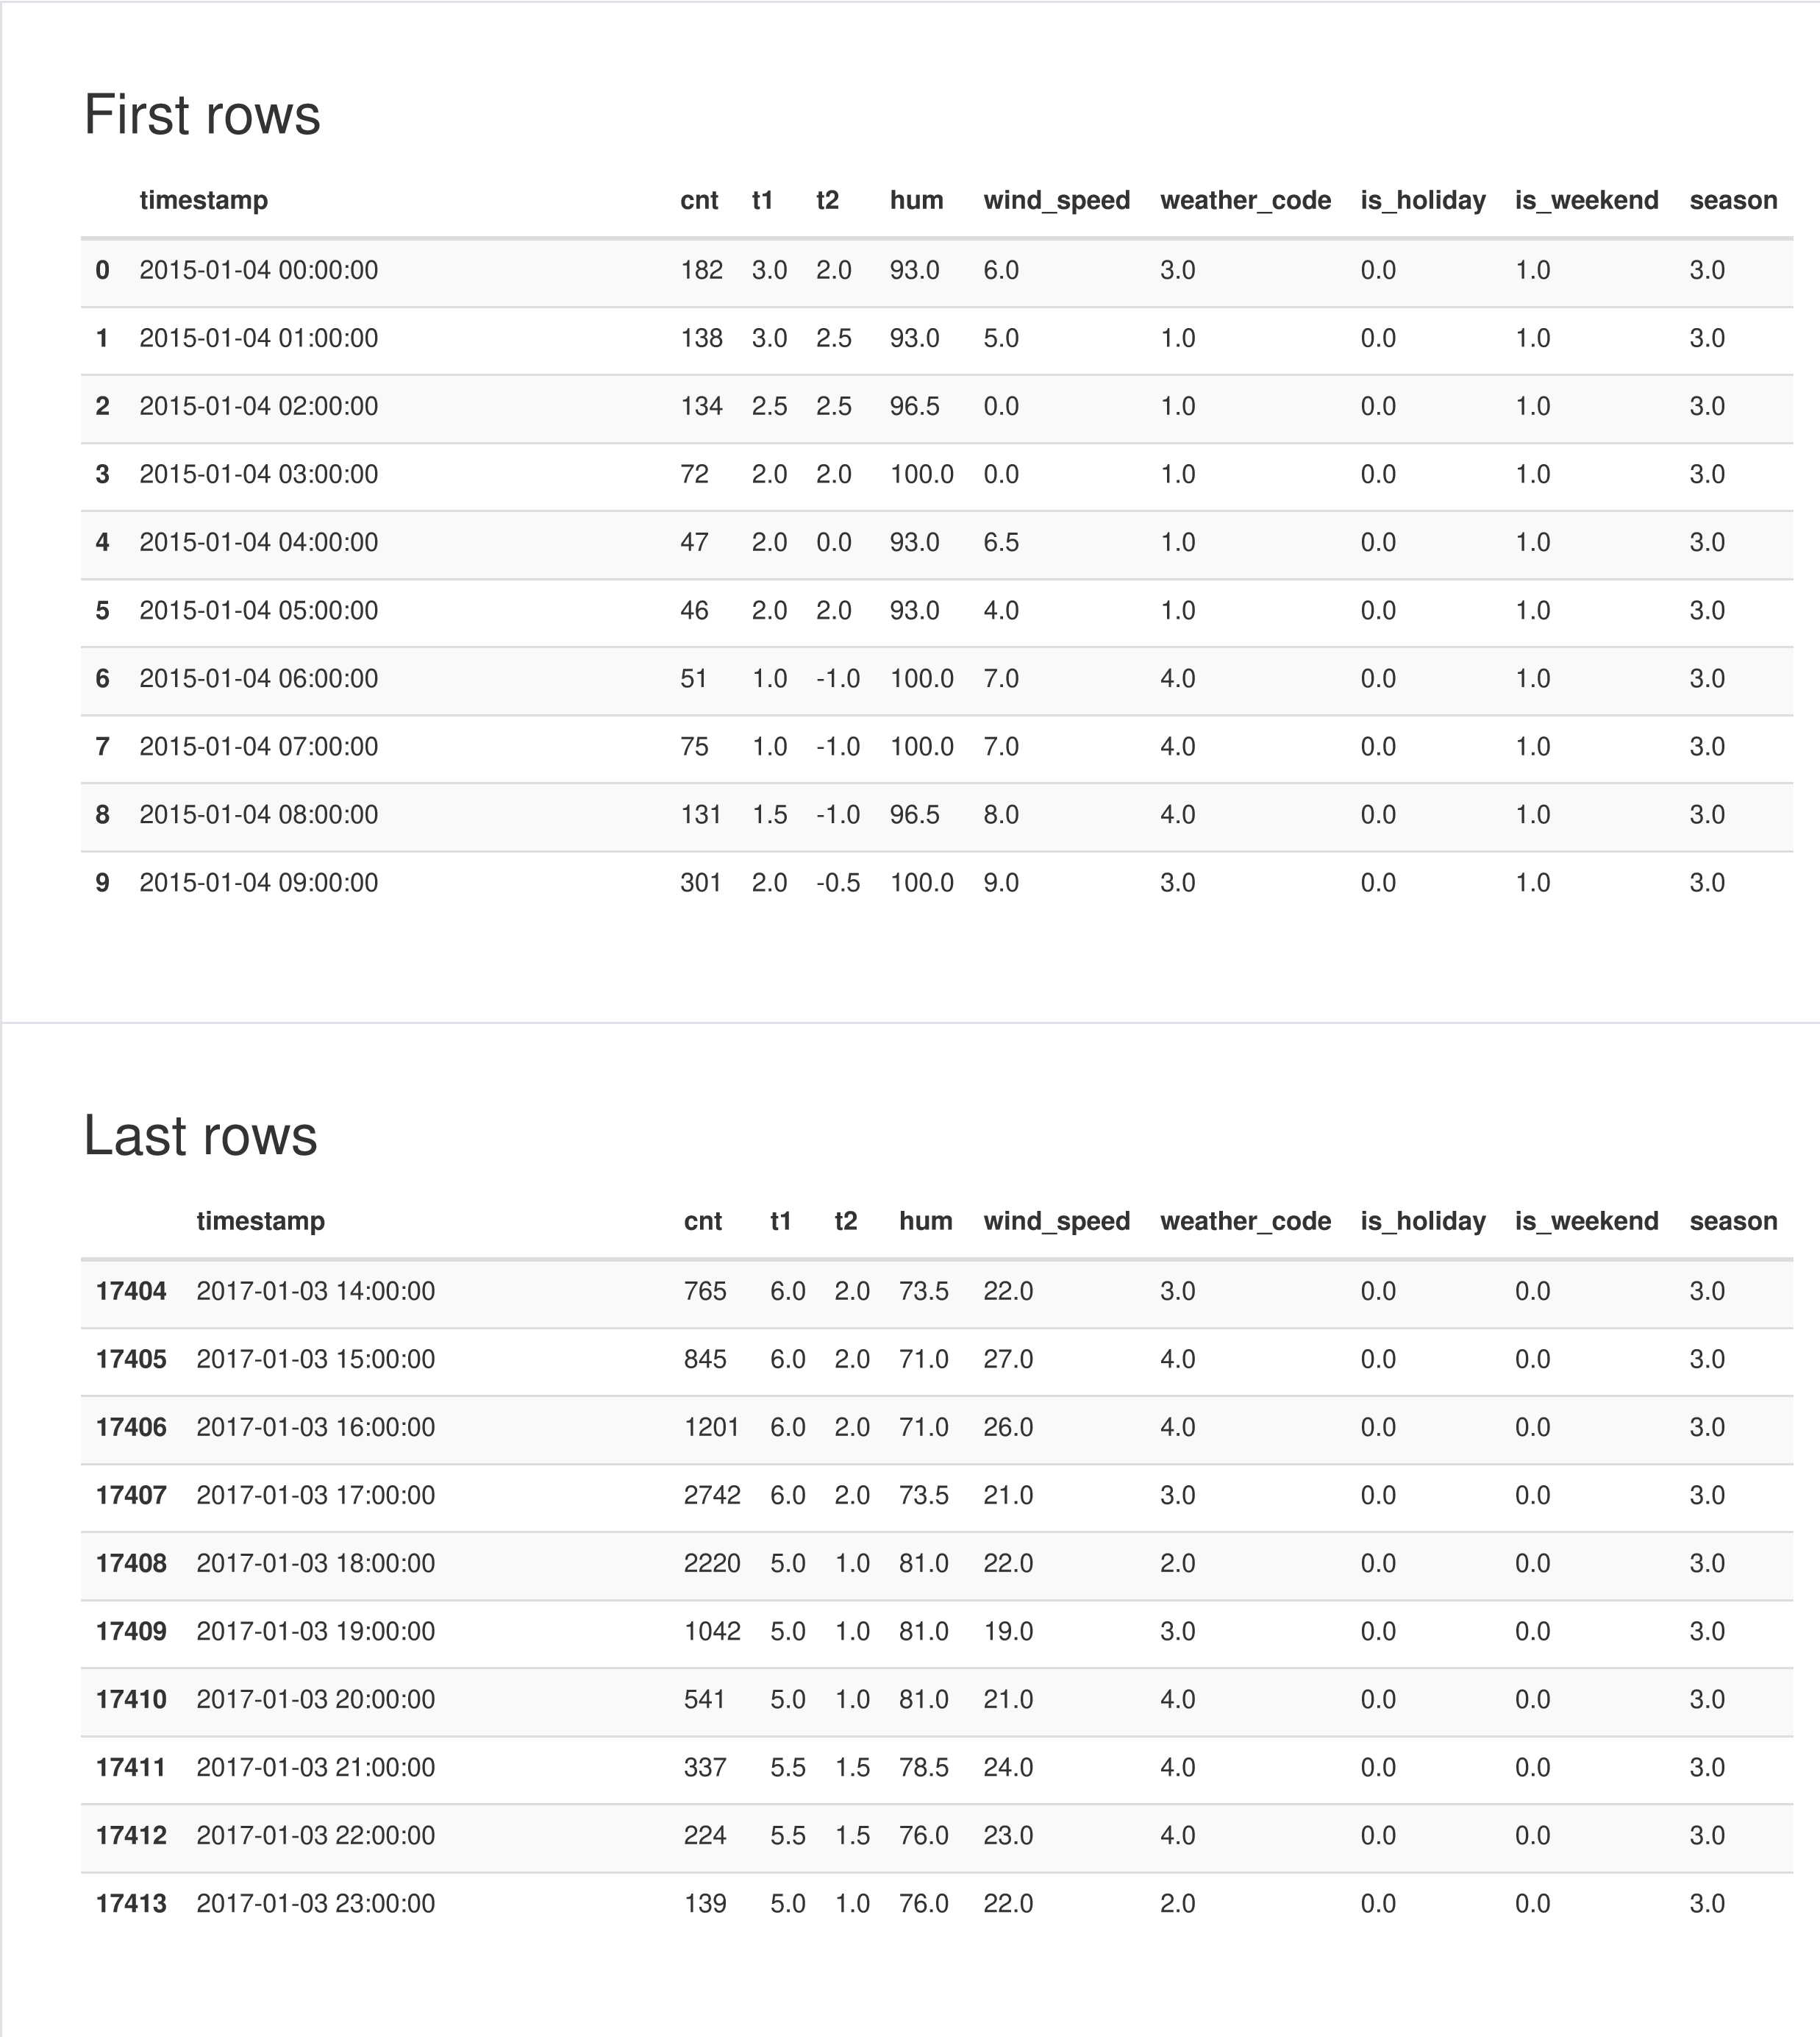Correlations Missing values



Count

Matrix

A simple visualization of nullity by column.

Sample

Report generated by [YData](https://ydata.ai/?utm_source=opensource&utm_medium=pandasprofiling&utm_campaign=report).