

Assessment Cover Page

Student Full Name | Hoai Nhan Nguyen
Student Number | sba24098
Module Title | Machine Learning
Assessment Title | CA2
Assessment Due Date | 22/12/2024
Date of Submission | 27/12/2024
Declaration
By submitting this assessment, I confirm that I have read the CCT policy on academic misconduct and understand the implications of submitting work that is not my own or does not appropriately reference material taken from a third party or other source.
I declare it to be my own work and that all material from third parties has been appropriately referenced.
I further confirm that this work has not previously been submitted for assessment by myself or someone else in CCT College Dublin or any other higher education institution.

Contents
Introduction 1
Supervised Machine Learning - Regression 1
Data Understanding and Preparation 2
Machine Learning Implementation 3
Hyperparameter Optimization 3
Machine Learning Evaluation 3
Conclusion 3
References 3
Bibliography 3

Introduction

In this assessment we were provided a biking dataset that has operational data from a global bike rental firm. The objective of the assessment is to analyse the dataset and implement a machine learning model to improve their pricing strategy, fleet management or customer satisfaction. The action that I have taken in this assessment is to improve their pricing strategy. I have implemented a supervised machine learning regression approach to predict the bike rental cost for dynamic pricing based on the features in the dataset.
The machine learning models that I have used are ridge and random forest regressions while applying hyperparameter optimization. I have also conducted an evaluation of the machine learning performance and provided a conclusion on my findings.

Supervised Machine Learning - Regression

I have implemented a supervised machine learning regression model to predict bike rental costs. I chose the supervised machine learning approach because the dataset includes the target variable, bike rental cost, which allows me to predict its continuous value based on the features in the dataset.
The main objective in supervised learning is to train the machine learning model on a labeled dataset to make predictions on unseen or future data. (Raschka and Mirjalili, 2019, p. 3) Supervised machine learning is commonly used for classification to predict a categorical label or regression to predict a continuous value. Below is the advantages and disadvantages of implementing supervised machine learning:
Advantage
- When implementing supervised learning there is a clear objective to predict a specific label.
- It offers some degree of interpretability to understand the outcome of the predictions.
- There is a clear performance metric to evaluate the machine learning implementation.
Disadvantages
- The model is dependent on the training data. If the training data is biased or incomplete it will have an effect on the model's performance.
- It requires a large amount of labeled data to achieve optimal performance on its implementation. It can be expensive and time consuming to retrieve a labeled dataset.
- When using large datasets, it can require significant computational resources.

Data Understanding and Preparation

I have conducted an exploratory data analysis to understand the dataset and prepared the data for the machine learning model. The dataset has 900 rows and 8 columns. The columns of the dataset is the following below:
Columns | 'City', 'Weather Condition', 'Rider Age', 'Bike Model', 'Ride Duration (min)', 'Distance Covered (km)', 'Rider Satisfaction' and Bike Rental Cost ($).

From inspecting the dataframe, I found several missing values and removed the rows that contained them to provide consistency on the data and to enhance the performance of the machine learning model. There were no duplicate rows or outliers in the dataframe. However I have found that there was only 1 row that contained the bike model “manual”. I have removed this row as there wasn’t enough data for the bike model “manual” compared to the other bike models.
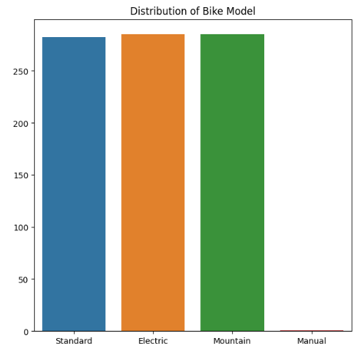

Based on the exploratory data analysis, I have used the following features and target for the machine learning regression implementation below:

Features | 'City', 'Weather Condition', 'Rider Age', 'Bike Model', 'Ride Duration (min)', and 'Distance Covered (km)'
Target | Bike Rental Cost ($).

I have excluded the 'Rider Satisfaction' column as a feature, as you won’t have access to this information for dynamic pricing of the bike rental cost. Rider satisfaction is assessed after the bike rental, so it shouldn’t be related to predicting the future price when a customer rents a bike.
As the ‘City', 'Weather Condition' and 'Bike Model' are categorical data, I have applied the one hot encoding method to convert it to numerical data for the machine learning implementation.

Machine Learning Implementation

Hyperparameter Optimization

Machine Learning Evaluation

Conclusion

References

- Sebastian Raschka and Vahid Mirjalili (2019) Python Machine Learning : Machine Learning and Deep Learning with Python, Scikit-learn, and TensorFlow 2. [S.l.]: Packt Publishing. Available at: https://research.ebsco.com/linkprocessor/plink?id=fde49815-c3b7-330b-8084-49a6b9f7d99a (Accessed: 24 December 2024).

Bibliography

- Sebastian Raschka and Vahid Mirjalili (2019) Python Machine Learning : Machine Learning and Deep Learning with Python, Scikit-learn, and TensorFlow 2. [S.l.]: Packt Publishing. Available at: https://research.ebsco.com/linkprocessor/plink?id=fde49815-c3b7-330b-8084-49a6b9f7d99a (Accessed: 24 December 2024).
- Tatsat, H., Puri, S. and Lookabaugh, B. (2020) Machine learning and data science blueprints for finance from building trading strategies to robo-advisors using Python Hariom Tatsat, Sahil Puri, and Brad Lookabaugh. O’Reilly Media. Available at: https://research.ebsco.com/linkprocessor/plink?id=6a8bbbb0-5554-3e24-af96-b563cc961ffc (Accessed: 24 December 2024).

