Interactive UK Population Density Dashboard
Geospatial and Demographic Analysis (2011–2022)

Contents
Introduction 1
Data Preparation Action and Justification 1
Data Transformation and Feature Engineering 2
Dashboard Design for Young Adult (18–35) 3
Conclusion 4
Dashboard Design Screenshots 5

Introduction

In this assessment, I have created an interactive dashboard that displays the UK population density for mid-2011 and mid-2022. The dashboard is specifically designed for the young adult demographic (ages 18–35). In this report I will be providing details on the data preparation I have taken and the design choices that I have made to ensure the dashboard is both engaging and relevant to the target demographic.

Data Preparation Action and Justification
From reviewing the Excel file (mye22final.xlsx) for this assessment, I identified multiple sheets containing detailed data on the UK population and geographical distribution. For this analysis, I used the sheets named MYEB1 and MYE5 for the following reasons:
- MYEB1: Provides population estimates for mid-2011 and mid-2022, categorized by gender, age, and location.
- MYE5: Contains population density data for UK local authorities in mid-2011 and mid-2022, including location, area (in square kilometers), and estimated population.
These sheets contain the gender, age, and location data to compare geographic population density in the UK for mid-2011 and mid-2022. I have taken the following action for the data preparation below:

Action | Description
Data Inspection | I conducted an initial inspection of the datasets by checking the first few rows using the .head() function, exploring data types with the .info() function, and examining the number of unique values in the geographical location column using the .nunique() function. These actions provided an overview and better understanding of the data structure.
Data Cleaning | I renamed the columns in the MYE5 dataframe using a snake_case naming convention to ensure consistency between the MYE5 (df_uk_density) and MYEB1 (df_uk_population) dataframes.
Data Validation | I checked for null and duplicate values using a custom function to ensure data quality and accuracy for visualisation. I found that there were no null or duplicate entries in the dataframe.
Data Filtering | I filtered both dataframes to include only the following geography types: Unitary Authority, London Borough, Metropolitan District, Non-metropolitan District, Council Area, and Local Government District. This step ensured that there was no overlap in locations when analysing population density.

Data Transformation and Feature Engineering
I performed data transformation and feature engineering on the MYEB1 (df_uk_population) dataframe to segment the population by gender, age group, and population density. This enabled the development of interactive visualizations where users can filter and explore data based on these demographic characteristics. I have taken the following actions below:

Action | Description
Aggregated male and female populations by location | Transformed the df_uk_population dataframe (MYEB1 sheet) to calculate the total male and female populations for 2011 and 2022 by location code.
Calculated gender-specific population densities per square kilometer | Calculated the population density per square kilometer separately for males and females in both 2011 and 2022.
Merged gender population and density data into the density dataset | Merged the gender-specific population totals and their corresponding densities into the df_uk_density dataframe (MYE5 sheet) using the shared location code.
Aggregated age group populations by gender and location | Grouped the df_uk_population dataframe (MYEB1 sheet) by gender, age group, and location to calculate total populations in each segment for 2011 and 2022.
Calculated age group population densities per square kilometer | Calculated the density of each gender and age group combination per square kilometer for both 2011 and 2022.
Merged age group population and density data into the density dataset | Merged the gender and age group population and density data into the df_uk_density dataframe (MYE5 sheet) using the shared location code.

Afterwards I have split the df_uk_density dataset into two separate dataframes representing the years 2011 and 2022. Each of these was then exported as a CSV file: df_uk_population_density_2011.csv and df_uk_population_density_2022.csv. These final datasets include location metadata, overall population and density, and breakdowns by gender and age group.

Dashboard Design for Young Adult (18–35)

For the development of the dashboard, I used three datasets generated during the data preparation phase: df_uk_population.csv, df_uk_population_density_2011.csv, and df_uk_population_density_2022.csv. These datasets contain essential population and density information segmented by age group and gender for the years 2011 and 2022.

Purpose and Design of the Dashboard

The interactive dashboard was designed with a focus on the young adult demographic (ages 18–35). It was built using Streamlit for the user interface and Plotly Express for creating dynamic and responsive visualizations. Its primary goal is to visualize UK population densities by geographic location, allowing users to filter data by year, age group, and gender. The dashboard features two main visualizations: a choropleth map to illustrate the spatial distribution of population density across local authorities, and a bar chart to display age-specific population counts.

Visualizations and Layout

I adopted a minimalist design approach by limiting the visualizations to just the choropleth map and bar chart. This streamlined layout avoids visual clutter and enables users to focus on key insights into UK population density. The choropleth map is the dashboard’s central visual element, allowing users to explore geographic variations in density. It includes hover functionality that reveals detailed information such as location name, code, population size, and density values. To complement the choropleth map, I included a bar chart that shows population distribution by age. This chart dynamically updates based on the selected gender and year, making the data dynamic with the choropleth map.

Interactive Features and User Experience

I have applied a gender-based colour scheme that changes dynamically based on user selection. The colour palettes were chosen to adapt effectively to the gender filter options in the sidebar. The dashboard also included a sidebar control panel that allows users to filter the data by year (2011 or 2022), gender, and age group, including a dedicated option for young adults. These filters provide real-time updates to both visualizations, creating a responsive and interactive experience. The titles and population details adjust dynamically based on the selected filters, ensuring that users always have a clear understanding of the data they’re viewing.

Conclusion
From the development of the interactive population dashboard, I gained experience ranging from data preparation to creating interactive visualisations. When designing the dashboard layout and its interactive features, I learned the importance of tailoring the design to a specific audience, as this can influence its visual aesthetic and functionality. I strengthened my skills in using Streamlit to build responsive filter options and Plotly Express to create interactive visualisations. Together, these tools enabled me to produce a dashboard that is functionally and interactive.

Overall, this project provided practical knowledge in data visualisation and dashboard development with the importance of designing for a specific user group.

Dashboard Design Screenshots
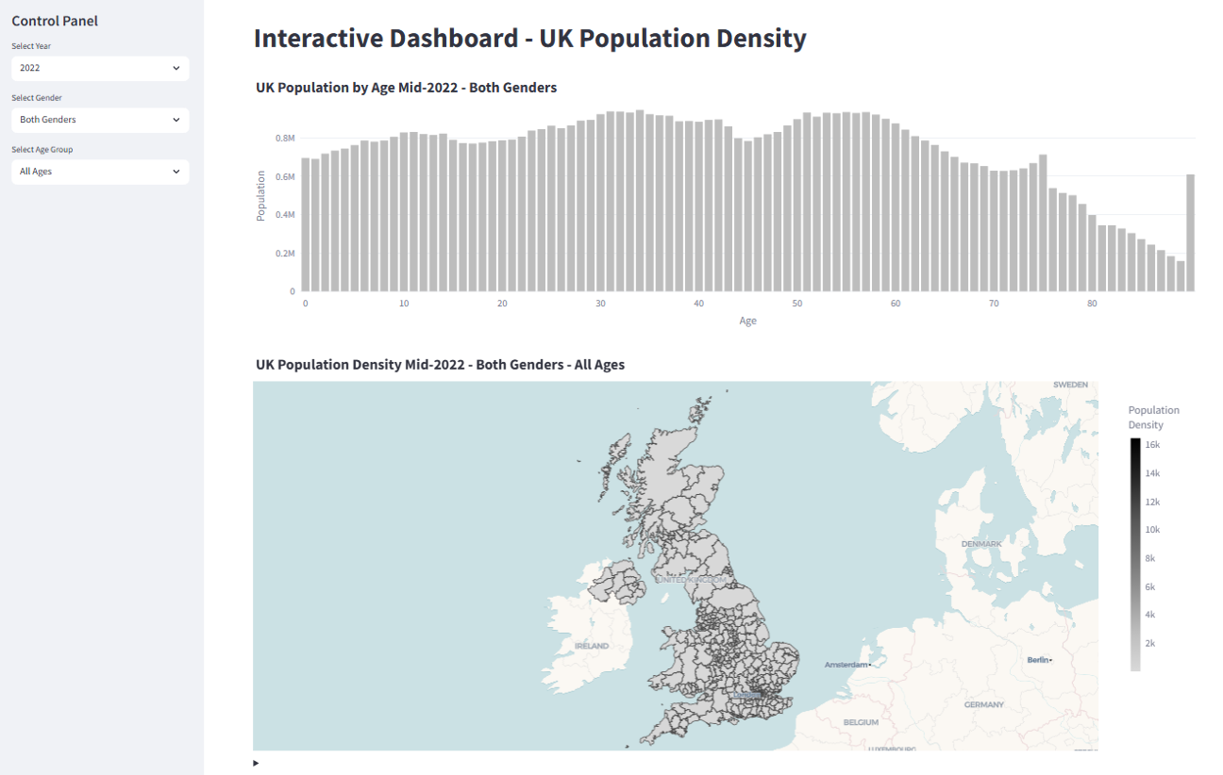
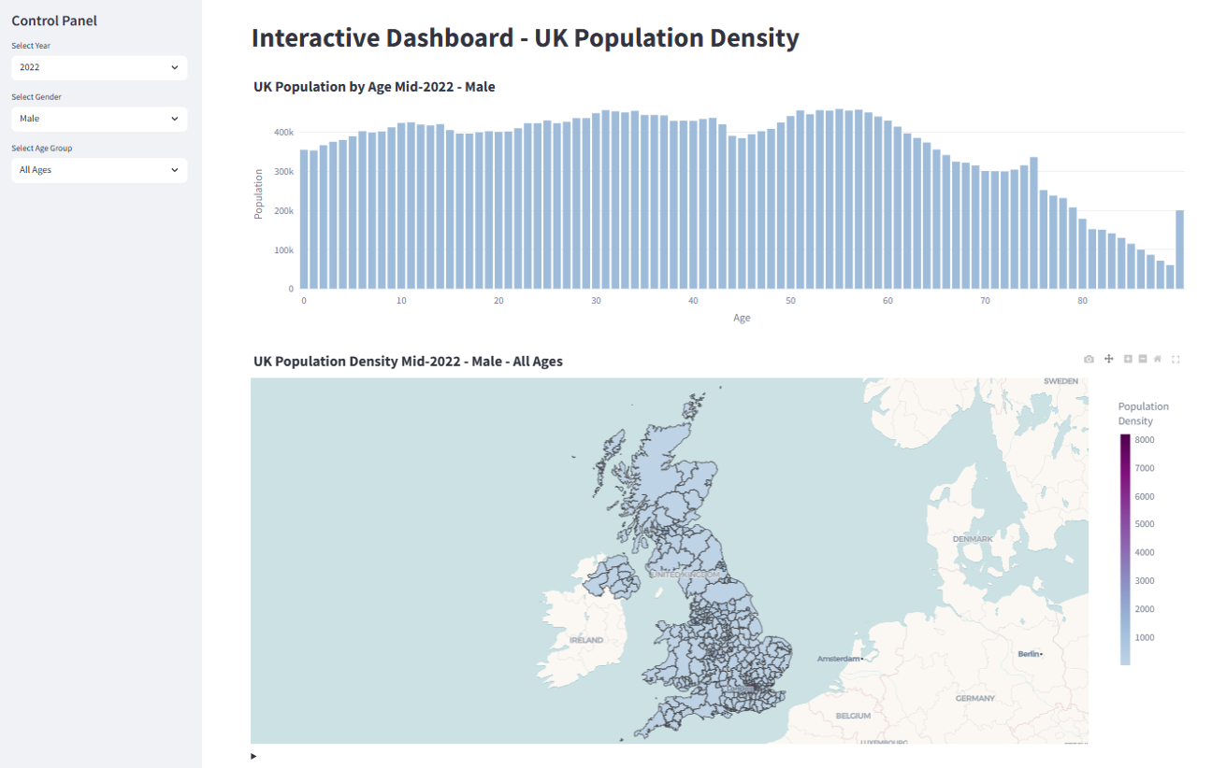
Figure 1 - Dashboard with both gender selected

Figure 2 - Dashboard with male gender selected

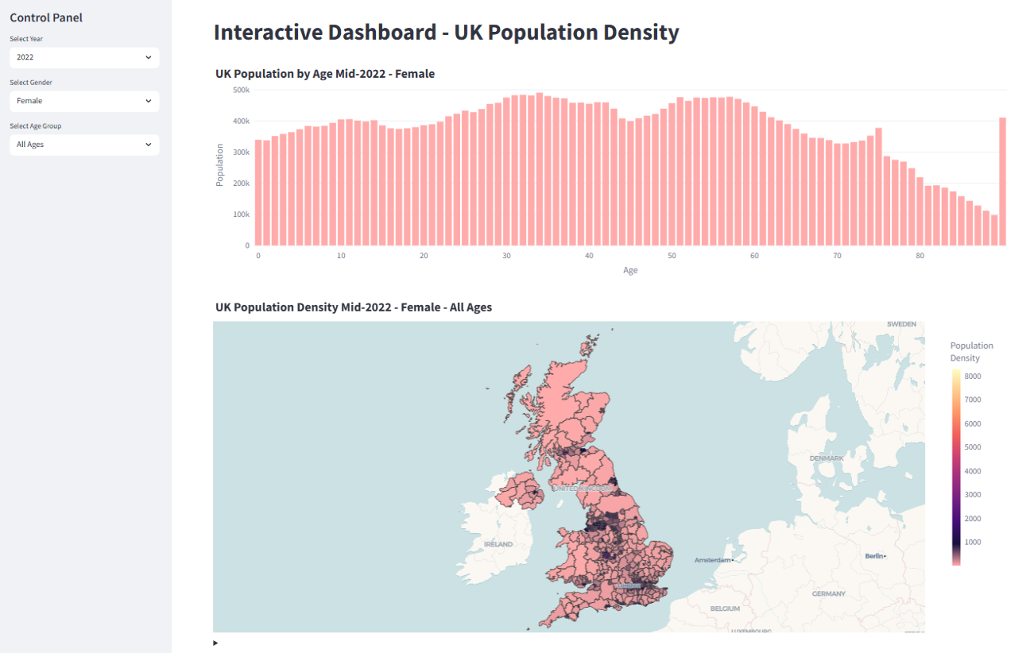
Figure 3 - Dashboard with female gender selected
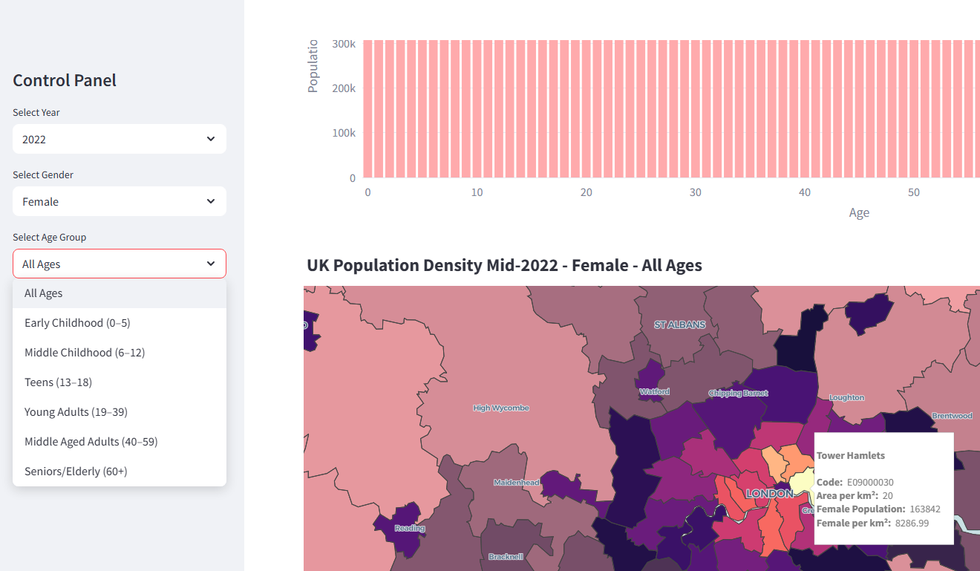

Figure 4 - Control panel filter and hover functionality.

