The History of Computers

Drivers for computers evolution
- National security (military superiority) – SIGINT, spying
- Commercial imperative – replace people, do things cheaper
- Related technologies – need to interface with other systems
- More recently:
  - Gaming, Big Data, AI (GPUs from gaming)

Moore’s Law
States that power approximately doubles every year. It clearly doesn’t hold like it used to
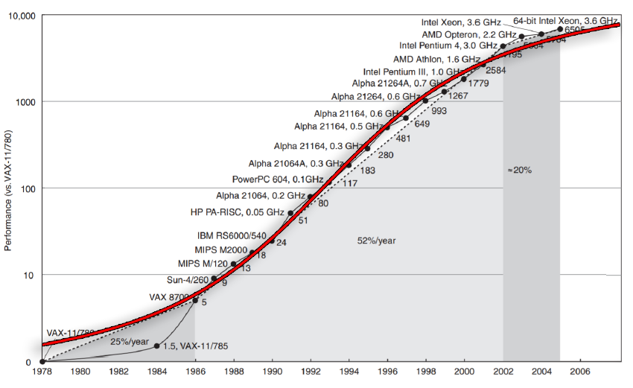

Major historical computing paradigms
- Batch mode Processing
  - IN the earliest days of computing, from 1950s onward, the most common paradigm was batch mode processing, Programs had to be loaded up and then run. You would have to wait some time, maybe a day or even more, for an output from that program
- Time Sharing
  - Time-sharing was where there was one centralized processing system (CPU) serving many terminals, but you could log in to them and then communicate with a CPU
- Personal Computer
  - The PC really brought the entire computer into one box. It was a big boom of the 1980s. Big companies, such as Microsoft, were involved with the development of the PC.
- Networking
  - Networking was always present, however, became very prevalent in the 1990s with the internet allowing us to then have PCs talk to each other across the network.
- Embedded Systems
  - The last 20 years has seen an emergence of things like embedded computing, where we start to actually place computers not on the desktop anymore, but within other things. For example, the way a car is driven these days is primarily via a computer embedded within a bigger system.
- Super Computers and GPU
  - The last decade has seen the emergence of graphic processing units (GPU) and GPU accelerated supercomputers, which are very large rooms of GPUs providing massively parallelised programming

