Lab 1

5:
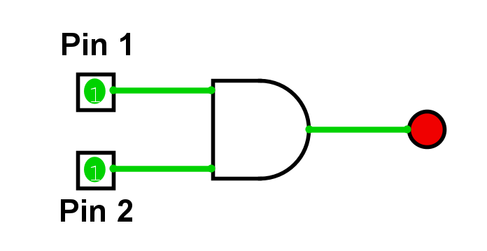 | AND
 | 1 | 0 | 0
 | 0 | 1 | 0
 | 1 | 0 | 0
 | 1 | 1 | 1

8:
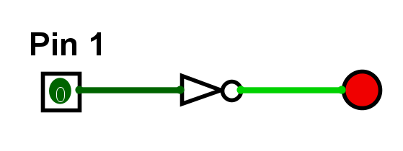 | NOT
 | 0 | 1
 | 1 | 0

10:
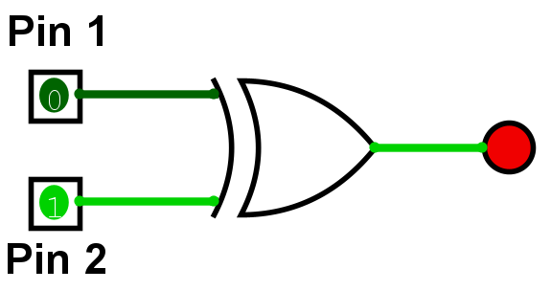 | XOR
 | 0 | 0 | 0
 | 1 | 0 | 1
 | 0 | 1 | 1
 | 1 | 1 | 0

12:
XNOR gate is required and thus A and B are required to be the same for the result to be true. To write this in boolean algebraic form is done as follows:
A⊙B or (A⋅B)+(!A⋅!B)

13:
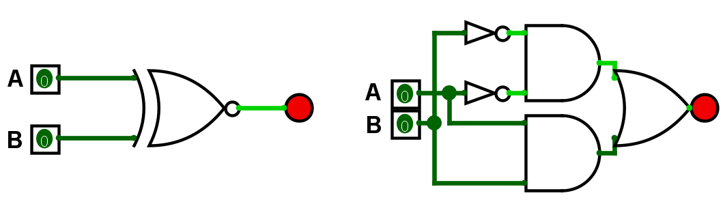

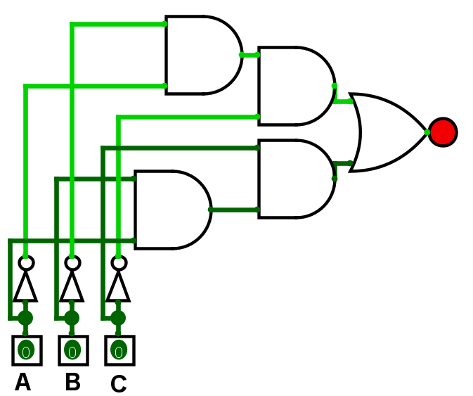
15:
A | B | C | Output
0 | 0 | 0 | 1
1 | 0 | 0 | 0
0 | 1 | 0 | 0
0 | 0 | 1 | 0
1 | 1 | 0 | 0
1 | 0 | 1 | 0
0 | 1 | 1 | 0
1 | 1 | 1 | 1

