Use Case 2 Student Guide: Predictive Analysis of NYC Building Energy Usage

The challenge
Can we use information from existing buildings to estimate how much energy another building might consume?
In this use case, you will use building characteristics to create a simple prediction of energy consumption for multifamily buildings in NYC. This analysis will help us understand the drivers of building energy usage and help NYPA benchmark it and provide energy efficiency programs to targeted buildings.
Your team gets a dataset of NYC multifamily buildings prepared and cleaned by the New York Power Authority (NYPA): each building's size, age, units, bedrooms, height and other features, plus its annual energy use.
Why this matters: conducting building energy consumption analysis is essential for New York City because buildings are one of the largest sources of greenhouse gas emissions, and understanding energy use is critical to meeting the goals established by New York State's Climate Leadership and Community Protection Act (CLCPA) and NYC Local Law 97. Energy consumption analysis helps building owners identify efficiency opportunities, reduce operating costs, track emissions and demonstrate compliance with increasingly stringent carbon reduction requirements. As a leader in advancing New York's clean energy transition, NYPA supports its customers through energy efficiency programs, benchmarking and analytics tools, and technical expertise that help organizations reduce energy use, lower emissions and accelerate progress toward decarbonization goals.
Deliverables and submission package:
- Calculated energy consumption per square footage
- Charts and graphs showing how energy consumption varies by construction year, building size and building height
- One simple prediction method
- A comparison between predicted and actual energy consumption
- A presentation displaying the results
- A brief explanation of the findings

Choose your level
Every team must finish the Minimum deliverable first. Move up only once it works.
Level | Suggested project | Expected deliverable
Minimum | Simple Building Energy Predictor | Calculate average energy usage per square foot for multifamily building records. Map out the variation of energy usage per square foot based on building year, building height and number of bedrooms. Test at least two prediction methods on the same testing file and compare their performance on the same evaluation metrics.
Intermediate | Building Energy Prediction Model | Use simple linear regression to predict energy consumption based on building size. Compare predictions with actual values.
Advanced | Building Energy Prediction Dashboard | Include additional building characteristics, compare prediction methods, evaluate accuracy and display results in an interactive dashboard.
Every level ends with a short presentation of the results.

Key ideas
Site energy is all the energy a building used in a year, measured at its meters: electricity, natural gas, steam and fuel oil, converted to one unit, kBtu (thousand British thermal units). For scale, 1 kWh of electricity = 3.412 kBtu.
Weather normalized means the number has been adjusted to what the building would have used in a year of average weather. A cold winter or hot summer would otherwise make a building look worse than it is. Use the weather-normalized value as your target.
Energy use intensity (EUI) is energy per square foot. It is not in the data file: you calculate it from two fields that are, as shown below. It lets you compare a small walk-up with a large tower:
EUI (kBtu/ft²) = weather-normalized site energy (kBtu) ÷ gross floor area (ft²)
Big buildings use more energy in total, so total energy mostly tells you about size. EUI tells you about efficiency.
A prediction is your model's estimate for a building. The error (also called the residual) is actual minus predicted. A large positive error means the building used much more than the model expected, which may make it a target for an efficiency program.
Test on buildings the model did not see. NYPA has already split the buildings into two files: a training file (about 80% of buildings) to build your model and a testing file (about 20%) to check it. Every team uses the same split, so results can be compared fairly. Never use the testing file to build or adjust your model. A model checked only on the buildings it was built from will look better than it really is.
How far off is the model?
Measure | What it means | Better when
Mean absolute error (MAE) | Average size of the error, in kBtu | Lower
Mean absolute percentage error (MAPE) | Average error as a percent of actual use | Lower
R² | Share of the variation in energy use the model explains, from 0 to 1 | Higher
Always compare your model with a simple baseline, such as "floor area × the median EUI". A model is only useful if it beats the baseline.

The dataset
NYPA provides two tables of NYC multifamily buildings in the data folder, already prepared, cleaned and split: a training file with 9,976 buildings (80%), multifamily_building_energy_consumption_training_dataset.csv, and a testing file with 2,495 buildings (20%), multifamily_building_energy_consumption_testing_dataset.csv. Both have the same columns, including actual energy use. One row is one building, with its characteristics and its annual energy use. Field names follow the ENERGY STAR Portfolio Manager tool that NYC buildings use to report energy. Every column is explained in Data_Dictionary.docx.
Group | Fields | Role
Energy use | Weather Normalized Site Energy Use (kBtu) | Target: what you predict
Size | Largest Property Use Type – Gross Floor Area (ft²) | Predictor
Age and use | Year Built; Occupancy (% of the building occupied) | Predictors
Units and bedrooms | Total Number of Residential Living Units; Number of Bedrooms; and each as a density per 1,000 ft² | Predictors
Height | Units in a High-Rise Building (10 or more stories); Units in a Mid-Rise Building (5–9 stories); and each as a density | Predictors
Equipment | Percent That Can Be Heated; Percent That Can Be Cooled; Laundry Hookups in All Units; Laundry Hookups in Common Area(s) | Predictors
Residents | Resident Population Type (a category, such as senior or student housing) | Predictor
Field you will create.
- EUI = energy ÷ gross floor area, in kBtu/ft²

Your five hours
Have EUI calculated and a first chart by the 1:30 checkpoint, then spend the middle of the day on prediction.
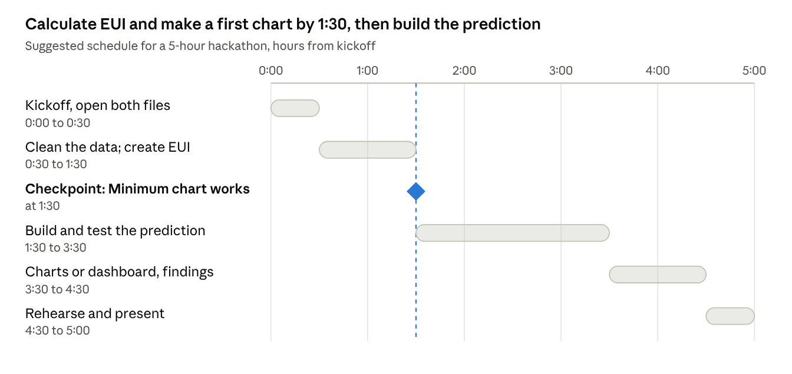
suggested schedule · 5 hours, 1 checkpoint
Split the work so nobody waits on anyone else:
Role | Owns
Data lead | Loading both files, cleaning, creating EUI in each
Modeler | The baseline and the prediction method; error measures
Visualization lead | Charts, labels, colors; the dashboard at Advanced level
Presenter | The 3-minute demo script and timekeeping; drafts the findings and the "what cannot be concluded" statement
Teams of three can merge Modeler and Presenter.

How to build each level
Your team chooses the tools. We provide the data; how you analyze and present it is up to you. Use Python or R for the models, and any tool you like for charts and dashboards, such as Power BI, Tableau or Looker Studio. Pick what your team already knows.

Minimum: simple building energy predictor
- Open the training file and add an EUI column: energy ÷ gross floor area.
- Calculate the average and the median EUI across the training buildings. The median is less affected by a few extreme buildings.
- Chart how EUI varies by building year, building height and number of bedrooms.

Intermediate: building energy prediction model
- Use the training file to build the linear regression model and the testing file to test your trained model. Both are provided; do not re-split the data. In Python or R, any linear regression function works.
- Compare predictions with actual values. And Calculate MAE, MAPE or R² on the test buildings
- Look at the 10 buildings with the largest errors. What do they have in common?
Tip: a few very large buildings can dominate the line. Try a chart with log scales, and check whether the model works as well for small buildings as for large ones.

Advanced: building energy prediction dashboard
- More predictors: add characteristics such as year built, units, bedrooms, high-rise and mid-rise units, percent heated and cooled, laundry hookups and resident population type. Turn categories into 0/1 columns. Add them to your methods and show how much the extra features improve accuracy on the testing file.
- Compare methods: test at least two methods on the same testing file, for example multiple regression, ridge regression, lasso regression, a decision tree model, random forest or a gradient boosting model if your team knows them. Compare their performance on the same evaluation metrics.

Then build a dashboard: filters for building year and building height, a predicted vs actual chart and a list of the buildings using the most energy above their prediction. Those are the buildings an efficiency program might visit first.
Never use energy use itself, or anything calculated from it such as EUI, as a predictor of energy use. The model would look perfect and be useless.

Demo and judging
You have about three minutes. Cover, in order: your question, the data you used and what you removed, your charts (live, not a screenshot), your prediction method and how accurate it is, your findings and your "what cannot be concluded" statement.
The "what cannot be concluded" statement is part of the Minimum deliverable. Name at least one thing your audience might assume from your results that the data does not prove. For example:
- Older buildings using more energy per square foot does not prove that age itself causes it; older buildings may also differ in heating systems or upgrades.
- A building using more than predicted is not proof it is wasteful; it may have features the data does not capture.
- A model that works on these buildings may not work for offices, schools or buildings outside NYC.

Criterion | Weight | What judges look for
Data & Technical Execution | 30% | Accuracy of analysis, soundness of methodology, appropriateness of assumptions and overall technical rigor.
Visualization & Insights | 20% | Clarity and effectiveness of visualizations, whether key insights are immediately apparent, appropriate chart selection, dashboard usability, and ability to answer the business question at a glance.
Innovation, AI & Automation | 15% | Creative use of analytics techniques, AI/GenAI capabilities, machine learning, automation of data ingestion or processing, and innovative approaches to solving the problem.
Potential Business Impact | 15% | Practical value of the solution, applicability to real-world challenges, scalability, or decision-making impact.
Demo & Storytelling | 20% | Clear and compelling presentation, logical flow, effective communication of findings, ability to explain technical concepts, staying within time limits, and engaging delivery

Before you present, check:
- ☐ Energy use per square foot calculated
- ☐ Charts by construction year, building size and building height
- ☐ One prediction method, with predicted vs actual compared
- ☐ An error measure (MAE, MAPE or R²) and the baseline for comparison
- ☐ A short explanation of the findings
- ☐ A "what cannot be concluded" statement
- ☐ Number of buildings used and data source stated on the slide

Questions to explore
- How does EUI change with building year?
- Do high-rise buildings use more or less energy per square foot than low-rise buildings?
- Does a higher number of bedrooms go with more or less energy per square foot?
- How much better is a regression on floor area than simply using floor area × median EUI?
- Which single characteristic, added to floor area, improves the prediction the most?
- Are the prediction errors larger for small buildings or large ones?
- Which 10 buildings use the most energy above their prediction, and what do they have in common?

Source
- NYC multifamily building characteristics and annual usage data (prepared and cleaned by NYPA). Field names and definitions follow ENERGY STAR Portfolio Manager.

