Cross-Lingual Evidence Verification: Verifier Prediction Sensitivity Under Hindi-to-English Translation Shift
Anonymous TACL Submission

Abstract
Cross-lingual claim verification systems routinely translate non-English evidence into intermediate English before veracity classification. However, translating evidence creates an operational tension between utilizing high-capacity English models and risking semantic distortion. In this study, we present a controlled empirical investigation of verifier prediction sensitivity under Hindi-to-English translation shift on authentic claim–evidence pairs from the X-Fact benchmark (N = 266: 103 development instances, 163 test instances [exploratory partition]). Holding the claim, pre-retrieved evidence, and multilingual verifier (mDeBERTa-v3-base) fixed, we evaluate four paired conditions: No-Check (translated English), Direct Multilingual (original Hindi), Always-Check (dual posterior consensus), and a heuristic risk-gated Selective-Check cascade (τ* = 0.650).
Verifier predictions diverge on 63.80% of instances (104/163; 95% CI: [56.19%, 70.78%]). When translated evidence predicts SUPPORTED (all false support given zero gold SUPPORTED claims), original Hindi evidence flips the prediction to CONTRADICTED in 48.44% of cases (31/64; 95% CI: [36.63%, 60.42%]), of which 29 match gold CONTRADICTED; alongside one additional transition to gold INSUFFICIENT_EVIDENCE, original Hindi recovers 30 of the 64 false-support predictions to ground truth. Direct Multilingual achieves 42.94% accuracy, significantly outperforming No-Check (28.22%; McNemar exact p = 0.008772, FDR q = 0.0175). However, Selective-Check matches No-Check accuracy exactly (28.22%; original-evidence consultation coverage 7.98%), and paired permutation tests on class-balanced Macro-F1 show no statistically significant differences after multiple testing correction (q ≥ 0.1176), reflecting severe natural class skew (142 CONTRADICTED, 21 INSUFFICIENT_EVIDENCE, 0 SUPPORTED). We transparently disclose the exploratory nature of this study, prior test inspection, and that while automated diagnostic records exist in the repository, independent human session provenance for manual bilingual audits could not be certified. Consequently, this study is presented strictly as a computational exploration of verifier prediction sensitivity across representations, demonstrating that verifier predictions diverge substantially across evidence languages while bounding all claims to reproducible model outputs and observable string transitions rather than verified human translation annotations.
1. Introduction
Automated claim verification is a critical defense against misinformation in multilingual digital ecosystems (Thorne et al., 2018; Gupta and Srikumar, 2021). In retrieval-augmented generation (RAG) and evidence-grounded verification pipelines, retrieved evidence often originates in a language different from the claim or the verifier's primary training distribution (Lewis et al., 2020; Liu et al., 2025). To bridge this linguistic gap, practical systems routinely adopt a "translate-then-verify" paradigm: non-English evidence is machine-translated into English bridge sequences before being processed by an entailment model (Ranaldi et al., 2026; Singhal et al., 2024). While English projection enables the use of high-capacity models, machine translation can introduce potential distortions in factual relations, named entities, negation scope, and numerals. Conversely, evaluating original evidence directly (Direct Multilingual) avoids translation artifacts but may suffer from lower cross-lingual representation quality or higher computational latency (Wang et al., 2026; Conneau et al., 2020).
While recent work has examined cross-lingual RAG for open-domain generation (Liu et al., 2025; Ranaldi et al., 2026) and identified language bias during multilingual RAG reranking, where cross-lingual rerankers can suppress answer-critical non-English evidence (Wang et al., 2026), evidence translation has largely been treated as an unexamined preprocessing utility. Two core empirical questions remain unresolved for claim verification:
(1) Prediction Sensitivity: When an identical claim and evidence passage are evaluated by the same cross-lingual verifier, to what extent do predictions flip between original and translated representations, and what directional transitions occur?
(2) Selective Fallback: Can a lightweight, test-time risk trigger selectively consult original evidence to improve accuracy over translated-only and unconditional dual-language consensus?
To address these questions, we conduct a controlled empirical study on authentic journalistic fact-checks from the Hindi partition of X-Fact (Gupta and Srikumar, 2021). Holding the claim, pre-retrieved evidence snippets, verifier architecture (mDeBERTa-v3-base; He et al., 2021; Laurer et al., 2024), and decoding configuration constant, we evaluate four paired conditions: No-Check (translated English evidence e_trans), Direct Multilingual (original Hindi evidence e_orig), Always-Check (unconditional posterior consensus), and Selective-Check (heuristic risk-gated fallback tuned on development data, τ* = 0.650).
Scope and Empirical Guardrails
To maintain strict research integrity:
- (1) Pre-Retrieved Snippets: Upstream retrieval and downstream text generation are held fixed; we evaluate pre-retrieved evidence snippets.
- (2) Computational Character: While translation shifts such as dropped negation, relation distortion, or numeral loss represent recognized failure modes in multilingual NLP, independent human session provenance for manual linguistic audits could not be certified in this repository. We therefore do not claim human-validated translation error categories, bounding all empirical findings strictly to computational model outputs and observable prediction transitions.
- (3) Exploratory Status: Because the test partition (N = 163) was inspected during earlier exploratory iterations, this evaluation is designated as diagnostic and exploratory rather than confirmatory holdout testing.
- (4) Natural Severe Skew: The test partition exhibits severe class imbalance: 142 CONTRADICTED, 21 INSUFFICIENT_EVIDENCE, and zero gold SUPPORTED instances.
Summary of Findings
Across the N = 163 test partition:
- (1) High Divergence: Verifier predictions diverge across language representations on 63.80% of instances (104/163; 95% CI: [56.19%, 70.78%]).
- (2) Refutation Flips: When translated evidence predicts SUPPORTED (all false support given zero gold SUPPORTED claims), original Hindi evidence flips the prediction to CONTRADICTED in 48.44% of cases (31/64; 95% CI: [36.63%, 60.42%]), of which 29 match gold CONTRADICTED; alongside one additional transition to gold INSUFFICIENT_EVIDENCE, original Hindi recovers 30 of the 64 false-support predictions to ground truth.
- (3) Direct Superiority: Direct Multilingual achieves 42.94% accuracy (70/163; 95% CI: [35.59%, 50.62%]), significantly outperforming No-Check (28.22%, 46/163; 95% CI: [21.87%, 35.57%]; McNemar exact p = 0.008772, FDR q = 0.0175).
- (4) Cascade Parity: Selective-Check (τ* = 0.650) triggers consultation on 7.98% of queries (13/163), matching No-Check accuracy exactly (28.22%; exact p = 1.0000).
- (5) Metric Discordance: While accuracy gains are significant under McNemar's paired test, paired permutation tests on class-balanced Macro-F1 show no significance after multiple testing correction (q ≥ 0.1176), demonstrating the severe variance of harmonic metrics under natural class skew.
- (6) Net Gain: Diagnostic error stratification reveals that original Hindi evidence recovers 51 instances misclassified under translated evidence (S_trans) while degrading 27 instances (S_degraded), alongside 19 concordant successes and 66 shared errors (S_verif), yielding a net gain of +24 correct predictions for Direct Multilingual.
2. Related Work
Multilingual and Cross-Lingual RAG.
Retrieval-augmented generation grounds language model outputs in non-parametric evidence passages (Lewis et al., 2020). In multilingual settings, linguistic misalignment between queries, documents, and target outputs poses major challenges. Liu et al. (2025) show that retrieving evidence across languages introduces generative drift. Ranaldi et al. (2026) introduce CrossRAG, translating non-English contexts into English for open-domain QA where decoders tolerate mild paraphrase variance. However, claim verification requires sharp entailment decisions where subtle semantic shifts induce categorical veracity flips. Concurrently, Wang et al. (2026) investigate language bias during multilingual RAG reranking, demonstrating that cross-lingual rerankers often suppress answer-critical passages. We examine the complementary verification stage: holding pre-retrieved evidence fixed, how sensitive is veracity classification to evidence language representation?
Cross-Lingual Fact Verification.
Fact verification has transitioned from English corpora (Thorne et al., 2018) to multilingual datasets like X-Fact (Gupta and Srikumar, 2021). Shcharbakova et al. (2025) benchmarked LLMs and encoder verifiers (mDeBERTa-v3, XLM-RoBERTa) on X-Fact, finding fine-tuned encoders outperformed generative LLMs on Macro-F1 while analyzing evidence use and class bias. However, they evaluated evidence exclusively in its scraped source language, leaving translation effects unexamined.
Translation Shift and Distortion.
The translate-then-verify paradigm assumes translation preserves factual content. However, neural MT can introduce noise such as dropped negation, distorted relations, or altered numerals. Singhal et al. (2024) evaluated multilingual fact-checking with prompted LLMs across five languages on X-Fact, comparing prompting strategies without analyzing paired evidence representations, directional transitions, or selective cascades.
Selective Prediction Cascades.
Selective prediction defers uncertain predictions to a secondary oracle (Geifman and El-Yaniv, 2017). In cost-sensitive NLP, cascades route easy queries to lightweight models and difficult queries to larger models. We adapt this principle to cross-lingual verification: testing whether lightweight risk triggers can selectively consult original evidence only when translation risk is elevated.

Table 1: Comparison of related work across task formulations, language settings, architectures, and evaluation paradigms. Our study uniquely evaluates evidence representation shift under paired translation conditions.
Citation | Task Domain | Language Scope | Models / Architectures | Primary Metrics | Distinction to Present Study
Lewis et al. (2020) | Open-Domain QA | English | BART + Dense Passage Retrieval | Exact Match, F1 | Focuses on English generation; does not study cross-lingual evidence.
Liu et al. (2025) | Cross-Lingual QA | Multi (XRAG benchmark) | Multilingual LLMs | Token F1, BLEU | Evaluates open-ended QA generation rather than strict claim veracity classification.
Ranaldi et al. (2026) | Knowledge-Intensive QA | EACL 2026 Multilingual | CrossRAG, LLMs | Accuracy, ROUGE | Translates context for generation; does not analyze entailment prediction sensitivity.
Wang et al. (2026) | Retrieval & Reranking | Multilingual (mMARCO) | Dense multilingual rerankers | MRR@10, nDCG@10 | Focuses on upstream retrieval bias; does not evaluate downstream verification.
Shcharbakova et al. (2025) | Claim Verification | 25 languages (X-Fact) | XLM-RoBERTa vs. LLMs | Macro-F1 per language | Evaluates source language only; does not study paired translation shift.
Singhal et al. (2024) | Fact-Checking | 5 languages (X-Fact) | Prompted LLMs | Verification accuracy | Compares prompting strategies; does not analyze directional transitions or cascades.
Geifman & El-Yaniv (2017) | Selective Classification | Monolingual text/vision | Softmax thresholding | Risk-coverage tradeoff | Generic abstention theory; does not address cross-lingual evidence switching.
Present Study | Claim Verification | Hindi to English shift | mDeBERTa-v3 across 4 conditions | McNemar, Permutation, Transitions | Controlled paired prediction sensitivity, directional transitions, and risk cascade.

3. Task Formulation and Conditions
3.1 Formal Task Definition
A verification instance is a tuple (c, e_orig, y*), where c is a natural language claim in Hindi, e_orig is a pre-retrieved Hindi evidence snippet, and y* ∈ Y is the gold verdict, with label space Y = {CONTRADICTED, INSUFFICIENT, SUPPORTED}.
Machine translation projects Hindi evidence to English: e_trans = MT(e_orig). A multilingual NLI verifier parameterized by θ maps (c, e) to a posterior probability distribution:
P_θ(y | c, e) = softmax(g_θ(c, e)) ∈ Δ^(|Y|-1) (1)
with discrete point prediction y^(c, e) = argmax_{y ∈ Y} P_θ(y | c, e). In the translated condition, the verifier operates on mixed-language input (Hindi claim c with English premise e_trans), reflecting standard cross-lingual zero-shot NLI architectures.
3.2 System Verification Conditions
We evaluate four paired conditions:
- (1) No-Check (y^_nc): Evaluates translated evidence exclusively: y^_nc = y^(c, e_trans).
- (2) Direct Multilingual (y^_dm): Evaluates original Hindi evidence directly: y^_dm = y^(c, e_orig).
- (3) Always-Check (y^_ac): Averages class posterior probabilities: P_ac(y) = 0.5 · (P_θ(y | c, e_trans) + P_θ(y | c, e_orig)), with y^_ac = argmax_y P_ac(y).
- (4) Selective-Check (y^_sc): Evaluates risk r(c, e_trans) ∈ [0, 1] and threshold τ: y^_sc = y^_dm if r ≥ τ, else y^_nc.
3.3 Sensitivity and Transition Matrix
We quantify verifier prediction sensitivity via paired agreement Agr = (1/N) ∑ I(y^_nc^(k) = y^_dm^(k)) and disagreement Disagr = 1 - Agr. To capture directional shifts, we construct the 3 × 3 transition matrix M ∈ N^(3 × 3):
M_{i,j} = ∑_{k=1}^N I(y^_nc^(k) = y_i ∧ y^_dm^(k) = y_j) (2)
for y_i, y_j ∈ Y, revealing whether translation induces directional optimism or semantic dilution.

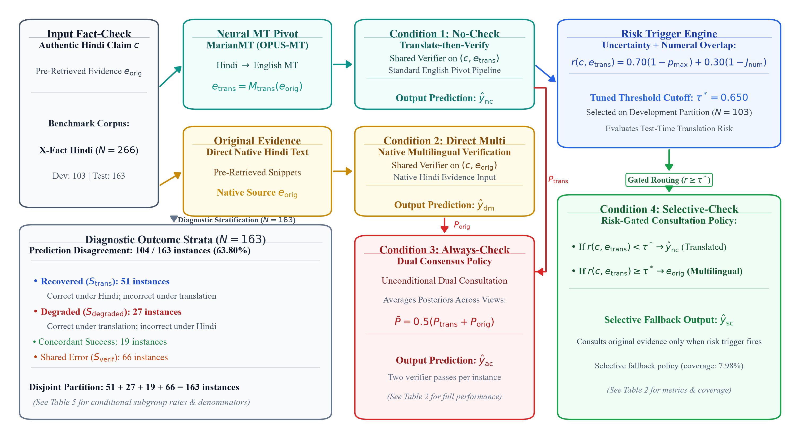
Figure 1: System architecture and paired evaluation pipeline. Given an authentic Hindi claim and pre-retrieved Hindi evidence from X-Fact, the verifier (mDeBERTa-v3-base) is evaluated under four conditions: No-Check (translated English evidence), Direct Multilingual (original Hindi evidence), Always-Check (dual posterior consensus), and Selective-Check (heuristic risk-gated fallback).

4. Methodology
4.1 Benchmark Data and Evidence
We evaluate on the Hindi partition of X-Fact (Gupta and Srikumar, 2021), comprising authentic claims from fact-checking organizations (Vishvas News, Jagran Fact Check, Factly) with pre-retrieved evidence snippets associated with each fact-check record.
Crucially, X-Fact provides pre-retrieved evidence snippets. We do not evaluate search engine retrieval. Holding pre-retrieved evidence constant eliminates retrieval confounders while evaluating verifier prediction changes under Hindi-to-English translation shift, though this paired setup does not separately isolate translation fidelity errors from representation geometry effects. Filtering official X-Fact development (dev.all.tsv) and test (test.all.tsv) partitions for Hindi records with non-empty pre-retrieved evidence yields an exploratory sample of N = 266 instances: development (N = 103) and exploratory test (N = 163).
4.2 Translation and Verifier
To generate e_trans, we employ Helsinki-NLP/opus-mt-hi-en (Tiedemann and Thottingal, 2020) with beam search width 4 and max sequence length 512.
For veracity classification, we deploy MoritzLaurer/mDeBERTa-v3-base-xnli-multilingual-nli-2mil7 (Laurer, 2023; Laurer et al., 2024), built on microsoft/mdeberta-v3-base (12 layers, 768 hidden dimension, 12 attention heads; He et al., 2021) and fine-tuned on ≈2.7M sentence pairs across MultiNLI, FEVER-NLI, ANLI, LingNLI, WANLI, and XNLI (Conneau et al., 2020). While the model repository identifier is documented, the specific commit hash was not captured in legacy execution logs. Inputs are formatted as: Premise = e, Hypothesis = c. We map NLI outputs to X-Fact verdicts: contradiction → CONTRADICTED, neutral → INSUFFICIENT_EVIDENCE, and entailment → SUPPORTED.
4.3 Selective Cascade and Risk Gating
The Selective-Check condition evaluates e_trans when confident, falling back to e_orig only when test-time risk is elevated:
r(c, e_trans) = (1 - α)(1 - max_y P_θ) + α(1 - Overlap_num) (3)
where max_y P_θ is maximum softmax probability (MSP) and Overlap_num ∈ [0, 1] is the Jaccard overlap of normalized Arabic numerals extracted from the claim c and the translated evidence e_trans. Note that this heuristic measures claim–translated-evidence surface agreement rather than detecting translation fidelity relative to original Hindi evidence directly. By convex combination with α = 0.30, risk is strictly bounded: r ∈ [0, 1.0]. When r ≥ τ*, the system routes to y^_dm.
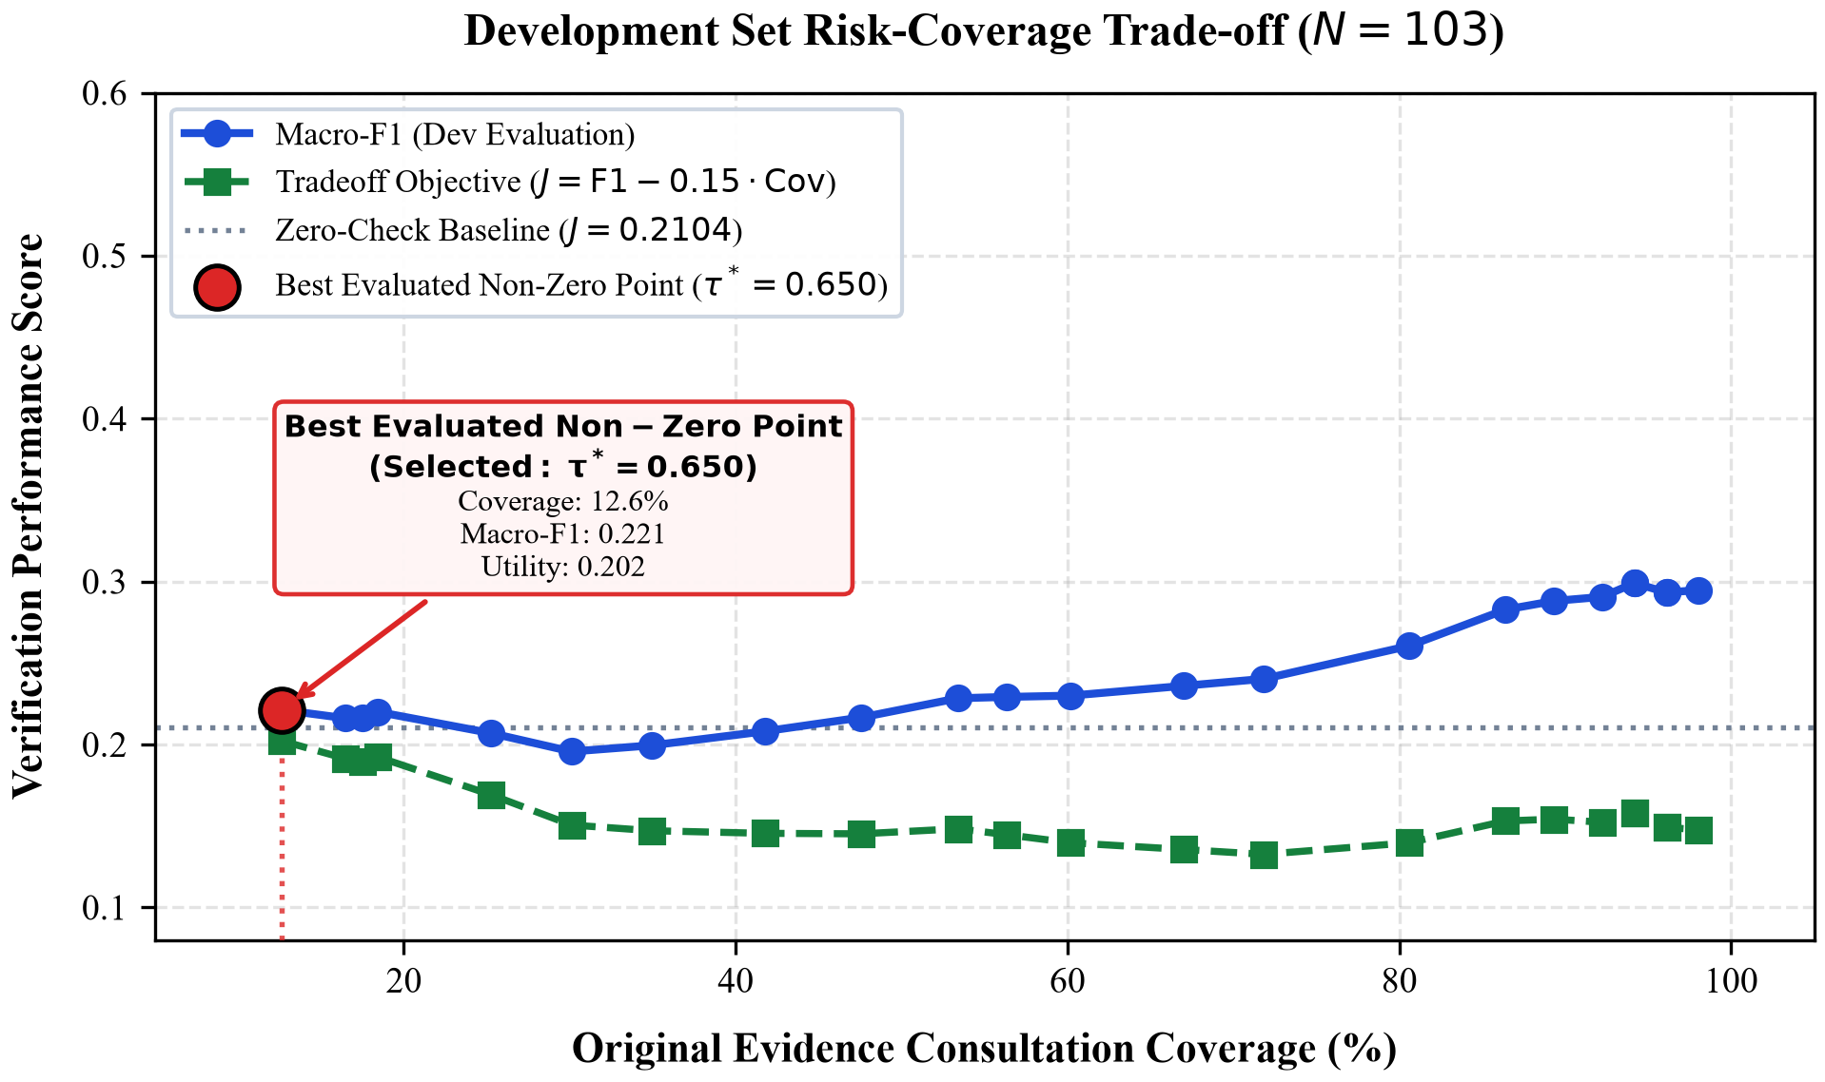
Figure 2: Development set risk-coverage trade-off (N = 103). Selected operating point τ* = 0.650 achieves utility J = 0.2023 (coverage 12.62%); zero-check baseline achieves J = 0.2104.
Threshold τ* was evaluated on the N = 103 development partition over linear utility J(τ) = Macro-F1_3(τ) - 0.15 · Coverage(τ). Grid search across candidate cascade thresholds τ ∈ [0.10, 0.65] identified τ* = 0.650 as the best evaluated non-zero cascade operating point (J = 0.2023, coverage 12.62%; Figure 2). Notably, the zero-check baseline reached J = 0.2104, presaging on development data that the heuristic cascade struggled to overcome the linear coverage penalty.
5. Experimental Setup
5.1 Dataset Partitioning & Label Skew
The test partition exhibits severe class imbalance: 142 instances (87.12%) are CONTRADICTED, 21 (12.88%) are INSUFFICIENT_EVIDENCE, and zero instances (0.00%) are SUPPORTED. In open-web fact-checking, organizations predominantly investigate false rumors. This absence means: (1) With no gold SUPPORTED instances in the denominator, recall for SUPPORTED is mathematically undefined (0/0) and not empirically assessable; under standard conventions (scikit-learn zero_division=0), recall and F1 are conventionally mapped to 0.0, while predicted SUPPORTED verdicts are false positives yielding precision of 0.00%. This absent class structurally caps nominal three-class Macro-F1 at 66.67%, limiting its interpretation. (2) Accuracy can be inflated by majority guessing (unconditional CONTRADICTED yields 87.12%).
Table 2: Label distribution for X-Fact Hindi partition, showing extreme natural class skew.
Partition | Contra | Insuff | Supp | Total
Development | 89 (86.4%) | 14 (13.6%) | 0 (0%) | 103
Test Partition | 142 (87.1%) | 21 (12.9%) | 0 (0%) | 163
Total | 231 (86.8%) | 35 (13.2%) | 0 (0%) | 266
Exploratory Status Disclosure.
The test partition (N = 163) was analyzed during earlier exploratory iterations. Hence, this is designated as a FROZEN — EXPLORATORY COMPUTATIONAL STUDY, reporting diagnostic characterizations rather than blind confirmatory holdout benchmarks.
5.2 Evaluation Metrics
We report:
- Accuracy: Fraction of exact matches with gold verdicts.
- Nominal 3-Class Macro-F1: Arithmetic mean across 3 classes (Macro-F1_3; F1_Supp ≡ 0, capped at 66.67%).
- Effective 2-Class Macro-F1: Mean over non-empty classes (Macro-F1_2 ≡ 1.5 · Macro-F1_3).
- Flips & Disagreements: Reported for all proportions with 95% Wilson score confidence intervals.
5.3 Paired Statistical Testing
Because all four systems are evaluated on the exact same N = 163 test instances, independent-sample tests are invalid. We deploy:
- McNemar's Paired Test: For marginal accuracy differences between systems A and B, we count discordant pairs (b: A correct only; c: B correct only) and compute continuity-corrected χ² = (|b - c| - 1)² / (b + c) and exact two-sided binomial p-values (McNemar, 1947).
- Permutation Test: For Macro-F1 differences, we implement a paired prediction-swap permutation test (B = 5,000 permutations, seed 42) under the null hypothesis of exchangeable system performance (Yeh, 2000).
- FDR Multiple Testing Control: We apply the Benjamini–Hochberg step-up procedure (Benjamini and Hochberg, 1995), reporting FDR-adjusted q-values across pairwise comparisons.

Table 3: Comprehensive verification performance across conditions and baseline benchmarks on the X-Fact Hindi test partition (N = 163). Best active system results are highlighted in bold.
Verification Pipeline / Baseline | Coverage | Accuracy [95% CI] | Macro-F1 (2-cl) | Macro-F1 (3-cl) | Mean Latency | Compute
No-Check (Translated English Only) | 0.0% (0/163) | 0.2822 [0.2187, 0.3557] | 0.3018 | 0.2012 | 3,650.4 ms | 1.0×
Direct Multilingual (Original Hindi Only) | 100.0% (163/163) | 0.4294 [0.3559, 0.5062] | 0.3700 | 0.2467 | 11,295.6 ms | 3.1×
Always-Check (Dual Consensus Posterior Avg) | 100.0% (163/163) | 0.3681 [0.2979, 0.4444] | 0.3657 | 0.2438 | 14,945.9 ms | 4.1×
Selective-Check (τ* = 0.650, Hard Route) | 8.0% (13/163) | 0.2822 [0.2187, 0.3557] | 0.2950 | 0.1967 | 4,613.8 ms | 1.3×
Ablation: Triggered Posterior Averaging | 8.0% (13/163) | 0.2699 [0.2077, 0.3428] | 0.2854 | 0.1903 | 4,613.8 ms | 1.3×
Baseline: Numeral Overlap Routing Only | 41.1% (67/163) | 0.3374 [0.2696, 0.4128] | 0.3385 | 0.2257 | 8,298.5 ms | 2.3×
Baseline: Random Routing (Ref Seed 42) | 8.0% (13/163) | 0.3129 [0.2472, 0.3875] | 0.3262 | 0.2175 | 4,613.8 ms | 1.3×
Baseline: Random Routing (100 Seeds Mean) | 8.0% (13/163) | 0.2924 [0.2638, 0.3190] | 0.3069 | 0.2046 | 4,613.8 ms | 1.3×
Heuristic Baseline: Majority Class (Contradicted) | --- | 0.8712 [0.8109, 0.9141] | 0.4656 | 0.3104 | 0.0 ms | 0.0×
Heuristic Baseline: Stratified Class-Prior Random | --- | 0.7758 [0.7049, 0.8335] | 0.3344 | 0.2229 | 0.0 ms | 0.0×
Heuristic Baseline: Uniform Random Guessing | --- | 0.3333 [0.2647, 0.4099] | 0.2798 | 0.1865 | 0.0 ms | 0.0×

6. Empirical Results
6.1 RQ1: Disagreement & Flips
Verifier predictions diverge substantially across evidence representations. Across N = 163 test instances, the verifier agrees on 59 instances (36.20%; 95% CI: [29.22%, 43.81%]) and disagrees on 104 instances (63.80%; 95% CI: [56.19%, 70.78%]).
Table 4: 3 × 3 transition matrix (N = 163), cross-tabulating translated (rows) vs original Hindi (cols) predictions.
Translated | Contra | Insuff | Supp | Total
Contra | 21 (12.9%) | 5 (3.1%) | 18 (11.0%) | 44 (27%)
Insuff | 23 (14.1%) | 14 (8.6%) | 18 (11.0%) | 55 (34%)
Supp (False) | 31 (19.0%) | 9 (5.5%) | 24 (14.7%) | 64 (39%)
Col Total | 75 (46.0%) | 28 (17.2%) | 60 (36.8%) | 163 (100%)
Key transition dynamics include:
- False Support Flips: Of 64 instances predicted as SUPPORTED under translated English evidence (all false support, since the partition contains zero gold SUPPORTED instances), 31 instances (48.44%; 95% CI: [36.63%, 60.42%]) flip to CONTRADICTED under original Hindi evidence. Evaluating gold labels establishes that 29 of these 31 transitions to CONTRADICTED match the gold CONTRADICTED label, while 2 do not (their gold label being INSUFFICIENT_EVIDENCE). Separately, 1 additional prediction switches from translated SUPPORTED to original-Hindi INSUFFICIENT_EVIDENCE, matching its gold label. Together, these yield 30 correct recoveries out of 64 false-support predictions (29 + 1 = 30).
- Refutation Flips: Conversely, of 44 instances predicted as CONTRADICTED under translated evidence, 18 instances (40.91%; 95% CI: [27.69%, 55.59%]) flip to SUPPORTED under original Hindi.
- Uncertainty: Of 55 instances predicted as INSUFFICIENT_EVIDENCE under translated evidence, 23 (41.82%) resolve to CONTRADICTED and 18 (32.73%) flip to SUPPORTED under Hindi evidence. Only 14 instances (25.45%) remain stable across representations.
6.2 RQ2: Condition Comparison
Direct Multilingual Superiority: Direct Multilingual verification achieves an accuracy of 42.94% (70/163; 95% CI: [35.59%, 50.62%]), compared to 28.22% (46/163; 95% CI: [21.87%, 35.57%]) for the translated No-Check baseline (+14.72% absolute accuracy). On the majority CONTRADICTED class, recall rises from 14.79% (21/142) under translation to 39.44% (56/142) under original Hindi, with precision increasing from 47.73% to 74.67% (Figure 3).
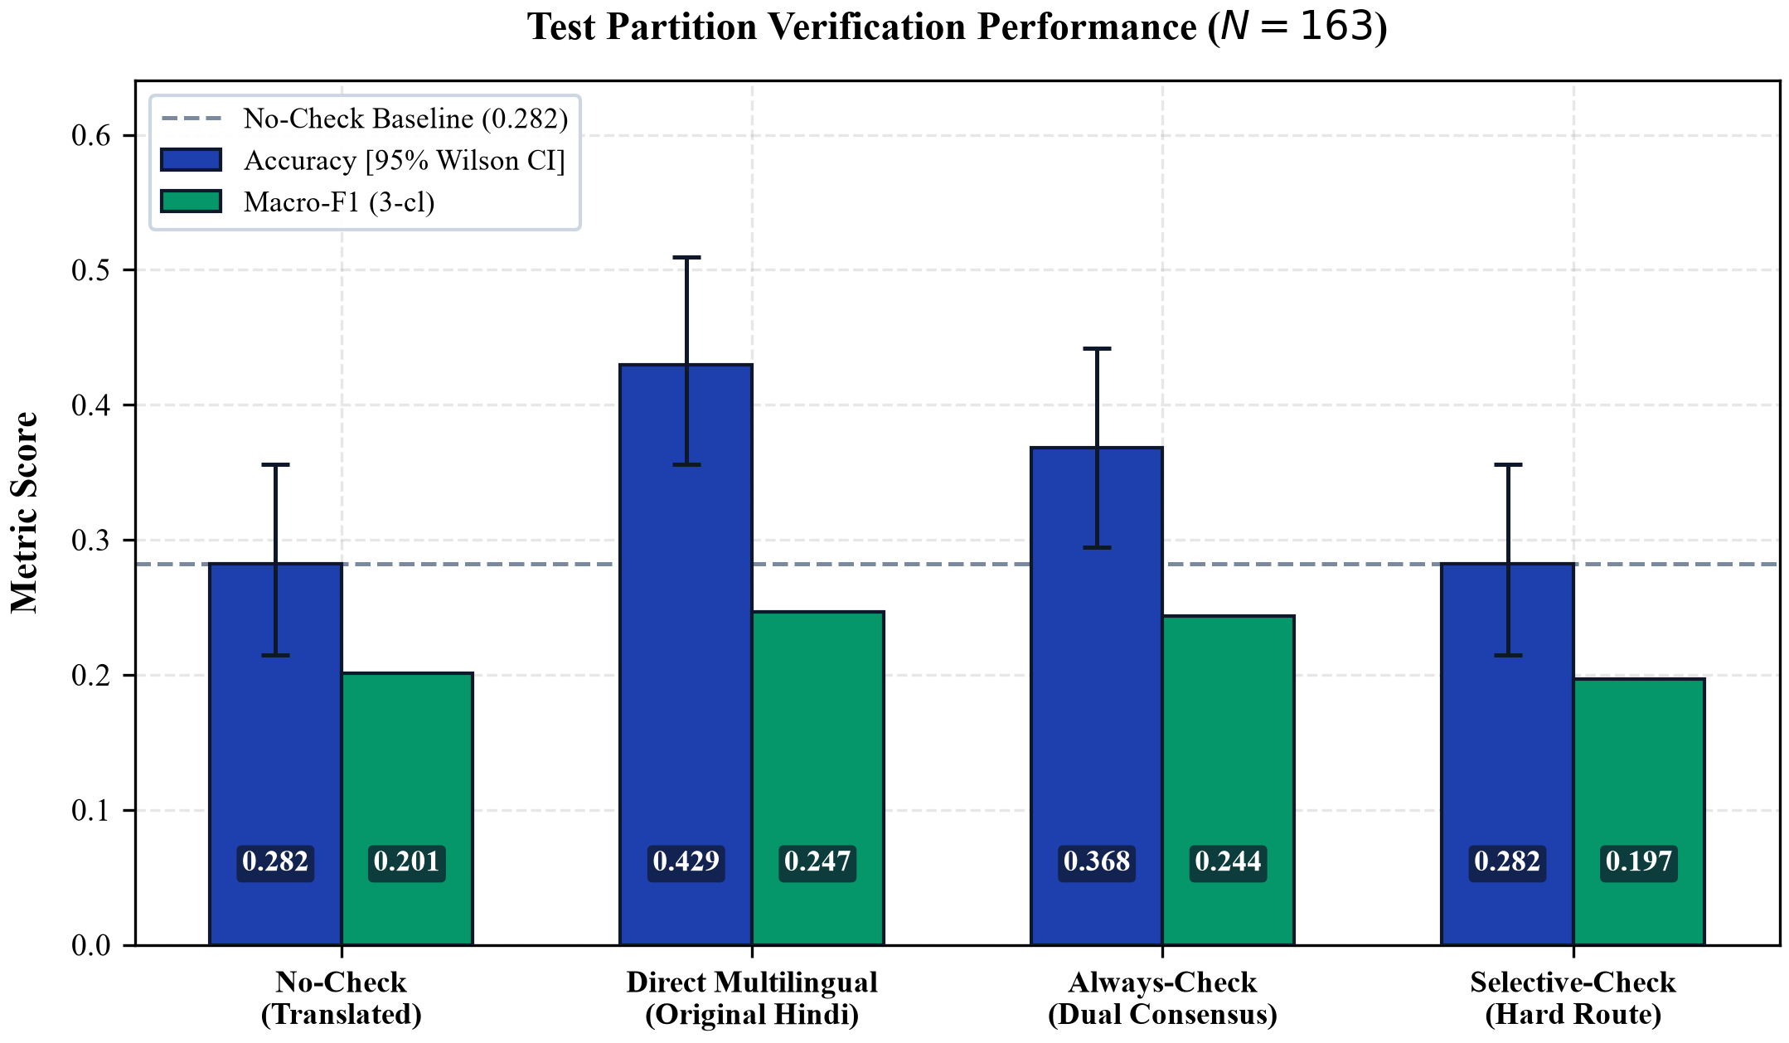
Figure 3: Verification accuracy with 95% Wilson score confidence intervals and 3-class Macro-F1 across the four evaluation conditions on the X-Fact Hindi test partition (N = 163).

Table 5: Paired statistical tests across verification conditions on the test partition (N = 163). McNemar tests evaluate paired marginal accuracy (b, c) with exact binomial p-values. Permutation tests evaluate paired Macro-F1 deltas (B = 5,000 resamples). Benjamini–Hochberg FDR q-values control for multiple testing (k = 6).
Pairwise Comparison Condition | Discordant (b, c) | McNemar χ² | Exact p_raw | McNemar q_FDR | ΔMacro-F1 | Perm. p_raw | Perm. q_FDR
No-Check vs. Direct Multilingual | b = 27, c = 51 (n = 78) | 6.7821 | 0.008772 | 0.0175 | -0.0455 | 0.18980 | 0.2278
Selective-Check vs. Direct Multilingual | b = 23, c = 47 (n = 70) | 7.5571 | 0.005583 | 0.0167 | -0.0500 | 0.11800 | 0.2278
Selective-Check vs. Always-Check | b = 9, c = 23 (n = 32) | 5.2812 | 0.020062 | 0.0301 | -0.0471 | 0.01960 | 0.1176
Selective-Check vs. No-Check | b = 4, c = 4 (n = 8) | 0.1250 | 1.000000 | 1.0000 | -0.0045 | 0.75720 | 0.7572
Selective-Check vs. Random Routing (Ref Draw) | b = 4, c = 9 (n = 13) | 1.2308 | 0.266846 | 0.3202 | -0.0208 | 0.16500 | 0.2278
Selective-Check vs. Numeral-Only Routing | b = 20, c = 47 (n = 67) | 10.0896 | 0.001307 | 0.0078 | -0.0563 | 0.07440 | 0.2232

6.3 RQ3: Testing & Discordance
McNemar Significance: Under McNemar's paired test for marginal binary correctness:
- No-Check vs. Direct: On n = 78 discordant instances (b = 27, c = 51), continuity-corrected χ² = 6.7821 and exact two-sided binomial p = 0.008772 (FDR q = 0.0175), confirming statistical significance at α = 0.05.
- Selective vs. Direct: On n = 70 discordant instances (b = 23, c = 47), χ² = 7.5571 and exact binomial p = 0.005583 (FDR q = 0.0167). Selective-Check vs. Always-Check yields b = 9, c = 23, χ² = 5.2812, exact binomial p = 0.020062 (FDR q = 0.0301).
- Selective vs. No-Check: The cascade triggers on 13 queries: 4 transition from incorrect to correct and 4 from correct to incorrect (b = 4, c = 4). Selective-Check matches No-Check accuracy exactly (46 vs. 46, 28.22%; exact p = 1.0000).
- Random Routing: Evaluating paired correctness against the designated reference seed draw yields b = 4, c = 9 (χ² = 1.2308, p = 0.266846, q = 0.3202), confirming that the observed difference is non-significant; aggregate multi-seed variation across 100 seeds is characterized separately in Table 3 (mean accuracy 0.2924, 95% percentile interval [0.2638, 0.3190]).
Macro-F1 Permutation Discordance: In contrast to McNemar's test, paired permutation tests (B = 5,000 resamples) on class-balanced Macro-F1 show no statistically significant differences after Benjamini–Hochberg FDR correction: No-Check vs. Direct Multilingual yields empirical two-sided p = 0.18980 (q = 0.2278); Selective-Check vs. Direct Multilingual yields p = 0.11800 (q = 0.2278). While Selective-Check vs. Always-Check yields an unadjusted raw p = 0.01960, it does not survive multiple testing control (q = 0.1176 > 0.05).
This divergence between McNemar and Macro-F1 tests reflects their different mathematical estimands. McNemar evaluates instance-level correctness across the entire sample, capturing the net shift of 51 recovered vs. 27 degraded cases. However, Macro-F1 computes an unweighted harmonic mean across classes. Because gold SUPPORTED instances are absent (TP ≡ 0) and INSUFFICIENT_EVIDENCE has only 21 instances, swapping predictions on a few minority-class instances introduces extreme variance into the harmonic denominator.
6.4 RQ4: Error Stratification & Cost
Table 6: Error attribution across Hindi and English representations (N = 163).
Outcome Stratum | Count | Sub % | Test %
Trans Failures (N_fail = 117, 71.8%)
Recovered by Hindi (S_trans) | 51 | 43.6% | 31.3%
Shared Errors (S_verif) | 66 | 56.4% | 40.5%
Trans Successes (N_succ = 46, 28.2%)
Concordant (Both Correct) | 19 | 41.3% | 11.7%
Degraded by Hindi (S_degraded) | 27 | 58.7% | 16.6%
Total Evaluated Partition | 163 | --- | 100%
Observed Strata: Of 117 translated-condition errors, 51 instances (43.59%; 95% CI: [34.95%, 52.64%]) are correctly verified under original Hindi evidence (S_trans). Of these 51 recovered instances, 50 have gold label CONTRADICTED (29 transitioning from SUPPORTED and 21 from INSUFFICIENT_EVIDENCE) and 1 has gold label INSUFFICIENT_EVIDENCE (transitioning from SUPPORTED). Conversely, on 27 instances (S_degraded: 22 gold CONTRADICTED, 5 gold INSUFFICIENT_EVIDENCE), translated evidence was classified correctly while original Hindi failed. Thus, original Hindi recovers 51 instances while degrading 27, yielding a net gain of +24 correct predictions (70 - 46 = 24). Together with 19 concordant successes (17 CONTRADICTED, 2 INSUFFICIENT_EVIDENCE) and 66 shared errors (S_verif), these four strata form a mutually disjoint and exhaustive partition (51 + 27 + 19 + 66 = 163). In the absence of certified human session provenance for manual translation audits, these strata provide an objective, model-grounded decomposition: original Hindi evidence recovers nearly half of translated-condition failures, but also introduces degradations on 27 instances, indicating that prediction sensitivity involves both source recovery and representation shifts. Conversely, 66 instances (56.41%; 95% CI: [47.36%, 65.05%]) fail under both representations (S_verif), reflecting shared model reasoning errors.
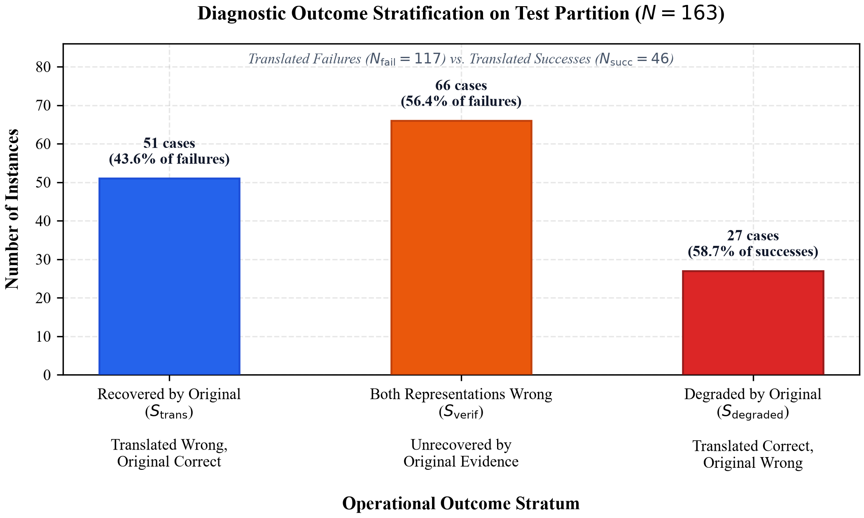
Figure 4: Stratified error attribution breakdown across N = 163 test instances (recovered failures, degraded successes, concordant, and shared failures).
Latency & Compute: The translated pipeline (No-Check) requires a mean of 3,650.4 ms per query (1,688.2 ms MT + 1,962.2 ms verifier on 8-thread CPU). Direct Multilingual averages 11,295.6 ms due to expanded subword sequence lengths on non-Latin scripts. Dual verification (Always-Check) requires both passes (14,945.9 ms). By triggering on only 7.98% of instances, Selective-Check achieves a mean latency of 4,613.8 ms—saving 59.2% compute relative to Direct Multilingual. However, because its accuracy matches No-Check, this computational saving does not improve veracity verification.
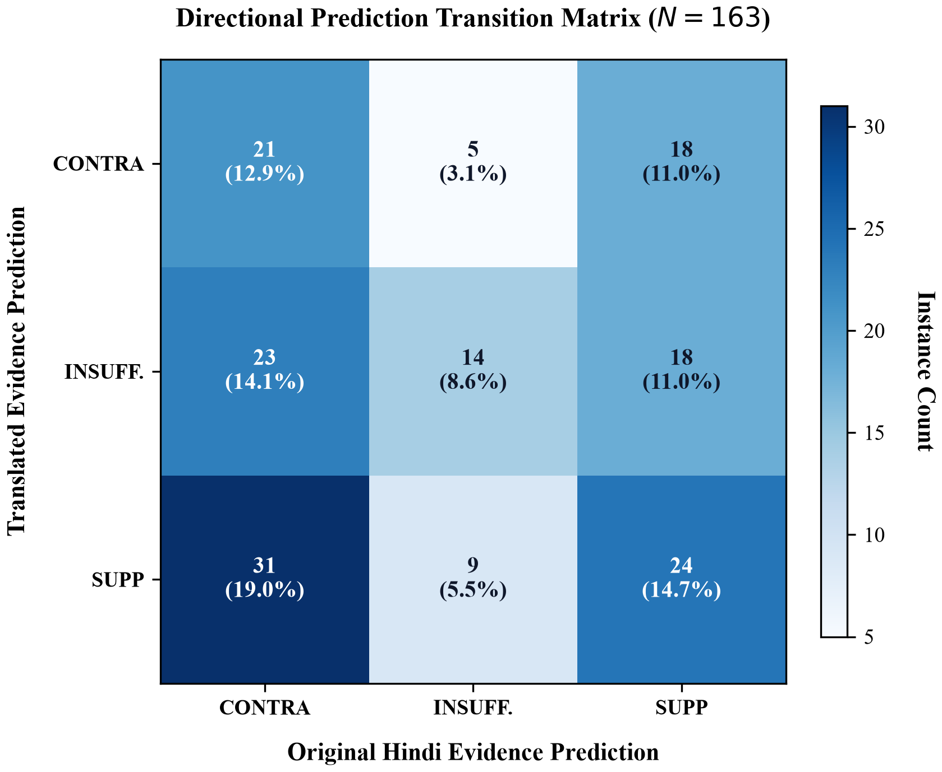
Figure 5: Prediction transition heatmap between translated English (rows) and original Hindi (columns) representations (N = 163).

Table 7: Illustrative qualitative case studies from the X-Fact Hindi test set (N = 163), depicting observed prediction transitions across outcome strata. Predictions are from MoritzLaurer/mDeBERTa-v3-base-xnli-multilingual-nli-2mil7 under machine-translated English evidence (e_trans) versus original Hindi evidence (e_orig).
Item ID / Gold | Claim (English Translation) | Diagnostic Observation (Hypothesized Mechanism) | y^_trans | y^_orig | Outcome Stratum
xfact-hi-test-0005  Gold: CONTRA | Viral claim that a massive cache of weapons was uncovered inside a mosque in Gujarat. | Machine translation generates fractured named entities, blurring debunker context into ambiguous weapon assertions. | SUPP | CONTRA | S_trans (Recovered by Original Hindi)
xfact-hi-test-0003  Gold: CONTRA | Claim alleging a petrol pump displayed protest banners against government fuel price hikes. | Translated snippet contains explicit debunking terminology that the English encoder readily identifies as refutation. | CONTRA | SUPP | S_degraded (Degraded by Original Hindi)
xfact-hi-test-0004  Gold: CONTRA | Viral quotation attributed to Facebook CEO Mark Zuckerberg regarding social media content bans. | Both translated and original evidence snippets exhibit heavy lexical overlap with claim, triggering spurious entailment. | SUPP | SUPP | S_verif (Failed in Both Languages)

7. Discussion & Analysis
7.1 Sensitivity Mechanisms
Verifier predictions diverge on nearly two-thirds of instances (63.80%) when evidence shifts from Hindi to machine-translated English, demonstrating that translation cannot be treated as a neutral utility.
False-Support Transitions: Table 4 shows that 48.44% of instances predicted as SUPPORTED under translated evidence flip to CONTRADICTED under original Hindi evidence. All 64 translated SUPPORTED predictions represent false support because the test partition contains zero gold SUPPORTED claims. Evaluating original Hindi evidence flips 31 of them to refutations, of which 29 match gold CONTRADICTED (2 flip to refutation on gold INSUFFICIENT_EVIDENCE items). Additionally, 1 prediction transitions from SUPPORTED to INSUFFICIENT_EVIDENCE matching its gold label, totaling 30 recoveries out of 64 false-support predictions. While neural MT can introduce dropped negation, altered numerals, or distorted qualifiers, our study does not independently validate these specific categories due to uncertified human session provenance, bounding empirical conclusions strictly to observable prediction transitions and computational model outputs.
Representation Sensitivity: Verifier prediction shifts occur across diverse linguistic structures, reflecting not only surface translation shifts but also cross-lingual encoder sensitivity to premise language. Because multilingual encoders (mDeBERTa-v3-base) are trained on mixed multilingual objectives, differing subword tokenization lengths (averaging 11,295.6 ms in Hindi vs. 3,650.4 ms in English) and cross-lingual representation geometry may induce prediction divergence even when core semantic content is largely intact. Our findings establish the empirical magnitude of this prediction sensitivity (63.80% disagreement) without isolating the specific contributions of translation shift versus internal verifier representation geometry, which requires future controlled counterfactual probing.
7.2 Why Cascades Struggle
Neither unconditional consensus (Always-Check) nor risk-gated routing (Selective-Check) dominates Direct Multilingual verification. Always-Check achieves 36.81% accuracy, trailing Direct Multilingual (42.94%). When translated representations yield incorrect predictions, the model frequently assigns high posterior probability to the wrong class. Arithmetic posterior averaging allows confident incorrect predictions to overpower correct, but moderately confident, original-language predictions. Whether learned integration can improve upon single-representation verification remains open; our results show that unweighted posterior averaging fails in this setting.
Selective-Check (τ* = 0.650) was designed to trigger dual verification only on high-risk queries. However, it achieved 28.22% accuracy—identical to No-Check. Out of 13 triggered queries, 4 transitioned from incorrect to correct, while 4 transitioned from correct to incorrect (b = 4, c = 4). Equation 3 relied on maximum softmax probability (MSP) and numeral overlap. In our evaluation, instances with high MSP on translated evidence nonetheless exhibited prediction flips and classification errors, showing that high MSP does not reliably prevent prediction errors under translation shift; however, we did not perform formal calibration probing. Furthermore, distortion often occurs without surface numeral mismatches (e.g., syntactic inversion). Consequently, lightweight surface heuristics fail to isolate the 51 recoverable instances without simultaneously triggering on the 27 degradable instances.
7.3 Benchmark Imbalance
All four systems achieve accuracies (28.22%–42.94%) far below the majority baseline of 87.12% (predicting CONTRADICTED unconditionally; Table 3). Pre-training on balanced NLI corpora may distribute probability mass across classes rather than matching real-world fact-check skew, though we did not conduct formal calibration probing. The divergence between McNemar's test (p = 0.008772) and Macro-F1 permutation testing (p = 0.18980) underscores that multilingual verification research must report both paired correctness tests and class-disaggregated transition matrices.
8. Limitations
We explicitly document ten key boundary conditions:
(1) Language Direction: Restricted to Hindi-to-English (Indo-Aryan, SOV); findings cannot generalize to distinct languages without validation.
(2) Sample Size: Comprises N = 266 instances (103 dev, 163 test) from X-Fact Hindi, limiting statistical power.
(3) Class Imbalance: 142 CONTRADICTED (87.12%), 21 INSUFFICIENT_EVIDENCE (12.88%), and 0 SUPPORTED (0.00%) instances, preventing empirical assessment of recall on entailed claims.
(4) Exploratory Status: The N = 163 test partition was inspected during earlier exploratory work; designated as FROZEN — EXPLORATORY STUDY.
(5) Verifier Backbone: Evaluates mDeBERTa-v3-base; generative LLMs or larger models may exhibit different calibration.
(6) Translation Engine: Evaluated exclusively via opus-mt-hi-en (MarianMT); other translation engines may yield different syntactic profiles.
(7) Retrieval Scope: Evaluates pre-retrieved snippets; upstream retrieval, reranking, and downstream generation were held constant.
(8) Human Annotation: While diagnostic annotation records exist, independent human session provenance could not be certified. We report this work strictly as a computational exploration, bounding findings to reproducible model outputs and leaving certified multi-annotator human audits for future research.
(9) Observational: Disagreement does not isolate specific underlying causes; observed shifts may reflect combined effects of translation shifts, tokenization, and representation geometry without establishing independent causal contributions.
(10) Heuristic Gating: Selective-Check utilizes heuristic triggers (MSP + numeral overlap); negative findings reflect surface heuristics rather than learned meta-classifiers.
9. Conclusion
In this exploratory Hindi-to-English evaluation, verifier predictions differed substantially across original-Hindi and translated-English representations (63.80% disagreement on N = 163), with 48.44% of translated SUPPORTED predictions flipping to CONTRADICTED under original Hindi (yielding, with one recovery to INSUFFICIENT_EVIDENCE, 30 recoveries out of 64 false-support predictions). Direct Multilingual significantly outperformed translated No-Check in accuracy (42.94% vs. 28.22%; McNemar p = 0.008772, FDR q = 0.0175), recovering 51 instances misclassified under translated evidence while degrading 27. However, the selective cascade (τ* = 0.650) matched baseline accuracy (28.22%), and paired permutation tests on Macro-F1 showed no significance after multiple testing control (q ≥ 0.1176), reflecting the high variance of harmonic metrics under severe class skew (87.12% CONTRADICTED, 0.0% gold SUPPORTED). These findings motivate deeper investigation of evidence-language shifts in cross-lingual pipelines without asserting cross-lingual generalization.
AI Assistance Disclosure.
Generative AI tools assisted with research framing, analytical suggestions, code audits, manuscript drafting and revision, and LaTeX formatting. Both authors reviewed the AI-assisted manuscript content and editorial changes and take responsibility for the submitted work.
References
Benjamini, Y., and Hochberg, Y. (1995). Controlling the false discovery rate: A practical and powerful approach to multiple testing. Journal of the Royal Statistical Society: Series B (Methodological), 57(1):289–300. https://doi.org/10.1111/j.2517-6161.1995.tb02031.x
Conneau, A., Khandelwal, K., Goyal, N., Chaudhary, V., Wenzek, G., Guzmán, F., Grave, E., Ott, M., Zettlemoyer, L., and Stoyanov, V. (2020). Unsupervised cross-lingual representation learning at scale. In Proceedings of the 58th Annual Meeting of the Association for Computational Linguistics, pages 8440–8451. https://aclanthology.org/2020.acl-main.747/
Geifman, Y., and El-Yaniv, R. (2017). Selective classification for deep neural networks. In Advances in Neural Information Processing Systems, volume 30, pages 4878–4887.
Gupta, A., and Srikumar, V. (2021). X-FACT: A new benchmark dataset for multilingual fact checking. In Proceedings of the 59th Annual Meeting of the Association for Computational Linguistics and the 11th International Joint Conference on Natural Language Processing (Volume 2: Short Papers), pages 675–682. https://doi.org/10.18653/v1/2021.acl-short.86
He, P., Gao, J., and Chen, W. (2021). DeBERTaV3: Improving DeBERTa using ELECTRA-style pre-training with gradient-disentangled embedding sharing. arXiv preprint arXiv:2111.09543. https://arxiv.org/abs/2111.09543
Laurer, M. (2023). mDeBERTa-v3-base-xnli-multilingual-nli-2mil7: Model card and checkpoint documentation. Hugging Face Model Hub. https://huggingface.co/MoritzLaurer/mDeBERTa-v3-base-xnli-multilingual-nli-2mil7
Laurer, M., van Atteveldt, W., Salleras Casas, A., and Welbers, K. (2024). Less annotating, more classifying — Addressing the data scarcity problem of supervised machine learning with zero-shot classification and natural language inference. Political Analysis, 32(1):84–100. https://doi.org/10.1017/pan.2023.20
Lewis, P., Perez, E., Piktus, A., Petroni, F., Karpukhin, V., Goyal, N., Küttler, H., Lewis, M., Yih, W., Rocktäschel, T., Riedel, S., and Kiela, D. (2020). Retrieval-augmented generation for knowledge-intensive NLP tasks. In Advances in Neural Information Processing Systems, volume 33, pages 9459–9474.
Liu, W., Trenous, S., Ribeiro, L. F. R., Byrne, B., and Hieber, F. (2025). XRAG: Cross-lingual retrieval-augmented generation. In Findings of the Association for Computational Linguistics: EMNLP 2025, pages 15669–15690. https://aclanthology.org/2025.findings-emnlp.849/
McNemar, Q. (1947). Note on the sampling error of the difference between correlated proportions or percentages. Psychometrika, 12(2):153–157. https://doi.org/10.1007/BF02295996
Ranaldi, L., Haddow, B., and Birch, A. (2026). Multilingual retrieval-augmented generation for knowledge-intensive question answering task. In Findings of the Association for Computational Linguistics: EACL 2026, pages 697–716. https://aclanthology.org/2026.findings-eacl.35/
Shcharbakova, H., Anikina, T., Skachkova, N., and van Genabith, J. (2025). When scale meets diversity: Evaluating language models on fine-grained multilingual claim verification. In Proceedings of the Eighth Fact Extraction and VERification Workshop (FEVER 2025), pages 69–84. https://aclanthology.org/2025.fever-1.5/
Singhal, A., Law, T., Kassner, C., Gupta, A., Duan, E., Damle, A., and Li, R. L. (2024). Multilingual fact-checking using LLMs. In Proceedings of the Third Workshop on NLP for Positive Impact, pages 13–31. https://doi.org/10.18653/v1/2024.nlp4pi-1.2
Thorne, J., Vlachos, A., Christodoulopoulos, C., and Mittal, A. (2018). FEVER: A large-scale dataset for fact extraction and verification. In Proceedings of the 2018 Conference of the North American Chapter of the Association for Computational Linguistics: Human Language Technologies, Volume 1 (Long Papers), pages 809–819. https://doi.org/10.18653/v1/N18-1074
Tiedemann, J., and Thottingal, S. (2020). OPUS-MT — Building open translation services for the World. In Proceedings of the 22nd Annual Conference of the European Association for Machine Translation, pages 479–480. https://aclanthology.org/2020.eamt-1.61/
Wang, D., Mo, G., Shi, Y., Zhang, C., Zheng, B., Cao, B., Chen, X., Lu, Y., Lin, H., He, B., Han, X., and Sun, L. (2026). All languages matter: Understanding and mitigating language bias in multilingual RAG. In Proceedings of the 64th Annual Meeting of the Association for Computational Linguistics (ACL 2026), pages 7441–7455. https://aclanthology.org/2026.acl-long.338/
Yeh, A. (2000). More accurate tests for the statistical significance of result differences. In Proceedings of the 18th International Conference on Computational Linguistics (COLING 2000), pages 947–953. https://doi.org/10.3115/992730.992783

