Experiment No. 1

Title:
Introduction to OOP Concepts
Aim:
Write a program to create a simplified Library Management System using object-oriented programming principles in Python. This system should manage books and patrons (library users), allowing for basic operations such as adding new books, registering patrons, borrowing books, and returning books.
Theory:
- Object-oriented programming (OOP) is a method of structuring a program by bundling related properties and behaviors into individual objects.
- A class is a blueprint that defines the attributes and methods of an object, while an instance is an actual object built from that class containing real data.
- Instance attributes are defined inside the __init__() method and vary from object to object, whereas class attributes are shared by every instance of the class.
- Instance methods are functions defined inside a class that always take self as their first parameter and operate on a particular object.
- Inheritance is the process by which a child class takes on the attributes and methods of a parent class, and it can override or extend them using super().
- Encapsulation bundles data and the methods acting on that data inside a single unit, keeping the internal state protected from outside interference.
- Dunder (magic) methods such as __init__() and __str__() customise object creation and how an object is displayed when printed.
Pseudocode:
1. Define the Book class with attributes title, author, isbn, is_borrowed and methods __init__(), borrow(), return_book().
2. Define the Patron class with attributes name, patron_id, borrowed_books and methods __init__(), borrow_book(), return_book().
3. Define the Library class with attributes books, patrons and methods add_book(), register_patron(), borrow_book(), return_book().
4. In the main program, create a library instance, add books and register patrons.
5. Perform borrow and return operations and display the relevant information after each step.

Experiment 1 Title:
Introduction to OOP Concepts
Experiment 1 Code:
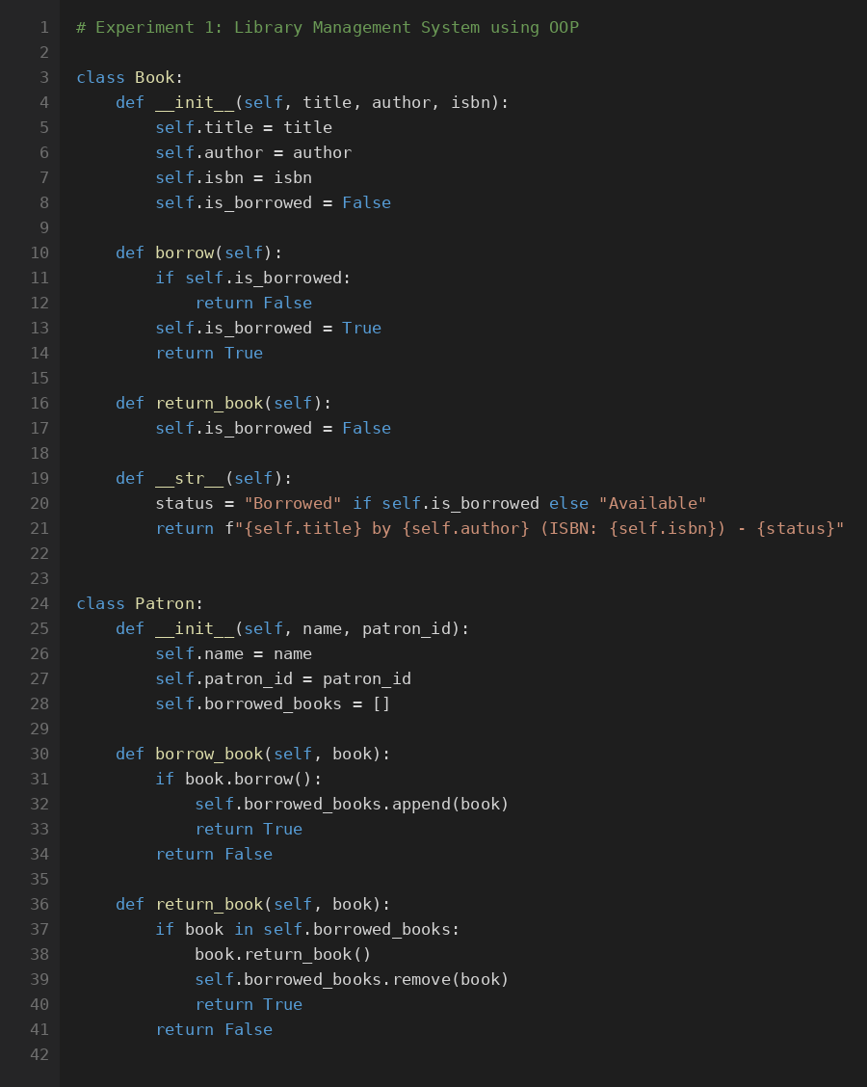
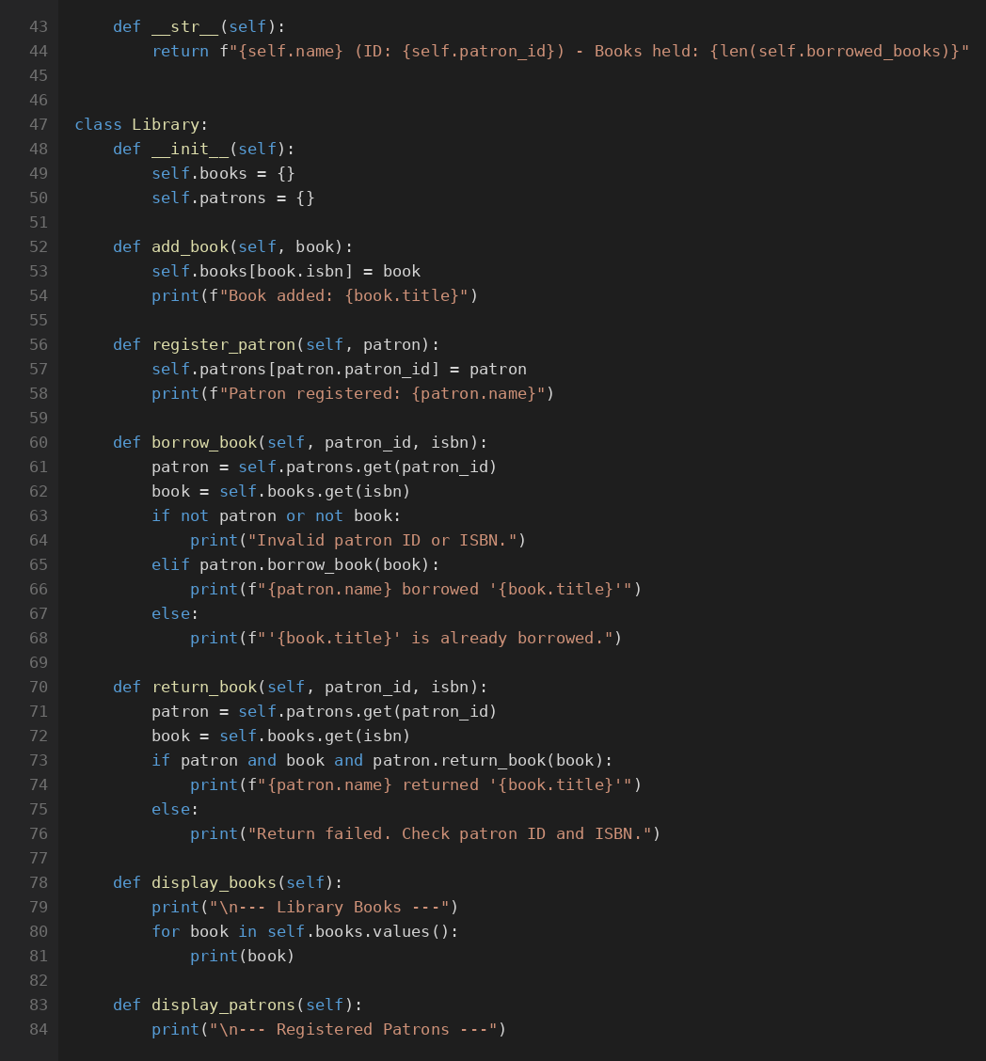
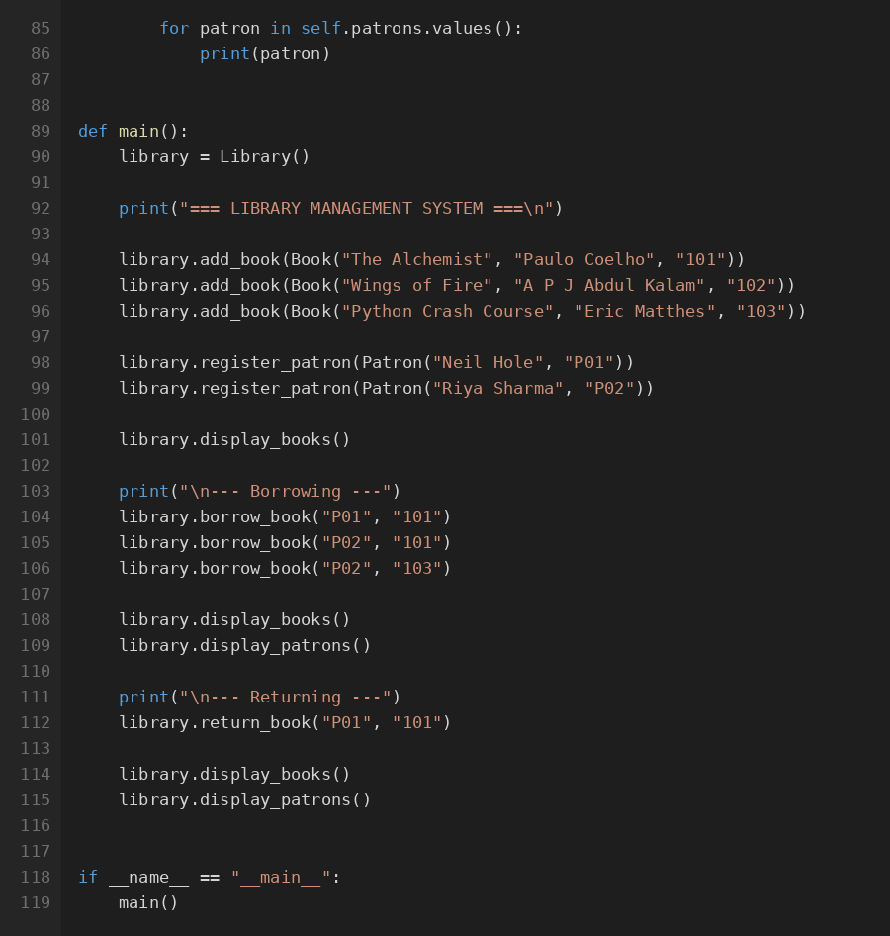
Experiment 1 Output (Screenshot):
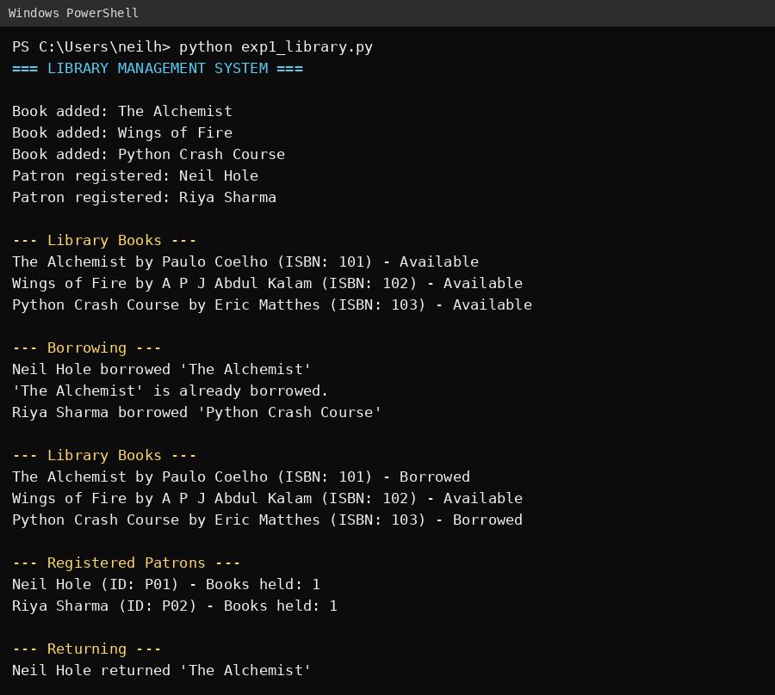
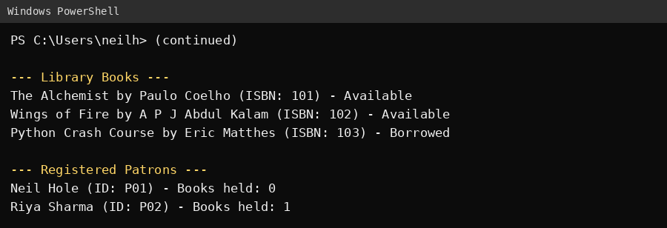

Bucket List Experiment Title:
8. Product with Magic Methods
Scenario: Create a Product class that allows adding products together (combining total cost), comparing prices, and printing readable output using magic methods.
Bucket List Experiment Code:
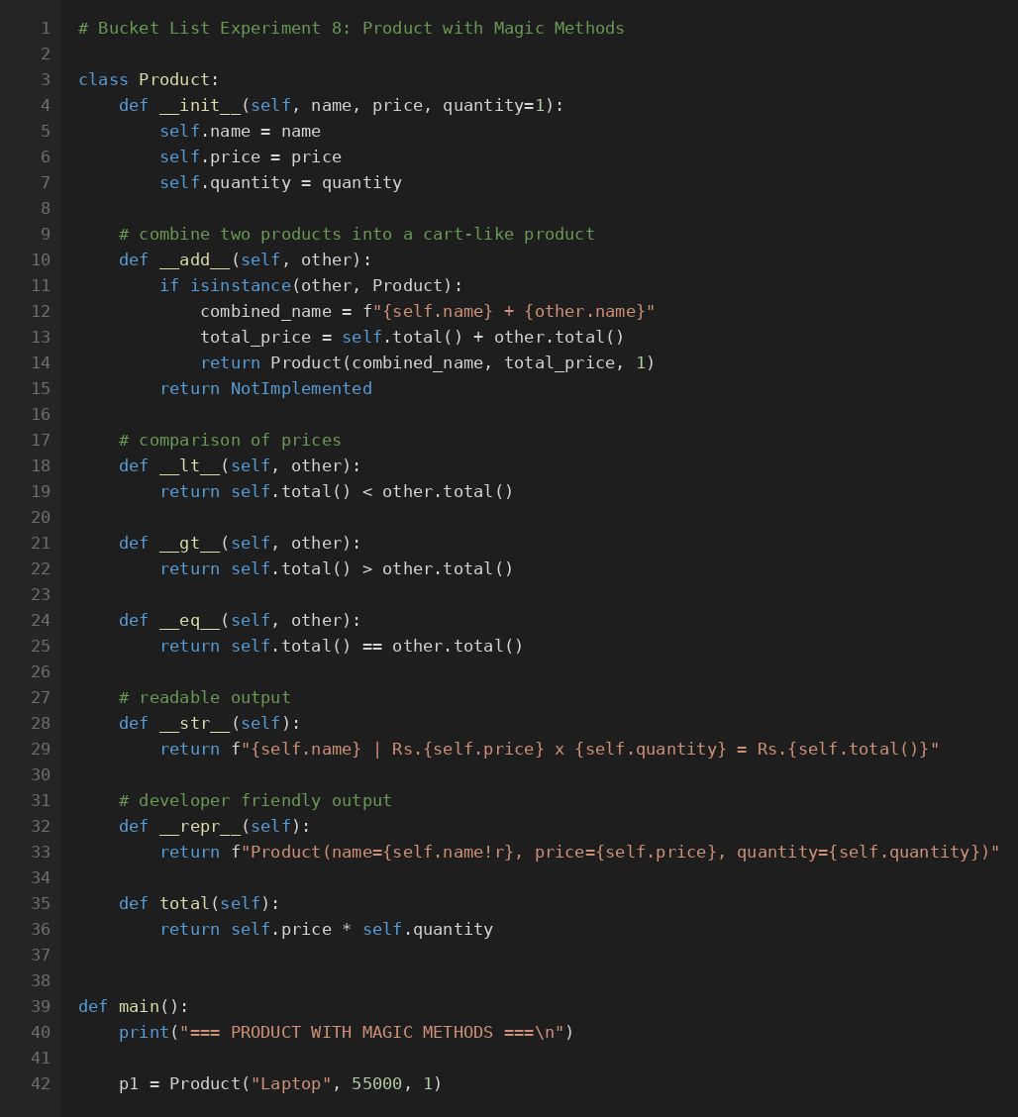
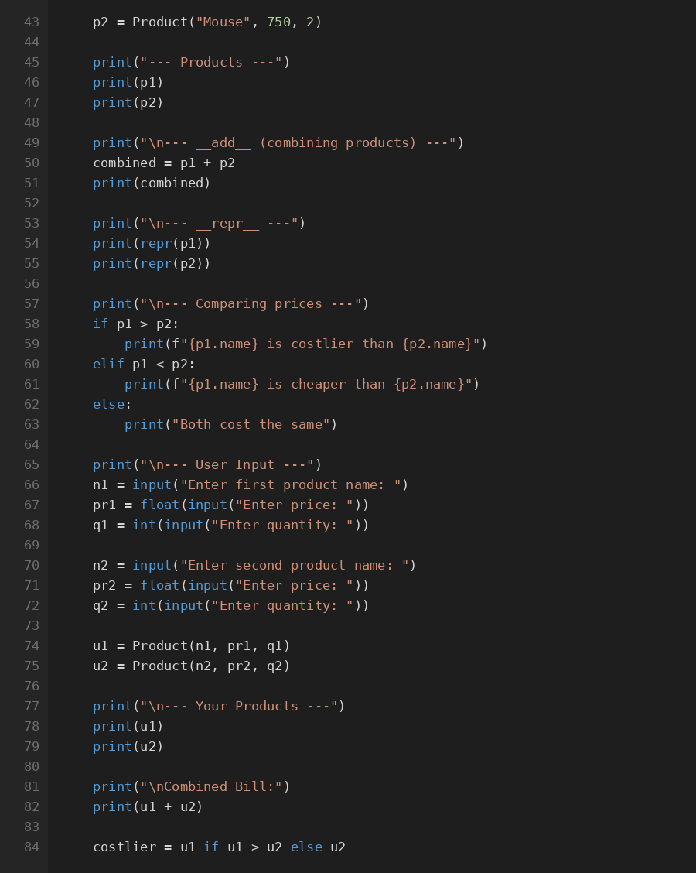
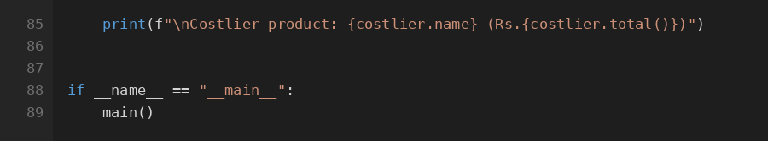
Bucket List Experiment Output (Screenshot):
