Experiment No. 2

Title:
Advanced Class Concepts – Decorators and Magic Methods
Aim:
Design a dynamic report generator in Python that uses decorators, class methods, and magic methods to customize and format reports. The system should allow users to define report templates and apply various formatting options dynamically.
Theory:
- Decorators are functions or classes that modify the behavior of another function or class without changing its source code, and are applied using the @ syntax.
- A function decorator takes the target function as an argument and returns a wrapper function that adds the new logic before or after the original call.
- A class decorator uses the __call__() magic method, which lets an instance of a class be called as if it were a function, and can maintain state across calls.
- Class methods are bound to the class rather than the instance and can modify class state that applies across all instances.
- Magic (dunder) methods begin and end with double underscores and are used for operator overloading and for customising object behaviour.
- __str__() defines the readable string form of an object, __repr__() returns a machine-readable representation, and __call__() makes an object callable.
Pseudocode:
1. Define decorators for formatting (bold_text) and for logging report generation (log_generation).
2. Define the Report class with a class variable templates for storing template functions.
3. Add class methods add_template() and get_template() to register and retrieve templates.
4. Implement the magic method __call__() so a report instance can be called with a template name, plus __str__() and __repr__().
5. Define a simple template function and a fancy template function decorated with the formatting decorators.
6. In main(), register the templates, create a report instance, generate reports with different templates and display them.

Experiment 2 Title:
Advanced Class Concepts – Decorators and Magic Methods
Experiment 2 Code:
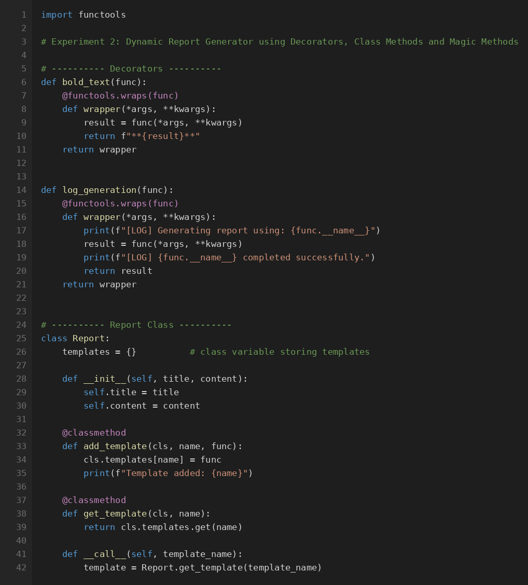
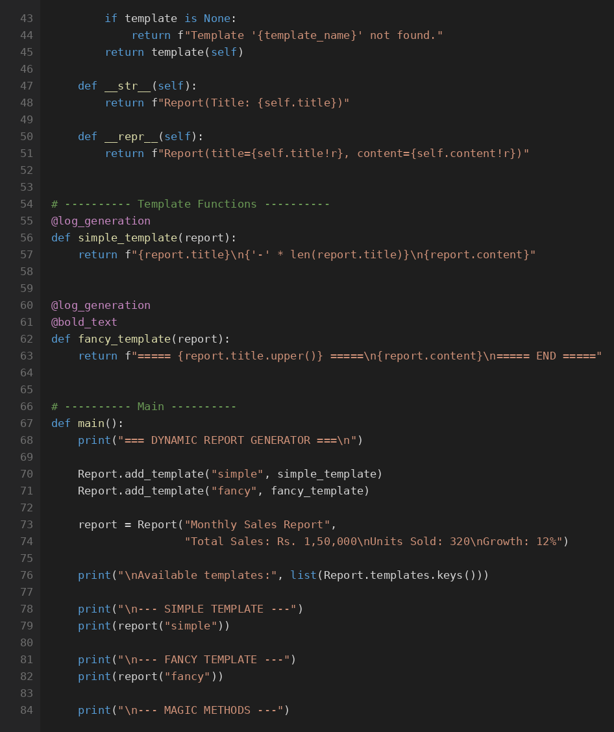
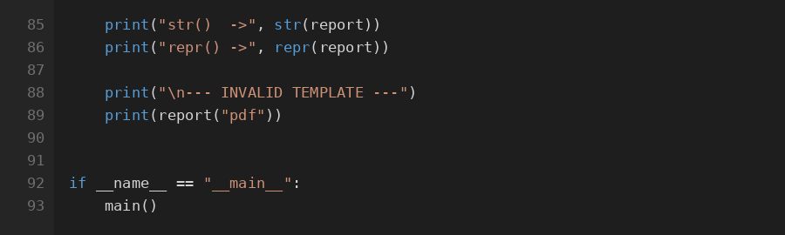
Experiment 2 Output (Screenshot):
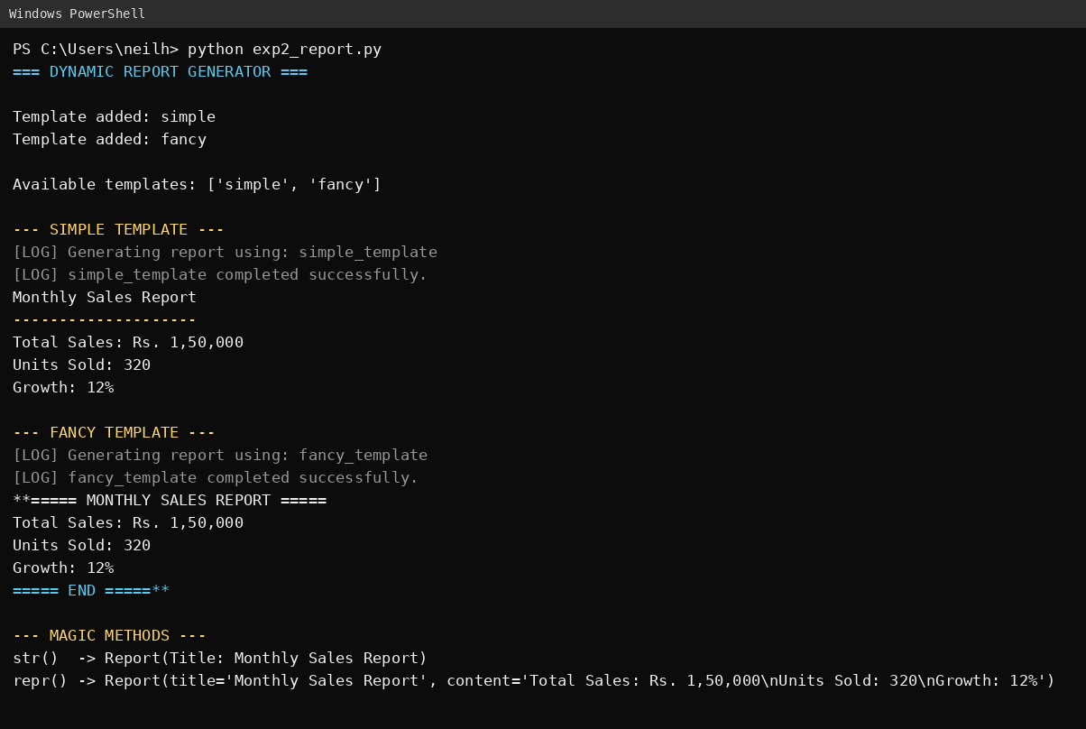
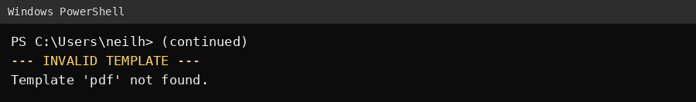

Bucket List Experiment Title:
8. Product with Magic Methods
Scenario: Create a Product class that allows adding products together (combining total cost), comparing prices, and printing readable output using magic methods.
Bucket List Experiment Code:
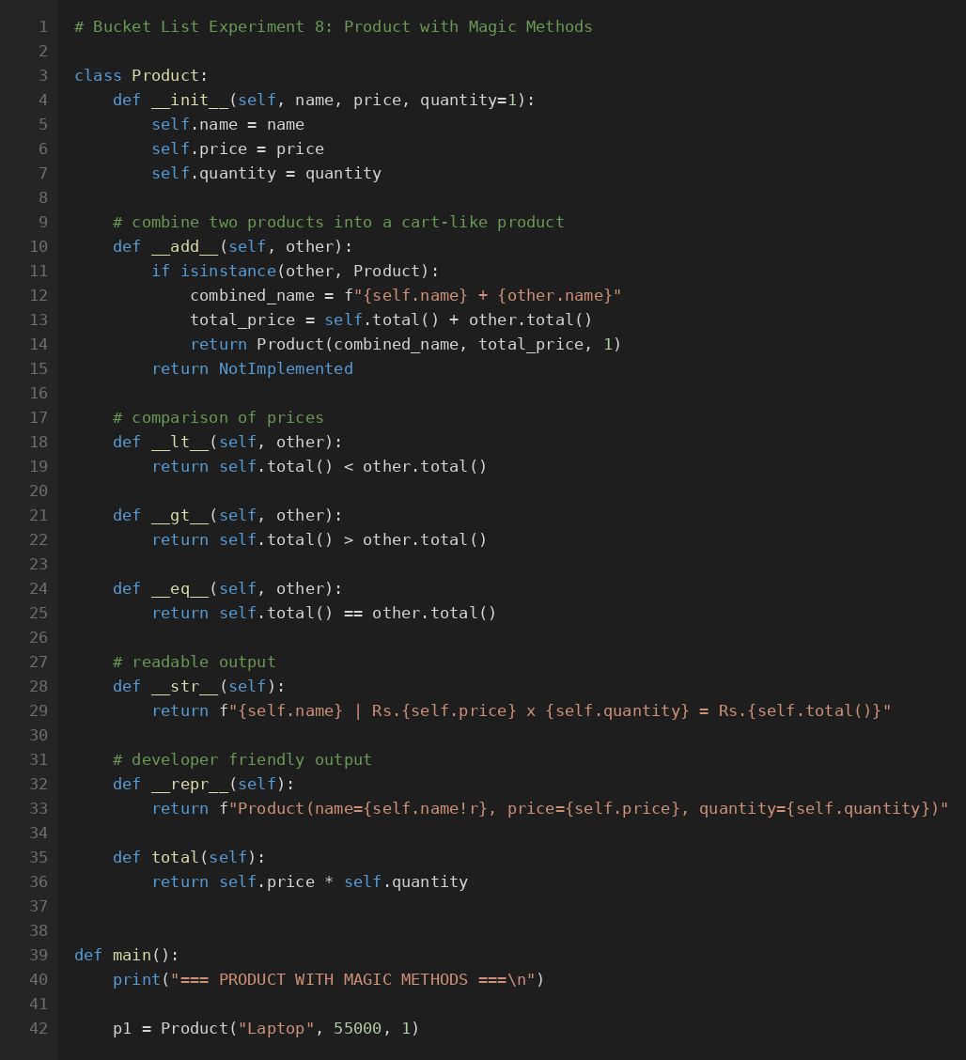
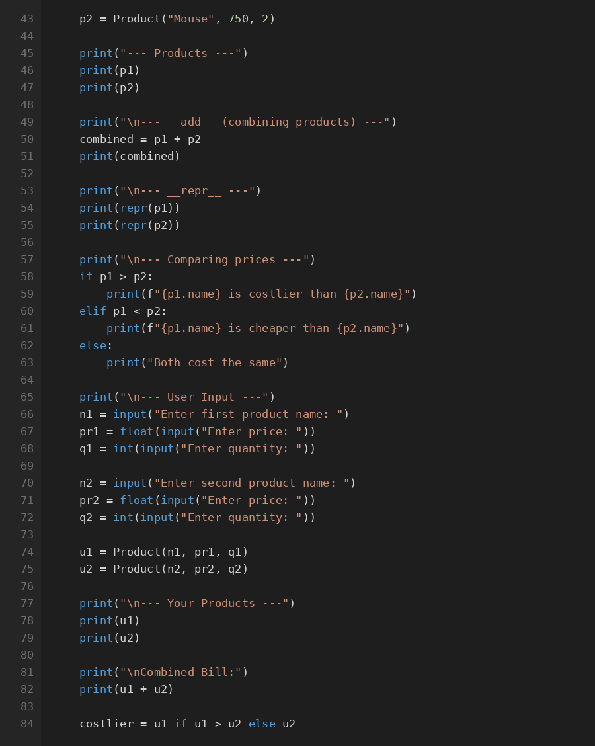
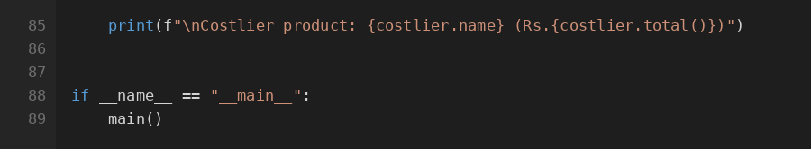
Bucket List Experiment Output (Screenshot):
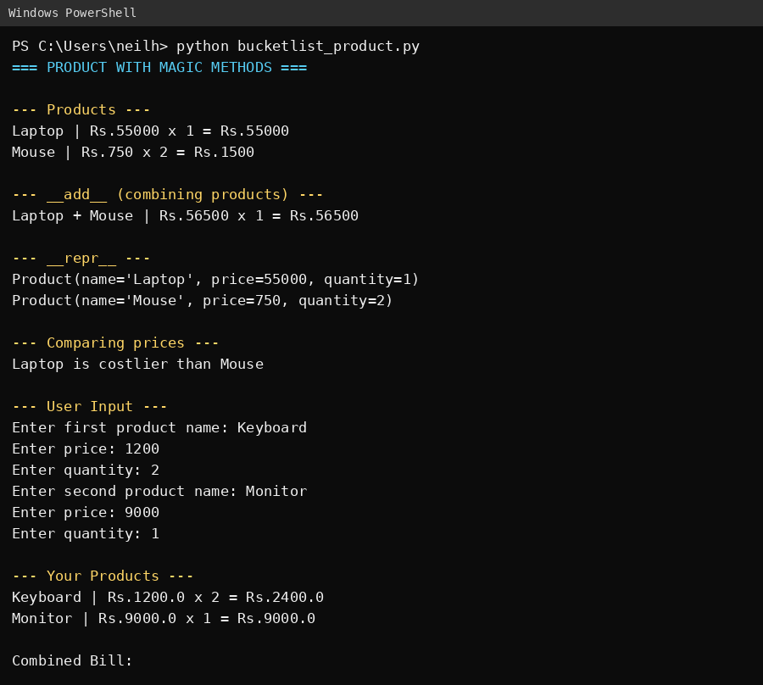
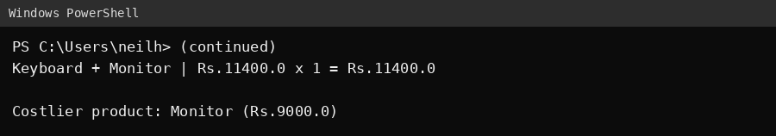

Theory Questions (Handwritten):
Q 1: What is the purpose of a decorator in Python, and how can it be used to modify the behavior of a class method? Provide a brief example.
Q 2: Explain what a generator is in Python and provide a basic example of how it differs from a regular function.
Conclusion:
The dynamic report generator demonstrates the use of decorators, class methods, and magic methods to create a flexible and customizable report generation system. This approach enables users to define and apply various formatting options dynamically, enhancing the reusability and maintainability of the code.

