Experiment No. 3

Title:
Design Patterns in Python
Aim:
Write a program to implement a Configurable Payment Processing System Using Strategy Pattern.
Theory:
- Design patterns are general, reusable solutions to problems that commonly occur during software design and development.
- They are broadly classified into Creational patterns (Factory, Abstract Factory, Builder, Prototype, Singleton), Structural patterns (Adapter, Bridge, Composite, Decorator, Facade, Proxy, Flyweight) and Behavioural patterns (Observer, Strategy, State, Command, Chain of Responsibility, Template, Interpreter, Visitor, Mediator, Memento).
- The Strategy Pattern is a behavioural design pattern that defines a family of algorithms, encapsulates each one, and makes them interchangeable.
- Strategy lets the algorithm vary independently from the clients that use it, so the payment method can be selected at runtime.
- A payment processing system handles transactions from various payment methods, ensuring flexibility and scalability.
- The pattern promotes the Open/Closed Principle, keeping the system open for extension but closed for modification.
Pseudocode:
1. Define a PaymentStrategy interface with an abstract method pay().
2. Implement various payment strategies (CreditCardPayment, PayPalPayment, BitcoinPayment, UPIPayment) inheriting from PaymentStrategy.
3. Create a PaymentProcessor class that holds and uses a PaymentStrategy to process payments.
4. Allow the PaymentProcessor to switch strategies at runtime using set_strategy().
5. In main(), process payments with different strategies and let the user select a method at runtime.

Experiment 3 Title:
Design Patterns in Python
Experiment 3 Code:
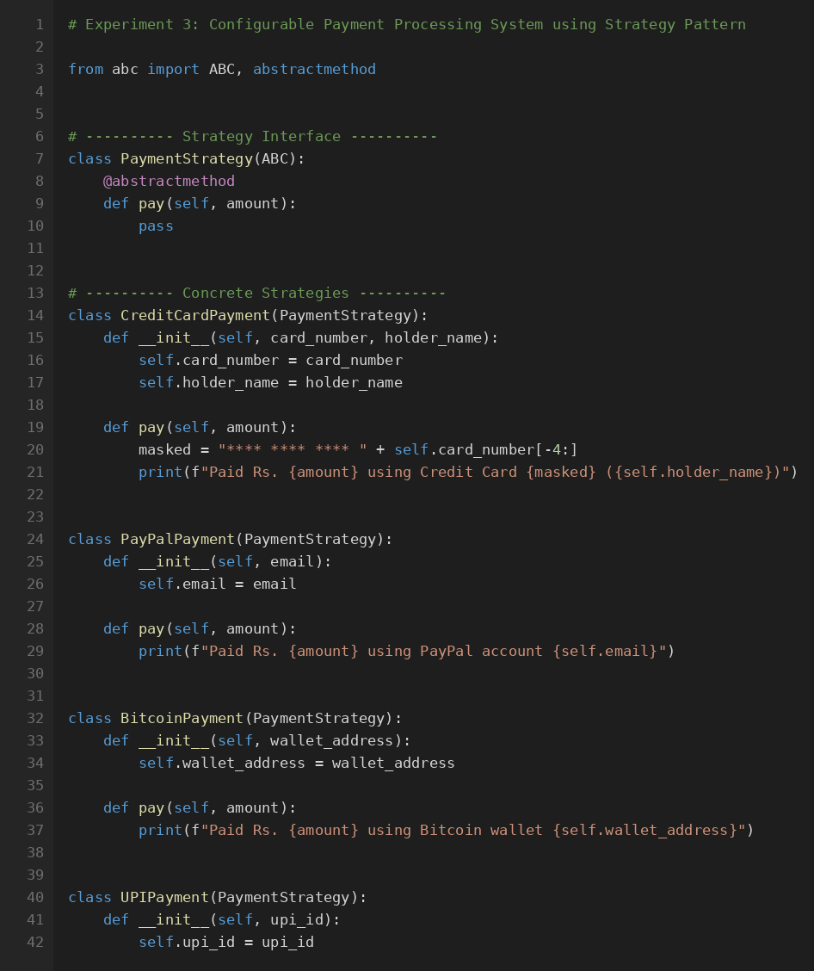
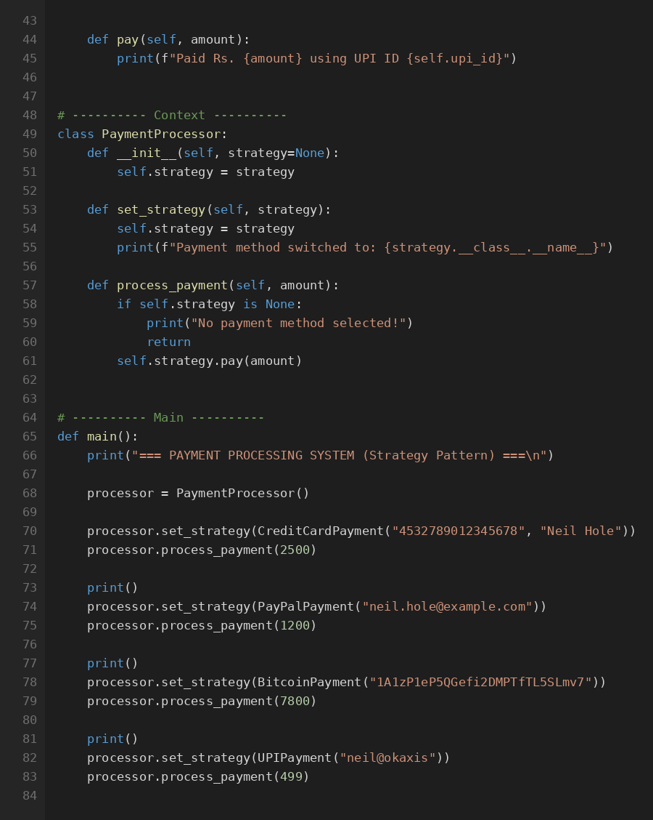
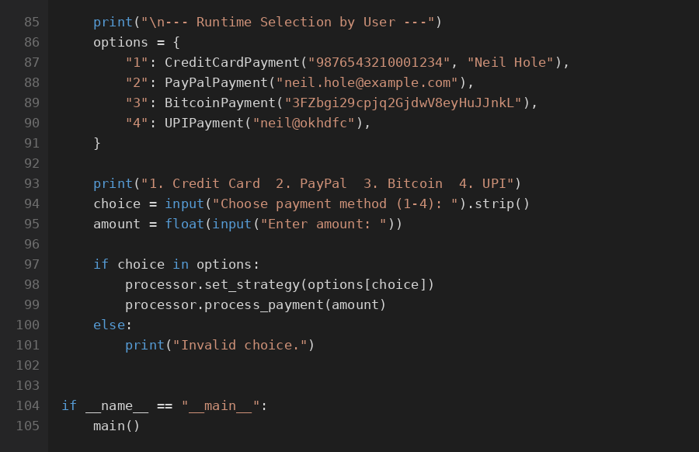
Experiment 3 Output (Screenshot):
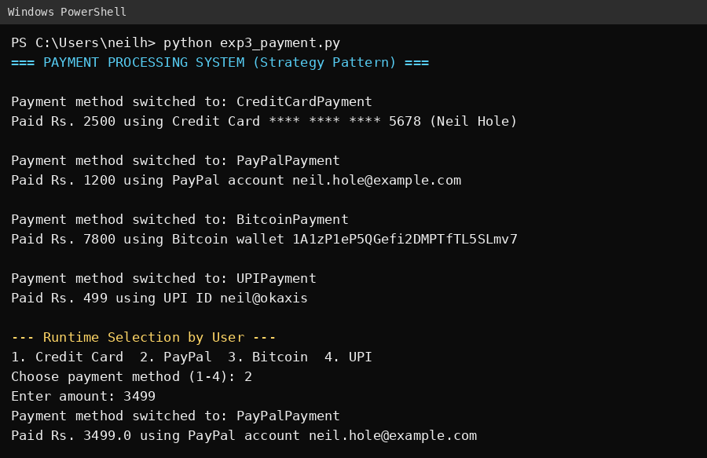

Bucket List Experiment Title:
8. Product with Magic Methods
Scenario: Create a Product class that allows adding products together (combining total cost), comparing prices, and printing readable output using magic methods.
Bucket List Experiment Code:
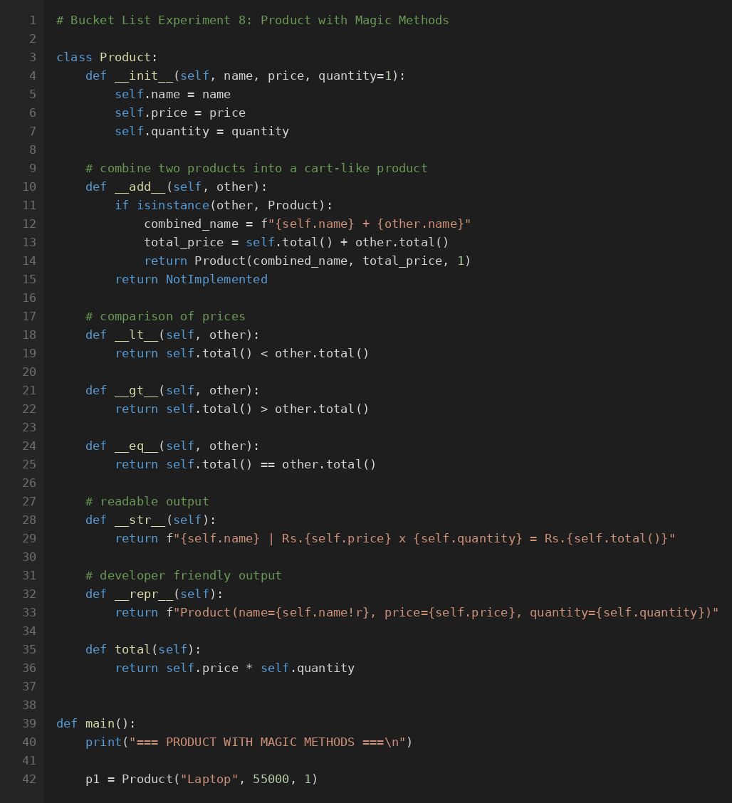
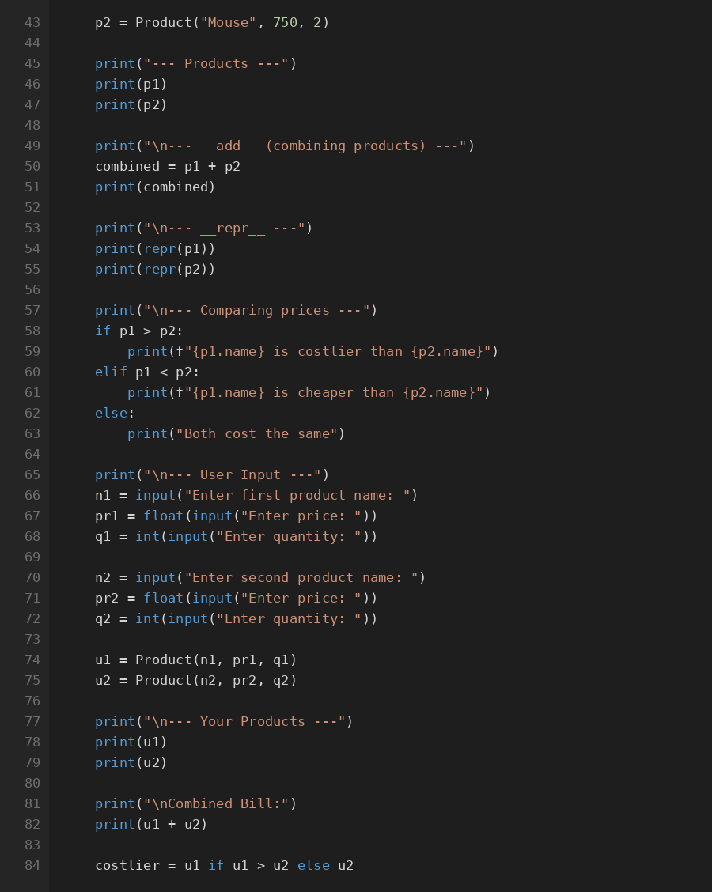
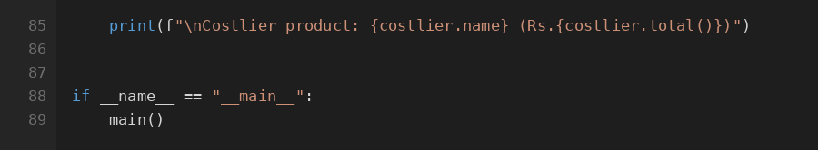
Bucket List Experiment Output (Screenshot):
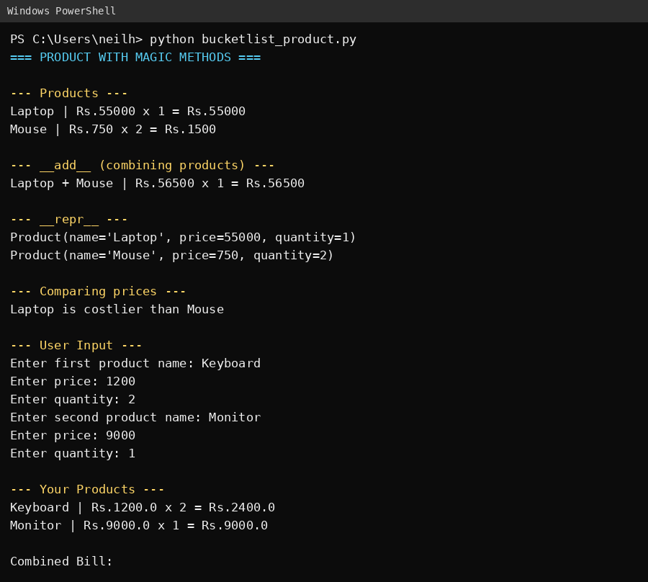
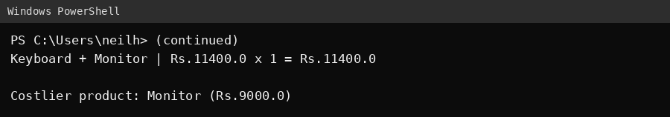

Theory Questions (Handwritten):
Q 1: Explain the Singleton design pattern in Python. How does it ensure that only one instance of a class is created? Provide a basic code example to demonstrate its implementation.
Q 2: Describe the Factory design pattern in Python. How does it differ from directly creating objects? Provide a simple example of a factory method that produces different types of objects based on input.
Conclusion:
The Strategy Pattern provides a flexible and scalable way to manage different payment methods in a payment processing system. By encapsulating each payment method within its own class, the system can easily switch between different algorithms at runtime without modifying the client code. This design pattern promotes the Open/Closed Principle, making the system open for extension but closed for modification.

