

**Department of B.B.A. (Computer Application)**

**A**

**Project**

**On**

**“Cake Shop”**

**Submitted in partial fulfillment of the requirement of the degree**

**B.B.A. (Computer Application)**

**Under the Guidance of**

**Prof.Atkar P .R**

**-: Submitted By :-**

**MR. POOJA ZUMBAR WADEKAR**

**-:Submitted To:-**

**Savitribai Phule Pune University**

**(2021-2022)**

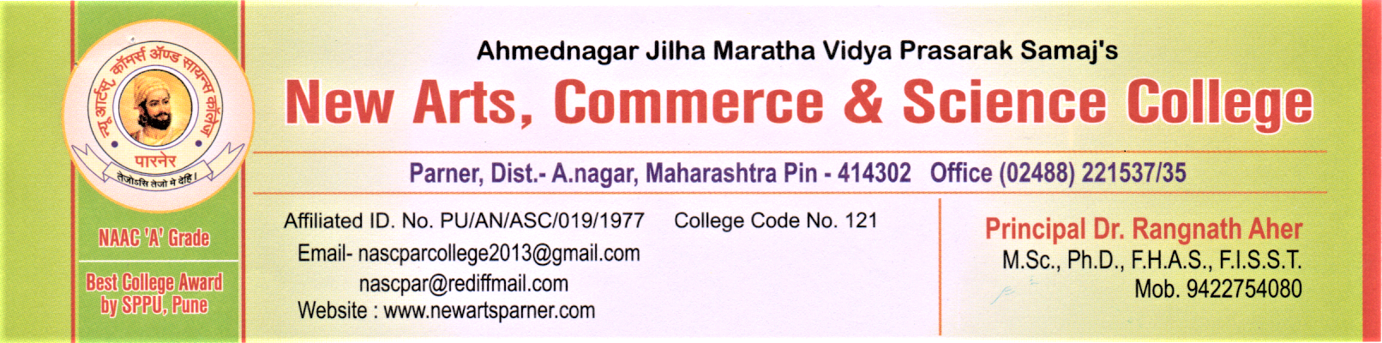

**CERTIFICATE**

**DEPARTMENT OF BBA-CA**

This is to certify that **Name:- Pooja zumbar wadekar** BBA (Computer Application) has completed the Project titled **“Project Name –”Cake Shop”** as per syllabus laid down by the Savitribai Phule Pune University during academic year 2021-22. he is sincere, honest and completes the work allotted to him within stipulated time.

Her performance is excellent/good______________

**Internal Examiner External Examiner**

**Project Guide Head of Department**

Acknowledgement

* After complete this year project, I would like to take this chance to express my sincere gratitude to my project teacher which is mam **Prof.Atkar P .R**
* who has guided me throughout the project. When I still doing nothing while project due date is getting close,**Prof.Atkar P.R**

give me some pressure to complete the project.

* Without her, I think I can’t finish the project on time. I faced a lot of problems in this project , but finally I found a particular problem solution with the help of the Internet and other reference books.
* I would like to thank her for one more time because she shared her experience with us so that we can get more logical understanding on how to develop software which is suitable for the current society.
* Finally I would also like to thank my friends who helped me a lot in finalizing this project within the limited time frame.

**INDEX**

|  |  |  |
| --- | --- | --- |
| **Sr. No.** | **Title** | **Page No.** |
| 1 | **Introduction.** |  |
|  | Introduction of system. | 5 |
|  | Scope of System. | 6 |
|  | Proposed System. | 7 |
| 2 | **System Analysis.** |  |
|  | Fact Finding Techniques. | 8 |
|  | Feasibility Study. | 9 |
|  | Hardware and Software Requirement. | 10 |
| 3 | **System Design.** |  |
|  | Entity Relationship Diagram. | 11 |
|  | System Testing | 13 |
| 4 | **File Design.** |  |
|  | File design with input values. | 18 |
| 5 | **Reports.** | 34 |
| 6 | **Advantages and Disadvantages.** | 35 |
| 7 | **Feature Enhancement.** | 36 |
| 8 | **Conclusion.** | 37 |
| 9 | **Webibliography.** | 38 |

# Introduction to System

It is a system that allows users to check for various cakes available at the online store and purchase online. The project consists of list of Cakes and bakery products displayed in various categories. The user may browse through these items as per categories. If the user likes a product he may add it to his shopping cart. He may even pay through a credit card or cash on delivery. Once the user makes a successful transaction he gets a copy of the shopping receipt on his email id. User has also option for ordering custom cakes according to their requirements like cake's flavor, size, shape and so on. Thus the online Cake shopping project brings an entire cake shop online and makes it easy for both buyer and seller.

**Scope of System**

# project Scope is the parameter of the project.

# It defines What are the deliverable requirements and expectations for the Project and provide a baseline to exclude unrelated works.

# And this process is referring to as the project scope management.

# Proposed System

* + The proposed system should have the following features. The transaction should take place in a secured format between various clients in the network. It provides flexibility to the user to transfer the data through the network very easily.
  + The project “Cake Shop” is developed in HTML and CSS, which mainly focuses on basic operations in photos like adding new photos, new employees, and updating information, searching images,videos,etc.
  + It will maintain the record of all candidates irrespective of the selection and results and thus provide the user with a File System of prospective candidates.

# Fact Finding Technique

* To develop any system the user needs to collect facts and all the relevant information .The success of any project depends upon the accuracy of available data .
* Fact Finding is the formal process of using research, interviews , questionnaires and other techniques to collect information about a system .
* **Interviews**

Bakery is no place for pansies. You will do night shifts, you will bake bread in the wee hours, and you will work hard. People want their fresh bread and croissant in the morning, and so someone has to make it possible-it can be you.

* **Record View**
  + Records and reports are the collection of information and data about the system and its operations.
  + The information related to the system is available in documents, newspapers, magazines, journals, electronic media etc.

# Feasibility Study

* The demand for baked items has witnessed a steady increase in the last couple of years. Baked goods offer customers convenience and affordability, and the growing demand has led to a lot of home-bakers and chefs venturing into the bakery business. As per a report, the Indian bakery market is estimated to grow at a CAGR of 8.5% between 2021 and 2026 and is set to reach a value of USD 12.39 billion by 2026, thus making bakeries a highly lucrative restaurant format. In this article, we will talk in detail about how to open a bakery business in India.
* **Technical Feasibility**
* Technical feasibility refers to the technical resources needed to develop, purchase, install or operate the system.
* Technical feasibility assesses the current resources and technology, which are required to accomplish user requirements in the software within the allocated time and budget.
* **Operational Feasibility**
* The selection of the right location for the food facility is important to minimize any food safety risk and to ensure that neighbouring activities do contamination industries not become source due and a to transferring hazards by wind, water, pollution or increasing the risk of pest infestation. Potential sources of contamination need to be considered when deciding where to locate establishment, as well as food the effectiveness of any reasonable measures that might be taken to protect food.
* **Economic Feasibility**
* The wholesale baking industry mixes tradition and innovation to feed the world and the economy - generating some major dough while employing almost 800 thousand people in the United States. ABA's interactive map reveals the current economic impact of baking in each Congressional district and state.

# Hardware and Software Requirement

Hardware Requirement

* Processor: Pentium p4 and Above
* Main Memory: Minimum 1GB RAM
* Hard Disk:80 GB HDD

Software Requirement

* Front-End : HTML, CSS, JavaScript
* Operating System : Windows7 and Above.

# Entity Relationship Diagram

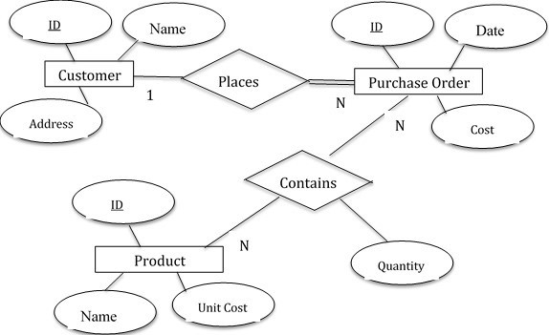

**File Design with input values**

**Home Page:-**

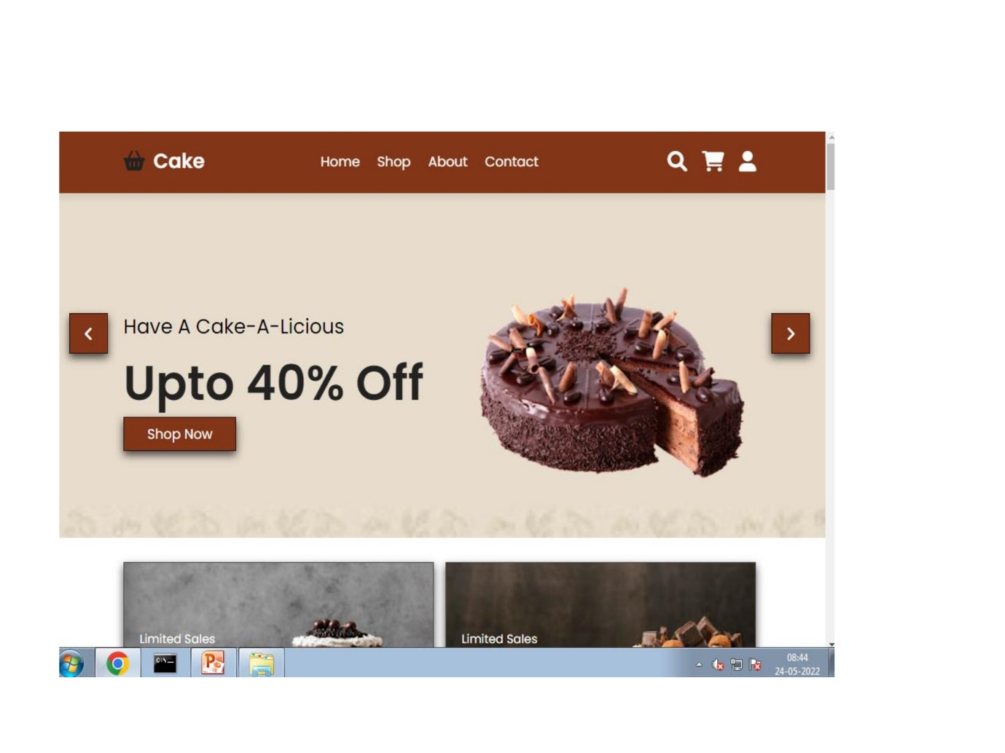

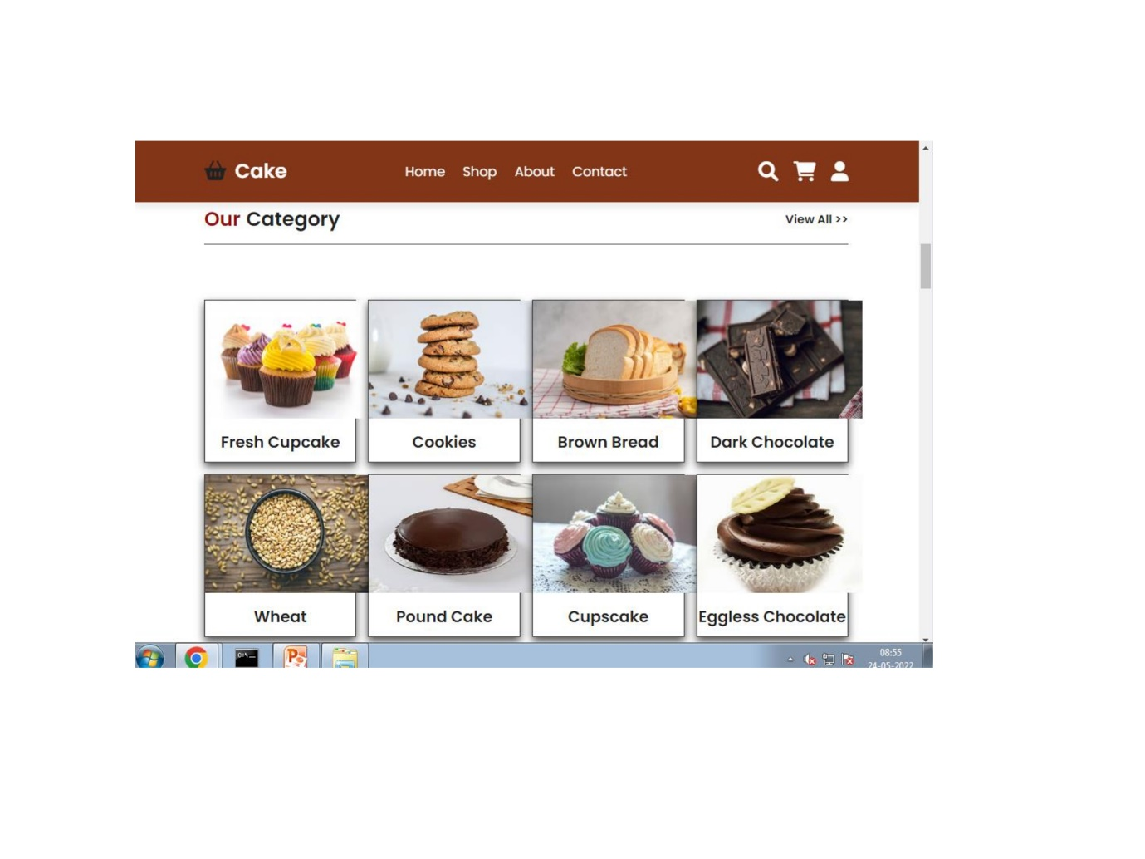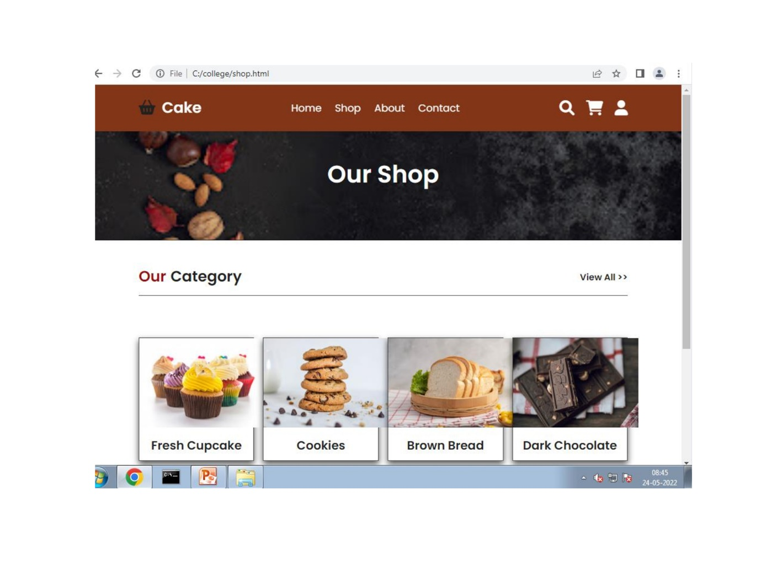

**Gallery Page:-**

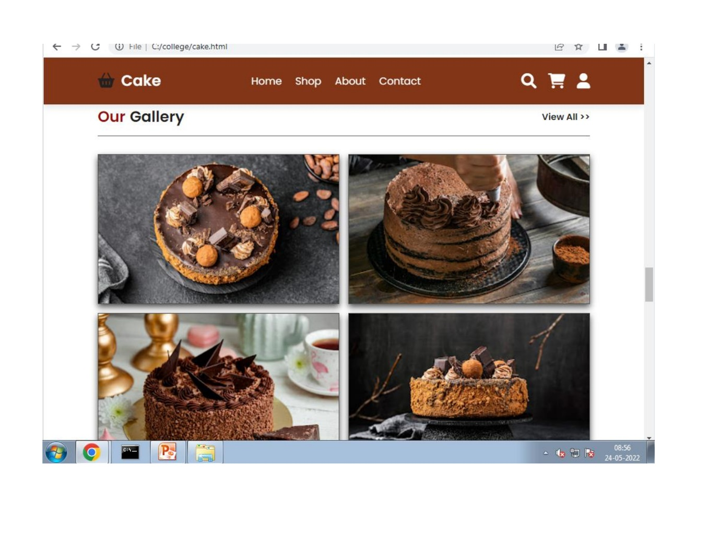

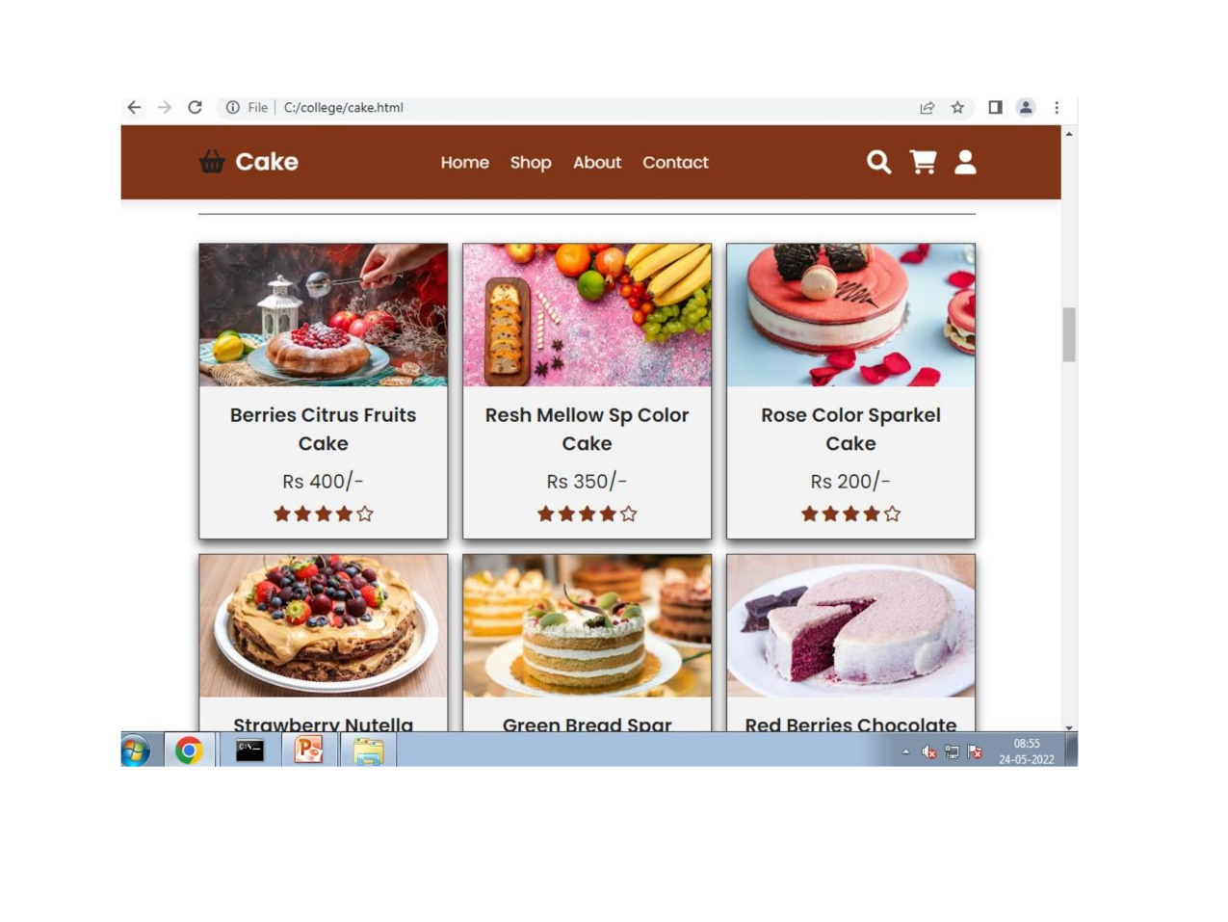

**Contact Page:-**

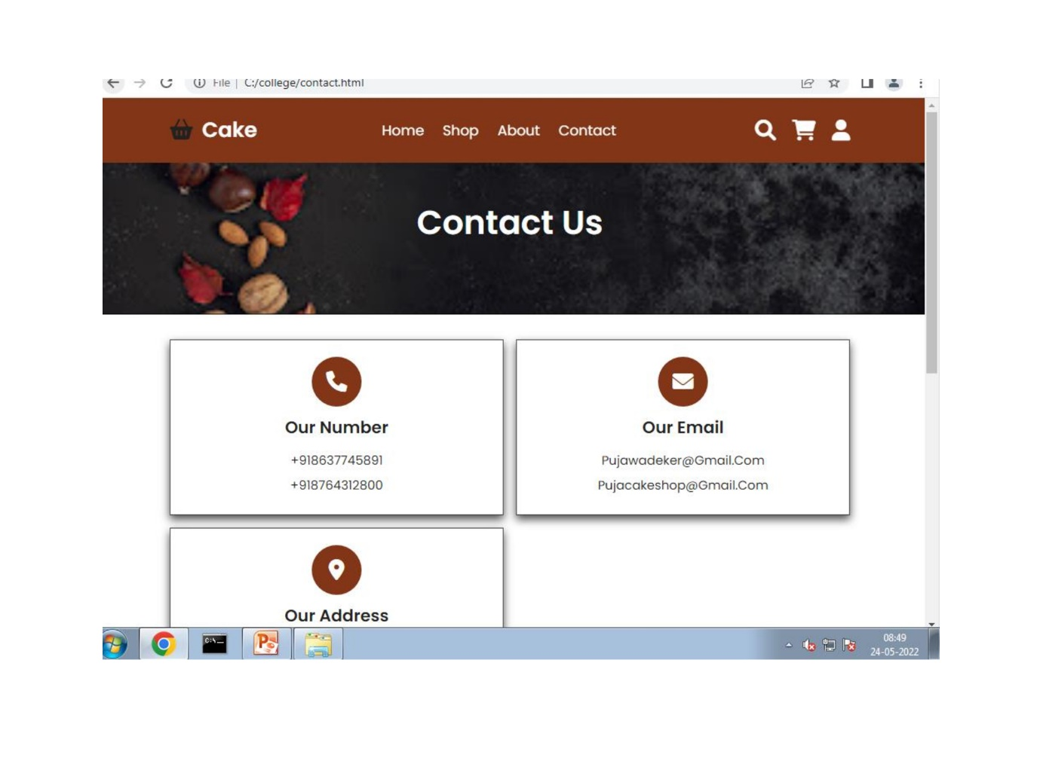

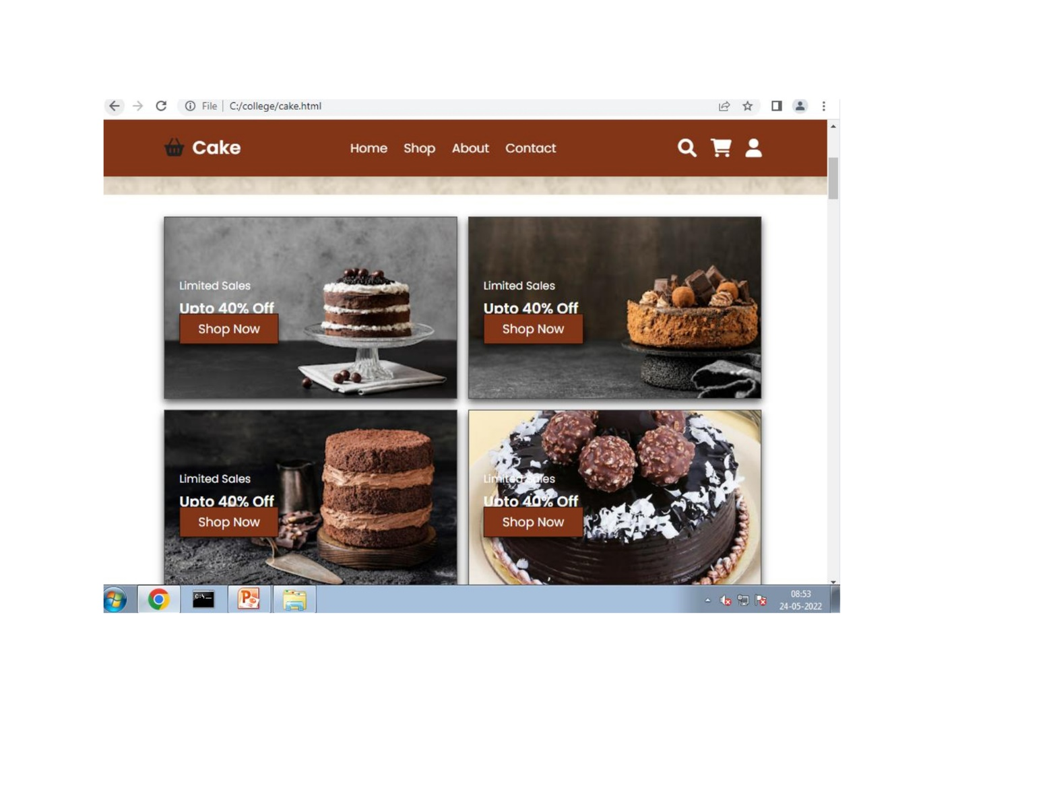

**Footer:-**

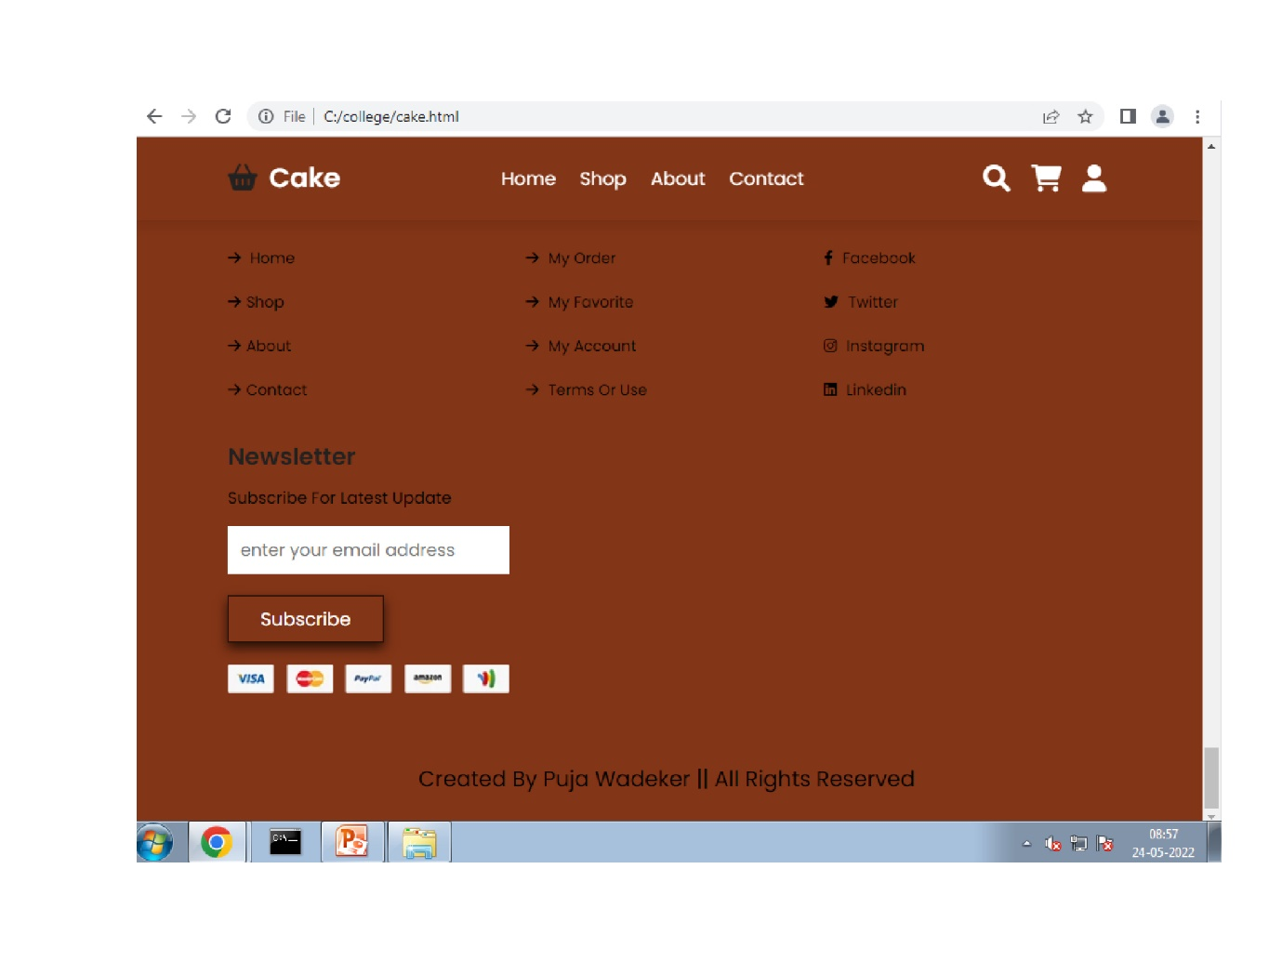

**Reports:-**

* Project Study-The primary purpose of the Photography Shop System Project is the discipline of the planning, coordination, and management of the Shop’s activities.
* Our project aims to make the work of the Shop.Administration joins the archives with the new photos and gathers the content available in the Shop.
* In This project, Admin can modify the photos and Employee details as well as keep record maintainable and secure

**Advantages:-**

* Diversified options. While ordering cakes online, you will get to know that there are more than 100 designs and sizes of the cake and you can chose the one you like to have. ...
* Delivery at Doorstep....
* Perfect quality. ...
* Avoid forgetting. ...
* Midnight Delivery.

**Disadvantages:-**

* Crowded Space
* Finding The Right Supplier
* Security Issues

**Feature Enhancement :-**

Who doesn't like refreshing their taste and appealing their sweet tooth with some tantalizing sweet dishes? Everyone does, right? This is the very reason why we have seen the proliferation in the number of bakery stores in India. According to the NRAI Indian Food Services Report, the share of bakery and desserts in the foodservice market across different formats is 6%. And this number is likely to grow at a great pace, increasing the number of bakery shops in India. This can also be accounted to the fact that technology has enabled many home bakers to showcase their baking talents and run successful home bakeries. Find out what it takes to open a bakery here. In this article, we bring you bakery business tips that will help you make it a successCreate the master and slave database structure to reduce the overload of the database queries

**Conclusion :-**

* The project as a whole described the scope and viability of the trending industry and mainly of the financial technical and it's market potential.

**Bibliography:-**

* + The Complete Book of Backing.
  + Passionate About Baking.
  + Mary Berry’s Baking Bible.
  + Web Design with HTML and CSS

**Weblography :**

* + [https://www.w3schools.com](https://www.w3schools.com/)
  + [https://htmlcodex.com](https://htmlcodex.com/)
  + [https://themeforest.net](https://themeforest.net/)