Studio 3

Name and Student Id:Onkar Uttam Kalpavriksha 30473764

Self-Evaluation :

|  |  |  |  |  |  |
| --- | --- | --- | --- | --- | --- |
| Need Help | Work in Progress | Pass | Credit | Distinction | High Distinction |

Tutor Evaluation {To be highlighted by Tutor only}:

|  |  |  |  |  |  |
| --- | --- | --- | --- | --- | --- |
| Incomplete | Needs improvement | Pass | Credit | Distinction | High Distinction |

Task 3:

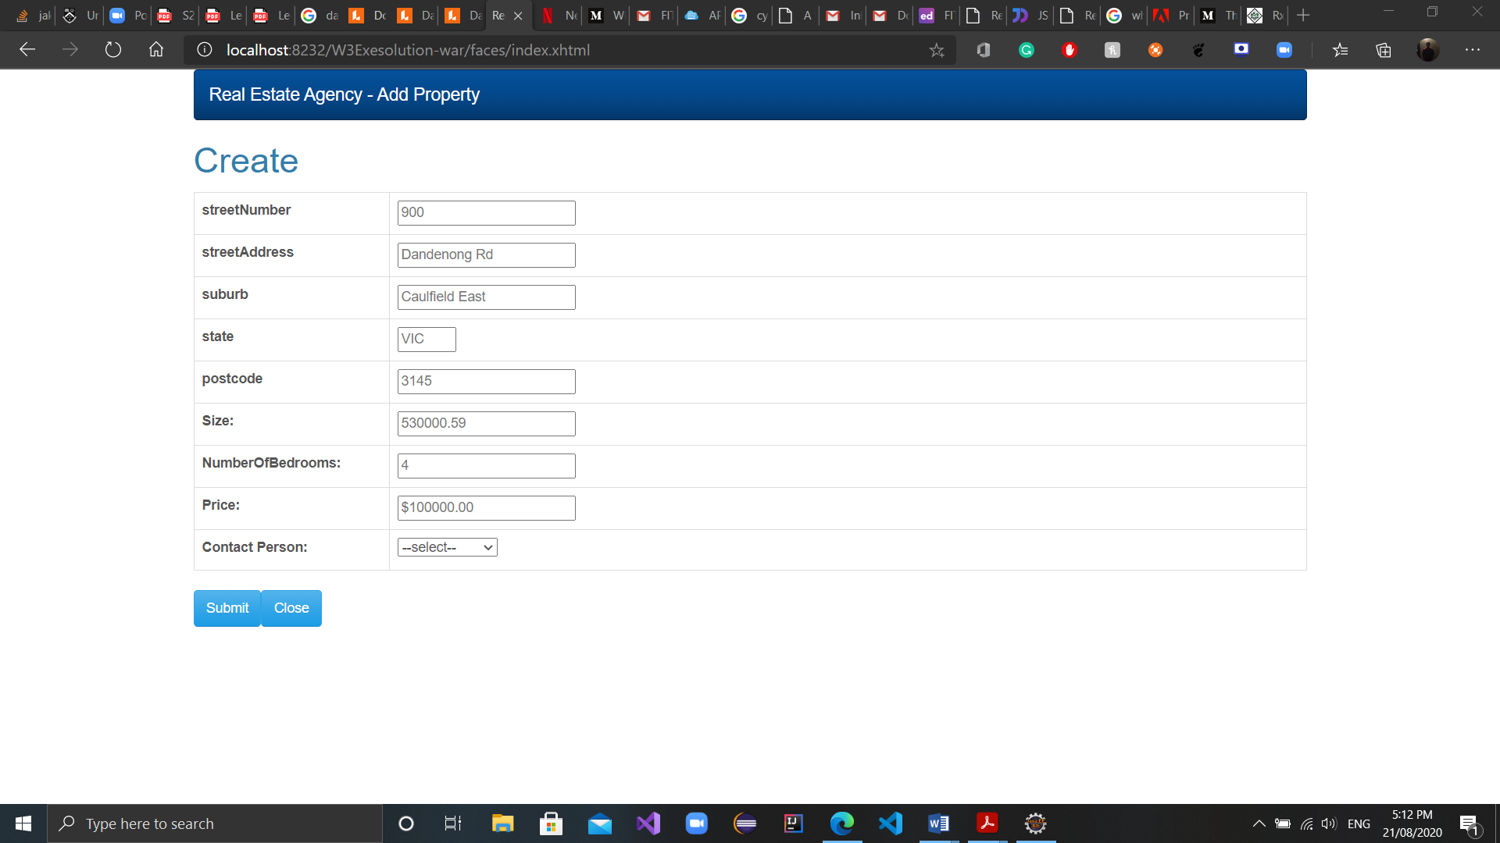

Figure add new property

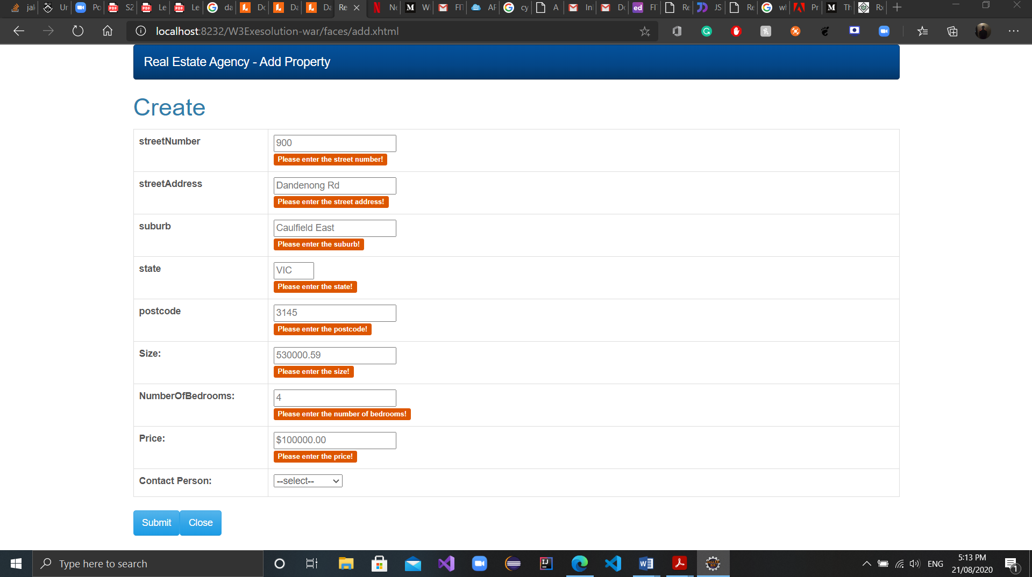

Figure validation

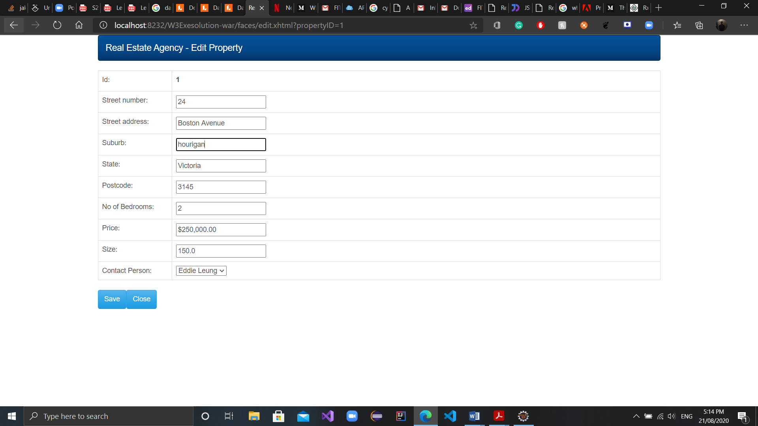

Figure edit property

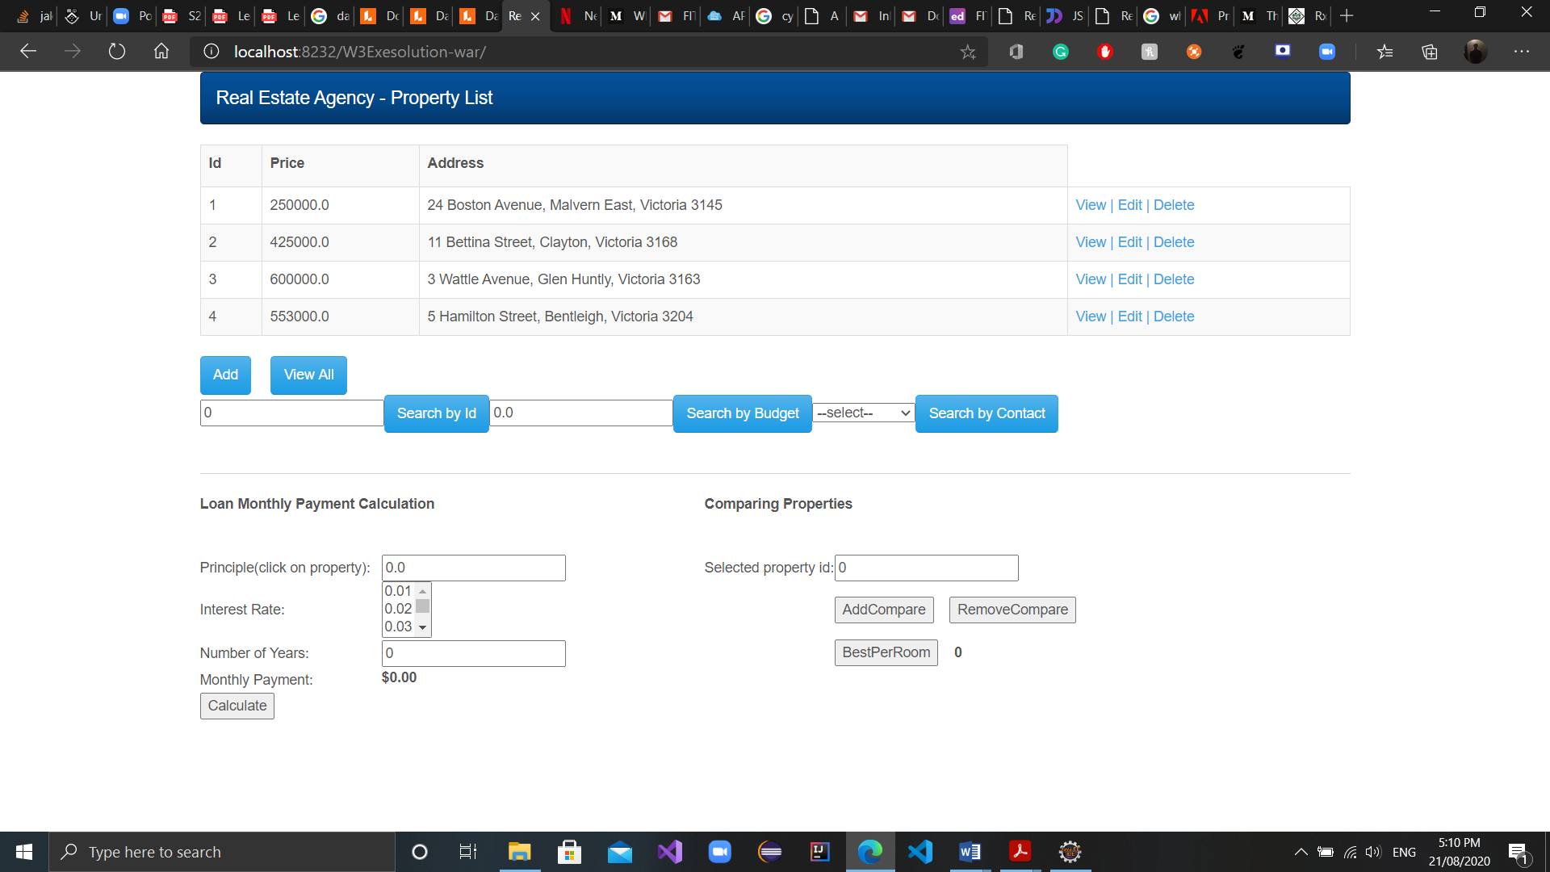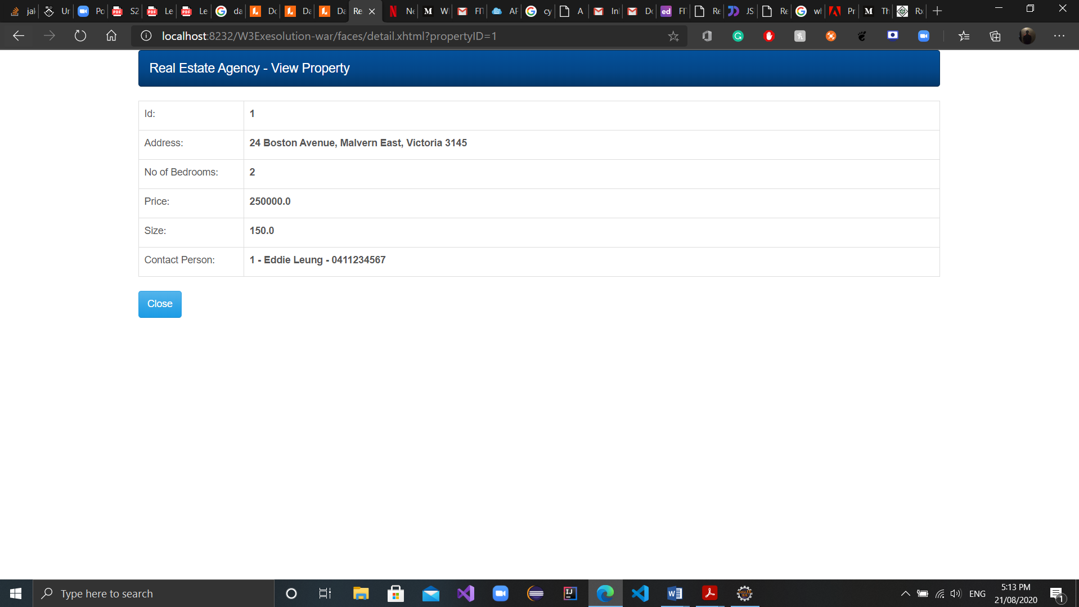

Figure view property

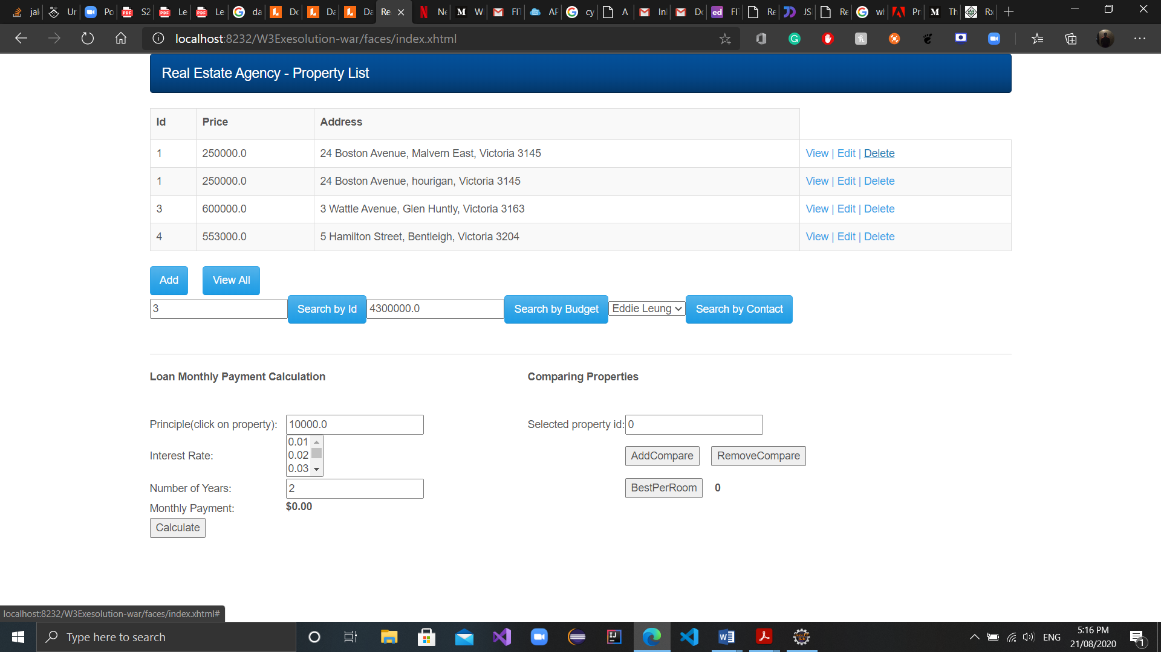

Figure view all

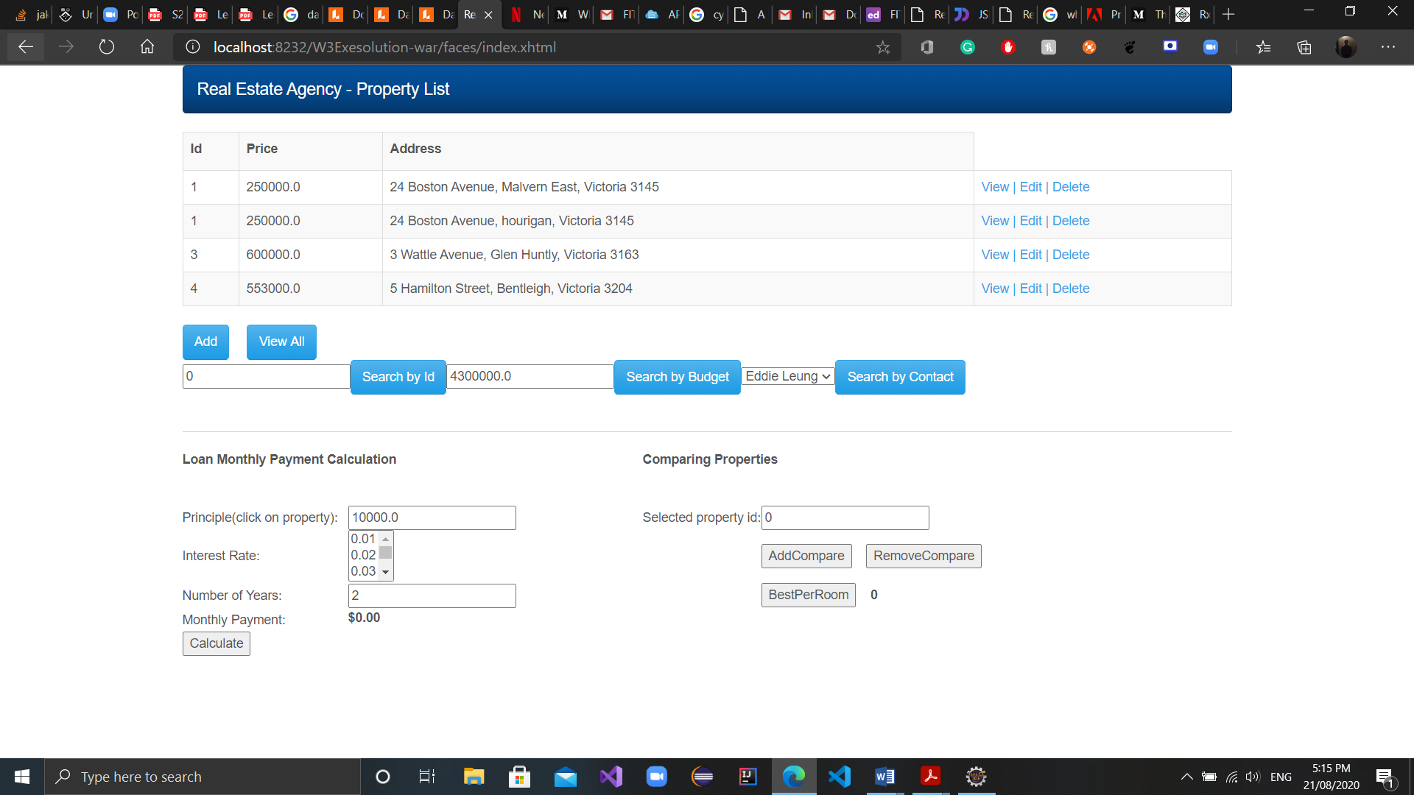

Figure search by budget

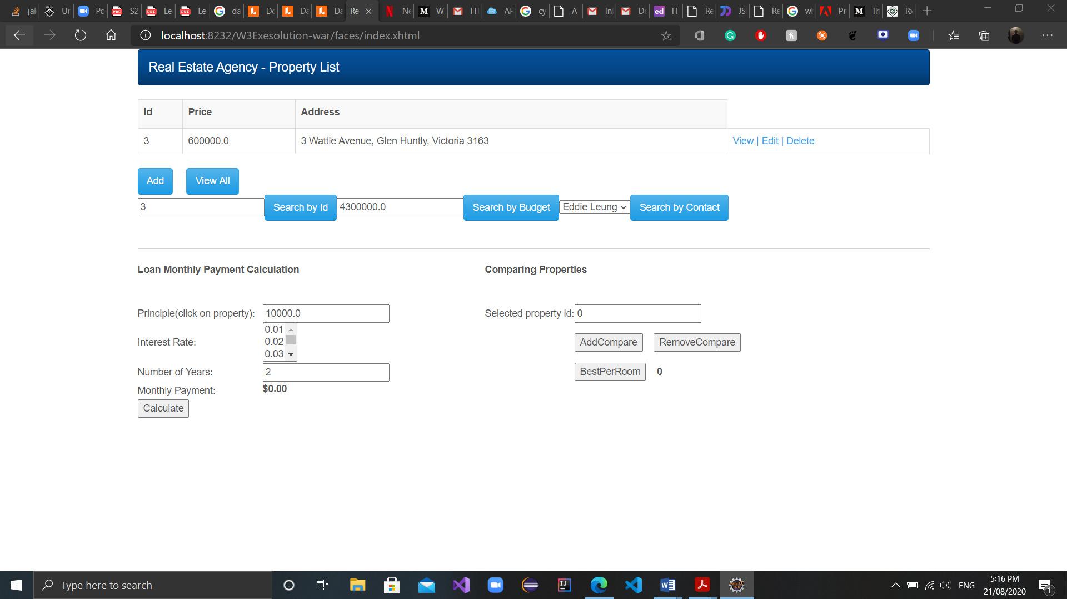

Figure search by id

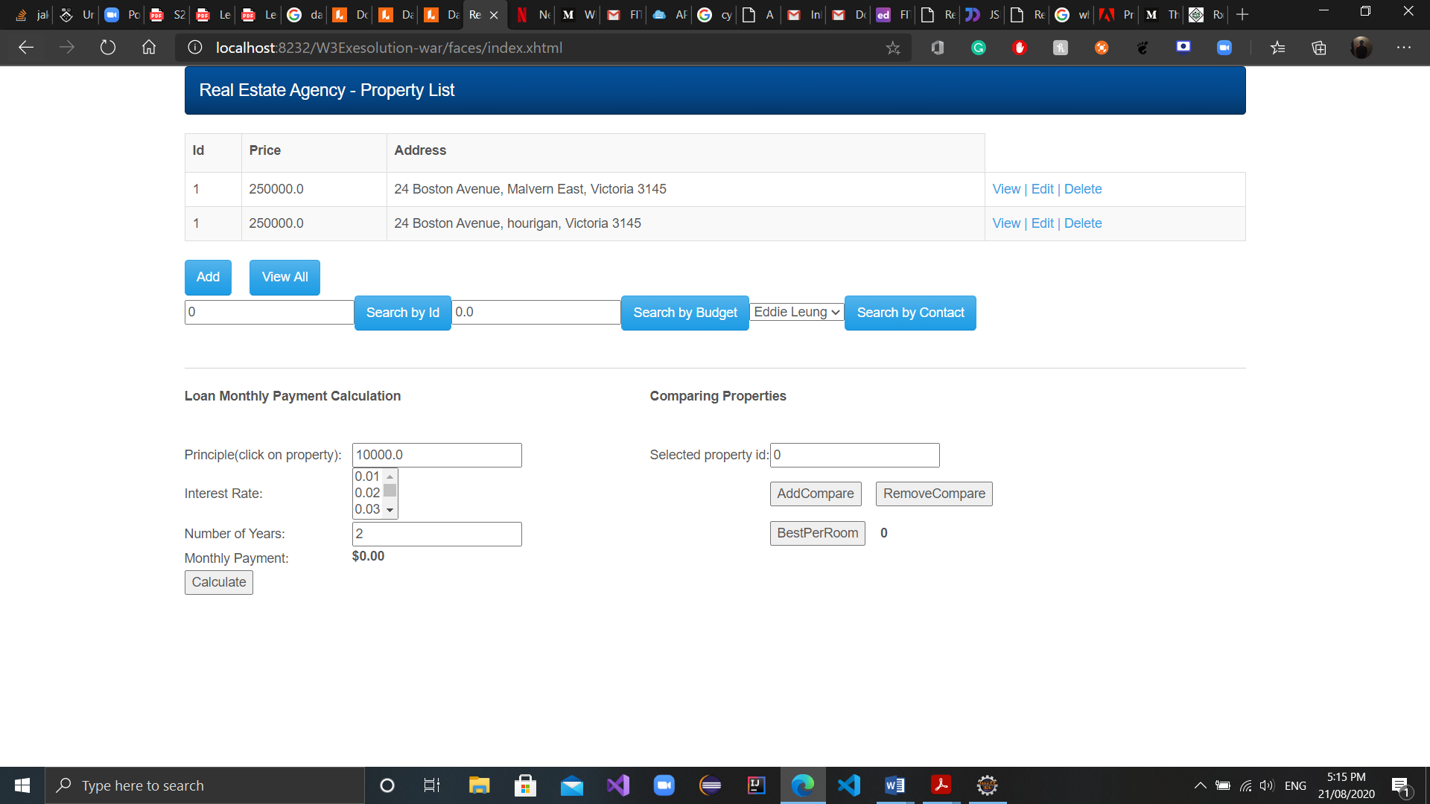

Figure search by contact

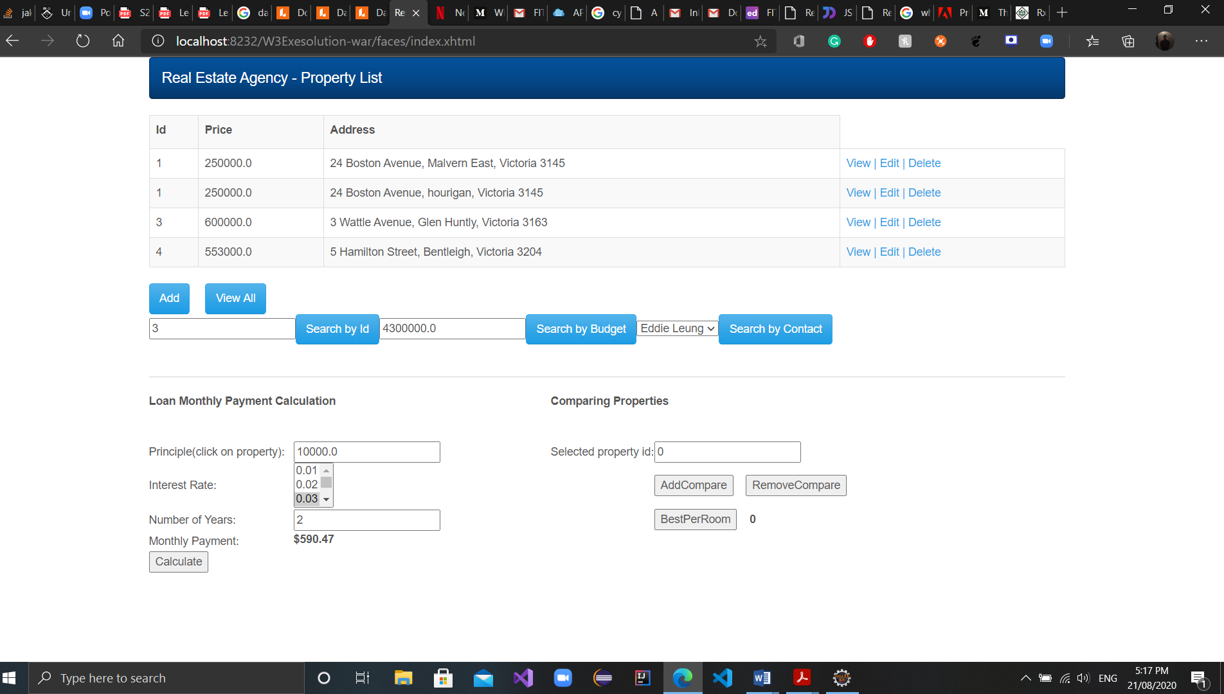

Figure Monthly payment calculatror

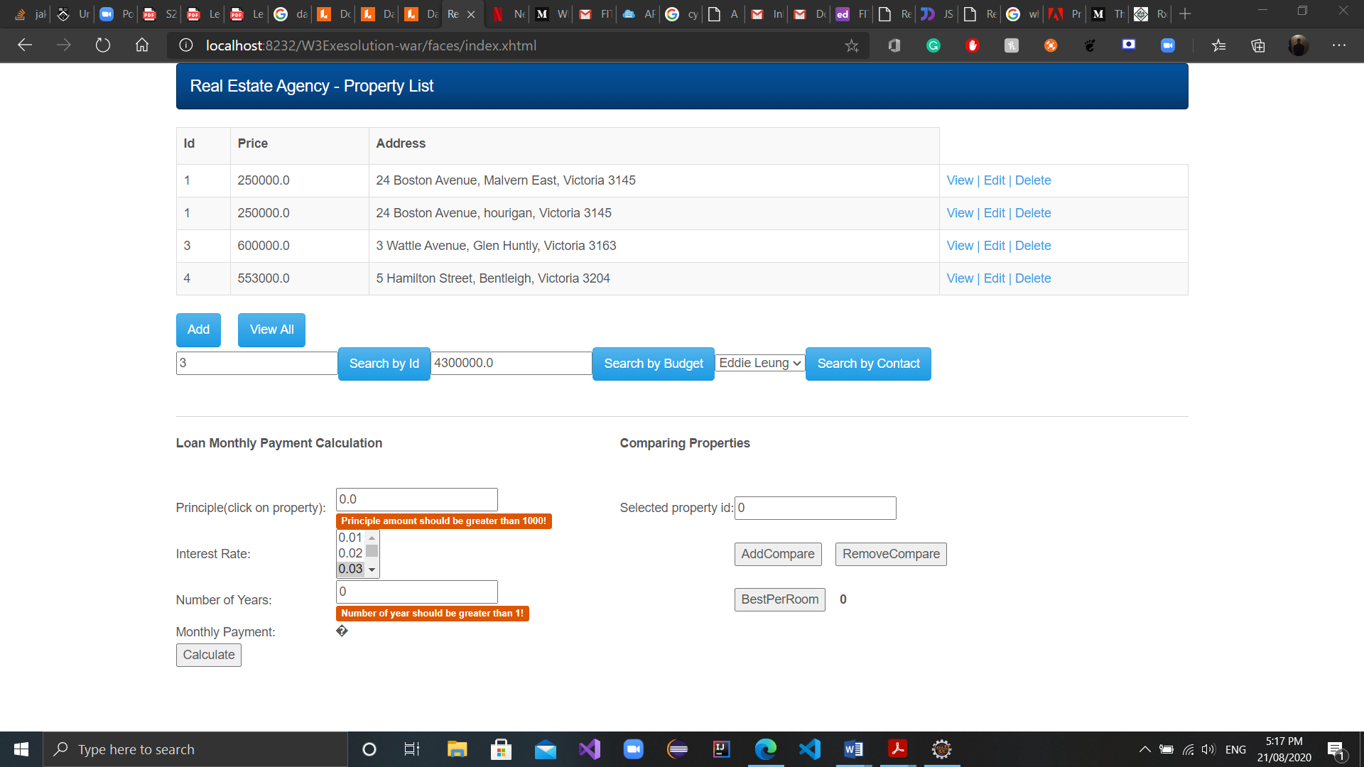

Figure Validations

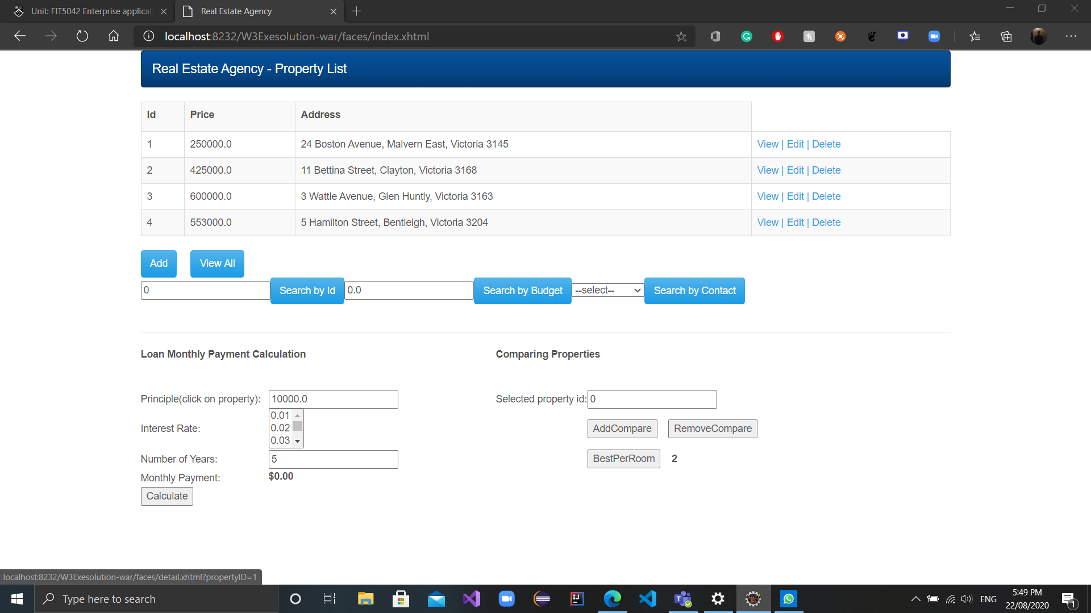

Figure best per room

Github:

# Declaration

I declare that this eFolio tasks and the linked code are my individual work. I have not copied from any other student’s work or from any other source except where due acknowledgment is made explicitly in the text and code, nor has any part of this submission been written for me by another person.

Signature of student: Onkar Uttam Kalpavriksha __________________