Studio 1

Name and Student Id:Onkar Uttam Kalpavriksha 30473764

Self-Evaluation :

|  |  |  |  |  |  |
| --- | --- | --- | --- | --- | --- |
| Need Help | Work in Progress | Pass | Credit | Distinction | High Distinction |

Tutor Evaluation {To be highlighted by Tutor only}:

|  |  |  |  |  |  |
| --- | --- | --- | --- | --- | --- |
| Incomplete | Needs improvement | Pass | Credit | Distinction | High Distinction |

Task 1.1:

eFolio URL : <https://drive.google.com/drive/folders/1Ba1XJhxGmPwcuAM-V1REXg376mJBVfEK?usp=sharing>

Screen Shot:

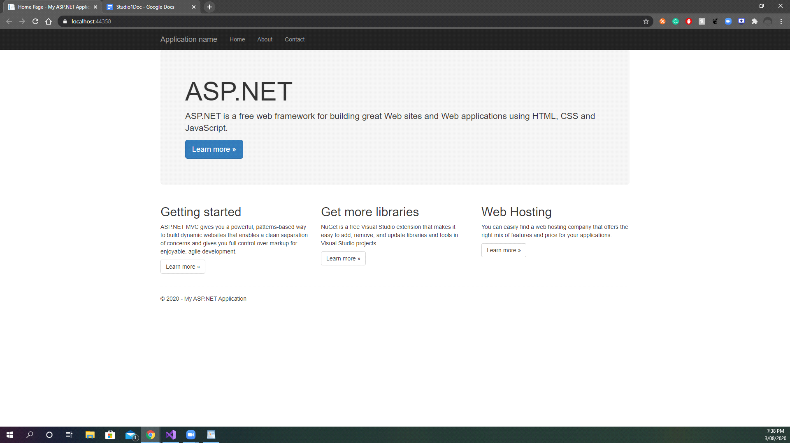

Task 1.2:

Answers:

Five different IDE's used for Agile development are

* Visual Studio
* Android Studio
* XCode
* Intellij
* Pycharm

The Five features of Visual studio Community edition are

* Advanced debugging and diagnostics - The IDE contains various debugging tools such as Code Metrics and Graphic Debugging and many other for advanced debugging and diagnostics.
* Testing tools - The IDE includes testing tools for Unit Testing, Code Coverage, IntelliTest and various other tools for testing the code.
* Cross-Platform - The IDE is used for making various applications on Android,IOS,Mac, Windows etc.
* Collaboration Tools and Features - The IDE contains collaboration tools such as PowerPoint StoryBoarding, Code Review doe collaboration between different groups of developers
* Integrated Development Environment - As an IDE it contains many tools such as Code clone, CodeLen, Peek Definition which help developers speed up the development and deployment time of the applications under development

Screen Shots

Visual Studio as an IDE

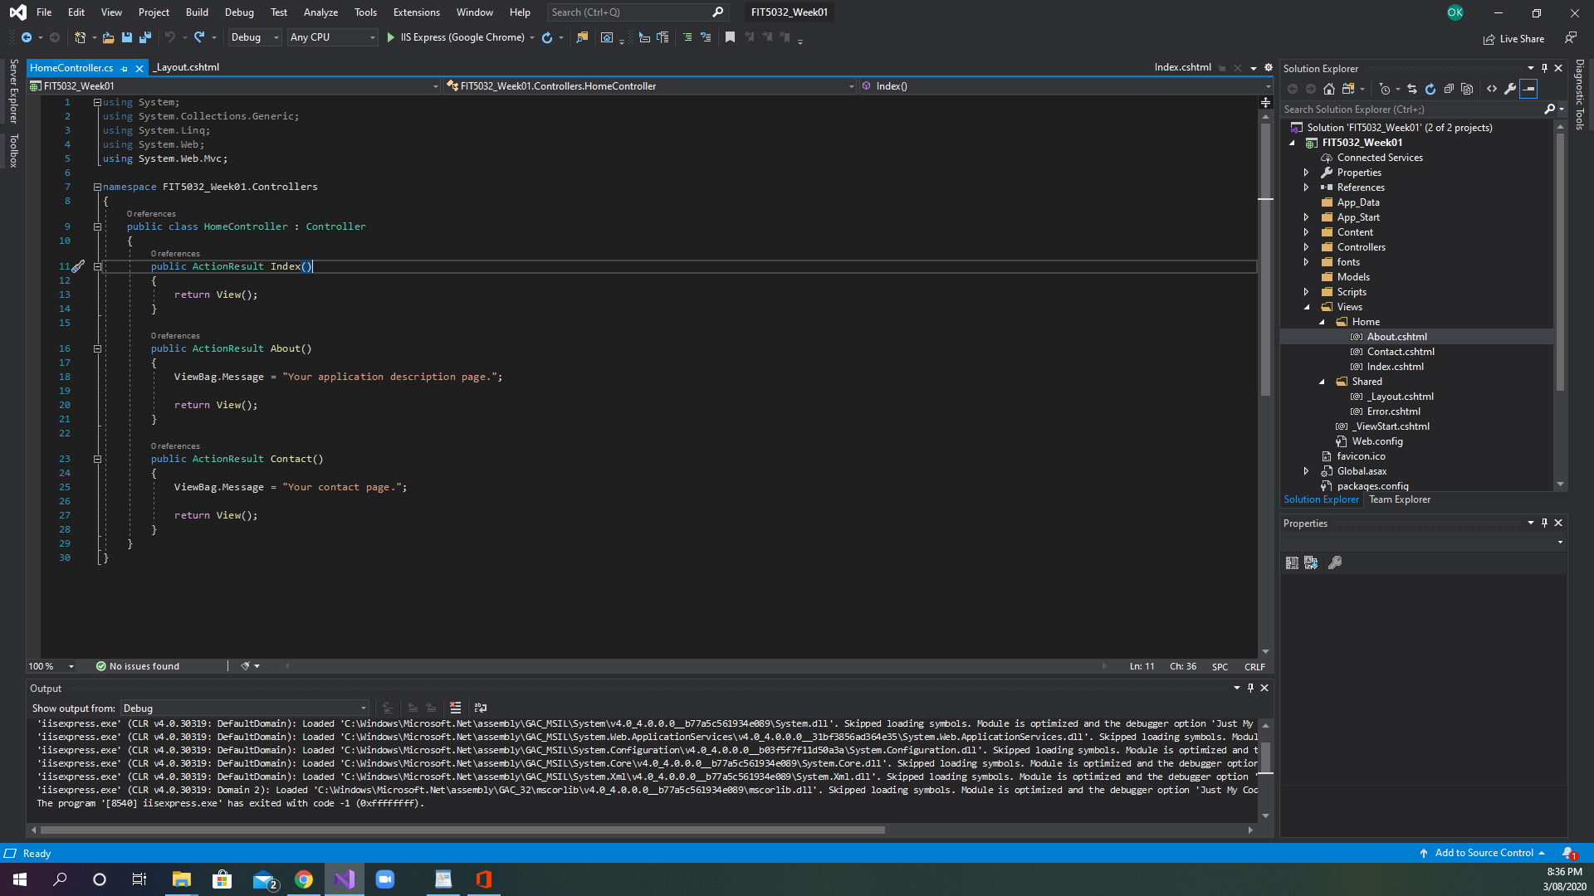

References

https://visualstudio.microsoft.com/vs/compare/

# Declaration

I declare that this eFolio tasks and the linked code are my individual work. I have not copied from any other student’s work or from any other source except where due acknowledgment is made explicitly in the text and code, nor has any part of this submission been written for me by another person.

Signature of student: Onkar Uttam Kalpavriksha __________________