





# Objective:

To create working prototype of cross-platform application (involving both frontend and backend components with interactions between them) for the specified user stories using the technologies / frameworks discussed in the classroom sessions

# **Problem STATEMENT:**

A web based vaccine tracking system to be specifically designed for administration, tracking and management of vaccination for schools

As a part of this assignment, you are required to implement the User Interface and its related functionality for the features listed below as user stories.

# System Architecture:

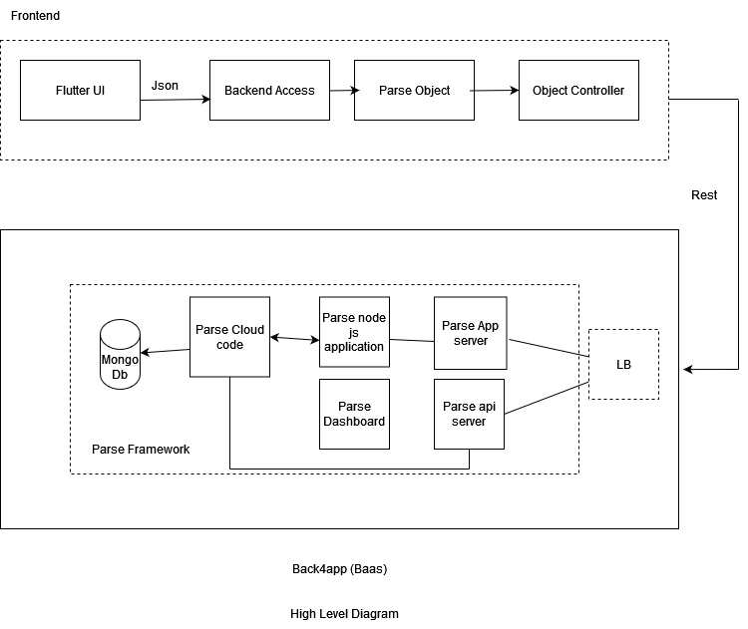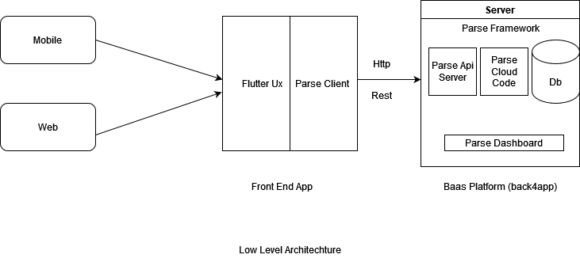

# flow diagrams:

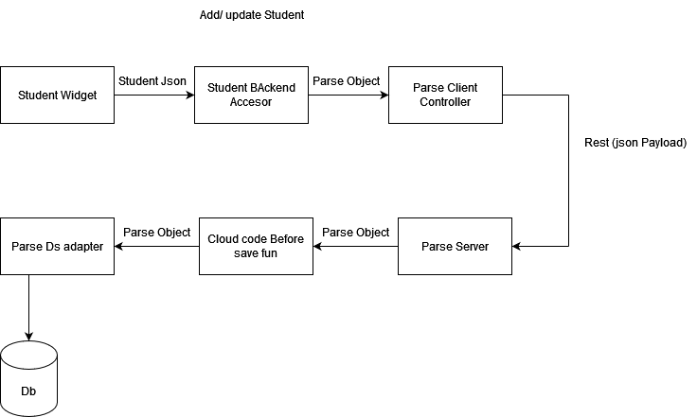

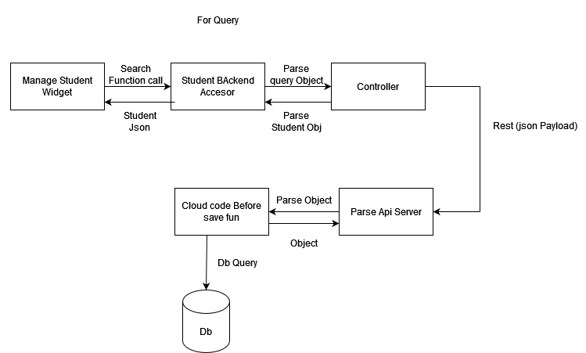

# Tech Stack:

# Overall Software Working:

# Git Repo And Video Link: