Priora: The Last-Minute Life Saver
An Autonomous, Voice-Enabled AI Productivity Ecosystem

Application UI Showcase
Below are screenshots of the fully functional Priora application, showcasing the Premium Glassmorphic Design, AI Strategist, Immersive Focus Mode, and the Voice-Enabled Assistant.
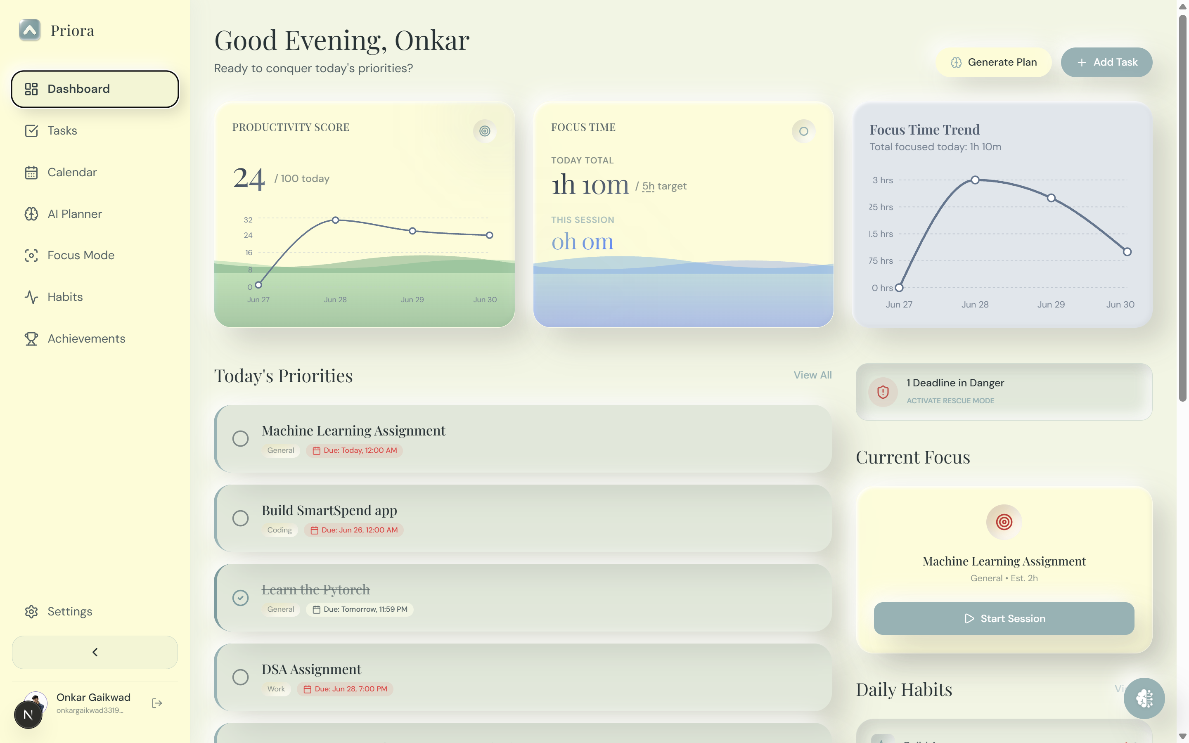
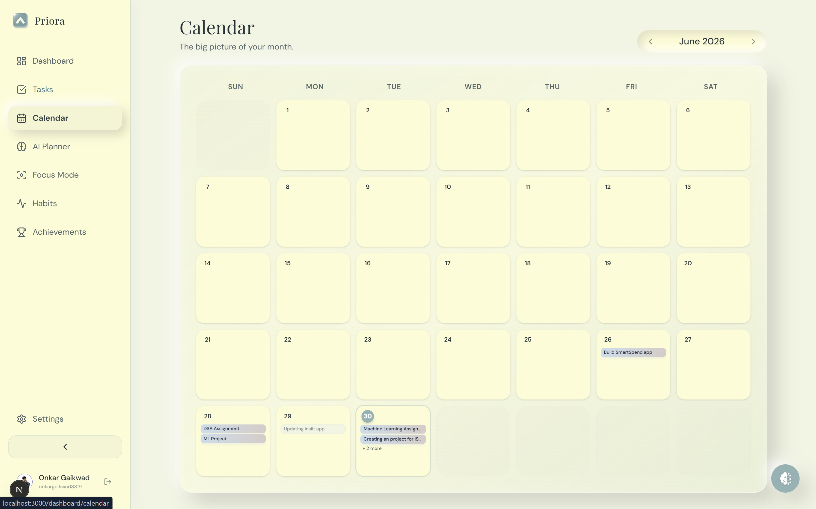
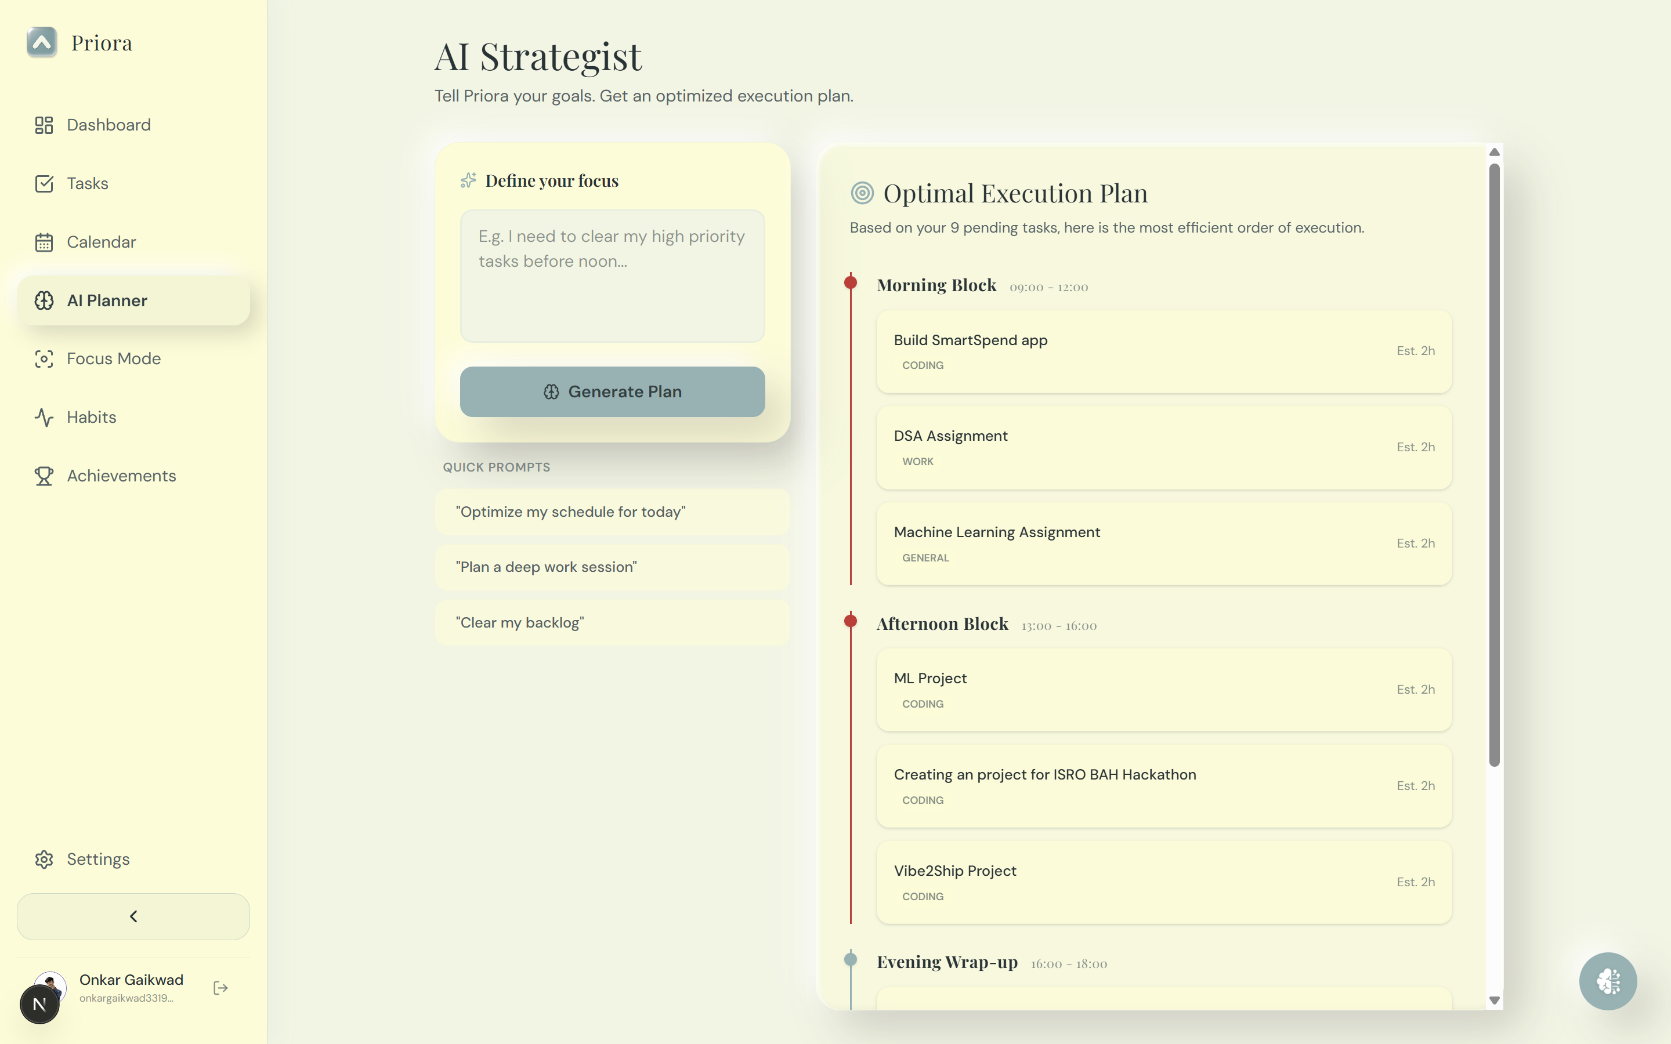
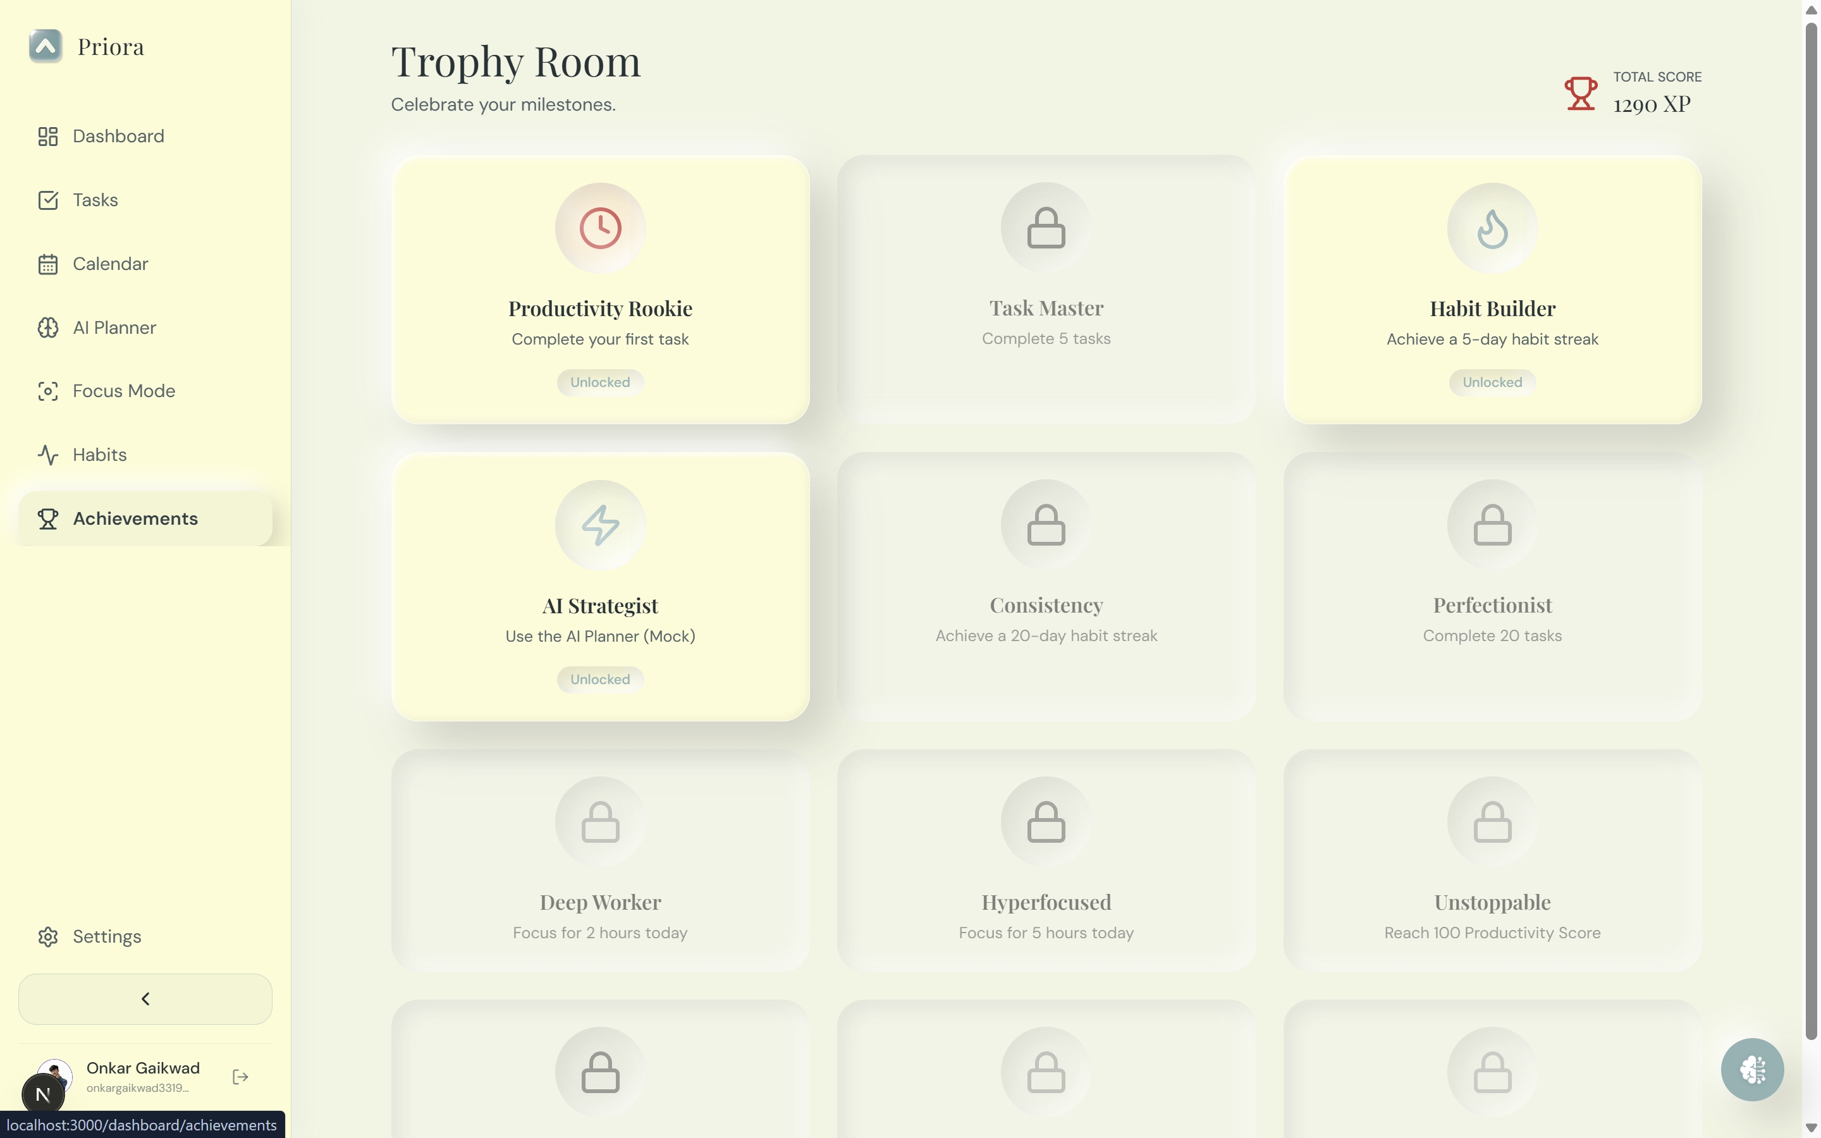
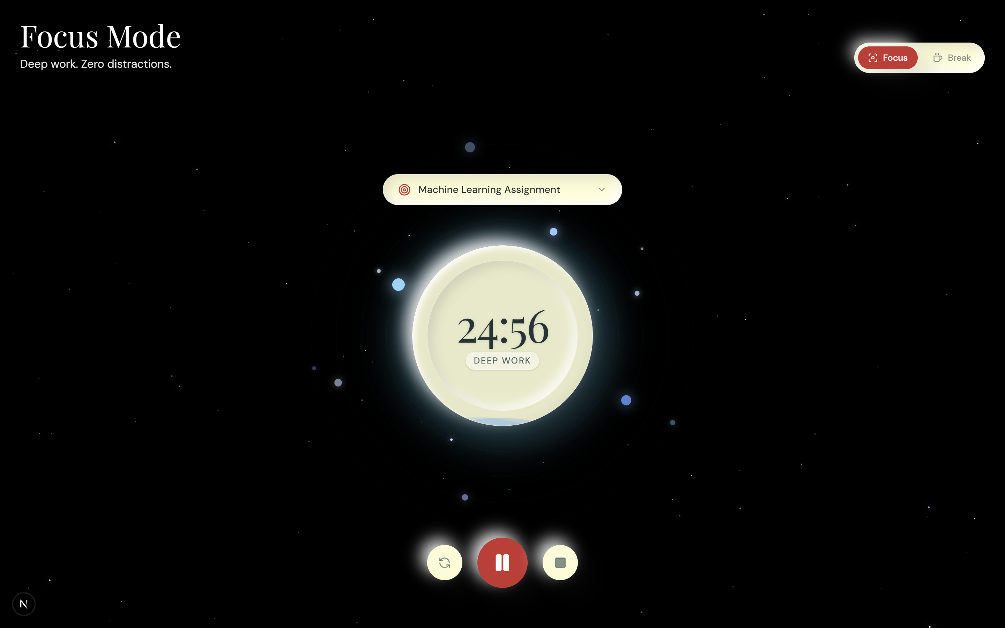
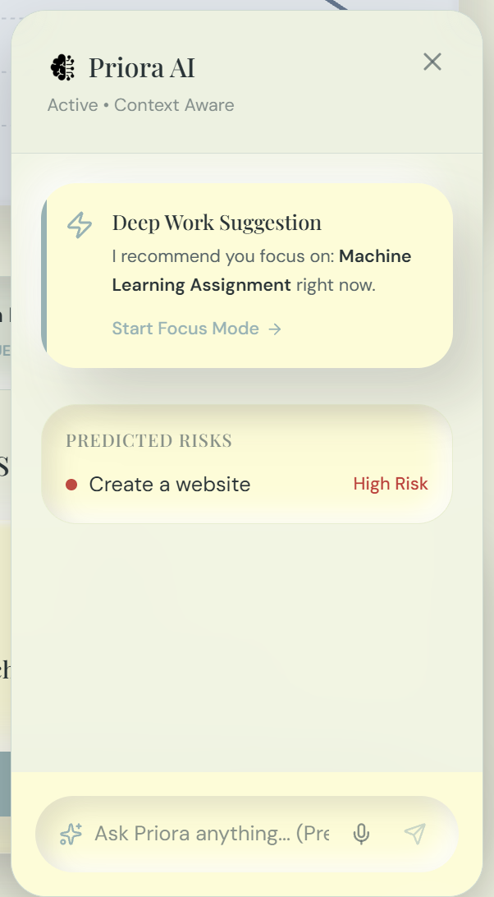

1. Problem Statement Selected
Challenge: Build an AI-powered productivity companion that proactively assists users in planning, prioritizing, and completing tasks before deadlines are missed. The solution must move beyond traditional, passive reminders and focus on helping users take meaningful action.

2. Solution Overview
Existing productivity tools rely on passive notifications that are easily dismissed. Priora solves this by acting as an autonomous, proactive strategist. Rather than just storing a list of tasks, Priora analyzes the user's workload, predicts which deadlines are at risk, and autonomously segments tasks into strategic, executable time blocks (Morning, Afternoon, Evening).
To bridge the gap between planning and execution, Priora offers a fully voice-enabled AI assistant for frictionless task management and an immersive 'Focus Mode' powered by ambient YouTube soundscapes, effectively forcing the user into a state of deep work.

3. Key Features & Innovations

A. Intelligent Task Prioritization & Predictive Risk Modeling
- Dynamic Dashboard: Tasks are algorithmically sorted by urgency and priority (Critical, High, Medium, Low).
- Context-Aware Reminders: The AI constantly scans pending items and surfaces 'Predicted Risks' in the sidebar, proactively warning the user about high-priority tasks nearing their deadline before it's too late.

B. Autonomous AI Strategist (Scheduling Assistance)
- Overwhelming lists cause paralysis. Priora's AI Planner extracts pending tasks and generates a bespoke daily battle plan, intelligently distributing the cognitive load across Morning, Afternoon, and Evening blocks.

F. Technical Implementation & Completeness (15%)
- Robust Stack: Next.js 14 Edge routes, Supabase (PostgreSQL) auth and database, Web Speech API integration, completely functional from login to execution.
- PWA Ready: Engineered as a Progressive Web App (PWA), allowing users to install Priora directly to their home screens for a native, distraction-free mobile/desktop experience.

C. Voice-Enabled Autonomous Assistant (Priora Chat)
- Hands-Free Productivity: By integrating the Web Speech API and Speech Synthesis (TTS), users can converse naturally with Priora via microphone.
- Actionable NLP: The AI isn't just a chatbot; it autonomously extracts intents and executes database mutations instantly while audibly confirming the action.

D. Immersive Focus Mode (Action-Oriented Execution)
- To ensure users take 'meaningful action', Focus Mode provides a distraction-free, full-screen environment.
- Deep Work Soundscapes: Integrates ultra-low bandwidth (vq=tiny) YouTube audio streams (Interstellar, Avatar, Harry Potter) to induce flow state.
- Personalized Recommendations: The AI suggests exactly which task to tackle during the focus session based on current priority metrics.

4. Technologies Used
- Frontend Architecture: Next.js 14 (App Router), React, TypeScript, Tailwind CSS, Framer Motion
- Application Type: Web Application (with Progressive Web App capabilities for native installation).
- Backend / Database: Next.js Edge API Routes, Supabase (PostgreSQL)
- Native Browser APIs: Web Speech API (SpeechRecognition & SpeechSynthesis)

5. Google Technologies Utilized
- Google DeepMind Antigravity: Utilized Google's advanced Agentic AI Coding Assistant for rapid ideation, pair-programming, and complex architectural implementation throughout the hackathon.
- Google Gemini API (2.5 Flash & 2.5 Pro): Serves as the central brain of Priora. Gemini powers the complex reasoning required for the Daily AI Strategist, processes unstructured voice transcripts into structured JSON payloads for task creation, and generates contextual risk predictions.
- YouTube Embed API: The engine behind Focus Mode's ambient soundscapes, seamlessly delivering immersive audio experiences via parameterized background iframes without compromising application performance.

6. Alignment with Evaluation Focus
The challenge requested a solution demonstrating how AI can improve productivity by helping users make better decisions and complete tasks more effectively.
Priora completely eliminates decision fatigue via the AI Strategist and Deep Work Suggestions. Instead of the user deciding what to do, the AI tells them what is most critical. Furthermore, the combination of Voice-Enabled task entry and the immersive Focus Mode actively shepherds the user from the 'planning' phase into the 'execution' phase. Priora doesn't just remind you to work; it builds the perfect environment for you to succeed.

