# INFO 6046 Media Fundamentals Fall 2024 Final Exam

**Total**: 80 Marks (+30 bonus)

*You may reference old projects, notes, recorded videos as-well as FMOD Documentation.*

# All work must be done alone, and all code must be your own. You may start from the provided code.

**Description**

Develop a client side only audio application that allows users to record audio using FMOD, during recording store the audio data in a ring buffer to be prepared to be sent over VoIP or writing to an audio file. Additionally, users should be able to play back recorded audio with DSP effects.

# Ring Buffer (20 marks)

A ring buffer (also known as a circular buffer or cyclic buffer) is a data structure that uses a fixed-size buffer, and when it reaches its capacity, it starts overwriting the oldest elements with

the newest ones. It can be thought of as a circular or ring-shaped structure where data is written and read cyclically. This is particularly useful in scenarios where a continuous stream of data needs to be processed or stored, and only a certain amount of recent data needs to be retained.

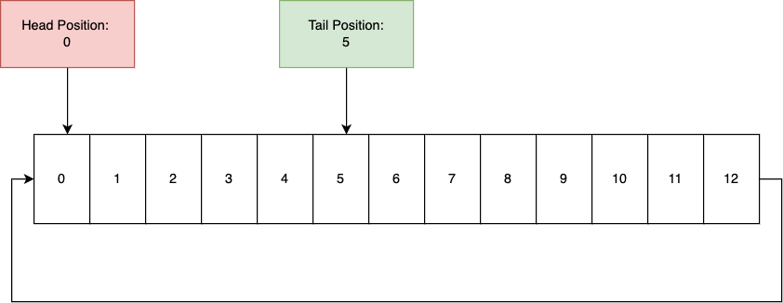

Implement RingBuffer class in RingBuffer.h

# Recording to RingBuffer (10 marks)

As a Sound is being recorded within Audio Manager. We want to retrieve the data and store it within our Ring Buffer. This can be achieved in ProcessRecording in AudioManager. Implement the call to RingBuffer.Write in both locations in that function

# Recorded Sound Playback (10 marks)

Create a function that plays the recorded sound back. Ensure the sound doesn't play immediately. Use the channel to setPaused (false) afterwards. This sound should only **play once, and not loop**.

# Playback with DSP (20 marks)

Add DSP effect to the recorded sound being played back. There should be 3 DSP effects that are created through a function or within AudioManager Initialize.

Select DSP in main.cpp within PressKey function and call a function in AudioManager to set the active DSP. This can be stored in m_ActiveDSP. Check the TODOs in AudioManager.h

# Recording Storage (20 marks)

After each recording, store the sound within a container. Press a key to play a random sound within this container with the active DSP.

# BONUS (30 marks)

Write the recorded data to an audio file from the RingBuffer during recording.