# **INFO-6028 “Graphics 1”** Instructor: Michael Feeney

**Midterm Exam, Friday, October 25th, 2024**

## The exam format:

* It is an “open book” exam. You have access to anything you book or internet resource you’d like.
* You may use any resources you feel are necessary to complete the exam, and we’ve discussed what you can and can’t do in class. You are free to use whatever resources have been provided for you (github, etc.) and any code *you* have made for yourself during this term.   
  + <http://www.fanshawec.ca/admissions/registrars-office/policies/cheating-policy>
  + <http://www.fanshawec.ca/sites/default/files/assets/Ombuds/cheating_flowchart.pdf>
* I’m mostly concerned about that *you* did this *yourself* in that you know what you’ve typed in. If I suspect this is something you’ve taken/stolen/generated from somewhere else and you have no clue what it does or how it works, I’ll ask you about it; if *you* wrote it yourself, you should know how it works and how it might be changed/updated/fixed/done-differently – if not, then how did you do it?
* The questions are ***NOT*** of equal weight. The exam has **five (5)** questions and **eight (8)** pages.
* Separate the questions or combine?   
  + I will *not* modify your code, so **don’t** add some “comment/un-comment this block of code” or “move file X to location Y…” nonsense, because:  
    1. you should be able to add something like a keystroke/menu/whatever to change how your program runs and…
    2. I’m not going to change the code, so it’s pointless.
  + If you feel that the questions “build” or “combine” together clearly, then you may submit combined answers to each question. For example: if Q1 had “draw an island”, then Q2 had “add some buildings”, and Q3 had “put some lights on the buildings”, etc. – then these reasonably “build” on one another. A different way of thinking about this: If you submitted an answer with building with lights that sat on an island, think: does this answer all three (Q1-Q3) questions? If yes, then you can combine them.   
      
    What wouldn’t combine might be a day/night scene, say Q4 (in this example) was “change the scene so it’s nighttime by adjusting the lights from Q3”. If you added a keyboard shortcut that switched from day to night, then you *could* submit one program, but if you didn’t do this, then you’d have to submit two programs: one for daytime (Q1-Q3) and one for night-time (Q4).
  + If you submit one solution/project, I’m going to assume that it answers all the questions, i.e. you have combined all the questions into one answer.
  + If you submitted separate solutions/projects, then CLEARLY indicate which ones answer what questions. If you do this, I’d suggest copying the entire project (or entire solution) and CLEARLY renaming it something like “Question_01” or “Questions_01_to_04” or something like that.
  + Do whatever you think would make it the easiest for me to mark.
  + If there’s something I need to know (keyboard controls, pressing a button to start, etc.) then make a README type file AT THE ROOT location, not buried somewhere in the folder or code.
  + You many have other “utility” libraries, like ones to load textures, models, sounds, etc. However, make sure your submission is complete so that I can build your solution.
  + Please delete all the “extra” Visual Studio files before zipping it up (like the “Debug” and “Release” folders, “obj”, as well as the IntelliSense file (the “.vs” folder).
  + **If the solution does not build (and run), I will not mark it** (so you will receive zero on questions that can't be built and/or won't run). When I say "run", I'm not speaking about some, random, unforeseen bug, but rather something that you should have obviously dealt with, like memory exceptions, etc.  
      
    This includes you missing parts of your project/solution. Be *sure* you are submitting everything you need. An good check is to place your submission on another drive (or better, another computer) and see if you have everything you need.
  + Solutions must be using a x64 Release library C++ project using the **default** settings of Visual Studio 2022 (C++ **14**) using the OpenGL 4.x API (with glfw, glad, and glm).
  + If you use the C++ “**auto**” keyword, you will get a mark of zero. No exceptions.   
    If you use the “boost” library (or any derivative), you will also receive a mark of zero.
  + Your solution may not contain any third party “core C++” libraries (like boost). The same goes for any other libraries you have not cleared with me before hand (like assimp). The *only* libraries that should be present are GLFW, glm, and glad. Note: If you are using some sound libraries from another course, that’s likely fine – just warn me. I’m referring to C/C++ libraries.

|  |
| --- |
| You have until **11:59 PM** on **Friday, October 24**th to submit all your files to the appropriate drop box on Fanshawe Online (FOL).  **NOTE:** Although this may “look and feel” like a project, it isn’t, it’s an exam, so there is *no concept of “late marks”*; if you don’t submit your files the time the drop box closes, then you effectively didn’t submit anything for the exam, there’s nothing to mark, so you’d get a mark of zero. |

See Policy A131 (<https://www.fanshawec.ca/sites/default/files/2023-09/A131%20-%20Evaluation%20of%20Student%20Learning.pdf>) for an explanation of “exceptional circumstances”.

*Please don’t be late submitting.*

(Also be **SURE** that you are actually submitting the correct files)

## NOTE: Unless otherwise indicated, you should be displaying the ply files that were included with the exam (in the PLYFiles.7z and PLYFiles.zip folder – they are the same files, just different archives).

**Some notes about the models:**

* The models are of *VERY* different resolutions. Depending on your system, the larger ones will take *MUCH* longer to load, particularly with the Debug build.
* However, the “matching” models (example: all the “Galactica…”) are the same overall size (i.e. the “bounding box” or “extents” of the various models are the same). They are also (sort of) the same shape, though the size reduction mangles the models somewhat.

My suggestion is the USE THE LOWEST RES MODELS you can handle loading (time wise) and when everything is working like you want it, replace with the highest resolution and run the solution with the Release build.   
  
**I will be marking with the high-resolution models. If your submission shows the lower resolution models, you will lose marks. Same with**

The models are in the "PLY Files" (7z & zip) file:

* Battlestar Galactica (several resolutions)
* "new" version of the Viper
* Cylon Raider
* "old" version of the Viper (several resolutions)

The format has xyz, normals, and UVs (texture coordinates) but not colours.

If you end up using larger models – and have a larger “scene” – you will have to change the “near” and “far” clipping plane on the projection matrix.   
  
The two videos are in the Videos.7z.001 to .005 files. Opening the 7z.001 file will allow you to extract the entire set of files (I had to split them up fit under gits < 50 Mbyte limit):

* Battlestar Galactica - Big Battle Compilation (720p).mp4
* Cylons take out the newer Vipers by hacking (x265.HVEC).mkv

## The Questions:

***“Fleeing from the Cylon tyranny, the last battlestar, Galactica, leads a rag-tag fugitive fleet on a lonely quest...a shining planet known as Earth.”***

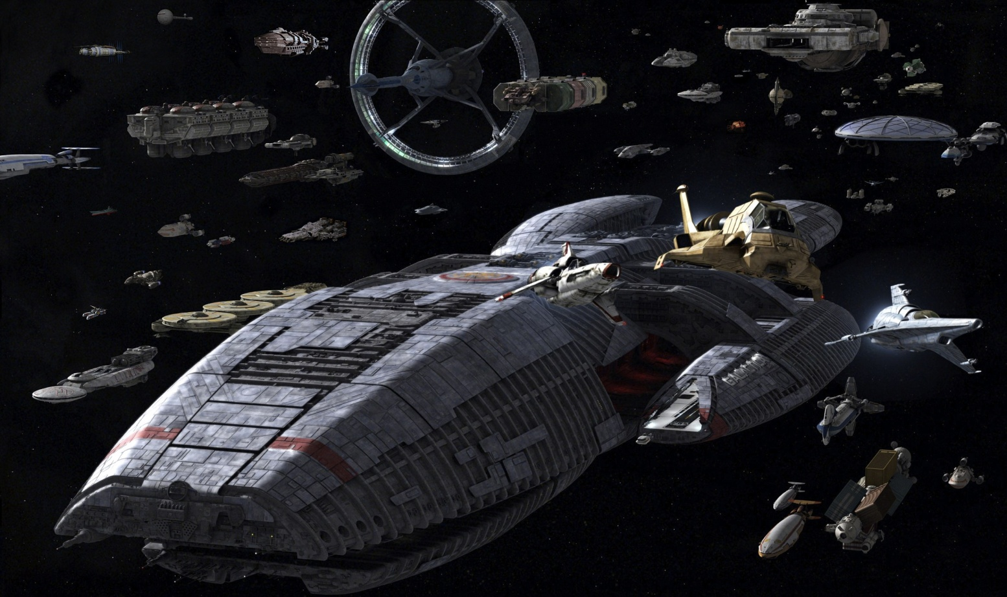

Just in case you have no idea what “Battlestar Galactica” is, here’s a brief summary:

Battlestar Galactica was originally a 1978 TV show, attempting to duplicate the "buzz" of Star Wars (which released in 1977). In 2004 a "re-imagined" version hit the Syfy network (trivia note: apparently "re-imagined" was 1st used for Battlestar Galactica).

You should watch it. It's awesome. Lots of ships, lots of interpersonal drama. Edward James Olmos, Mary McDonnell, James Callis, and the until then, virtually unknown Katee Sackhoff and Tricia Helfer - what's there not to love?

In the future (or is it the distant past??), humans are all over the galaxy. They make robot servants - called "Cylons" - who revolt and there's war, then a tenuous peace.   
  
(Fun fact: in the original 1978 version, an alien race made the Cylons, not the humans.)

During the war, enormous "space aircraft carriers" (basically) called "Battlestars" are made. They are several kilometers long (really), with thousands of humans crew members living on board. They also have hundreds of single person space fighters called "Vipers".   
  
In the picture (above), the Battlestar Galactica is the giant ship (if you are unclear... seriously?). The picture shows two version of the Viper, an older one (in left yellow circle) and a newer one (in the right yellow circle).   
  
You can see one of the huge landing bays Galactica (yellow arrow). The Vipers (and other ships) land on these runways sort of things inside the bays. Note that these landing bays bays are HUGE relative to the Vipers (the right picture):

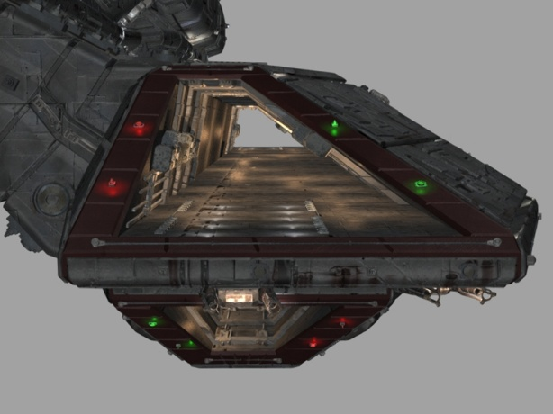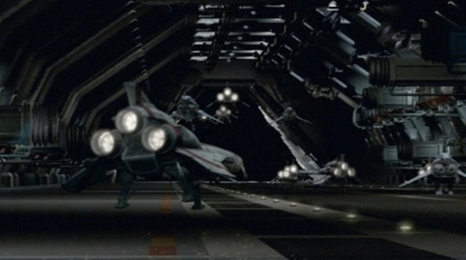

1. (20 marks) Place the Galactica in the scene, along with a couple Vipers, in a "dramatic" shot like on page 3.   
   * Place the camera in a “dramatic” location, far away and above, looking "down" on the Galactica (like in the picture on page 4).
   * Place two (2) Vipers, one “new” and one “old”, in front of the Galactica (again, like the picture on page #4). They should both be closer to the camera and "flying up and off" at an angle (like the picture)
   * Newer Vipers (the curvier ones) are more dark grey - colour them as such
   * Older Vipers (the less curvy ones) are much lighter *almost* white coloured - colour them like that.
   * The Galactica is dark grey.
   * Note that the scene is HUGE, so you'll have to place at least a few (likely three) lights in the scene, and manipulate the distance and attenuation so everything is more-or-less evenly lit. i.e. I *don't* want some giant glaring "bright" spot on one (or more) of the models.
2. (80 marks) ALTER YOUR ANSWER FROM Q1 by:   
     
   Add four light-blue/white lights to show the "plasma" (or whatever) engine exhaust (or whatever) that's coming out of the Galactica:

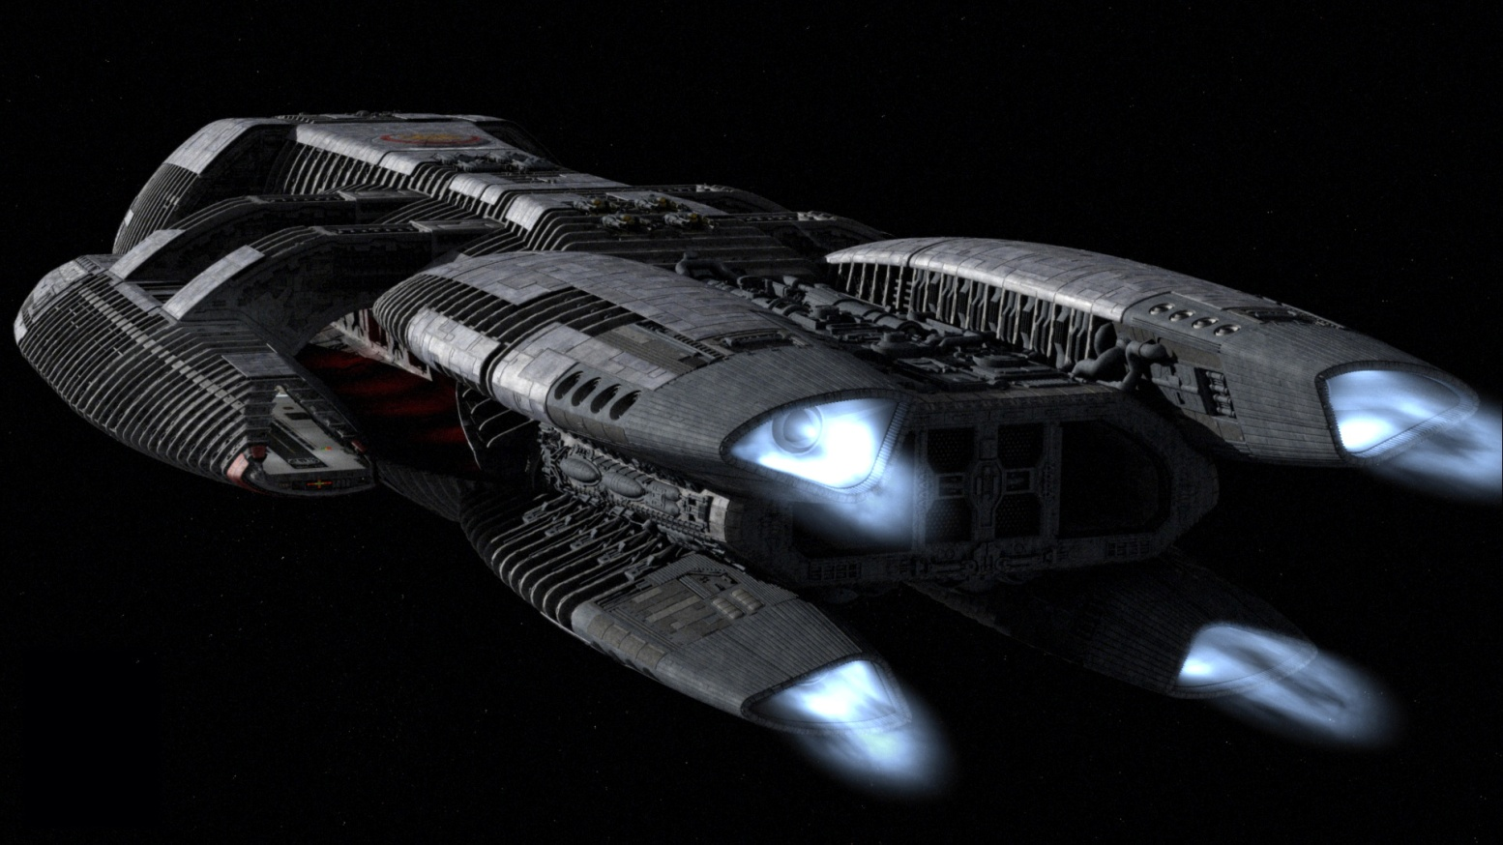

* Place the camera near the rear of the Galactica (like the picture above)
* Add four lights, inside the "engine" area (like indented parts). Note you'll need to control the attenuation and/or the "cut off distance" to make the lights both bright AND limited to insides of the engines. A little bit of light "spilling out" is OK, but I want the lights on the *inside* of the engines and not washing all over the ship
* You still need to see the Galactica, so you'll need to keep the same "general" lighting that you had in Q1 (it doesn't have to be *exactly* the same lights, just that it's a general area light, like in the picture)
* Use the "9" key to place the camera at this rear location and angle (see the picture above), and the "0" key to put the camera back where it was in Q1 (looking at the two vipers and facing the front of the Galactica).

**BONUS (10 marks):** When you press the “9” and “0” keys, the camera gradually moves/animates between these two locations and directions. Think of this like if you were in a spaceship in the scene, looking out the windows, and the keys “flew” this ship from the one location to the other. This is as opposed to instantly snapping/teleporting to the two camera location and views.

1. (80 marks) If you watch the "Battlestar Galactica - Big Battle Compilation (720p)", you'll see Vipers launching from, and landing on, the Galactica, as well as the "Cylon Raiders" (the evil Frisbee/robot looking ships with the scary back-and-forth red "eye" things) leaving their "BaseStar" and attacking. There's also a lot of things blowing up. And yelling... So.Much.Yelling. This will give you a sense of the type of ships, the scale, how they move, the colours, the placement of the ships relative to each other, etc.   
     
     
   You are to recreate a specific scene from the pilot episode (the clip, which *isn't* from YouTube) where the Cylons take on an entire wing of "newer" Vipers and "hack" them or something, making them useless. Then they destroy them all.   
     
   This is the "***Cylons take out the newer Vipers by hacking.mp4***" clip, around 3:17 in.   
     
   The "older" Vipers are immune to this hacking, so some of them get launched to “kick Cylon butt”. Unfortunately, the people in the “new” Vipers don’t have a good day.  
   * Place five (5) “new” Vipers flying towards the Cylons. They should be "pretty far" away from the Galactica (you can see in the YouTube clip they are quite far away, like 50 km maybe?). They should be in some kind of sensible "formation" (i.e. like the video - facing the Cylons, flying away from the Galactica, near each other, etc.). These need to be the "newer" Raiders (so make them the right colour - dark grey)
   * Place two (2) Cylon "Raiders", in formation, flying towards the Vipers. They should be pretty far away from the Vipers. **NOTE:** I realize that you only have a limited amount of "space" in your "scene", since you have to have *both* the Vipers and Cylons in the same screen ("shot"), so when I say "pretty far", I mean they shouldn't be "right beside" each other, but I also don't want them to be micro-tiny, either. (the “Battlestar Galactica - Big Battle Compilation” can give you an idea of how they handled this in the TV series).
   * Using a really tiny sphere, and a really "tiny" light (i.e. mess with the attenuation and cut-off), mimic the "eye" thing on one of the Cylons. I'm pretty flexible about this, but it should be clear that there's a little, bright "eye" light, but I don't want the entire Cylon Raider awash with red light, either.   
       
     You can also simulate this some other way, too. Like you could place a spot light that shines back at the cylons “eye” slot thing, maybe?
2. (40 marks): The new Vipers are having a *really* bad day... mimic the slaughter of the poor Viper pilots, *after* the Cylon hacking thing has happened (around 3:59 in the YouTube clip), but just before they all blow up (around 4:20 and on).

* Change the orientation of the five (5) “new” vipers *across all axes* (x, y, and z) so they look sort of "random", like they have "drifted", like they are in the clip.
* Add a bunch (at least five (5)) of "missiles" or "bullets" from the Cylons. You can use the "Tear Drop" shaped model for this to mimic this effect:  
  + One of these models has the normals facing “out”, like every one of the other models. The other one has the normals facing “in” (their normal “inverted”).
  + These “inverted” models are “inside out” – i.e. their normal are facing inwards. Remember that by default, only the “front” facing triangles are rendered. Also, the lighting only “lights” objects that face the camera. When these are drawn, you are really seeing the “back” of the model.   
      
    This mean if you place a small light at the same location as these “inverted” models will sort of look like they “glow” because they are actually lighting up the “back” (or “inside”) of the model and the “front” of the model isn’t being drawn.
  + The regular ones (the ones that don’t have “inverted” in the title) can still be lit up, but if you place a light at the same location, the light will be “inside” the model. The problem is that since the normal face *away* from the light, the object isn’t lit.   
    To illuminate these sorts of models, you’d have to place a number of lights *around* the model to get the same effect.
  + You can use whichever model you’d like, but I’m looking for this “glowing tracer bullet” sort of effect that you can see in the two clips.

1. (40 marks each): Implement some rudimentary animation for this "hacking" scene:

* By pressing a key, the new vipers start to *slowly* drift and spin (like in the video).   
  This runs continuously after the button is pressed (i.e. I do *not* want to *hold* the button down for this to take place) and stops when I press *the same button*.
* Add the back and forth eye animation on the front of the Cylon Raider.   
    
  I want to be able to move the camera close to the face of the Cylon to see this sort of effect. You can also add keyboard shortcut that appropriately places the camera, too.   
    
  Of course, I’m not looking for “film perfection” here, but I’d like to see that this “eye” is moving along the eye “slit” and is tracking the surface. Like not some cartoon giant red ball or that it’s changing size or whatever. It should look reasonable given what you know how to do. If you’re unsure how “good” it should look

That’s it.