**Practical No. 1**

**Q.1 A. Create book table (book_id(pk), title, author, price, book_rating) with range Partition on rating with 1, 2 and 3 for three different partitions. Insert at least 10 record in the table.**

**B.Display all the books with rating 3 and price in the range 200 and 1000.**

**SQL Query:**

Create table book(book_id varchar2(20) primary key,title varchar2(50),author varchar2(50), price number(10),book_rating int)

partition by range(book_rating)(

Partition p1 values less than (1),

Partition p2 values less than (2),

Partition p3 values less than (3),

Partition p4 values less than(MAXVALUE)

);

insert into book values('A01', 'Rich Dad Poor Dad', 'Robert KioSaki', 750, 5);

insert into book values('A02', 'Anna Karenina', 'Leo Tolstoy', 900, 4);

insert into book values('A03', 'Madame Bovary', 'Gustave Flaubert', 550, 5);

insert into book values('A04', 'War and Peace', 'Leo Tolstoy', 250, 2);

insert into book values('A05', 'The Great Gatsby', 'F. Scott Fitzgerald', 750, 2);

insert into book values('A06', 'Lolita', 'Vladimir Nabokov', 150, 1);

insert into book values('A07', 'Middlemarch', 'George Eliot', 850, 4);

insert into book values('A08', 'The Adventures of Huckleberry Finn', 'Mark Twain', 650, 1);

insert into book values('A09', 'In Search of Lost Time', 'Marcel Proust', 280, 2);

insert into book values('A10', 'Hamlet', 'William Shakespeare', 120, 1);

insert into book values('A11', 'Middlemarch', 'George Eliot', 850, 3);

insert into book values('A12', 'The Adventures of Huckleberry Finn', 'Mark Twain', 650, 3);

insert into book values('A13', 'In Search of Lost Time', 'Marcel Proust', 280, 3);

insert into book values('A14', 'Hamlet', 'William Shakespeare', 120, 3);

SELECT * FROM book partition(p4)

WHERE price BETWEEN 200 AND 1000;

**Output:**

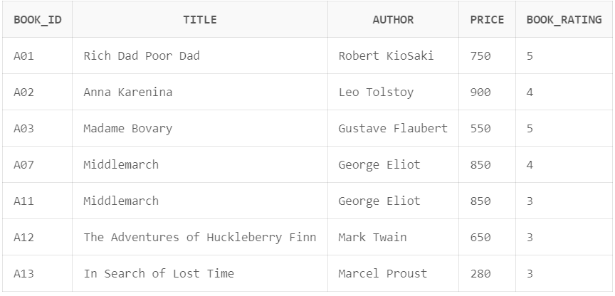

**Q.2 A. Create 3 Partition in table cabinet using range partition on cid Column of cabinet (cid, mem_name, address, state_rep, phone_number, sal) P1 cid < 101; P2 cid < 501; P3 cid <1001.**

**Insert at least 10 records in the Table.**

1. **Display the Contents of third Partition.**

**SQL Query:**

Create table cabinet (

cid number(5),

mem_name varchar2(20),

address varchar2(30),

state_rep varchar2(30),

phone_number number(12),

sal number (8)

)Partition by range(cid)(

Partition P1 values less than (101),

Partition P2 values less than (501),

Partition P3 values less than (1001)

);

insert into cabinet values(900,'Onkar','Canada','USA',7020767185,100000);

insert into cabinet values(95,'Rasika','Ratanagiri','Uk',8160124511,20000);

insert into cabinet values(200,'Atharv','Ramgad','SouthAmerica',8060124511,25000);

insert into cabinet values(800,'Abhi','Devagad','England',8067124511,200000);

insert into cabinet values(922,'Sonali','Canada','USA',8064021211,120000);

insert into cabinet values(611,'Vaishnavi','Europe','New Jeresy',8060664511,285400);

insert into cabinet values(422,'Rahul','Goa','New Jeresy',8770124511,20000);

insert into cabinet values(80,'Aniket','Ratanagiri','New Jeresy',9060124511,206540);

insert into cabinet values(90,'Esha','America','New Jeresy',8055124511,200080);

insert into cabinet values(210,'Aditya','Phonda','New Jeresy',7060124511,207800);

select * from cabinet partition (P3);

**Output:**

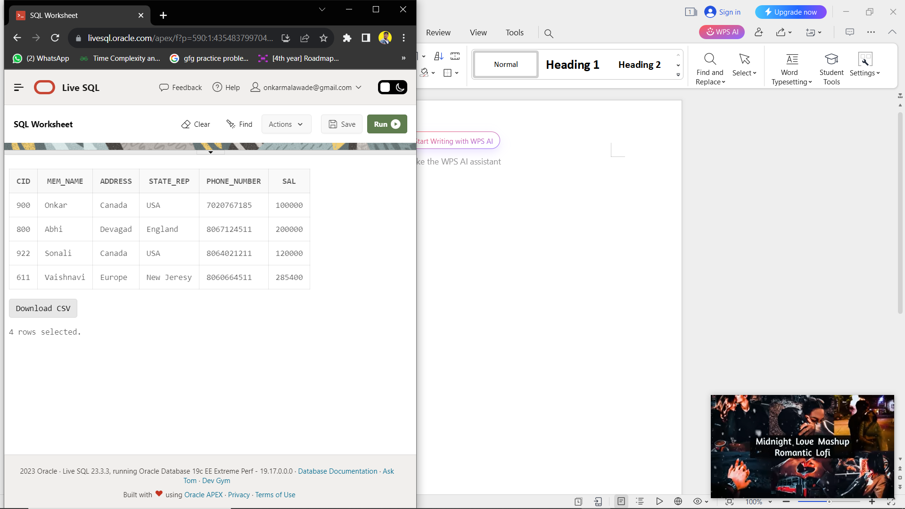

**Q.3 A.Create table Employee with attributes empid, name, age, salary and joining date by using hash partition based on employee salary with minimum 3 partitons. Insert at least 10 records in the table.**

1. **Display the contents of the third partition.**

**SQL Query:**

CREATE TABLE employee

(empid NUMBER,

empname VARCHAR2 (100),

age NUMBER,

joiningDate date,

salary NUMBER

)

PARTITION BY HASH (salary)

(PARTITION s1, PARTITION s2, PARTITION s3);

insert into employee values(1,'Rupali',22,'12-jan-2013',450000);

insert into employee values(2,'Vishal',23,'21-feb-2015',529999);

insert into employee values(3,'Mahek',24,'10-jan-2011',480000);

insert into employee values(4,'Hafsa',22,'1-march-2013',600000);

insert into employee values(5,'Nafia',21,'18-aug-2017',740000);

insert into employee values(6,'Mahesh',25,'29-sep-2013',370000);

insert into employee values(7,'Mayur',24,'25-oct-2014',620000);

insert into employee values(8,'Rahul',21,'16-nov-2015',762000);

insert into employee values(9,'Onkar',23,'18-dec-2020',400000);

insert into employee values(10,'Aditya',26,'22-jan-2022',250000);

select * from employee;

select * from employee partition (s1) order by empid;

select * from employee partition (s2) order by empid;

select * from employee partition (s3) order by empid;

**Output:**

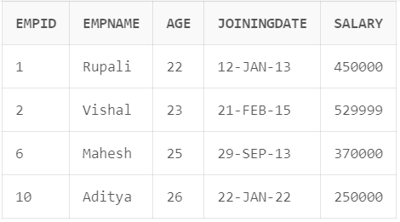

**Q.4 A.Create test_record(test_id, test_type, patient_name, employee_no, labno, result) with list partition on result field as below:**

**P1 = (positive)**

**P2 = (negative)**

**Insert at least 10 records in the table.**

**Display the test_records which have negative result.**

**SQL Query:**

Create table test_record(

test_id varchar2(20),

test_type varchar2(50),

patient_name varchar2(50),

employee_no number(10),

labno varchar2(20),

res varchar2(10))

partition by list(res)(

partition res1 values('positive'),

partition res2 values('negative')

);

insert into test_record values('A101', 'Haemoglobin Test','Raju',7020304010,'LAB01','positive');

insert into test_record values('A102', 'Haemoglobin Test','kaju',7020304011,'LAB02','positive');

insert into test_record values('A103', 'Haemoglobin Test','Paju',7020304012,'LAB01','positive');

insert into test_record values('A104', 'Haemoglobin Test','Naju',7020304013,'LAB02','positive');

insert into test_record values('A105', 'Haemoglobin Test','Haju',7020304013,'LAB01','negative');

insert into test_record values('A106', 'Haemoglobin Test','Biaju',7020304014,'LAB02','negative');

insert into test_record values('A107', 'Haemoglobin Test','RAMju',7020304015,'LAB01','negative');

insert into test_record values('A108', 'Haemoglobin Test','Rja',7020304016,'LAB02','negative');

select * from test_record partition(res2);

**Output:**

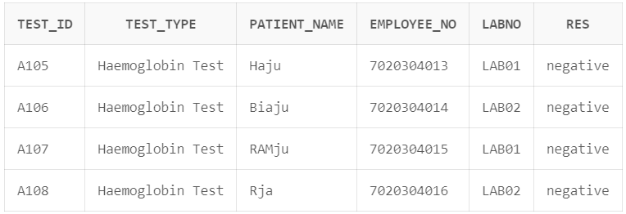

1. **5 A.Create table Bank with fields BankId, BName, Location. Partition the**
2. **Bank table based on Location as per following.**

**BK1 = (Mumbai,Pune,Nashik), BK2 = (Lucknow, Kanpur, Varanasi),**

**BK3 = (Chandigarh, Mohali, Amritsar), BK4 = (GandhiNagar,Ahmedabad,Surat)**

**Insert 10 records in Bank Table.**

**B.Add values “Ratnagiri” in BK1 partition.**

**SQL Query:**

CREATE TABLE Bank(BankId number(5),

BName varchar2(20),

Location varchar2(30))

partition by list(Location)

(partition BK1 values ('Mumbai','Pune','Nashik'),

partition BK2 values ('Lucknow','Kanpur','Varanasi'),

partition BK3 values ('Chandigarh','Mohali','Amritsar'),

partition BK4 values ('GandhiNagar','Ahmedabad','Surat'));

insert into Bank values(101,'Talere','Mumbai');

insert into Bank values(102,'Talere','Pune');

insert into Bank values(103,'Talere','GandhiNagar');

insert into Bank values(104,'Talere','Mohali');

insert into Bank values(105,'Talere','Ahmedabad');

insert into Bank values(106,'Talere','Kanpur');

insert into Bank values(107,'Talere','Chandigarh');

insert into Bank values(108,'Talere','Varanasi');

insert into Bank values(109,'Talere','Lucknow');

insert into Bank values(110,'Talere','Pune');

ALTER TABLE Bank

MODIFY PARTITION BK1

ADD VALUES ('Ratanagiri');

insert into Bank values(111,'Talere','Ratanagiri');

insert into Bank values(112,'Talere','Ratanagiri');

insert into Bank values(113,'Talere','Ratanagiri');4

insert into Bank values(114,'Talere','Ratanagiri');

select * from Bank partition(BK1);

**Output:**

