**#CREATE RANGE PARTITIONING**

create table Sales(year number(4),product varchar(10), amount number(10,2))

Partition by range(year)(

Partition p1 values less than(1990),

Partition p2 values less than(1993),

Partition p3 values less than(MAXVALUE)

);

insert into Sales values(1991,'IRON',2300);

insert into Sales values(1989,'CYCLE',8000);

insert into Sales values(1992,'PEN',10);

insert into Sales values(1996,'PHONES',40000);

insert into Sales values(1991,'CEMENT',390);

insert into Sales values(1989,'SCREWS',100);

insert into Sales values(2000,'DATA',10000);

insert into Sales values(1976,'NAILPAINT',100);

insert into Sales values(1992,'SHEET',9000);

insert into Sales values(1998,'AC',10000);

SELECT * FROM Sales;

select * from sales partition(p1);

select * from sales partition(p2);

select * from sales partition(p3);

**Output:**

SELECT * FROM Sales;

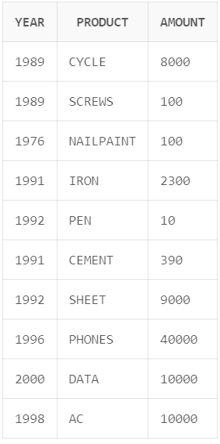

select * from sales partition(p1);

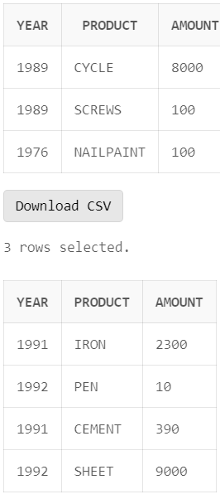

select * from sales partition(p2);



select * from sales partition(p3);

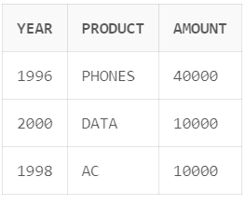

**#CREATE LIST PARTITIONING**

CREATE TABLE customers(custcode number(5),

cust_name varchar2(20),

Address varchar2(10),

City varchar2(20),

Bal number(10))

partition by list(City)

(partition north values ('DELHI','CHANDIGARH'),

partition east values ('KOLKOTA','PATNA'),

partition south values ('HYDERABAD','BANGALORE','CHENNAI'),

partition west values ('BOMBAY','GOA'));

insert into customers values(101,'Onkar','Talere','BANGALORE',5000000);

insert into customers values(102,'Aniket','Talere','BOMBAY',5000000);

insert into customers values(103,'Ram','Talere','GOA',5000000);

insert into customers values(104,'Shyam','Talere','GOA',5000000);

insert into customers values(105,'Sundar','Talere','KOLKOTA',5000000);

insert into customers values(106,'Om','Talere','BOMBAY',5000000);

insert into customers values(107,'Raju','Talere','CHANDIGARH',5000000);

insert into customers values(108,'Tejas','Talere','GOA',5000000);

insert into customers values(109,'Sandip','Talere','CHENNAI',5000000);

insert into customers values(110,'Alpha','Talere','BOMBAY',5000000);

insert into customers values(111,'Beta','Talere','CHENNAI',5000000);

insert into customers values(112,'Aditya','Talere','CHENNAI',5000000);

insert into customers values(113,'Sachin','Talere','CHENNAI',5000000);

insert into customers values(114,'Thugesh','Talere','HYDERABAD',5000000);

insert into customers values(115,'Shreeman','Talere','HYDERABAD',5000000);

insert into customers values(116,'Sitaram','Talere','HYDERABAD',5000000);

insert into customers values(117,'Vishal','Talere','BOMBAY',5000000);

insert into customers values(118,'Uzaif','Talere','CHANDIGARH',5000000);

insert into customers values(119,'Kunal','Talere','CHANDIGARH',5000000);

insert into customers values(120,'Suyash','Talere','PATNA',5000000);

insert into customers values(121,'Yash','Talere','PATNA',5000000);

insert into customers values(122,'Rajan','Talere','BANGALORE',5000000);

insert into customers values(123,'Sahil','Talere','BANGALORE',5000000);

insert into customers values(124,'Rahul','Talere','BANGALORE',5000000);

insert into customers values(125,'Paresh','Talere','BOMBAY',5000000);

insert into customers values(126,'Kaustubh','Talere','BANGALORE',5000000);

insert into customers values(127,'Kamu','Talere','KOLKOTA',5000000);

insert into customers values(128,'Satyajit','Talere','BANGALORE',5000000);

insert into customers values(129,'Sahil1','Talere','BANGALORE',5000000);

insert into customers values(130,'Rahul1','Talere','DELHI',5000000);

insert into customers values(131,'Paresh1','Talere','KOLKOTA',5000000);

insert into customers values(132,'Kaustubh1','Talere','DELHI',5000000);

insert into customers values(133,'Kamu1','Talere','KOLKOTA',5000000);

insert into customers values(134,'Satyajit1','Talere','DELHI',5000000);

select * from customers;

select * from customers partition(west);

select * from customers partition(south);

select * from customers partition(north);

select * from customers partition(east);

insert into customers values(134,'Satyajit1','Talere','DELHI',5000000);

insert into customers values(135,'Satyajit2','Talere','NAGPUR',5000000);

insert into customers values(136,'Sahil2','Talere','NAGPUR',5000000);

insert into customers values(137,'Rahul2','Talere','NAGPUR',5000000);

insert into customers values(138,'Paresh3','Talere','NAGPUR',5000000);

insert into customers values(139,'Kaustubh2','Talere','BHOPAL',5000000);

insert into customers values(140,'Kamu2','Talere','BHOPAL',5000000);

insert into customers values(141,'Satyajit3','Talere','BHOPAL',5000000);

select * from customers;

select * from customers partition(west);

select * from customers partition(south);

select * from customers partition(north);

select * from customers partition(east);

ALTER TABLE customers ADD PARTITION central_India VALUES ('BHOPAL','NAGPUR');

select * from customers partition(central_India);

ALTER TABLE customers

MODIFY PARTITION south

ADD VALUES ('KOCHI', 'MANGALORE');

insert into customers values(142,'Om1','Talere','KOCHI',5000000);

insert into customers values(143,'Raju1','Talere','KOCHI',5000000);

insert into customers values(144,'Tejas1','Talere','KOCHI',5000000);

insert into customers values(145,'Sandip1','Talere','MANGALORE',5000000);

insert into customers values(146,'Alpha1','Talere','MANGALORE',5000000);

insert into customers values(147,'Beta1','Talere','MANGALORE',5000000);

select * from customers partition(south);

ALTER TABLE customers MODIFY PARTITION south DROP VALUES ('CHENNAI', 'MANGALORE');

select * from customers partition(south);

Delete from customers where City = 'CHENNAI';

Delete from customers where City = 'MANGALORE';

ALTER TABLE customers MODIFY PARTITION south DROP VALUES ('CHENNAI', 'MANGALORE');

select * from customers partition(south);

ALTER TABLE customers SPLIT PARTITION west INTO

(PARTITION northwest VALUES ('BOMBAY'),

PARTITION restofthewest);

select * from customers partition(northwest);

select * from customers partition(restofthewest);

**Output:**

