**Practical - 02**

**Title: -** Implementation of Analytical queries

**Aim: -** Implementation of Analytical queries like Roll_UP, CUBE, First, Last, Lead ,Lag,Rank AND Dense Rank.

**Q.1.** Create tables Employee and Department as per the given schema and insert data into them. dept(deptno number(2,0),dname varchar2(14),loc varchar2(13),constraint pk_dept primary key (deptno)); emp(empno number(4,0),ename varchar2(10), job varchar2(9), mgr number(4,0),hiredate date,sal number(7,2),comm number(7,2),deptno number(2,0), constraint pk_emp primary key (empno),constraint fk_deptno foreign key (deptno) references dept (deptno));

**Execute the following queries.**

Create a table employee with attribute empid, name, deptid, deptname, salary and joining date.

**Write the queries -**

1. To return the first salary reported in each department.

2. To show us how the average salary has changed over the years

3.To display the salary of each employee, along with the lowest and highest within their department

4. To divide the whole result set into five buckets based on salary

5. To display for each employee in Department 30 in the employees table, the hire date of the employee hired just after

**SQL Query:**

CREATE TABLE department (

deptno NUMBER(2,0),

dname VARCHAR2(14),

loc VARCHAR2(13),

CONSTRAINT pk_dept PRIMARY KEY (deptno)

);

CREATE TABLE employee (

empno NUMBER(4,0),

ename VARCHAR2(10),

job VARCHAR2(9),

mgr NUMBER(4,0),

hiredate DATE,

sal NUMBER(7,2),

comm NUMBER(7,2),

deptno NUMBER(2,0),

CONSTRAINT pk_emp PRIMARY KEY (empno),

CONSTRAINT fk_deptno FOREIGN KEY (deptno) REFERENCES department (deptno)

);

**1. To return the first salary reported in each department.**

**SQL Query:**

SELECT deptno, MIN(sal) AS first_salary

FROM employee GROUP BY deptno;

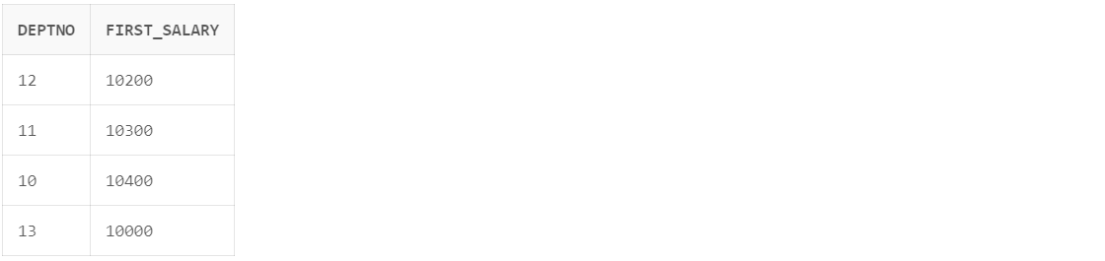

**2. To show us how the average salary has changed over the years**

**SQL Query:**

SELECT hiredate, AVG(sal) AS average_salary

FROM employee GROUP BY hiredate ORDER BY hiredate ASC;

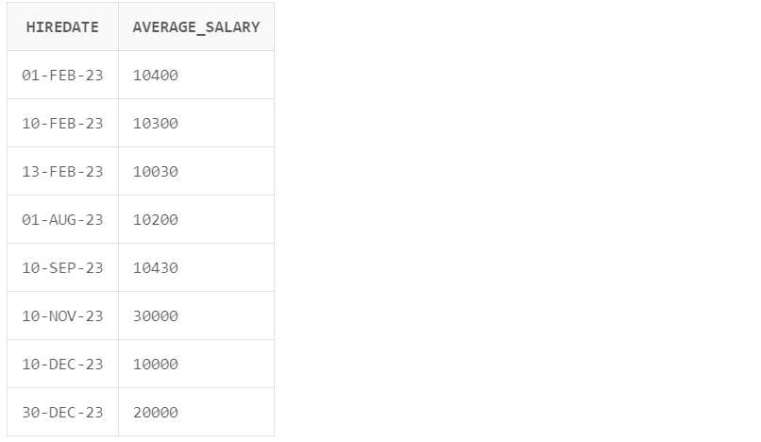

SELECT hiredate, AVG(sal) AS average_salary

FROM employee GROUP BY hiredate ORDER BY hiredate DESC;

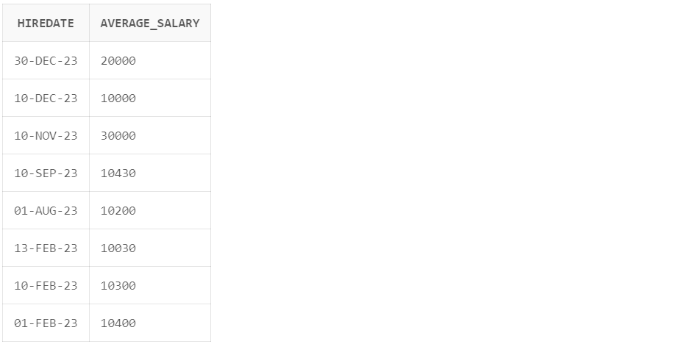

1. **To display the salary of each employee, along with the lowest and highest within their department**

**SQL Query:**

SELECT empid, name, salary, MIN(salary) OVER (PARTITION BY deptid) AS lowest_salary, MAX(salary) OVER (PARTITION BY deptid) AS highest_salary FROM employee;

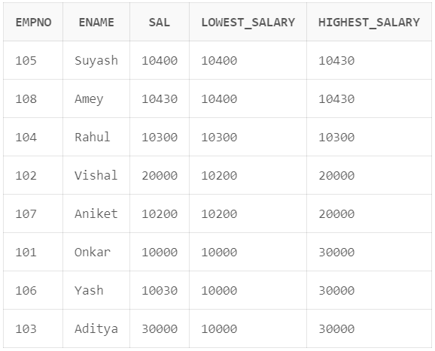

1. **To divide the whole result set into five buckets based on salary**

**SQL Query:**

SELECT empno, ename, sal,

NTILE(5) OVER (ORDER BY sal) AS salary_bucket

FROM employee;

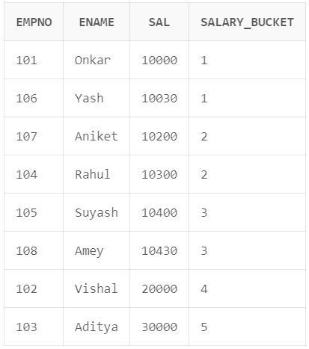

1. **To display for each employee in Department 13 in the employees table, the hire date of the employee hired just after**

**SQL Query:**

SELECT empno, ename, hiredate,

LAG(hiredate) OVER (PARTITION BY deptno ORDER BY hiredate) AS next_hire_date

FROM employee WHERE deptno = 13;

