**Q.2. Create the table Sales and insert records as given.**

**Write analytical queries -**

1. To find total profit for each country.

2. Display Country with maximum profit.

3. Display products with maximum and minimum profit in each country.

4. Display average sale of each product in each country.

5. Find total profit product wise.

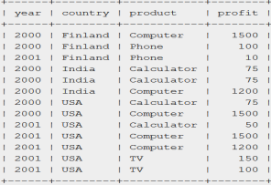

**SQL Query:**

Create table Sales (year int, country varchar(20), product varchar(20), profit int);



1. **To find total profit for each country.**

**SQL Query:**

SELECT country, SUM(profit) AS total_profit

FROM Sales GROUP BY country ORDER BY total_profit DESC;

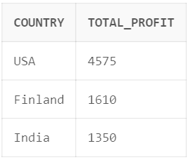

1. **Display Country with maximum profit.**

**SQL Query:**

SELECT country, MAX(profit) AS max_profit

FROM Sales GROUP BY country ORDER BY max_profit DESC LIMIT 1;

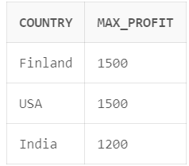

1. **Display products with maximum and minimum profit in each country.**

**SQL Query:**

SELECT country, product, MAX(profit) AS max_profit, MIN(profit) AS min_profit

FROM Sales GROUP BY country, product ORDER BY country, product;

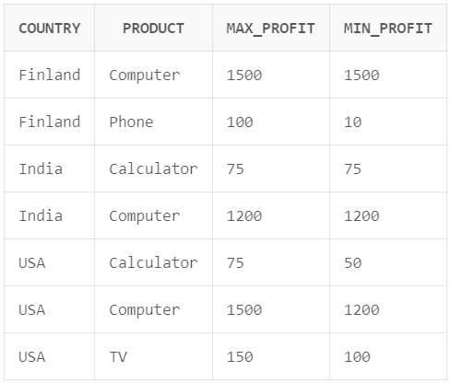

1. **Display average sale of each product in each country.**

**SQL Query:**

SELECT country, product, AVG(profit) AS average_sale

FROM Sales GROUP BY country, product ORDER BY country, product;

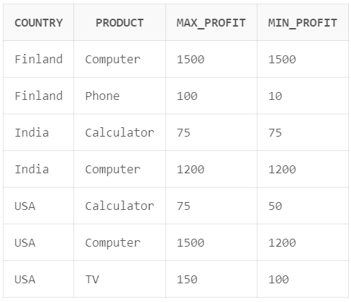

1. **Find total profit product wise.**

**SQL Query:**

SELECT product, SUM(profit) AS total_profit

FROM Sales GROUP BY product ORDER BY total_profit DESC;

