**Q.3.** The research is about to create the star schema for the sales system. The research consists of all the information related to the sale’s record like items, location and the time etc. Create a schema (database) with fact and dimension tables. Perform the OLAP operations on your schema.

• Suppose we want to record in a warehouse information about every Item sale, e.g.:

– Product number,

– location from where the product was sold,

– date of the sale, and

– Units sold.

• The fact table is thus:

Sales(item_key, loc_key, time_key, units)

• The dimension tables include information about the Items, Location, and time “dimensions”:

* Loc(loc_key, city,state,country)
* items(item_key,item_name, item_category, color,price)
* Time(time_key,sdate,week,month,quarter,syear),

1. Display data for quarter 1.

2. Display total sales of pen or jeans from “mumbai" or “chennai” for quarter 1 or 2.

3. Find the total units sales in each state.

4. Find the total units sales in each city

**1. Display data for quarter 1.**

**SQL Query:**

SELECT *

FROM salesfact

JOIN times ON salesfact.time_key = times.time_key

WHERE times.quater = 1;

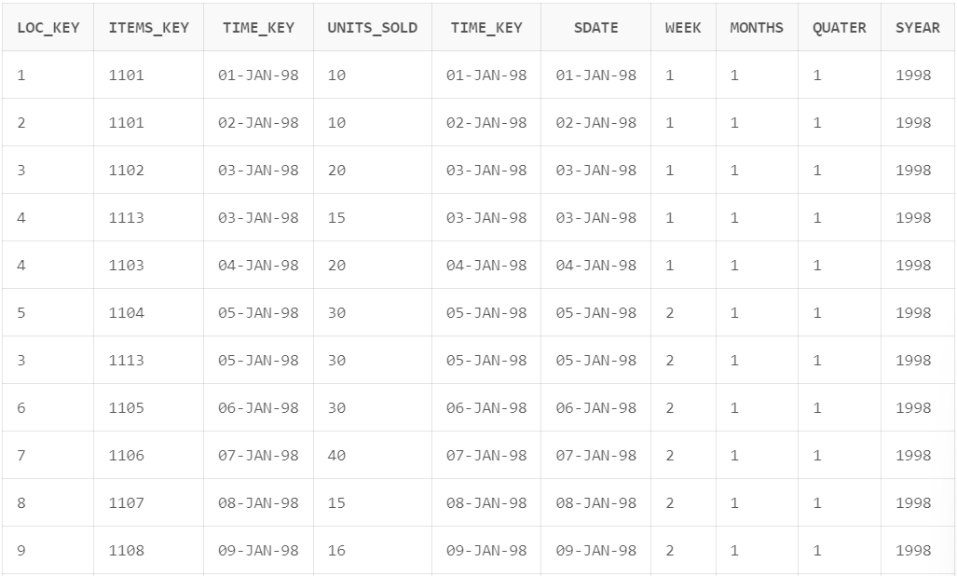

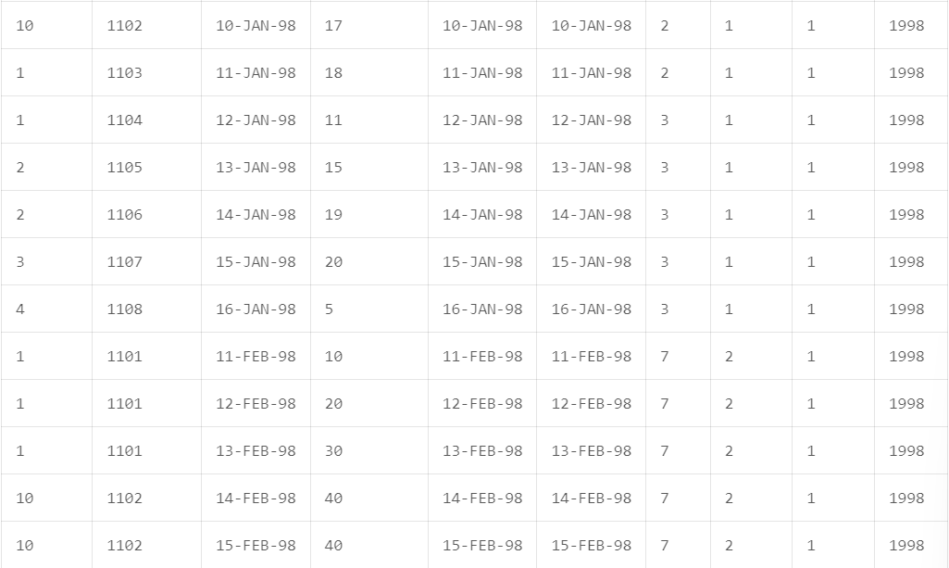

1. **Display total sales of pen or jeans from “mumbai" or “chennai” for quarter 1 or 2.**

**SQL Query:**

select i.item_name, l.city,t.quater, sum(s.units_sold) from salesfact s

left join items i on s.items_key = i.items_key

left join loc l on s.loc_key = l.loc_key

left join times t on s.time_Key = t.time_Key

where(i.item_name in ('Pen','Jeans') and l.city in ('Mumbai','Chennai'))

group by(i.item_name, l.city, t.quater);



**If we check total sales of 'GoProHero' or 'Caravaan2' from 'Los Angeles' or 'Oakland' for quarter 1 or 2.**

**SQL Query:**

select i.item_name, l.city,t.quater, sum(s.units_sold) from salesfact s

left join items i on s.items_key = i.items_key

left join loc l on s.loc_key = l.loc_key

left join times t on s.time_Key = t.time_Key

where(i.item_name in ('GoProHero','Caravaan2') and l.city in ('Los Angeles','Oakland') and t.quater in (1,2))

group by(i.item_name, l.city, t.quater)

order by t.quater;

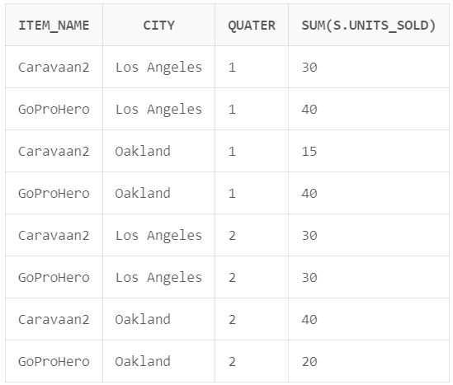

1. **Find the total units sales in each state.**

**SQL Query:**

SELECT

loc.states,

SUM(salesfact.units_sold) AS total_units_sold

FROM salesfact

JOIN loc ON salesfact.loc_key = loc.loc_key

GROUP BY loc.states

ORDER BY total_units_sold DESC;

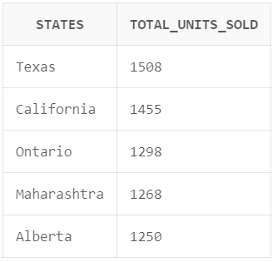

1. **Find the total units sales in each city.**

**SQL Query:**

SELECT

loc.city,

SUM(salesfact.units_sold) AS total_units_sold

FROM loc

LEFT JOIN salesfact ON salesfact.loc_key = loc.loc_key

GROUP BY loc.city

ORDER BY total_units_sold asc;

