**Practical No. 1**

**Q.1 Write a program to implement symmetric encryption using Ceaser Cipher algorithm.**

**Code:**

# Implementation of Caesar Cipher

def encrypt(text, shift):

result = ""

for i in range(len(text)):

char = text[i]

if(char == " "):

result += " "

else:

if(char.isupper()):

result += chr((ord(char) + ord(shift) - 65) % 26 + 65)

else:

result += chr((ord(char) + ord(shift) - 97) % 26 + 97)

return result

text = input("Enter text to encrypt : ")

shift = input("Enter the value of shift : ")

print("Plain Text : " + text)

print("Shift pattern : " + shift)

print("Ceaser Cipher Text is " + encrypt(text, shift))

**Output:**

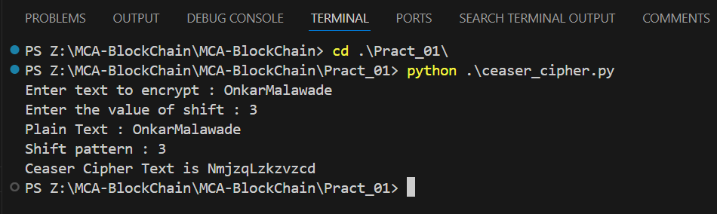

**Q.2 Write a program to implement asymmetric encryption using RSA algorithm. Generate both keys public key and private key and store it in file. Also encrypt and decrypt the message using keys.**

**Code:**

from Crypto.Cipher import PKCS1_OAEP

from Crypto.PublicKey import RSA

from binascii import hexlify

message = b"Public and Private keys Encryption"

private_key = RSA.generate(1024)

public_key = private_key.publickey()

print(type(private_key), type(public_key))

private_pem = private_key.export_key().decode()

public_pem = public_key.export_key().decode()

print(type(private_pem), type(public_pem))

with open('public_pem.pem','w') as pu:

    pu.write(public_pem)

with open('private_pem.pem','w') as pr:

    pr.write(private_pem)

pr_key = RSA.import_key(open('private_pem.pem','r').read())

pu_key = RSA.import_key(open('public_pem.pem','r').read())

print(type(pr_key),type(pu_key))

cipher = PKCS1_OAEP.new(key=pu_key)

cipher_text = cipher.encrypt(message)

print(cipher_text)

decyText = PKCS1_OAEP.new(key=pr_key)

decyText_text = decyText.decrypt(cipher_text)

print(decyText_text)

**Output:**

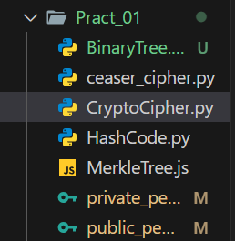

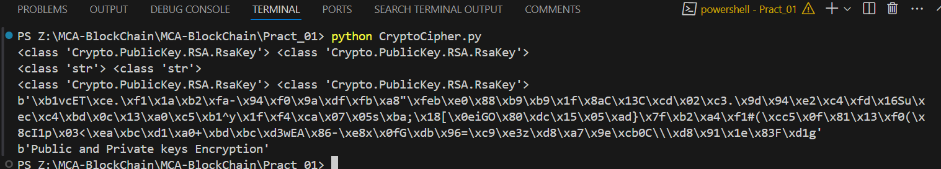

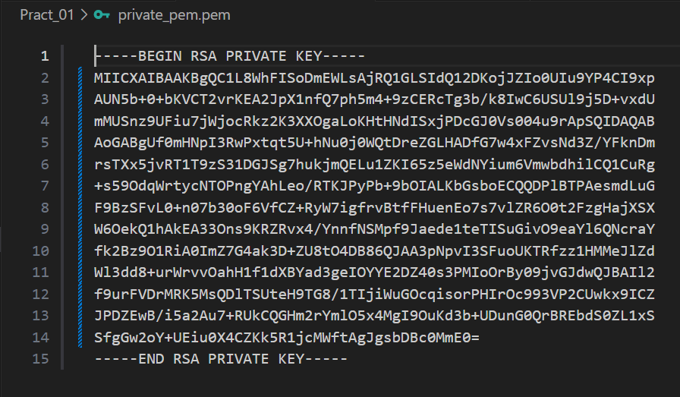

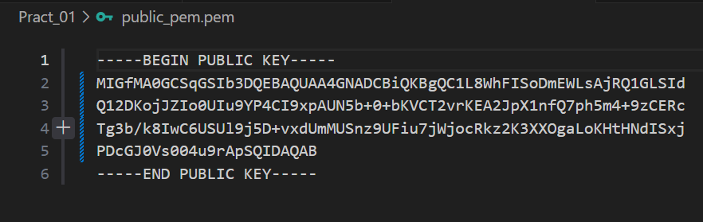

**Q.3 Write a program to demonstrate the use of Hash Functions (SHA-256).**

**Code:**

import hashlib

str = "Hello, How are you?"

encoded = str.encode()

result = hashlib.sha256(encoded)

print("String : " , end = "")

print(str)

print("Hash Value : ", end="")

print(result)

print("Hexadecimal equivalent : ", result.hexdigest())

print("Digest Size : ",end="")

print(result.digest_size)

print("Block Size : ", end = "")

print(result.block_size)

**Output:**

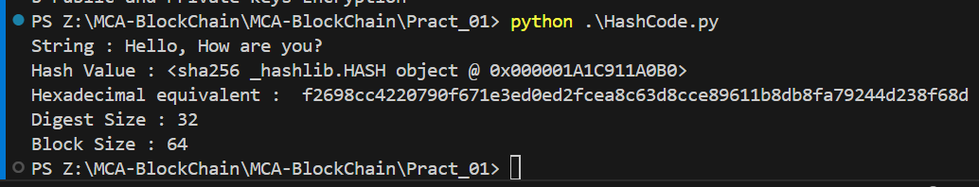

**Q.4 Write a program to demonstrate Merkle Tree.**

**Code:**

// Program to create merkle Tree

var merkle = require('merkle');

var str = 'Fred, Bert, Bill, Bob, Alice, Trent'

var arr = str.split(',');

console.log("Input : \t \t", arr);

var tree = merkle('sha1').sync(arr)

console.log("Root Hash : \t", tree.root());

console.log("Tree Depth : \t", tree.depth());

console.log("Tree Level : \t",tree.levels());

console.log("Tree Nodes : \t",tree.nodes());

var i;

for (i = 0; i < tree.levels(); i++) {

    console.log("\nLevel ", i);

    console.log(tree.level(i));

}

**Output:**

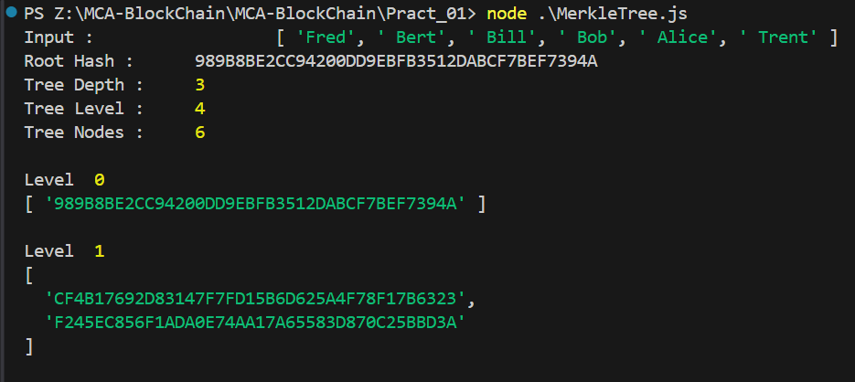 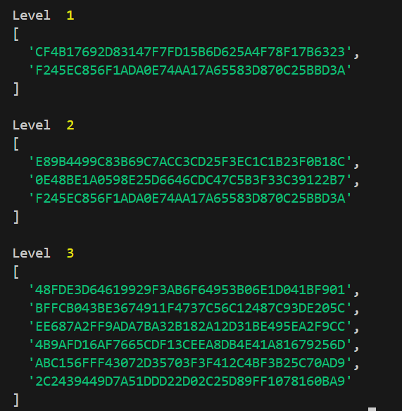

**Q.5 Write a program to implement Merkle Tree using JavaScript**

**Code:**

import hashlib

class MerkleTree:

    def __init__(self, leaves):

        self.leaves = [self._hash(leaf) for leaf in leaves]

        self.root = self._build_tree(self.leaves)

    def _build_tree(self, leaves):

        if len(leaves) == 1:

            return leaves[0]

        next_level = []

        for i in range(0, len(leaves), 2):

            if i + 1 < len(leaves):

                combined = leaves[i] + leaves[i + 1]

            else:

                combined = leaves[i] + leaves[i]

            next_level.append(self._hash(combined))

        return self._build_tree(next_level)

    def _hash(self, data):

        return hashlib.sha256(data.encode()).hexdigest()

    def get_root(self):

        return self.root

    def get_proof(self, index):

        proof = []

        current_index = index

        current_level = self.leaves

        while len(current_level) > 1:

            if current_index % 2 == 0:  # Even index

                if current_index + 1 < len(current_level):

                    proof.append(('right', current_level[current_index + 1]))

            else:

                proof.append(('left', current_level[current_index - 1]))

            current_index //= 2

            current_level = self._get_next_level(current_level)

        return proof

    def _get_next_level(self, current_level):

        next_level = []

        for i in range(0, len(current_level), 2):

            if i + 1 < len(current_level):

                combined = current_level[i] + current_level[i + 1]

            else:

                combined = current_level[i] + current_level[i]  # Handle odd number of nodes by duplicating

            next_level.append(self._hash(combined))

        return next_level

    def verify_proof(self, proof, target_hash):

        current_hash = target_hash

        for direction, sibling_hash in proof:

            if direction == 'left':

                combined = sibling_hash + current_hash

            else:

                combined = current_hash + sibling_hash

            current_hash = self._hash(combined)

        return current_hash == self.root

leaves = ["leaf1", "leaf2", "leaf3", "leaf4"]

tree = MerkleTree(leaves)

root = tree.get_root()

print("Merkle root:", root)

proof = tree.get_proof(0)

print("Proof for leaf1:", proof)

target_hash = hashlib.sha256("leaf1".encode()).hexdigest()

is_valid = tree.verify_proof(proof, target_hash)

print("Is proof valid?", is_valid)

**Output:**



**Q.6 Write a program to implement RSA algorithm**

**Code:**

import random

def gcd(a, b):

while b:

a, b = b, a % b

return a

def multiplicative_inverse(e, phi):

def extended_gcd(a, b):

if a == 0:

return b, 0, 1

else:

gcd, x, y = extended_gcd(b % a, a)

return gcd, y - (b // a) * x, x

gcd, x, y = extended_gcd(e, phi)

if gcd != 1:

raise Exception("Modular inverse does not exist")

else:

return x % phi

def generate_keypair(p, q):

n = p * q

phi = (p - 1) * (q - 1)

e = random.randrange(2, phi)

while gcd(e, phi) != 1:

e = random.randrange(2, phi)

d = multiplicative_inverse(e, phi)

return ((e, n), (d, n))

def encrypt(pk, plaintext):

e, n = pk

ciphertext = [pow(ord(char), e, n) for char in plaintext]

return ciphertext

def decrypt(pk, ciphertext):

d, n = pk

plaintext = [chr(pow(char, d, n)) for char in ciphertext]

return ''.join(plaintext)

p = 5

q = 7

public, private = generate_keypair(p, q)

print("Public Key:", public)

print("Private Key:", private)

message = "Hello, World!"

encrypted_message = encrypt(public, message)

print("Encrypted Message:", encrypted_message)

decrypted_message = decrypt(private, encrypted_message)

print("Decrypted Message:", decrypted_message)

**Output:**

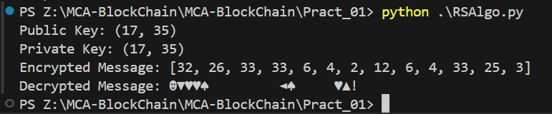

**Q.7 Implement Binary Tree using python**

**Code:**

class Node:

def __init__(self, value):

self.value = value

self.left = None

self.right = None

class BinaryTree:

def __init__(self):

self.root = None

def insert(self, value):

if self.root is None:

self.root = Node(value)

else:

self._insert_recursive(self.root, value)

def _insert_recursive(self, current_node, value):

if value < current_node.value:

if current_node.left is None:

current_node.left = Node(value)

else:

self._insert_recursive(current_node.left, value)

else:

if current_node.right is None:

current_node.right = Node(value)

else:

self._insert_recursive(current_node.right, value)

def inorder_traversal(self):

result = []

self._inorder_traversal_recursive(self.root, result)

return result

def _inorder_traversal_recursive(self, current_node, result):

if current_node:

self._inorder_traversal_recursive(current_node.left, result)

result.append(current_node.value)

self._inorder_traversal_recursive(current_node.right, result)

def preorder_traversal(self):

result = []

self._preorder_traversal_recursive(self.root, result)

return result

def _preorder_traversal_recursive(self, current_node, result):

if current_node:

result.append(current_node.value)

self._preorder_traversal_recursive(current_node.left, result)

self._preorder_traversal_recursive(current_node.right, result)

def postorder_traversal(self):

result = []

self._postorder_traversal_recursive(self.root, result)

return result

def _postorder_traversal_recursive(self, current_node, result):

if current_node:

self._postorder_traversal_recursive(current_node.left, result)

self._postorder_traversal_recursive(current_node.right, result)

result.append(current_node.value)

def delete(self, value):

self.root = self._delete_recursive(self.root, value)

def _delete_recursive(self, current_node, value):

if current_node is None:

return current_node

if value < current_node.value:

current_node.left = self._delete_recursive(current_node.left, value)

elif value > current_node.value:

current_node.right = self._delete_recursive(current_node.right, value)

else:

if current_node.left is None:

return current_node.right

elif current_node.right is None:

return current_node.left

min_value_node = self._find_min_value_node(current_node.right)

current_node.value = min_value_node.value

current_node.right = self._delete_recursive(current_node.right, min_value_node.value)

return current_node

def _find_min_value_node(self, current_node):

while current_node.left is not None:

current_node = current_node.left

return current_node

tree = BinaryTree()

tree.insert(5)

tree.insert(3)

tree.insert(7)

tree.insert(2)

tree.insert(4)

tree.insert(6)

tree.insert(8)

# L N R

print("Inorder traversal:", tree.inorder_traversal())

# N L R

print("Preorder traversal:", tree.preorder_traversal())

# L R N

print("Postorder traversal:", tree.postorder_traversal())

tree.delete(4)

print("Inorder traversal after deletion:", tree.inorder_traversal())

**Output:**

