**Google App Engine Code in Eclipse Java EE:**

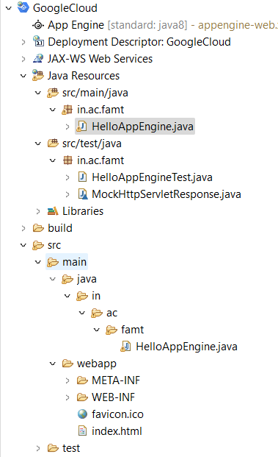

**Code:**

**HelloAppEngine.java**

package in.ac.famt;

import java.io.IOException;

import javax.servlet.annotation.WebServlet;

import javax.servlet.http.HttpServlet;

import javax.servlet.http.HttpServletRequest;

import javax.servlet.http.HttpServletResponse;

@WebServlet(

name = "HelloAppEngine",

urlPatterns = {"/hello"}

)

public class HelloAppEngine extends HttpServlet {

@Override

public void doGet(HttpServletRequest request, HttpServletResponse response)

throws IOException {

response.setContentType("text/plain");

response.setCharacterEncoding("UTF-8");

response.getWriter().print("Hello App Engine! By Bhushan Shirsat 75\r\n");

}

}

**HelloAppEngineTest.java**

package in.ac.famt;

import java.io.IOException;

import org.junit.Assert;

import org.junit.Test;

public class HelloAppEngineTest {

@Test

public void test() throws IOException {

MockHttpServletResponse response = new MockHttpServletResponse();

new HelloAppEngine().doGet(null, response);

Assert.assertEquals("text/plain", response.getContentType());

Assert.assertEquals("UTF-8", response.getCharacterEncoding());

Assert.assertEquals("Hello App Engine!\r\n", response.getWriterContent().toString());

}

}

**Index.html**

<!DOCTYPE html>

<html xmlns="http://www.w3.org/1999/xhtml" lang="en">

<head>

<meta http-equiv="content-type" content="application/xhtml+xml; charset=UTF-8" />

<title>Hello App Engine</title>

</head>

<body>

<h1>Hello App Engine!</h1>

<table>

<tr>

<td colspan="2" style="font-weight:bold;">Available Servlets:</td>

</tr>

<tr>

<td><a href='/hello'>The servlet Bhushan: </a></td>

</tr>

</table>

</body>

</html>

**Output:**

