**Google App Engine project using Eclipse IDE. The process involves installing the required Google Cloud Tools, configuring your server runtime environment, creating a Google App Engine project, and running it.**

**Step 1: Install Google Cloud Tools for Eclipse**

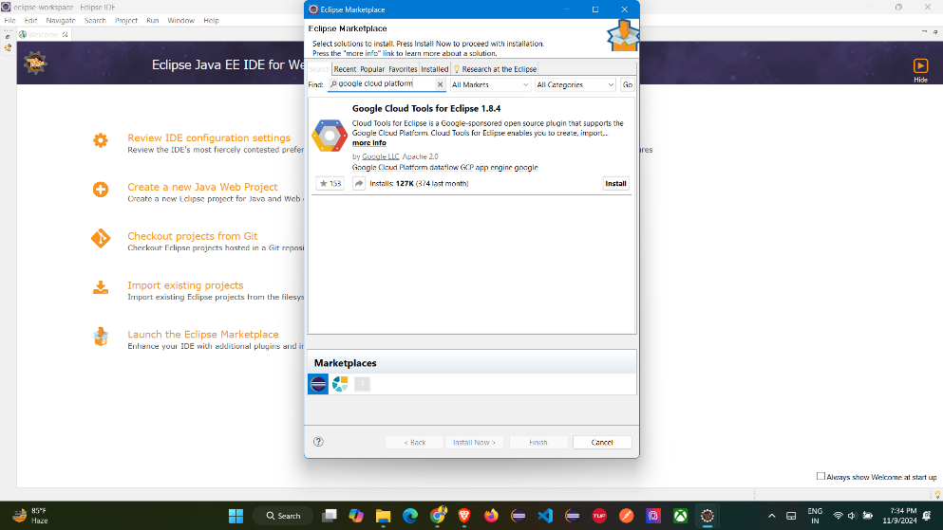

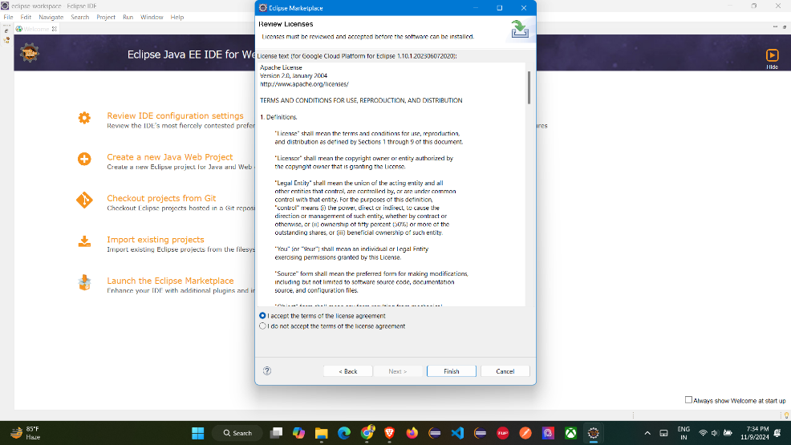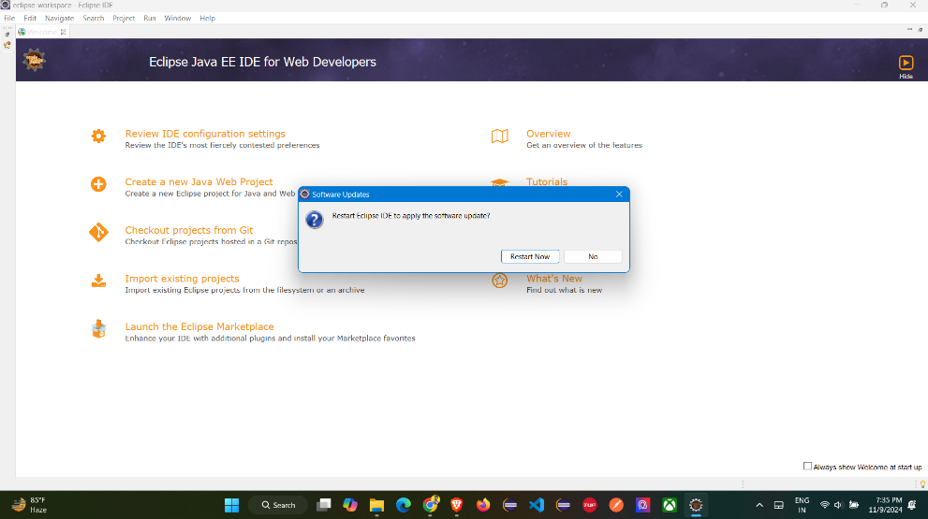

**Step 2: Verify Installation using Windows -> Preferences -> Google Cloud Platform**

**Check if the SDK Version is 500.0.0 or higher.**

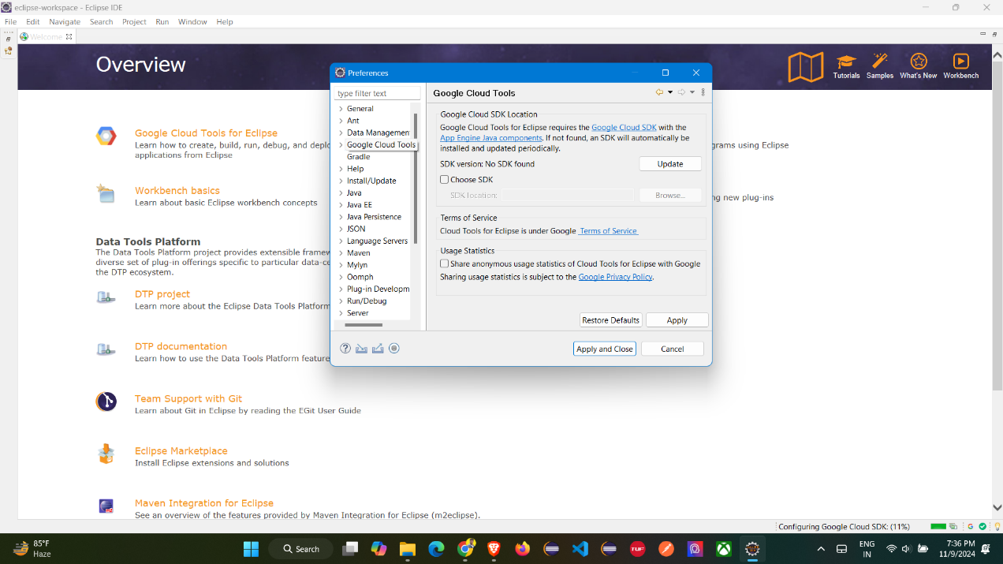

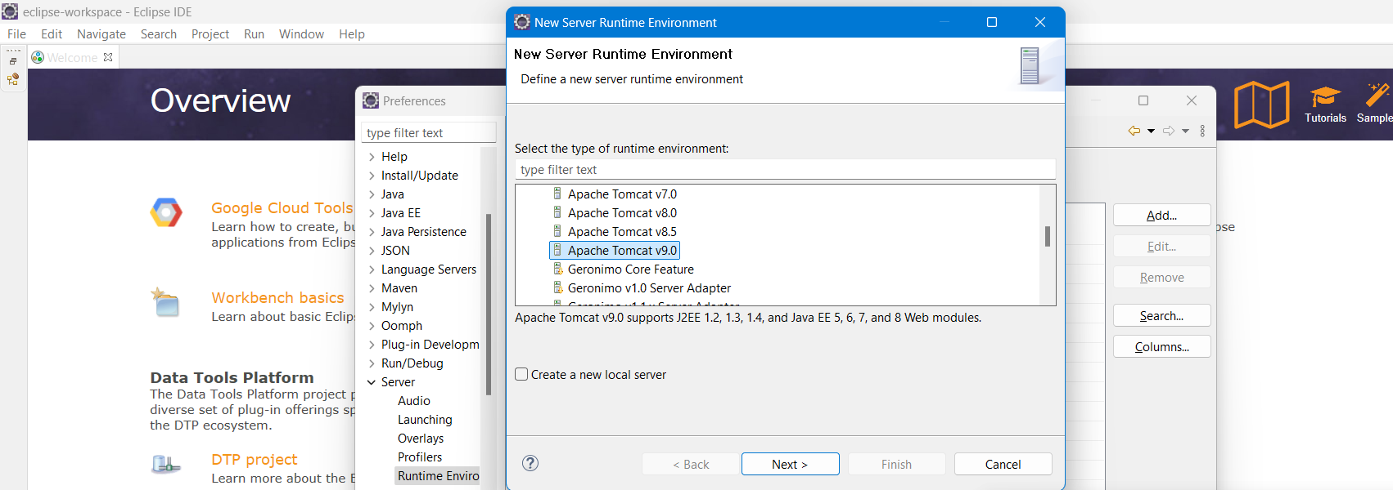

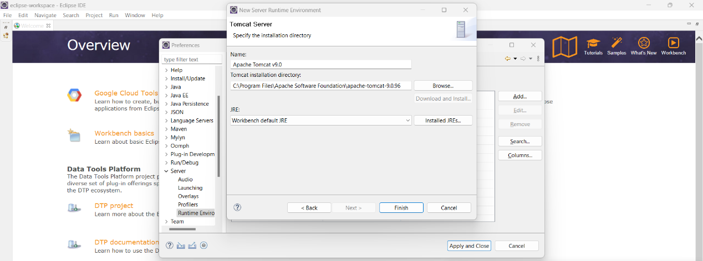

**Step 3: Configure Apache Tomcat Server Runtime, In the preferences window, navigate to Server > Runtime Environments. Look for Apache Tomcat v9.0 in the list.**

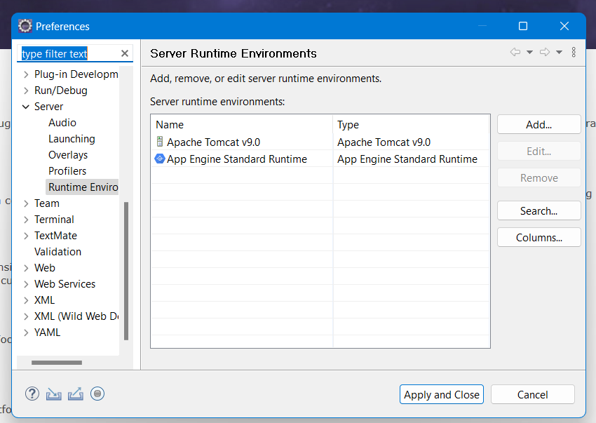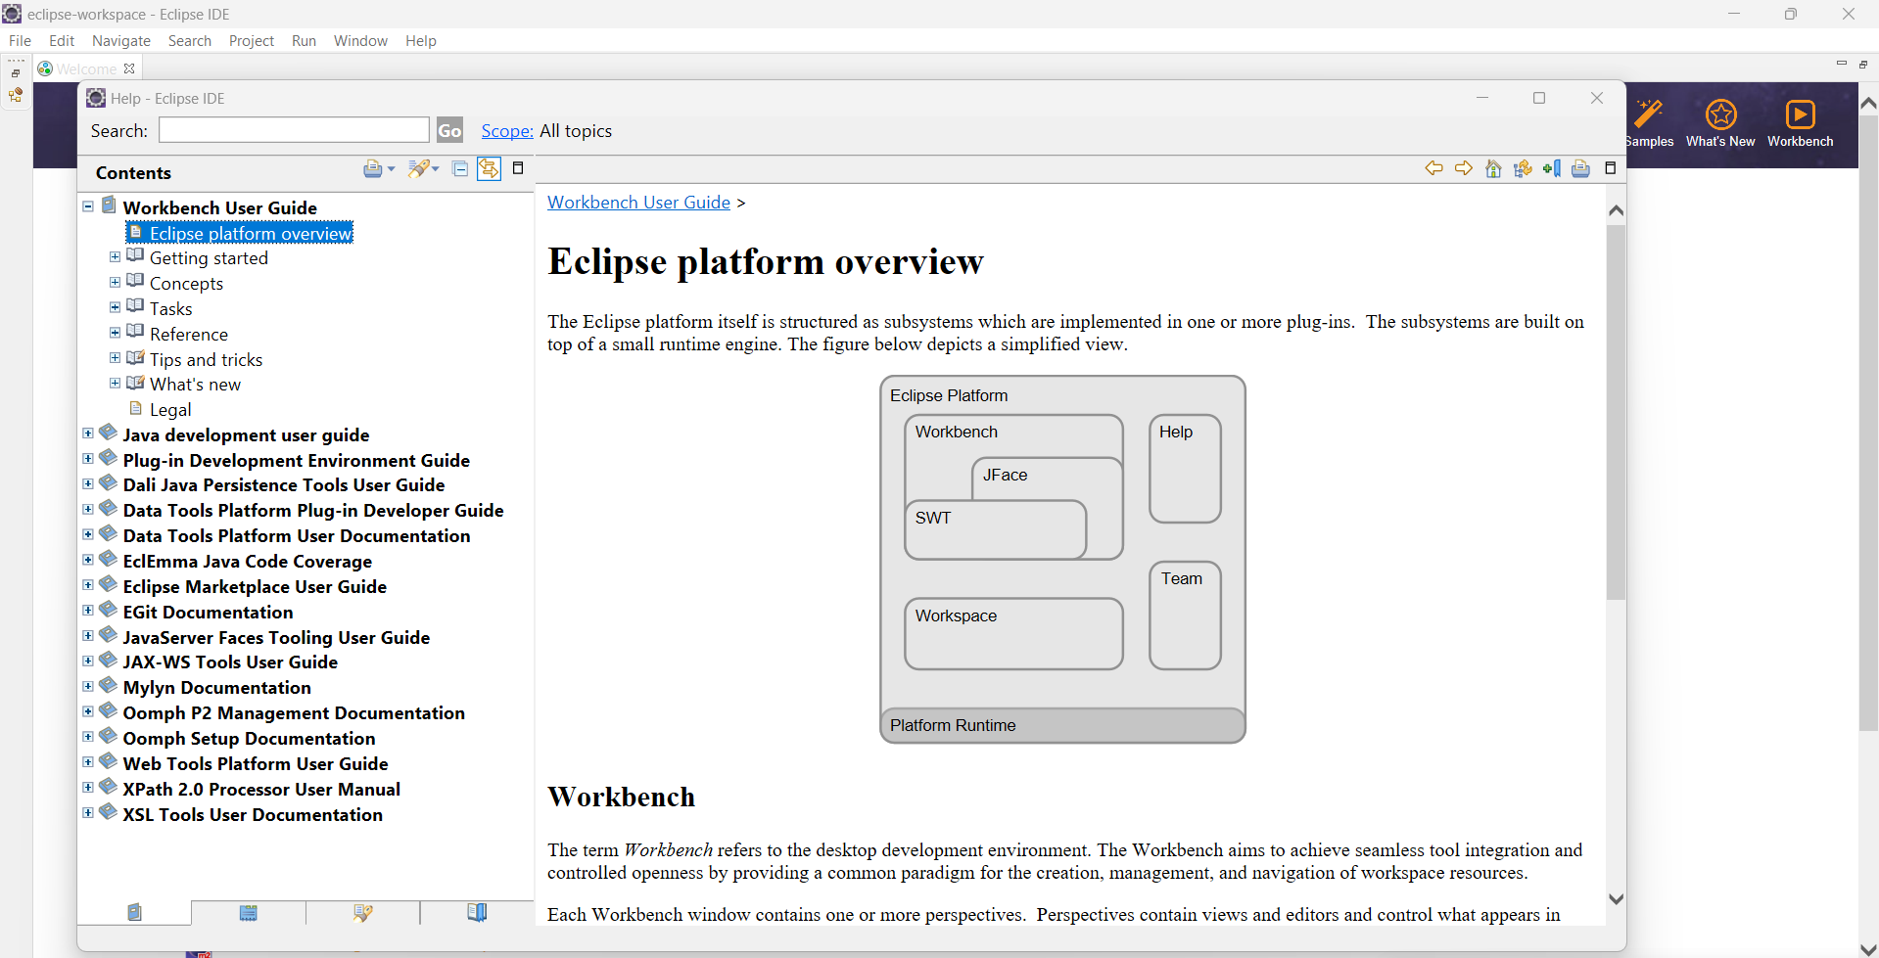

**Step 4: Install JDK and JRE 1.8**

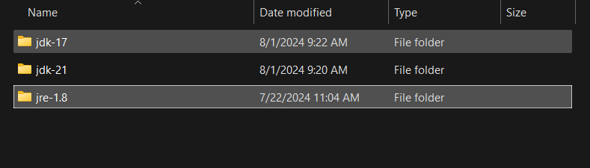

**Step 5: Create a Google App Engine Standard Java Project**

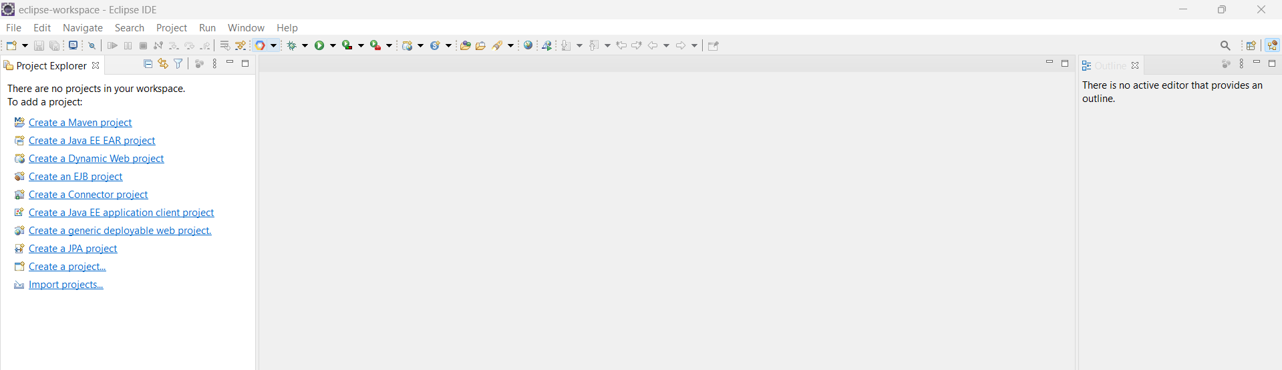

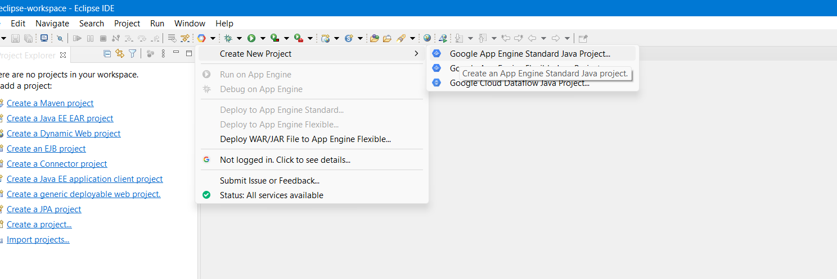

**In Eclipse, go to Google Cloud Platform in the top menu.**

**Select Create New Project from the dropdown.**

**Choose Google App Engine Standard Java Project.**

**Assign a name to your project and specify a Java package.**

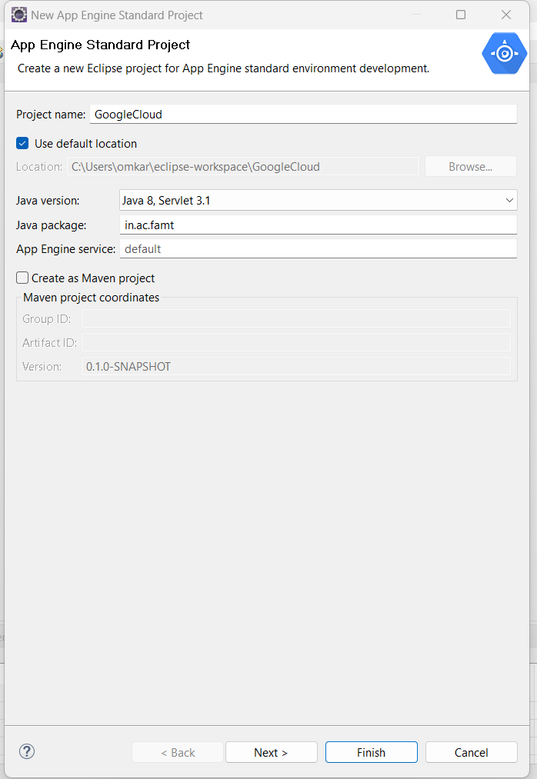

**Select App Engine API for the project.**

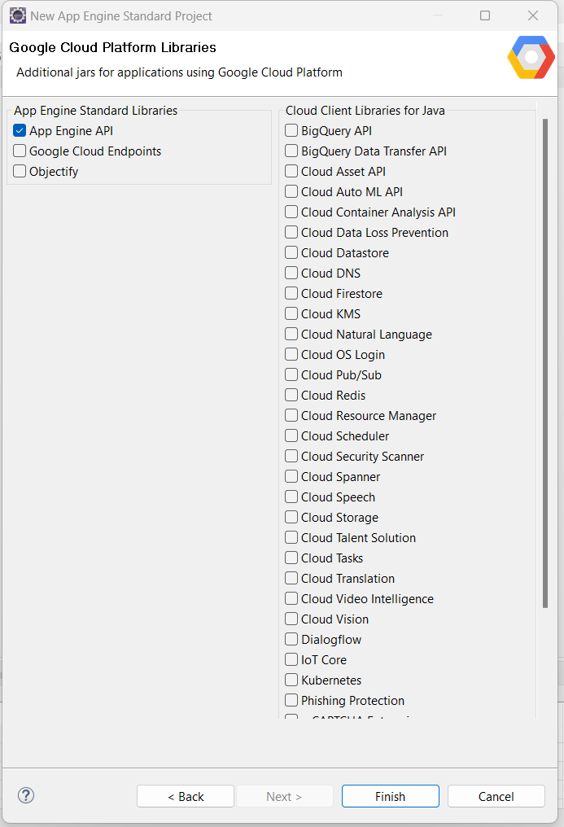

**Step 6: Add Apache Tomcat as Server Runtime**



**Step 7: Verify and Set JRE System Library**

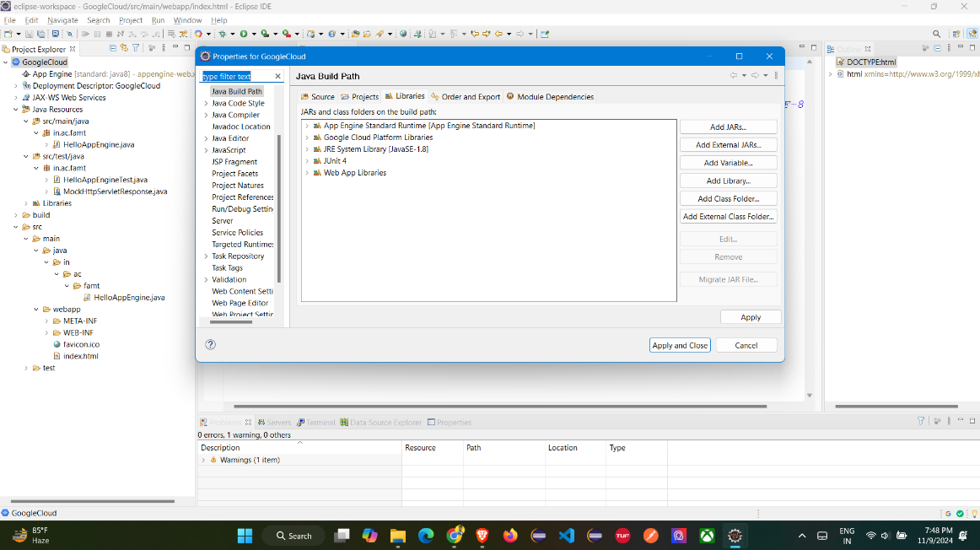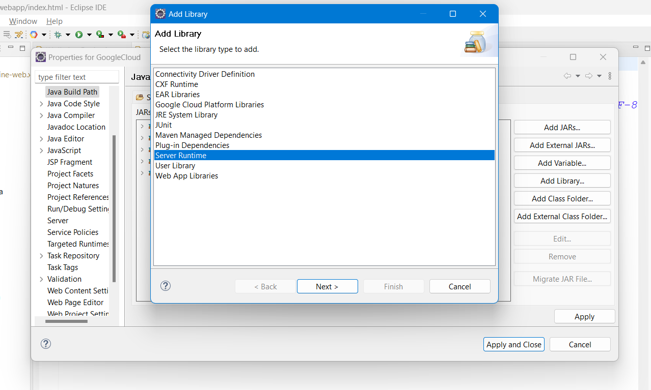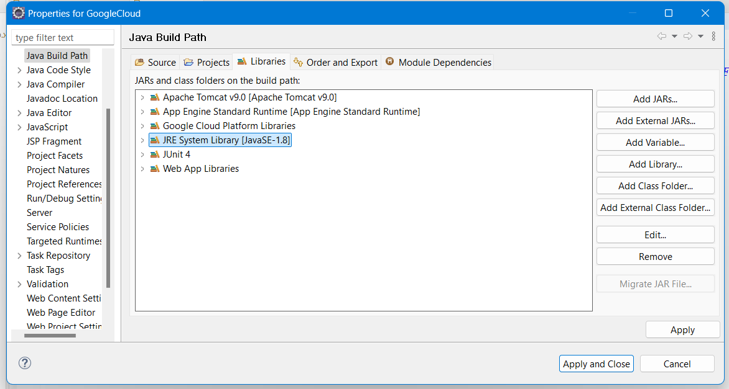

**Step 8: Run the Application on App Engine**

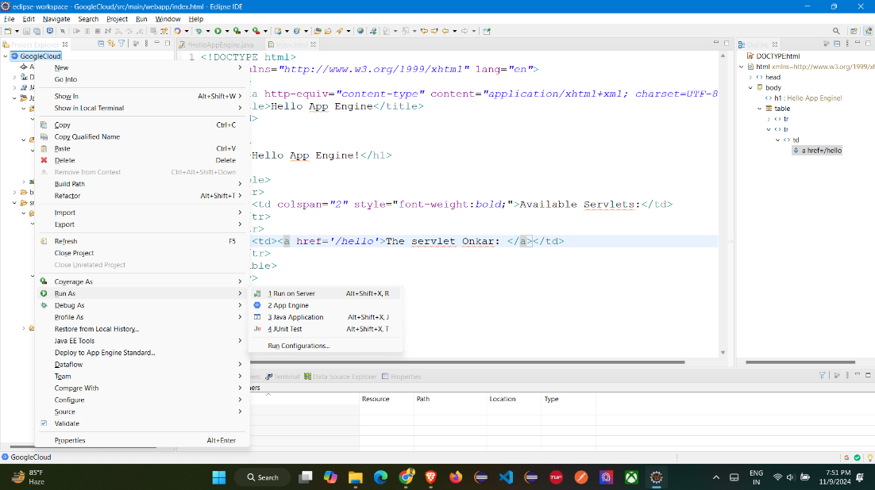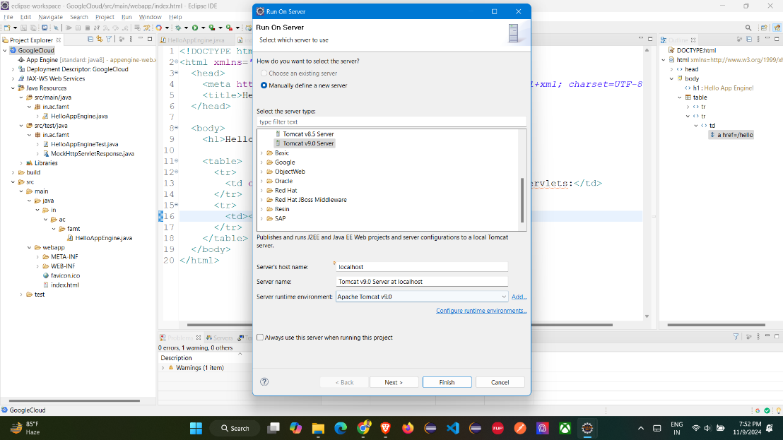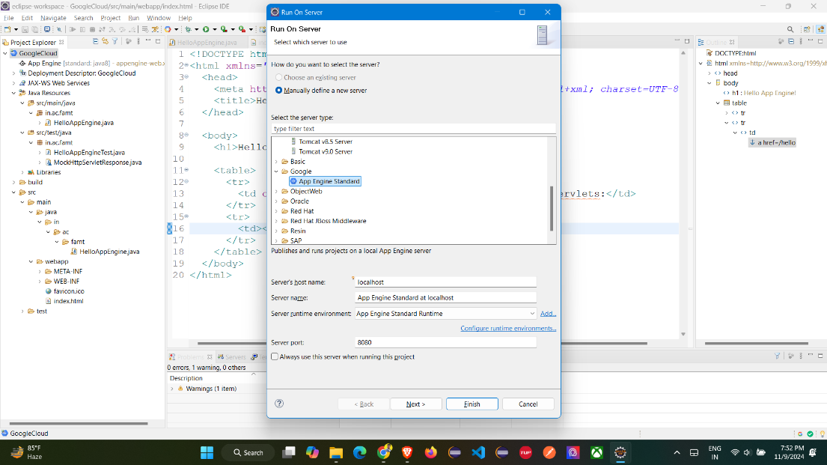

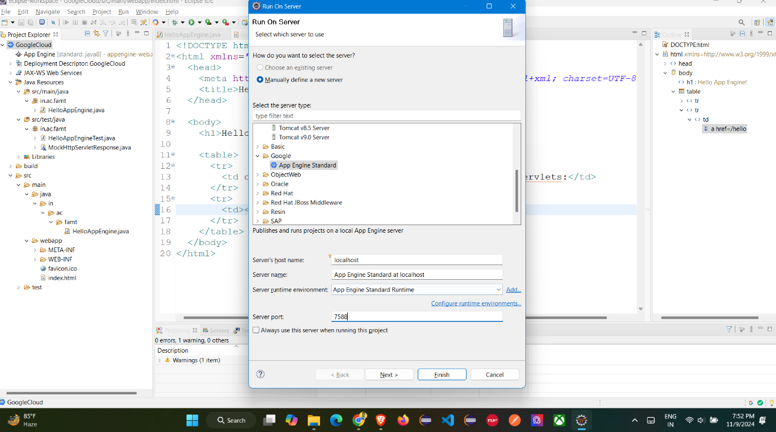

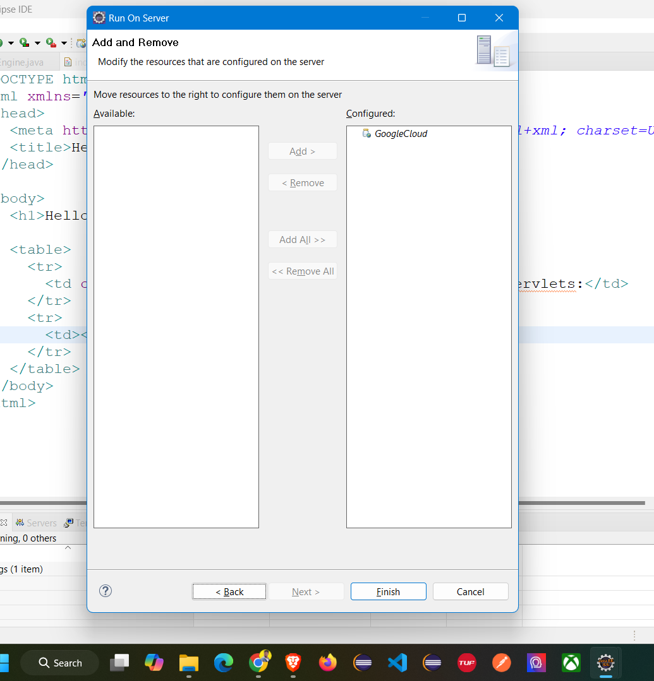

**Step 9: Deploy the Application**

