**Google App Engine IDE Runs Code with Python 2.7:**

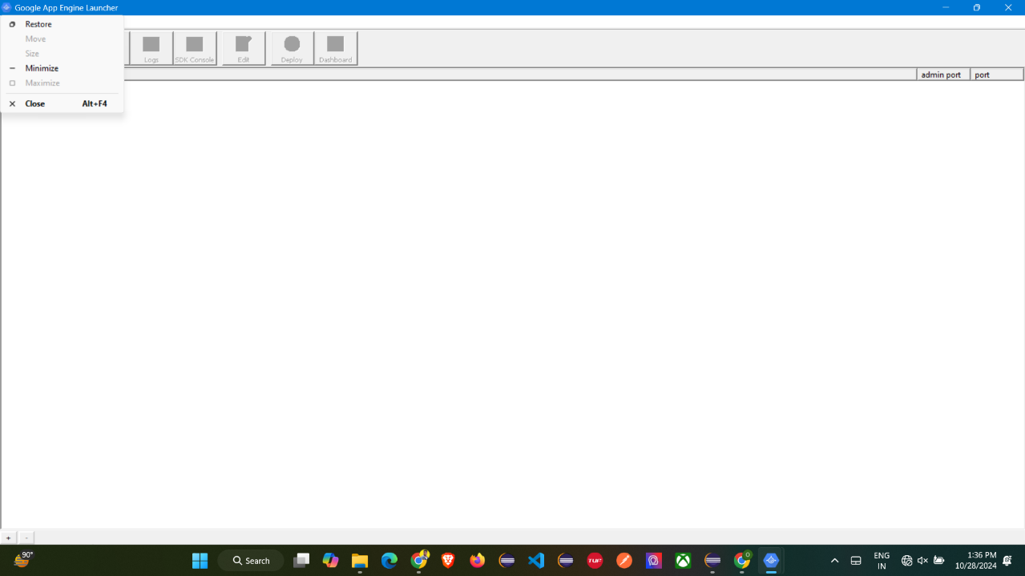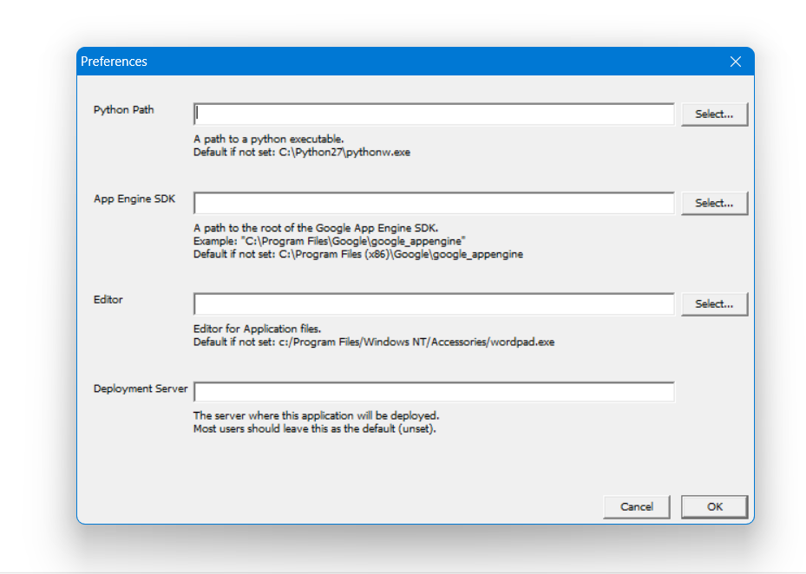

**Setup Python Path:**

**Add Path of the File:**

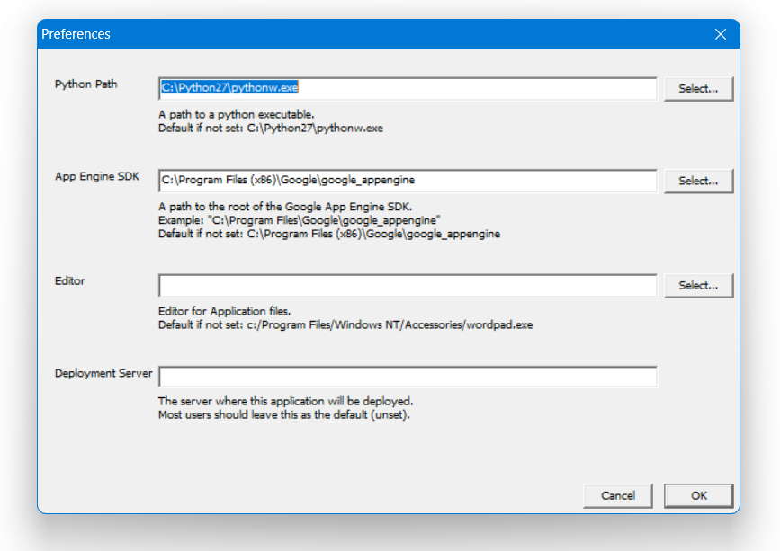

**Add Code inside of it:**

**import webapp2**

**class MainHandler(webapp2.RequestHandler):**

**def get(self):**

**self.response.write('Hello world!')**

**app = webapp2.WSGIApplication([**

**('/', MainHandler)],**

**debug=True)**

**Google App Engine Configuration:**

**Add New Application in Google App Engine:**

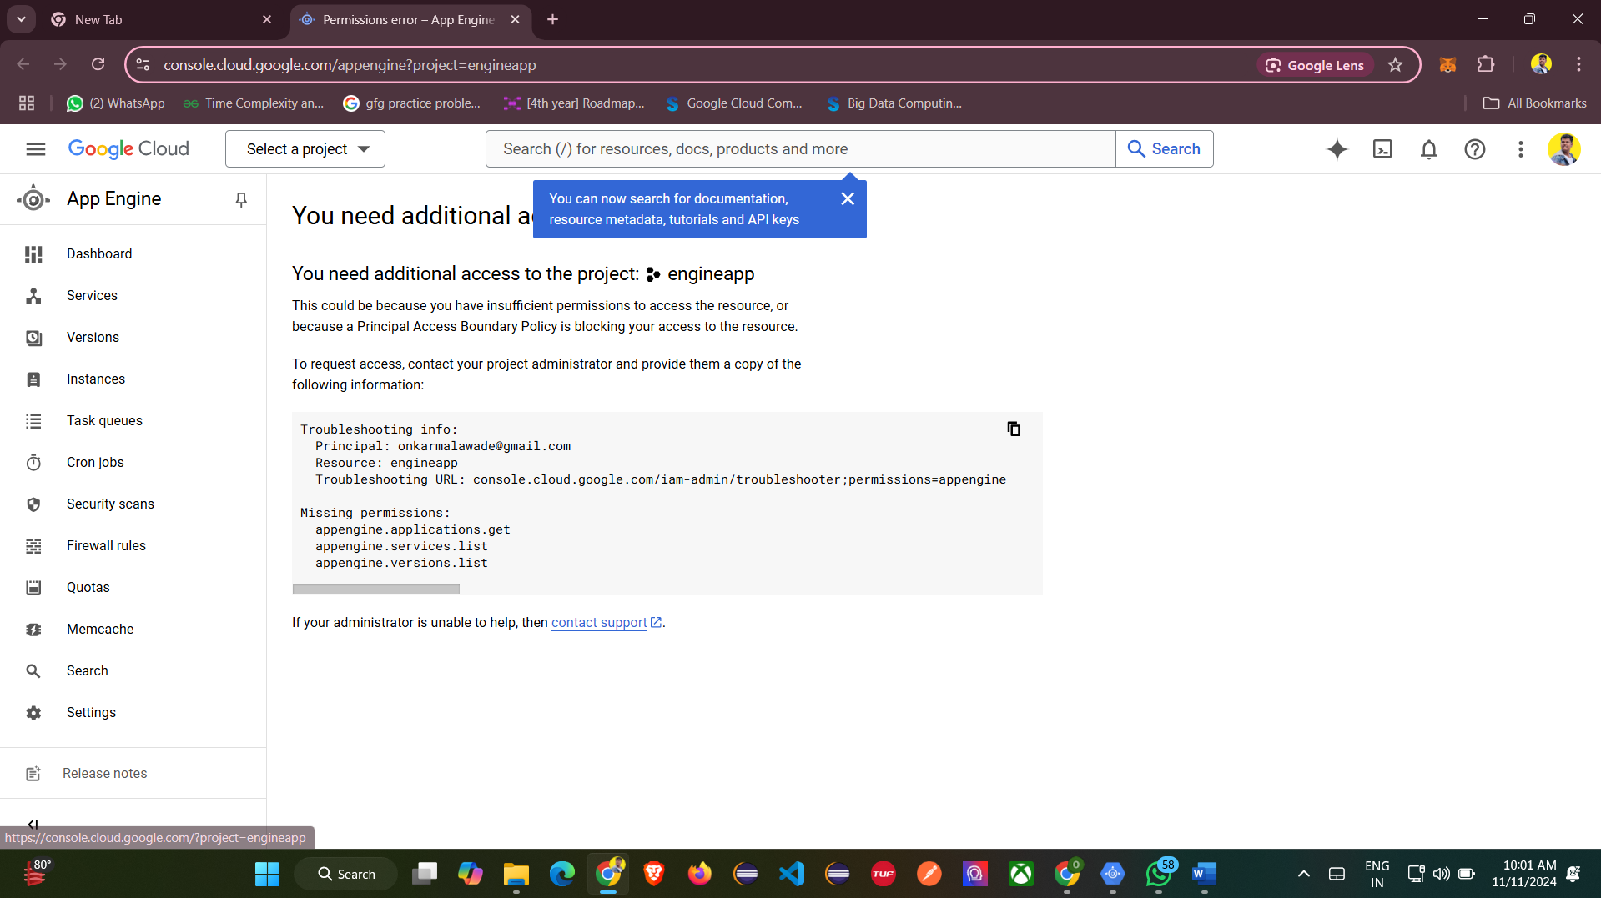 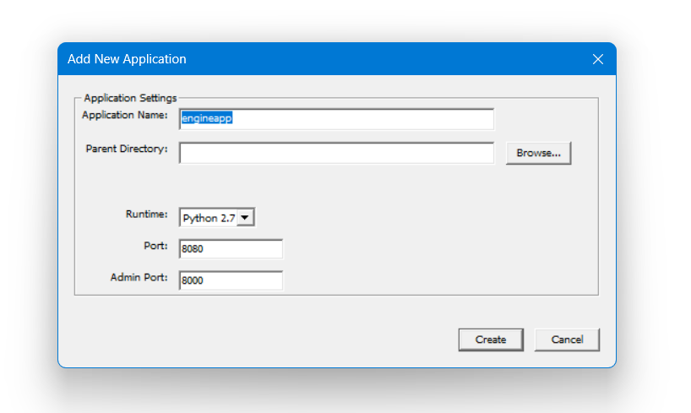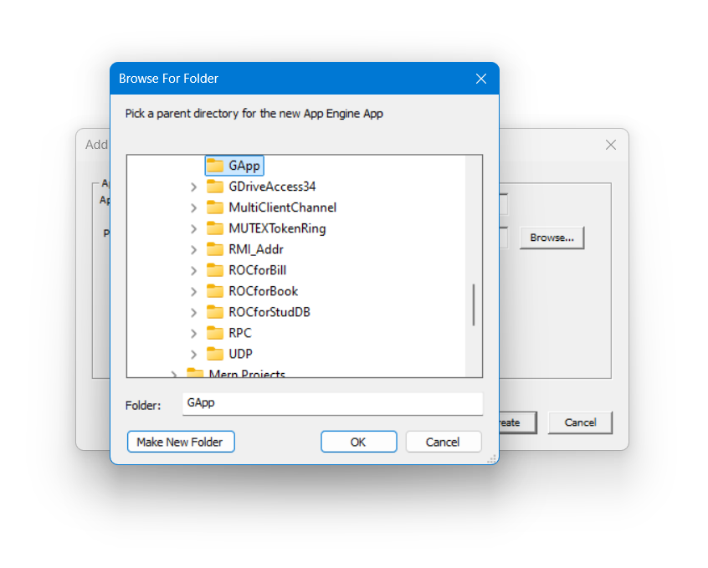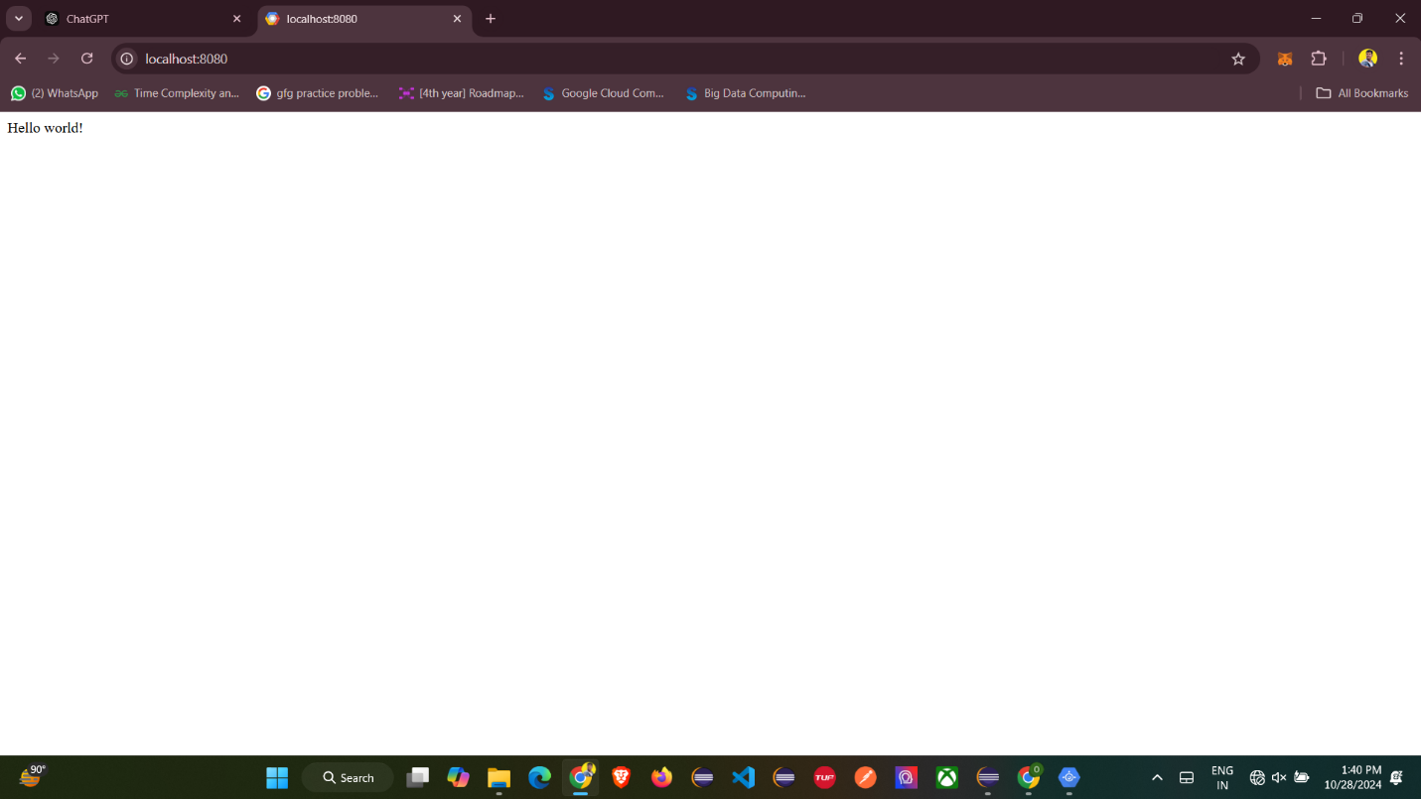

**Browse For Folder in Google App Engine:**

**Run the Localhost port that Setup:**